INDIAN INSTITUTE OF TECHNOLOGY
EE-3202
Power System II


Experiment-4

Submitted By:
Shaurya Aggarwal
2301EE56

Swing Equation
Aim-
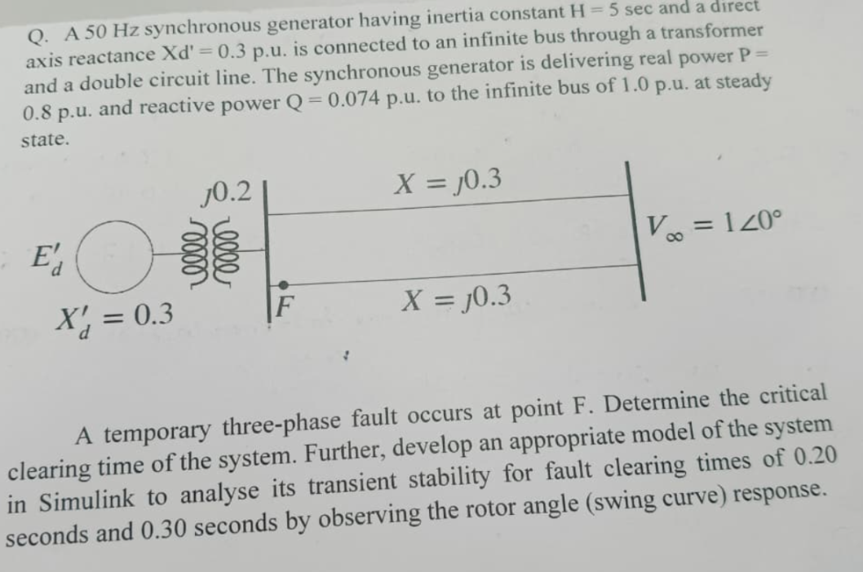

Calculation-
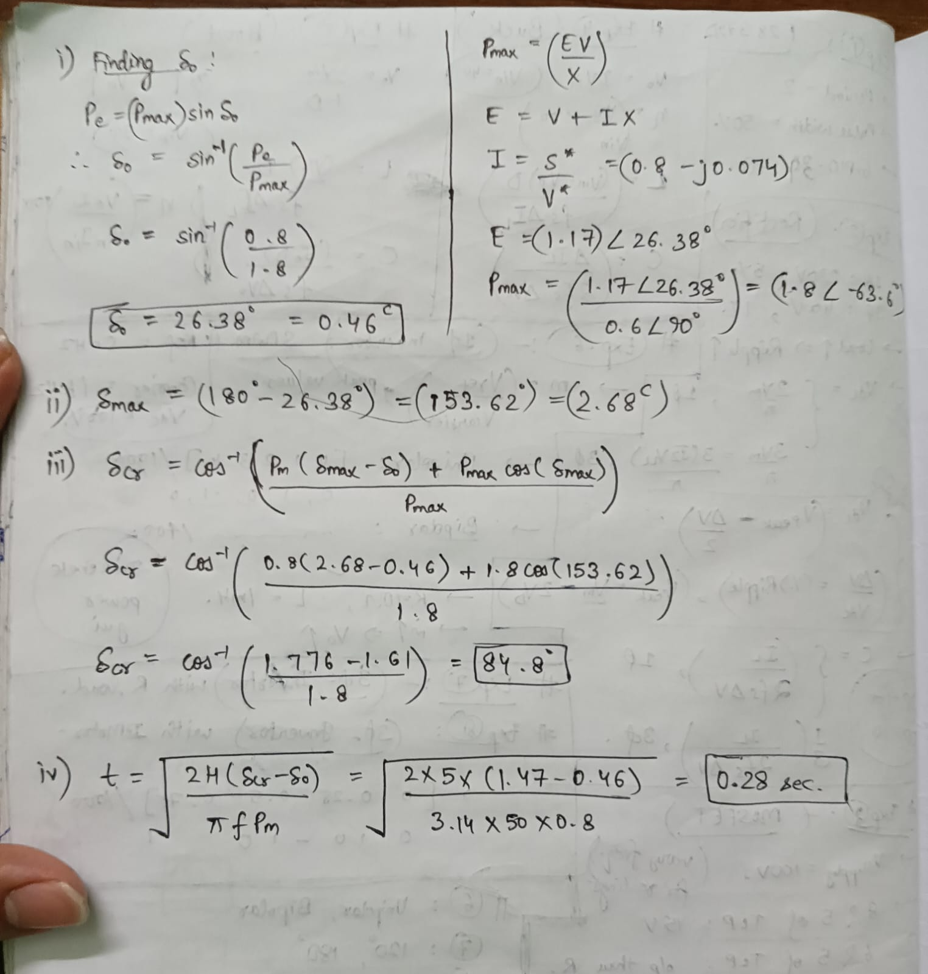

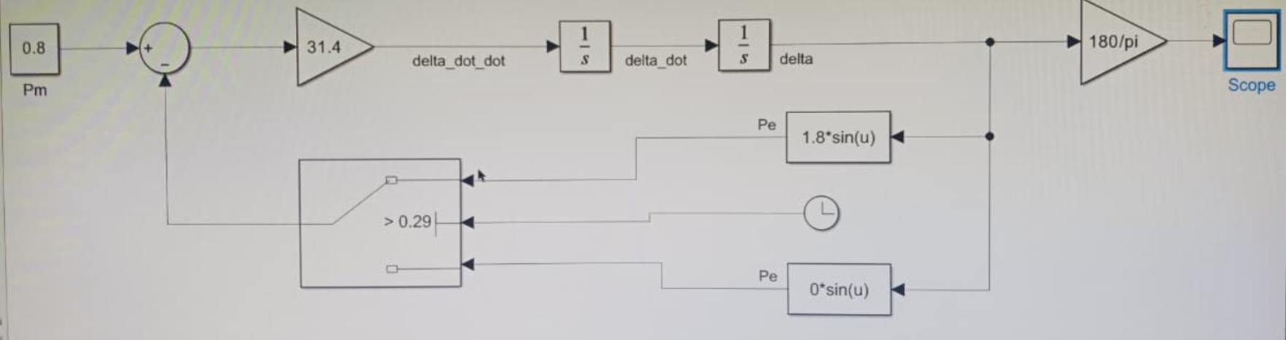
Simulation-

Outputs-
- For 0.29:
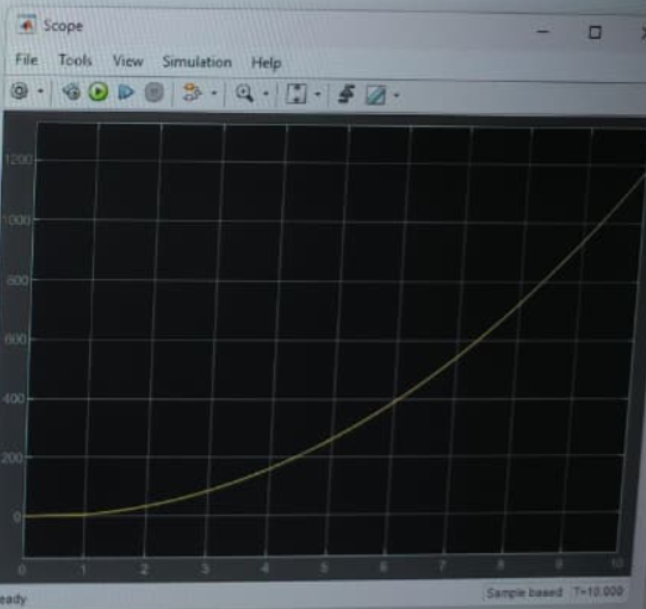
- For 0.28
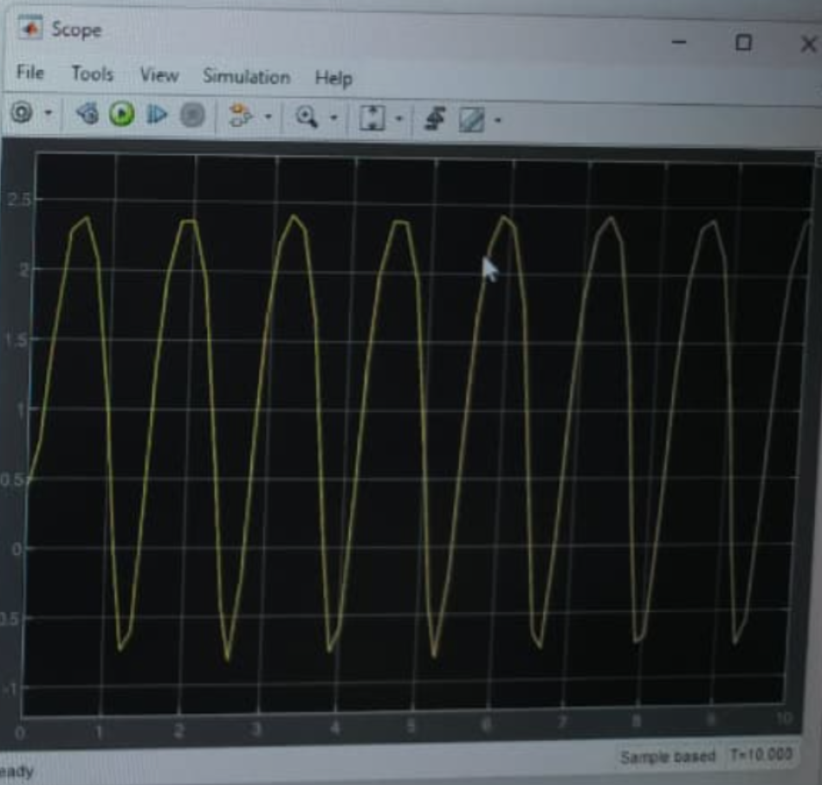
- For 0.21:
