Bike Demand Prediction Analysis: Q4 2024

1. Quarter Selection
This analysis focuses on Q4 2024 (October–December). This quarter was selected to capture seasonal variation in bike share demand as Philadelphia transitions into colder winter months. Compared to spring or summer periods, Q4 is characterized by lower temperatures, shorter daylight hours, and increased weather variability, all of which are expected to influence biking behavior.
Analyzing Q4 provides a useful test of model robustness under less stable demand conditions and allows for comparison with the Q1 2025 baseline, which represents a transition toward more favorable weather conditions.

2. Model Comparison Results
A series of six models were developed with increasing complexity, incorporating temporal, demographic, and station-level features. Model performance improved consistently as additional predictors were introduced.
The baseline model using time and weather variables provided a reasonable starting point, but the inclusion of temporal lag variables significantly improved predictive accuracy, confirming that past demand is a strong predictor of future usage. Further gains were achieved by incorporating demographic characteristics and station fixed effects, which capture spatial heterogeneity in demand.
The final model, which included engineered features such as a “good weather” indicator, a weekly lag (same hour last week), and a rolling 24-hour average, achieved the best performance, reducing MAE from 0.44 to 0.42 (approximately a 4–5% improvement).
A Poisson model was also tested to account for the count nature of the data but did not outperform the linear model, likely due to overdispersion and the strong predictive power of temporal features already included.
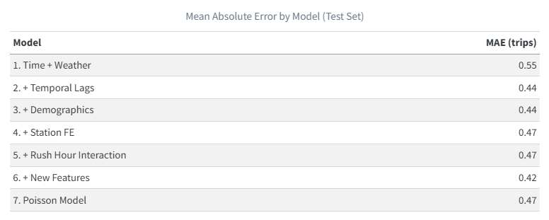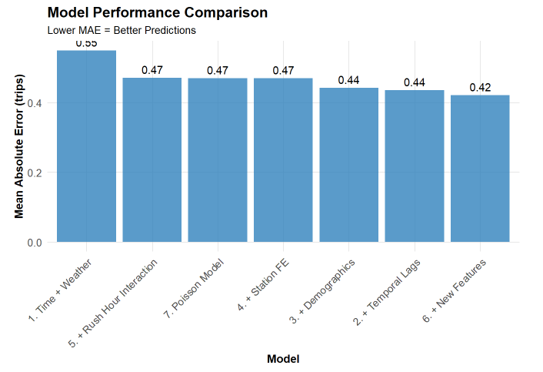

3. Error Analysis Insights
Spatial Patterns:
Prediction errors are spatially concentrated in high-demand areas, particularly in Center City and surrounding commercial districts. These locations exhibit more dynamic and context-dependent demand, likely influenced by factors such as employment density, tourism, and events that are not captured in the model. In contrast, residential neighborhoods show lower and more stable errors.
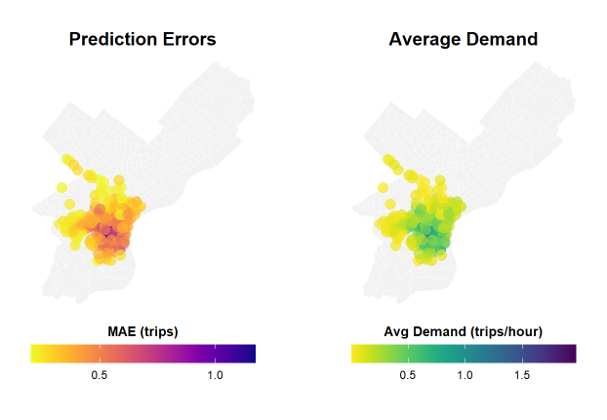

Temporal Patterns:
Errors are highest during peak commuting hours, especially during morning and evening rush periods. These periods combine high demand with greater variability, making them more difficult to predict accurately. Errors are lower during off-peak and overnight periods, where demand is more stable.
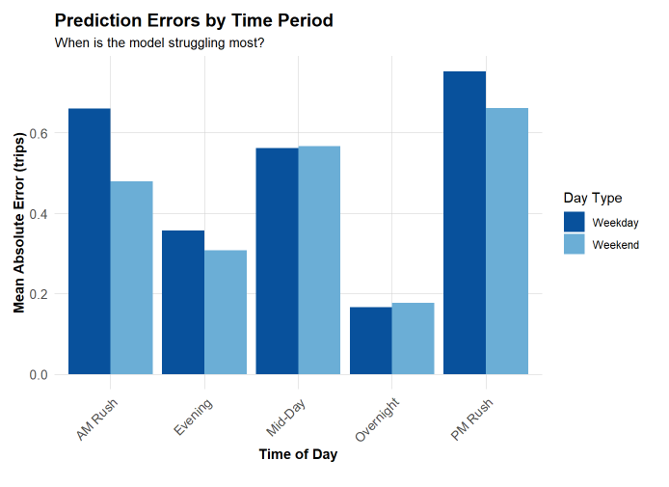

Demographic Patterns:
Prediction errors show some relationship with neighborhood characteristics. Areas with higher income and higher transit usage tend to exhibit greater errors, likely reflecting more complex and multimodal travel behavior. This raises potential equity concerns, as uneven prediction accuracy may translate into uneven service reliability.
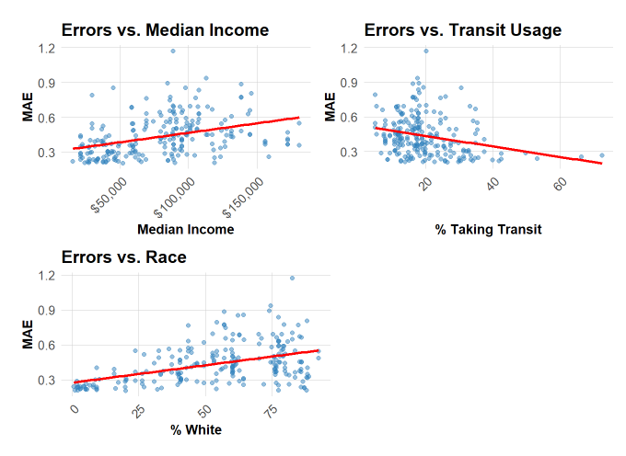

4. Feature Engineering and Model Improvement
Based on observed error patterns, three new features were introduced: a “good weather” indicator, a weekly lag variable, and a rolling 24-hour average demand.
The “good weather” variable captures favorable biking conditions, while the weekly lag reflects strong cyclical commuting patterns. The rolling average smooths short-term fluctuations and reduces noise in the data.
These features improved model performance, particularly during high-demand periods where earlier models struggled. The weekly lag was especially effective, highlighting the importance of capturing recurring behavioral patterns.
Overall, the reduction in MAE from 0.44 to 0.42 demonstrates that incorporating both environmental and temporal structure leads to more accurate and stable predictions.

5. Critical Reflection on Deployment
From an operational perspective, the final model achieves relatively low prediction error and could be used as a decision-support tool for bike rebalancing. However, errors remain higher during peak demand periods, which are the most critical for system performance. Inaccurate predictions during these times could lead to bike shortages or surpluses at key stations.
From an equity standpoint, the presence of higher errors in certain neighborhoods raises concerns about uneven service provision. If the model is used to guide resource allocation, it could inadvertently disadvantage areas where predictions are less accurate. Safeguards such as minimum service thresholds or targeted rebalancing strategies would be necessary to ensure equitable outcomes.
The model also has important limitations. It does not account for short-term demand shocks such as special events, holidays, or disruptions, nor does it incorporate infrastructure factors like bike lanes or station capacity. Additionally, it assumes that relationships between predictors and demand remain stable over time, which may not hold in real-world deployment.
With more time and data, the model could be improved by incorporating event data, richer spatial features, and real-time inputs. More advanced modeling approaches could also help capture non-linear relationships and better account for station-level heterogeneity.

