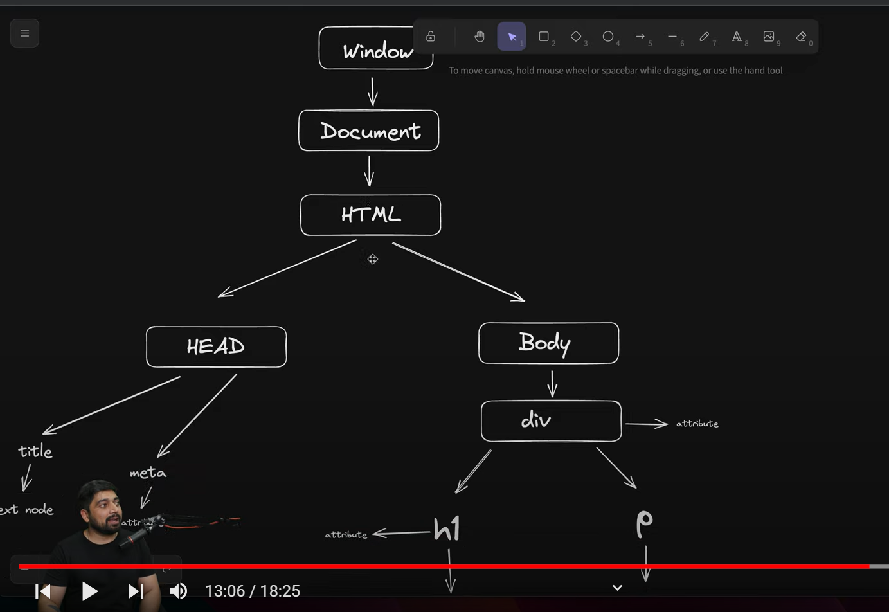

STRUCTURE OF OBJECTS IN HTML TO BE MODIFIED INDIVIDUALLY IF NEEDED LATER ON

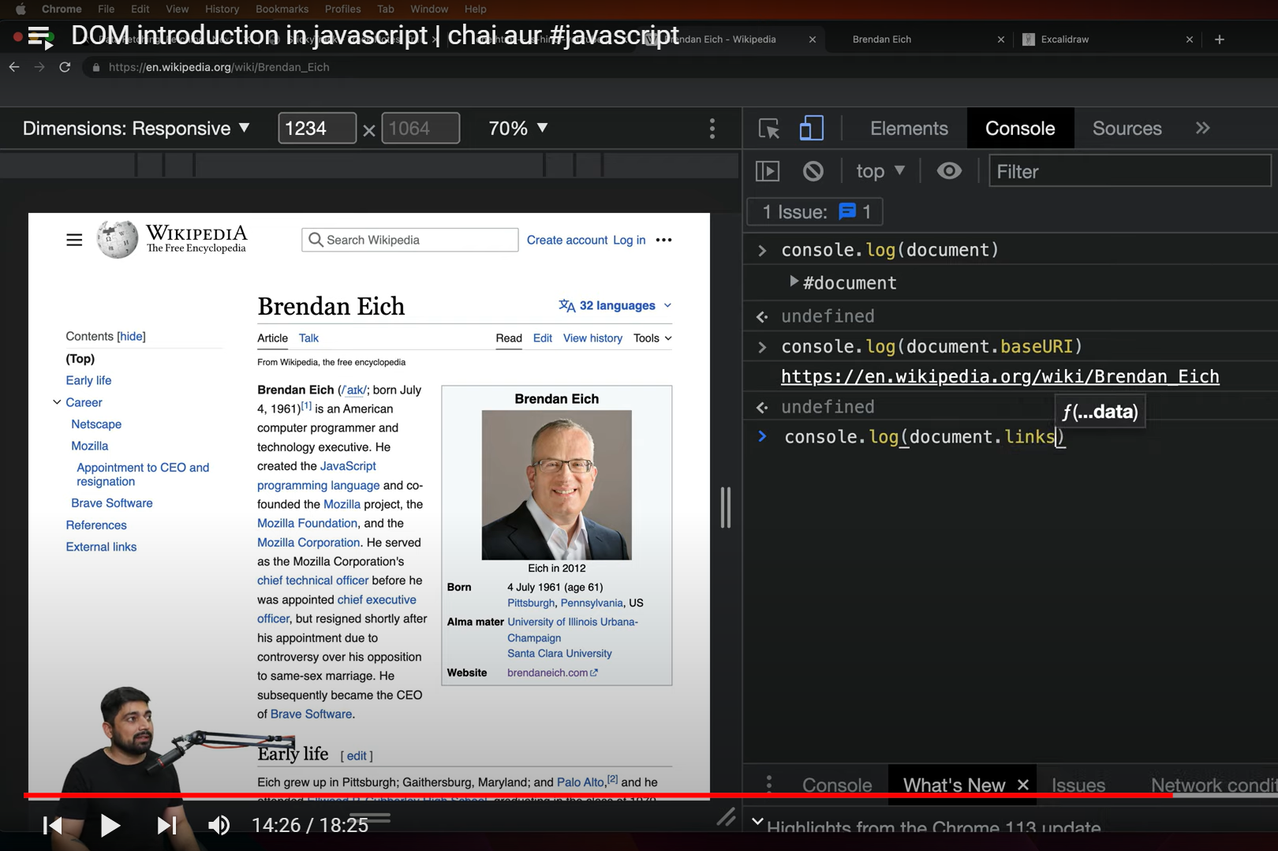

ABOVE PIC REPRESENTS FEW OOF MANY FUNCTIONS TO BE USED ON DOCUMENT I.E WHOLE WEB PAGE.

HTML LINKS IS A COLLECTION OF LINKS LIKE AN ARRAY ON DOCUMENT

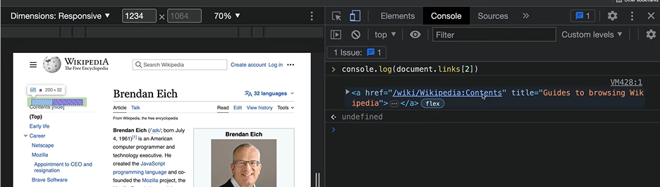

HOW TO FETCH ELEMENTS BY IDS,THEN MANIPULATE:-

