PROJECT PART B
Construction and Simulation of a CMOS NAND Gate Using MOS Transistors in KiCad
Electronic Product Design & Reverse Engineering

Group Number | 42

Group Members
- Pranjal Shukla
- Shaurya Kumar
- Komal Sharma
- Deepanita
- Anshika Tyagi
TinkerCad Link: https://www.tinkercad.com/things/jtpvZVraZcT-cmos-nand-gate?sharecode=_czzY0fDtKrhrPqq-2byCUFAH4nlPG9UY3XyO0eih9U

1. Objective
To construct and simulate a two-input CMOS NAND gate using MOS transistors in KiCad, observe its output for all possible input combinations, and verify its truth table.

2. Components and software
Software: KiCad Schematic Editor and its SPICE simulator.
Components: two PMOS transistors, two NMOS transistors, a 5 V DC supply, two input voltage sources configured as pulse sources, ground, and an optional output load resistor (for example, 10 kΩ).
Important: the MOSFET symbols must have compatible SPICE simulation models assigned. Verify each model's drain, gate, source and bulk pin mapping before running the simulation.

3. Theory
A NAND gate is the complement of the AND operation. Its Boolean expression is Y = NOT(A AND B) = (A·B)̅. The output is logic 0 only when both inputs are logic 1; for every other input combination, the output is logic 1.
In CMOS logic, the PMOS pull-up network connects the output to VDD when at least one input is low. The NMOS pull-down network connects the output to ground only when both inputs are high. The PMOS devices are therefore connected in parallel and the NMOS devices in series.

4. Circuit diagram
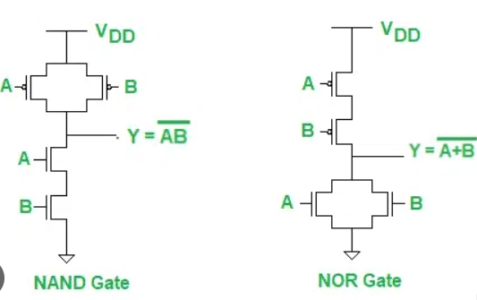
The following is a conceptual connection diagram for understanding the topology. In KiCad, use actual MOSFET symbols with valid SPICE models and check the symbol pin order. This illustration is not a substitute for checking the model pin mapping.

5. Connection table
P1 (PMOS): source and bulk to VDD; drain to output Y; gate to input A.
P2 (PMOS): source and bulk to VDD; drain to output Y; gate to input B.
N1 (NMOS): drain to output Y; gate to input A; source to intermediate node X.
N2 (NMOS): drain to node X; gate to input B; source and bulk to ground.
Connect a 5 V DC supply between VDD and ground. Both input sources must share the same ground reference as the circuit.

6. Truth table
The expected logic-level behavior is shown below. In an actual SPICE run, output voltages may be slightly different from exactly 0 V and 5 V due to the selected transistor model.
Input A | Input B | Output Y = NOT(A·B)
0 (LOW) | 0 (LOW) | 1 (HIGH)
0 (LOW) | 1 (HIGH) | 1 (HIGH)
1 (HIGH) | 0 (LOW) | 1 (HIGH)
1 (HIGH) | 1 (HIGH) | 0 (LOW)

7. KiCad simulation procedure
1. Open KiCad and create a new project. Open the Schematic Editor.
2. Place two PMOS and two NMOS transistor symbols. Place a 5 V DC supply, two input sources, and a SPICE ground reference.
3. Wire the PMOS devices in parallel between VDD and Y, and wire the NMOS devices in series between Y and ground. Connect the gates to inputs A and B as listed in the connection table.
4. Assign suitable SPICE models to all four MOSFETs. Check that the symbol pin mapping agrees with the model terminals. If the generic models in your KiCad version do not match the selected symbols, use a compatible model or correct the pin mapping.
5. Set the supply to 5 V DC. Configure the input sources to alternate between 0 V and 5 V. For example, use pulse sources with A period = 40 ms and B period = 20 ms, both with 1 µs rise/fall time, zero delay, and 5 V pulse amplitude. Set pulse width to half the respective period.
6. Open Inspect → Simulator Select transient analysis and set stop time to 40 ms. Run the simulation.
7. Plot the voltages at A, B and Y. Compare the output with the truth table. If the simulator reports an error, check model assignment, pin mapping, source syntax, and ground connections.

8. Expected observations
When A = 0 and B = 0, the output should be HIGH.
When A = 0 and B = 1, the output should be HIGH.
When A = 1 and B = 0, the output should be HIGH.
When A = 1 and B = 1, the output should be LOW.
Replace this section with your own screenshot and measured output levels after successfully running the KiCad simulation. Do not present expected values as measured results.

9. Result
The CMOS NAND gate is expected to perform the NAND logical operation. Successful simulation should show a LOW output only during the interval in which both inputs are HIGH. Attach the actual KiCad waveform screenshot before final submission.

10. Conclusion
A two-input CMOS NAND gate uses a parallel PMOS pull-up network and a series NMOS pull-down network. Its operation follows Y = (A·B)̅. The truth table and transient waveform can be used to verify the circuit's logical behavior.

