TopoPatch invention disclosure
Completed responses to Invention Disclosure Format B
Reference form: VIT IPR&TTCELL, Document 02-IPR-R003, Issue 2 dated 01.02.2024. These continuation pages expand the ten fields in the supplied form and accompany its completed two-page copy.

1 Title of the invention
Source consistent counterfactual validation and controlled commit of selective vector model migration

2 Field or area of invention
Computer implemented information retrieval; vector database migration; retrieval augmented generation infrastructure; transaction control and validation of mixed embedding indexes.

3 Prior patents and publications
The following is a focused technical comparison. It identifies relevant overlap and a proposed distinction for examination; it does not establish novelty or freedom to operate. Publication dates and claim scope require review against the actual filing date.
Reference | Relevant teaching | Proposed distinction to examine
[R1] US20240303516A1  Vector as a service  HubSpot, 12 Sep 2024 | Vector management and reindexing associated with embedding model changes. | Action-specific mixed-state retrieval evidence bound to source versions and checked again at commit.
[R2] US20250342179A1  Cloudera, 6 Nov 2025 | Detecting dataset mutations and selectively updating affected vector-index content. | Migration selection based on measured retrieval effects of an A-to-B representation change, including unchanged source content.
[R3] Qdrant  Migrate to a New Embedding Model  Online documentation | Operational model migration using new vectors while maintaining service. | A recorded action-effect witness, declared-query barrier and immutable preview-to-commit check.
[R4] BEIR  Benchmark and SciFact data | Evaluation resources for heterogeneous retrieval systems. | Used as evaluation material; no novelty is claimed over the dataset or standard retrieval metrics.
The proposed contribution is the particular validation and commit sequence. Selective indexing, model replacement, rank fusion, caching and transactions individually are established techniques. A broader claims search is still necessary.

4 Summary and background of the invention
A search system may need a new embedding model while continuing to answer queries. Re-encoding a small set of documents seems attractive, but a partial migration changes the composition of both native-space rankings. A document can move down the merged result even though its own source has not changed. Checking only the candidate document or its new vector does not expose every such effect.
TopoPatch evaluates a proposed migration in the same mixed-state retrieval path used for serving. It records the documents in the action, their source hashes, the experiment epoch, the proposed vectors and the observed ranks of required results. A durable update is admitted only when the recorded state remains current and the declared retrieval constraints still pass.
The candidate inventive concept is the coupling of an action-effect witness to a source-consistent commit barrier for selective model migration. The prototype demonstrates that this barrier can reject harmful actions and preserve inspected retrieval constraints. It has not demonstrated that selective migration achieves full-target quality with lower total encoding cost.

5 Objectives of the invention
• Expose retrieval regressions caused by a proposed partial model upgrade before changing active membership.
• Associate each tested action with reproducible source, model, policy and epoch evidence.
• Prevent stale or altered preview evidence from authorizing a durable migration.
• Count all target encodings used for discovery and preview, including rejected work.
• Support declared-query fallback and rollback when their preconditions hold.
• Investigate whether constrained migration can eventually reduce upgrade work while retaining useful target-model quality. This last objective remains unvalidated.

6 Working principle in brief
The controller selects candidate objects and materializes their B vectors. A preview temporarily serves those objects through B and the remaining objects through A. Each query is embedded and scored within its own model space; results are combined by rank. The controller measures the action against declared required-document rank limits and, when configured, a development-query nDCG floor.
A SHA-256 digest identifies the preview payload. At commit, the controller acquires the database write transaction, verifies snapshot and payload integrity, re-evaluates the barrier, then writes membership, vectors, epoch and history atomically. Failure leaves active membership unchanged. A validated legacy route is available for registered queries.
Evidence modes are explicit: heuristic candidates support exploration; strict mode rejects unresolved coverage; exhaustive mode computes all current B document vectors before strict admission. Exhaustive coverage resolves unseen-candidate uncertainty at full encoding cost. It does not guarantee that mixed rankings equal full B.

7 Detailed description of the invention
Figure 1 shows the implemented control sequence. Preview changes are counterfactual: computing a target vector and writing evidence do not by themselves activate that vector.
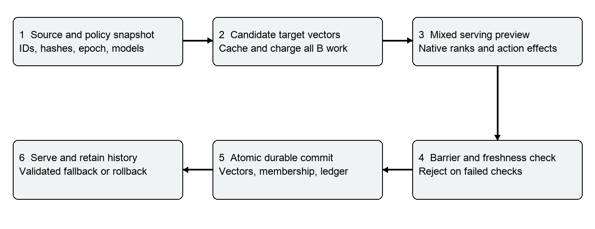
Figure 1 Implemented migration validation and commit sequence

Data and serving state
Each document stores its ID, text, source version, source digest, original A vector, optional B vector and active membership. The target-vector cache is keyed by document ID and source digest. A persisted model pair and fusion policy prevent reopening an experiment with an incompatible configuration. Preview records and events retain evidence for inspection.
In the default embodiment, migrated objects are excluded from the A result list. Reciprocal rank fusion uses 1/(60 + rank); ties favor B and then document ID. No cosine comparison is made between A and B vector spaces. The default fixture deliberately uses different vector dimensions, 128 and 256.

Witness selection and commit
Candidate discovery combines protected-query results, token-overlap candidates and required objects. The controller enumerates singleton and pair actions over at most 24 candidates; if none pass, it tries a bundle of protected objects. Each witness records the selected IDs, rank changes, pass status and object count. Selection minimizes object count among inspected actions only; it is not a global or compute-cost optimum.
The snapshot includes source versions, membership, model identities, fusion policy and the development gate. Commit rechecks that snapshot, the payload digest and current source hashes inside a SQLite write transaction. Tests cover altered evidence, a second writer changing source data, stale epochs and injected write failure. Source changes invalidate the affected B representation. Rollback restores the latest unchanged committed membership in a new epoch.

Separate experimental embodiment
Continuity fusion retains all A vectors as a shadow ranking and weights A by 1 minus the migrated fraction and B by the migrated fraction. Its endpoints are legacy A and full B. This departs from the frozen A-removal embodiment and adds legacy storage and query work. ANN graph repair, distributed transactions and sublinear certified candidate discovery are not implemented.

8 Experimental validation results
The functional implementation passed 25 automated regression tests. Browser checks independently exercised candidate analysis, a blocked preview, a successful commit and rollback. These results validate specified software behavior; they are not proof of novelty, industrial-scale reliability or the intended economic advantage.
Experiment | Measured result | Interpretation
Authored 40-document fixture  4 protected queries | 14 B document encodings; 1 migrated object; 13 rejected singleton actions; 0 protected violations. | The gate makes an observable decision. Held-out full-B top-5 overlap is 0.80, below legacy 0.95.
Full fixture trajectory | 40 safe commits; 40 B document encodings; full membership migration. | The controller can finish this fixture. There is no final encoding saving.
Exhaustive strict evidence  40-document fixture | All 40 B vectors materialized and charged; an admissible commit completed. | Complete candidate coverage is available at full cost. Candidate enumeration remains capped.
Source and transaction tests | Stale source, stale epoch, altered preview and injected write failure rejected. | Active membership is protected under the tested local SQLite failure cases.

Public dataset experiments
SciFact samples contain 160 documents, selected by retaining relevant documents for sampled queries and adding distractors. This relevance-aware selection can make evaluation easier and is not the full BEIR benchmark. The table reports held-out nDCG@10; higher values indicate better relevance ranking. L6 and L12 refer to the cached all-MiniLM sentence-transformer models.
Variant and split | A / selective / B | B charged / migrated | Result
L6 to L12, RRF  6 protected, 12 held-out | .887 / .526 / .893 | 80 / 6 | 300 candidate previews rejected; 0 protected violations; 15% full-B top-10 envelope miss rate.
L6 to L12, continuity  6 protected, 12 held-out | .887 / .887 / .893 | 80 / 1 | Preserved A quality without measured improvement. Exploratory split reused during redesign.
Lexical to L12, continuity  6 protected, 6 development, 6 held-out | .384 / .384 / .898 | 83 / 1 | Development floor passed; target-quality progress was not achieved. Envelope miss rate 28.3%.
Full-B evaluation additionally encoded all 160 documents in a separate ledger for each run. It was not supplied to action selection. Historical runs differ in constraints and splits; they are not a controlled ablation. The random fixture baseline matches migrated-object count, not discovery compute. No equal-budget superiority or statistically significant quality gain is claimed.
Conclusion: the implementation supports the validation-and-commit mechanism, while the main cost-quality hypothesis remains unproven. Protected-query success alone was insufficient to prevent broader retrieval loss. The disclosure therefore requests review of the concrete control mechanism without asserting validated migration savings.

8 Experimental validation screenshots
Actual local browser captures from the authored lexical fixture. Screenshots illustrate the workflow; numeric results and failure checks are supported by the JSON exports and test log.
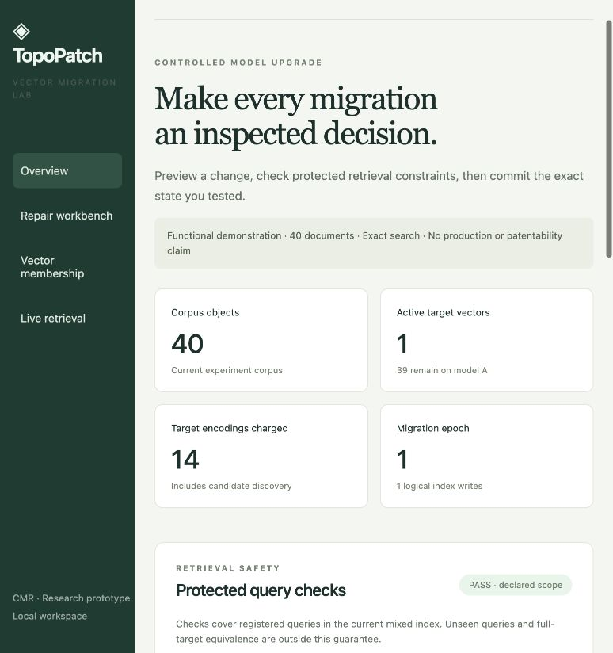
Figure 2 Successful commit: 1 active B object, 14 target encodings and epoch 1.

8 Experimental validation screenshots continued

Figure 3 After rollback to epoch 2, the car-guide preview fails q-policy and commit is disabled.
The full-resolution screenshots are included in the evidence package. No screenshot represents a neural benchmark or a production deployment.

9 Aspects of the invention needing protection
We request examination of the following combination in a computer implemented vector migration system, subject to a claim-by-claim prior-art and eligibility assessment:
• Constructing an action-specific mixed retrieval state that applies candidate B representations and the corresponding A-membership change before durable migration.
• Producing an action-effect witness containing required-result ranks, the tested action, source digests and experiment state, and using that witness to select an admissible migration.
• Binding the inspected vectors and retrieval policy to an immutable preview identifier, then independently rechecking freshness, integrity and retrieval constraints within the durable commit operation.
• Refusing strict admission when candidate evidence remains unresolved; permitting complete evidence through an exhaustive target-vector path with its full computation cost recorded.
• Retaining a verifiable event trail and providing constrained rollback or a validated legacy route following a migration decision.
The intended technical effect is prevention of a durable index transition that violates the inspected retrieval constraints or uses stale source evidence. The local tests support this effect within their stated scope. Generic rank fusion, embeddings, caching, source hashes, database transactions and the dashboard are not presented as individually novel. The exhaustive path is a conservative implementation fallback, not an asserted inventive source of encoding savings.
A patent professional should assess the combined mechanism under the applicable computer-related invention requirements, including Section 3(k) of the Indian Patents Act [R7]. These proposed protection points are disclosure material, not final patent claims or a conclusion of patentability.

10 Technology readiness level
Selected level: [X] TRL 3 — Experimental proof of concept
[ ] TRL 1 [ ] TRL 2 [X] TRL 3 [ ] TRL 4 [ ] TRL 5
[ ] TRL 6 [ ] TRL 7 [ ] TRL 8 [ ] TRL 9
The project has an executable local prototype, controlled experiments, regression tests and reproducible evidence of the validation and commit sequence. TRL 3 is the conservative proposed selection, consistent with the supplied form and VIT TRL guide [R6]. Faculty assessment should confirm the final selection.
TRL 4 is not claimed for the full frozen design. The current prototype lacks a low-cost certified candidate bound, validated ANN topology repair and persuasive independent cost-quality evidence. A browser interface alone does not close these gaps.

Faculty review focus
VIT policy describes review of novelty, utility and inventive step and the role of its IPR and Technology Transfer Cell [R5]. We request technical review of the mechanism, its overlap with the listed references, and the evidence needed before deciding whether to file. Institutional selection and patent grant remain separate decisions.

Evidence and reproduction
Run the offline demonstration from the project directory with Python 3.11 or later:
python3 -m topopatch serve --port 8767 --db artifacts_private/faculty-demo.sqlite
Open http://127.0.0.1:8767. Analyze candidates, inspect the rejected car-guide action, inspect and commit password-policy, export evidence, then roll back. Use a previously unused database path for an initial-state demonstration.
Strict exhaustive demonstration: add --evidence exhaustive and use another fresh database. It should charge all 40 target vectors. Strict unresolved demonstration: use --evidence strict; analysis and commit must refuse unbounded evidence.
Regression suite: python3 -m unittest discover -s tests -v
Fixture benchmark: python3 -m topopatch benchmark
Evidence file in artifacts_private | Purpose
test-results.txt | 25-test regression result
benchmark.json and trajectory.json | Fixture single-step and full trajectory ledgers
exhaustive-evidence.json | Complete candidate coverage and strict commit
scifact-rrf-strict-ranks.json | Frozen-style RRF experiment reported in Section 8
scifact-continuity-strict-ranks.json | Shadow-A continuity comparison
scifact-lexical-to-neural-progress-gated.json | Separated development and held-out query run
final-demo-evidence.json | Export from the screenshot demonstration
final-overview.jpg and final-blocked-detail.jpg | Unmodified browser captures
The archive includes a SHA-256 manifest for traceability. A hash identifies the packaged bytes; it is not a notarized timestamp or proof of authorship. Historical JSON files preserve their original measurements and model identities.

References
[R1] HubSpot. Vector as a service. US20240303516A1.
https://patents.google.com/patent/US20240303516A1/en
[R2] Cloudera. Methods and apparatus to manage input data sets to reflect dataset mutations for GenAI and RAG applications. US20250342179A1.
https://patents.google.com/patent/US20250342179A1/en
[R3] Qdrant. Migrate to a New Embedding Model.
https://qdrant.tech/documentation/tutorials-operations/embedding-model-migration/
[R4] BEIR benchmark repository and SciFact archive.
https://github.com/beir-cellar/beir
[R5] VIT. Intellectual Property Rights and Technology Transfer Policy and Guidelines. Amendment 16 April 2024.
https://vit.ac.in/files/IPR-and-Technology-Transfer-Policy.pdf
[R6] VIT. A guide on Technology Readiness Levels.
https://vit.ac.in/wp-content/uploads/2025/08/A_guide_on_Technology_Readiness_Levels.pdf
[R7] IP India. Patents Act 1970, Section 3.
https://ipindia.gov.in/acts/patent-act-1970/section-3
Online references checked 15 October 2026. Source dataset archive: data/scifact.zip. The original project specification is retained in doc/.

