 | Invention Disclosure Format (IDF)-B | Document No. 02-IPR-R003  Issue No/Date 2/01.02.2024  Amd. No/Date 0/00.00.0000

1. Title of the invention:
Validation and controlled commit of partial embedding model migrations

2. Field /Area of invention:
The invention concerns search systems that store document embeddings in a vector index. It focuses on replacing the embedding model for selected documents, checking the resulting search behaviour, and controlling when those changes become active. Possible uses include enterprise search and retrieval augmented generation systems.
TopoPatch addresses a practical question: when only some documents have moved to a new embedding model, can the system check the effect on search results before making that change permanent? The prototype calculates the proposed mixed result, records the evidence and repeats the checks inside the commit operation.
The present prototype shows this control sequence locally. It has not yet shown that selective migration gives the quality of a full upgrade at lower cost.
The main embodiment removes migrated documents from the active old-model ranking. A separate experimental variant retains that ranking as a shadow signal. Their results and limitations are kept separate throughout this document.

3. Prior Patents and Publications from literature
The references below show why model migration, selective indexing and validation cannot, by themselves, be treated as new. The final column identifies the narrower feature that needs comparison with each reference. These are candidate distinctions, not a finding that the invention is novel.
Reference | Relevant teaching | Proposed distinction to examine
[R1] US20240303516A1  Vector as a service  HubSpot, 12 Sep 2024 | Vector management and reindexing associated with embedding model changes. | Action-specific mixed-state retrieval evidence bound to source versions and checked again at commit.
[R2] US20250342179A1  Cloudera, 6 Nov 2025 | Detecting dataset mutations and selectively updating affected vector-index content. | Migration selection based on measured retrieval effects of an A-to-B representation change, including unchanged source content.
[R3] Qdrant  Migrate to a New Embedding Model  Online documentation | Operational model migration using new vectors while maintaining service. | A recorded partial-index action and its retrieval effects, checked again against source state at commit.
[R8] US11610143B1  Amazon, 21 Mar 2023 | Client-specific tests guide whether an updated machine-learning model is deployed. Claims 1 to 3 cover validation-based migration decisions. | Test the exact partial A/B document-membership change and bind it to source state at commit. This narrower distinction still needs examination.
[R9] US20260195572A1  9 Jul 2026 | Localized embedding patches with a model that maps new embeddings back to the original space; see claim 1. | TopoPatch uses native-space rankings without a trained cross-space mapping. Generic local patching is not claimed as new.
[R10] SPFresh  SOSP 2023 | Incremental in-place vector-index updates using local partition rebalancing. | The prototype controls model migration through retrieval checks; it does not implement a new ANN repair method.
[R12] Cormack et al.  SIGIR 2009 | Reciprocal rank fusion combines ranked result lists without cross-model score calibration. | Rank fusion is established supporting machinery, not the proposed novel step.
[R11] SQLite documentation | Standard isolation and atomic database transactions. | The retrieval-specific admission logic needs examination; the database transaction itself is established.
BEIR and SciFact [R4] are evaluation resources used in Section 8, not competing inventions. Live web documentation needs a dated archived version before it is relied on as pre-filing prior art.
The main question is whether testing a specific partial-index change and binding that result to a source-consistent commit adds a non-obvious technical contribution. The references make broad claims to validation, selective updates or rollback difficult to defend.

4. Summary and background of the invention (Address the gap / Novelty)
Changing an embedding model can change what a search system returns. During a partial upgrade, some documents use the old model and others use the new one. Combining their result lists can push an important document down the ranking even when that document has not been edited. Testing only the new vectors can miss this problem.
TopoPatch checks the proposed mixed index before activating the change. It uses the same ranking routine as the live search path and records which documents would move, their source hashes, the current migration epoch and the ranks of required results. The commit step checks that the evidence is still current and runs the retrieval checks again before updating active membership.
The feature proposed for examination is the link between a tested partial-index change, its measured effect on protected queries, and the checks that authorize the database update. The prototype rejects changes that fail those checks. It has not yet shown that a partial upgrade can match a full upgrade while using less total encoding work.

5. Objective(s) of Invention
• Find search regressions before a partial model upgrade becomes active.
• Keep enough information to identify the source and experiment state used in each preview.
• Reject a commit when the preview is stale, altered or fails the current checks.
• Count the target vectors computed during discovery and testing, including work on rejected actions.
• Allow a checked legacy route and restoration of the latest unchanged committed membership.
• Investigate whether this control process can reduce upgrade work without losing the benefit of the new model. This remains a research objective.

6. Working principle of the invent (in brief)
Let A be the old embedding model and B the new model. The controller computes B vectors for a proposed set of documents. Without changing live membership, it calculates the search results that would follow if those documents used B and the rest used A. It combines ranks from the two spaces and checks whether each protected result stays within its allowed rank. An optional development-query check also requires nDCG@10 to stay above a configured minimum.
A SHA-256 digest identifies the preview record. At commit, the controller starts a SQLite write transaction, checks the source snapshot and record digest, and repeats the retrieval checks. It then writes the target vectors, active membership, epoch and commit history together. If a check or write fails, the membership change is not committed. The digest detects changes to that record; it is not a digital signature or a tamper-proof audit system.
The prototype offers two ways to acquire candidates: a heuristic that examines a subset, and an exhaustive mode that computes every current B document vector. Strict admission refuses the heuristic evidence. Exhaustive mode establishes complete vector availability, but pays the full encoding cost and still does not guarantee that mixed results equal full-B results.

7. Description of the invention in detail (Include drawing and or photograph as needed)
Figure 1 shows the implemented sequence. A preview asks what the search results would be after a particular change. Computing vectors and recording the answer do not activate the change.
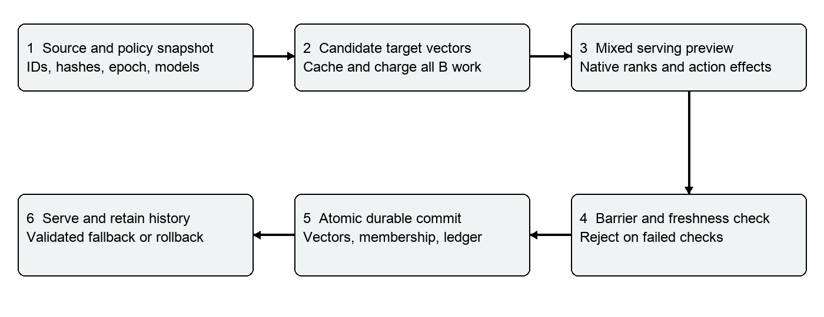
Figure 1 Implemented migration validation and commit sequence

Data and serving state
Each document stores its ID, text, version, source hash, A vector, optional B vector and active membership. The B cache uses the ID and source hash. Reopening checks model identifiers and fusion policy, assuming unchanged model files. Preview and event records retain the evidence.
In the default embodiment, migrated objects are excluded from the A result list. Reciprocal rank fusion uses 1/(60 + rank); ties favor B and then document ID. No cosine comparison is made between A and B vector spaces. The default fixture deliberately uses different vector dimensions, 128 and 256.

Preview and admission flow
Figure 2 separates the proposed state from the active state. Candidate analysis may compute and cache B vectors, but it leaves active membership unchanged. The preview evaluates exactly the proposed member set and records the ranking changes for every declared protected query. A failed check ends that proposed action. A passing check creates an evidence record; it does not by itself activate the change.
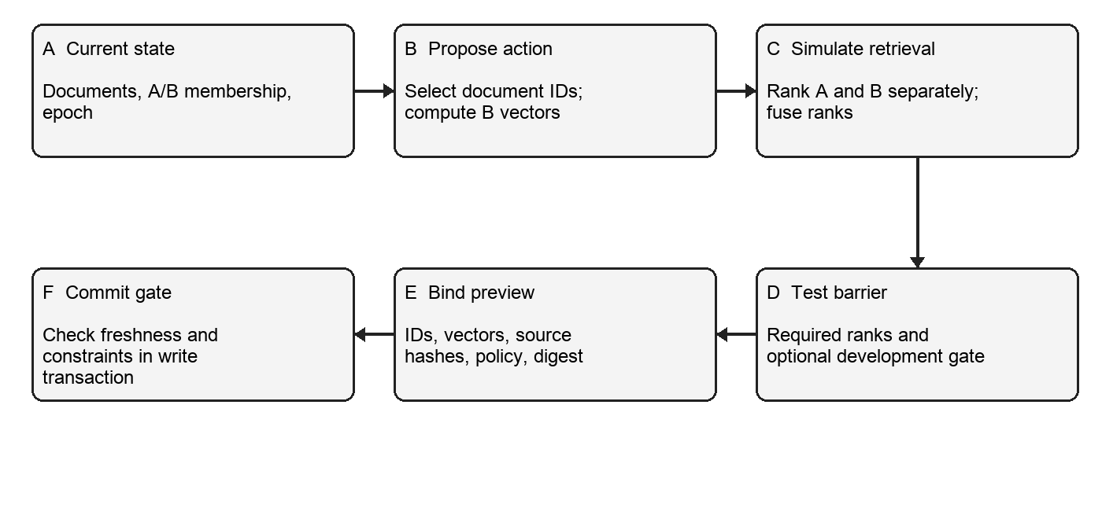
Figure 2 Proposed action, preview evidence and commit gate. A rejected action leaves active membership unchanged.

Stored record and decision conditions
Item | Meaning in the prototype | Why it matters
Source version and hash | Version of each source document used to build its vector. | An edited document invalidates its earlier B representation.
Active membership and epoch | Which representation serves each document, with a migration counter. | A preview for an older epoch cannot silently authorize a later state.
Preview action and digest | Candidate IDs, vectors, tested results and SHA-256 record identifier. | The commit step detects alteration of the saved preview record.
Protected query rule | Required document ID and maximum permitted rank. | A passing action must keep the declared result visible within its bound.
Development gate | Optional minimum nDCG@10 on declared development queries. | Adds a broader relevance check, but only for those queries.

Witness selection and commit
Candidate discovery combines protected-query results, token overlap and required documents. The controller tests singletons and pairs over at most 24 candidates, then a protected-document bundle if needed. Each action record contains IDs, rank changes, pass status and object count. It chooses the smallest passing action among those tested, not a global or compute-cost optimum.
The snapshot covers source versions, membership, model identifiers, fusion and the development gate. Commit rechecks the snapshot, digest, source hashes and current retrieval constraints within a write transaction. Tests cover altered evidence, stale source or epoch, and write failure. Source changes invalidate B. Rollback restores the latest unchanged committed membership; the demonstration uses a server that serializes requests.

Transaction and refusal cases
The commit begins with a SQLite BEGIN IMMEDIATE transaction. It reads the current database state, compares it with the preview snapshot, verifies the evidence identifier and the current source hashes, and evaluates the retrieval barrier again. Only then does it update vector cache entries, active membership, the epoch and the event record. If any condition fails, the transaction rolls back. This ordering makes a preview an admission request rather than authority to mutate the index.
Observed case | Decision in the local prototype
Selected document source changes after preview | Reject stale evidence; invalidate B representation.
Migration epoch changes after preview | Reject the earlier preview.
Preview evidence is altered | Reject digest mismatch.
A protected result moves below its bound | Reject that candidate action.
A tested write fails | Roll back the local transaction; keep active membership unchanged.

Example of an indirect ranking change
In the authored fixture, moving car-guide to B leaves q-car within its allowed rank but moves password-policy to rank 2 for q-policy, whose maximum is 1. The controller therefore rejects the action. Moving password-policy instead passes all four checks. This illustrates why the preview examines the mixed result list, including effects on documents outside the selected action.

Separate experimental embodiment
Continuity fusion retains all A vectors as a shadow ranking and weights A by 1 minus the migrated fraction and B by the migrated fraction. Its endpoints are legacy A and full B. This departs from the frozen A-removal embodiment and adds legacy storage and query work. ANN graph repair, distributed transactions and sublinear certified candidate discovery are not implemented.

7.1 Technical boundary and state model
The data plane answers a user query from the currently committed index state. The control plane examines possible migration actions and is allowed to commit only an accepted action. In the local prototype both functions live in one Python process, but the distinction matters: calculating a preview result must not itself change the membership seen by an ordinary query. A target embedding computed during analysis may be cached, which consumes real work and storage; it becomes an active representation only after commit.
For a document d, the stored record contains stable object ID, source text, source version, a hash of that text, an A vector, an optional B vector and an active representation flag. The migration epoch increments after a successful membership change. A proposed action U is a set of currently A-active document IDs. Its hypothetical state is the durable state with members of U assigned to B. The controller evaluates that hypothetical state through the same ranking function that serves committed mixed states.
This boundary avoids a common ambiguity in model migrations. “B vector exists” means the target computation has been performed; it does not mean that the document participates in B retrieval. “Preview passes” means the declared checks passed for one proposed state and one snapshot; it is not a claim that all future queries are safe. “Committed” means active membership and the associated event are written in one local database transaction.
Symbol or term | Definition used here | Scope
A and B | Old and proposed new embedding models. | Separate vector dimensions and score distributions are permitted.
U | Set of A-active document IDs proposed for one migration action. | A tested action, not necessarily a global optimum.
x and x[U] | Current durable state and simulated state after U. | Preview reads x[U] without activating it.
epoch | Counter incremented for a successful membership commit. | Used in freshness checking.
protected query | A declared query with one required ID and a maximum allowed rank. | Other relevant items are not checked by that rule.
witness | Recorded rank effect for an examined action. | Evidence of the examined query set, not a mathematical proof for unseen queries.

7.2 Query path across native embedding spaces
For a query q, the serving path computes q_A = E_A(q) and q_B = E_B(q), where E_A and E_B are the corresponding query encoders. A-active documents are scored only against q_A; B-active documents are scored only against q_B. Each group is sorted within its native space. The program then assigns a contribution of 1/(60 + rank) to each document in its respective ranked group and sorts by the summed contribution. A stable document ID resolves any remaining tie after the B preference used in the implementation.
The controller does not compare an A cosine score directly with a B cosine score. This is essential where dimensions, normalization or training objectives differ. It also means that moving one document from A to B can change the ranks of documents not moved in that action: a B entry changes the fused order, and removal from A changes the ranks assigned to surviving A entries. The preview therefore calculates the entire mixed result for the declared queries rather than judging only the moved document.
The implementation uses exact flat scoring over the local corpus. A practical ANN backend could use two native indexes and the same membership rule, but ANN traversal and graph repair are not present in the tested prototype. Any claim about ANN cost or topology changes would need a backend-specific implementation and measurements.
Serving condition | A path | B path | Result handling
Legacy state | All active documents | No active B documents | A ranking is the served result.
Mixed committed state | Documents with active A flag | Documents with active B flag | Native ranks are fused; one logical document appears once.
Preview of action U | Active A documents excluding U | Committed B documents plus U | Used for admission; active flags remain unchanged.
Full B state | No active A documents | All active documents | B ranking is the served result.

7.3 Candidate acquisition and the evidence limit
The heuristic candidate path gathers IDs appearing near the top of the current result lists for protected queries, IDs with token overlap against those query texts, and each required document ID. It computes missing B vectors for the gathered IDs and charges every new encoding, even where the action later fails. The candidates are sorted, with the proposal search limited to the first 24. It tests singleton actions and then pairs. If no tested action passes, it can try a bundle of required documents. This bounded enumeration is simple enough to reproduce, but it can miss a useful action outside the candidate cap.
No valid bound on unseen B competitors follows from top A results or lexical overlap alone. A document that is unremarkable in A can be highly ranked in B. The controller marks the heuristic envelope HEURISTIC_UNBOUNDED, and strict mode refuses to authorize a durable commit from it. This is a substantive safety distinction: a favourable score within an incomplete candidate set must not be presented as complete candidate coverage.
The alternative exhaustive mode computes current B vectors for every corpus object and records that full work. It removes the vector-availability uncertainty for the finite source snapshot; it does not make every possible action tested, nor does it guarantee that a mixed result equals the full B result. The strict setting requires both exhaustive mode and current full cache coverage at commit. Exhaustive coverage therefore improves the basis of the admission decision by spending the encoding cost that selective migration hoped to avoid.

7.4 Witness records and selection rule
For each candidate action, the controller first has a baseline rank for every protected required document. It calculates a preview for the action, then records the new rank, the change from baseline, pass or fail for each rule, and the number of documents in the action. These records are action-effect witnesses: they say what happened under the tested source state, ranking routine and query set. They are more informative than a list of related documents because an apparently helpful action can create a failure for another protected query.
The selector chooses the smallest passing action among the enumerated actions, using total rank improvement and document IDs for tie-breaking. It does not minimize actual compute cost, bytes written, ANN edits or end-to-end time. It also does not prove global minimum cardinality, because only a restricted candidate/action set is searched. The present claim of technical effect should therefore concern rejecting an unsafe transition and maintaining source consistency, not finding a minimum-cost repair.
The frozen research plan describes a richer witness hypergraph and resource-weighted solver. That could compare actions by charged B calls, bytes, index mutations, latency and fallback penalty. It would also need to record new failures created by a combined action and re-evaluate the complete proposed state. This remains a design direction, not a demonstrated result in the present implementation.
Candidate action | Observed protected result | Decision
Move car-guide to B | q-car remains within its rule, but password-policy becomes rank 2 for q-policy, whose limit is rank 1. | Reject.
Move password-policy to B | All four declared protected rules pass in the authored fixture. | Eligible for commit after freshness and integrity checks.
Alter a saved preview after creation | Its recomputed SHA-256 identifier no longer agrees with its ID. | Reject.
Change a source or epoch after preview | Current state differs from the preview snapshot. | Reject and require a new preview.

7.5 Preview record and commit sequence
A preview saves the selected IDs, current epoch, state snapshot digest, target vectors for those IDs, their source hashes and the barrier result. The preview ID is the SHA-256 digest of that payload. The snapshot includes epoch, source IDs, hashes, versions, membership, model-pair identifiers, fusion mode and development gate. It does not include every protected-query policy input or strict-mode flag. At commit the current constraints are re-evaluated, but a separate complete policy manifest would be needed to claim full policy binding.
The commit transaction starts with BEGIN IMMEDIATE. It reads the preview, compares the saved snapshot to current state, checks source hashes, verifies the digest, checks the required candidate coverage when strict mode is enabled, and recalculates the retrieval barrier. A failing condition denies the change. If all pass, the transaction writes B vectors and active membership for selected objects, increments the epoch, records logical write count and stores a commit event. A failure during this local transaction rolls back the writes. This sequence is the mechanism actually exercised by the SQLite prototype.
The saved digest is a consistency check, not a signature, timestamp attestation or append-only record. Someone with authority to rewrite the database and recompute hashes could alter the stored history. The model-pair identity used when reopening a database likewise assumes model files behind the configured identity have not changed. These limits matter if evidence authenticity or production auditability becomes part of a later claim.

7.6 Source updates, fallback and restoration
When source text changes, the document version and hash change. A cached B vector linked to the old hash no longer represents that source. The implementation invalidates B for the edited document, restores its active membership to A and advances the epoch. A preview made before that change fails the snapshot comparison. This prevents the local demonstration from committing a target vector for an obsolete source version.
A query-specific legacy fallback is available only for a declared protected query whose legacy route satisfies its rule. It is a route for that checked query, not a universal safety result for every query. Rollback restores the latest unchanged committed membership in the serialized local server demonstration. The current rollback function checks the last event and epoch before opening its write transaction, leaving a potential interleaving with an external writer. That race must be closed before asserting general concurrent rollback safety.
In a production architecture, an adapter would need explicit behaviour for source changes during long embedding jobs, crash recovery, index availability and concurrent readers. The frozen design suggests source-version validation, change-log replay or dual writes as possible strategies. Only the local version/hash checks and SQLite transaction behaviour described above have been implemented and tested here.

7.7 Scope of the broader frozen design
The original project freeze also proposes a candidate envelope with a defensible exclusion bound, a barrier that accounts for retrieval and ANN uncertainty, and local ANN dependency-cone repair. These mechanisms could be valuable if implemented, but a requirement to “bound” unseen candidates is not an algorithm. The current heuristic has no such bound. The current index is exact flat scoring, so there is no ANN graph to repair or instrument.
A future candidate-bound embodiment would have to state its assumptions, what data establish a bound, how the bound is updated as B vectors are acquired, and which result is returned when it remains unresolved. A future ANN embodiment would have to define the affected graph or partition scope, measure the actual changes, and show that the preview faithfully predicts the serving index after commit. The present disclosure does not use either planned feature as evidence of achieved efficiency.
The separate continuity experiment retains A as a shadow rank signal and changes A/B weights as migration progresses. It is useful for investigating whether a gradual path can avoid abrupt degradation, but it pays continued A query/storage cost. It is an experimental variant of the frozen A-removal serving path. Results from that variant are separately labelled in Section 8.

7.8 Step-by-step operation of one migration epoch
An epoch starts from a durable table of documents and active membership. The operator or candidate selector requests analysis. For each declared protected query, the engine obtains the current mixed ranking and gathers candidate IDs. A missing B vector for a candidate is computed and entered in the cache with the current source hash; the charged B counter advances. This work happens even if no candidate action is later committed.
The engine enumerates singleton actions and, if needed, pairs within the capped candidate set. For each action it creates a temporary selected-ID set, executes the normal search function with that set supplied as an overlay, checks required ranks and the optional development gate, and stores the resulting payload. Actions that fail the gate remain visible as rejected witnesses. If no action passes, a protected-document bundle can be tested. The smallest passing action among those examined is recommended. No live membership flag changes during this phase.
The operator selects a passing preview ID for commit. The engine opens the database write transaction and retrieves the saved payload. It compares the snapshot against present source and membership state, verifies selected source hashes and payload digest, and checks strict candidate coverage where requested. It then evaluates the selected action again. A failure produces no accepted migration. A pass writes each selected B vector and active flag, increments the epoch and records the commit event before releasing the transaction. The next ordinary query is served from that new committed state.
The exact point at which the system refuses an action matters. The barrier is evaluated before the durable membership update and again inside the transaction. A dashboard that merely reports degraded search after migration would not have this property. Conversely, the property is only as broad as the configured checks: unlisted queries are outside the tested barrier.
Stage | Reads | Writes or side effect | Can alter live membership?
Register and initialize | Source records, A model, B model. | A vectors, source hashes, model identifiers. | Initialization only.
Acquire candidates | Protected queries, current ranks, source text. | B cache and charged encoding count. | No.
Preview action | Current state plus selected IDs and B vectors. | Preview payload, digest and event. | No.
Admission check | Saved preview, current snapshot, constraints. | Failure result or a validated decision. | No.
Commit | Validated preview and current source versions. | B vectors, active flags, epoch, event in one local transaction. | Yes, on pass.
Rollback | Latest commit record and current state. | Restored membership and new epoch when allowed. | Yes, in local serialized setting.

7.9 Worked ranking example
Consider the authored protected query q-policy. Its declared required object is password-policy and its allowed maximum rank is 1. Before a candidate action, the local search routine puts that object at rank 1. An operator proposes moving car-guide to B. The preview masks car-guide from A, inserts its computed B vector into the B group, ranks both groups and fuses their positions. The resulting combined order puts password-policy at rank 2. The action violates q-policy even though car-guide itself is unrelated to the policy query and q-car remains within its own rule.
This is the sort of indirect interaction the witness record must show. A simple “migrated item improved” measurement would miss it. The record ties the effect to car-guide, q-policy, the source hashes and the current epoch. The action is rejected, not silently retried as if it had passed. The alternative password-policy singleton passes all four fixture rules, but it is accepted only after its saved preview is checked again at commit. That acceptance says nothing about the untested queries, as the SciFact results later illustrate.
The example also shows why the action is evaluated as a state change, not as an isolated vector update. Removing a document from one ranked group and adding it to another changes the denominators and positions used by rank fusion. When several objects move together, the combined result can differ from the sum of their individual apparent benefits. The current solver tests only small bundles and cannot guarantee it has found the best such combination.

7.10 Proposed extension and enablement boundary
The frozen specification envisions a candidate envelope that could progressively expand from legacy top results, lexical candidates and local neighbours. To support an actual efficiency claim, that envelope would need an explicit exclusion test for unseen B competitors. One possible implementation would store a provable upper bound on target similarity for omitted source groups, derived from an index structure or a validated embedding bound. The current project has no such bound. A heuristic sample or audit frequency is not equivalent to one.
The specification also envisions an ANN dependency cone for a migrated object: affected graph neighbours, entry routes, partitions or insertion paths. A real implementation would log which nodes or partitions are visited and changed, and would run the preview through the same backend behaviour expected after commit. The present flat scorer has no graph structure; the diagram therefore shows only the validated control flow, not an implemented graph repair.
A production evidence record would further include cryptographic hashes of exact model weights and configuration, all protected policy inputs, the ranking implementation version and the backend index identity. It would coordinate rollback under the same write guard used for commit and verify that a persistent B representation is queryable before removing its A membership. These details identify where the research prototype must be strengthened. They are not asserted as functions already measured in this disclosure.

8. Experimental validation results:
The prototype passed 25 automated regression tests. The browser demonstration also exercised candidate analysis, rejection, commit and rollback. These checks support the behaviour described below. They do not establish novelty, production reliability or a reduction in migration cost.
Experiment | Measured result | Interpretation
Authored 40-document fixture  4 protected queries | 14 B document encodings; 1 migrated object; 13 rejected singleton actions; 0 protected violations. | The gate makes an observable decision. Held-out full-B top-5 overlap is 0.80, below legacy 0.95.
Full fixture trajectory | 40 safe commits; 40 B document encodings; full membership migration. | The controller can finish this fixture. There is no final encoding saving.
Exhaustive strict evidence  40-document fixture | All 40 B vectors materialized and charged; an admissible commit completed. | Complete candidate coverage is available at full cost. Candidate enumeration remains capped.
Source and transaction tests | Stale source, stale epoch, altered preview and injected write failure rejected. | Active membership is protected under the tested local SQLite failure cases.

Public dataset experiments
SciFact samples contain 160 documents, selected by retaining relevant documents for sampled queries and adding distractors. This relevance-aware selection can make evaluation easier and is not the full BEIR benchmark. The table reports held-out nDCG@10; higher values indicate better relevance ranking. L6 and L12 refer to the cached all-MiniLM sentence-transformer models.
Variant and split | A / selective / B | B charged / migrated | Result
L6 to L12, RRF  6 protected, 12 held-out | .887 / .526 / .893 | 80 / 6 | 300 candidate previews rejected; 0 protected violations; 15% full-B top-10 envelope miss rate.
L6 to L12, continuity  6 protected, 12 held-out | .887 / .887 / .893 | 80 / 1 | Preserved A quality without measured improvement. Exploratory split reused during redesign.
Lexical to L12, continuity  6 protected, 6 development, 6 held-out | .384 / .384 / .898 | 83 / 1 | Development floor passed; target-quality progress was not achieved. Envelope miss rate 28.3%.
Full-B evaluation additionally encoded all 160 documents in a separate ledger for each run. It was not supplied to action selection. Historical runs differ in constraints and splits; they are not a controlled ablation. The random fixture baseline matches migrated-object count, not discovery compute. No equal-budget superiority or statistically significant quality gain is claimed.
The experiments support a limited conclusion: the controller can reject actions that fail its declared checks. Passing those checks did not reliably preserve quality on other queries. The intended quality and cost advantage remains unproven.

8.1 Experimental question and acceptance rule
The primary question tested by the local prototype is whether a proposed partial migration can be examined before activation and refused when it violates a declared retrieval rule or uses stale evidence. A protected rule pairs a query with one required document and a maximum permitted rank. The prototype evaluates that rule on the full mixed result ordering for its current local corpus. If an optional development gate is configured, mean nDCG@10 across its development queries must also meet a configured floor. The commit repeats these checks on current state.
This is narrower than showing that migration generally improves search. The test does not check every relevant document for a query, every possible query, worst-case production traffic or an independent unseen collection. A pass is meaningful for the declared tests and snapshot. Any wider quality claim would need a representative, independent evaluation and a bound or an explicit statistical uncertainty estimate.
Question | Evidence source | What a pass supports
Can an unsafe action be refused? | Authored fixture action previews and protected query ranks. | The controller changes the decision for the tested failure.
Can stale or altered evidence authorize commit? | Regression tests for source, epoch and preview digest. | The tested stale and alteration cases are rejected.
Can exhaustive strict mode commit? | 40-document fixture with all B vectors charged. | Admission is possible with complete target-vector availability.
Does selective migration save work at equal quality? | Public sample and fixture trajectory. | Current data do not establish this benefit.
Does the result generalize to unseen queries? | Small held-out samples. | Only exploratory observations; no general guarantee.

8.2 Authored fixture and action trace
The demonstration fixture contains 40 authored documents and four protected query rules. Its lexical model pair uses different vector sizes so that the two score spaces cannot accidentally be treated as one common coordinate system. The initial browser workflow shows candidate discovery, proposed actions, a rejected action, a passing action, commit and rollback. The saved evidence export records the preview IDs and measured ranks; screenshots show the corresponding interface state.
A useful negative test is moving car-guide to B. That action does not violate the rule associated with car-guide, but it moves password-policy to rank 2 for q-policy. That query requires password-policy at rank 1. The candidate is denied. A different singleton action moving password-policy passes the four declared rules and can be committed after the snapshot and digest are rechecked. The difference demonstrates why the controller evaluates the composed mixed ranking instead of relying on the apparent relevance of the selected document alone.
The one-step fixture uses 14 charged target document encodings to discover and test actions and migrates one document. It rejects 13 singleton candidates and records no violation of the four protected rules for the selected action. This is evidence that the gate affects decisions in that fixture. It does not show that 14 encodings are cheaper than every alternative migration strategy. In a full 40-step trajectory, all 40 target vectors are eventually encoded. The trajectory therefore provides no final B-encoding saving over a full migration.

8.3 Failure injection and state integrity
The automated suite has 25 passing tests. The tests cover a source update between preview and commit, a migration epoch change, an altered preview payload and an injected write failure. In those tested cases, the operation is rejected or rolled back without accepting the stale action as a new active membership. The suite also checks local serving and demonstration behaviour. The test log is included in the evidence package.
These tests do not simulate a distributed ANN backend, independent process crash at every possible instruction, malicious database administrators or the external-writer rollback race identified in the technical review. The tested invariant is a local one: under the tested SQLite and serialized server conditions, membership changes require a current passing preview and the transaction does not expose a partially completed tested write.
Fault introduced | Expected local result | Interpretation
Edit a source after preview | Old preview becomes stale and cannot commit. | Source-version binding works for this exercised path.
Advance epoch before using preview | Earlier preview is rejected. | A proposal cannot silently cross a committed state change.
Change saved preview payload | Digest comparison fails. | Accidental or unauthorized payload edit is detectable if ID remains fixed.
Raise error during write | Transaction rolls back. | Local atomicity relies on SQLite, not a new database invention.

8.4 Public corpus sampling and split discipline
The SciFact experiments use a 160-document relevance-aware sample: documents relevant to the sampled queries are retained, then distractors are added. This is not the full SciFact corpus and may make retrieval easier than an unconstrained deployment. The protected, development and held-out query roles are recorded for each run. In the lexical-to-neural run they are separated, with six queries in each role. In the earlier L6-to-L12 comparisons, exploratory redesign reused a split, so those results should not be described as confirmatory independent validation.
Held-out nDCG@10 is reported separately from the protected barrier. In the L6-to-L12 RRF run, the A baseline is approximately 0.887, the selective state approximately 0.526, and full B approximately 0.893. The controller used 80 charged B document encodings and migrated six documents; 300 candidate previews were rejected and no declared protected rule was violated. The held-out decrease shows that satisfying declared rank rules does not ensure broad relevance quality. It is a central negative result, not an inconvenience to hide.
In the continuity variant using the same broad model pair, selective quality stays near the A baseline of 0.887 while one object is migrated with 80 B encodings. That result suggests continuity can preserve legacy behaviour on this sample, but it does not show progress toward full B or an efficiency win. In the lexical-to-L12 continuity run, A and selective quality are both about 0.384 while full B is about 0.898. The development floor passes, but the selected action does not realize the available full-B gain. The target-envelope miss rate is about 28.3 percent in that run.

8.5 Cost ledger and fair comparison
The B-charged count records document encodings used by discovery and action testing. Cached vectors are reused when possible. Full-B evaluation additionally computes the target representation of all 160 sampled documents to establish a reference ranking; that evaluation work is in a separate ledger and is not made available to action selection. This accounting avoids misrepresenting a complete offline reference index as a low-cost online method.
The count of migrated objects is not the same as compute cost. An action can migrate one document after many other B vectors were computed and rejected. Likewise, “logical writes” count selected objects but do not measure bytes written, ANN graph changes, query CPU, model latency, energy or memory. An honest cost claim would require these quantities for TopoPatch and a comparable ordinary validate-then-migrate baseline under the same queries and source freshness rules.
Current comparisons do not meet that standard. The fixture random baseline matches the number of migrated objects, not discovery compute. The public runs have small samples, different constraints and no confidence intervals. As a result, Section 9 asks review of the concrete admission-control sequence. It does not ask VIT to rely on an unmeasured low-cost or improved-quality outcome.

8.6 Evidence provenance and demonstration interpretation
The package contains JSON exports, the unit-test transcript and the browser captures used here. Their SHA-256 manifest identifies the packaged bytes. The browser figures show the authored fixture, while the SciFact values come from saved public-data experiment files. These are separate experiments and should never be read as one run. The screenshot of a successful commit shows the chosen local action; the blocked screenshot shows a different, rejected preview after rollback.
The evidence gives VIT a reproducible path to examine the prototype and its limitations. It is not an authenticated laboratory notebook, a notarized priority record, a proof of inventorship or an independent replication. Model snapshot identities in the current engine do not cryptographically hash every underlying model file. The attached patentability review records these gaps and the experiments needed to close them.

Fresh reproducible prototype trace
A separate script reran the functional sequence from a fresh SQLite database. It performs assertions rather than copying a dashboard reading. The raw trace is packaged as prototype-proof-trace.json; the 25-test transcript is packaged as test-results.txt.
Checkpoint | Measured state or result | What it demonstrates
Initial state | Epoch 0; active B 0; B document encodings 0. | No migration was active before the exercise.
Candidate analysis | Epoch 0; active B 0; 14 B document encodings charged. | Discovery has real cost while membership stays unchanged.
Unsafe action | car-guide; barrier fails; commit raises Unsafe preview: commit denied. | An inadmissible preview cannot activate membership.
Passing action | password-policy; preview top five exactly equals the top five served after commit. | Preview and committed serving agree for the checked query in this run.
Commit and restart | Epoch 1; active B 1; persisted snapshot agrees after reopening. | The accepted state is durable in local SQLite.
Rollback | Epoch 2; active B 0; B encodings still charged 14. | Membership is restored without erasing incurred compute.
Strict and fault modes | Heuristic strict path rejects; exhaustive strict path charges 40 B documents and commits; injected write failure rolls back. | The evidence policy and failure path affect control decisions.
The trace supports repeatable behaviour of this exact local fixture. It does not prove that every query is protected, that a real ANN index would behave the same way, or that the migration saves total compute.
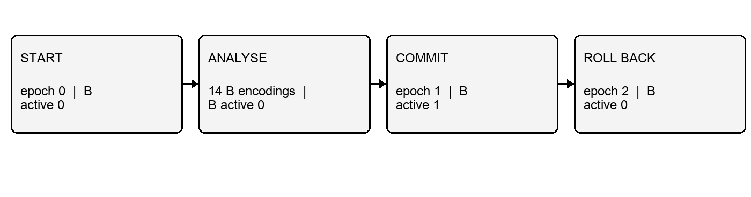
Figure 3 Measured membership and charged target encodings during one fresh local proof run. The rejected action occurs before the commit checkpoint.

Reproducibility and evidence record
The saved evidence package includes the 25-test log, a fixture benchmark, a 40-step migration trajectory, strict exhaustive evidence, three SciFact experiment records and a browser evidence export. The screenshots below are from the authored 40-document fixture. Their source JSON and the full-size captures are included in the package. The SciFact tables represent separate sampled experiments, not the pictured browser state.
To reproduce the local browser case, start the server with a fresh database, analyze candidates, inspect the rejected car-guide action, commit the passing password-policy action, export the record and then roll back. The run instructions and exact command are in the accompanying demo guide. Repeating the historical SciFact measurements requires the recorded model snapshots and sampled IDs.

Prototype screenshots
Actual local browser captures from the authored lexical fixture. Screenshots illustrate the workflow; numeric results and failure checks are supported by the JSON exports and test log.

Figure 4 Successful commit: 1 active B object, 14 target encodings and epoch 1.
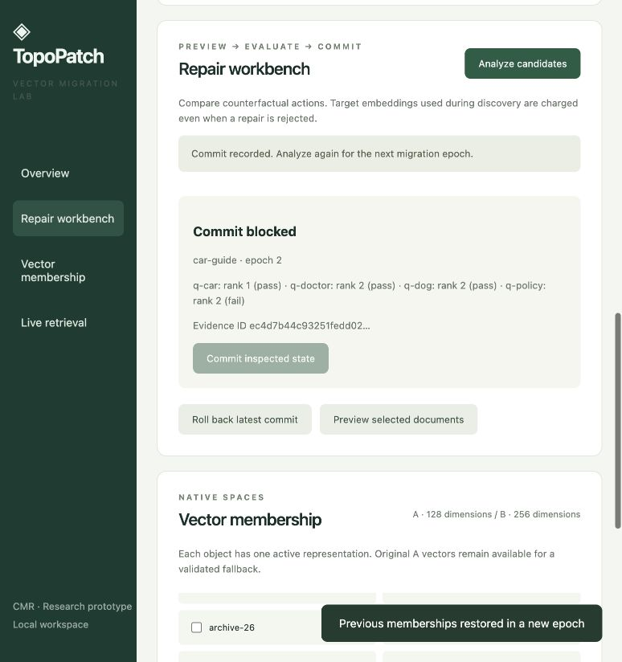
Figure 5 After rollback to epoch 2, the car-guide preview fails q-policy and commit is disabled.
The full-resolution screenshots are included in the evidence package. No screenshot represents a neural benchmark or a production deployment.

9. What aspect(s) of the invention need(s) protection?
We ask the IPR Cell to examine the following sequence as a possible combined contribution. The proposed scope is limited to the concrete migration process described here:
• Calculate the mixed search state for a selected set of B vectors, including removal of those documents from the active A ranking, before committing the change.
• Record the effect of that action on protected result ranks, together with document IDs, source digests and experiment state, and use the record to choose an admissible action.
• Identify the preview by a digest of its tested vectors and recorded state. Within the write transaction, reject stale or altered evidence and recheck the current retrieval constraints before changing membership.
• In the strict mode, require current target-vector coverage before admission. The implemented exhaustive fallback computes all vectors and records that full cost.
• Keep an inspectable event history, restore the latest unchanged committed membership when requested, and allow a legacy route only for a query that has passed its legacy check.
The intended effect is to stop an index change that fails the inspected retrieval constraints or relies on stale source evidence. The local tests support that behaviour. Whether the combination adds an inventive step over model validation and standard transaction control remains unresolved. Rank fusion, hashing, caching, SQLite atomicity and the dashboard are supporting techniques. The exhaustive fallback is not claimed to save encoding work.
A patent professional should assess the combined mechanism under the applicable computer-related invention requirements, including Section 3(k) of the Indian Patents Act [R7]. These proposed protection points are disclosure material, not final patent claims or a conclusion of patentability.

Technical feature comparison for claim review
Feature to examine | Closest established teaching | TopoPatch evidence and remaining question
Validate before activating a newer model | Amazon R8 validates model migration using client test data. | The local controller validates document-level mixed membership. Is that interaction technically distinct enough?
Selectively reindex documents | Cloudera R2 updates affected vector-index content; HubSpot R1 supports model-related re-embedding. | The action is chosen from observed mixed-rank effects. Search scope is capped and savings are unproven.
Keep old and new spaces available | Qdrant R3 documents practical embedding-model migration. | The tested path fuses native ranks and masks a selected A membership during preview.
Check source and commit atomically | Checksums and ordinary database transactions are established. | The local prototype links a previewed retrieval result to the state checked at commit; inventive step remains open.
Repair ANN topology | SPFresh R10 already studies local index updates. | No ANN graph repair is implemented here; it is outside the demonstrated protection request.
The possible point of distinction is the cooperation among a concrete mixed-state action preview, a query-level refusal decision and freshness-checked commit. Each ingredient alone appears in related work. The table is a claim-review aid, not a conclusion that the combination is new or non-obvious.

References for sections 3 and 8
[R1] HubSpot. Vector as a service. US20240303516A1.
https://patents.google.com/patent/US20240303516A1/en
[R2] Cloudera. Methods and apparatus to manage input data sets to reflect dataset mutations for GenAI and RAG applications. US20250342179A1.
https://patents.google.com/patent/US20250342179A1/en
[R3] Qdrant. Migrate to a New Embedding Model.
https://qdrant.tech/documentation/tutorials-operations/embedding-model-migration/
[R4] BEIR benchmark repository and SciFact archive.
https://github.com/beir-cellar/beir
[R5] VIT. Intellectual Property Rights and Technology Transfer Policy and Guidelines. Amendment 16 April 2024.
https://vit.ac.in/files/IPR-and-Technology-Transfer-Policy.pdf
[R6] VIT. A guide on Technology Readiness Levels.
https://vit.ac.in/wp-content/uploads/2025/08/A_guide_on_Technology_Readiness_Levels.pdf
[R7] IP India. Patents Act 1970, Section 3.
https://ipindia.gov.in/acts/patent-act-1970/section-3
[R8] Amazon. Client-specific validation for migrating to a version of a machine learning model using client-supplied test data. US11610143B1.
https://patents.google.com/patent/US11610143B1/en
[R9] Embedding Patches for Localized Improvement of Embeddings. US20260195572A1.
https://patents.justia.com/patent/20260195572
[R10] Xu et al. SPFresh. SOSP 2023. Author laboratory publication page.
https://ustc-mlsys.github.io/publications/spfresh-sosp-2023/
[R11] SQLite. Isolation in SQLite.
https://sqlite.org/isolation.html
[R12] Cormack, Clarke and Buettcher. Reciprocal Rank Fusion outperforms Condorcet and individual Rank Learning Methods. SIGIR 2009.
https://research.google/pubs/reciprocal-rank-fusion-outperforms-condorcet-and-individual-rank-learning-methods/
Online references checked 15 October 2026. Source dataset archive: data/scifact.zip. The original project specification is retained in doc/.

