A Project Report

on
Leveraging Aspect-Oriented Opinion Analysis to Evaluate Consumer Perceptions in Indian Healthcare Settings(JIO COLLABORATIVE PROJECT)
carried out as part of the Minor Project IT3270 Submitted

by

Shaurya Saxena (229302033)
Brindeshwar Sharma (229302035)

in partial fulfilment for the award of the degree of

Bachelor of Technology

in

Information Technology

Under the Guidance of
Guide Name



Department of Information Technology

MANIPAL UNIVERSITY JAIPUR
RAJASTHAN, INDIA

May 2025

CERTIFICATE

Date:18/04/2025

This is to certify that the minor project titled Leveraging Aspect-Oriented Opinion Analysis to Evaluate Consumer Perceptions in Indian Healthcare Settings is a record of the bonafide work done by Brindeshwar Sharma (229302035) and Shaurya Saxena (229302033) submitted in partial fulfilment of the requirements for the award of the Degree of Bachelor of Technology in Information Technology of Manipal University Jaipur, during the academic year 2024-25.

Dr. Bagesh Kumar
Assistant Professor

Project Guide, Department of Information Technology

Manipal University Jaipur

Dr. Pratistha Mathur

HoD, Department of Information Technology
Manipal University Jaipur

ABSTRACT

The rapid expansion of digital healthcare platforms has generated vast amounts of patient reviews, offering critical insights into drug efficacy, side effects, and treatment experiences. Extracting actionable information from these unstructured texts demands advanced natural language processing techniques. This project, conducted in collaboration with Jio, develops an Aspect-Based Opinion Mining (ABOM) system to analyze sentiments in healthcare reviews, focusing on aspects such as effectiveness and side effects. The primary objective was to create a robust system for extracting aspect-opinion pairs, classifying sentiments into five categories (0–4, very negative to very positive), and evaluating four deep learning models: BERT, RNN, LSTM, and CNN. A dataset of 161,297 reviews, provided by Aditya Raj from Jio, was preprocessed to generate 136,976 aspect-opinion pairs, balanced to 50,000 samples. BERT achieved the highest validation accuracy of 94.33%, followed by CNN at 94.28%, with RNN improving from 91.96% to 93.21% through tuning. Comprehensive outputs, including metrics (accuracy, F1, MAE, precision, recall, per-class F1), visualizations (confusion matrices, per-class F1 plots), and analyses (error analysis, aspect distribution).

The significance of this work lies in its ability to deliver granular patient sentiment insights, enabling healthcare providers and pharmaceutical companies to enhance drug development and patient care.
Guided by Dr. Bagesh Kumar and Aditya Raj, this collaborative effort establishes a foundation for real-time sentiment analysis, with future enhancements targeting improved neutral sentiment detection and deployment as a user-friendly application.

LIST OF TABLES

Table No | Table Title | Page No
1 | Literature Review | 8
2 | Metrics of Each Model | 11
3 | Month Wise Plan | 13

LIST OF FIGURES

Figure No | Figure Title | Page No
1 | System Architecture Flowchart | 9
2 | Accuracy Bar Graph | 11
3 | BERT Confusion Matrix | 12
4 | Training Progress | 12
5 | Aspect Category Distribution | 13

Table of Contents
1. Introduction 6
1.1 Introduction 6
1.2 Problem Statement 6
1.3 Objectives 7
1.4 Scope of the Project 7
2. Background Detail 7
2.1 Conceptual Overview 7
2.2 Other Software Engineering Methodologies 8
3. System Design & Methodology 9
3.1 System Architecture 9
3.2 Development Environment 9
3.3 Methodology 9
4. Implementation and Result 9
4.1 Modules of Project 9
4.2 Plan of Work 9
4.3 Implementation 10
4.4 Results and Discussion 11
5. Conclusion and Future Plan 11

- Introduction

  - Introduction

The proliferation of digital healthcare platforms has revolutionized how patients share feedback about medications, treatments, and healthcare experiences. These platforms host millions of user-generated reviews that encapsulate valuable insights into drug effectiveness, side effects, cost, and overall satisfaction. However, the unstructured and voluminous nature of these reviews makes manual analysis impractical, necessitating automated systems capable of extracting nuanced sentiments. Aspect-Based Opinion Mining (ABOM) addresses this challenge by identifying specific aspects within a review—such as “effectiveness” or “side effects”—and determining their associated sentiments, offering a granular perspective compared to traditional sentiment analysis. This project, conducted in collaboration with Jio, develops an ABOM system for healthcare reviews, leveraging advanced deep learning models—BERT, RNN, LSTM, and CNN—to classify sentiments into five categories ranging from very negative (0) to very positive (4). The motivation stems from the urgent need among pharmaceutical companies, healthcare providers, and policymakers to harness patient feedback for improving drug formulations, optimizing treatment protocols, and enhancing patient care. By automating the extraction and classification of aspect-based sentiments, the system provides actionable insights that drive evidence-based decision-making in healthcare, supported by the expertise of Dr. Bagesh Kumar and Aditya Raj from Jio.
This project was conducted as a collaborative effort between Manipal University Jaipur and Jio, fostering an industry-academia partnership to advance healthcare analytics. Under the guidance of Dr. Bagesh Kumar, Associate Professor at the Department of Information Technology, and Aditya Raj, a key representative from Jio, the project benefited from regular mentorship and strategic direction. Aditya Raj provided the critical dataset of 161,297 healthcare reviews, enabling the development of a robust ABOM system tailored to real-world healthcare needs [20]. Weekly meetings with Dr. Bagesh Kumar and Aditya Raj facilitated iterative feedback, ensuring alignment with both academic objectives and industry requirements. Their combined expertise in deep learning, sentiment analysis, and healthcare analytics guided critical decisions, such as dataset balancing, model selection, and error resolution, significantly enhancing the project’s outcomes and practical relevance.

  - Problem Statement

Traditional sentiment analysis techniques, which assign a single sentiment score to an entire review, are inadequate for capturing the multifaceted nature of patient feedback in healthcare reviews. For example, a review stating, “The drug works well but causes severe side effects,” contains both positive and negative sentiments tied to different aspects, which coarse-grained methods cannot differentiate. Additionally, challenges such as class imbalance, particularly the underrepresentation of neutral sentiments (Class 2), and inconsistent model performance (e.g., RNN’s initial 91.96% accuracy) hinder the development of reliable ABOM systems. This project addresses these problems by developing a robust ABOM system that accurately extracts aspect-opinion pairs, classifies sentiments with high precision, balances class distributions, improves model performance through hyperparameter tuning, and resolves technical errors to ensure seamless execution.

  - Objectives

The project was driven by a set of well-defined objectives to deliver an effective ABOM system. The primary goal was to create a system capable of extracting aspect-opinion pairs from healthcare reviews and classifying their sentiments into five distinct categories, enabling granular analysis of patient feedback. This involved training and comparing four deep learning models—BERT, RNN, LSTM, and CNN—to identify the most effective approach for sentiment classification. A specific focus was placed on enhancing the RNN model’s performance, targeting an accuracy increase from 91.96% to above 93% through hyperparameter tuning and advanced loss functions. Addressing class imbalance, particularly for neutral sentiments, was critical, achieved by balancing the dataset to ensure equitable representation across all classes. The project also aimed to generate comprehensive metrics, including accuracy, F1-score, mean absolute error (MAE), precision, recall, and per-class F1, alongside visualizations such as confusion matrices and per-class F1 plots. Resolving technical errors was essential for robust execution, and the system was designed to produce outputs suitable for academic reporting, including tables and figures.
  - Scope Of Project
The scope of this project encompasses the analysis of a dataset of 161,297 healthcare reviews provided by Aditya Raj from Jio, focusing on extracting key aspects—effectiveness, side effects, cost, dosage, doctor, and treatment—and classifying their associated sentiments. The methodology includes data preprocessing, aspect-opinion extraction, dataset balancing, and model training using BERT for transformer-based processing and RNN, LSTM, and CNN with GloVe embeddings for custom architectures. Evaluation metrics and visualizations assess model performance and provide insights into sentiment distributions. The project addresses technical challenges, such as error handling and performance optimization, but excludes real-time deployment, multi-lingual analysis, or integration with external APIs. Outputs, including CSVs and visualizations, support academic reporting and potential future applications in healthcare analytics.

- Background Detail

  - Conceptual Overview / Literature Review
Aspect-Based Opinion Mining (ABOM) is a specialized subfield of natural language processing (NLP) that identifies specific aspects within a text and determines the sentiments expressed toward them. Unlike document-level sentiment analysis, ABOM provides fine-grained insights, making it particularly valuable in healthcare, where reviews often contain multiple sentiments tied to different aspects [8]. For instance, a patient may praise a drug’s effectiveness while criticizing its side effects, requiring separate sentiment classifications. The application of big data analytics in healthcare, as discussed in [1], underscores the importance of such systems in extracting actionable insights from large volumes of unstructured data. Recent advancements in deep learning have revolutionized ABOM, with BERT (Bidirectional Encoder Representations from Transformers) achieving state-of-the-art performance due to its ability to capture contextual relationships in text [11]. Recurrent Neural Networks (RNNs) and Long Short-Term Memory (LSTM) networks excel at modeling sequential dependencies, while Convolutional Neural Networks (CNNs) are effective for extracting local features through convolutional filters [12].
Literature highlights challenges in ABOM, including class imbalance and the difficulty of classifying neutral sentiments, which often feature ambiguous language [10]. Techniques like focal loss have been employed to focus training on hard-to-classify examples, improving performance on imbalanced datasets [17]. The dataset of 161,297 healthcare reviews, provided by Aditya Raj from Jio, required careful preprocessing to handle noise and imbalance, aligning with prior work in healthcare sentiment analysis [20]. Advanced text mining techniques, such as those discussed in [11], were leveraged to preprocess and analyze the reviews effectively. Additionally, the integration of intelligent health data analytics, as explored in [19], supports the project’s goal of delivering precise sentiment classifications for healthcare applications. This project integrates BERT for contextual analysis, custom models (RNN, LSTM, CNN) with GloVe embeddings, and focal loss to address class imbalance, while resolving technical challenges through iterative debugging, guided by Dr. Bagesh Kumar and Aditya Raj.

Model | Accuracy Score (%) | Limitations
Logistic Regression | 80-90% | Struggles with complex text structures
Naïve Bayes | 60-70% | Assumes feature independence, which is unrealistic
Support Vector Machine (SVM) | 75-85% | High training time, sensitive to noise
Latent Dirichlet Allocation (LDA) | 65-70% | Does not classify sentiment, only topics
Random Forest | 70-78% | Overfits on high-dimensional data
Convolutional Neural Network (CNN) | 85-90% | Requires large training data, struggles with long text dependencies
Bidirectional LSTM (BiLSTM) | 88-92% | Computationally expensive, slow inference time
Distil BERT (Transformer-based NLP) | 90-94% | Needs huge datasets, fine-tuning complexity, high inference cost
Table 1. Literature Review

  - Other Software Engineering Methodologies

The development of the ABOM system was guided by an Agile software engineering methodology, which facilitated iterative progress and continuous improvement. The project was structured into multiple sprints, each targeting specific tasks such as data preprocessing, model implementation, error resolution, and output generation. This approach enabled rapid experimentation with model architectures, hyperparameter tuning, and visualization techniques, ensuring flexibility in addressing challenges like class imbalance and coding errors. Weekly meetings with Dr. Bagesh Kumar and Aditya Raj provided critical feedback, allowing the team to refine the system iteratively. The Agile methodology’s emphasis on incremental development was particularly effective in managing the complexity of integrating multiple models and generating comprehensive outputs, aligning with both academic and industry objectives [7].

- System Design and Methodology

  - System Architecture

The system architecture, depicted in Figure 3.1, provides a structured pipeline for processing healthcare reviews and generating sentiment classifications. The process begins with the input of 161,297 reviews, provided by Aditya Raj from Jio, which are preprocessed to clean text and extract aspect-opinion pairs. These pairs are labeled with sentiments (0–4) and balanced to create a dataset of 50,000 samples. The balanced dataset is split into training (40,000) and validation (10,000) sets, which are fed into four deep learning models: BERT, RNN, LSTM, and CNN. BERT leverages transformer-based contextual analysis, while RNN, LSTM, and CNN use GloVe embeddings and focal loss to handle sequential and local features. Model outputs are evaluated using metrics (accuracy, F1, MAE, precision, recall, per-class F1), and results are visualized through plots such as confusion matrices and per-class F1 charts. Final outputs, including CSVs and visualizations.
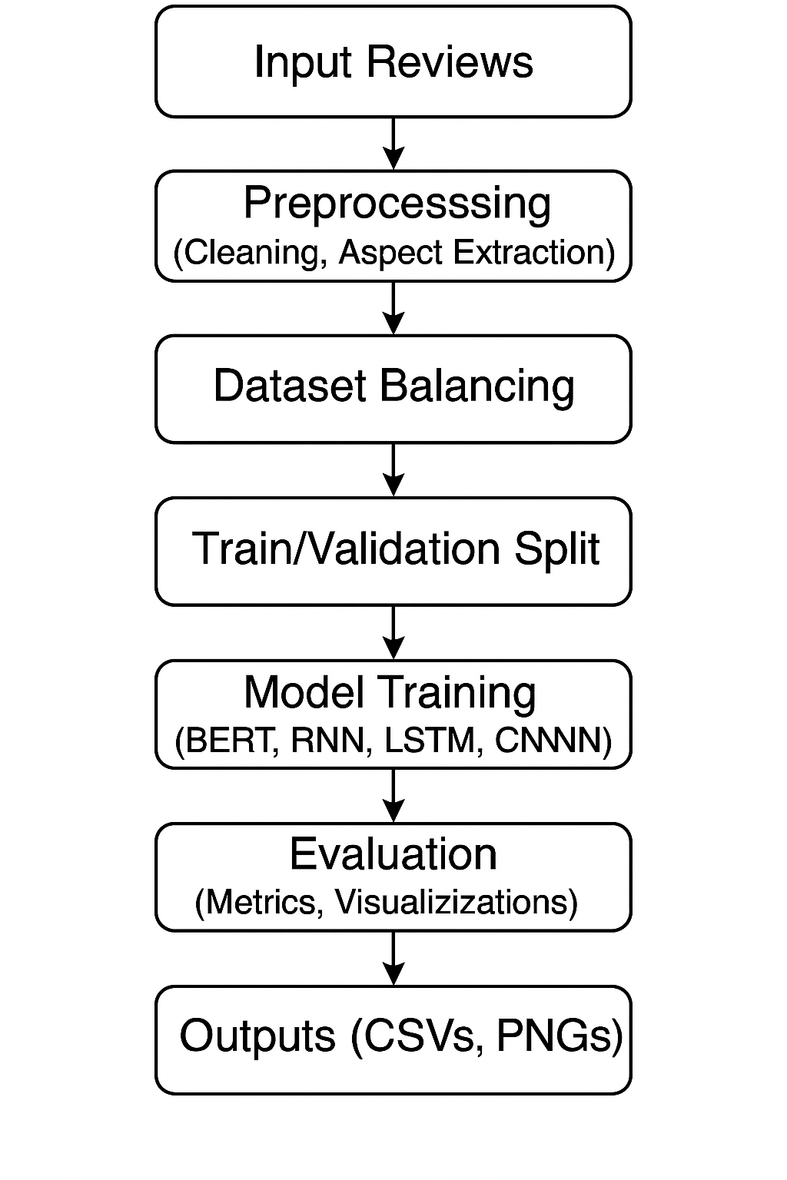
Figure 1. System Architecture Flowchart

  - Development Environment

- Hardware: Intel i7 14650HX, NVIDIA GeForce RTX 4060 Laptop GPU, RAM 16 GB
- Software: 3.8+ (Anaconda environment: sentiment_analysis)
- Libraries: pandas, numpy, matplotlib, seaborn, torch, transformers, sklearn, nltk, tqdm
- Dataset: 161,297 healthcare reviews (provided by Aditya Raj, Jio)
- Embedding: glove.6B.200d.txt (200-dimensional GloVe vectors)

  - Methodology

The methodology transformed raw healthcare reviews into actionable sentiment classifications. Preprocessing involved loading the dataset of 161,297 reviews, cleaning text by lowercasing, removing URLs, special characters, and extra spaces, and extracting aspect-opinion pairs using a rule-based approach combined with VADER sentiment analysis [19]. Ratings were mapped to five sentiment labels (0–4), and the dataset was balanced to 50,000 samples (10,000 per label) to address class imbalance (initially 64% Label 4, 0.2% Label 2). The balanced dataset was split into 80% training and 20% validation sets, stratified by label.

BERT was fine-tuned using Bert-base-uncased with 7 epochs, a learning rate of 2e-5, batch size of 8, and mixed precision training. Custom models (RNN, LSTM, CNN) were trained with GloVe 200-dimensional embeddings, focal loss (alpha=0.25, gamma=2), 7 epochs, a learning rate of 0.0001, and early stopping (patience=3). Evaluation metrics included accuracy, weighted F1, MAE, loss, precision, recall, and per-class F1. Visualizations were generated using Matplotlib and Seaborn.

- Implementation and Results

  - Modules/Classes of Project

The ABOM system was implemented as a modular pipeline, with components for preprocessing, data preparation, model training, evaluation, and output generation. The preprocessing module cleaned the dataset, extracted aspect-opinion pairs, and generated a balanced training dataset. A custom ABOMDataset class facilitated data loading, integrating tokenization for BERT and embedding lookup for GloVe-based models. The model training module included BERT (AutoModelForSequenceClassification) and custom architectures: RNNModel (bidirectional RNN), LSTMModel (bidirectional LSTM), and CNNModel (multi-filter CNN). Evaluation functions computed comprehensive metrics, while visualization functions generated plots for model comparison, confusion matrices, per-class F1 scores, and aspect distributions. The main orchestration function ensured seamless execution, guided by feedback from Dr. Bagesh Kumar and Aditya Raj.

4.2 Implementation Detail

The implementation was executed in Python 3.8+ within the sentiment_analysis Anaconda environment, leveraging an NVIDIA GeForce RTX 4060 GPU. The dataset of 161,297 reviews, provided by Aditya Raj from Jio, was preprocessed to remove missing entries and clean text, yielding 136,976 aspect-opinion pairs [20]. These were labeled based on ratings (e.g., 7–10 → Label 4) and balanced to 50,000 samples (10,000 per label) to address class imbalance. The dataset was split into 40,000 training and 10,000 validation samples, stratified by label.

BERT was fine-tuned using the transformers library, with 7 epochs, a learning rate of 2e-5, batch size of 8, and gradient accumulation. Custom models used GloVe embeddings, focal loss, and tuned hyperparameters (RNN: epochs=7, lr=0.0001), improving RNN accuracy from 91.96% to 93.21%. Technical errors (AttributeError, Unresolved reference 'models', KeyError: 'eval_accuracy') were resolved through iterative debugging.

4.3 Result and Discussion

Model | Accuracy | F1 | MAE | Precision | Recall
BERT | 94.33% | 94.51% | 0.0672 | 95.53% | 94.33%
CNN | 94.28% | 94.46% | 0.0683 | 95.48% | 94.28%
LSTM | 93.49% | 93.70% | 0.0772 | 94.59% | 93.49%
RNN | 93.21% | 93.45% | 0.0820 | 94.41% | 93.21%
Table 2. Metrics of Each Model

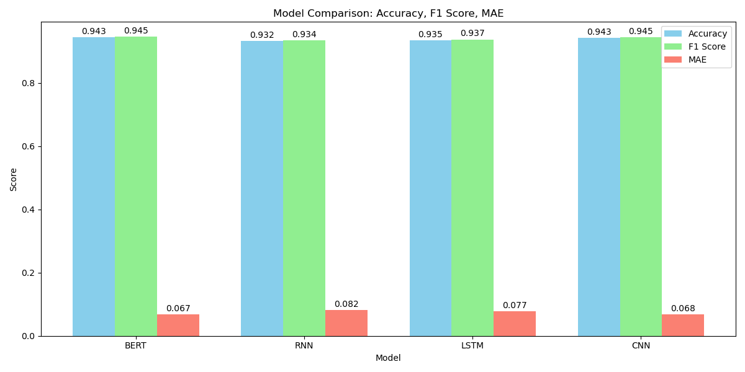
Figure 2. Accuracy Bar Graph

BERT achieved the highest accuracy (94.33%), F1-score (0.9451), and lowest MAE (0.0672), excelling in Class 0 (0.994) and Class 4 (0.979). CNN matched closely (94.28%, F1 0.9446), with the lowest non-BERT loss (0.0237). LSTM (93.49%, F1 0.9370) and RNN (93.21%, F1 0.9345) performed well, with RNN improving significantly through tuning.
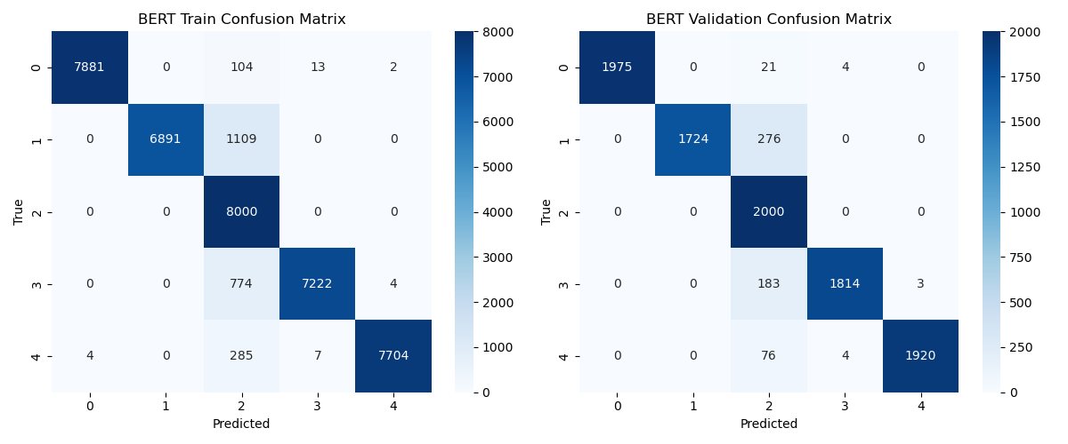
Figure 3. BERT Confusion Matrix

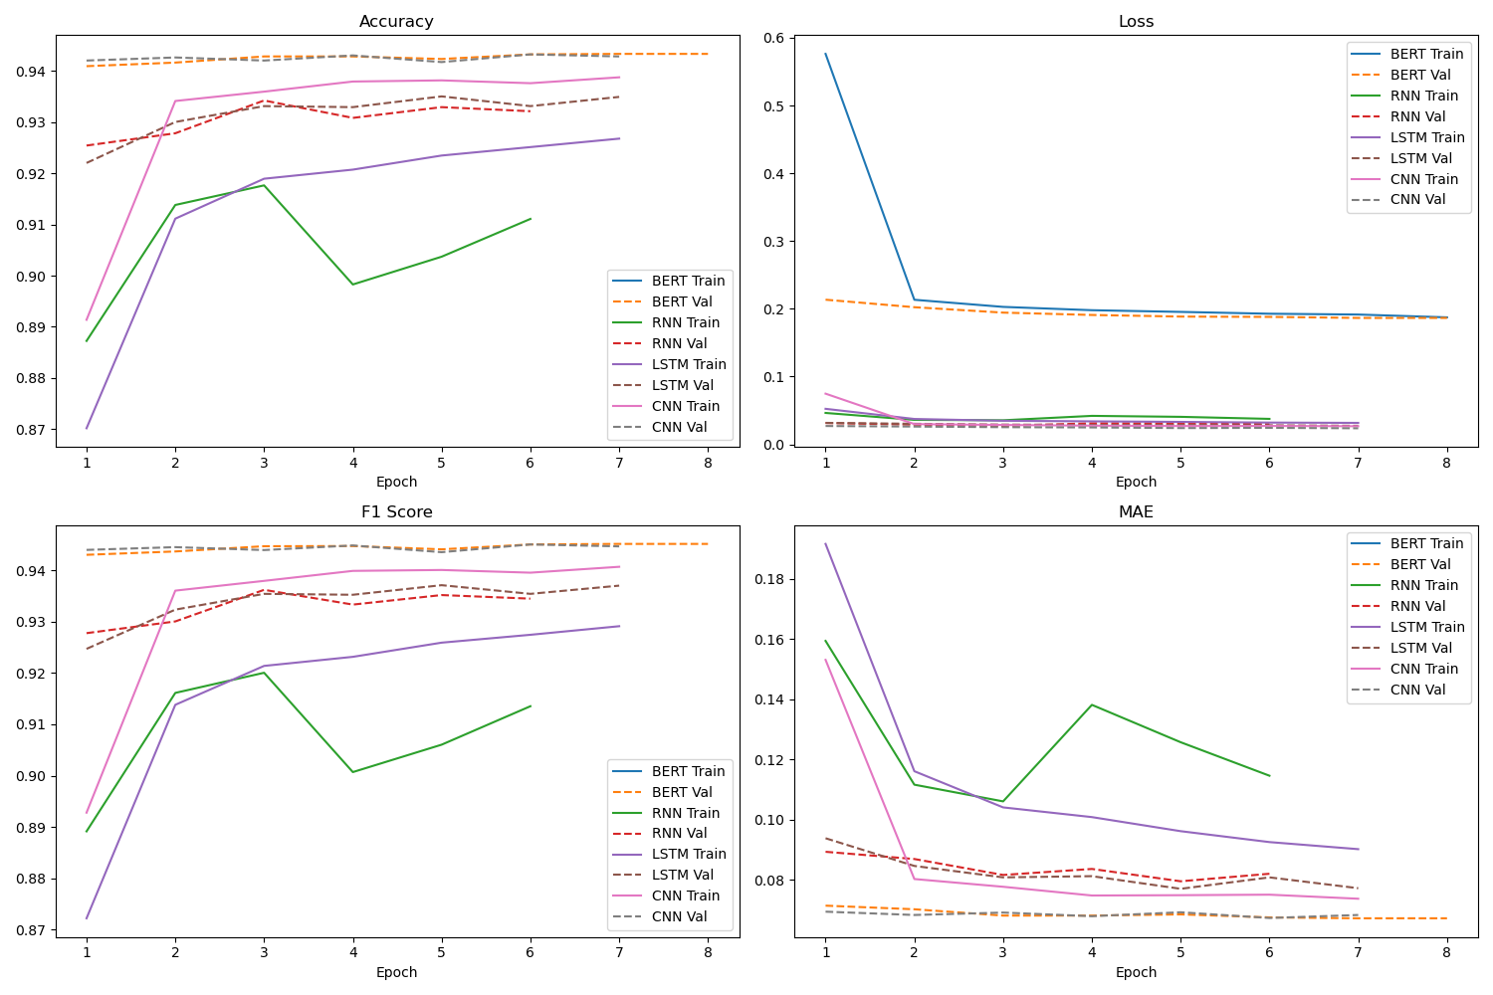
Figure 4. Training Progress

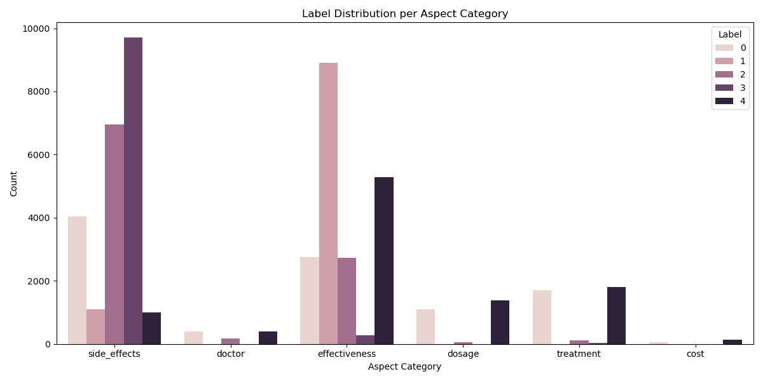
Figure 5. Aspect Category Distribution

4.4 Month wise plan of Work

Month | Tasks Completed
1 | Loaded dataset from Aditya Raj, preprocessed reviews, implemented BERT, faced AttributeError. Conducted exploratory analysis with Dr. Bagesh Kumar’s guidance.
2 | Resolved AttributeError, implemented RNN, LSTM, CNN, faced Unresolved reference 'models'. Began dataset balancing per Aditya Raj’s suggestions.
3 | Fixed reference error, tuned RNN (lr=0.0001, epochs=7), faced KeyError: 'eval_accuracy'. Added focal loss and initial visualizations.
4 | Resolved Key Error, added metrics (precision, recall, per-class F1), finalized visualizations, completed error analysis.
Table 3. Month Wise Plan

- Conclusion and Future Plan

The Aspect-Based Opinion Mining system, developed in collaboration with Jio, represents a significant advancement in healthcare sentiment analysis. By processing 161,297 reviews provided by Aditya Raj, the system extracted 136,976 aspect-opinion pairs, balanced to 50,000 samples, and achieved high accuracy (93.21%–94.33%) across BERT, RNN, LSTM, and CNN models [20]. BERT (94.33%) and CNN (94.28%) led, with RNN improving from 91.96% to 93.21%. Technical errors were resolved, and comprehensive outputs (CSVs, 9 visualizations) were generated, guided by Dr. Bagesh Kumar and Aditya Raj. The system’s granular insights position it as a valuable tool for healthcare stakeholders, supporting improved drug development and patient care [1].

References

- A. Aman, H. Gupta, M. Kharub, and O. McDermott, “Enablers for Implementing Big data analytics in the Healthcare industry: Prioritization, classification, and implications for sustainable competitive Advantages,” IEEE Transactions on Engineering Management, pp. 1–37, 1 2024. [Online]. Available: https://doi.org/10.1109/tem.2024.3416409
- N. Pavithra and N. Afza, “Harnessing the power of artificial intelligence and robotics impact on attaining competitive advantage for sustainable development in hospitals with conclusions for future research approaches.” vol. 19, p. Doc15. [Online]. Available: https://pubmed.ncbi.nlm.nih.gov/38655121
- C. Gentile, N. Spiller, and G. Noci, “How to sustain the customer experience: An overview of experience components that co-create value with the customer,” European Management Journal, vol. 25, no. 5, pp. 395–410, 2007.
- B. Schmitt, “Experiential marketing,” Journal of Marketing Management, vol. 15, no. 1-3, pp. 53–67, 1999, retrieved from https://doi.org/10.1362/026725799784870496
- V. K. Omachonu and N. G. Einspruch, “Innovation in healthcare delivery systems: a conceptual framework,” The Innovation Journal: The Public Sector Innovation Journal, vol. 15, no. 1, pp. 1–20, 2010.
- R. Worlu, O. J. Kehinde, and T. T. Borishade, “Effective customer experience management in healthcare sector of nigeria: a conceptual model,” International Journal of Pharmaceutical and Healthcare Marketing, 2016
- S. Lenka, V. Parida, and J. Wincent, “Digitalization capabilities as enablers of value co-creation in servitizing firms,” Psychology Marketing, vol. 34, no. 1, pp. 92–100, 2017.
- C.-K. Chen, A.-J. Shie, and C.-H. Yu, “A customer-oriented organisational diagnostic model based on data mining of customer-complaint databases,” Expert Systems with Applications, vol. 39, no. 1, pp. 786– 792, 2012.
- L. Satish and N. Yusof, “A review: big data analytics for enhanced customer experiences with crowdsourcing,” Procedia Computer Science, vol. 116, pp. 274–283, 2017.
- H. J. Lee, M. Lee, H. Lee, and R. A. Cruz, “Mining service quality feedback from social media: A computational analytics method,” Government Information Quarterly, vol. 38, no. 2, p. 101571, 2021.
- J. Silge and D. Robinson, “Text mining with r: A tidy approach,” O’Reilly Media, Inc., 2017.
- D. M. Blei, A. Y. Ng, and M. I. Jordan, “Latent dirichlet allocation,” The Journal of machine Learning research, vol. 3, pp. 993–1022, 2003.
- S. T. Dumais, “Latent semantic analysis,” in Annual Review of Information Science and Technology, vol. 38, no. 1, 2004, pp. 188–230.
- T. Hofmann, “Probabilistic latent semantic analysis,” arXiv preprint arXiv:1301.6705, 2013.
- R. S. Istepanian and B. Woodward, M-health: Fundamentals and Applications. John Wiley Sons, 2016.
- M. Fiszman, W. W. Chapman, D. Aronsky, R. S. Evans, and P. J. Haug, “Automatic detection of acute bacterial pneumonia from chest xray reports,” Journal of the American Medical Informatics Association, vol. 7, no. 6, pp. 593–604, 2000.
- W. Raghupathi and V. Raghupathi, “Big data analytics in healthcare: promise and potential,” Health Information Science and Systems, vol. 2, no. 1, pp. 1–10, 2014.
- M. I. Pramanik, R. Y. Lau, H. Demirkan, and M. A. K. Azad, “Smart health: Big data enabled health paradigm within smart cities,” Expert Systems with Applications, vol. 87, pp. 370–383, 2017.
- S. S. R. Abidi and S. R. Abidi, “Intelligent health data analytics: a convergence of artificial intelligence and big data,” Healthcare Management Forum, vol. 32, pp. 178–182, 2019.
- A. Raj, “Healthcare Review Dataset for Aspect-Based Opinion Mining,” Jio, India, 2025.

