EXPLORING MUSIC PREFERENCES:
A REPORT ON LISTENING HABITS
AND TRENDS


Kratika Pant

Advisor: Mr. Sahabzada Betab Badar
Department of Computer Science and Information Technology
Jain (Deemed-to-be) University

This report is submitted for the course of
Fundamentals of Computer Application(24BCA1C05)
Jain University, Bengaluru November 2024

Declaration

I hereby declare that except where specific reference is made to the work of others, the contents of this report are original and have not been submitted in whole or in part for consideration for any degree or qualification in this or any other university. This report is our own work and contains nothing that is the outcome of work done in collaboration with others except as specified in the text and Acknowledgements

Kratika Pant
Usn no: JUUG24BCAS43942,
Department of Computer Science and Information Technology,
Jain (Deemed-to-be) university, Bengaluru.

Acknowledgements

I acknowledge Prof. Sahabzada Betab Badar’s invaluable guidance and support throughout this project. My gratitude for their mentorship extends to all the Department of Computer Science and Information Technology faculty at Jain (Deemed-to-be) university, Bengaluru. I also thank my friends for my cherished moments continuing in this degree. My appreciation goes out to my parents and family members for their unwavering encouragement and support to continue all my studies.

Abstract

This study examined music listening preferences and habits through a survey targeting diverse demographics. Respondents were asked about the most preferred genres, platforms, time spent listening, and how music impacts their lives. The findings indicate that Pop and Rock are the most preferred genres, and Spotify is the dominant platform. Music is primarily used for relaxation and mood enhancement. The survey conducts an analysis of trends in music discovery and points to a significant role played by social media. It contributes to the understanding of consumer behavior in the music industry, offering valuable implications for streaming services and marketers. Future studies should probe cultural or regional influences on music preferences.

Table of Contents
- Introduction 7
1.1 Objective . . . . . . . . . . . . . . . . . . . . . . . . . . . . . . . . . . . . . . . . . . . . . . 8
1.2 Organization . . . . . . . . . . . . . . . . . . . . . . . . . . . . . . . . . . . . . . . . . . . 9
1.3 Contribution . . . . . . . . . . . . . . . . . . . . . . . . . . . . . . . . . . . . . . . . . . . 10

- Methodology . . . . . . . . . . . . . . . . . . . . . . . . . . . . . . . . . . . . . . . . . . . 11

- Respondent Demographics . . . . . . . . . . . . . . . . . . . . . . . . . . . . . . 12
3.1 Gender distribution. . . . . . . . . . . . . . . . . . . . . . . . . . . . . . . . . . 12
3.2 Age groups . . . . . . . . . . . . . . . . . . . . . . . . . . . . . . . . . . . . . . . . . 13
3.3 Insights . . . . . . . . . . . . . . . . . . . . . . . . . . . . . . . . . . . . . . . . . . . . 13

- Survey Findings. . . . . . . . . . . . . . . . . . . . . . . . . . . . . . . . . . . . . . . 14
4.1 Frequency of Music Listening. . . . . . . . . . . . . . . . . . . . . . . . 14
4.2 Preferred Music Genres. . . . . . . . . . . . . . . . . . . . . . . . . . . . . 16-17
4.3 Favorite Artist/Band . . . . . . . . . . . . . . . . . . . . . . . . . . . . . . . . 18
4.4 Preferred Platforms for Listening . . . . . . . . . . . . . . . . . . . . . 19 4.5 Time Spent Listening Daily . . . . . . . . . . . . . . . . . . . . . . . . . . 20
4.6 Playlist Creation . . . . . . . . . . . . . . . . . . . . . . . . . . . . . . . . . . . 21
4.7 Primary Reasons for Listening. . . . . . . . . . . . . . . . . . . . . . . . 22-23
4.8 Impact of Music on Mood. . . . . . . . . . . . . . . . . . . . . . . . . . . . 24-25
4.9 Activities Paired with Music . . . . . . . . . . . . . . . . . . . . . . . . . . 26
4.10 Discovering New Music. . . . . . . . . . . . . . . . . . . . . . . . . . . . . 27
4.11 Sharing Music with Others . . . . . . . . . . . . . . . . . . . . . . . . . . 28
4.12 Attendance at Live Concerts/Festivals. . . . . . . . . . . . . . . . 29
4.13 Listening Preferences . . . . . . . . . . . . . . . . . . . . . . . . . . . . . . 30
4.14 Interest in Musical Instruments . . . . . . . . . . . . . . .. . . . . . . 31
4.15 Use of Music-Related Apps/Gadgets . . . . . . . . . . . . . . . . . 32
4.16 Significance of Quality Audio. . . . . . . . . . . . . . . . . . . . . . . . 33

- Conclusion. . . . . . . . . . . . . . . . . . . . . . . . . . . . . . . . . . . . . . . . . . . . 34

- Recommendation. . . . . . . . . . . . . . . . . . . . . . . . . . . . . . . . . . . . . . 35-36

- Appendix. . . . . . . . . . . . . . . . . . . . . . . . . . . . . . . . . . . . . . . . . . . . . . 37

Chapter 1

Introduction

Music forms the most fundamental aspect of the lives around people. It impacts mood and efficiency in working. It also serves as an expression for personal taste. This kind of survey investigates general trends of listening and preferences apart from how much influence it yields in everyday life. The best thing about this would be that it'd enable prime stakeholders like artists, streaming platforms, and marketers to tailor their offerings according to the best preferences of the listeners.

1.1 Objective
The primary objectives of this report are as follows:
- To analyze the frequency and duration of music listening habits.
- To identify popular music genres, platforms, and discovery methods.
- To explore the emotional and functional impact of music on individuals.
- To provide insights into demographic influences on music preferences.

1.2 Organization
This report is structured as follows:
- Section 2: Methodology
Describes the survey design, data collection methods and demographic profile of respondents.[2]
- Section 3: Findings
Presents an analysis of the survey results, highlighting key trends and patterns in music preferences.[3]
- Section 4: Discussion
Interprets the findings in context, discussing their implications for individuals, music platforms, and industry stakeholders.[4]
- Section 5: Conclusion and Recommendations
Summarizes the report's insights and offers actionable recommendations for leveraging the findings.[5]

1.3 Contribution
This report contributes to a deeper understanding of how people interact with music in their daily lives. It provides valuable data for music streaming platforms, marketers, and industry professionals aiming to align their services with audience preferences. Additionally, it sheds light on the evolving role of music in the digital age, paving the way for future research on cultural and regional influences on music consumption.
I was responsible for Data Collection and Organization. Distributed the survey across targeted demographics using online platforms. Monitored the survey responses to ensure a balanced demographic representation, resulting in participation from diverse age groups and gender categories. Compiled and organized raw data for further analysis

Chapter 2

Methodology

Survey Title: Exploring Music Preferences: A Survey on Listening Habits and Trends
Distribution: Google Forms
Duration: Approximately 5-10 minutes
Anonymity: All responses are anonymous except for the recorded email addresses for verification purposes.

Chapter 3

Respondent Demographics

Understanding the demographic distribution of your respondents is crucial as it provides context to the preferences and habits observed.

3.1 Gender Distribution:

Male: 63.1%
Female: 36.9%
Prefer not to say: 0%
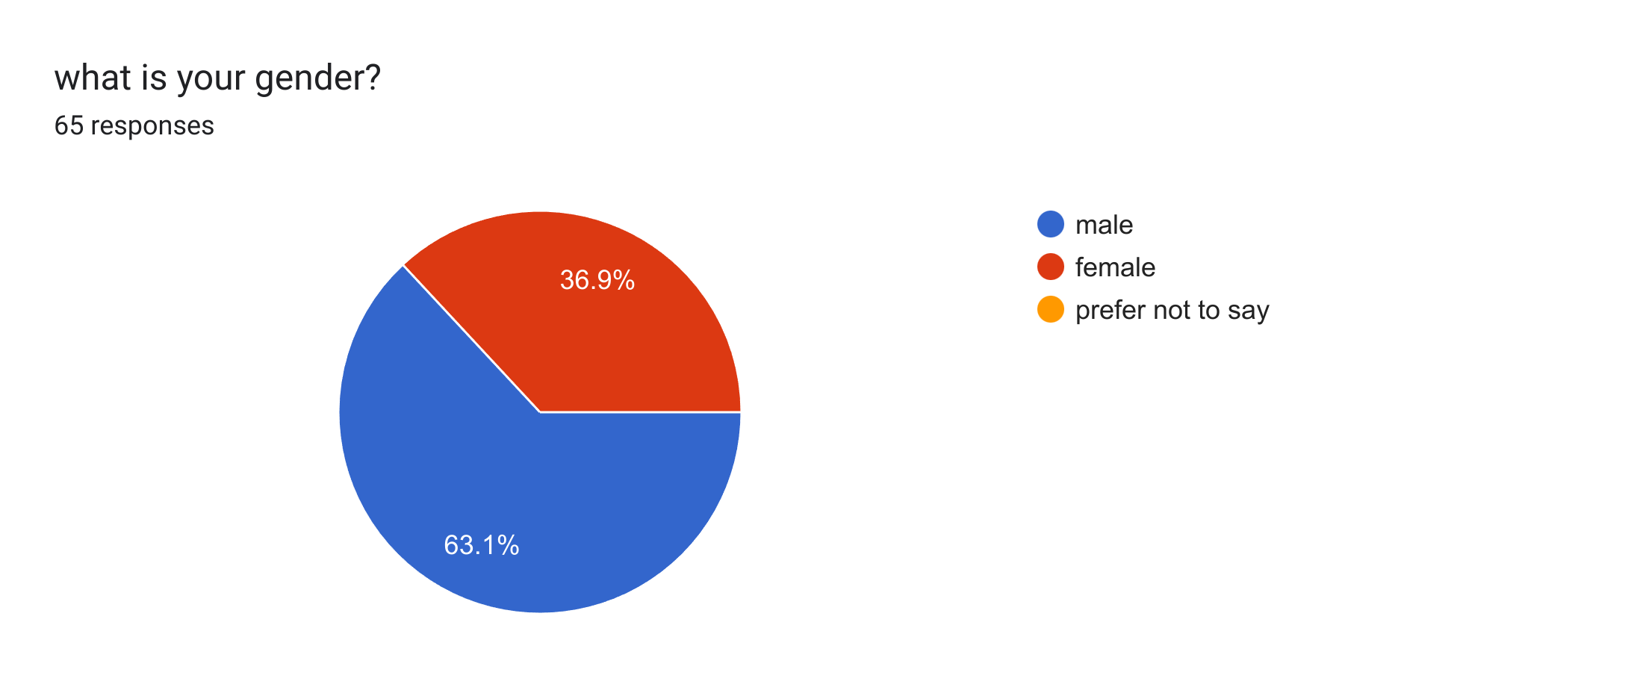

3.2 Age Groups:

10-15: 0%
15-18: 15.4%
18+: 84.6%
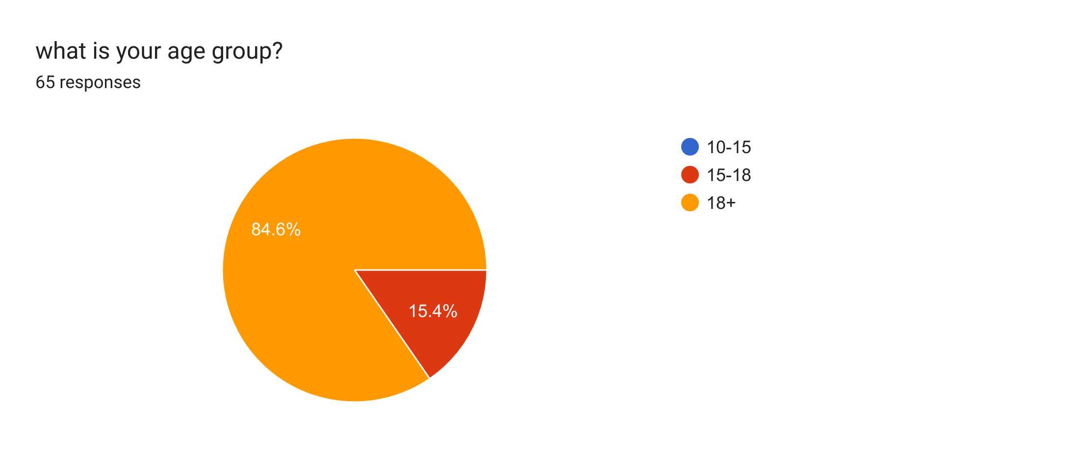

3.3 Insights:
The majority of respondents fall within the 18+ age group, indicating that the findings may be more reflective of young adults.
Gender distribution appears balanced, allowing for diverse perspectives in the data.

Chapter 4

Survey Findings

4.1 Frequency of Music Listening
Responses:65
Every day: 87.7%
A few times a week: 9.2%
Once a week: 0%
A few times in a month: 0%
Rarely: 3.1%
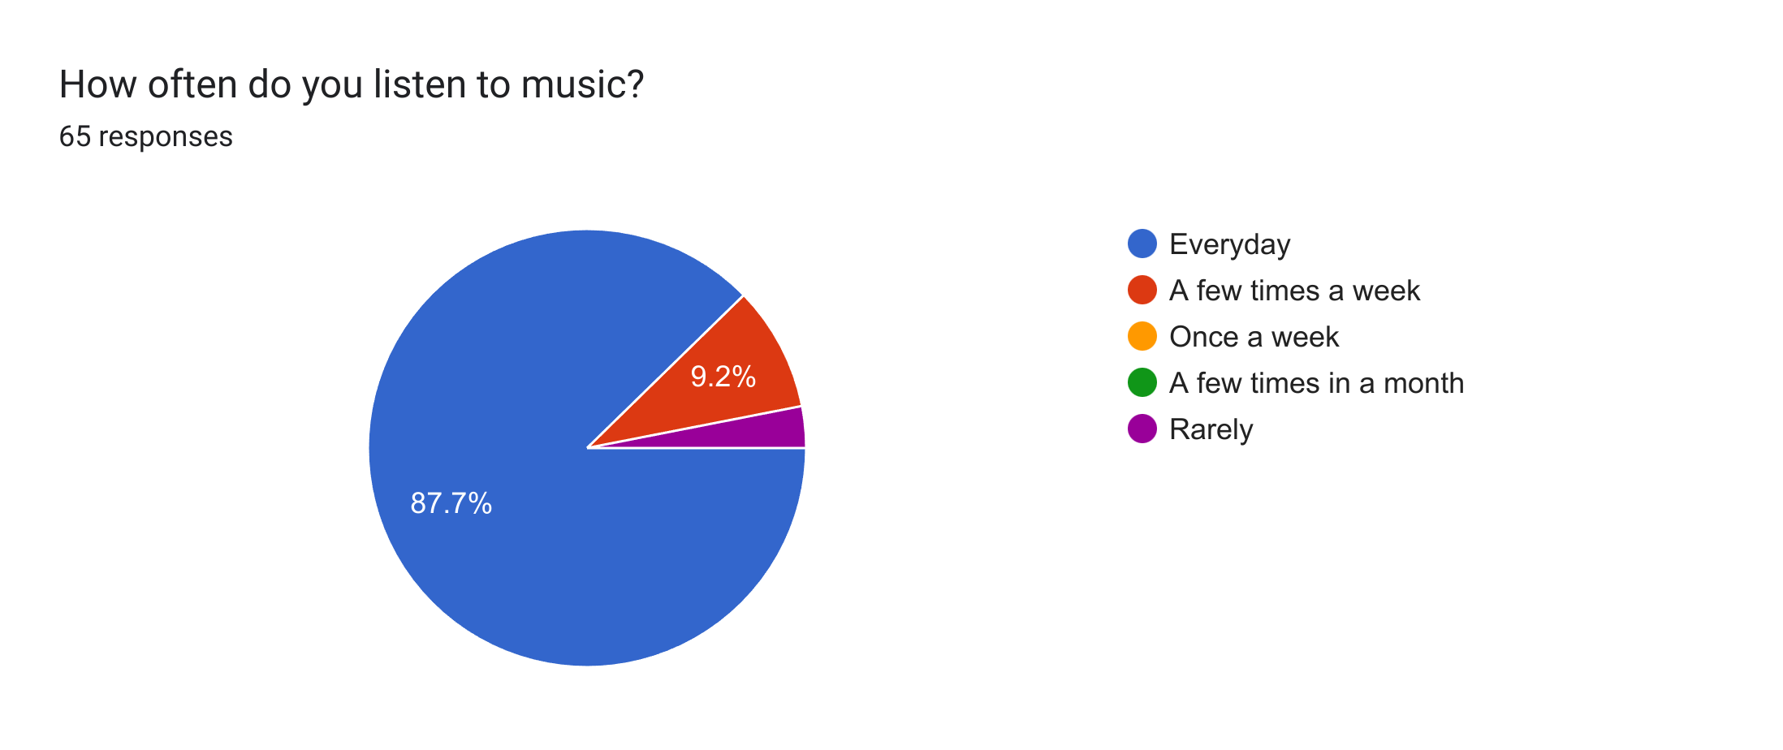

Analysis:

A vast majority (87.7% + 9.2%) listen to music daily or several times a week, and thus, clearly points towards the omnipresence of music in everyday life.
Lower frequencies (Several times in a month or rarely) are relatively low, and this might reflect occasional listeners or those who listen because of specific situational needs.

4.2 Favorite Genres of Music
Pop: 38.8%
Rock:32.3%
Hip-hop/Rap: 27.7%
Classical: 29.2%
Jazz: 15.4%
Electronic/Dance: 12.3%
Country: 12.3%
Indie/Alternative: 16.9%
Other: 4.6%

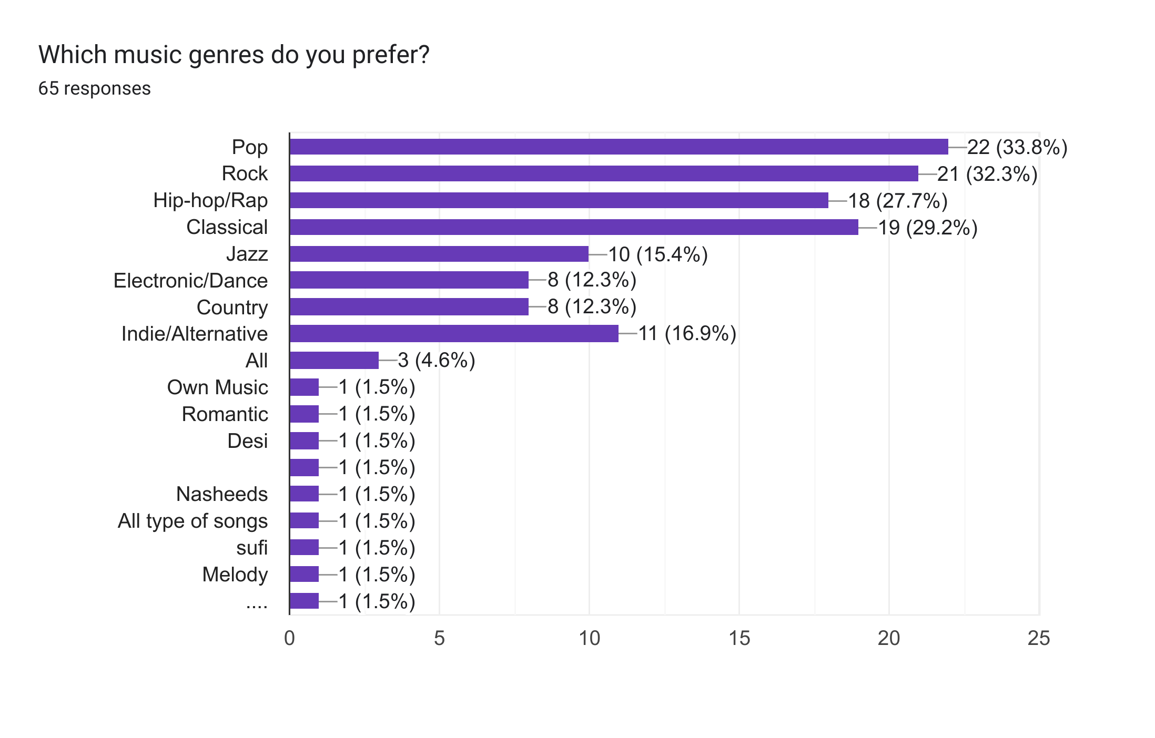

Analysis:
Pop, Rock, and Hip-hop/Rap are the most preferred genres of listening, following the mainstream.
Classical and Jazz are catered to narrower sections, and Electronic/Dance or Indie/Alternative are heard by respondents across a wide panorama.
The "Other" category (4.6%) suggests a section of emerging or less common genres which are on an upswing.

Reference:

Personality Traits and Musical Tastes
Do your preferences for certain genres of music indicate something about your personality? In one older study, researchers asked more than 36,000 participants worldwide to rate more than 104 different musical styles. They also filled out Big 5 personality inventories and provided information about their favorite music.
The results indicated that personality and musical taste are indeed linked, but other individual differences factor in, too. Here are some of the personality traits studies linked to certain musical styles.

4.3 Favorite Artist/Band
Highest Responses:12(Arijit Singh)
Anirudh: 3
Ed Sheeran: 2

Arijit Singh is the favorite artist, indicating significant regional or personal influence.

Diverse preferences in an artist reflect the heterogeneity of musical tastes and maybe the cultures too of the respondents.

4.4 Listening Platforms
Responses:
Spotify: 76.9%
Apple Music:4.6%
YouTube Music:13.8%
Amazon Music: 3.1%
Jio Saavan: 1.5%
Sound Cloud: 0%
Spotify and YouTube Music lead by a large margin due to their rich repositories and user-friendly interfaces.
Apple Music and Amazon Music are the ones that have significant market shares, denoting brand loyalty and proprietary features for a platform.
Jio Saavan is attractive to independent and up-coming artists' fans.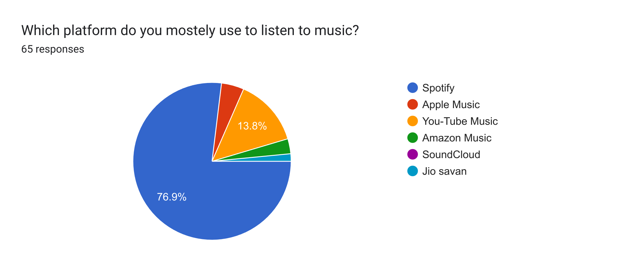

4.5 Time Spent Listening Daily

Below 30 minutes: 10.8%
30 minutes to 1 hour: 26.2%
1-2 hours: 24.6%
2-3 hours: 10.8%
More than 3 hours: 27.7%

Findings

The largest percentage spends 1-2 hours per day listening to music, which denotes a well-balanced incorporation with daily life.
A significant percentage listens for longer than 3 hours, perhaps while commuting, exercising, or studying.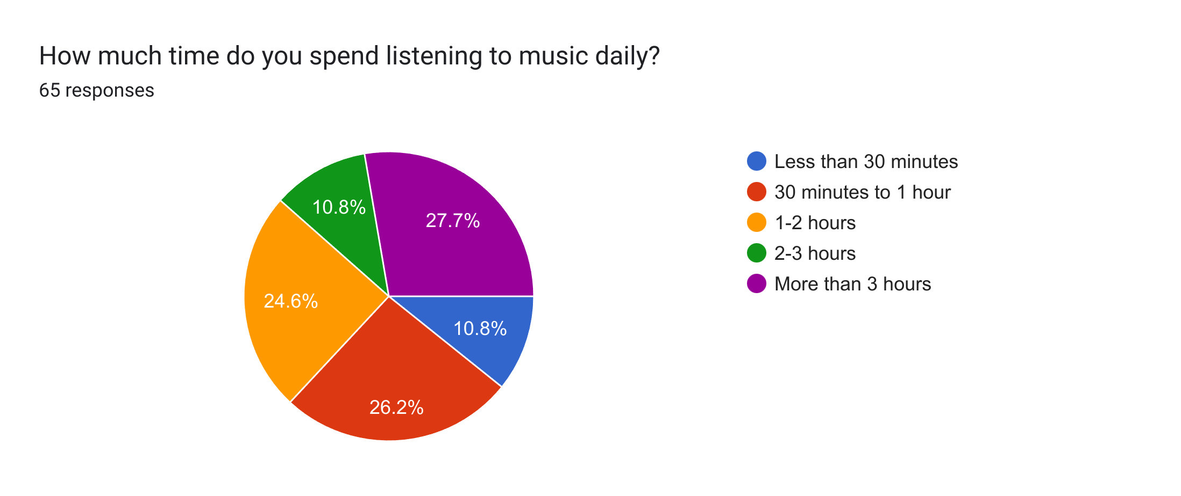
4.6 Customized Playlists
Responses:
Yes: 84.6%
No: 15.4%
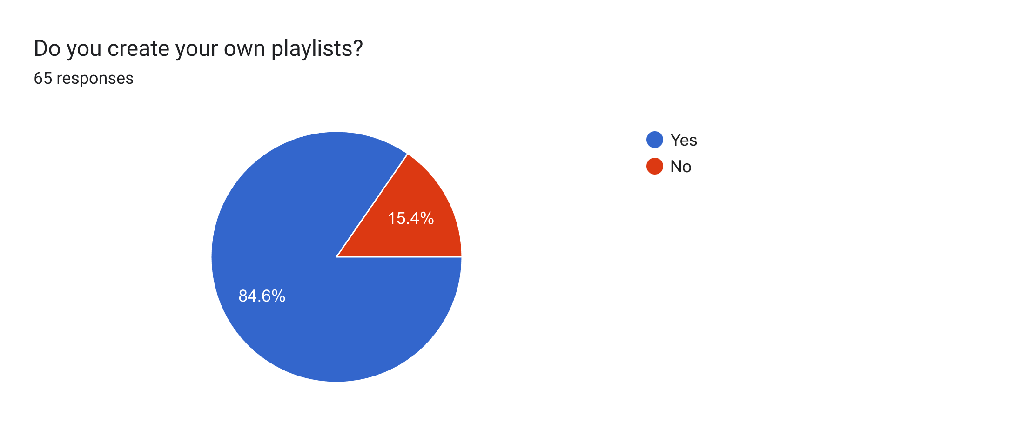

Conclusion:
Many people report making their own playlists, indicating that they enjoy personalized involvement with music.
Those who do not create playlists may likely use algorithm-based recommendations or prefer accidental listening.

4.7 Most Important Reasons to Listen
Responses:
Relaxation: 38.5%
To better their mood or energy: 32.3%
As accompaniment to exercise or work/study: 24.6%
For inspiration or creativity: 0%
To kill time: 3.1%
Other: 1.5%

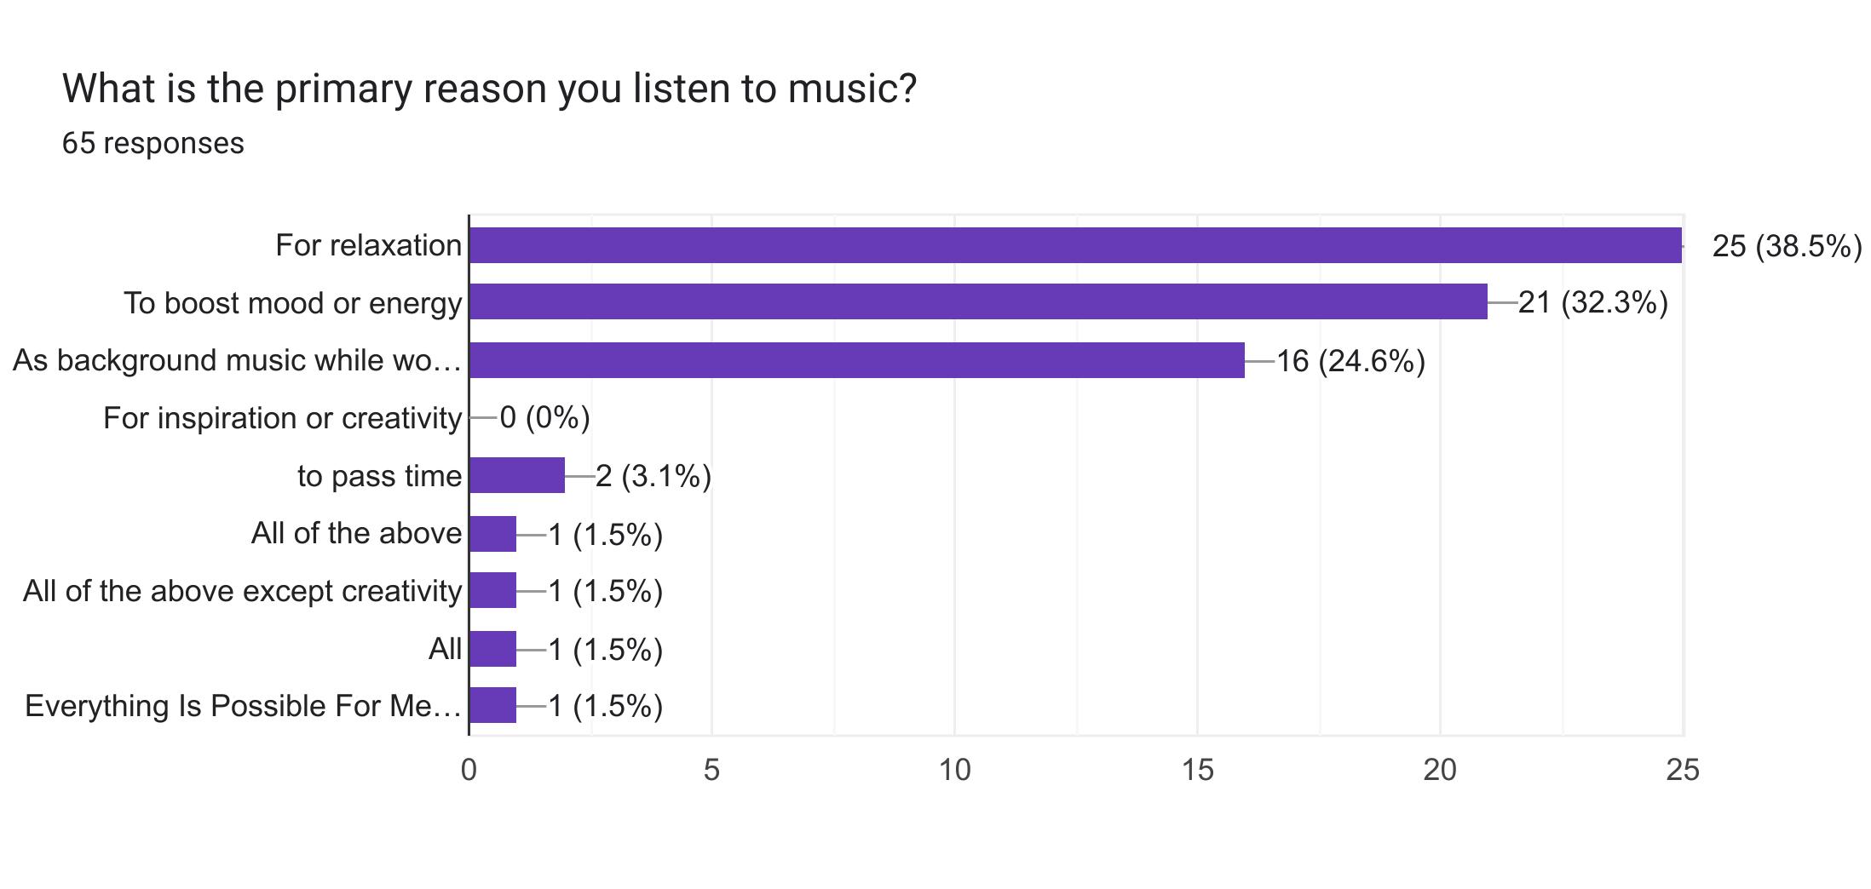

Interpretation

Relaxing and elevating mood or energy most definitely describes and supports the way music has contributed to emotional life.
Ambient music at work/study is important, revealing significant impact on productivity.

Reference:
Exploring music preferences

4.8 Music and Mood
Answers:(On a scale of 1-5)
1(No Effect): 3.1%
2(Little bit of Effect): 0%
3(Moderate Effect): 36.2%
4(Good Impact): 33.8%
5(Strong Impact): 36.9%
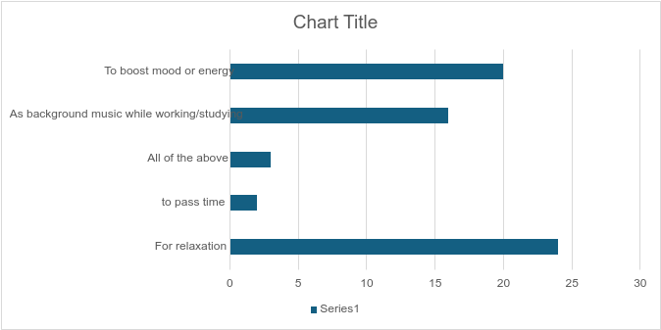

Interpretation

Most respondents rate the impact of music on mood as 4 or 5, indicating that music has a very positive influence on their affect.
A smaller portion possibly felt neutral or minimal impact, which indicates that there is individual difference when perceiving music.

Reference:
The influence of induced mood on music preference

4.9 Activities Done Along with Music

Study/work: 58.3%
Exercise: 47.7%
Commute/journey: 49.2%
Socializing/Party: 20%
Relax/meditation: 33.8%
Other: 1.5%
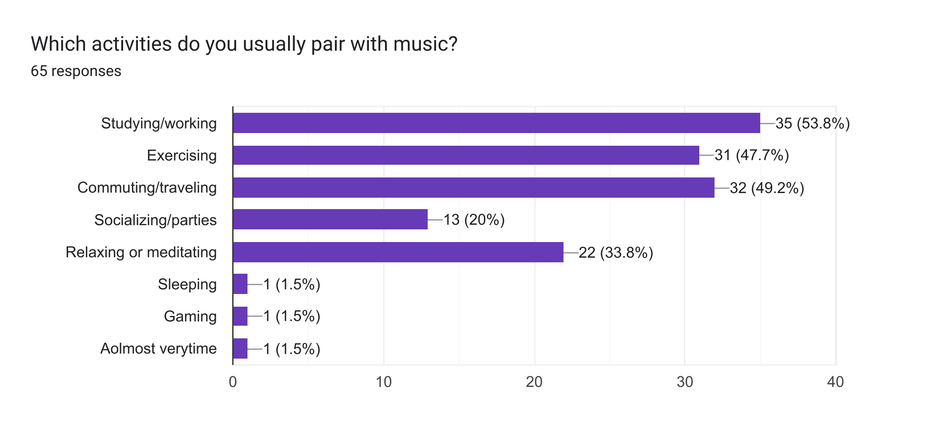Analysis:
Most frequently in combination with listening to music are studying/work and commuting/transport.Exercising and relaxing/meditating are also often done in combination with listening to music, further pointing to its functionality in different situations.
4.10 Discovering New Music

Friends/ family recommendations: 53.2%
Curated playlists (Spotify/ Apple Music): 41.5%
TikTok, Instagram, etc.: 63.1%
Music blogs/websites: 6.2%
The radio: 1.5%
Other: 1.5%
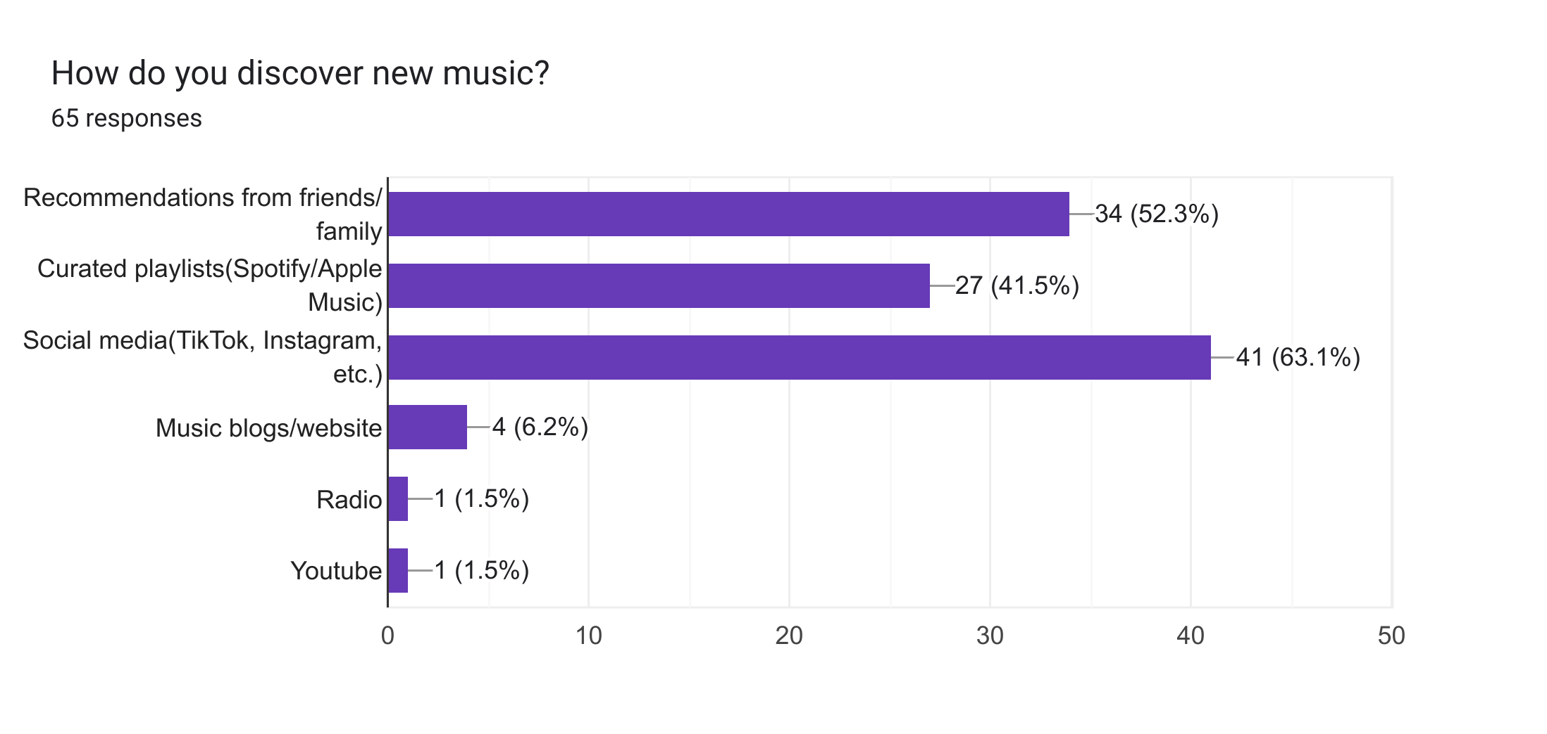

The leading source to discover new music is social media platforms and curated playlists, reflecting the digital age.
Recommendations from friends/family are important, underlining the influence of personal networks in music discovery.
4.11 Sharing Music with Others

Daily: 12.3%
Weekly: 16.9%
Monthly: 9.2%
Rarely: 44.6%
Never: 16.9%
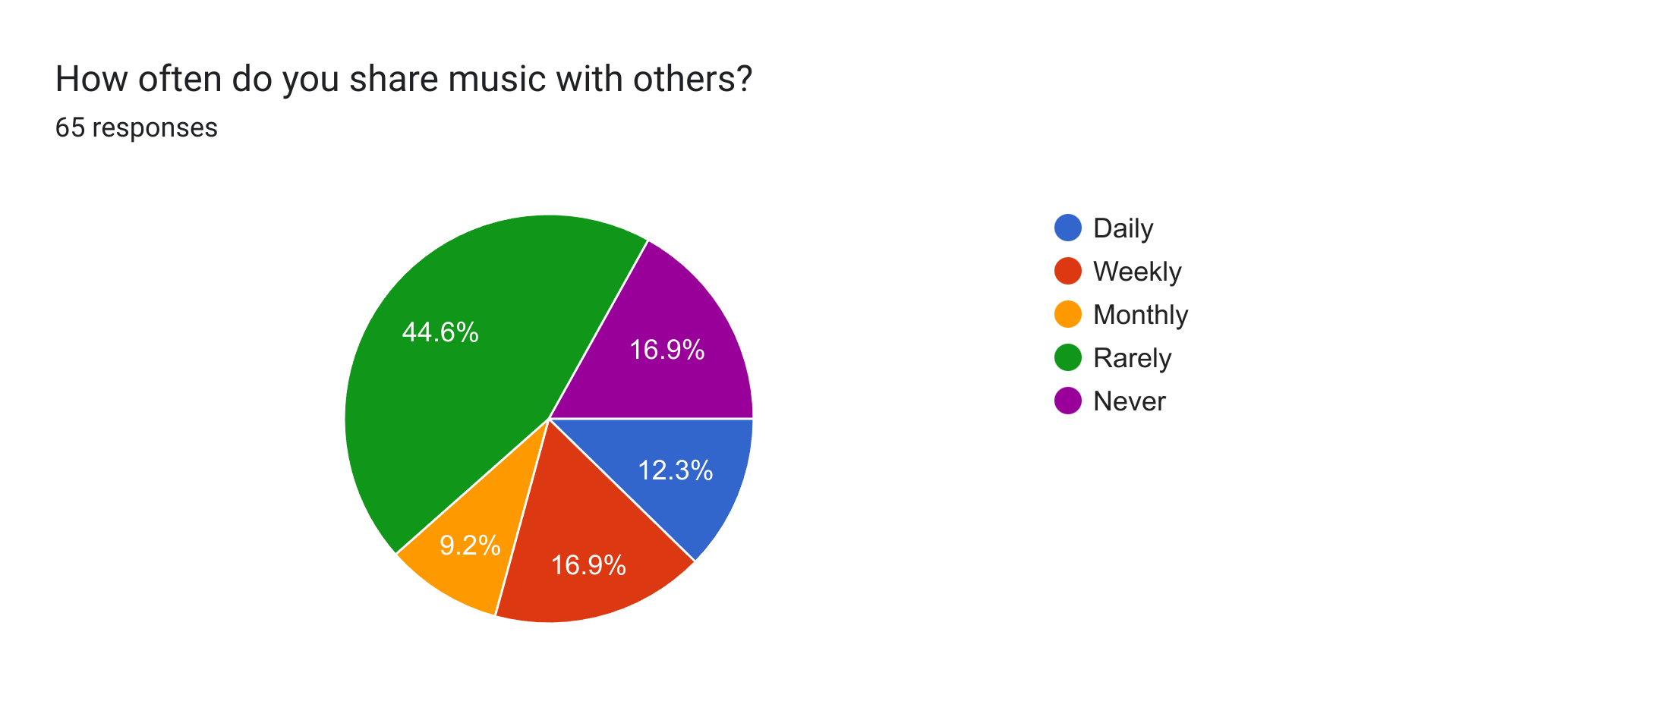

Analysis:
Daily and weekly sharing suggest that there is a significant social aspect to the consumption of music, creating community and shared experiences.
Comparatively, Rarely and never answers represent more private listening habits.
4.12 Attendance at Live Concerts/Festivals
Responses:
Yes: 73.2%
No: 27.7%
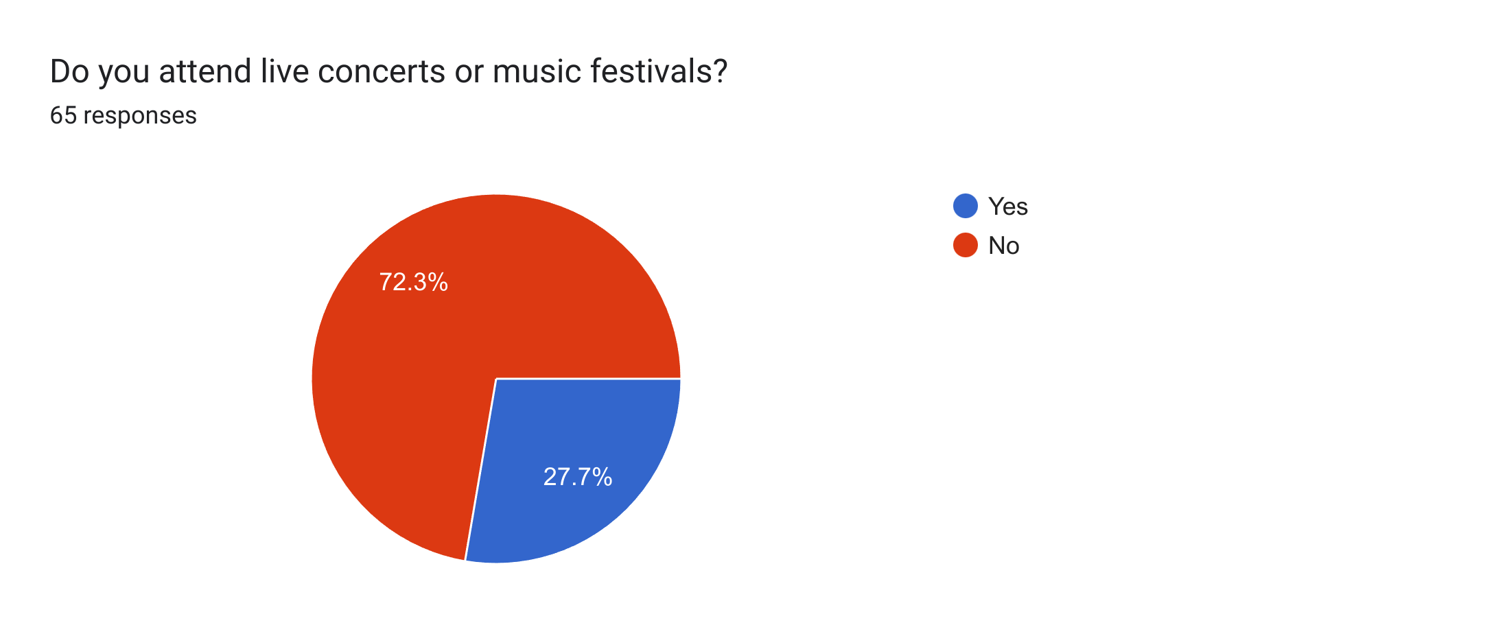

Analysis:

A balanced distribution between attendees and non-attendees suggests varied preferences or constraints related to live events.
Factors influencing attendance could include availability, interest in live performances, or financial considerations.

4.13 Listening Preferences

Alone: 58.5%
With others: 3.1%
Both equally: 38.5%
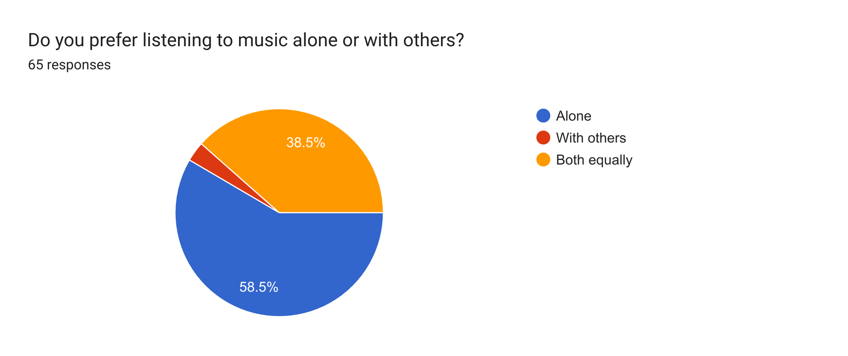

Analysis:

Listening alone is predominant, indicating personal use of music for introspection, focus, or relaxation.
With others and both equally emphasize the sociality of music, for instance, spending shared moments or enjoying shared experiences.

4.14 Interest in Musical Instruments

Yes: 75.4%
No: 24.6%
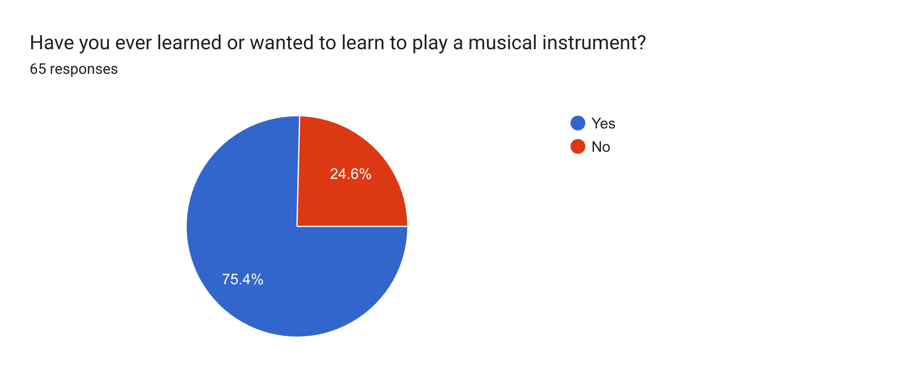

Discussion:

A large percentage showing interest in learning instruments is an indication of deeper consumption of music than merely passive listening
Yes, answers are positively related to greater musicality or musical taste homogeneity.

4.15 Use of Music-Related Apps/Gadgets

Yes: 93.8%
No: 6.2%
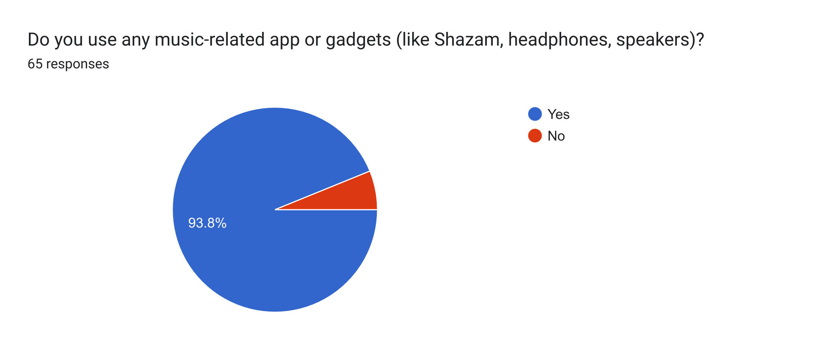

Discussion:

High gadget usages through the headphones, speakers, or apps such as Shazam make listening more enjoyable and even add functionalities.
No responses might be a result of widespread usage of devices at the lowest levels or means.

4.16 Sound Quality is Important

1: 1.5%
2: 0%
3: 10.8%
4: 20%
5: 67.7%
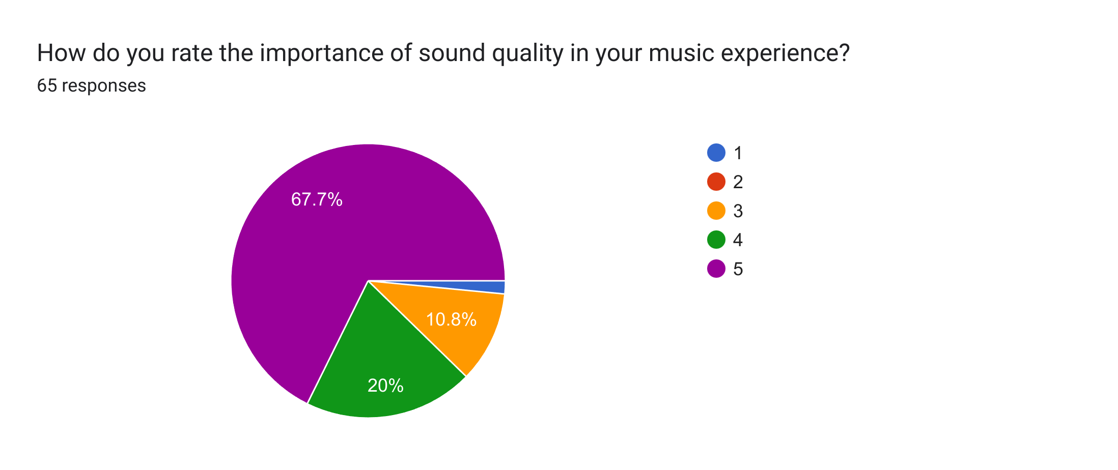

Conclusion:

The majority rates sound quality as 4 or 5, highlighting the significance of high-fidelity audio for an overall music experience.
Emphasized the importance of the audience and quality of streaming.
Chapter 5

Conclusion

The results of the survey indicate music plays an important role for the majority of the respondents, as it helps them relax, lift their mood, or be productive. The preference of mainstream genres such as Pop, Rock, and Hip-hop/Rap reflects the trends within the industry, and in particular, the high usage of digital platforms like Spotify and YouTube Music points to the increased demand for streaming services. Personalized engagement over playlist creation and the great deal of emphasis on quality of sound distinctly point towards user needs for customization coupled with quality audio experiences.

Chapter 6

Recommendations

To Streaming Companies

Curated Playlists Enhancement: Personalized and genre-specific playlists must be prominently featured to cater to different tastes.
Social Features: Incorporate more shared features and social interactions that facilitate community formation.
Stream Quality Options: Provide streamed content at higher quality levels to accommodate the audiophiles.

To Artists and Music Creators

Leverage social media: Use TikTok and Instagram to market music and discover through engaging fans.
Engage Fans: Promote playlist making or content sharing for more visibility and audience interaction.
Concerts: Invest in virtual concerts or live streaming to reach a wider audience.
For Marketers
Targeted Advertising: Use data on preferred genres and listening habits to craft targeted marketing campaigns.
Collaborations: Work with best-rated platforms and artists to increase the visibility of the brand and its engagement.

To Educators and Institutions
Collaboration for School Curriculum
Interest in Music Instruments: Organize education programs that encourage greater interest and productive involvement with music.
Research and Development: Continued studies of the effects of music on productivity and well-being will help inform future programs

Chapter 7

Appendices

Appendix A: Survey Questionnaire
Appendix B: Raw Data
Appendix C: Reference 1
Reference 2
Reference 3
Some illustrations include:
Bar Charts to depict frequency distributions.
Pie Charts for categorical variables such as genres and platforms.
Histograms for time-based responses.
Word Clouds to depict open-ended responses such as favorite artists.

Thanks for taking the time to complete this survey and for using this report to get a better understanding of these trends related to preferences in listening to music. If you need more analysis or help with visualizing your data, don't hesitate to contact!

