

**SOFTWARE ENGINEERING-II**

**COMPUTER SCIENCE AND ENGINEERING**

**Requirement Analysis and Specification Document**

**StudentXCompanies**

**Authors**

Shaurya Aditya Singh

Ergun Gani Çalışkan

Mohammadali Khaledi

**Academic year**

**2024-25**

**Deliverable: RASD  
Title: Requirements Analysis Specification Document**

**Authors:**

**Version: 1.0  
Date: 15-November-2024**

**Download page:  
Copyright: Copyright © 2024,**

**– All rights reserved**

# 

Contents

**Introduction**

1.1 Purpose .................................................. 5

  1.1.1 Goals ................................................ 5

1.2 Scope .................................................... 5

  1.2.1 World Phenomena .................................... 5

  1.2.2 Shared Phenomena ................................... 6

1.3 Definitions, Acronyms, Abbreviations ...................... 6

  1.3.1 Definitions ........................................ 6

  1.3.2 Acronyms ........................................... 6

  1.3.3 Abbreviations ...................................... 6

1.4 Revision History .......................................... 6

1.5 Reference Documents ....................................... 6

1.6 Document Structure ........................................ 7

**Overall Description**

2.1 Product Perspective ....................................... 8

  2.1.1 Scenarios .......................................... 8

  2.1.2 Domain Class Diagram ............................... 8

  2.1.3 State Diagrams ..................................... 9

2.2 Product Functions ......................................... 10

2.3 User Characteristics ...................................... 11

  2.3.1 Student ............................................ 11

  2.3.2 Educator ........................................... 11

2.4 Assumptions, Dependencies, and Constraints ............... 11

  2.4.1 Regulatory Policies ................................ 11

  2.4.2 Domain Assumptions ................................ 12

**Specific Requirements**

3.1 External Interface Requirements .......................... 13

  3.1.1 User Interfaces ................................... 14

  3.1.2 Hardware Interfaces ............................... 15

  3.1.3 Software Interfaces ............................... 16

  3.1.4 Communication Interfaces .......................... 16

3.2 Functional Requirements ................................... 16

  3.2.1 Use Cases Diagram .................................. 16

  3.2.2 Use Cases .......................................... 18

  3.2.3 Sequence Diagrams .................................. 19

  3.2.4 Requirement Mapping ................................ 25

3.3 Performance Requirements .................................. 26

3.4 Design Constraints ........................................ 27

  3.4.1 Standards Compliance ............................... 27

  3.4.2 Hardware Limitations ............................... 27

  3.4.3 Other Constraints .................................. 27

3.5 Software System Attributes ................................ 27

  3.5.1 Reliability ........................................ 28

  3.5.2 Availability ....................................... 28

  3.5.3 Security ........................................... 28

  3.5.4 Maintainability .................................... 28

  3.5.5 Portability ........................................ 28

**Formal Analysis Using Alloy**

4.1 Examples .................................................. 29

**Effort Spent** .............................................. 32

**Bibliography** ................................................. 33

**List of Figures** .............................................. 34

**List of Tables** ............................................... 35

**1| Introduction**

##### **Purpose**

As the demand for skilled professionals grows, internships have become a crucial bridge between academic learning and real-world experience. However, the process of matching students to the right internship opportunities often lacks efficiency and personalization. The **Students & Companies (S&C)** platform aims to address this issue by connecting students seeking internships with companies offering them. By leveraging modern technologies such as machine learning for recommendation systems, S&C enhances the internship application process, ensuring that students find opportunities that align with their skills and aspirations while companies identify suitable candidates.

**Goals** [G1] Enabling students to create detailed profiles, including uploading CVs and listing their skills.  
 [G2] Allow companies to post detailed internship descriptions, including required skills and timelines.  
 [G3] Match students and internships using an intelligent recommendation system.  
 [G4] Facilitate application tracking, feedback sharing, and seamless communication between students and companies.

**Scope**

The **S&C platform** serves two primary user groups: students and companies.

* **Students**: Students can create profiles, upload their CVs, and browse personalized internship recommendations. They can apply to internships, track application status, and receive feedback from companies.
* **Companies**: Companies can post internship opportunities with detailed descriptions and requirements, track applications, and communicate directly with applicants.

The platform also incorporates a recommendation system that analyzes a student’s CV and skills to suggest suitable internships, improving the efficiency and relevance of matches.

**World Phenomena**

**World Controlled** [WP1] Students create profiles, upload CVs, and list their skills.  
 [WP2] Companies create internship postings with required skills and other details.  
 [WP3] Students apply to internships and track application progress.  
 [WP4] Companies review applications and provide feedback.

**Machine Controlled** [SP1] The system recommends internships to students based on their profiles and CVs.  
 [SP2] The system notifies students and companies about application updates.  
 [SP3] The system tracks applications and provides status updates to both students and companies.

##### **Definitions, Acronyms, and Abbreviations**

**Definitions**

* **Recommendation System**: A machine learning system that matches students and internships based on their profiles and CVs.
* **CV (Curriculum Vitae)**: A document summarizing a student’s academic background, skills, and experiences.
* **Internship Post**: A job description posted by a company detailing the internship opportunity.

**Acronyms**

* S&C: Students & Companies
* UI: User Interface

**Abbreviations**

* G*: Goal
* WP*: World Phenomena
* SP*: Shared Phenomena

##### **Revision History**

* **Version 1.0** (03/12/2024): Initial draft of the document.
* **Version 2.0** (15/12/2024): Added detailed user interface design and formal requirements.

##### **Reference Documents**

* The specification of the RASD and DD assignment of the **Software Engineering II** course, A.Y. 2024/25.
* Slides and lectures of the course available on WeBeep.

##### **Document Structure**

1. **Introduction**: Provides a brief description of the project, including its purpose, goals, and scope.
2. **Overall Description**: Explains the high-level functioning of the system, detailing world and machine-controlled phenomena.
3. **Specific Requirements**: Analyzes the functional and non-functional requirements of the platform.
4. **Formal Analysis**: Includes a formal description of the phenomena using tools like Alloy.
5. **Effort Spent**: Records the time and resources utilized to create this document.
6. **References**: Lists any materials referenced during the creation of this document.

**2| Overall Description**

#### **Product Perspective**

The S&C platform is designed to facilitate seamless interaction between students seeking internships and companies offering opportunities. It acts as a bridge where both parties can find, connect, and engage based on mutual requirements and compatibility.

#### **Scenarios**

**1. Company Posts an Internship** Company A wants to post a new internship. After logging into the S&C platform with their credentials, they navigate to the "Post New Internship" section. They fill out a form specifying the internship title, required qualifications, job description, application deadline, and other relevant details. The internship posting becomes visible to students once approved by the platform moderators.

**2. Company Reviews Applicants** Company B, having posted an internship, receives applications from several students. The HR representative logs in and navigates to the "My Postings" section, selects the specific internship, and accesses a dashboard displaying the profiles of all applicants. From here, they can review resumes, and portfolios, and shortlist candidates for interviews.

**3. Student Creates a Profile** Student C, who has recently joined the platform, fills out their profile by providing personal details, academic history, skills, and portfolio links. The platform verifies the information and enables the profile for searches by companies.

**4. Student Applies for an Internship** Student D, browsing the platform, comes across an internship that aligns with their interests and qualifications. They review the job description, click "Apply," and attach a personalized cover letter and resume. The platform confirms the submission and updates the application status in their dashboard.

**5. Company Invites a Student for an Interview** Company E identifies a promising candidate, Student F, from the pool of applicants. They send an interview invitation through the platform. Student F receives an email notification and sees the invite on their dashboard, which contains the interview details and allows them to accept or reschedule.

**6. Internship Completion and Feedback** After completing an internship, the platform allows companies to provide feedback and ratings for students. Similarly, students can rate their experience with the company. This feedback helps maintain transparency and improve platform services.

**7. Generating Recommendations for Students and Companies** The platform uses AI to recommend internships to students based on their profiles and preferences. Similarly, it suggests suitable candidates to companies based on job requirements and prior intern performance metrics.

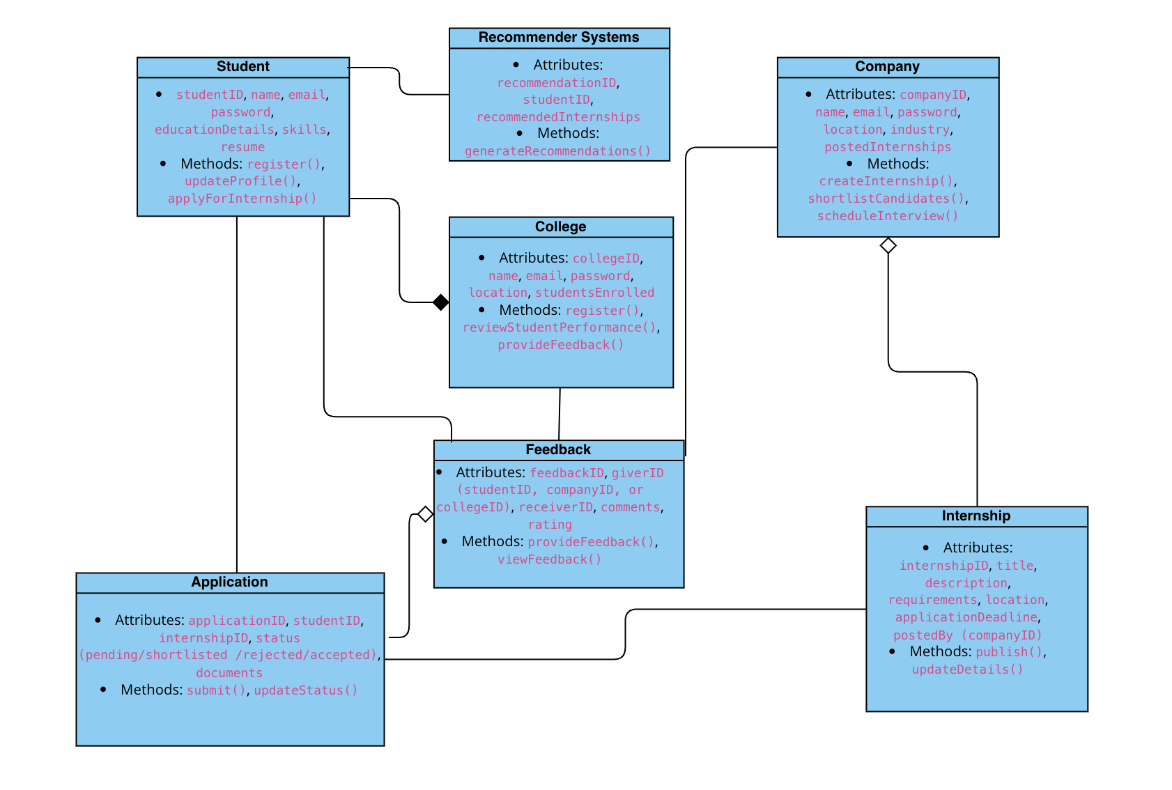

#### **2.1 Domain class diagram**

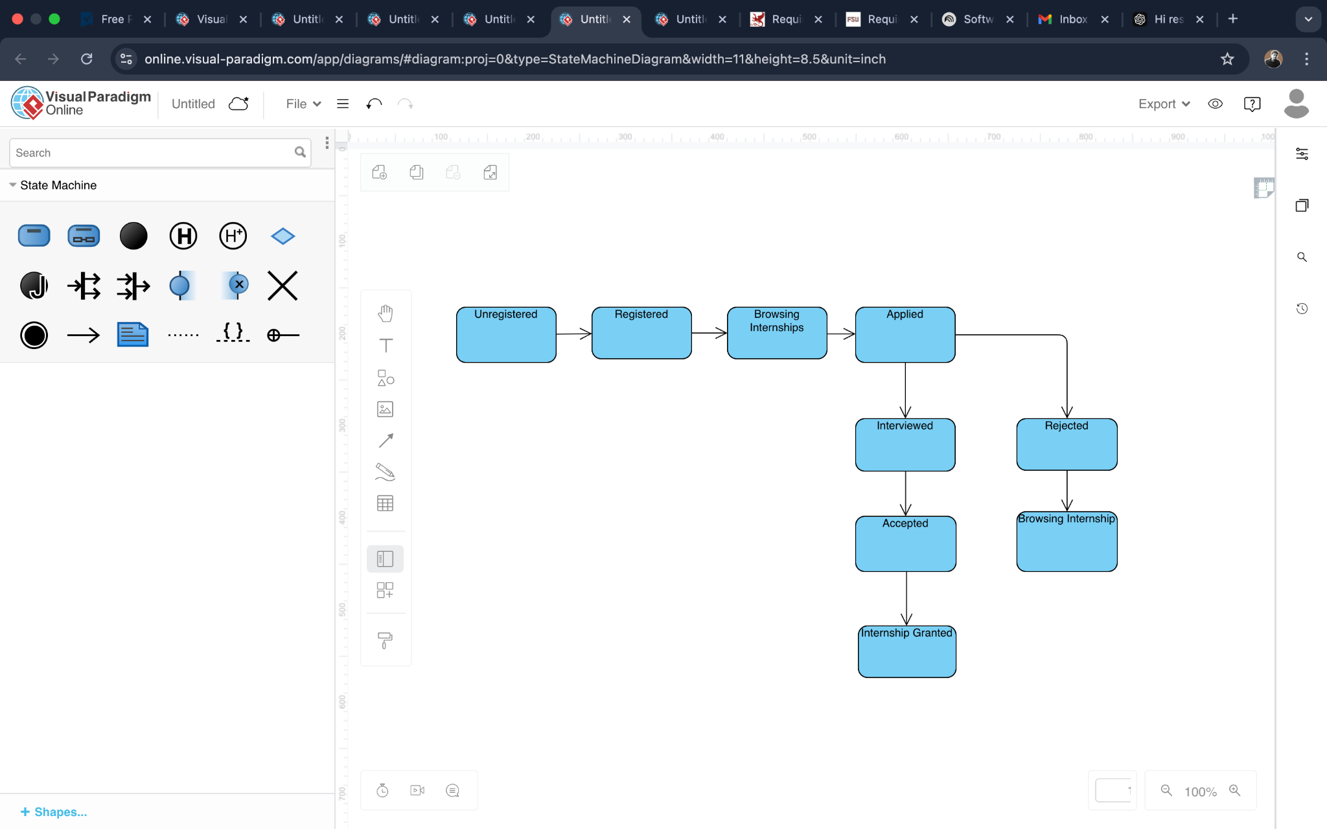

#### **2.2. State diagram-Internship selection**

#### 

#### 

#### **2.3 State diagram-Internship posting**

#### **Product Functions**

**1. Sign Up and Log In** The platform allows both students and companies to register and log in. Students create profiles showcasing their qualifications and interests. Companies create organizational profiles to post internships and view applicants.

**2. Internship Management** Companies can post, edit, and manage internship opportunities. They can define requirements, deadlines, and desired qualifications, and access an applicant management dashboard.

**3. Application Tracking** Students can track the status of their applications and receive notifications for updates. Companies can manage applicant shortlists and maintain organized records of communication with candidates.

**4. AI-Based Matching** The platform employs AI to match students with internships based on skills, preferences, and historical data. It also provides recommendations for companies to identify the best candidates for their roles.

**5. Feedback and Ratings** The platform facilitates mutual feedback between students and companies post-internship, contributing to a transparent ecosystem.

**6. Notification System** The platform sends automated notifications for new internships, application updates, interview schedules, and other relevant activities.

#### **User Characteristics**

**Students** Students can build comprehensive profiles, search for internships, apply to relevant opportunities, and track their progress. They can also showcase certifications, projects, and portfolio work to improve visibility.

**Companies** Companies use the platform to post internship opportunities, review applications, shortlist candidates, and provide feedback. They can also access metrics and analytics to refine their hiring process.

#### **Assumptions, Dependencies, and Constraints**

**Regulatory Policies** The platform processes personal data in compliance with GDPR regulations. Companies and students must consent to data use policies during registration.

**Domain Assumptions**

* [D1] Users have a reliable internet connection.
* [D2] Students accurately fill out their profiles with genuine information.
* [D3] Companies provide clear and concise internship details.
* [D4] Notifications for application updates and other activities are timely.
* [D5] Feedback provided by both parties is constructive and honest.

**3 | Specific Requirements**

#### **External Interface Requirements**

##### **User Interfaces**

The **Students & Companies (S&C)** platform supports two primary types of users: **Students** and **Companies**. Each user group has a distinct interface tailored to their specific needs and actions within the platform.

* **Student Interface:**
  + Ability to create a profile, fill out personal details, and specify academic interests.
  + Ability to search for internship opportunities based on skills, location, and preferences.
  + Ability to apply for internships and track application statuses.
  + Dashboard showing the student’s applications, upcoming deadlines, and feedback from companies.
  + Ability to modify and update personal details and application information.
* **Company Interface:**
  + Ability to create a company profile and specify available internships.
  + Ability to list internship opportunities, including descriptions, required skills, deadlines, and application procedures.
  + Ability to review student applications, shortlist candidates, and communicate with them.
  + Dashboard showing incoming applications, candidate status, and feedback tools.
  + Ability to update internship status (open, closed, filled) and manage the recruitment process.

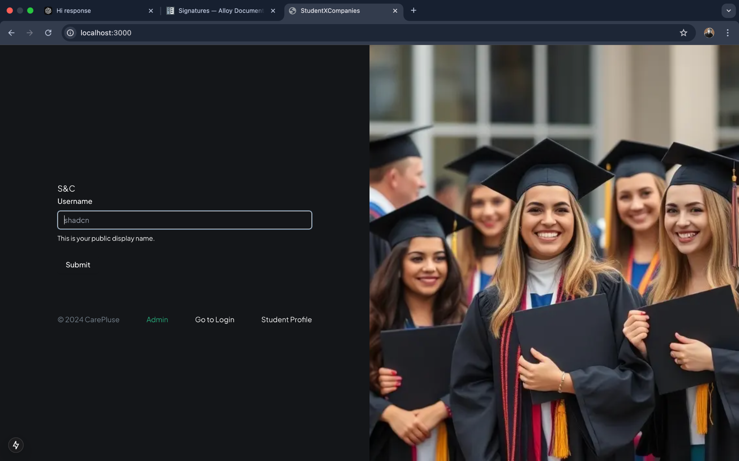

Figure 3.1- Home Screen UI

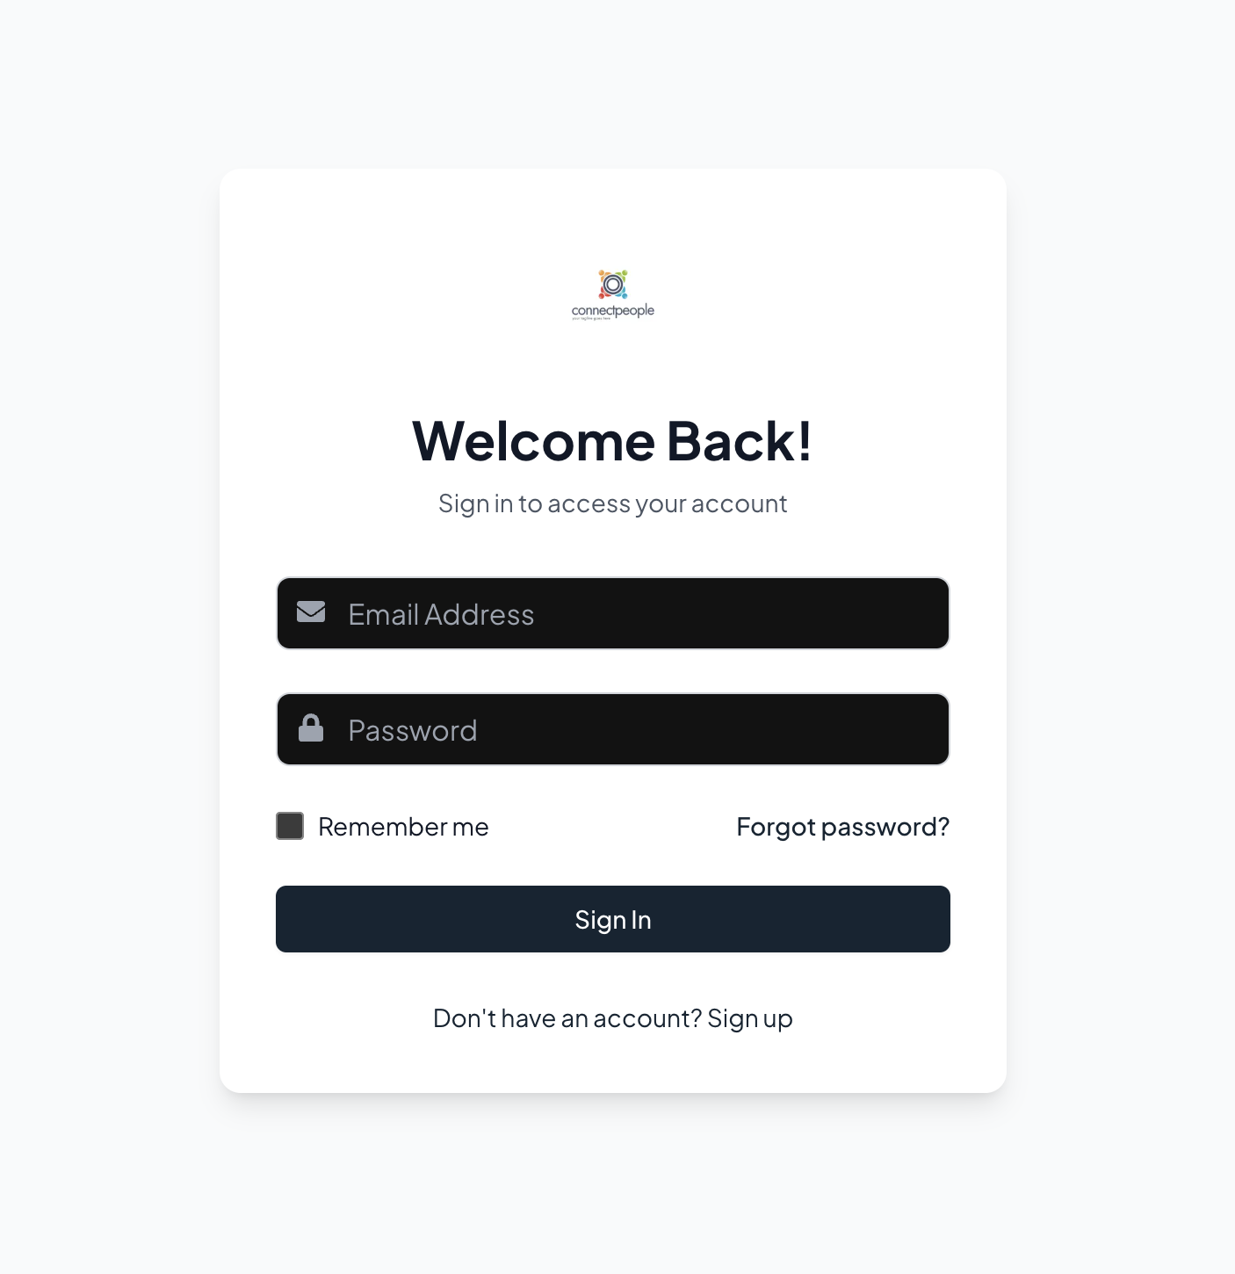

Figure 3.2- Login Screen

##### **Hardware Interfaces**

The platform is designed to be a **web-based application**, meaning there are no specific hardware requirements beyond a device that supports a modern web browser (laptop, desktop, or mobile device).

##### **Software Interfaces**

The platform will integrate with the following:

* **Email Service**: For sending application status updates, reminders, and communication between students and companies.
* **Document Management System**: For storing and sharing resumes, cover letters, and other application materials.

##### **Communication Interfaces**

The platform uses **HTTP/HTTPS** for secure communication between users and the backend system, ensuring all data transactions are encrypted and protected. It will also integrate with external job boards and academic portals to pull in relevant internship opportunities and student data when necessary.

#### **Functional Requirements**

##### **Account Creation and Management**

* **[R1]** The system allows students to register using their email and academic information.
* **[R2]** The system allows companies to register and create internship opportunities.
* **[R3]** Students can log in to the platform to view internship listings, apply for internships, and track application progress.
* **[R4]** Companies can log in to manage internship postings and review student applications.

##### **Internship Search and Application Process**

* **[R5]** Students can search for internships based on filters like skill requirements, location, and duration.
* **[R6]** Students can apply to multiple internships by submitting their resume, cover letter, and any required documents.
* **[R7]** Companies can view applications, filter candidates, and shortlist students for interviews.

##### **Internship Posting and Management**

* **[R8]** Companies can create internship listings with required qualifications, internship duration, location, and application deadline.
* **[R9]** Companies can update internship listings, change the status (open, closed, filled), and remove listings if necessary.

##### **Communication and Notifications**

* **[R10]** The system sends notifications to students about the status of their applications (shortlisted, rejected, interview scheduled, etc.).
* **[R11]** Students receive reminders about application deadlines and upcoming interviews.
* **[R12]** Companies can send interview invites or requests for additional information to shortlisted candidates.

##### **Student Profile Management**

* **[R13]** Students can update their profiles, including personal details, resume, and academic information.
* **[R14]** The system tracks students' application history and feedback from companies, providing a complete view of each student's activities.

##### **Company Profile and Application Review**

* **[R15]** Companies can create and manage their profile, listing information such as industry, size, and available internship programs.
* **[R16]** Companies can review student profiles, view resumes, and provide feedback or rejection notices.
* **[R17]** Companies can track which internships are still open and how many applications have been received for each.

#### **Use Cases**

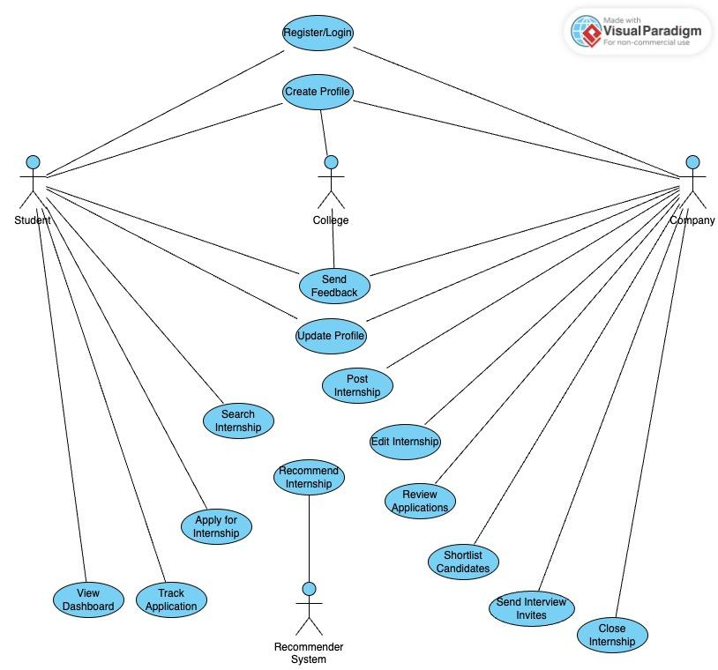

#### 3.3 Use Case diagram

##### **[UC1] Student Registration**

* **Actors**: Student, System
* **Entry Condition**: The student accesses the platform for the first time.
* **Event Flow**:
  1. The student clicks on the "Register" button.
  2. The system prompts the student to enter personal details and academic information.
  3. The student submits the registration form.
  4. The system verifies the data and creates a student profile.
  5. The student is redirected to the login page.
* **Exit Condition**: The student profile is created, and the student can log in to the platform.

##### **[UC2] Internship Application**

* **Actors**: Student, Company, System
* **Entry Condition**: The student has logged in and browsed available internship opportunities.
* **Event Flow**:
  1. The student selects an internship listing they want to apply for.
  2. The system asks the student to upload necessary application documents.
  3. The student submits the application.
  4. The system notifies the company of the new application.
* **Exit Condition**: The application is submitted, and the student is notified of the submission status.

##### **[UC3] Internship Posting**

* **Actors**: Company, System
* **Entry Condition**: The company is logged in to the platform.
* **Event Flow**:
  1. The company clicks on the "Create Internship" button.
  2. The system prompts the company to enter details like position, qualifications, location, etc.
  3. The company submits the form to create a new internship listing.
  4. The system publishes the internship listing on the platform.
* **Exit Condition**: The internship listing is live, and students can apply.

##### **[UC4] Shortlisting Candidates**

* **Actors**: Company, System
* **Entry Condition**: The company is logged in and has received applications for an internship.
* **Event Flow**:
  1. The company reviews the list of applications.
  2. The company shortlists candidates based on resume and application materials.
  3. The system notifies the shortlisted candidates and updates their application status.
* **Exit Condition**: The shortlist is completed, and candidates are notified.

#### 

#### **Sequence Diagrams**

##### **[SD1] Student Registration**

* **Figure 3.4**: Sequence diagram for student registration, showing interactions between the student, the system, and the database for profile creation (Placeholder).

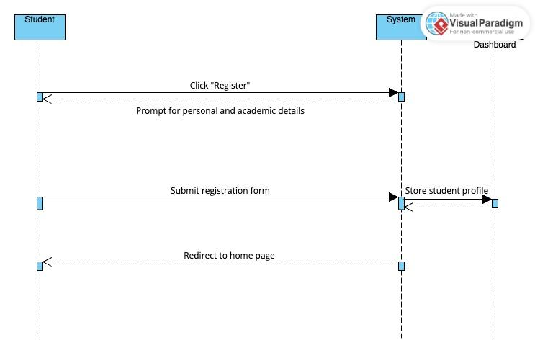

#### 3.4 Student Registration Sequence diagram

##### **[SD2] Internship Application**

* **Figure 3.5**: Sequence diagram for internship application, illustrating interactions between the student, the internship listing, and the company.

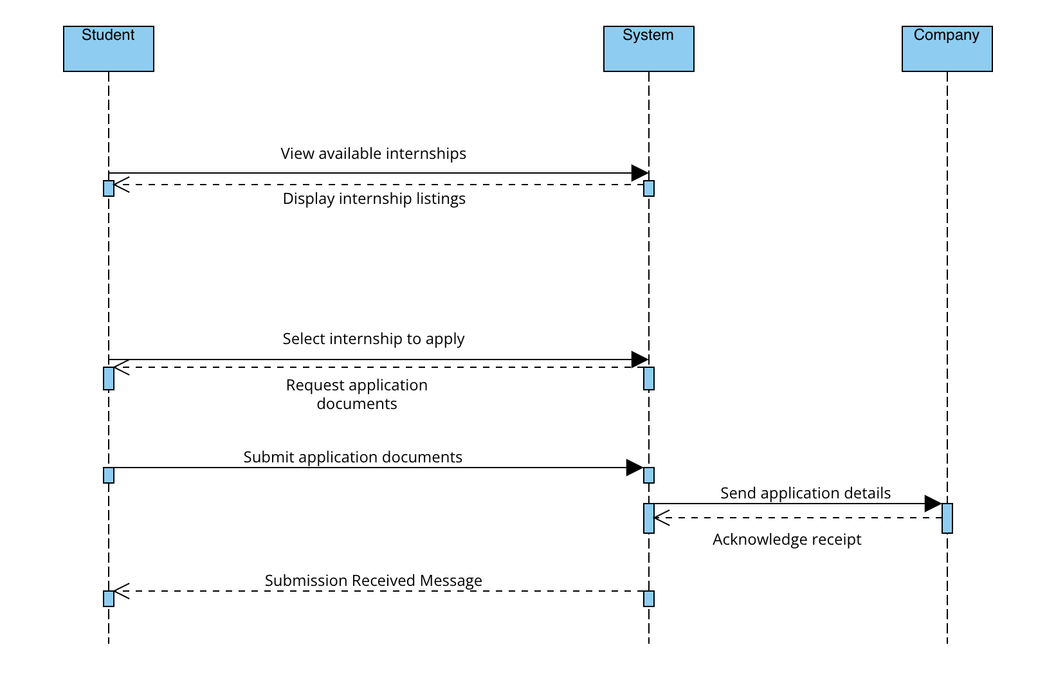

#### 3.5 Internship Sequence diagram

##### **[SD3] Internship Posting**

##### **Figure 3.6**: Sequence diagram for internship posting by the company

#### 3.6 Internship Posting

##### **[SD4] Shortlisting Candidates**

* **Figure 3.7**: Sequence diagram for candidate shortlisting, showing interactions between the company, applications, and notifications.

### 

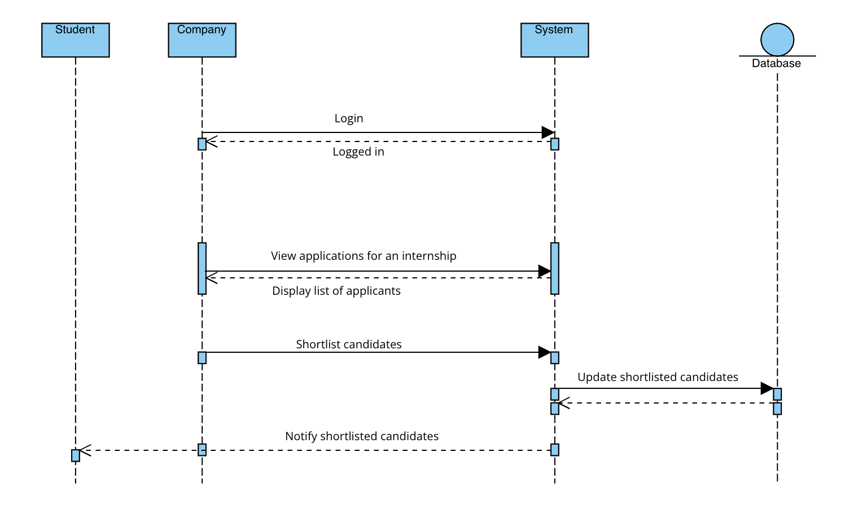

#### 3.7 Shortlisting candidates diagram

##### 

##### 

##### 

##### 

##### 

##### 

##### 

##### 

##### 

##### **[SD5] Updating Profile**

* **Figure 3.8**: Sequence diagram for profile update for any type of user.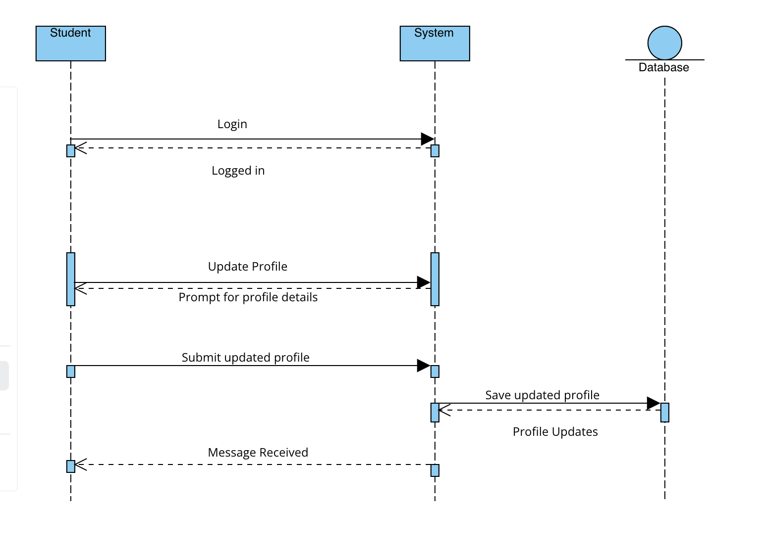

#### 3.8 Update Profile diagram

##### **[SD6] Recommend Internship**

* **Figure 3.9**: Recommendation system to recommend best suited internship for any student based on his/her resume.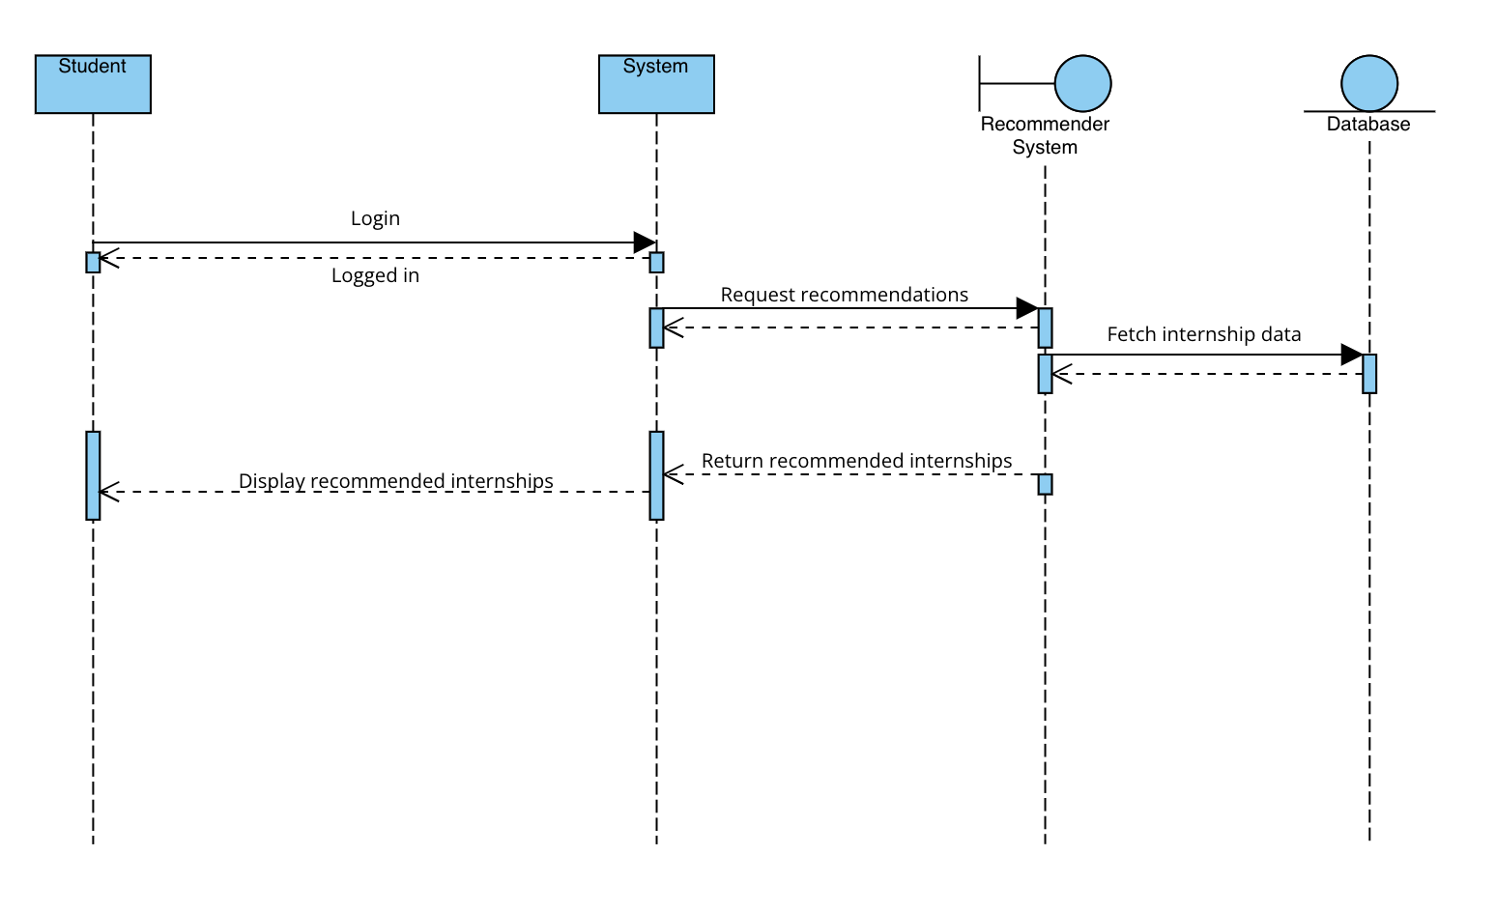

#### 3.9 Recommendation of Internship

##### **[SD7] Scheduling Interview**

* **Figure 3.10**: Sequence diagram for scheduling interviews for selected candidates.

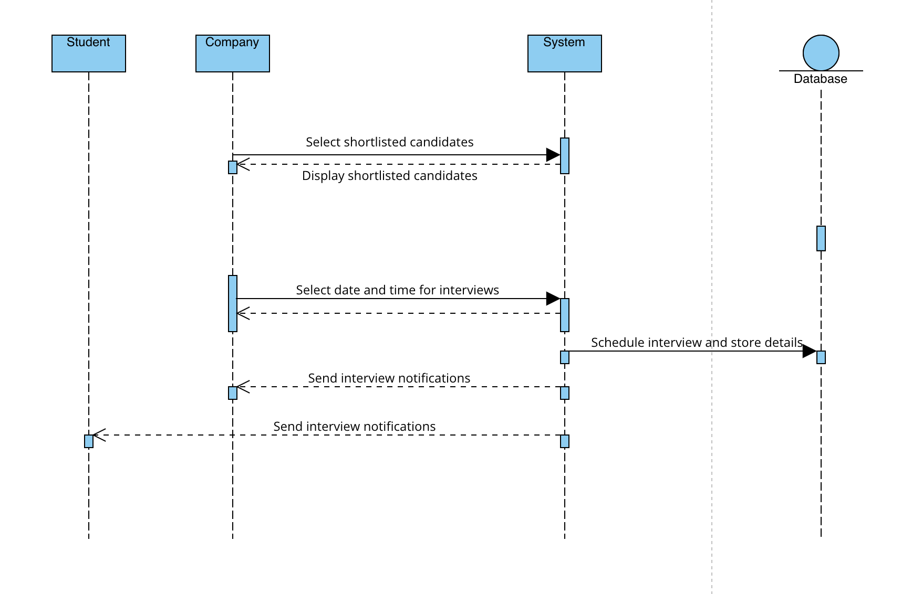

#### 3.10 Scheduling interview diagram

##### **[SD8] Submit Feedback**

* **Figure 3.11**: Sequence diagram for submit feedback, showing feedback and complaints between the company, student, and colleges.

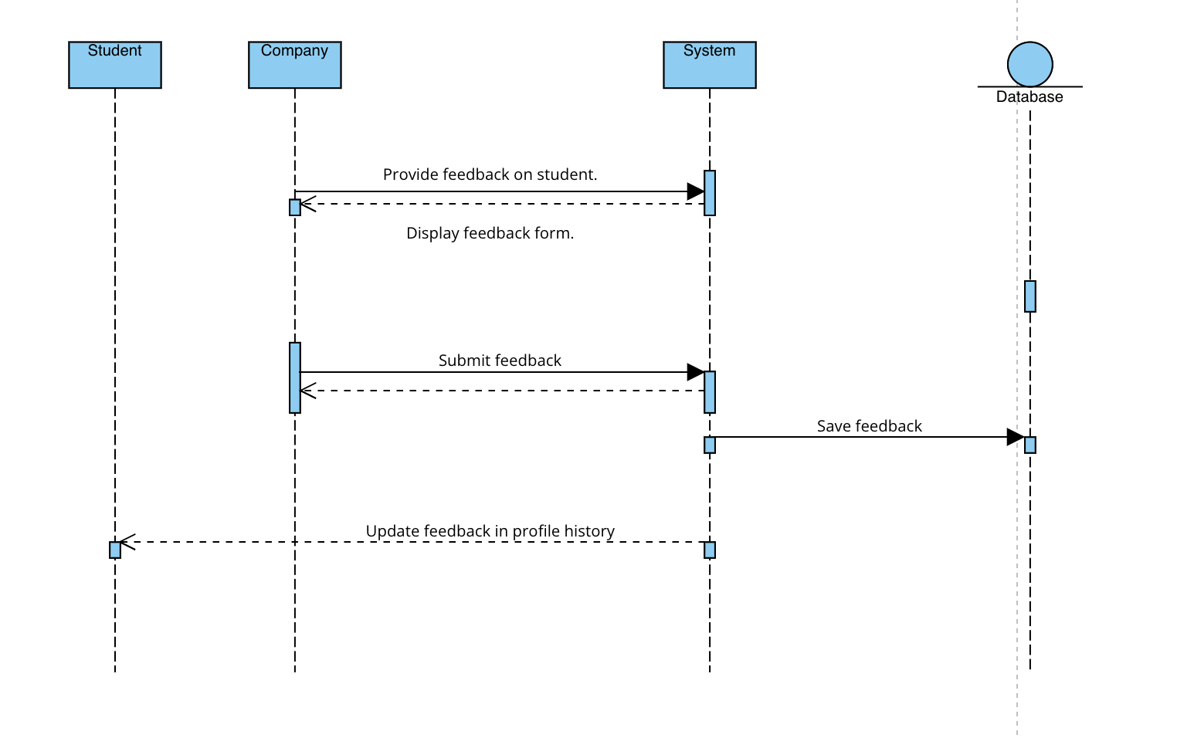

#### 3.11 Submit Feedback diagram

#### **Functional Requirements Mapping**

**[G1] Educators create and manage internships**

* **R1**: The system allows educators to register by providing their personal information (Full Name, etc.), a valid email address, and a password.
* **R2**: The system allows registered educators to log in.
* **R3**: The system allows educators to create, modify, and manage internships, including uploading internship descriptions, skills required, and other necessary details.
* **R4**: The system allows educators to set internship application deadlines, including the start and end dates for internships.
* **R5**: The system allows educators to give or deny permission to colleagues to modify or manage an internship listing.
* **R6**: The system allows educators to define criteria for selecting students for internships (e.g., skills, academic performance).
* **R7**: The system allows educators to review student applications and accept or reject candidates for internships.

**[G2] Students apply for internships and communicate with companies**

* **R1**: The system allows students to register using a Google account.
* **R2**: The system allows registered students to log in.
* **R3**: The system allows students to create and update their profiles, including education details, skills, and past experience.
* **R4**: The system allows students to search and apply for internships based on various filters such as company, location, skills, etc.
* **R5**: The system allows students to create or join teams with other students to apply for internships as a group.
* **R6**: The system sends notifications to students about internship opportunities, application deadlines, and status updates.
* **R7**: The system allows students to communicate directly with companies regarding internship details, requirements, and interviews.
* **R8**: The system tracks the progress of applications and notifies students when they are selected or rejected for an internship.

**[G3] Companies and organizations review and select students for internships**

* **R1**: The system allows companies to create and post internship opportunities.
* **R2**: The system allows companies to specify the qualifications, skills, and responsibilities for the internship.
* **R3**: The system allows companies to review student profiles and applications based on set criteria.
* **R4**: The system allows companies to invite students for interviews and send offers for internship positions.
* **R5**: The system allows companies to track internship application progress and send feedback to students.

#### 

#### **Design Constraints**

**Standards Compliance**

The Students&Companies (S&C) platform complies with the **General Data Protection Regulation (GDPR)** for data privacy and protection, ensuring all user data is handled in accordance with the regulation. Moreover, the platform follows international standards for date and time formats.

**Hardware Limitations**

To properly use the system, users should meet the following hardware requirements:

* Devices must have reliable internet connectivity (3G, 4G, 5G, or Wi-Fi standards such as IEEE 802.11 and IEEE 802.3).
* Devices should be equipped with modern processors (Intel i5 or i7) and at least 8GB of RAM.
* Users should have a screen resolution of at least Full HD for optimal user experience.

#### **Software System Attributes**

**Reliability**

The system must ensure reliable performance with high availability. It should employ replication and consistency measures to avoid system crashes. Regular backups must be performed to ensure the security of user data.

**Availability**

The system should guarantee 99% availability to support educators and students. The platform must be resilient to high traffic, especially during application deadlines, by implementing replication policies to avoid a single point of failure.

**Security**

Security is a priority as the system will handle sensitive user data, including personal information and application materials. The system must employ encryption for passwords and sensitive data storage. It should also have robust protection against cyber threats to maintain data integrity, confidentiality, and availability.

**Maintainability**

The system's code should be well-documented and easy to maintain. Automated testing routines must cover at least 75% of the system's core functionalities, excluding the UI code. This ensures that new features can be added and bugs can be addressed efficiently.

**Portability**

The platform is a web-based application that must be compatible with various browsers (such as Google Chrome, Firefox) and devices (smartphones, tablets, and desktops) to ensure accessibility to all users.

#### **Performance Requirements**

The system must deliver quick response times to ensure a smooth user experience, with a target response time of less than one second. The platform must be scalable to accommodate a large number of simultaneous users, especially during peak periods such as application deadlines.

**4 | Formal Analysis Using Alloy**

| **open util/ordering[Time] enum TruthValue { True, False } sig Time {}  abstract sig User {  first_name: one String,  last_name: lone String,  email: one String,  password: one String,  country_code: lone String,  phone_number: lone String,  is_active: one TruthValue,  is_staff: one TruthValue,  date_joined: one Time,  user_type: one UserType,  parent: lone User // A lone User relation (parent-child relation) }  enum UserType { student, company, university }  // Ensure emails are unique across all users fact UniqueEmails {  all u1, u2: User | u1 != u2 implies u1.email != u2.email }  // Student Signature sig Student extends User {  university: one String,  cv: lone String,  recommendations: set Internship }  // Company Signature sig Company extends User {  company_name: one String,  description: lone String }  // University Signature (added to represent the university in hierarchy) sig University extends User {  university_name: one String }  // Internship Signature sig Internship {  company: one Company,  title: one String,  description: lone String,  skills_required: lone String,  is_paid: one TruthValue,  start_date: one Time,  end_date: one Time,  ongoing_status: one TruthValue }  // Ensure internship dates are consistent fact InternshipDates {  all i: Internship | i.start_date != i.end_date  all i: Internship | i.start_date in Time and i.end_date in Time }  // Application Signature sig Application {  student: one Student,  internship: one Internship,  date_applied: one Time,  status: one ApplicationStatus }  enum ApplicationStatus { applied, under_review, accepted, rejected }  // Feedback Signature sig Feedback {  user: one User,  message: one String,  date_submitted: one Time,  resolved: one TruthValue }  // Complaint Signature sig Complaint {  user: one User,  message: one String,  status: one ComplaintStatus,  date_submitted: one Time,  resolution_date: lone Time }  enum ComplaintStatus { submitted, in_progress, resolved }  // Interview Signature sig Interview {  company: one Company,  student: one Student,  internship: one Internship,  scheduled_time: one Time,  status: one InterviewStatus }  enum InterviewStatus { pending, completed, canceled }  // User Activity States fact UserActivity {  all u: User | u.is_active = False implies u.is_staff = False }  // Hierarchical Constraints (Corrected) fact UserHierarchy {  // A student must have a university as their parent (indirect hierarchy via university)  all s: Student | (s.parent = none or s.parent in University)   // A company can be independent (no parent constraint)  all c: Company | c.parent = none   // A university can be independent, but may have students under it  all u: University | (u.parent = none or u.parent in University) }** |
| --- |

**4 | Effort Spent**

In this part there is an overview of the time effort spent by each member of this team. Everyone has spent some time writing each section of this document and here it is visible the amount of time.

* Student 1

| **chapter** | **Effort(In hours)** |
| --- | --- |
| 1 | 10 |
| 2 | 10 |
| 3 | 10 |
| 4 | 5 |

* Student 2

| **chapter** | **Effort(In hours)** |
| --- | --- |
| 1 | 10 |
| 2 | 10 |
| 3 | 10 |
| 4 | 10 |

* Student 3

| **chapter** | **Effort(In hours)** |
| --- | --- |
| 1 | 10 |
| 2 | 15 |
| 3 | 10 |
| 4 | 8 |

**4 | Bibliography**

[1] **Unified Modeling Language (UML) - Object Management Group (OMG).** (2024). *UML 2.5 Superstructure Specification.*URL: https://www.omg.org/spec/UML/2.5/

* Provides official specifications for UML, including use case diagrams, class diagrams, sequence diagrams, and more, which are essential for documenting the S&C system.

**[2]Alloy Analyzer - The Alloy Modeling Language.** (2024). *Alloy Modeling Language and Analyzer.*URL:<https://alloytools.org/>

* Offers resources and documentation on the Alloy language, which can be used for formal verification of systems like S&C.

[3]**Visual Paradigm.** (2024). *Visual Paradigm UML Tool.*URL:<https://www.visual-paradigm.com/>

* A UML tool that can be used to create the various diagrams (use case, class, sequence, etc.) for the S&C platform.

**5 | List of Figures**

Figure-2.1- Domain class diagram

Figure-2.2- State diagram-Internship selection

Figure-2.3-State diagram-Internship posting

Figure-3.1-Home Screen UI

Figure-3.2-Login Screen

Figure-3.3-Use Case Diagram

Figure-3.4-Student Registration Sequence diagram

Figure-3.5-Student Registration Sequence diagram

Figure-3.6-Internship Posting

Figure-3.7-Shortlisting candidates diagram

Figure-3.8-Update Profile diagram

Figure-3.9-Recommendation for Internship

Figure-3.10-Scheduling interview diagram

Figure-3.11-Submit Feedback diagram

**4 | List of Tables**