

**SOFTWARE ENGINEERING-II**

**COMPUTER SCIENCE AND ENGINEERING**

**Requirement Analysis and Specification Document**

**StudentXCompanies**

**Authors**

Shaurya Aditya Singh

Ergun Gani Çalışkan

Mohammadali Khaledi

**Academic year**

**2024-25**

**Deliverable: RASD  
Title: Requirements Analysis Specification Document**

**Authors:**

**Shaurya Aditya Singh**

**Ergun Gani Çalışkan**

**Mohammadali Khaledi**

**Version: 3.0  
Date: 01-February-2024**

**Download page:  
Copyright: Copyright © 2024,**

**– All rights reserved**

# 

Contents

**Introduction**

1.1 Purpose .................................................. 5

  1.1.1 Goals ................................................ 5

1.2 Scope .................................................... 5

  1.2.1 World Phenomena .................................... 5

  1.2.2 Shared Phenomena ................................... 6

1.3 Definitions, Acronyms, Abbreviations ...................... 6

  1.3.1 Definitions ........................................ 6

  1.3.2 Acronyms ........................................... 6

  1.3.3 Abbreviations ...................................... 6

1.4 Revision History .......................................... 6

1.5 Reference Documents ....................................... 6

1.6 Document Structure ........................................ 7

**Overall Description**

2.1 Product Perspective ....................................... 8

  2.1.1 Scenarios .......................................... 8

  2.1.2 Domain Class Diagram ............................... 8

  2.1.3 State Diagrams ..................................... 9

2.2 Product Functions ......................................... 10

2.3 User Characteristics ...................................... 11

  2.3.1 Student ............................................ 11

  2.3.2 Educator ........................................... 11

2.4 Assumptions, Dependencies, and Constraints ............... 11

  2.4.1 Regulatory Policies ................................ 11

  2.4.2 Domain Assumptions ................................ 12

**Specific Requirements**

3.1 External Interface Requirements .......................... 13

  3.1.1 User Interfaces ................................... 14

  3.1.2 Hardware Interfaces ............................... 15

  3.1.3 Software Interfaces ............................... 16

  3.1.4 Communication Interfaces .......................... 16

3.2 Functional Requirements ................................... 16

  3.2.1 Use Cases Diagram .................................. 16

  3.2.2 Use Cases .......................................... 18

  3.2.3 Sequence Diagrams .................................. 19

  3.2.4 Requirement Mapping ................................ 25

3.3 Performance Requirements .................................. 26

3.4 Design Constraints ........................................ 27

  3.4.1 Standards Compliance ............................... 27

  3.4.2 Hardware Limitations ............................... 27

  3.4.3 Other Constraints .................................. 27

3.5 Software System Attributes ................................ 27

  3.5.1 Reliability ........................................ 28

  3.5.2 Availability ....................................... 28

  3.5.3 Security ........................................... 28

  3.5.4 Maintainability .................................... 28

  3.5.5 Portability ........................................ 28

**Formal Analysis Using Alloy**

4.1 Examples .................................................. 29

**Effort Spent** .............................................. 32

**Bibliography** ................................................. 33

**List of Figures** .............................................. 34

**List of Tables** ............................................... 35

**1| Introduction**

##### **Purpose**

As the demand for skilled professionals grows, internships have become a crucial bridge between academic learning and real-world experience. However, the process of matching students to the right internship opportunities often lacks efficiency and personalization. The **Students & Companies (S&C)** platform is designed as a comprehensive web-based application that transforms how students connect with internship opportunities. Unlike traditional job boards, S&C utilizes advanced AI-powered matching that goes beyond keyword analysis to understand the nuances of student skills, academic backgrounds, and career aspirations. This ensures that students are matched with opportunities that genuinely align with their goals and that companies find candidates who are both qualified and a good fit for their culture. S&C is not just about matching; it's about creating a holistic internship experience by providing:

* Personalized learning paths that recommend specific courses and projects to prepare students for target internships.
* Transparent feedback loops that allow students and companies to rate and review their experiences, enhancing accountability and facilitating better matches over time.
* A focus on academic relevance through direct integration with university systems and syllabus information to ensure that internships align with a student's area of study.

The goal of the S&C platform is to streamline all internship-related activities into a single, user-friendly platform. By providing a single place to create profiles, browse opportunities, apply for positions, track applications, communicate with companies, and give feedback, S&C aims to improve the overall internship experience for both students and companies.

**Goals**

[G1] Enables students to create detailed profiles that include their academic background, skills, interests, and uploaded CVs, while also linking their profile with the university syllabus.

[G2] Empower companies to post detailed internship descriptions with clearly defined requirements and timelines, and also provide feedback on interns.

[G3] Facilitate the matching of students and internships using an intelligent recommendation system that analyzes student skills, academic records, and career aspirations to identify relevant opportunities.

[G4] Ensure a transparent and seamless internship process by facilitating application tracking, feedback sharing, and efficient communication between students and companies.

**Scope**

The **S&C** platform focuses on connecting two primary user groups:

* **Students:** Students can create comprehensive profiles, upload their CVs, and receive personalized internship recommendations based on the university syllabus. They can apply for internships, track their application status, and receive feedback from companies. This is a one-stop platform for students to manage all aspects of their internship search.
* **Companies:** Companies can create profiles showcasing their organization and post detailed internship opportunities. They can also manage applications, communicate with applicants, and provide feedback on interns. This is a one-stop platform for companies to manage all their internship programs.

The platform also incorporates a recommendation system that analyzes student profiles, skills, and university syllabus information to suggest suitable internships, improving the efficiency and relevance of matches.

**World Phenomena (World Controlled):**

**[WP1]** Students create profiles, upload CVs, and list their skills, which also includes the university syllabus.

**[WP2]** Companies create internship postings with required skills and other details, and can leave feedback on students.

**[WP3]** Students apply to internships and track their application progress.

**[WP4]** Companies review applications and provide feedback on interns.

**Shared Phenomena (Machine Controlled):**

**[SP1]** The system recommends internships to students based on their profiles, CVs, and university syllabus information.

**[SP2]** The system notifies students and companies about application updates.

**[SP3]** The system tracks applications and provides status updates to both students and companies.

##### **Definitions, Acronyms, and Abbreviations**

**Definitions**

* **Recommendation System**: A machine learning system that matches students and internships based on their profiles and CVs.
* **CV (Curriculum Vitae)**: A document summarizing a student’s academic background, skills, and experiences.
* **Internship Post**: A job description posted by a company detailing the internship opportunity.

**Acronyms**

* S&C: Students & Companies
* UI: User Interface

**Abbreviations**

* G*: Goal
* WP*: World Phenomena
* SP*: Shared Phenomena

##### **Revision History**

* **Version 1.0** (03/12/2024): Initial draft of the document.
* **Version 2.0** (15/12/2024): Added detailed user interface design and formal requirements.
* **Version 3.0** (1/2/2024): Added important features and requirements.

##### **Reference Documents**

* The specification of the RASD and DD assignment of the **Software Engineering II** course, A.Y. 2024/25.
* Slides and lectures of the course available on WeBeep.

##### **Document Structure**

1. **Introduction**: Provides a brief description of the project, including its purpose, goals, and scope.
2. **Overall Description**: Explains the high-level functioning of the system, detailing world and machine-controlled phenomena.
3. **Specific Requirements**: Analyzes the functional and non-functional requirements of the platform.
4. **Formal Analysis**: Includes a formal description of the phenomena using tools like Alloy.
5. **Effort Spent**: Records the time and resources utilized to create this document.
6. **References**: Lists any materials referenced during the creation of this document.

**2| Overall Description**

#### **Product Perspective**

The S&C platform is designed to facilitate seamless interaction between students seeking internships and companies offering opportunities. It acts as a bridge where both parties can find, connect, and engage based on mutual requirements and compatibility.

#### **Scenarios**

**1. Company Posts an Internship** Company A wants to post a new internship. After logging into the S&C platform with their credentials, they navigate to the "Post New Internship" section. They fill out a form specifying the internship title, required qualifications, job description, application deadline, and other relevant details. The internship posting becomes visible to students once approved by the platform moderators.

**2. Company Reviews Applicants** Company B, having posted an internship, receives applications from several students. The HR representative logs in and navigates to the "My Postings" section, selects the specific internship, and accesses a dashboard displaying the profiles of all applicants. From here, they can review resumes, and portfolios, and shortlist candidates for interviews.

**3. Student Creates a Profile** Student C, who has recently joined the platform, fills out their profile by providing personal details, academic history, skills, and portfolio links. The platform verifies the information and enables the profile for searches by companies.

**4. Student Applies for an Internship** Student D, browsing the platform, comes across an internship that aligns with their interests and qualifications. They review the job description, click "Apply," and attach a personalized cover letter and resume. The platform confirms the submission and updates the application status in their dashboard.

**5. Company Invites a Student for an Interview** Company E identifies a promising candidate, Student F, from the pool of applicants. They send an interview invitation through the platform. Student F receives an email notification and sees the invite on their dashboard, which contains the interview details and allows them to accept or reschedule.

**6. Internship Completion and Feedback** After completing an internship, the platform allows companies to provide feedback and ratings for students. Similarly, students can rate their experience with the company. This feedback helps maintain transparency and improve platform services.

**7. Generating Recommendations for Students and Companies** The platform uses AI to recommend internships to students based on their profiles and preferences. Similarly, it suggests suitable candidates to companies based on job requirements and prior intern performance metrics.

**8. University administrator creating a profile with coursework details**

An additional scenario for the Student&Companies (S&C) platform involves a university administrator creating a profile with coursework details. The administrator logs in, navigates to the "University Profile" section, and completes the university profile form, including the university's name, location, description, and contact information. A section detailing relevant coursework is added, which includes course titles, descriptions, and key skills. Specific skills acquired by students for each course are tagged.

The administrator saves the university profile and the system verifies the data. This coursework information is then used in the recommendation process, where the system identifies universities offering courses that align with the skills a company seeks, boosting the visibility of students from those universities and highlighting students who have taken relevant coursework.

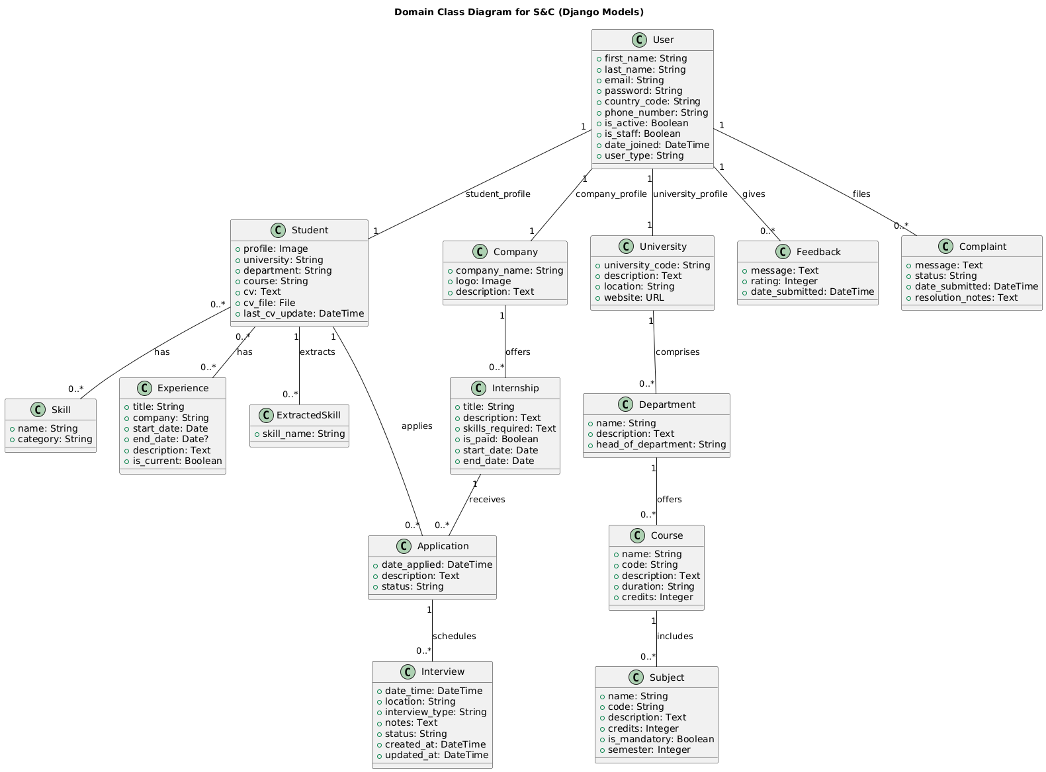

#### **2.1 Domain class diagram**

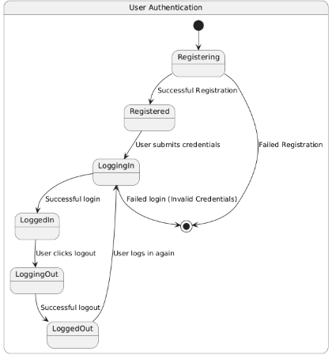

#### **2.2. State diagram-Authentication**

#### 

#### 

#### **2.3 State diagram-Internship**

#### **Product Functions**

**Sign Up and Log In**

The platform allows both students and companies to register and log in. Students create profiles showcasing their qualifications and interests. Companies create organizational profiles to post internships and view applicants.

**Internship Management**

Companies can post, edit, and manage internship opportunities. They can define requirements, deadlines, and desired qualifications, and access an applicant management dashboard.

**Application Tracking**

Students can track the status of their applications and receive notifications for updates. Companies can manage applicant shortlists and maintain organized records of communication with candidates.

**AI-Based Matching**

The platform employs AI to match students with internships based on skills, preferences, and historical data. It also provides recommendations for companies to identify the best candidates for their roles.

**Feedback and Ratings**

The platform facilitates mutual feedback between students and companies post-internship, contributing to a transparent ecosystem.

**Interview Scheduling**

Companies can schedule interviews directly through the platform, integrating with calendar tools for better time management. Students receive interview invitations and can confirm or reschedule as needed.

**Internship Completion & Verification:**

Upon completion of an internship, companies can verify the student’s participation, providing a completion certificate. Students can add this to their profiles, enhancing their professional credentials.

#### 

#### 

#### **User Characteristics**

**Students**

Students can build comprehensive profiles, search for internships, apply to relevant opportunities, and track their progress. They can also showcase certifications, projects, and portfolio work to improve visibility. The platform supports skill assessments and AI-driven resume suggestions to enhance their applications.

**Companies**

Companies use the platform to post internship opportunities, review applications, shortlist candidates, and provide feedback. They can also access metrics and analytics to refine their hiring process. Additionally, companies can set up employer branding pages, showcasing their work culture, past interns' success stories, and benefits of joining their organization.

**Universities**

Universities can partner with the platform to monitor student internship activities, ensuring compliance with academic requirements. They can access reports on student participation, industry engagement, and performance, aiding curriculum development and career support services.

#### **Assumptions, Dependencies, and Constraints**

**Regulatory Policies** The platform processes personal data in compliance with GDPR regulations. Companies and students must consent to data use policies during registration.

**Domain Assumptions**

* [D1] Users have a reliable internet connection.
* [D2] Students accurately fill out their profiles with genuine information.
* [D3] Companies provide clear and concise internship details.
* [D4] Notifications for application updates and other activities are timely.
* [D5] Feedback provided by both parties is constructive and honest.

**3 | Specific Requirements**

#### **External Interface Requirements**

##### **User Interfaces**

The **Students & Companies (S&C)** platform supports two primary types of users: **Students** and **Companies**. Each user group has a distinct interface tailored to their specific needs and actions within the platform.

* **Student Interface:**
  + Ability to create a profile, fill out personal details, and specify academic interests.
  + Ability to search for internship opportunities based on skills, location, and preferences.
  + Ability to apply for internships and track application statuses.
  + Dashboard showing the student’s applications, upcoming deadlines, and feedback from companies.
  + Ability to modify and update personal details and application information.
* **Company Interface:**
  + Ability to create a company profile and specify available internships.
  + Ability to list internship opportunities, including descriptions, required skills, deadlines, and application procedures.
  + Ability to review student applications, shortlist candidates, and communicate with them.
  + Dashboard showing incoming applications, candidate status, and feedback tools.
  + Ability to update internship status (open, closed, filled) and manage the recruitment process.

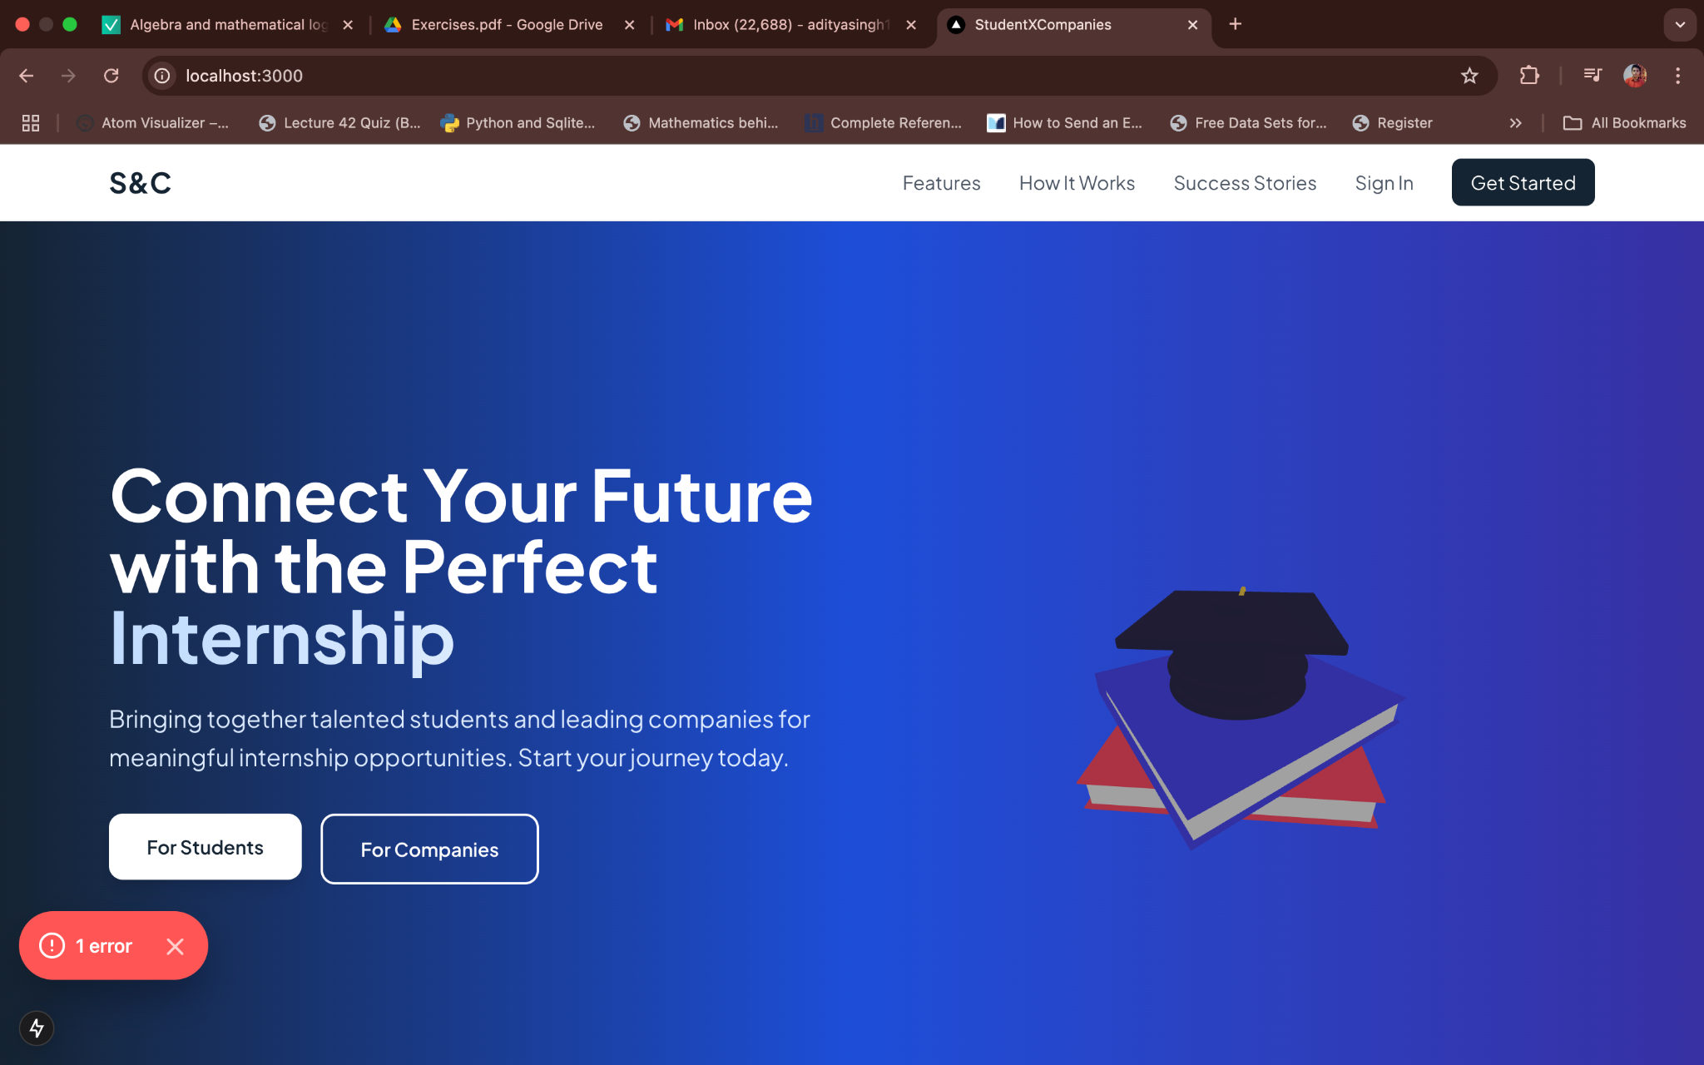

Figure 3.1- Home Screen UI

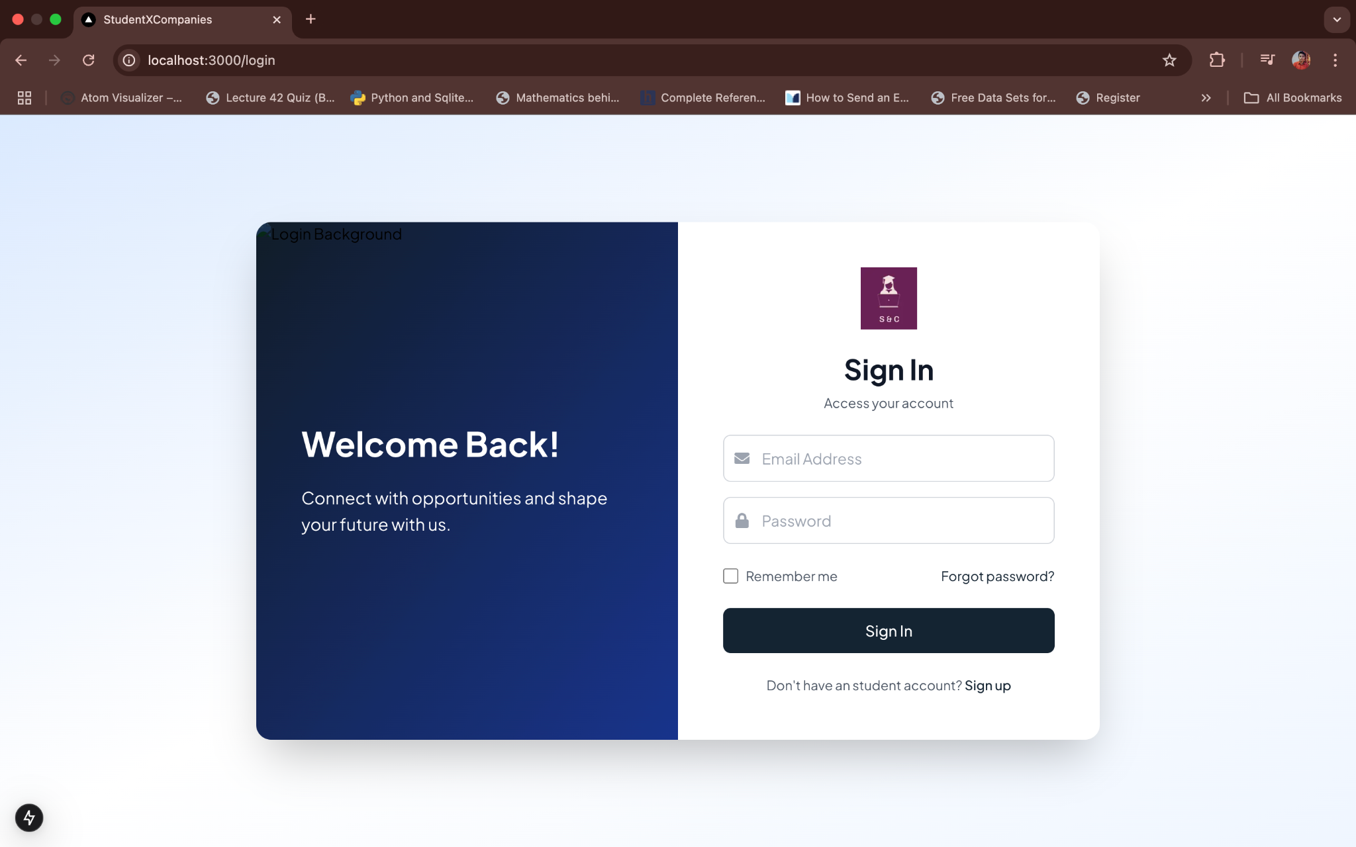

Figure 3.2- Login Screen

Figure 3.3- Student Profile Page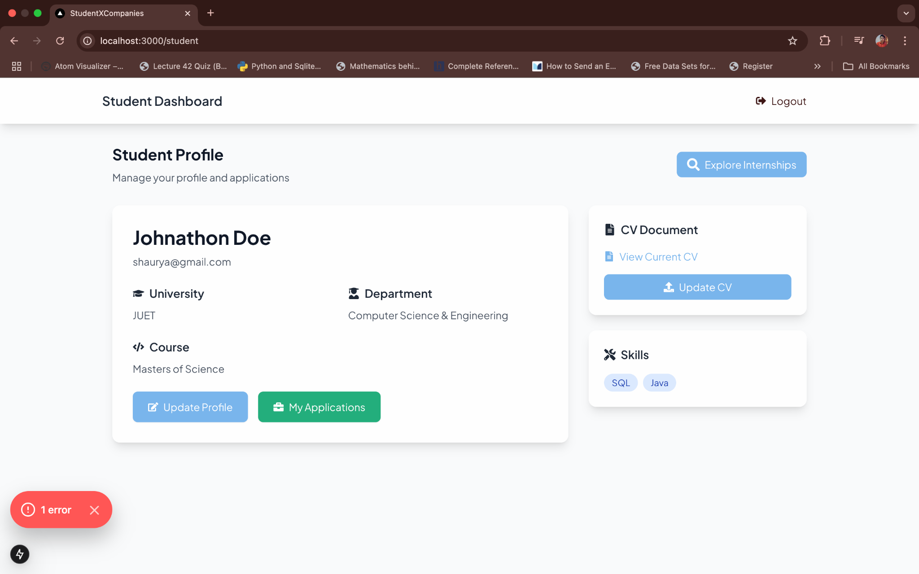

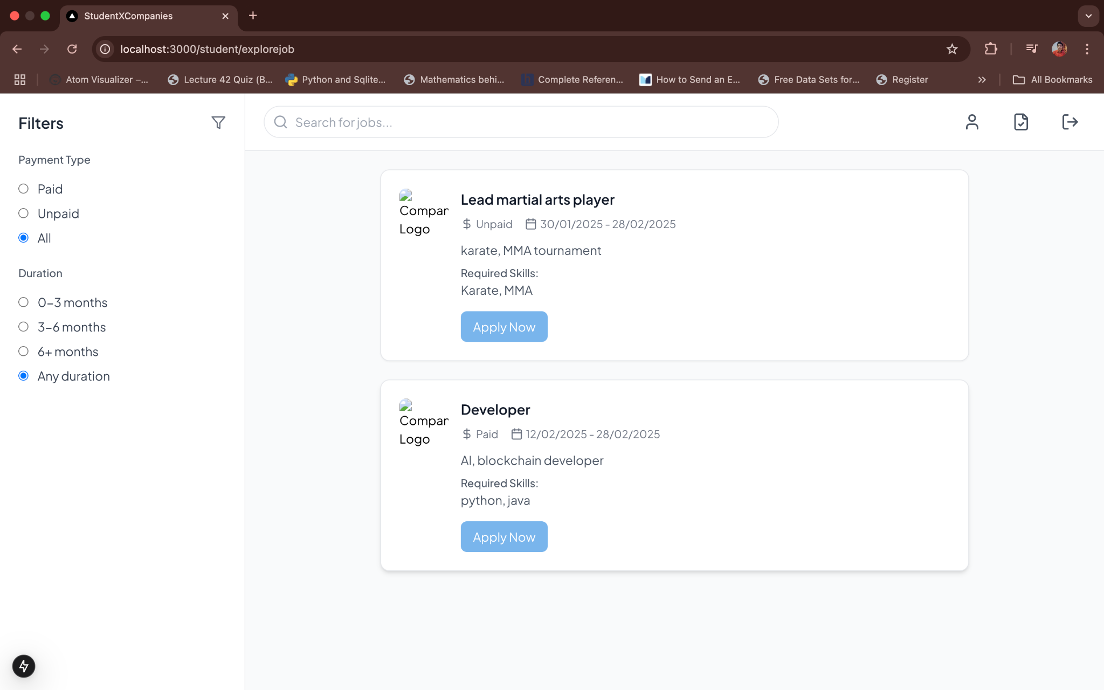

Figure 3.4- Student Explore Page

Figure 3.5- Student Applied internship Page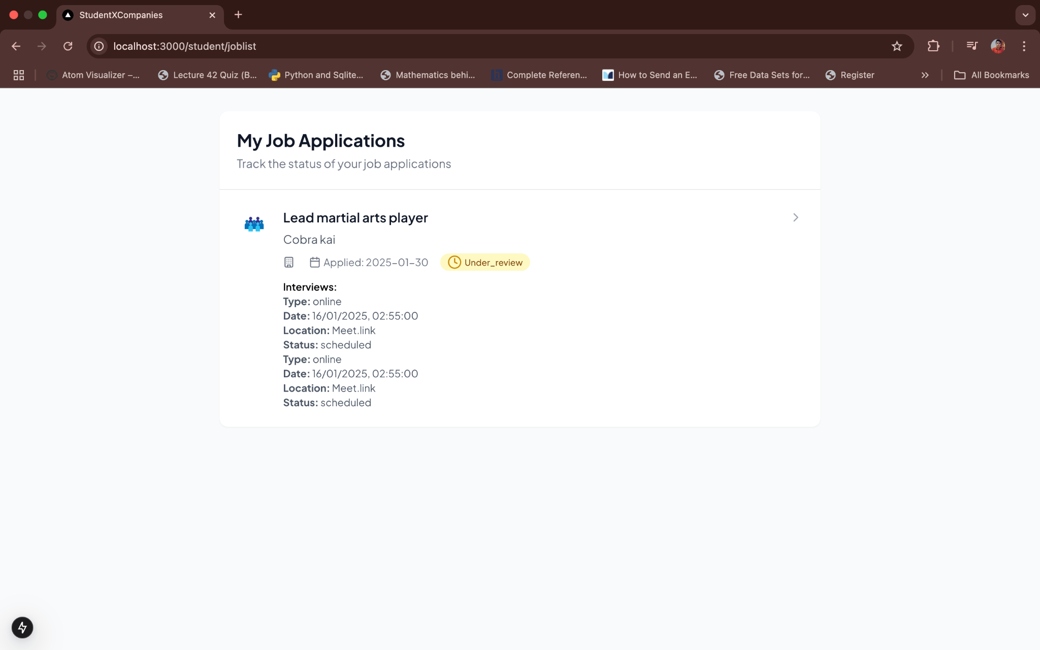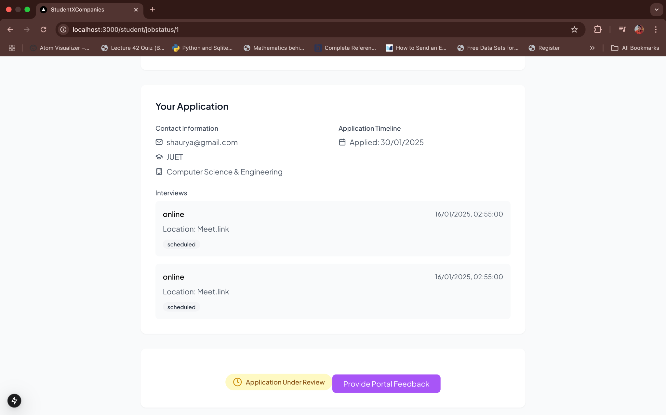

Figure 3.6- Student internship Status Page

##### **Hardware Interfaces**

The platform is designed to be a **web-based application**, meaning there are no specific hardware requirements beyond a device that supports a modern web browser (laptop, desktop, or mobile device).

##### **Software Interfaces**

The platform will integrate with the following:

* **Email Service**: For sending application status updates, reminders, and communication between students and companies.
* **Document Management System**: For storing and sharing resumes, cover letters, and other application materials.

##### **Communication Interfaces**

The platform uses **HTTP/HTTPS** for secure communication between users and the backend system, ensuring all data transactions are encrypted and protected. It will also integrate with external job boards and academic portals to pull in relevant internship opportunities and student data when necessary.

#### **Functional Requirements**

##### **Account Creation and Management**

* **[R1]** The system allows students to register using their email and academic information.
* **[R2]** The system allows companies to register and create internship opportunities.
* **[R3]** Students can log in to the platform to view internship listings, apply for internships, and track application progress.
* **[R4]** Companies can log in to manage internship postings and review student applications.
* **[R5]** Universities can register and create institutional profiles to monitor student internship activities.

##### **Internship Search and Application Process**

* **[R6]** Students can search for internships based on filters like skill requirements, location, and duration.
* **[R7]** Students can apply to multiple internships by submitting their resume, cover letter, and any required documents.
* **[R8]** Companies can view applications, filter candidates, and shortlist students for interviews.

##### **Internship Posting and Management**

* **[R9]** Companies can create internship listings with required qualifications, internship duration, location, and application deadline.
* **[R10]** Companies can update internship listings, change the status (open, closed, filled), and remove listings if necessary.

##### **Communication and Notifications**

* **[R11]** The system sends notifications to students about the status of their applications (shortlisted, rejected, interview scheduled, etc.).
* **[R12]** Students receive reminders about application deadlines and upcoming interviews.
* **[R13]** Companies can send interview invites or requests for additional information to shortlisted candidates.

##### **Student Profile Management**

* **[R14]** Students can update their profiles, including personal details, resume, and academic information.
* **[R15]** The system tracks students' application history and feedback from companies, providing a complete view of each student's activities.
* **[R16]** Universities can access and review student internship records to assess program effectiveness.

##### **Company Profile and Application Review**

* **[R16]** Companies can create and manage their profile, listing information such as industry, size, and available internship programs.
* **[R17]** Companies can review student profiles, view resumes, and provide feedback or rejection notices.
* **[R18]** Companies can track which internships are still open and how many applications have been received for each.
* **[R19]** Universities can view aggregated internship data to improve career services and partnerships with companies.

#### **Use Cases**

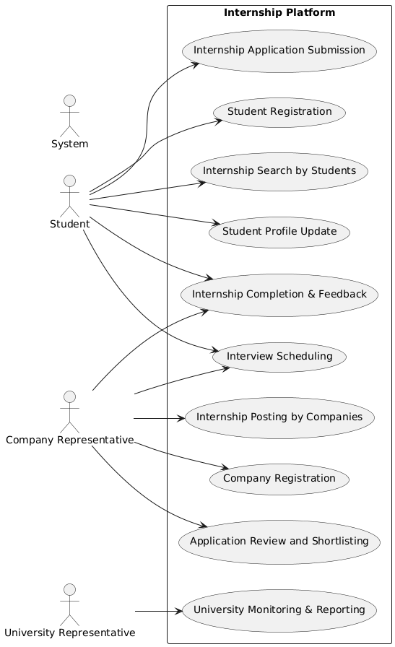

#### 3.7 Use Case diagram

#### 

**[UC1] Student Registration** **Actors:** Student, System  
 **Entry Condition:** The student accesses the platform for the first time.  
 **Event Flow:**

1. The student clicks on the "Register" button.
2. The system prompts the student to enter personal details and academic information.
3. The student submits the registration form.
4. The system verifies the data and creates a student profile.
5. The student is redirected to the login page.

**[UC2] Company Registration** **Actors:** Company Representative, System  
 **Entry Condition:** The company representative accesses the platform for the first time.  
 **Event Flow:**

1. The representative clicks on "Register" and selects "Company" as the account type.
2. The system prompts for company details and administrator contact information.
3. The representative submits the form.
4. The system verifies the data and creates a company profile.
5. The company representative is redirected to the login page.

**[UC3] Internship Application Submission** **Actors:** Student, System  
 **Entry Condition:** The student finds an internship listing and decides to apply.  
 **Event Flow:**

1. The student selects an internship and clicks "Apply."
2. The system prompts the student to upload required documents.
3. The student submits the application.
4. The system confirms submission and notifies the company.

**[UC4] Application Review and Shortlisting** **Actors:** Company Representative, System  
 **Entry Condition:** The company has received internship applications.  
 **Event Flow:**

1. The company logs in and navigates to the applications dashboard.
2. The system displays a list of received applications.
3. The company reviews resumes and other submitted documents.
4. The company shortlists candidates for interviews.
5. The system notifies shortlisted candidates.

**[UC5] Interview Scheduling** **Actors:** Company Representative, Student, System  
 **Entry Condition:** The company has shortlisted candidates for an internship.  
 **Event Flow:**

1. The company selects a candidate and initiates an interview request.
2. The system prompts the company to select an available date and time.
3. The student receives a notification about the interview request.
4. The student confirms or requests rescheduling.
5. The system updates the interview schedule accordingly.

**[UC6] Internship Completion & Feedback** **Actors:** Student, Company Representative, System  
 **Entry Condition:** The student has completed the internship.  
 **Event Flow:**

1. The company verifies that the student has completed the internship.
2. The company provides feedback and, if applicable, a completion certificate.
3. The system updates the student’s profile with the completion details.
4. The student submits feedback about the internship experience.
5. The system stores the feedback for analytics and transparency.

**[UC7] University Monitoring & Reporting** **Actors:** University Representative, System  
 **Entry Condition:** Universities want to track student internship activities.  
 **Event Flow:**

1. The university logs into the platform and accesses student internship records.
2. The system generates reports on student participation and industry engagement.
3. The university reviews the data and identifies trends.
4. The university provides feedback to improve future internship programs.

**[UC8] Student Profile Update** **Actors:** Student, System  
 **Entry Condition:** The student wants to update their profile.  
 **Event Flow:**

1. The student logs into their account and navigates to the profile section.
2. The system displays the existing profile information.
3. The student updates academic details, skills, or uploaded documents.
4. The student submits the changes.
5. The system verifies and saves the updated profile information.

**[UC9] Internship Posting by Companies** **Actors:** Company Representative, System  
 **Entry Condition:** The company wants to post a new internship.  
 **Event Flow:**

1. The company logs into the platform and selects "Post Internship."
2. The system prompts for details such as job description, qualifications, and duration.
3. The company submits the internship listing.
4. The system verifies the listing and makes it visible to students.

**[UC10] Internship Search by Students** **Actors:** Student, System  
 **Entry Condition:** The student wants to find internship opportunities.  
 **Event Flow:**

1. The student logs in and accesses the internship search feature.
2. The system provides filtering options such as location, skills, and company.
3. The student applies search filters and browses the available internships.
4. The student selects an internship for further details.
5. The system displays comprehensive internship information.

#### 

#### **Sequence Diagrams**

##### **[SD1] Student Registration**

* **Figure 3.8**: Sequence diagram for student registration, showing interactions between the student, the system, and the database for profile creation.

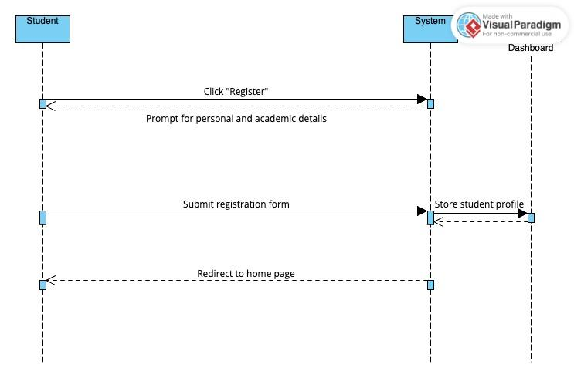

#### 3.8 Student Registration Sequence diagram

##### **[SD2] Internship Application**

* **Figure 3.9**: Sequence diagram for internship application, illustrating interactions between the student, the internship listing, and the company.

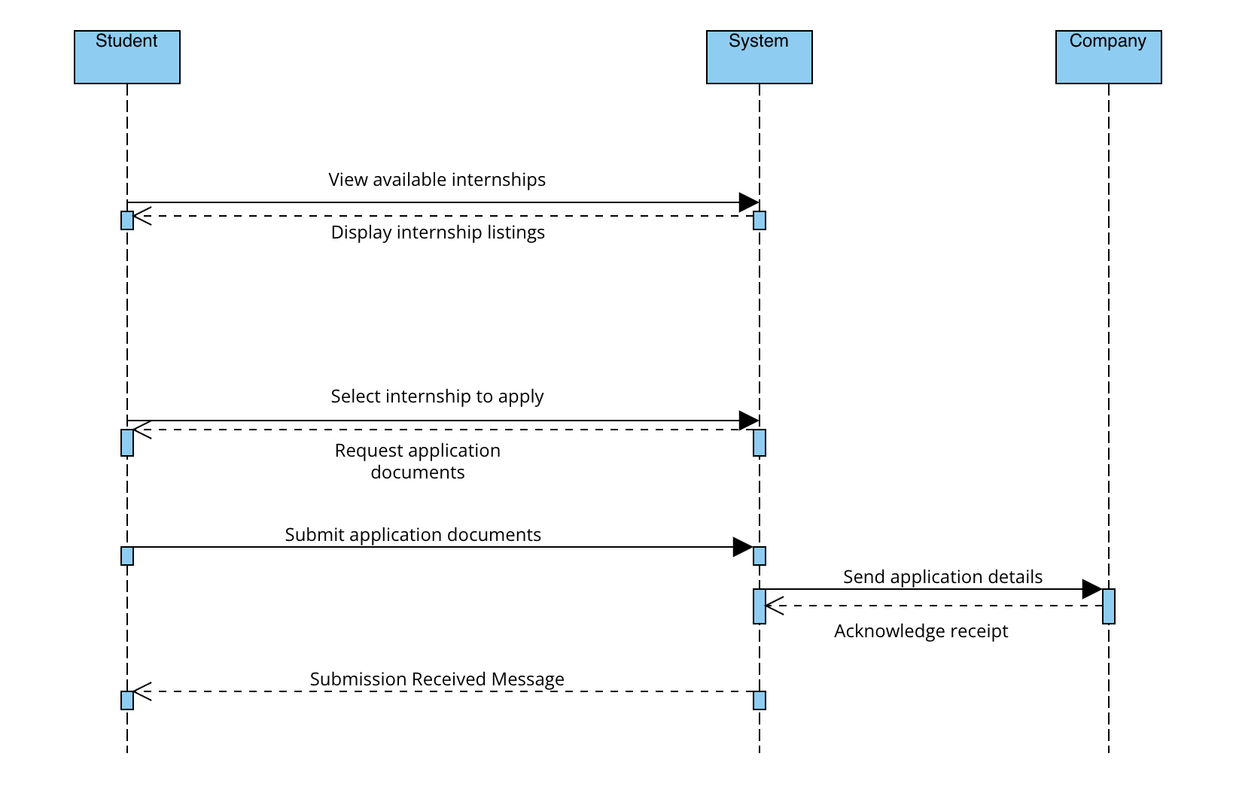

#### 3.9. Internship Sequence diagram

##### **[SD3] Internship Posting**

##### **Figure 3.10**: Sequence diagram for internship posting by the company

#### 3.10. Internship Posting

##### **[SD4] Shortlisting Candidates**

* **Figure 3.11**: Sequence diagram for candidate shortlisting, showing interactions between the company, applications, and notifications.

### 

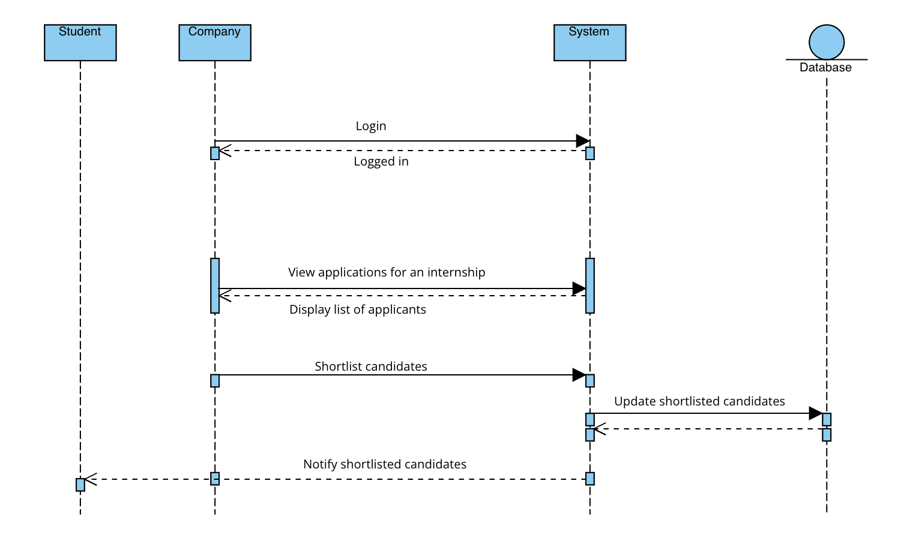

#### 3.11. Shortlisting candidates diagram

##### 

##### 

##### 

##### 

##### 

##### 

##### 

##### 

##### 

##### **[SD5] Updating Profile**

* **Figure 3.12**: Sequence diagram for profile update for any type of user.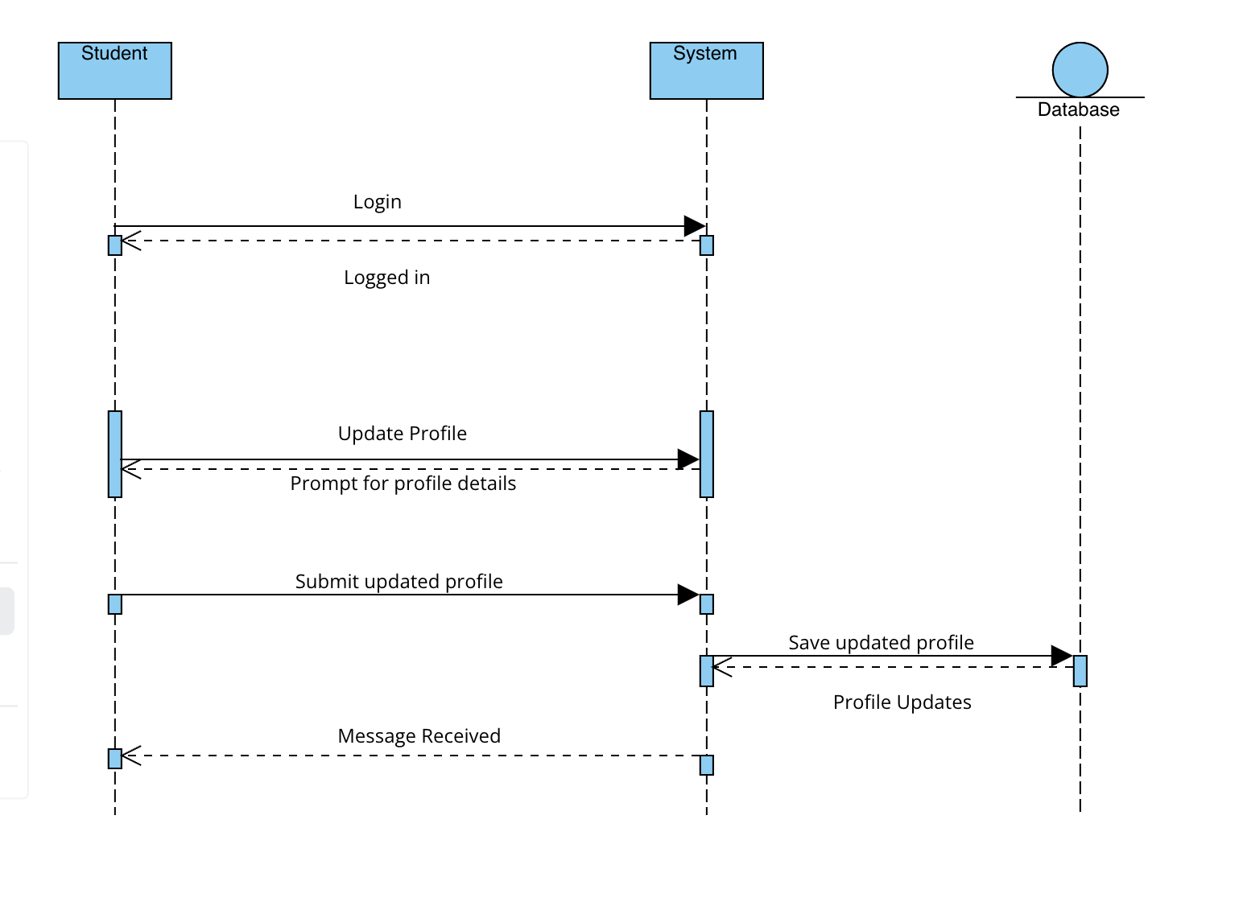

#### 3.12 Update Profile diagram

##### **[SD6] Recommend Internship**

* **Figure 3.13**: Recommendation system to recommend best suited internship for any student based on his/her resume.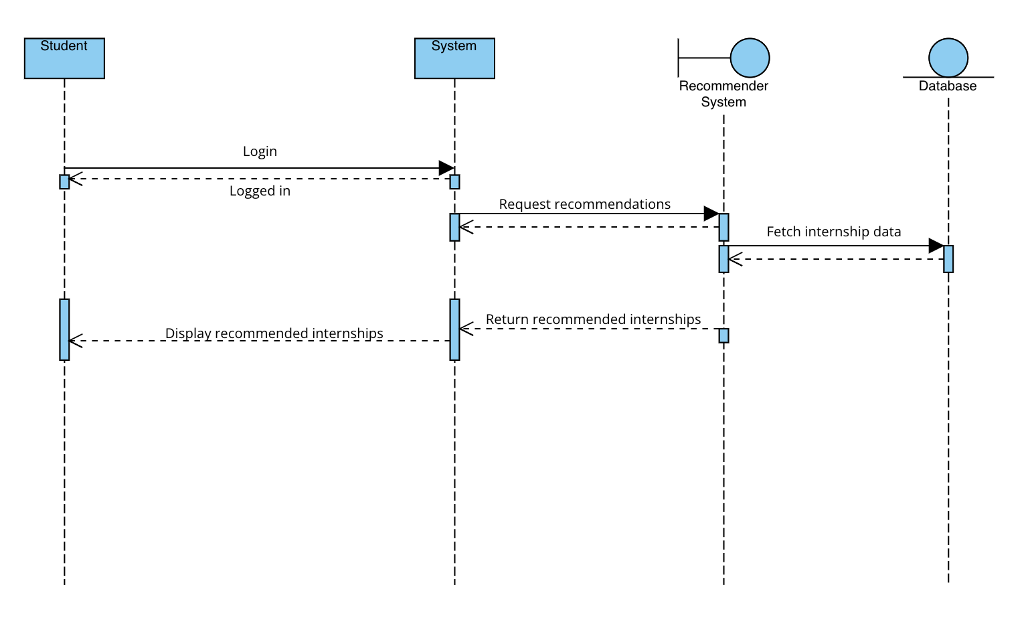

#### 3.13 Recommendation of Internship

##### **[SD7] Scheduling Interview**

* **Figure 3.14**: Sequence diagram for scheduling interviews for selected candidates.

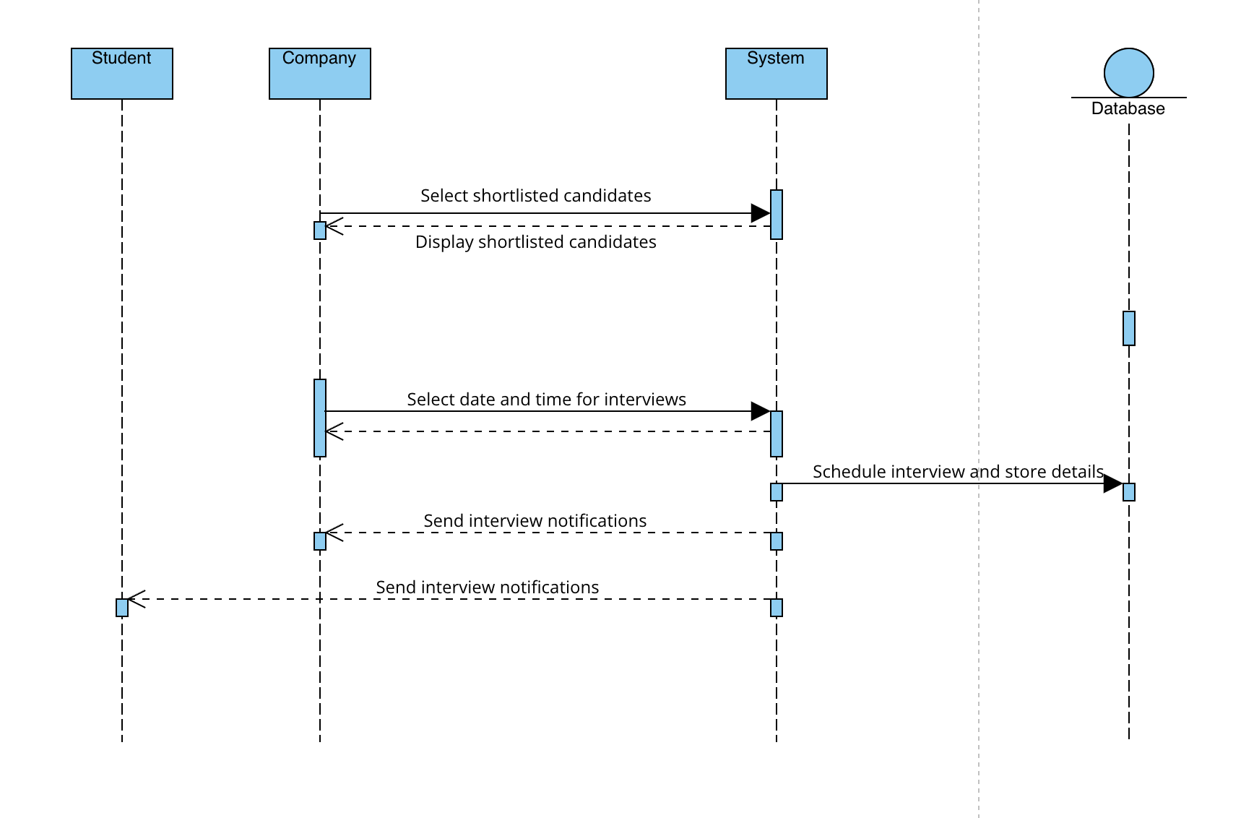

#### 3.14 Scheduling interview diagram

##### **[SD8] Submit Feedback**

* **Figure 3.15**: Sequence diagram for submit feedback, showing feedback and complaints between the company, student, and colleges.

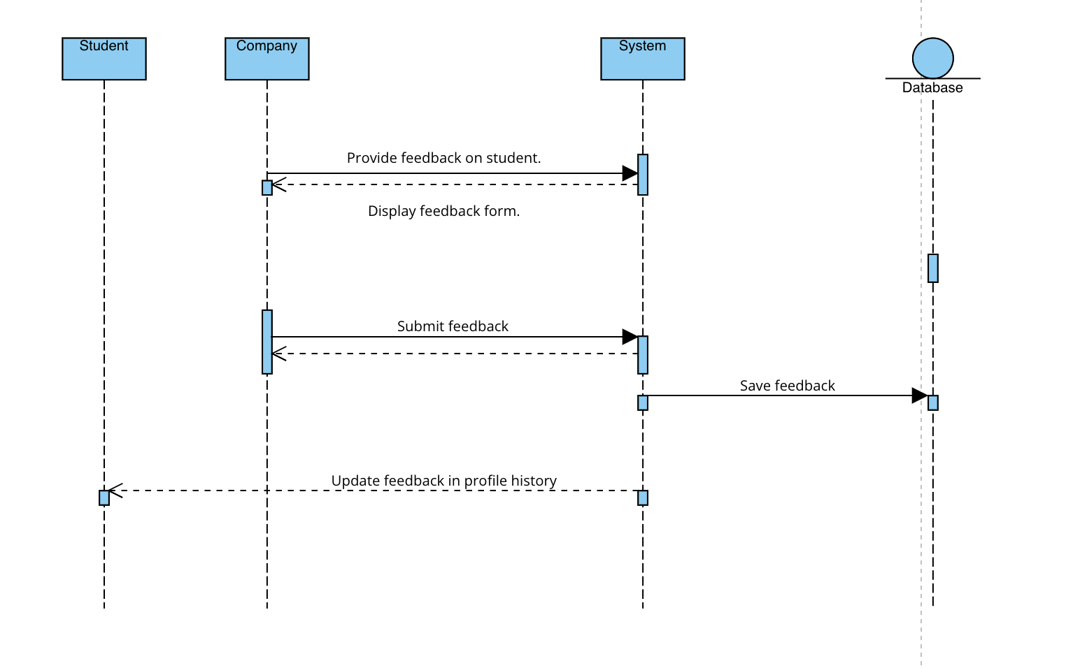

#### 3.15 Submit Feedback diagram

#### **Functional Requirements Mapping**

**[G1] Companies create and manage internships**

* R1: The system allows companies to register by providing their organization details, a valid email address, and a password.
* R2: The system allows registered companies to log in and access the internship management dashboard.
* R3: The system allows companies to create, modify, and manage internship listings, including uploading descriptions, required skills, and necessary details.
* R4: The system allows companies to set internship application deadlines, including the start and end dates for internships.
* R5: The system allows companies to review student applications, shortlist candidates, and accept or reject applicants.
* R6: The system allows companies to schedule interviews and communicate with candidates.
* R7: The system allows companies to provide feedback on students' performance post-internship.

**[G2] Students apply for internships and communicate with companies**

* R1: The system allows students to register using their email and academic details.
* R2: The system allows registered students to log in.
* R3: The system allows students to create and update their profiles, including education details, skills, and past experience.
* R4: The system allows students to search and apply for internships using filters such as company, location, skills, and duration.
* R5: The system sends notifications to students about internship opportunities, application deadlines, and status updates.
* R6: The system allows students to communicate with companies regarding internship details, requirements, and interviews.
* R7: The system tracks the progress of applications and notifies students when they are selected or rejected for an internship.
* R8: The system allows students to receive and provide feedback post-internship.

**[G3] Companies review and select students for internships**

* R1: The system allows companies to create and post internship opportunities.
* R2: The system allows companies to specify the qualifications, skills, and responsibilities for the internship.
* R3: The system allows companies to review student profiles and applications based on predefined criteria.
* R4: The system allows companies to invite students for interviews and extend internship offers.
* R5: The system allows companies to track internship application progress and send feedback to students

#### **Design Constraints**

**Standards Compliance**

The Students&Companies (S&C) platform complies with the **General Data Protection Regulation (GDPR)** for data privacy and protection, ensuring all user data is handled in accordance with the regulation. Moreover, the platform follows international standards for date and time formats.

**Hardware Limitations**

To properly use the system, users should meet the following hardware requirements:

* Devices must have reliable internet connectivity (3G, 4G, 5G, or Wi-Fi standards such as IEEE 802.11 and IEEE 802.3).
* Devices should be equipped with modern processors (Intel i5 or i7) and at least 8GB of RAM.
* Users should have a screen resolution of at least Full HD for optimal user experience.

#### **Software System Attributes**

**Reliability**

The system must ensure reliable performance with high availability. It should employ replication and consistency measures to avoid system crashes. Regular backups must be performed to ensure the security of user data.

**Availability**

The system should guarantee 99% availability to support educators and students. The platform must be resilient to high traffic, especially during application deadlines, by implementing replication policies to avoid a single point of failure.

**Security**

Security is a priority as the system will handle sensitive user data, including personal information and application materials. The system must employ encryption for passwords and sensitive data storage. It should also have robust protection against cyber threats to maintain data integrity, confidentiality, and availability.

**Maintainability**

The system's code should be well-documented and easy to maintain. Automated testing routines must cover at least 75% of the system's core functionalities, excluding the UI code. This ensures that new features can be added and bugs can be addressed efficiently.

**Portability**

The platform is a web-based application that must be compatible with various browsers (such as Google Chrome, Firefox) and devices (smartphones, tablets, and desktops) to ensure accessibility to all users.

#### **Performance Requirements**

The system must deliver quick response times to ensure a smooth user experience, with a target response time of less than one second. The platform must be scalable to accommodate a large number of simultaneous users, especially during peak periods such as application deadlines.

**4 | Formal Analysis Using Alloy**

| **open util/ordering[Time]**  **// Time Signature**  **enum TruthValue {**  **True, False**  **}**  **enum UserType {**  **student, company, university**  **}**  **enum ApplicationStatus {**  **applied, under_review, accepted, rejected**  **}**  **enum ComplaintStatus {**  **submitted, in_progress, resolved**  **}**  **sig Time {}**  **// Abstract User Signature**  **abstract sig User {**  **first_name: lone String,**  **last_name: lone String,**  **email: lone String,**  **password: lone String,**  **is_active: one TruthValue,**  **user_type: one UserType**  **}**  **sig Student extends User {**  **university: lone University,**  **cv: lone String**  **}**  **sig Company extends User {**  **company_name: lone String,**  **internships: set Internship**  **}**  **sig University extends User {**  **complaints: set Complaint**  **}**  **sig Internship {**  **company: some Company,**  **title: lone String,**  **description: lone String,**  **start_date: lone Time,**  **end_date: lone Time**  **}**  **sig Application {**  **student: some Student,**  **internship: some Internship,**  **status: one ApplicationStatus**  **}**  **sig Complaint {**  **user: some User,**  **university: lone University,**  **message: lone String,**  **status: one ComplaintStatus**  **}**  **// Debugging Fact: Ensure Basic Relationships Exist**  **fact DebugRelationships {**  **some s: Student | some s.university**  **some i: Internship | some i.company**  **some a: Application | some a.student and some a.internship**  **some c: Complaint | some c.university**  **}**  **// Simplified Predicate**  **pred MinimalInstance {**  **some Student**  **some Company**  **some Internship**  **some Application**  **}**  **run MinimalInstance for 3 but 3 Time** |
| --- |

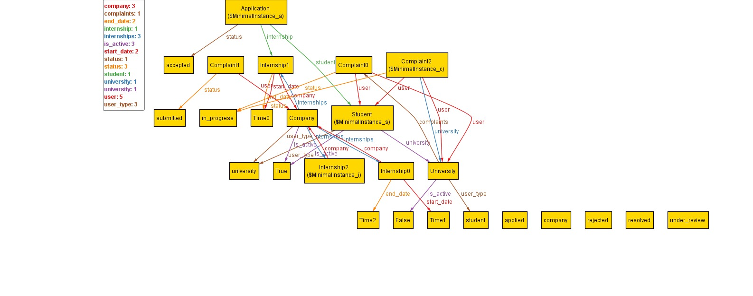

Fig. 4.1 Alloy output

**5 | Effort Spent**

In this part there is an overview of the time effort spent by each member of this team. Everyone has spent some time writing each section of this document and here it is visible the amount of time.

* Student 1

| **chapter** | **Effort(In hours)** |
| --- | --- |
| 1 | 10 |
| 2 | 10 |
| 3 | 10 |
| 4 | 5 |

* Student 2

| **chapter** | **Effort(In hours)** |
| --- | --- |
| 1 | 10 |
| 2 | 10 |
| 3 | 10 |
| 4 | 10 |

* Student 3

| **chapter** | **Effort(In hours)** |
| --- | --- |
| 1 | 10 |
| 2 | 15 |
| 3 | 10 |
| 4 | 8 |

**6 | Bibliography**

[1] **Unified Modeling Language (UML) - Object Management Group (OMG).** (2024). *UML 2.5 Superstructure Specification.*URL: https://www.omg.org/spec/UML/2.5/

* Provides official specifications for UML, including use case diagrams, class diagrams, sequence diagrams, and more, which are essential for documenting the S&C system.

**[2]Alloy Analyzer - The Alloy Modeling Language.** (2024). *Alloy Modeling Language and Analyzer.*URL:<https://alloytools.org/>

* Offers resources and documentation on the Alloy language, which can be used for formal verification of systems like S&C.

[3]**Visual Paradigm.** (2024). *Visual Paradigm UML Tool.*URL:<https://www.visual-paradigm.com/>

* A UML tool that can be used to create the various diagrams (use case, class, sequence, etc.) for the S&C platform.

**7 | List of Figures**

**8 | List of Tables**