**Lab File**

Software Engineering

DEPARTMENT

OF

COMPUTER SCIENCE AND ENGINEERING



Submitted To: Submitted By:

Dr. Sumit Kumar Shaurya Guliani

A2305219086

Associate Professor

CSE Department, ASET 6CSE – 2X

**CASE STUDY: LIBRARY MANAGEMENT SYSTEM**

**AMITY SCHOOL OF ENGINEERING AND TECHNOLOGY**

**AMITY UNIVERSITY UTTAR PRADESH**

**NOIDA-201301**

**INDEX**

|  |  |  |  |  |  |  |  |  |
| --- | --- | --- | --- | --- | --- | --- | --- | --- |
| **Experiment No.** | **Category**  **of Assignment** | **Code** | **Name of Experiment** | **Date of Allotment of experiment** | **Date of Evaluation** | **Max**  **Marks** | **Marks obtained** | **Sign.**  **of Faculty** |
|  | **Mandatory Experiment** | **LR (0)** | **Formulating the problem statement for library management system.** | **6/01/2022** | **13/01/2022** | **1** |  |  |
|  | **Mandatory Experiment** |  | **Use Case Diagram Design For Library Management System** | **13/01/2022** | **20/01/2022** | **1** |  |  |
|  | **Mandatory Experiment** |  | **Creating Level-0 and Level-1 Data Flow Diagram For Library Management System** | **20/01/2022** | **27/01/2022** | **1** |  |  |
|  | **Mandatory Experiment** |  | **Creating E-R Diagram for Library Management System** | **27/01/2022** | **3/02/2022** | **1** |  |  |
|  | **Mandatory Experiment** |  | **Creating Use Case Templates for Library Management System** | **3/02/2022** | **17/02/2022** | **1** |  |  |
|  | **Mandatory Experiment** |  | **Creating Sequence Diagrams for Library Management System** | **17/02/2022** | **03/03/2022** | **1** |  |  |
|  | **Mandatory Experiment** |  | **Creating A Class Diagram for Library Management System** | **03/03/2022** | **10/03/2022** | **1** |  |  |
|  | **Mandatory Experiment** |  | **Creating An Activity Diagram for Library Management System** | **10/03/2022** | **17/03/2022** | **1** |  |  |
|  | **Mandatory Experiment** |  | **Creating A State Chart Diagram for Library Management System** | **17/03/2022** | **24/03/2022** | **1** |  |  |
|  | **Mandatory Experiment** |  | **Creating A Component Diagram for Library Management System** | **24/03/2022** | **31/03/2022** | **1** |  |  |
|  | **Mandatory Experiment** |  | **Creating A Collaborative Diagram for Library Management System** | **31.03/2022** | **7/04/2022** | **1** |  |  |
|  | **Mandatory Experiment** |  | **Creating A Deployment Diagram for Library Management System** | **7/04/2022** | **21/04/2022** | **1** |  |  |

## Experiment 1

**Objective:** Formulating the problem statement for Library Management System

A university Library maintains a record for all the books that it stores and issues to the students. It is a huge record consisting of material from all the branches and courses of the material in an orderly manner. The record is used for:

* Locating the books inside the library
* Categorizing the books according to type and genre
* Maintaining data about book issued and the issuer along with the issued time
* Recording details and fine of late returns

University decides to digitalize the manual library record management process in order to make it more user friendly and convenient for students as well as the library management. This enhances the maintainability of the records keeping a unified platform.

The proposed system should perform the following functions:

* **Issue of library User ID to new members i.e. students and faculty**
* **Maintain a genre wise list of books and their locations inside the library:**
* Book name
* Book ISBN
* Author
* Genre
* Shelf number
* **Keeping record of issuing details:**
* Book Information – Book name, Book ISBN
* Issuer information - Name, User ID
* date of issue
* date of return
* late return fee (if any)

|  |  |  |  |
| --- | --- | --- | --- |
| Internal Assessment (Mandatory Experiment) Sheet for Lab Experiment Department of Computer Science & Engineering Amity University, Noida (UP) | | | |
| Program | B. Tech CSE | Course Name | Software Engineering |
| Course Code | IT301 | Semester | 6 |
| Student Name | Shaurya Guliani | Enrollment No. | A2305219086 |
| Marking Criteria | | | |
| Criteria | Total Marks | Marks Obtained | Comments |
| Concept (A) | 2 |  |  |
| Implementation (B) | 2 |  |  |
| Performance (C) | 2 |  |  |
| Total | 6 |  |  |

## Experiment 2

**Objective:** Use Case Diagram Design for Library Management System

**Software Used:** StarUML

**Theory:**

Use case diagrams are used to gather the requirements of a system including internal and external influences. These requirements are mostly design requirements. Hence, when a system is analyzed to gather its functionalities, use cases are prepared and actors are identified.

Use case diagrams specify the events of a system and their flows. But use case diagram never describes how they are implemented. Use case diagram can be imagined as a black box where only the input, output, and the function of the black box is known.

These diagrams are used at a very high level of design. This high level design is refined again and again to get a complete and practical picture of the system.

**Result:**

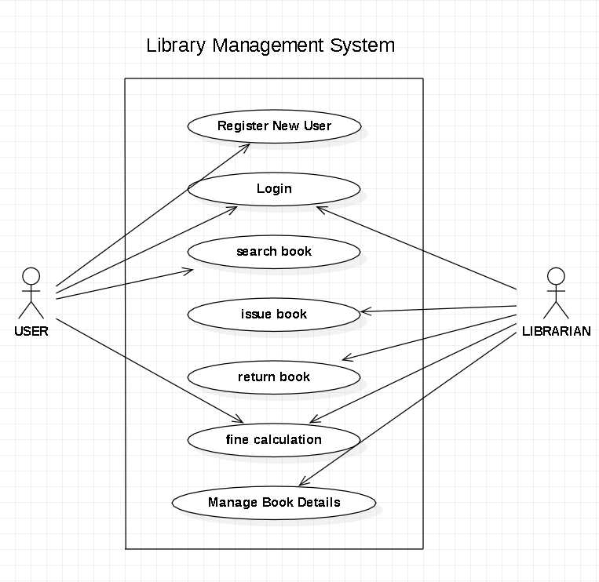

**USE CASE DIAGRAM**

|  |  |  |  |
| --- | --- | --- | --- |
| Internal Assessment (Mandatory Experiment) Sheet for Lab Experiment Department of Computer Science & Engineering Amity University, Noida (UP) | | | |
| Program | B. Tech CSE | Course Name | Software Engineering |
| Course Code | IT301 | Semester | 6 |
| Student Name | Shaurya Guliani | Enrollment No. | A2305219086 |
| Marking Criteria | | | |
| Criteria | Total Marks | Marks Obtained | Comments |
| Concept (A) | 2 |  |  |
| Implementation (B) | 2 |  |  |
| Performance (C) | 2 |  |  |
| Total | 6 |  |  |

## Experiment 3

**Objective:** Creating 0 - Level &1-Level Data Flow Diagram for Library Management System

**Software Used:** StarUML

**Theory:**

In Software engineering DFD (data flow diagram) can be drawn to represent the system of different levels of abstraction.

**0-level DFD:**   
It is also known as a context diagram. It’s designed to be an abstraction view, showing the system as a single process with its relationship to external entities. It represents the entire system as a single bubble with input and output data indicated by incoming/outgoing arrows.

**1-level DFD:**   
In 1-level DFD, the context diagram is decomposed into multiple bubbles/processes. In this level, we highlight the main functions of the system and breakdown the high-level process of 0-level DFD into sub processes.

**Result:**

**CONTEXT DIAGRAM :**

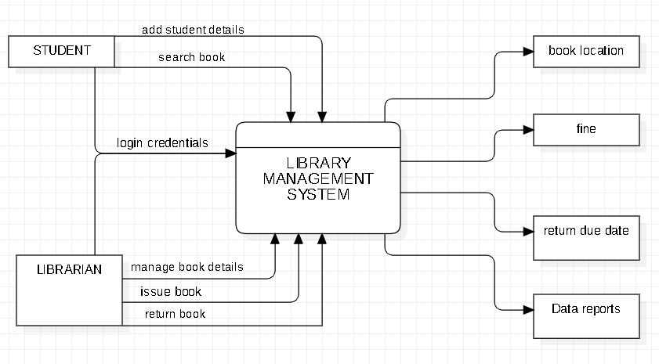

**LEVEL-1 DATA FLOW DIAGRAM :**

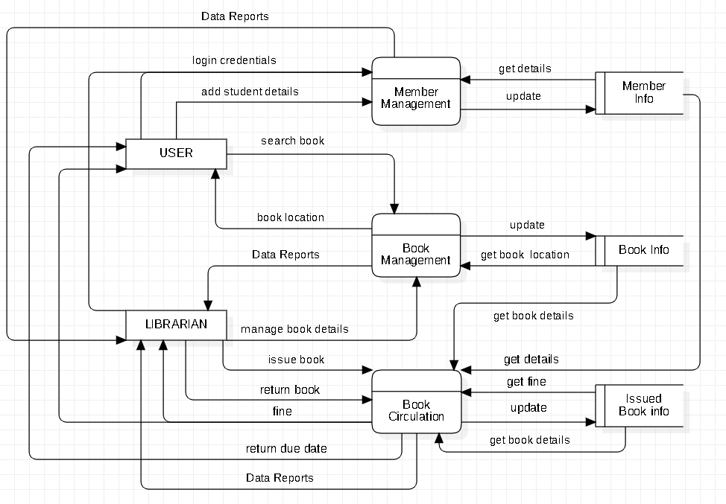

|  |  |  |  |
| --- | --- | --- | --- |
| Internal Assessment (Mandatory Experiment) Sheet for Lab Experiment Department of Computer Science & Engineering Amity University, Noida (UP) | | | |
| Program | B. Tech CSE | Course Name | Software Engineering |
| Course Code | IT301 | Semester | 6 |
| Student Name | Shaurya Guliani | Enrollment No. | A2305219086 |
| Marking Criteria | | | |
| Criteria | Total Marks | Marks Obtained | Comments |
| Concept (A) | 2 |  |  |
| Implementation (B) | 2 |  |  |
| Performance (C) | 2 |  |  |
| Total | 6 |  |  |

## Experiment 4

**Objective:** Creating E-R Diagram for Library Management System

**Software Used:** StarUML

**Theory:**

[ER Diagram](https://www.geeksforgeeks.org/introduction-of-er-model/) is known as Entity-Relationship Diagram, it is used to analyze to the structure of the Database. It shows relationships between entities and their attributes. An ER Model provides a means of communication.

This Library ER diagram illustrates key information about the Library, including entities such as staff, readers, books, publishers, reports, and authentication system. It allows for understanding the relationships between entities.

**Result:**

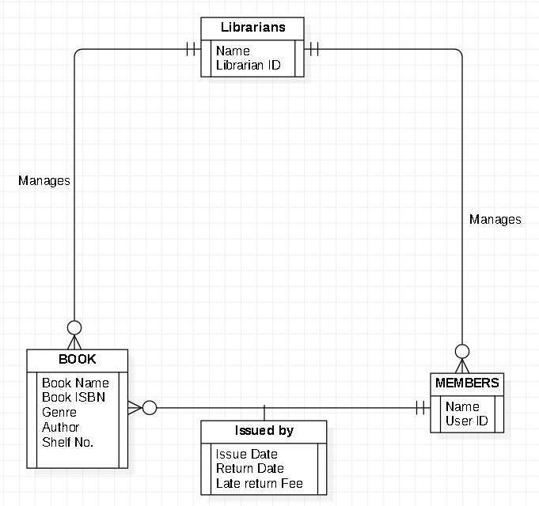

**ENTITY RELATIONSHIP DIAGRAM**

|  |  |  |  |
| --- | --- | --- | --- |
| Internal Assessment (Mandatory Experiment) Sheet for Lab Experiment Department of Computer Science & Engineering Amity University, Noida (UP) | | | |
| Program | B. Tech CSE | Course Name | Software Engineering |
| Course Code | IT301 | Semester | 6 |
| Student Name | Shaurya Guliani | Enrollment No. | A2305219086 |
| Marking Criteria | | | |
| Criteria | Total Marks | Marks Obtained | Comments |
| Concept (A) | 2 |  |  |
| Implementation (B) | 2 |  |  |
| Performance (C) | 2 |  |  |
| Total | 6 |  |  |

## Experiment 5

**Objective:** Creating Use Case Templates for Library Management System

**LOGIN**

**1.Introduction:** This use case describes how a user will Login for Library Management System

This includes:

* Input Username
* Input valid Password
* Check previous Records of the user

**2.Actors:**

1. User
2. Librarian

**3.Pre-Conditions:**

* Actors must have a login ID and password

**4.Post Conditions:**

* If use case is successful, the actor logs into the system successfully. Otherwise , there is no change in the system state.

**5. Flow of Events**

**Basic Flow:** Begins at the stage when the user wishes to login to university library.

1. System requests that the actor enters his/her name and password.
2. The actor enters his/her name & password.
3. System validates name & password, and if finds correct allow the actor to logs into the system.

**6.Alternative Flows**

Invalid name & password: If in the basic flow, the actor enters an invalid name and/or password, the system displays an error message. The actor can choose to either return to the beginning of the basic flow or cancel the login, at that point, the use case ends.

**7. Special Requirements:**

None

**8. Use case Relationships:**

None

**ISSUING OF BOOK**

**1.Introduction:** The use case handles the Issuing of book done by the user.

This includes:

* Add issuer details to the record
* Add issued book details to the record

**2.Actors:**

1. User
2. Librarian

**3.Pre-Conditions:**

* Issuer should be of the particular university with a valid UserID.
* Issuer should know the book’s location

**4.Post Conditions:**

* User has received the desired book
* Issuer details along with book ISBN is added/updated to the database

**5. Flow of Events**

**Basic Flow:** Begins at the stage when the user wishes to issue a book from university library.

1. Issuer arrives with book to the librarian along with valid userID
2. Issuer provides with the necessary details i.e. :
   * + Name of Issuer
     + UserID
     + Name of Book
     + Book ISBN
3. Librarian checks for availability of book
4. User is checked for previous fine dues
5. Librarian assigns issue date and return date for user
6. Book Issued.

**6.Alternative Flows** Issuer does not hold a valid UserID the system displays an error message.

Book not available hence, the actor can choose to either return to the beginning of the basic flow or cancel the Issue of book, at that point, the use case ends.

**7. Special Requirements:**

None

**8. Use case Relationships:**

None

**RETURN OF BOOK**

**1.Actors:**

1. User
2. Librarian

**2.Pre-Conditions:**

* User should have the book

**3.Post Conditions:**

* User has successfully returned book

**4. Flow of Events**

**Basic Flow:** Begins at the stage when the user wishes to return a book from university library.

1. User arrives with book to the librarian along with valid userID
2. Issuer provides with the necessary details i.e. :
   * + Name of Issuer
     + UserID
     + Name of Book
     + Book ISBN
3. Librarian checks for return date
4. User is checked for fine dues if any
5. Book Returned.

**5.Alternative Flows** Book ISBN does not match with issued book the system displays an error message.

Book fine is there for previous book not returned hence The actor can choose to either return to the beginning of the basic flow or cancel the return of current book, at that point, the use case ends.

**6. Special Requirements:**

None

**7. Use case Relationships:**

None

|  |  |  |  |
| --- | --- | --- | --- |
| Internal Assessment (Mandatory Experiment) Sheet for Lab Experiment Department of Computer Science & Engineering Amity University, Noida (UP) | | | |
| Program | B. Tech CSE | Course Name | Software Engineering |
| Course Code | IT301 | Semester | 6 |
| Student Name | Shaurya Guliani | Enrollment No. | A2305219086 |
| Marking Criteria | | | |
| Criteria | Total Marks | Marks Obtained | Comments |
| Concept (A) | 2 |  |  |
| Implementation (B) | 2 |  |  |
| Performance (C) | 2 |  |  |
| Total | 6 |  |  |

## Experiment 6

**Objective:** Creating a Sequence diagram for Library Management System

**Software Used:** Draw.io

**Theory:**

The sequence diagram is used primarily to show the interactions between objects in the sequential order that those interactions occur.

The Sequence Diagram for Library Management System represents the scenario and the messages that must be passed between objects. This is done in order for the scenario’s functionality to be realized. Sequence diagrams are helpful for displaying collaborations between items, but not so much for defining behavior precisely.

**Result:**

**SEQUENCE DIAGRAM**

**LOGIN**

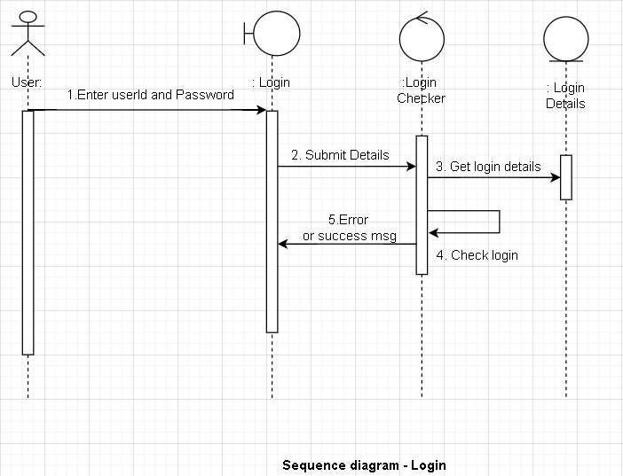

**SEQUENCE DIAGRAM**

**BOOK ISSUE**

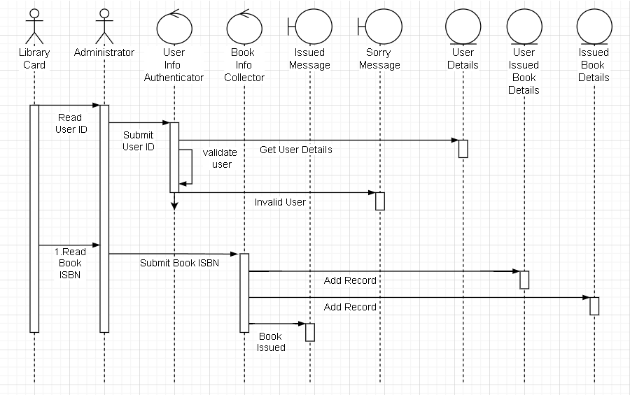

|  |  |  |  |
| --- | --- | --- | --- |
| Internal Assessment (Mandatory Experiment) Sheet for Lab Experiment Department of Computer Science & Engineering Amity University, Noida (UP) | | | |
| Program | B. Tech CSE | Course Name | Software Engineering |
| Course Code | IT301 | Semester | 6 |
| Student Name | Shaurya Guliani | Enrollment No. | A2305219086 |
| Marking Criteria | | | |
| Criteria | Total Marks | Marks Obtained | Comments |
| Concept (A) | 2 |  |  |
| Implementation (B) | 2 |  |  |
| Performance (C) | 2 |  |  |
| Total | 6 |  |  |

## Experiment 7

**Objective:** Creating a class diagram for Library Management System

**Software Used:** Draw.io

**Theory:**

Class diagram is a static diagram. It represents the static view of an application. Class diagram is not only used for visualizing, describing, and documenting different aspects of a system but also for constructing executable code of the software application.

Class diagram describes the attributes and operations of a class and also the constraints imposed on the system. The class diagrams are widely used in the modeling of objectoriented systems because they are the only UML diagrams, which can be mapped directly with object-oriented languages.

Class diagram shows a collection of classes, interfaces, associations, collaborations, and constraints. It is also known as a structural diagram

**Result:**

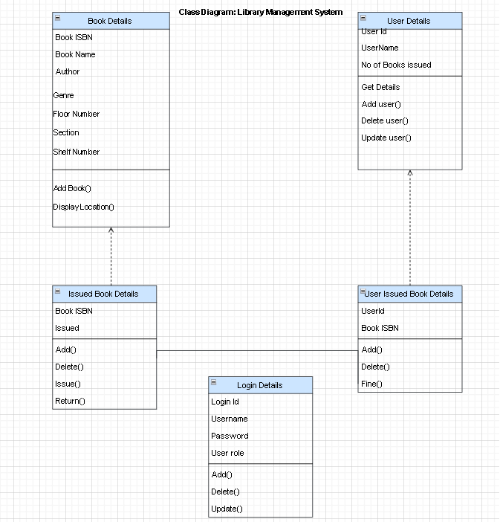

**CLASS DIAGRAM**

|  |  |  |  |
| --- | --- | --- | --- |
| Internal Assessment (Mandatory Experiment) Sheet for Lab Experiment Department of Computer Science & Engineering Amity University, Noida (UP) | | | |
| Program | B. Tech CSE | Course Name | Software Engineering |
| Course Code | IT301 | Semester | 6 |
| Student Name | Shaurya Guliani | Enrollment No. | A2305219086 |
| Marking Criteria | | | |
| Criteria | Total Marks | Marks Obtained | Comments |
| Concept (A) | 2 |  |  |
| Implementation (B) | 2 |  |  |
| Performance (C) | 2 |  |  |
| Total | 6 |  |  |

## Experiment 8

**Objective:** Creating an Activity diagram for Library Management System

**Software Used:** Draw.io

**Theory:**

Activity diagram is another important diagram in UML to describe the dynamic aspects of the system.

Activity diagram is basically a flowchart to represent the flow from one activity to another activity. The activity can be described as an operation of the system.

The control flow is drawn from one operation to another. This flow can be sequential, branched, or concurrent. Activity diagrams deal with all type of flow control by using different elements such as fork, join, etc

It does not show any message flow from one activity to another. Activity diagram is sometimes considered as the flowchart. Although the diagrams look like a flowchart, they are not. It shows different flows such as parallel, branched, concurrent, and single.

**Result:**

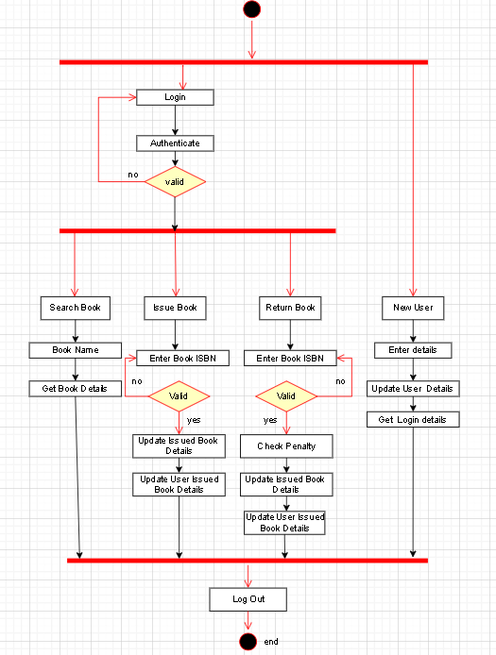

**ACTIVITY DIAGRAM**

|  |  |  |  |
| --- | --- | --- | --- |
| Internal Assessment (Mandatory Experiment) Sheet for Lab Experiment Department of Computer Science & Engineering Amity University, Noida (UP) | | | |
| Program | B. Tech CSE | Course Name | Software Engineering |
| Course Code | IT301 | Semester | 6 |
| Student Name | Shaurya Guliani | Enrollment No. | A2305219086 |
| Marking Criteria | | | |
| Criteria | Total Marks | Marks Obtained | Comments |
| Concept (A) | 2 |  |  |
| Implementation (B) | 2 |  |  |
| Performance (C) | 2 |  |  |
| Total | 6 |  |  |

## Experiment 9

**Objective:** Creating a State Chart Diagram for Library Management System

**Software Used:** Draw.io

**Theory:**

Statechart diagram is one of the five UML diagrams used to model the dynamic nature of a system. They define different states of an object during its lifetime and these states are changed by events. Statechart diagrams are useful to model the reactive systems. Reactive systems can be defined as a system that responds to external or internal events.

Statechart diagram describes the flow of control from one state to another state. States are defined as a condition in which an object exists and it changes when some event is triggered. The most important purpose of Statechart diagram is to model lifetime of an object from creation to termination.

Statechart diagrams are also used for forward and reverse engineering of a system. However, the main purpose is to model the reactive system.

**Result:**

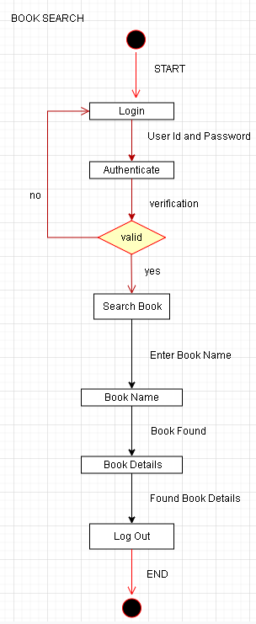 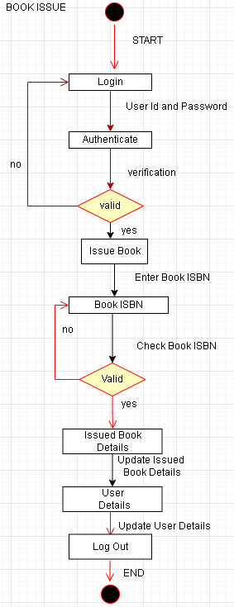

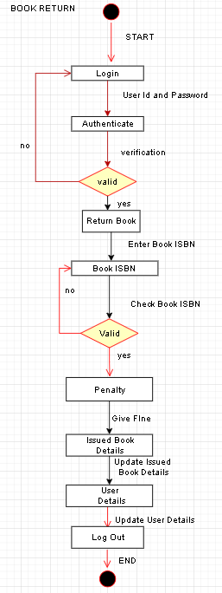 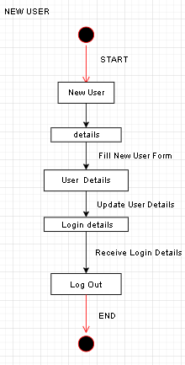

|  |  |  |  |
| --- | --- | --- | --- |
| Internal Assessment (Mandatory Experiment) Sheet for Lab Experiment Department of Computer Science & Engineering Amity University, Noida (UP) | | | |
| Program | B. Tech CSE | Course Name | Software Engineering |
| Course Code | IT301 | Semester | 6 |
| Student Name | Shaurya Guliani | Enrollment No. | A2305219086 |
| Marking Criteria | | | |
| Criteria | Total Marks | Marks Obtained | Comments |
| Concept (A) | 2 |  |  |
| Implementation (B) | 2 |  |  |
| Performance (C) | 2 |  |  |
| Total | 6 |  |  |

## Experiment 10

**Objective:** Creating A Component Diagram for Library Management System

**Software Used:** Draw.io

**Theory:**

A component diagram, also known as a UML component diagram, describes the organization and wiring of the physical components in a system. Component diagrams are often drawn to help model implementation details and double-check that every aspect of the system's required functions is covered by planned development.

**Result:**

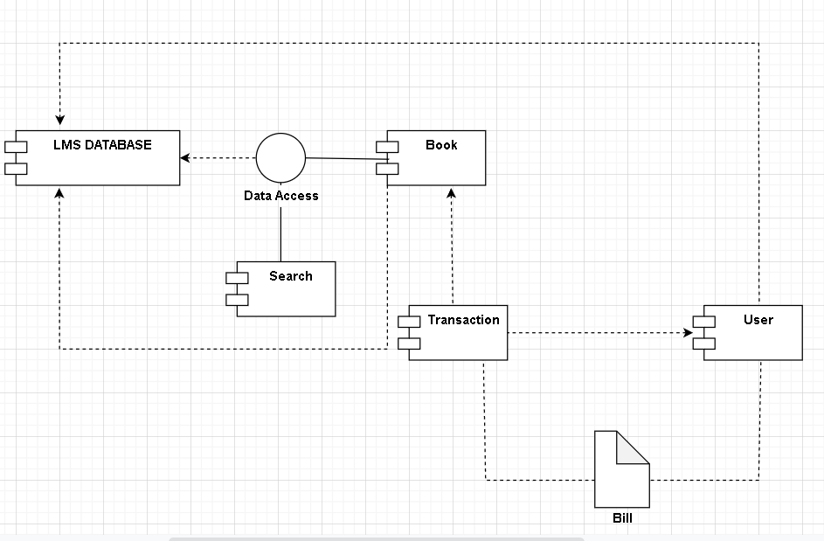

|  |  |  |  |
| --- | --- | --- | --- |
| Internal Assessment (Mandatory Experiment) Sheet for Lab Experiment Department of Computer Science & Engineering Amity University, Noida (UP) | | | |
| Program | B. Tech CSE | Course Name | Software Engineering |
| Course Code | IT301 | Semester | 6 |
| Student Name | Shaurya Guliani | Enrollment No. | A2305219086 |
| Marking Criteria | | | |
| Criteria | Total Marks | Marks Obtained | Comments |
| Concept (A) | 2 |  |  |
| Implementation (B) | 2 |  |  |
| Performance (C) | 2 |  |  |
| Total | 6 |  |  |

## Experiment 11

**Objective:** Creating A Collaborative Diagram for Library Management System

**Software Used:** Draw.io

**Theory:**

A collaboration diagram, also known as a communication diagram, is an illustration of the relationships and interactions among software [objects](https://www.techtarget.com/searchapparchitecture/definition/object) in the Unified Modeling Language ([UML](https://www.techtarget.com/searchsoftwarequality/definition/Unified-Modeling-Language)). These diagrams can be used to portray the dynamic behaviour of a particular [use case](https://www.techtarget.com/searchsoftwarequality/definition/use-case) and define the role of each object. Collaboration diagrams are created by first identifying the structural elements required to carry out the functionality of an interaction. A model is then built using the relationships between those elements. Several vendors offer software for creating and editing collaboration diagrams.

**Result:**

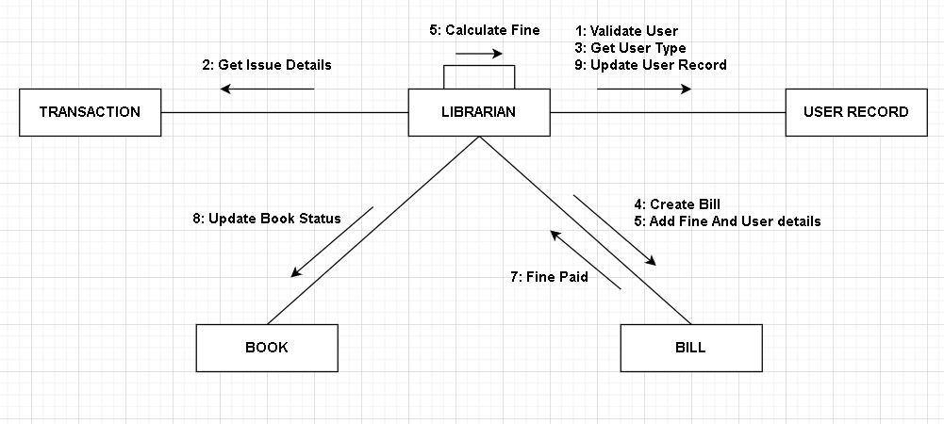

|  |  |  |  |
| --- | --- | --- | --- |
| Internal Assessment (Mandatory Experiment) Sheet for Lab Experiment Department of Computer Science & Engineering Amity University, Noida (UP) | | | |
| Program | B. Tech CSE | Course Name | Software Engineering |
| Course Code | IT301 | Semester | 6 |
| Student Name | Shaurya Guliani | Enrollment No. | A2305219086 |
| Marking Criteria | | | |
| Criteria | Total Marks | Marks Obtained | Comments |
| Concept (A) | 2 |  |  |
| Implementation (B) | 2 |  |  |
| Performance (C) | 2 |  |  |
| Total | 6 |  |  |

## Experiment 12

**Objective:** Creating A Deployment Diagram for Library Management System

**Software Used:** Draw.io

**Theory:**

A deployment diagram is a [UML diagram type](https://creately.com/lp/uml-diagram-tool) that shows the execution architecture of a system, including nodes such as hardware or software execution environments, and the middleware connecting them. Deployment diagrams are typically used to visualize the physical hardware and software of a system. Using it you can understand how the system will be physically deployed on the hardware. Deployment diagrams help model the hardware topology of a system compared to other [UML diagram](https://creately.com/lp/uml-diagram-tool) types which mostly outline the logical components of a system

**Result:**

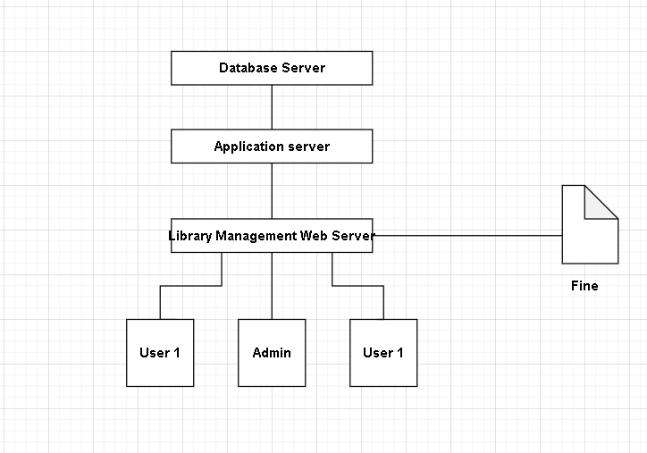

|  |  |  |  |
| --- | --- | --- | --- |
| Internal Assessment (Mandatory Experiment) Sheet for Lab Experiment Department of Computer Science & Engineering Amity University, Noida (UP) | | | |
| Program | B. Tech CSE | Course Name | Software Engineering |
| Course Code | IT301 | Semester | 6 |
| Student Name | Shaurya Guliani | Enrollment No. | A2305219086 |
| Marking Criteria | | | |
| Criteria | Total Marks | Marks Obtained | Comments |
| Concept (A) | 2 |  |  |
| Implementation (B) | 2 |  |  |
| Performance (C) | 2 |  |  |
| Total | 6 |  |  |