Batch: C4-01 Roll No.: 16010124216

Experiment / assignment / tutorial No: 4

Grade: AA / AB / BB / BC / CC / CD /DD

Signature of the Staff In-charge with date

|  |
| --- |
| **TITLE:** Write a program to demonstrate the use of User-defined functions in Python   1. **AIM**: 1) Write a Python program using a recursive function that takes a string as 2. input from the user and displays whether the string is Palindrome or not.   2) Write a Python program for a character frequency counter function that takes a list of strings from the user as input and displays the frequency of each character in the list.  .  **OUTCOME:** Students will be able to  **CO1:** Formulate problem statement and develop the logic (algorithm/flowchart) for its solution.  **CO3:** Use different Decision Making statements and Functions in Python. |

Use of input output function, Use different Decision Making statements and user defined functions in Python.

**______________________________________________________________________**

**Resource Needed: Python IDE**

**______________________________________________________________________**

**Books/ Journals/ Websites referred:**

1. Reema Thareja, *Python Programming: Using Problem Solving Approach*, Oxford University Press, First Edition 2017, India
2. Sheetal Taneja and Naveen Kumar, *Python Programming: A modular Approach*, Pearson India, Second Edition 2018,India
3. https://www.geeksforgeeks.org/python-strings/?ref=lbp

**______________________________________________________________________**

**Theory:**

## Python Functions

A function is a block of code that only runs when it is called. You can pass data, known as parameters, into a function. A function can return data as a result.

**Creating a Function:**

In Python, a function is defined using the def  keyword:

Example: def my_function():  
    print("Hello from a function")

**Arguments:**

Information can be passed into functions as arguments. Arguments are specified after the function name, inside the parentheses. You can add as many arguments as you want, just separate them with a comma.

**Parameters or Arguments:**

The terms parameter and argument can be used for the same thing: information that is passed into a function. From a function's perspective: A parameter is the variable listed inside the parentheses in the function definition. An argument is the value that is sent to the function when it is called.

## Number of Arguments:

## By default, a function must be called with the correct number of arguments, i.e. if your function expects 2 arguments; you have to call the function with 2 arguments, not more, and not less.

## Keyword Arguments

You can also send arguments using the key== value syntax.

This way, the order of the arguments does not matter.

## Arbitrary Keyword Arguments, **kwargs

If you do not know how many keyword arguments will be passed into your function, add two asterisks (**) before the parameter name in the function definition.

This way the function will receive a dictionary of arguments, and can access the items accordingly.

## Default Parameter Value

The following example shows how to use a default parameter value.

If we call the function without argument, it uses the default value:

## Passing a List as an Argument

## You can send any data type of argument to a function (string, number, list, dictionary, etc.), and it will be treated as the same data type inside the function.

## Return Values

To let a function return a value, use the return statement:

## The pass statement

Function definitions cannot be empty, but if you, for some reason, have a function definition with no content, put it in the pass statement to avoid getting an error.

## Recursion Function

## Python also accepts function recursion, which means a defined function can call itself. Recursion is a common mathematical and programming concept. It means that a function calls itself. This has the benefit of meaning that you can loop through data to reach a result. The developer should be very careful with recursion, as it can be quite easy to slip into writing a function that never terminates, or one that uses excess amounts of memory or processor power. However, when written correctly, recursion can be a very efficient and mathematically elegant approach to programming.

To a new programmer, it can take some time to work out how exactly this works, best way to find out is by testing and modifying it.

**Problem Definition:**

1) In the below table, the input variable, Python code, and output column is given. You have to complete a blank cell in every row.

|  |  |
| --- | --- |
| Python Code | Output |
| def my_function(fname,lname):   print(fname+ " " + lname)  my_function("Amit", "Kumar") | Amit Kumar |
| def my_function(fname, lname):   print(fname + " " + lname)  my_function("Emil") | Error  Emil Doe |
| def my_function(fname, lname):   print(fname + " " + lname)  my_function("Emil", “Doe”) |
| def my_function(*kids):  print("The youngest child is " + kids[2])  my_function("Emil", "Tobias", "Linus") | Linus |
| def my_function(college3, college2, college1):   print("The Best college is " + college3)  my_function(**"MIT", "Stanford", "Harvard"** ) | MIT |
| def my_function(**country= "Norway"**):   print("I am from " + country)  my_function("Sweden") my_function("India") my_function() my_function("Brazil") | I am from Sweden  I am from India  I am from Norway  I am from Brazil |
| def tri_recursion(k):  if(k > 0):  result = k + tri_recursion(k - 1)  print(result)  else:  result = 0  return result  print("Recursion Example Results")  tri_recursion(6) | 1  3  6  10  15  21 |

2) Write a Python program using a recursive function that takes a string as input from the user and displays whether the string is Palindrome.

3) Write a Python program for a character frequency counter function that takes a list of strings from the user as input and displays the frequency of each character in the list.

**Implementation details:**

**Experiment 2:**

string = input("Enter a String:")*;*

*def* check_palindrome(*a*):

  if(len(a)<=1):

    return True

  if(a[0]==a[-1]):

    return True

  else:

    return False

  check_palindrome(a[1:-1])

if(check_palindrome(string)):

  print("The given string is a Palindrome")

else:

  print("The given string is not a Palindrome")

**Experiment 3:**

def letter_frequency(*a*):

  a = *str*(a).upper()

  b = *list*(a)

  c = *list*(*set*(a))

  d = {}

  i = 0

  while(i < len(c)):

    d.update({c[i]:b.count(c[i])})

    i += 1

  return d

print(letter_frequency(input("Enter a String:")))

**Output(s):**

**Experiment 2:**

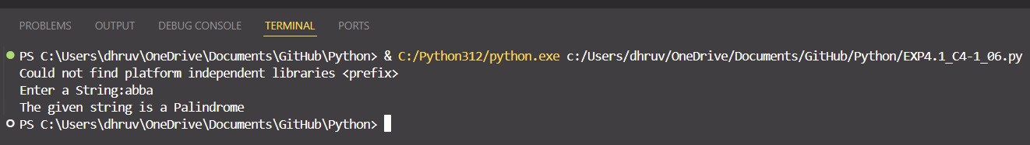

**Experiment 3:**

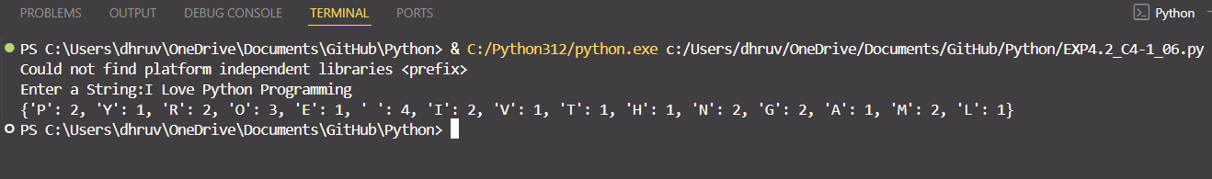

**Conclusion:**

One can use functions to store code blocks which are used multiple times in a program which helps to decrease the size of our code. Functions also take in various parameters which can be useful for calculating the same problem for a variety of values.

Recursive functions are functions which call themselves inside the function body, such functions are useful for calculating factorials, sum of n numbers etc.

**Post Lab Descriptive Questions**

1. Virtual lab on Loop: <https://python-iitk.vlabs.ac.in/exp/loops/>

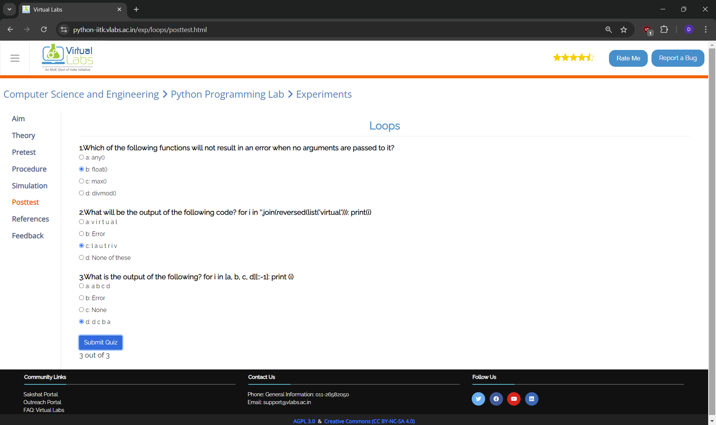

1. Virtual lab on String: <https://python-iitk.vlabs.ac.in/exp/strings/>

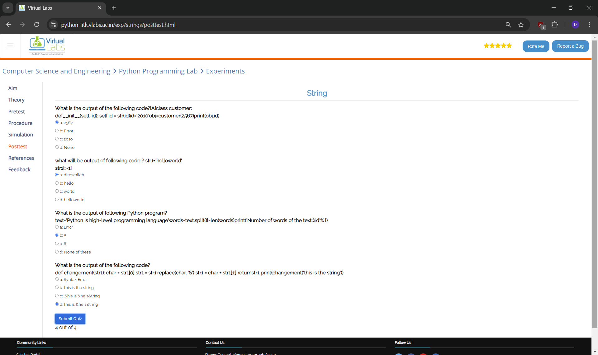

1. Write a Python program to calculate factorial using recursion

def factorial(no): if no == 0: return 1 else: return no*factorial(no-1)print("factorial of a given a number is:", factorial(8))

1. Define a function named 'test_range' that checks if a number 'n' is within the range 3 to 8 (inclusive)

def test_range(n): if(n in range(3, 9)): print("The given number is in between 3 and 8: ") else: print("The given number is out of range")a = input("Enter a number:")a = int(a)print(test_range(a))