FloodWatch: Mapping Flood Damage from Space
Multimodal AI Hackathon 2026, Track B. Case study: the 26 August 2026 Trishuli flood, Nepal.
Team Timepass: Nitin Raj (team leader), Shaurya Priyam, Ratnadeep Paul
Status: educational prototype. It is not an operational tool, and its results are not field-verified.

Abstract
When roads, bridges and phone lines are gone, rescuers still need to know where the damage is and who is cut off. FloodWatch is a pipeline that answers three questions from free satellite and map data alone: where the flood hit, what was damaged, and which settlements can no longer reach a hospital. Given a bounding box and a flood date, it compares Sentinel-1 radar images from before and after the event, overlays a pre-event OpenStreetMap snapshot on the resulting flood mask, and tests the road network for broken links to hospitals. A situation-report copilot then writes a bilingual (English and Nepali) summary in which every number is checked against a single facts file.
For the Trishuli case, the refined run detected 9.77 km2 of flood-affected ground. Of 39,477 OSM buildings loaded near the mask, 1,796 overlap it. 15 of 149 bridges and 35.51 km of 4,155.4 km of road fall inside the mask, and 27 Nepal-side settlements are flagged as possibly cut off from a hospital. Checked against the Copernicus EMS reference (EMSR927) inside its mapped areas, precision is high (0.93) but recall is low (0.16), so the system under-detects. This report describes the method, the results and, in detail, the limits of what we can claim.

1. Introduction

1.1 The problem
After a flood, responders need three answers quickly. First, where are the water and debris? Second, which buildings, roads and bridges are affected? Third, which communities are cut off from the nearest hospital? Monsoon cloud makes optical satellite images unreliable exactly when they are needed, and remote valleys have little ground information. Satellite radar can see through cloud, which is why FloodWatch is built around Sentinel-1.

1.2 Our approach
FloodWatch is deliberately simple to run. A user supplies a bounding box (west, south, east, north in degrees) and the day of the event. One function call, run(), then performs the full pipeline from raw satellite data and produces an interactive dashboard, a one-page report, a facts file and a flood-mask file. The notebook runs in Google Colab and caches rasters and OpenStreetMap data, so a second run takes seconds.
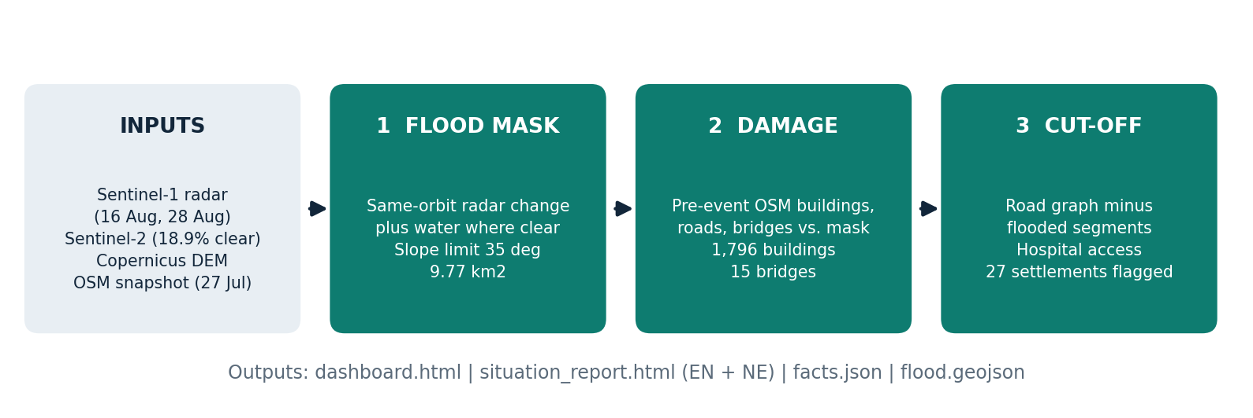
Figure 1. The FloodWatch pipeline, with the Trishuli case-study numbers at each step.

1.3 Contributions
- A radar-first flood and debris mask from a same-orbit before/after pair of Sentinel-1 images, with Sentinel-2 added only where the sky is clear enough.
- A damage count that uses OpenStreetMap as it was before the event, so that damage is not confused with later map edits.
- A cut-off analysis that removes flooded road segments from a road graph and reports which settlements lose their route to a hospital, with explicit categories for settlements that cannot be assessed.
- A DEM-based trace of the flood path down the valley, with the settlements along it.
- An AI situation-report copilot that cannot introduce numbers that are not in the computed results.
- A candid validation against an independent reference, including the first, failed run.

2. Data and rules

2.1 Inputs
Input | Use
Sentinel-1 radar (ascending orbit) | Flood and debris mask from a before/after comparison
Sentinel-2 optical | Open-water detection, only where both dates are clear
Copernicus DEM (WorldDEM-30) | Slope limit and flood-path tracing
OpenStreetMap snapshot, 27 July 2026 | Buildings, roads, bridges, settlements and hospitals before the event
The OSM snapshot is requested through the ohsome API. If ohsome refuses the request (for example with HTTP 403), the notebook falls back to an Overpass query with the same pre-event date. The code stops with an error if the snapshot date is not before the flood date.

2.2 Rules we followed
- Copernicus EMS EMSR927 was used only in the final evaluation cell, to check results after they were produced. It was never an input to the pipeline, and the EMSR927 files are not included in the repository.
- No model was trained, so no training dataset was used. Kuro Siwo and Sen1Floods11 were not used.
- Everything runs from raw data in one run() call. API keys are kept in Colab Secrets and never pasted into cells.

2.3 Imagery used in the case study
The Sentinel-1 pair is on the same ascending orbit track: 16 August 2026 (before) and 28 August 2026 (after), 12 days apart, with 99.7 percent valid pixels. Sentinel-2 was used, but only 18.9 percent of the area was clear on both dates, so radar carries most of the result. Using the same orbit track makes the two radar images directly comparable, because the viewing geometry is identical.

3. Method

3.1 Step 1: where did the flood hit?
FloodWatch compares the Sentinel-1 radar images from before and after the event and maps areas where the radar signal changed in a way consistent with debris or water. The final mask has two kinds of area: radar-change or debris-affected ground, and open water.
The first version of the detector found almost nothing (see section 5). The refined detector made structural changes: two smoothing scales, no morphological opening, agreement between the VH and VV channels, an offset correction between the two dates, and a slope limit of 35 degrees to remove steep terrain where radar artefacts are common. These changes were not fitted to EMSR927, but they were made after seeing the first result, and we say so plainly.
The radar change threshold has a large effect. The radar-only area is 1.56 km2 at a 4 dB threshold, 4.59 km2 at 3 dB and 29.13 km2 at 2 dB. The facts file records all three values so that a reader can see how sensitive the result is. The reported 9.77 km2 mask should be read as one defensible setting, not a precise measurement.

3.2 Step 2: what was damaged?
Buildings, roads and bridges are taken from the pre-event OpenStreetMap snapshot and intersected with the flood mask. The dashboard separates assets that intersect the mask from assets within 30 m of it, which we call at risk. Buildings were loaded only within about 1 km of the detected mask, so the building total is a local total, not a whole-valley total.
Overlap with the mask is not confirmed damage. It means only that an asset lies where the satellite saw change.

3.3 Step 3: who is cut off?
FloodWatch builds a road graph from the pre-event OSM roads, removes the road segments that intersect the flood mask, and checks whether each settlement can still reach the nearest hospital. If no town exists in OSM for the area, hospital access is the main test; where a town exists, access to it is tested as well. Settlements are placed in clear categories:
- Route to hospital kept.
- Longer route to hospital (a detour).
- Road link to hospital lost (candidate cut-off).
- No hospital route even before the flood (not a flood effect).
- No road data within 500 m (not assessed).
The last two categories matter for honesty. A settlement with no road in OSM cannot be judged, and we say so instead of guessing. Settlements whose OSM names are in Chinese script are probably across the border, so they are listed separately and are not reported as Nepali cut-off results.

3.4 Bonus: the flood path
Given an upstream point, FloodWatch uses the Copernicus DEM to trace the flood path down the valley and lists the settlements within a few hundred metres of that path, with their distance downstream.

4. The AI component: situation-report copilot

4.1 Design
The report's key figures are written directly from facts.json, identically in English and Nepali. A language model (Groq, openai/gpt-oss-120b) adds a short summary and answers questions. It receives only facts.json, never raw rasters or maps.

4.2 Guardrail
Every number in the model's text is checked against the facts file. If a number is not in the file, the text is rewritten, up to three times. If it still fails, the AI summary is left out of the report, and the figures remain. A separate consistency_check() cell confirms that the facts file, the report, the dashboard and the flood mask agree with each other.
The design principle is that a language model should explain computed results, not produce them. A fluent but wrong number in an emergency report is worse than no summary at all.

5. Results: the Trishuli case

5.1 Headline numbers
Quantity | Value
Detected flood area (a minimum) | 9.77 km2 (8.45 km2 radar-change/debris + 1.32 km2 water)
OSM buildings in mask | 1,796 of 39,477 (plus 820 within 30 m)
Road in mask | 35.51 km of 4,155.4 km
Bridges in mask | 15 of 149 (plus 3 within 30 m)
Settlements in the study area | 380
Settlements analysed for hospital access | 243 (96 have no road data within 500 m)
Settlements possibly cut off from a hospital | 27
Settlements not connected to a hospital even before the flood | 41
Settlements along the traced flood path | 12, up to about 48 km downstream

5.2 Cut-off settlements
Twenty-seven Nepal-side settlements are flagged as possibly cut off from a hospital, and the same group also loses its route to the nearest town. Three further settlements keep a route but face a longer detour. Fifteen settlements lie inside the flood zone itself. Twenty-five settlements with Chinese-script names are listed separately as probably cross-border.
This is a candidate list, not a confirmed one. OpenStreetMap coverage in remote valleys is thin, so a single flagged road segment can isolate a whole branch of the network.
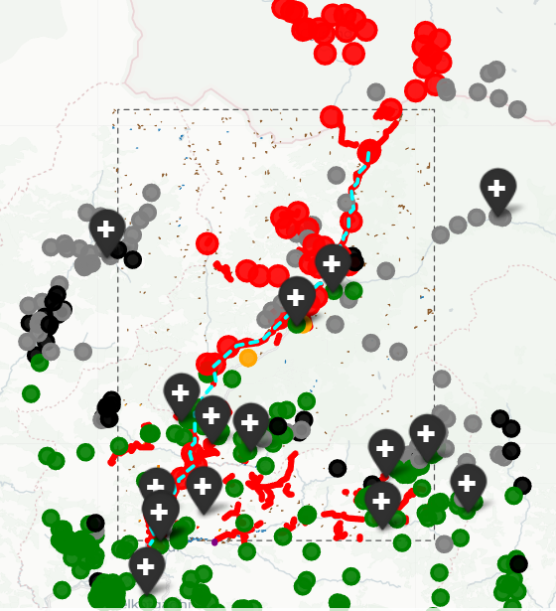
Figure 2. Dashboard close-up. Red markers are settlements whose road link to a hospital is lost, green kept a route, grey have no road data nearby. The cyan line is the DEM-traced flood path and the pins are hospitals.

5.3 The flood path
The DEM trace lists 12 settlements along the valley, from the upstream point to about 48 km downstream, each within roughly 100 to 460 m of the path. This gives responders a first ordering of communities by how far downstream they sit.

5.4 The dashboard
The interactive dashboard shows the flood mask (water and debris layers), the buildings, roads and bridges that intersect it, settlements coloured by hospital access, hospitals, and the traced flood path. Each layer can be toggled. A Report tab and a Numbers tab show the same figures that the facts file holds.
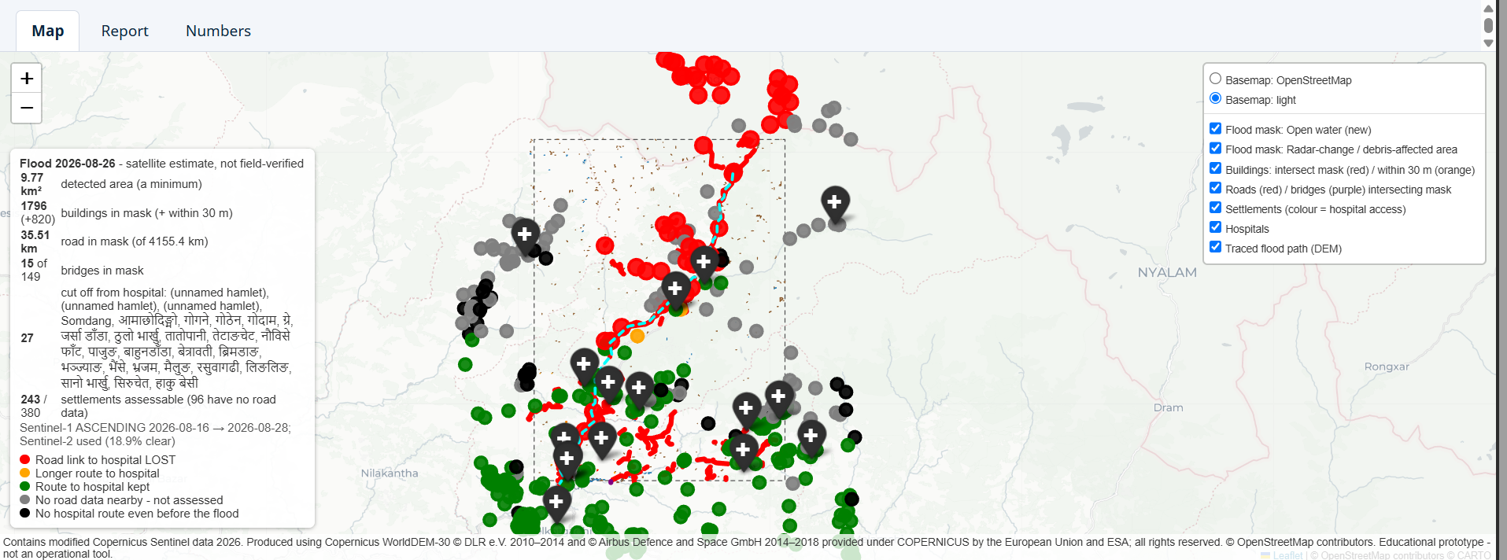
Figure 3. The interactive dashboard (dashboard.html). The panel on the left repeats the headline numbers; the control on the right switches layers on and off. Satellite estimate, not field-verified.

6. Validation against EMSR927

6.1 First run
The first run detected 0.07 km2 against 2.40 km2 of reference areas in EMSR927, with no overlap inside them (IoU 0.0, recall 0.0). Of 170 OSM buildings inside the reference areas, none were flagged, against 760 destroyed or damaged buildings in the reference. We report this result because hiding it would make the improvement look better than it is.

6.2 Refined run
Metric (inside the EMSR927 areas) | First run | Refined run
Mask area inside reference areas | about 0 km2 | 0.42 km2 of 2.40 km2
IoU | 0.0 | 0.16
Precision | not meaningful | 0.93
Recall | 0.0 | 0.16
F1 | 0.0 | 0.28
Precision of 0.93 means that nearly everything we flagged inside those areas was also mapped by EMSR927. Recall of 0.16 means we found only a small share of what EMSR927 mapped. The system is conservative: it is usually right where it speaks, but it misses a lot.

6.3 How much of the mask could be checked
Only 0.42 km2 of our 9.77 km2 mask lies inside the EMSR927 areas. The other roughly 9.35 km2 is unchecked, so we cannot say whether it is correct. On infrastructure, 15 bridges intersect our mask against 6 destroyed bridges in the reference. OSM buildings inside the reference areas could not be compared in the refined run because none were loaded.
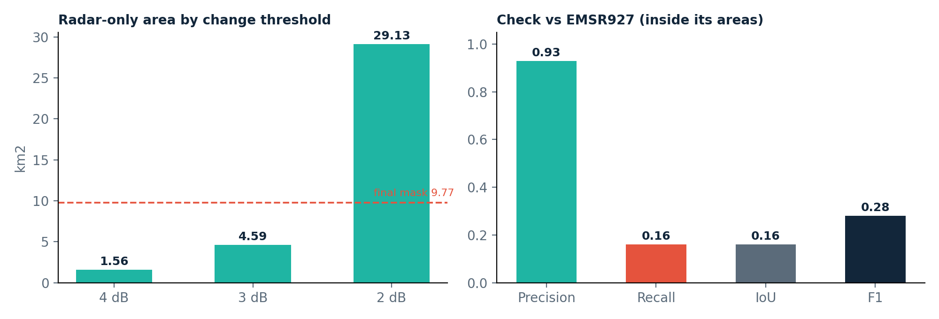
Figure 4. Left: the radar-only area changes almost twenty-fold between the 4 dB and 2 dB thresholds, against the final 9.77 km2 mask. Right: inside the EMSR927 areas, precision is high (0.93) while recall is low (0.16).

7. Limitations
- Detection depends on the threshold. The radar-only area ranges from 1.56 km2 to 29.13 km2 across 4 dB to 2 dB. Any single number is one setting among many.
- The detected area is a minimum. Narrow or steep gorge flow paths and radar-shadow areas can be missed. Low recall (0.16) confirms this.
- Changes were made after seeing a result. The refined detector was not fitted to EMSR927, but it was changed after the first result was known. The improvement is therefore not a clean held-out test.
- Validation covers a small part of the mask. Only 0.42 km2 of 9.77 km2 is inside the reference areas.
- OpenStreetMap is incomplete in remote valleys. Roads and buildings missing from OSM cannot be analysed, and 96 settlements had no road within 500 m.
- Cut-off status is fragile. It depends on a few road segments, so it should be treated as a candidate list.
- Overlap is not damage. Intersection with the mask is a signal to look, not a confirmed loss.
- Building totals are local. Buildings were loaded only within about 1 km of the mask.
- Revisit time. Sentinel satellites revisit every few days, so FloodWatch gives a fast first look after the event, not early warning.
- Cross-border settlements. Chinese-script names are probably across the border, and their road links to Nepali hospitals are not a Nepal-side result.
- Nothing is field-verified. No ground teams or responders have checked any output.

8. Responsible use
A flood map can influence where help is sent, so errors matter. We recommend that FloodWatch outputs be used only as a first-look layer next to other sources, never as the sole basis for a decision. Settlements flagged as cut off should be treated as places to check first, and settlements marked as not assessed should not be read as safe. The copilot's numeric guardrail reduces the risk of invented figures, but it cannot make the underlying detection more accurate.

9. Future work
- Calibrate detection thresholds on more flood events, using a proper split between tuning and testing.
- Add richer road data beyond OpenStreetMap, such as local government or responder datasets, to reduce the number of settlements that cannot be assessed.
- Validate with field and responder feedback, and measure how useful the dashboard is to people who must act on it.
- Improve gorge and radar-shadow handling to raise recall.
- Extend the building comparison to the full reference areas so that damage counts can be checked against EMSR927.

10. Reproducibility
- Open floodwatch.ipynb in Google Colab.
- Register for a free Copernicus Data Space account and create an OAuth client (Sentinel Hub) to get a client ID and secret.
- Get a free Groq API key for the copilot.
- Add CDSE_ID, CDSE_SECRET and GROQ_API_KEY to Colab Secrets and enable notebook access.
- Set the bounding box, flood date and OSM snapshot date in the CONFIG cell.
- Run all cells. RESULT = run() performs the pipeline; later cells display the dashboard, run consistency_check(RESULT) and compare with EMSR927 for checking only.
Requirements (installed by the first cell): rasterio, geopandas, shapely, pyproj, networkx, scipy, folium, requests, matplotlib. Python 3.10 or newer.
Outputs: dashboard.html (interactive map), situation_report.html (one-page report in English and Nepali), facts.json (all numbers used by the report and the copilot) and flood.geojson (flood mask polygons).

11. Conclusion
FloodWatch shows that free radar, elevation and map data can be turned into a fast, first-look answer to the three questions responders ask after a flood. Its most useful design choices are the pre-event map snapshot, the explicit not-assessed categories and the numeric guardrail on the AI text. Its weakest point is recall: validated against the official reference, it finds only a small share of what was mapped, though what it finds is mostly correct. We present it as an honest prototype and a starting point, not as a finished tool.

Attribution
- Contains modified Copernicus Sentinel data 2026.
- Produced using Copernicus WorldDEM-30 (c) DLR e.V. 2010-2014 and (c) Airbus Defence and Space GmbH 2014-2018, provided under COPERNICUS by the European Union and ESA; all rights reserved.
- (c) OpenStreetMap contributors (ODbL).
- Reference maps used for checking only: European Union, Copernicus Emergency Management Service data (EMSR927).
- Basemap tiles: (c) CARTO, (c) OpenStreetMap contributors.

