Experiment No. 1

Aim : Familiarization of Network Environment, Understanding and using network utilities: ipconfig, netstat, ping, telnet, ftp, traceroute etc.

Procedure :
- Ipconfig command

- Enter the ipconfig command in command prompt .

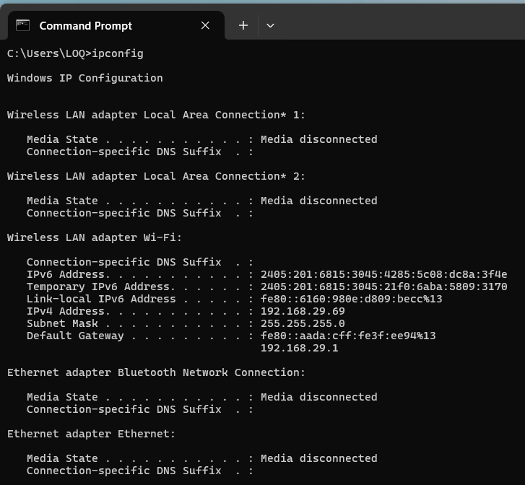

2. Netstat command
i) Enter the netstat command in command prompt .

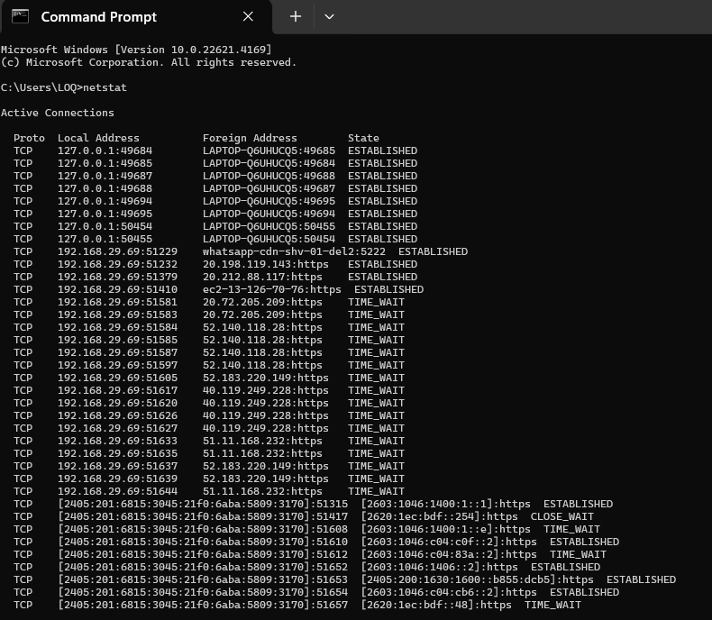

- Ping command
- Enter the ping command in command prompt .

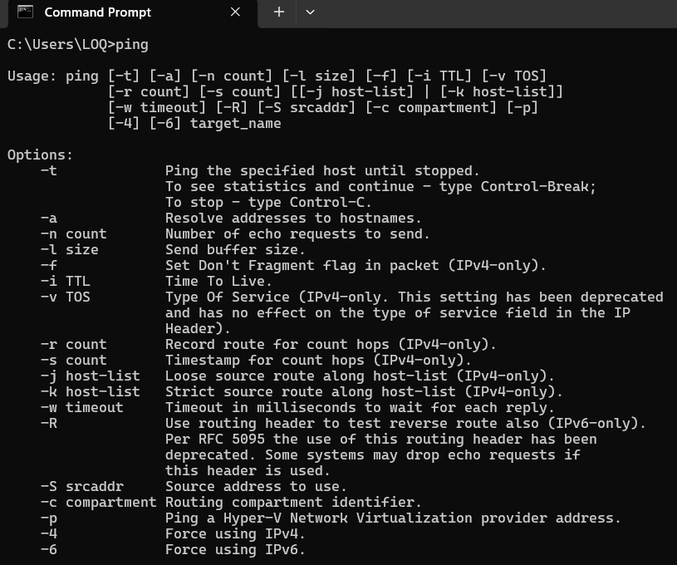

- Telnet command
- Enter the telnet command in command prompt .

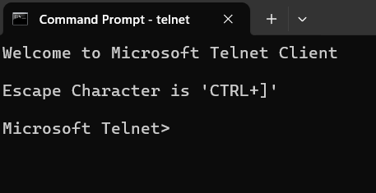
- FTP command
- Enter the ftp command in command prompt .
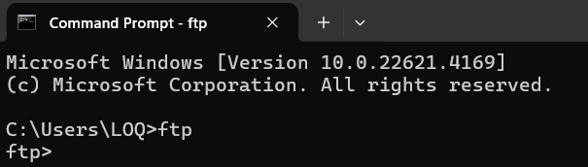

- Traceroute command
- Enter the tracert command which is the equivalent of the traceroute command in linux , in command prompt .
- Enter tracert <destination> . Example : tracert google.com

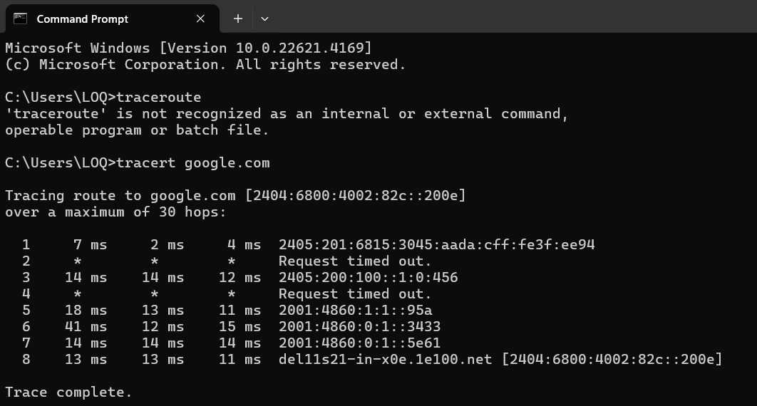

- Hostname command
- Enter the hostname command in command prompt .

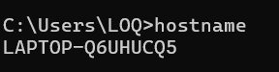

- Nslookup command
- Enter the nslookup command in command prompt .

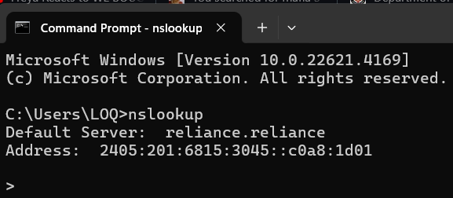

Result : Hence we tested the commands like ipconfig, netstat, ping, telnet, ftp, traceroute ,etc.

Experiment No. 2

Aim of the Experiment: - To familiarize oneself with transmission media and tools such as Co-axial cables, UTP cables, crimping tools, and connectors. This experiment involves preparing UTP cables for both cross and direct connections using a crimping tool.
Materials Needed:
- Co-axial cable
- UTP (Unshielded Twisted Pair) cable
- Crimping tool
- Connectors (RJ45 for UTP, RJ11 or similar for Co-axial if needed)
- Cable tester (optional but recommended)
- Wire stripper
Procedure:
- Introduction to Transmission Media and Tools:
  - Co-axial Cable: Understand the structure, including the inner conductor, dielectric insulator, metallic shield, and outer jacket. Co-axial cables are used for transmitting cable TV signals, internet, and other data.
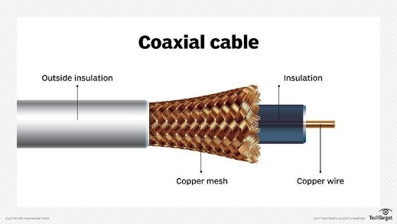
  - UTP Cable: Learn about the UTP cable, which consists of multiple twisted pairs of wires. It is commonly used in networking and telecommunication.
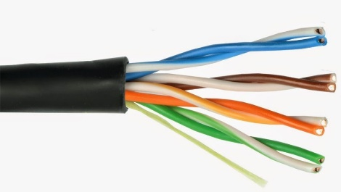
  - Crimping Tool: This tool is used for attaching connectors to the ends of cables. Familiarize yourself with its operation and different types of connectors.

  - Connectors: Review the types of connectors used with Co-axial and UTP cables.
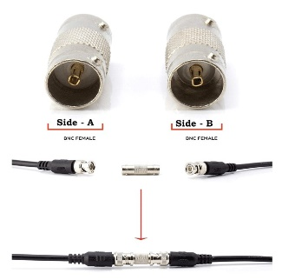
- Preparing UTP Cable for Connections:
  - Strip the Cable: Use a wire stripper to remove a portion of the outer jacket of the UTP cable, exposing the twisted pairs inside.
  - Arrange the Wires:
    - For Direct Connection (Straight-Through Cable):
Arrange the wires according to the T568A or T568B standard at both ends of the cable. These standards define the order of the color-coded wires.
    - For Cross Connection (Crossover Cable):
Arrange the wires in the T568A standard at one end and in the T568B standard at the other end. This configuration is used to connect similar devices directly, such as two computers.
- Crimping the Connectors:
  - Insert the arranged wires into the RJ45 connectors, ensuring each wire goes into its respective pin slot.
  - Use the crimping tool to press down on the connector, securing the wires in place.
- Testing the Cable (Optional):
  - Use a cable tester to ensure that the connections are correctly made and that there are no breaks or shorts in the cable.

Result: The results indicate a thorough understanding and application of the concepts related to transmission media and network cabling.

Experiment No. 3

Aim: Installation and introduction of simulation tool. (Packet Tracer)

Procedure:

Steps:

1. Installation of Cisco Packet Tracer:
- Download Cisco Packet Tracer:
  - Visit the official Cisco website or access it through the Cisco Networking Academy if you’re registered.
  - Download the latest version for your operating system (Windows, macOS, or Linux).
- Install Packet Tracer:
  - Follow the on-screen instructions to install the application on your computer.
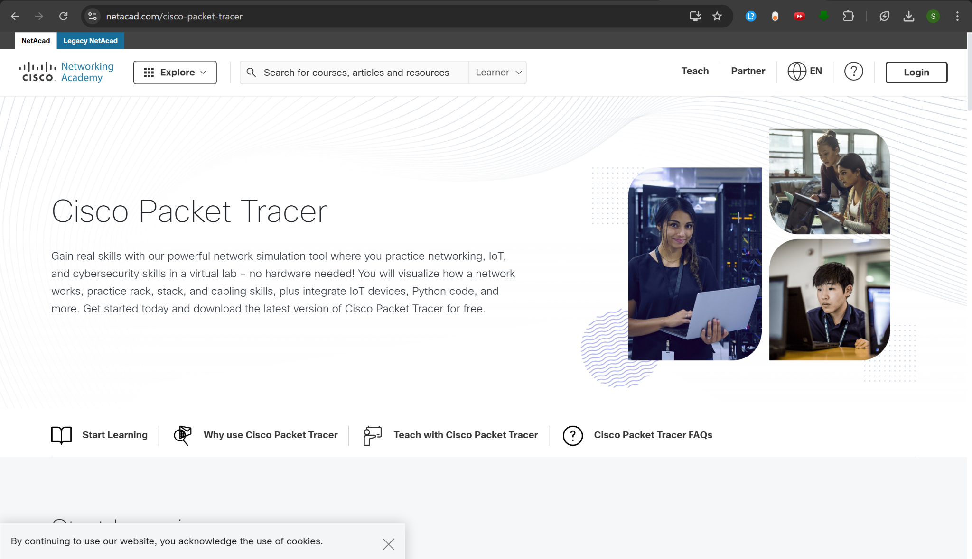
  - After installation, launch the tool and log in (if required) using your Cisco account.

2. Introduction to Packet Tracer Interface:
- Device Selection:
  - On the bottom left, you can find categories for different network devices such as routers, switches, end devices, firewalls, etc.
- Logical Workspace:
  - The main area where you drag devices and connect them to create a network topology.
- Toolbar:
  - Contains options to create new files, save files, zoom in/out, switch between simulation and real-time mode, etc.
- Simulation Mode:
  - Allows you to simulate the flow of data through the network and visualize how packets move across the network devices.
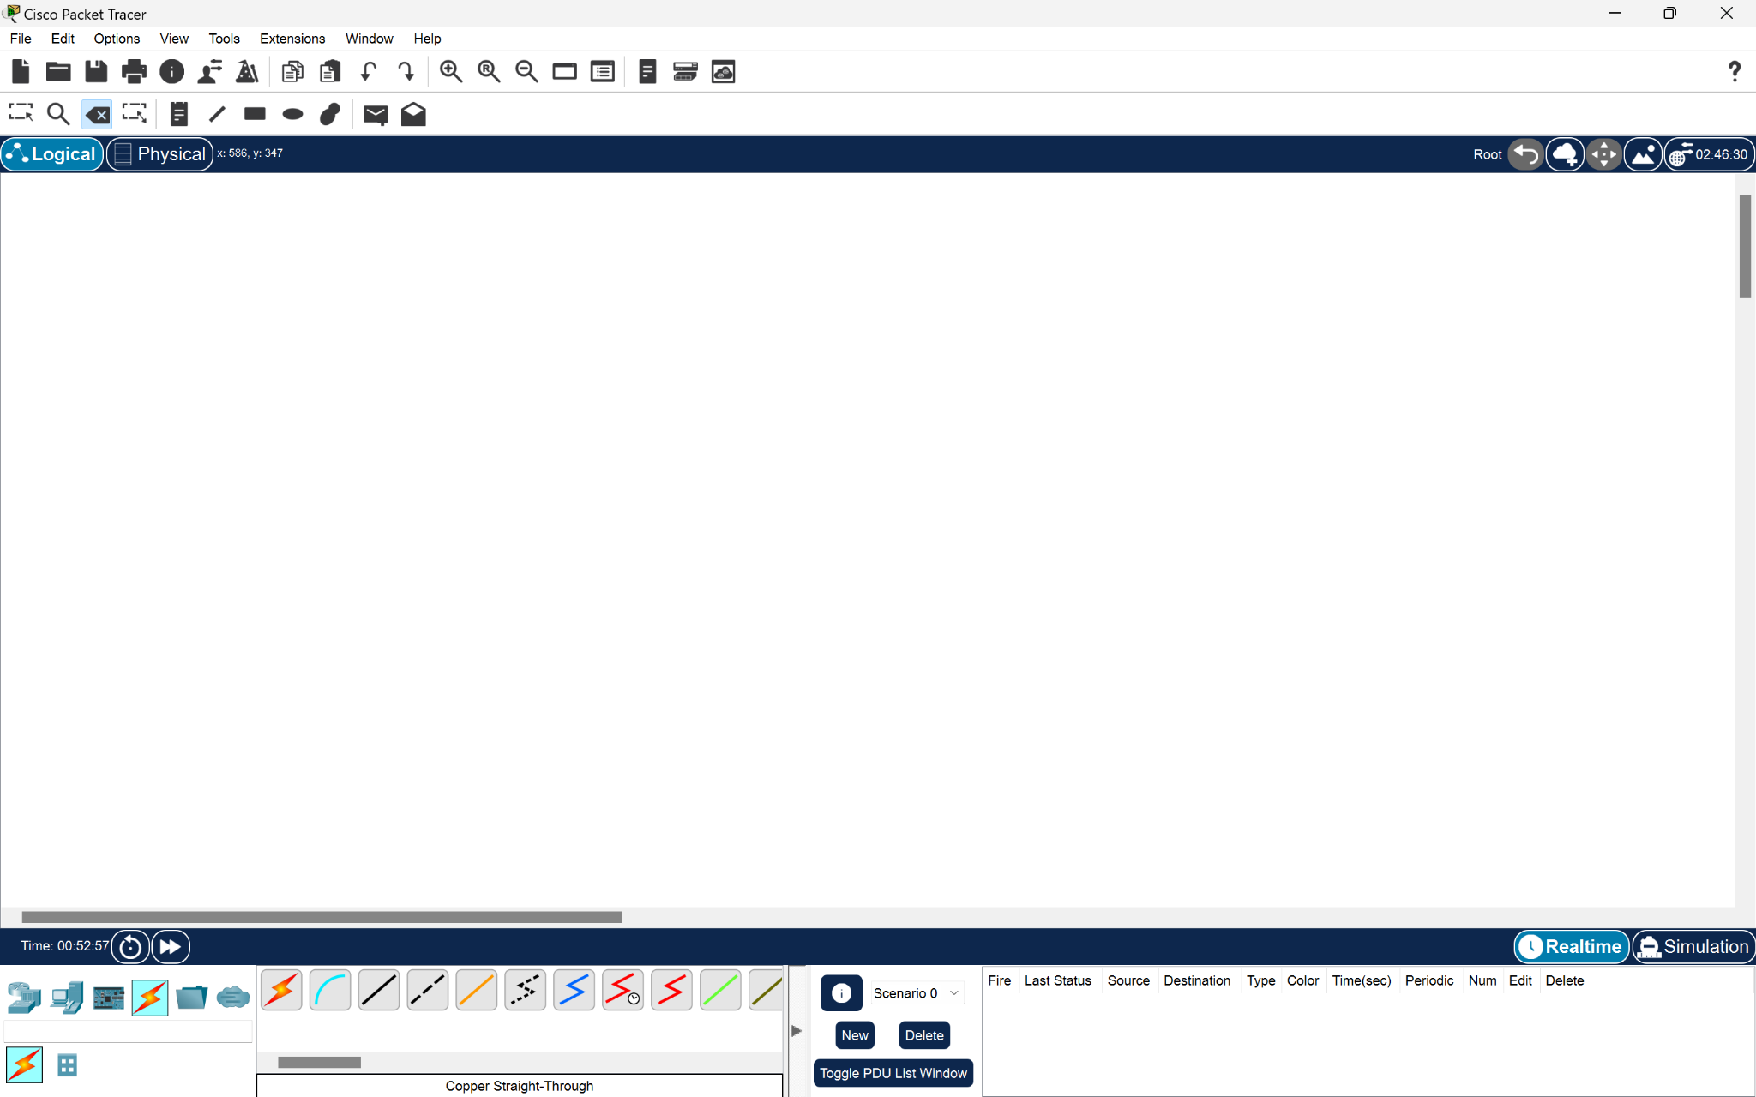

3. Basic Network Simulation:
- Creating a Simple Network:
  - Drag and drop two PCs (or laptops) and a switch from the device menu onto the workspace.
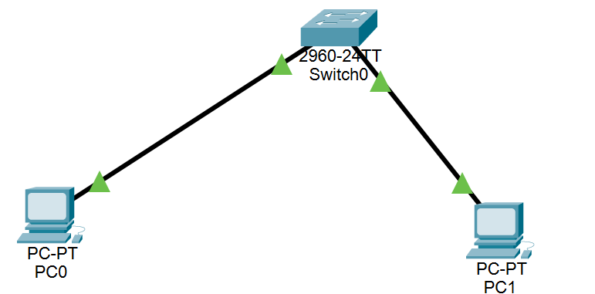
  - Connect the PCs to the switch using copper straight-through cables.

- Assigning IP Addresses:
  - Click on each PC and assign them unique IP addresses from the Desktop > IP Configuration menu (e.g., PC1: 192.168.1.2, PC2: 192.168.1.3).

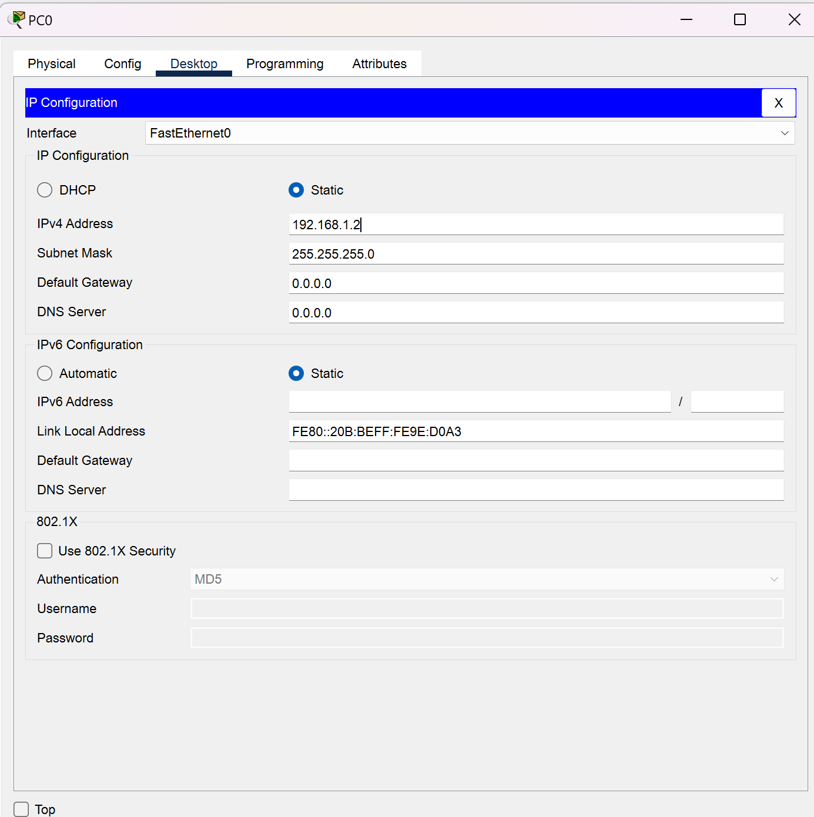

- Testing Connectivity:
  - Open the Command Prompt on PC1 and use the ping command to test the connection between PC1 and PC2.
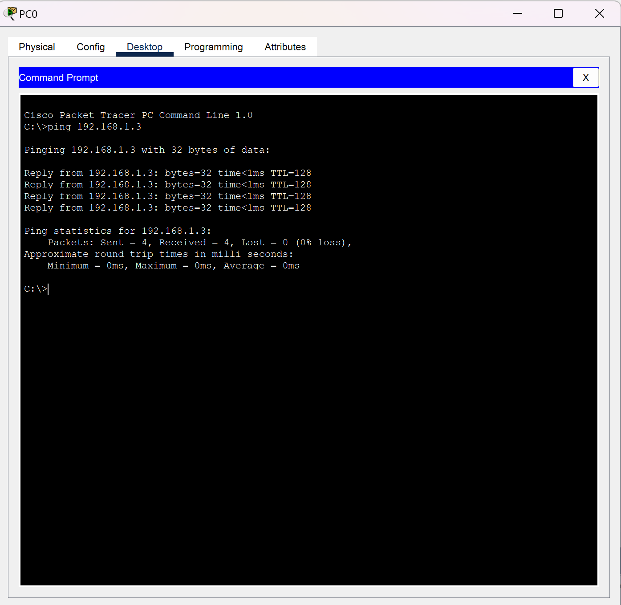
  - Example: ping 192.168.1.3 (PC2’s IP)

4. Simulation of Data Transfer:
- Switch to Simulation Mode to see the packet movement between the devices.
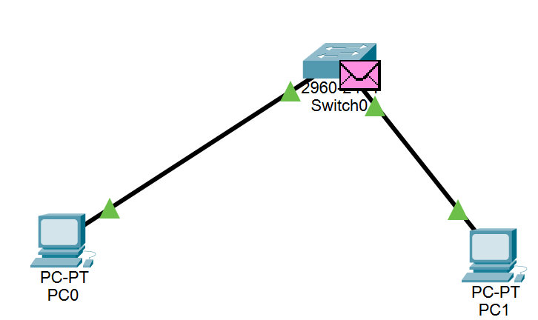
- Initiate a ping or any network activity (like sending an email or HTTP request) to observe how packets are transmitted and acknowledged across the network.

Result : Hence we installed the Packet Tracer and got hands on experiment done in which we made two computers communicate between them .

Experiment No. 4

Aim : To configure a basic network topology consisting of routers, switches, and end devices such as PCs or laptops. Configure IP addresses and establish connectivity between devices.

Steps :
Step 1: Set up the Network Topology
- Open Packet Tracer and drag the following devices from the left-hand side to the workspace:
  - One or more Routers (e.g., 1841).
  - One or more Switches (optional for multiple devices).
  - Two or more End Devices (PCs or laptops).
- Connect the devices:
  - Use copper straight-through cables to connect the PCs to the switch.
  - Connect the Switch to the Router's FastEthernet interface (e.g., FastEthernet0/0).
  - If you're connecting multiple routers, use serial cables to connect routers (e.g., Serial0/0/0 to Serial0/0/1).

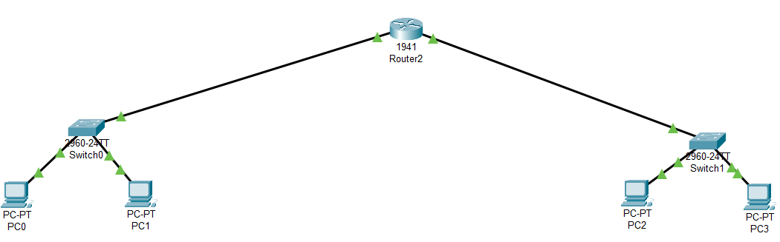

Step 2 : Configure the Router
- Open the config of router and manually set the IP address and subnet mask of the GigabitEthernet 0/0 (which is the left sub-network) .
IP : 10.0.0.3
Subnet mask : 255.0.0.0
- Set port status to on .

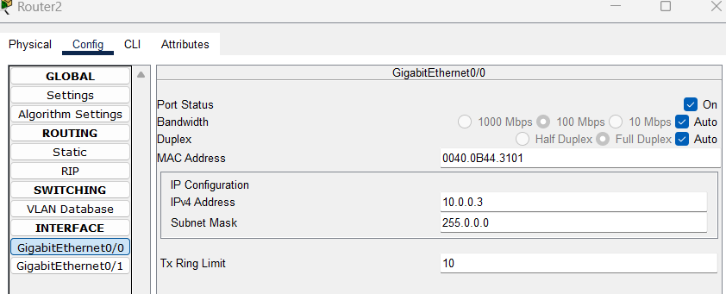

- Open the config of router and manually set the IP address and subnet mask of the GigabitEthernet 0/1 (which is the right sub-network) .
IP : 192.168.2.3
Subnet mask : 255.255.255.0

- Set the port status to on .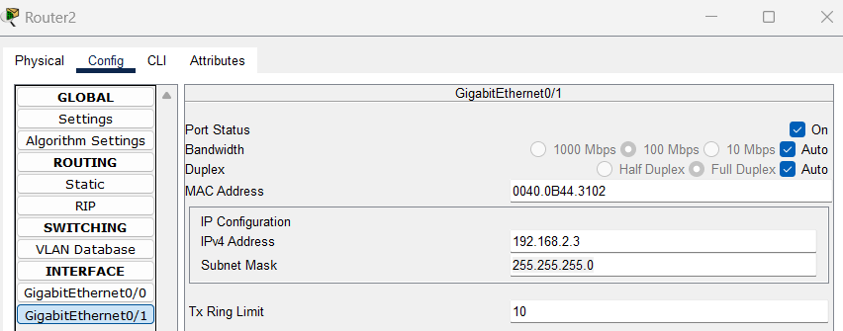
Step 3 : Configure all PCs manually
- Open the Desktop of a PC then click IP Configuration and set the IP address and Default Gateway .
IP : 10.0.0.1 (for a PC in left sub-network)
Default Gateway : 10.0.0.3 (for left sub-network)
Subnet Mask : 255.0.0.0

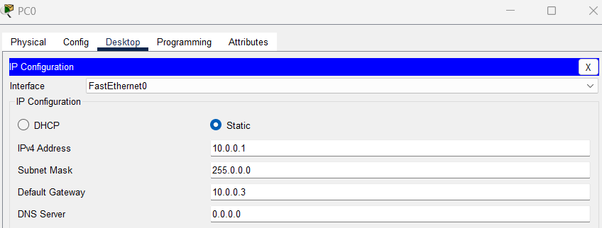

- Open the Desktop of a PC then click IP Configuration and set the IP address and Default Gateway .
IP : 192.168.2.1 (for a PC in right sub-network)
Default Gateway : 192.168.2.3 (for right sub-network)
Subnet Mask : 255.255.255.0

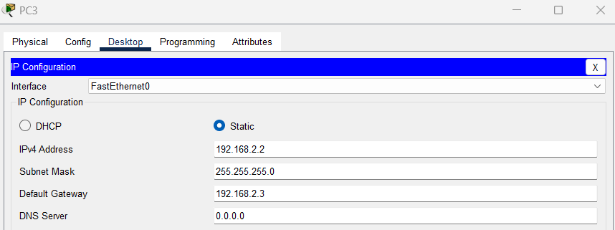

Step 4 : Verify network connectivity

- Select a PDU from options and place one on a PC in left sub-network and then place it on a PC in right sub-network .
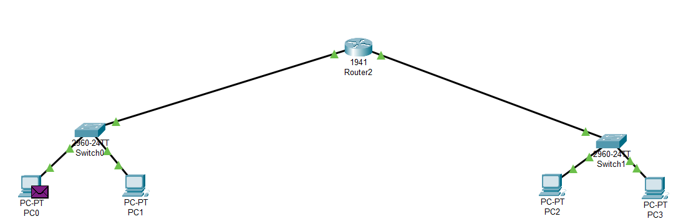

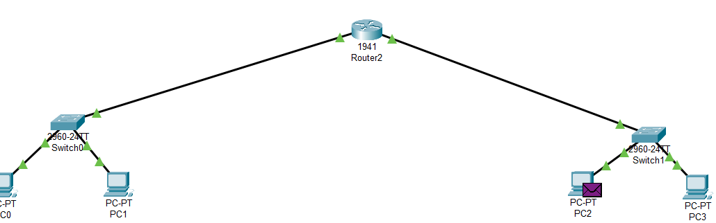

- Open the simulation mode and verify if the connection works successfully .

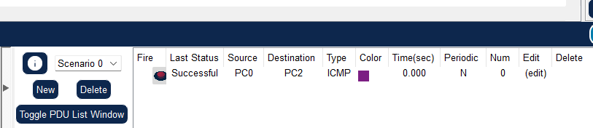

Result : We learned to configure a basic network topology consisting .

Experiment No. 5

Aim : To configure a DHCP server on a router or a dedicated DHCP server device. Assign IP addresses dynamically to devices on the network and verify successful address assignment.

1. USING ROUTER AS DHCP SERVER

Steps :
Step 1: Set up the Network Topology
- Open Packet Tracer and drag the following devices from the left panel to the workspace:
  - One Router
  - One or more PCs
  - One Switch
- Connect the devices:
  - Use copper straight-through cables to connect the PCs to the switch.
  - Connect the switch to one of the router's Fast Ethernet interfaces (e.g., FastEthernet0/0).
  - If you're using only one PC, directly connect the PC to the router's Fast Ethernet interface.
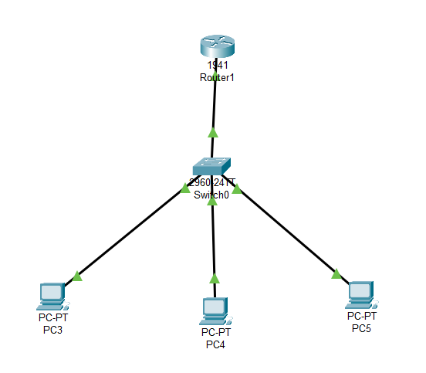

Step 2: Configure the Router
- Click on the Router and go to the CLI tab.
- Press Enter to access the CLI.
- Enter privileged mode by typing:
enable
- Enter global configuration mode:

configure terminal

Step 3 : Configure the Router as a DHCP Server
- Define the DHCP pool (this is the range of IP addresses that the router will assign):
#ip dhcp pool DHCP
#network 192.168.1.0 255.255.255.0
#default-router 192.168.1.1
#exit

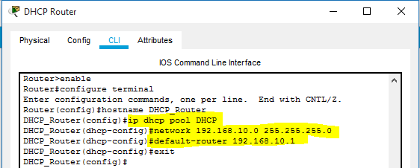

Step 5: Configure the PC to Obtain IP Automatically
- Click on the PC, go to the Desktop tab, and open IP Configuration.
- Select DHCP to obtain the IP address automatically.

Step 6: Verify the DHCP Assignment
- On the PC, check if an IP address is assigned automatically.
  - Go to Desktop -> IP Configuration and see the assigned IP, subnet mask, default gateway, and DNS server.

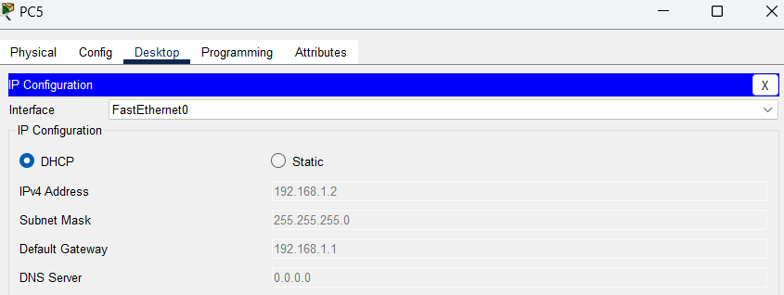

2. USING DEDICATED SERVER DEVICE AS DHCP SERVER

Step 1: Set up the Network Topology
- Open Packet Tracer and drag the following devices from the left panel to the workspace:
  - DHCP Server (You can find this under "Servers" and choose the "Generic Server").
  - One or more PCs (end devices).
  - One Switch to connect multiple devices.
  - Router to serve as the default gateway for the network.
- Connect the devices:
  - Use copper straight-through cables to connect the PCs to the switch.
  - Connect the DHCP Server to the switch.
  - Connect the switch to the Router (e.g., FastEthernet0/0 of the router).
This creates a simple network with PCs, a switch, a DHCP server, and a router.
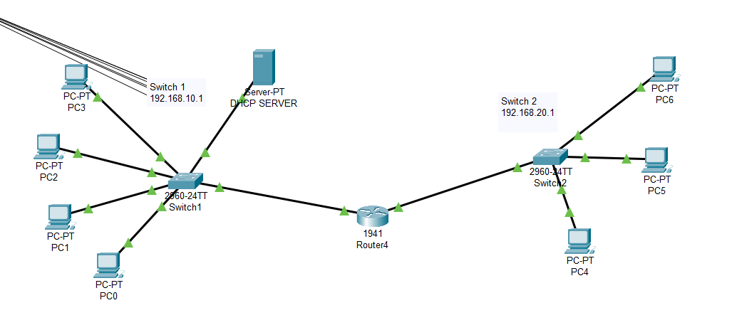

Step 2: Configure the Router
The router will act as the default gateway for your network, and the DHCP server will assign IP addresses to devices.
- Click on the Router and go to the CLI tab.
- Enter privileged mode by typing:
enable
- Enter global configuration mode:

configure terminal

- Assign an IP address to the interface connecting to the switch (e.g., FastEthernet0/0):

interface gigabit 0/1
ip helper-address 10.0.0.10

Step 3: Configure the DHCP Server
- Click on the DHCP Server device, go to the Desktop tab, and open the IP Configuration.
- Assign a static IP address to the DHCP Server that falls within the same network as the router's interface:
  - IP Address: 192.168.1.2
  - Subnet Mask: 255.255.255.0
  - Default Gateway: 192.168.1.1 (Router's IP address)

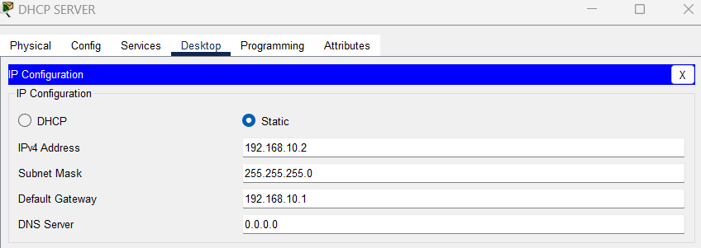

- After setting the server's static IP, go to the Services tab and follow these steps:
  - Select DHCP from the list of services.
  - Turn ON the DHCP service by toggling the button if it is not already on.
  - Under the DHCP Configuration section, configure the following:
    - Pool Name: You can name it something like "LAN".
    - Default Gateway: 192.168.10.1 (Router’s IP address).
    - DNS Server: 0.0.0.0 (Google DNS or any other DNS).
    - Start IP Address: 192.168.10.0 (or the first IP in the range you want to assign).
    - Subnet Mask: 255.255.255.0.
    - Max Number of Users: You can set this based on the size of your network, e.g., 50.
  - Click Add to apply the configuration.
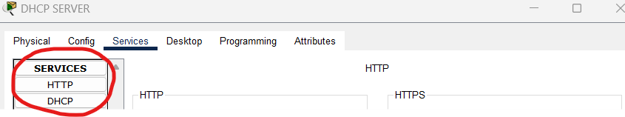

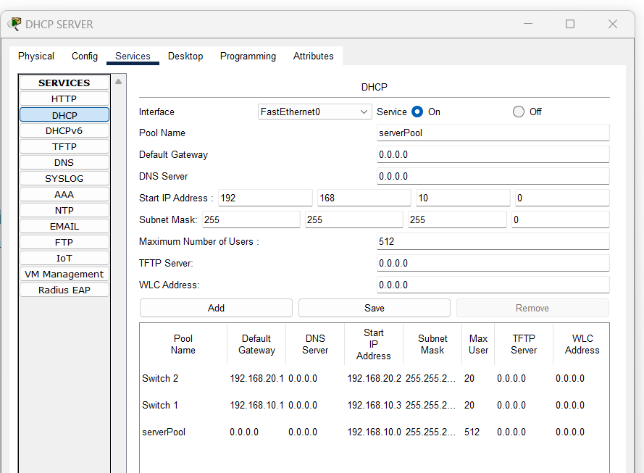

Step 4: Configure the PC to Obtain an IP Address Automatically
- Click on each PC, go to the Desktop tab, and open IP Configuration.
- Select DHCP to allow the PC to receive an IP address automatically from the DHCP server.
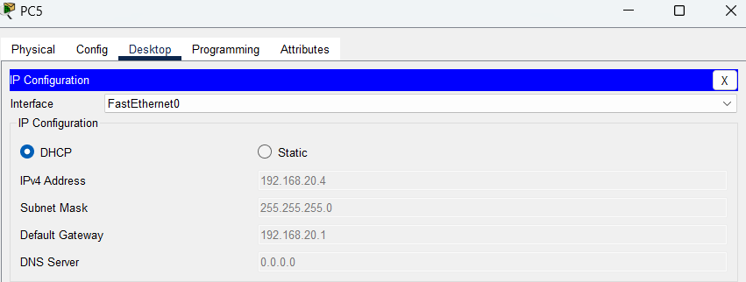

Step 5: Verify the DHCP Assignment
- Once the PC is set to DHCP, it should automatically receive an IP address from the DHCP server.
  - Go to the Desktop tab on the PC and check the IP Configuration. You should see an IP address assigned within the range specified in the DHCP server (e.g., 192.168.10.1 and above), along with the correct subnet mask, gateway, and DNS server.

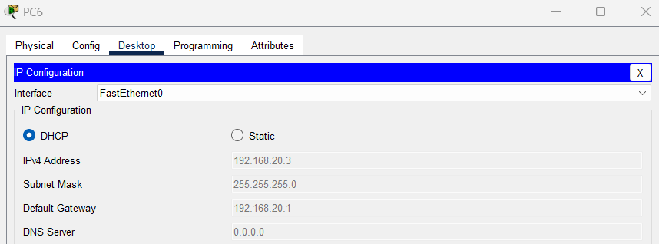

Result : We learned the way to configure a DHCP server on a router or a dedicated DHCP server device. Assign IP addresses dynamically to devices on the network and verify successful address assignment.

EXPERIMENT N0. 6

Aim :- To configure a local DNS server to resolve domain names within a network.

Procedure:-

Step1) Set Up the Devices
- Drag and drop the following devices onto the Packet Tracer workspace:
  - 1 Switch
  - 2 PCs
  - 1 Server (you will configure it as both a DNS server and a Web server)
- Connect the devices to the switch using Copper Straight-Through cables:
  - Connect PC1 and PC2 to the switch.
  - Connect the Server to the switch.
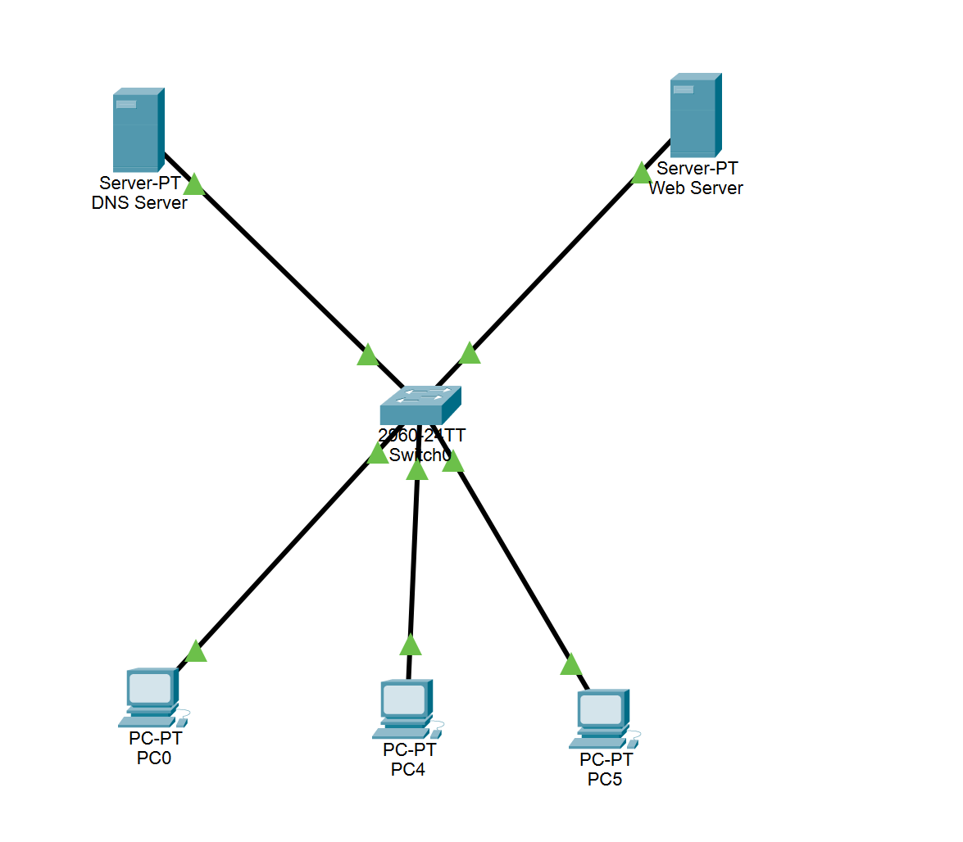

Step 2: Configure the DNS Server
- Select the Server.
- Go to the Services tab and click on DNS.
- Turn DNS Service On.
- In the Name field, add a domain name you want the DNS server to resolve (e.g., google.com).
- In the Address field, enter the IP address of the Web Server (this will be the same IP since the same server will act as both DNS and Web server).
  - Example: 192.168.1.2
- Click Add to save the domain and IP mapping.
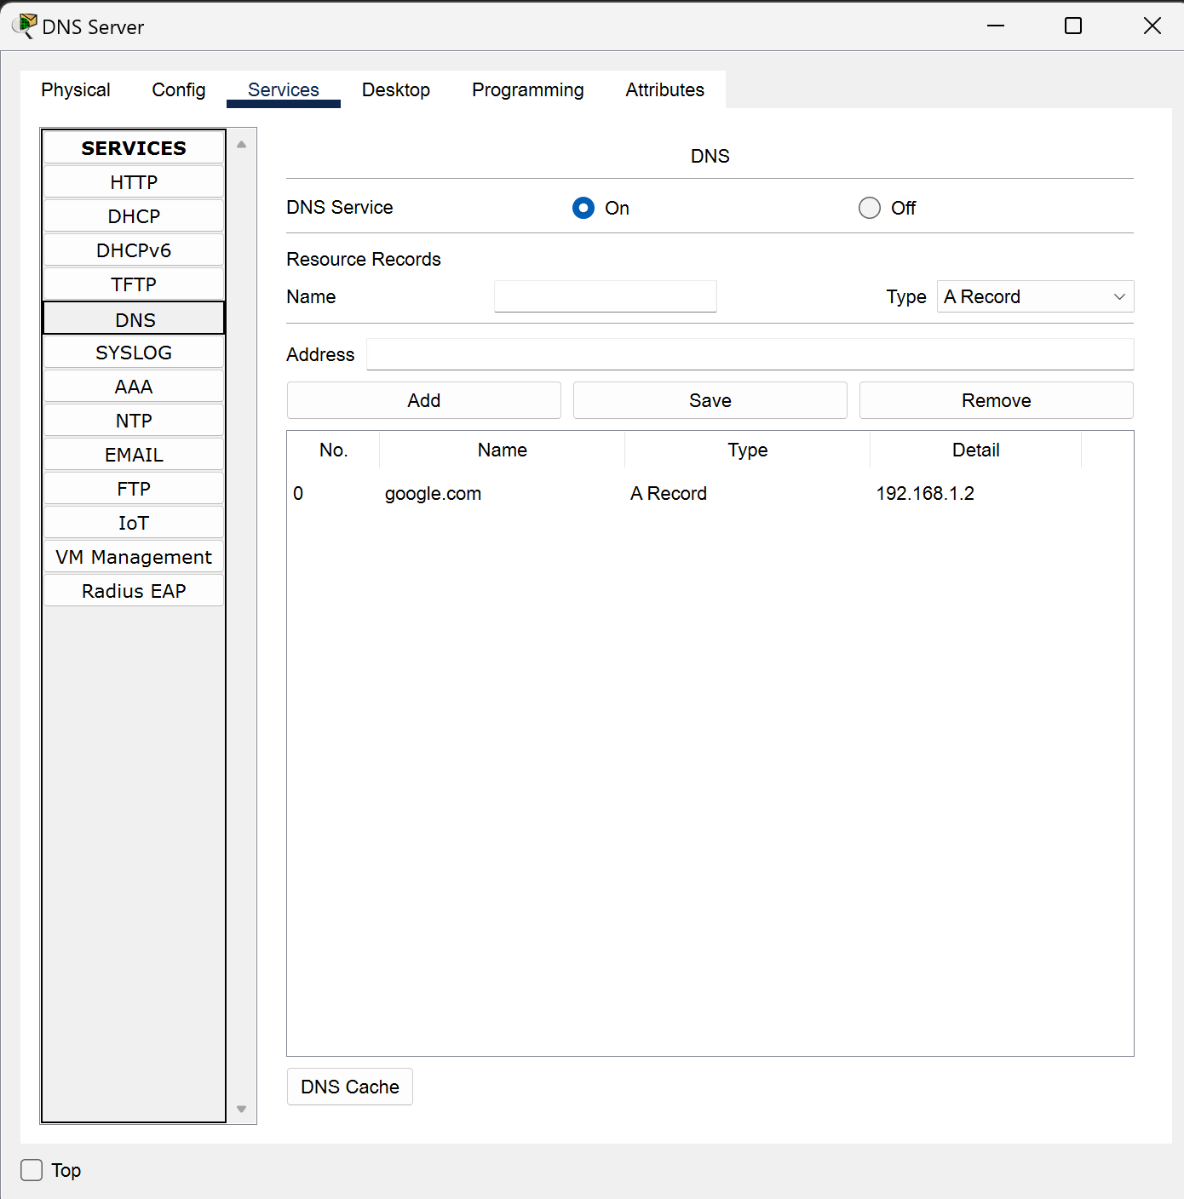

Step 3: Configure the Web Server
- Stay on the same Server.
- Go to the Services tab, and click on HTTP.
- Ensure that HTTP is on (so the server can serve web pages).
- You can modify the web content in the index.html file or leave it as default.
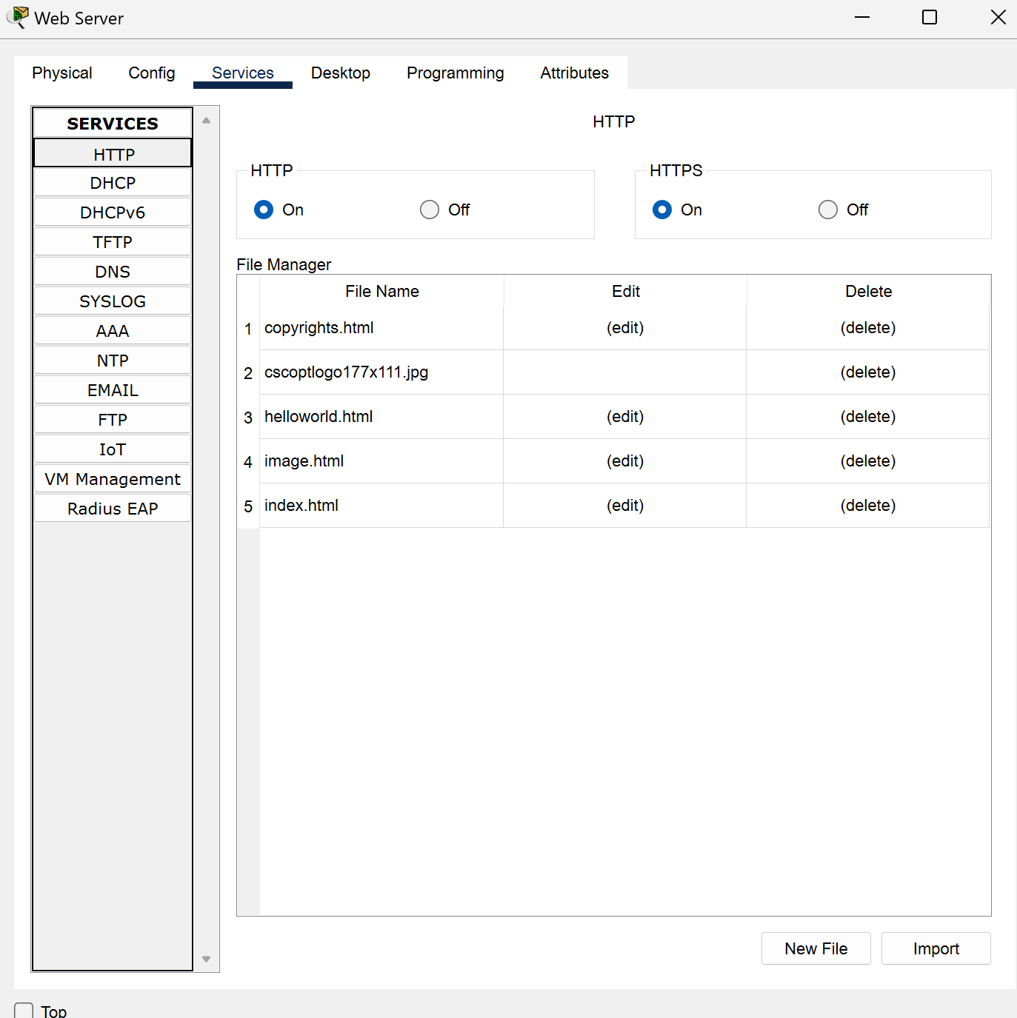

Step 4: Assign IP Addresses

For the DNS Server:
- Go to the Desktop tab of the Server and click on IP Configuration.
- Assign a static IP address to the server (e.g., 192.168.1.1).
  - Subnet Mask: 255.255.255.0

For the Web Server:
- Go to the Desktop tab of the Server and click on IP Configuration.
- Assign a static IP address to the server (e.g., 192.168.1.2).
  - Subnet Mask: 255.255.255.0

For the PC’s:
- Go to the Desktop tab of the PC and click on IP Configuration.
- Also set the DNS server address to 192.168.2.1(Which is addres of our DNS server)
- Assign a static IP address to the server (e.g., 192.168.1.3) and so on to the other systems.
  - Subnet Mask: 255.255.255.0
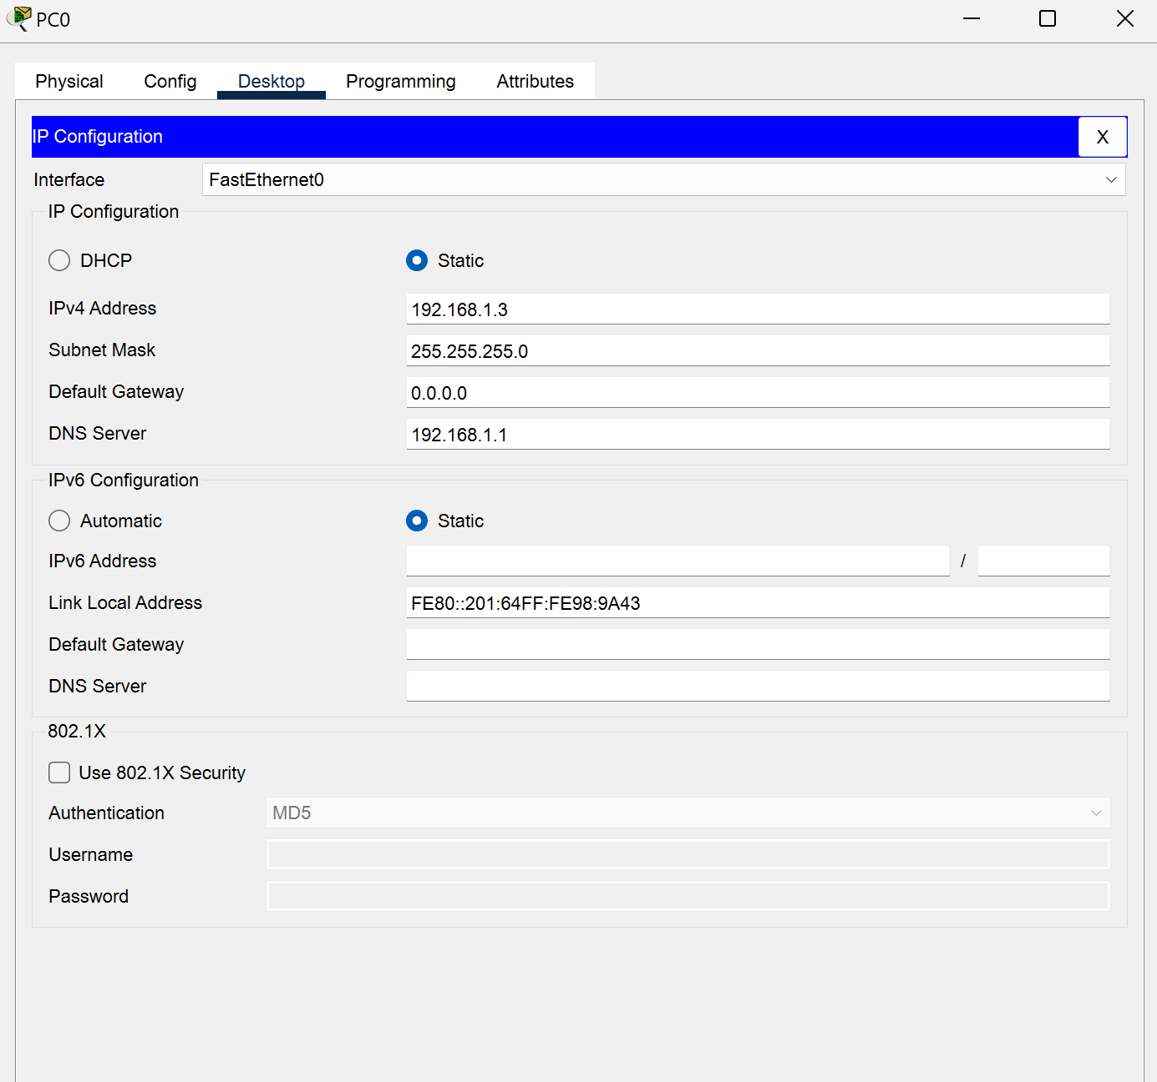

Step 4: Testing the DNS and Web server
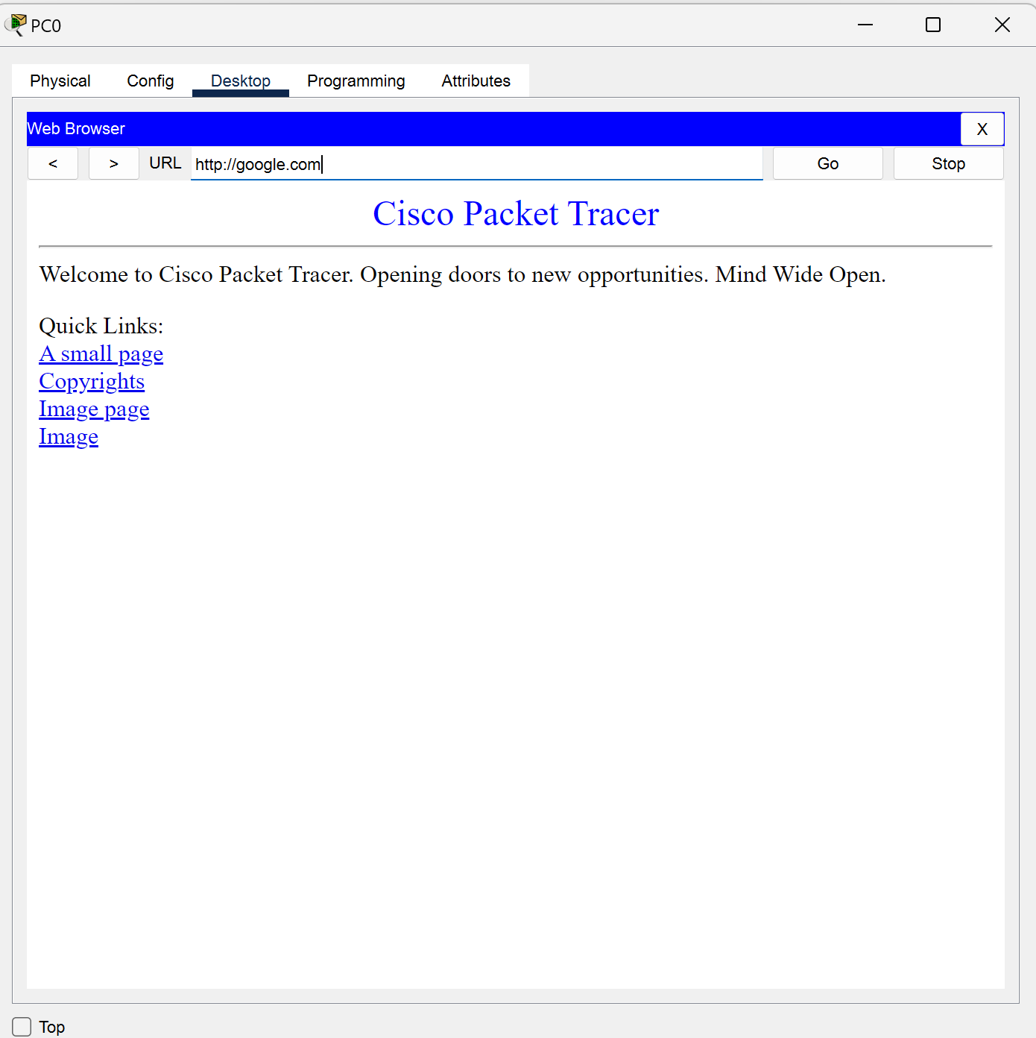
- Go to the PC0 and click on the Desktop and then click on the Web Browser and search “google.com”.

Result: Hence we learned to configure the DNS and Web Server .

Experiment No. 7

Aim:- To analyze the TCP header format using Wire Shark.

Steps:-
Step 1) First go to the official website of the Wireshark(https://www.wireshark.org/download.html).
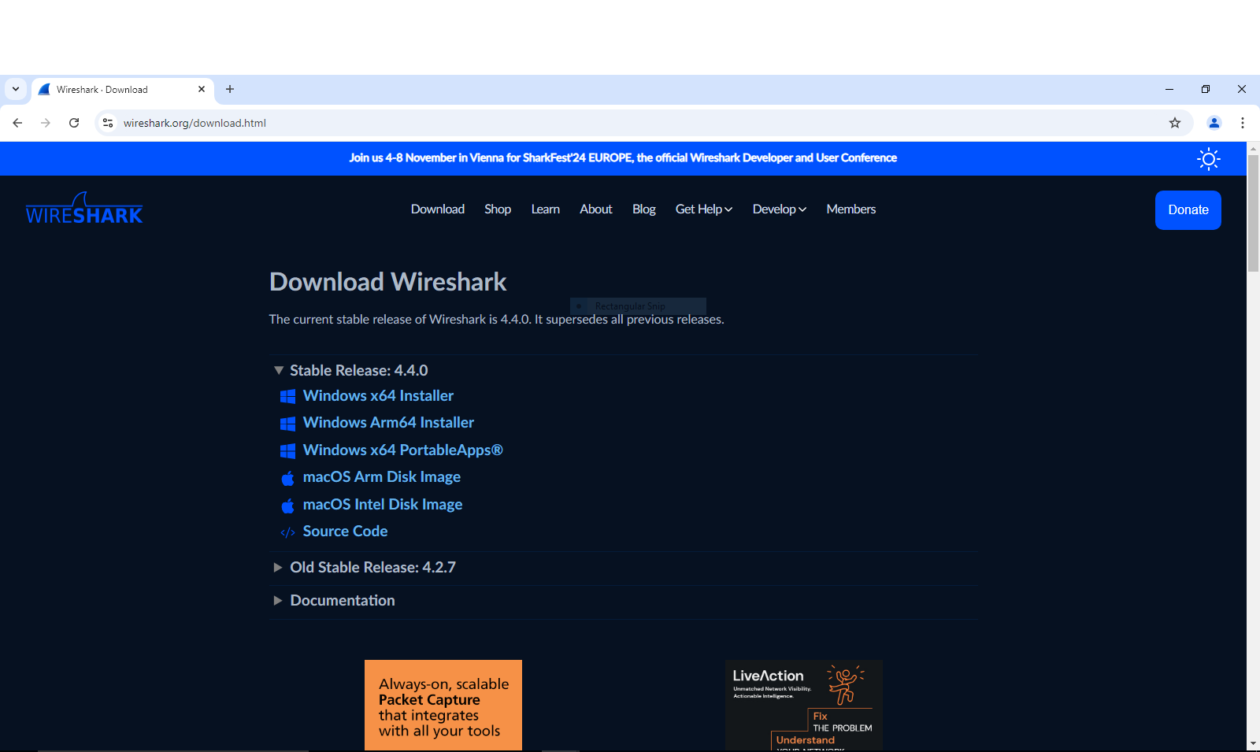

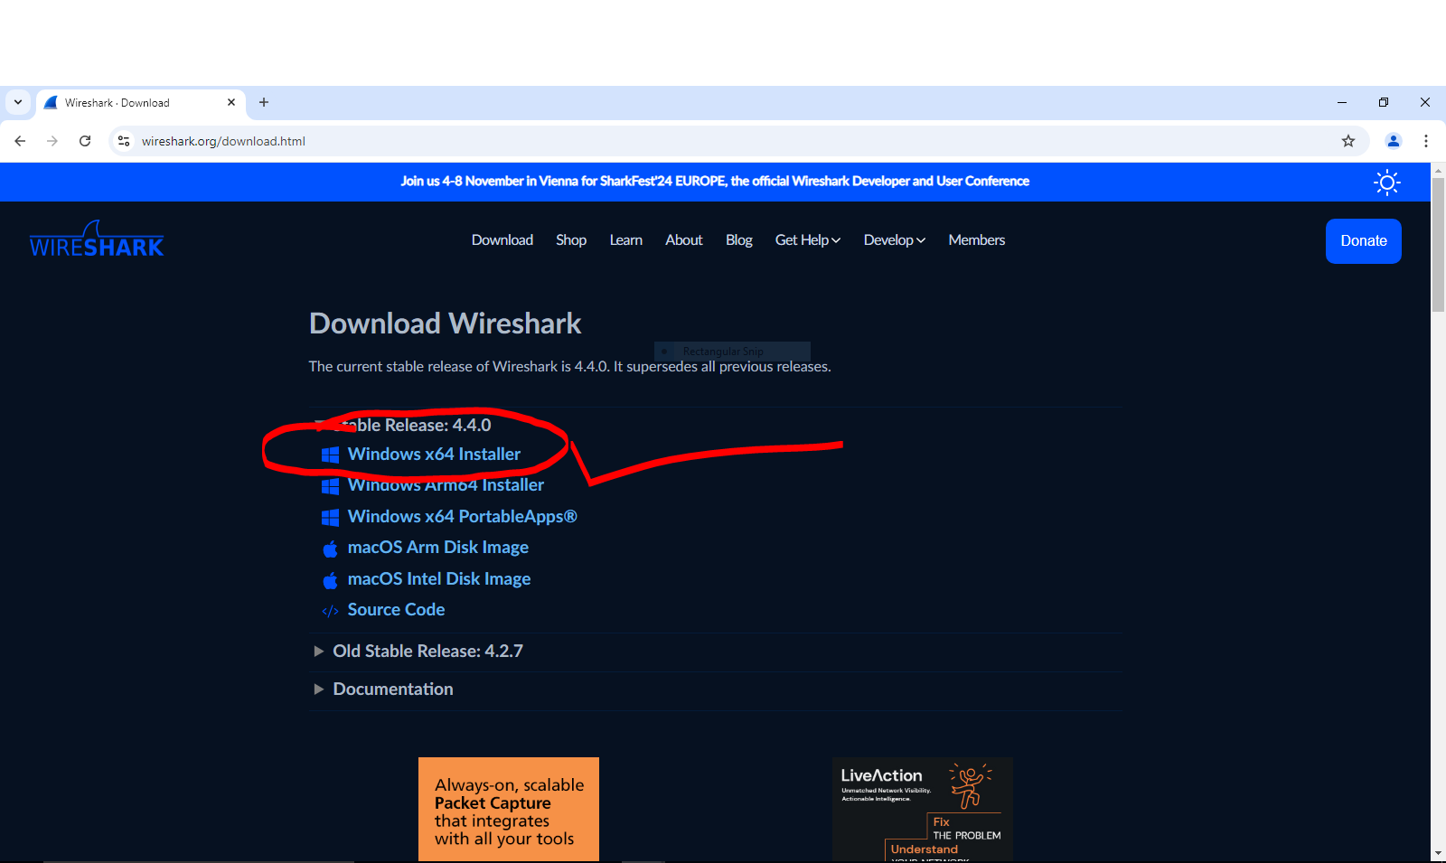
Step 2)Click ur OS compatible version according to your system requirement.

Step 3)Now install the downloaded file (exe) then open it.

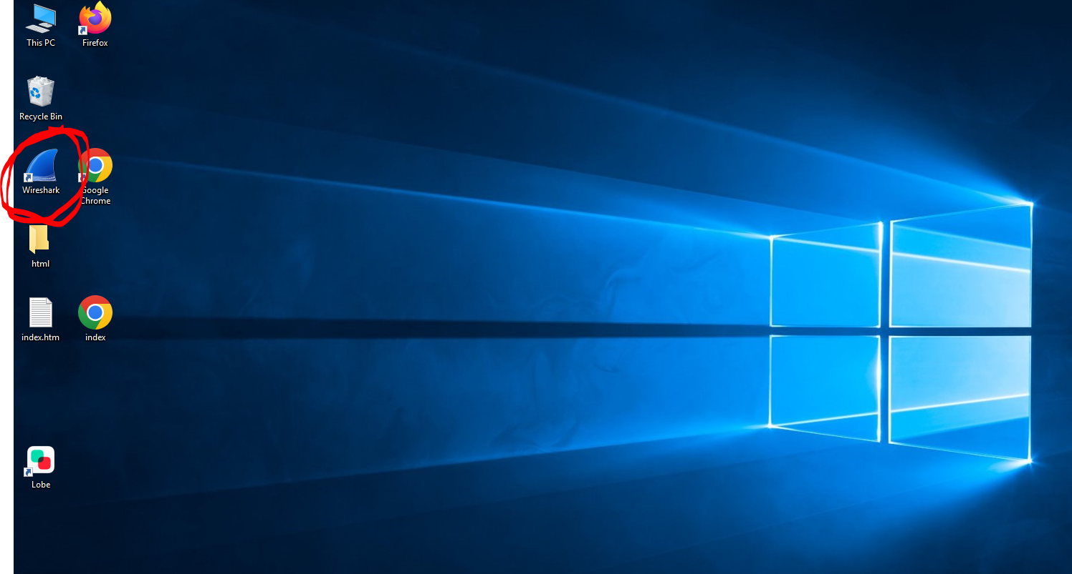

Step 4)Now you will get this kind of interface .
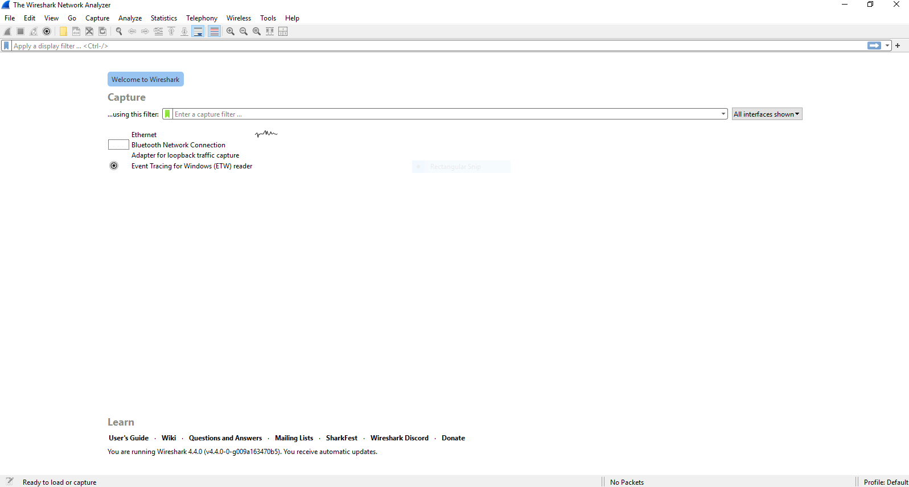

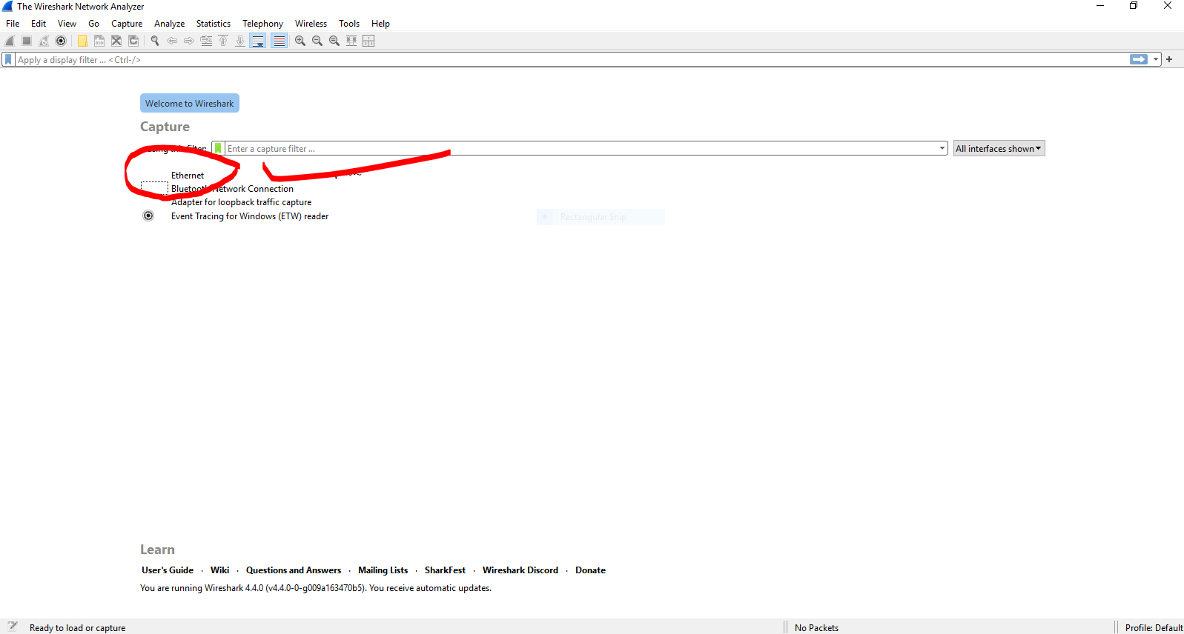
Step 5) Now click on the “Ethernet” option.To investigate the network packets of the “Ethernet” connection.

Step 6)Now u will get the random series of values or number coming in the window like this.

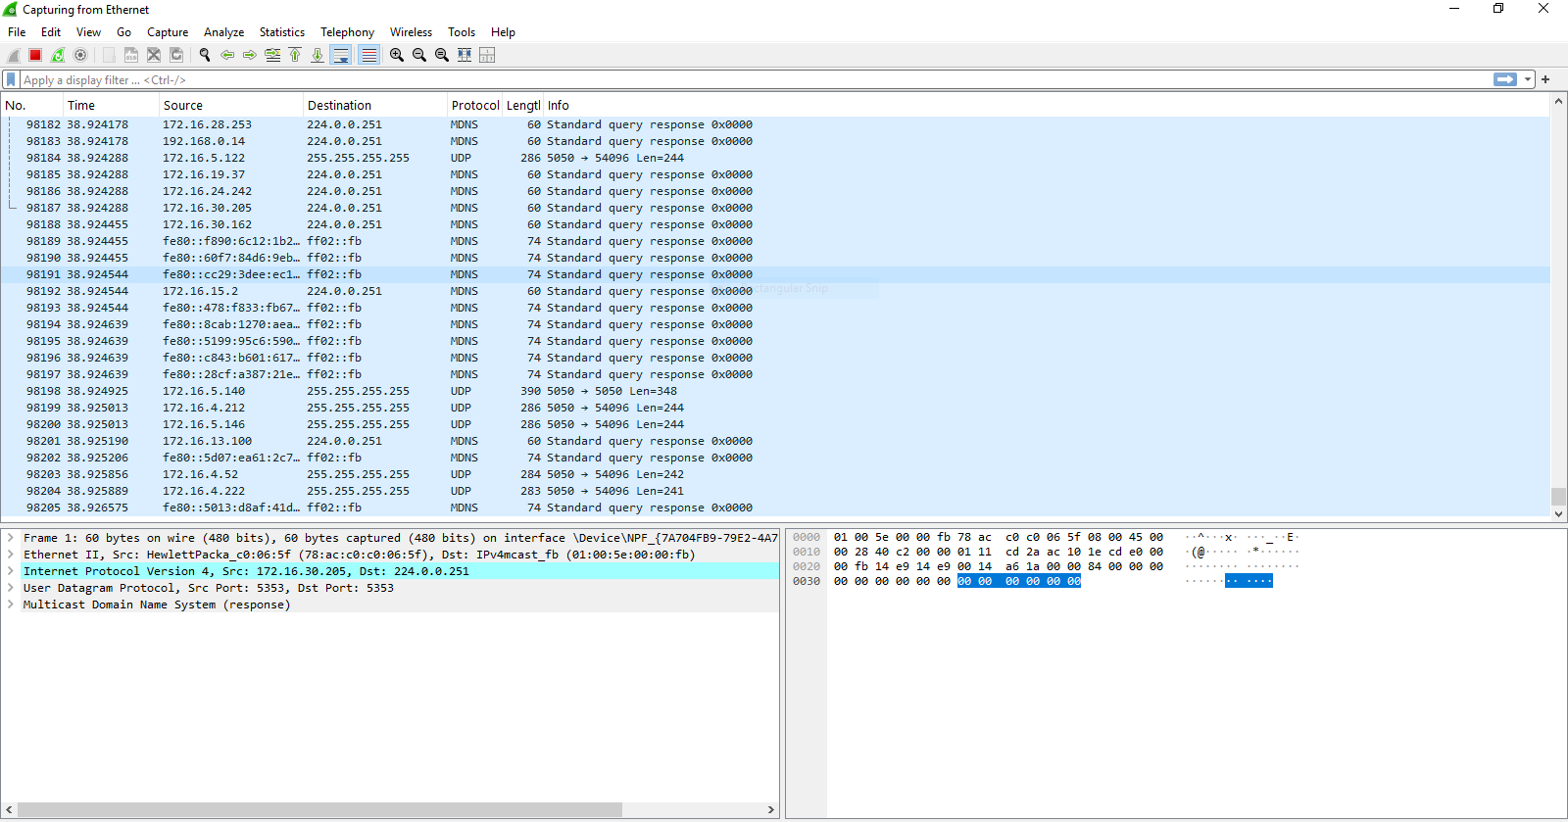

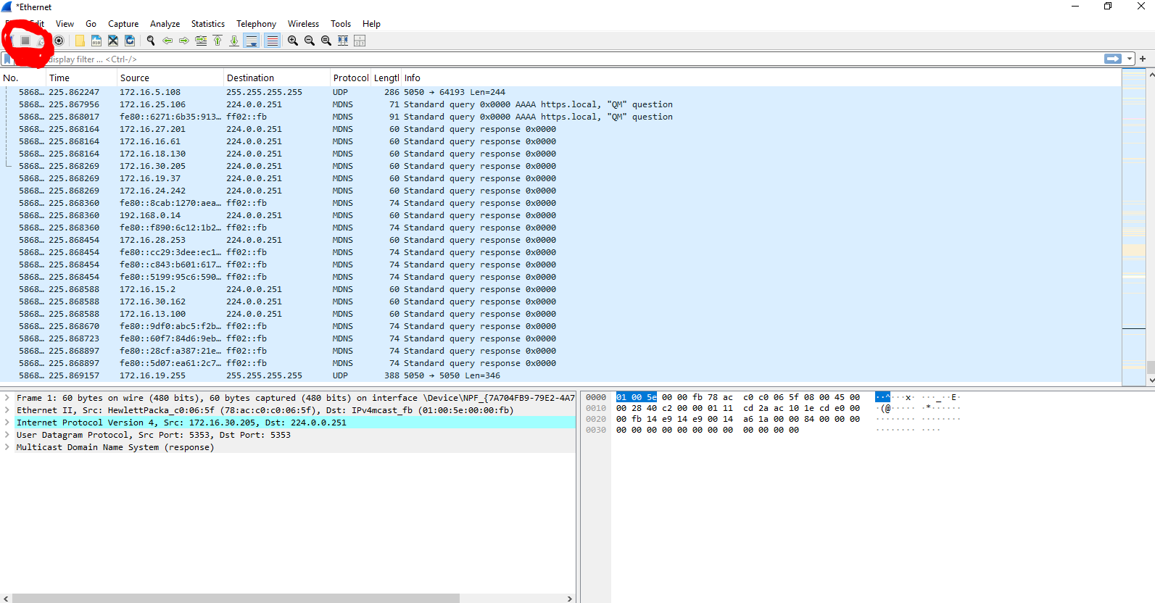
Step 7)Now click on the “Stop” option to stop the random sequences in the screen.

Step 8)Now search for the “tcp” in “Type Filter ” for searching the TCP related packets.

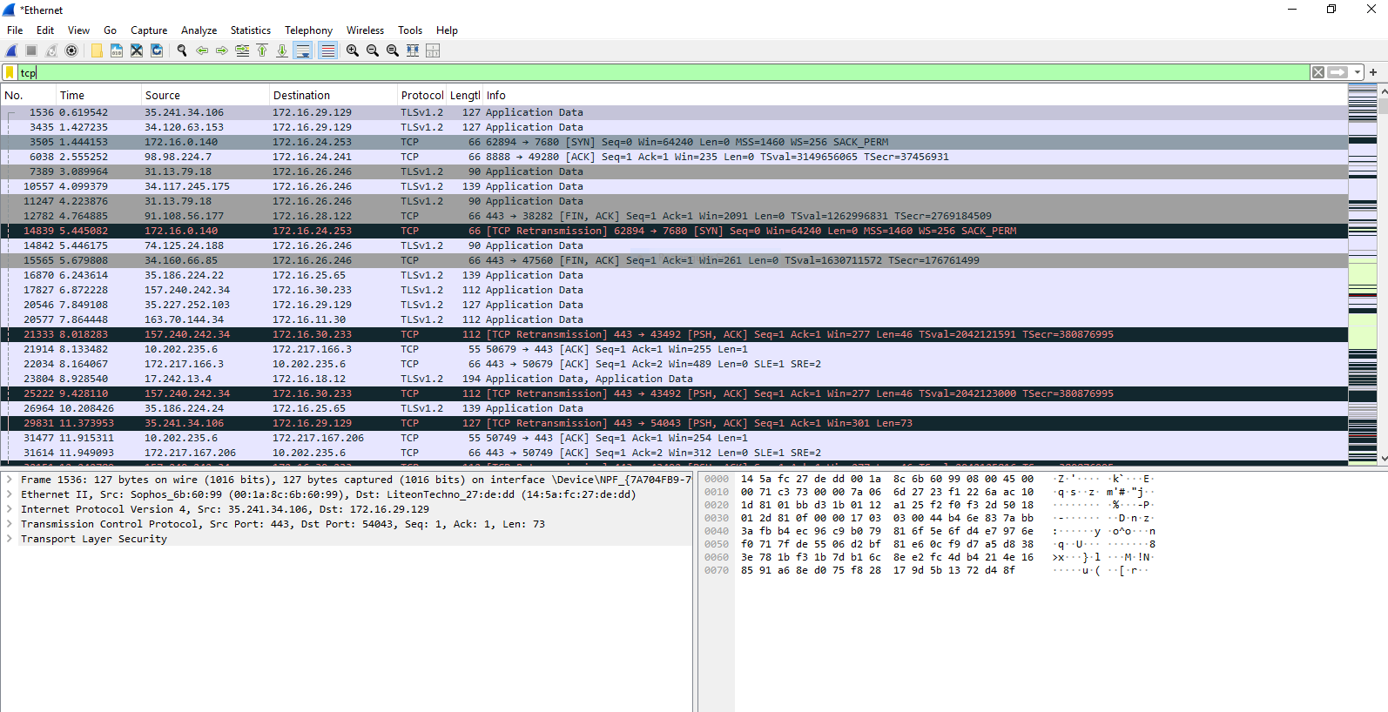

Step 9)Now you got the TCP packets , so now click any one of them and inspect the packet properties.
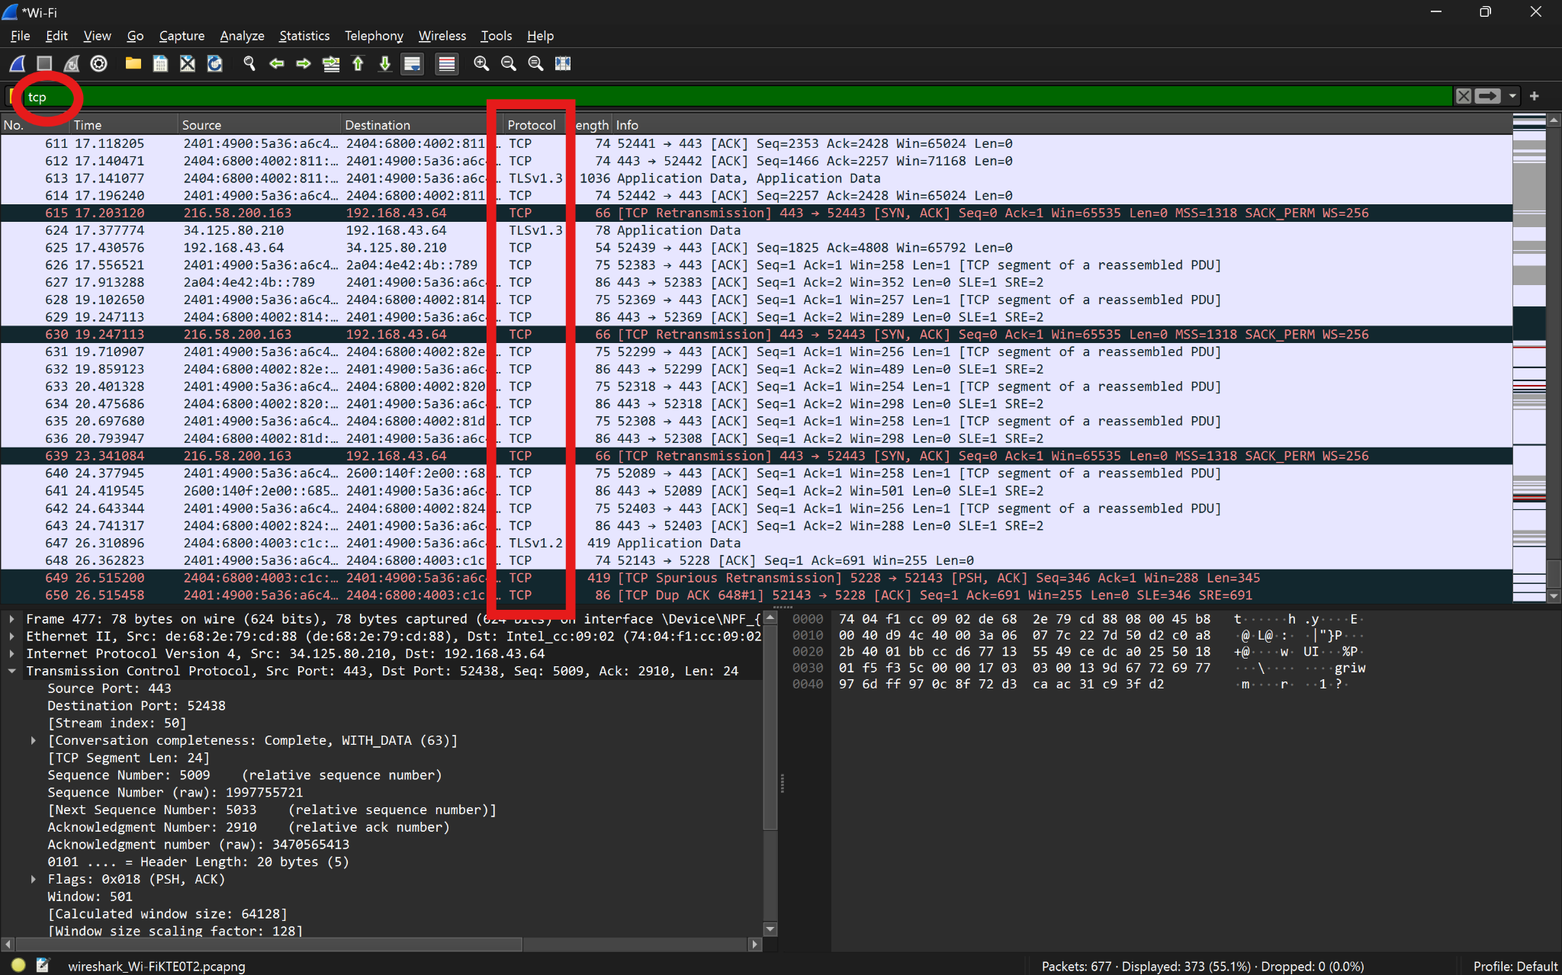

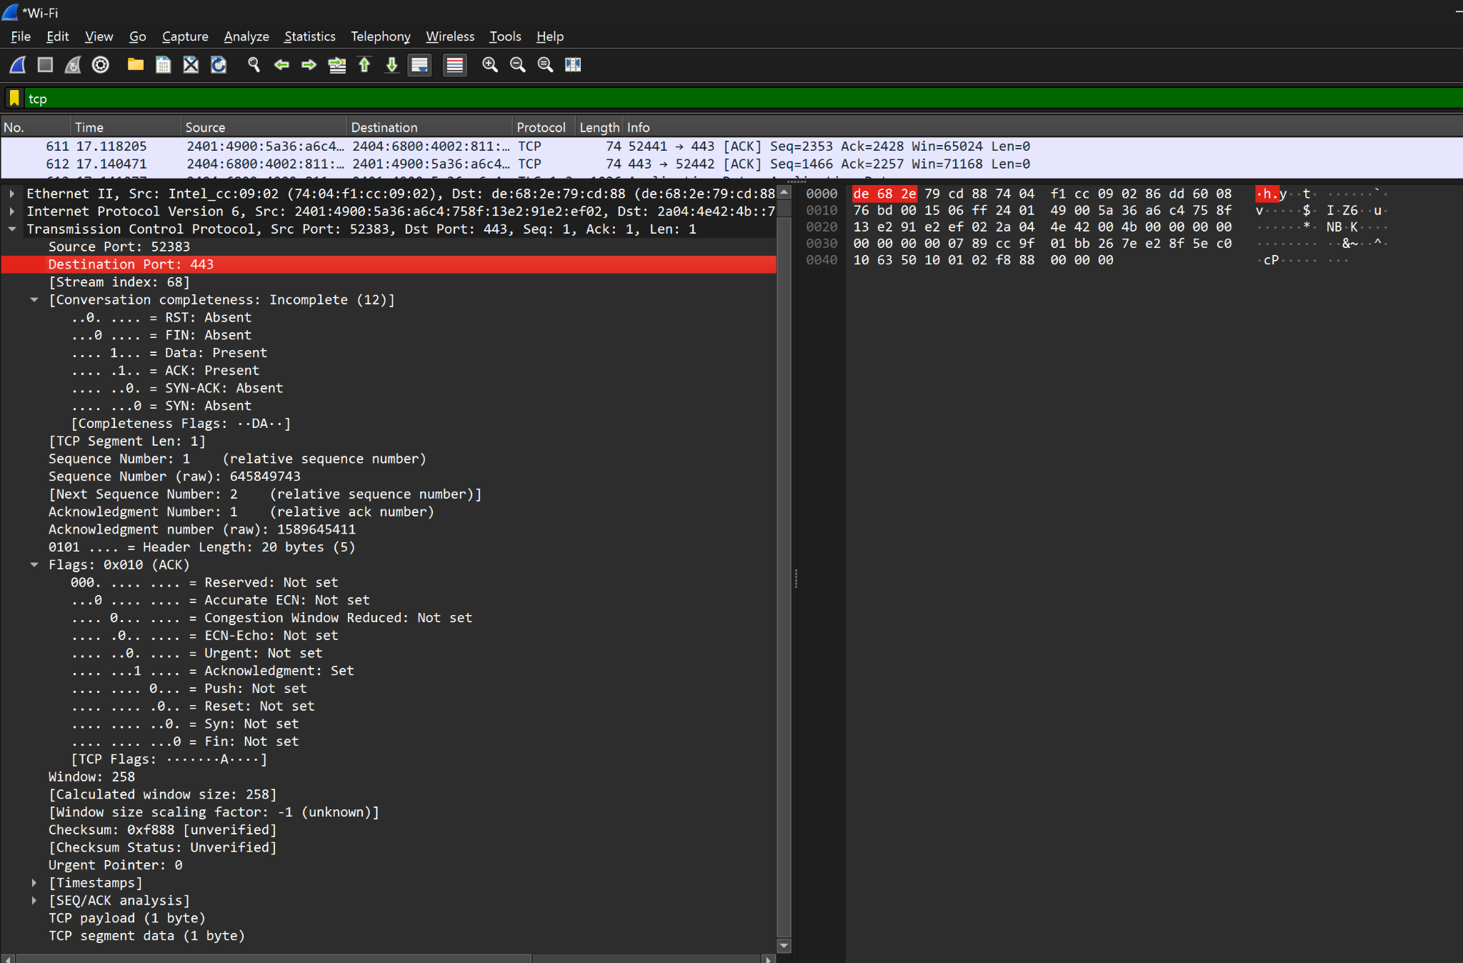
Step 10)Now check for the different attribute in the packets like Source IP,Destination IP , Flags ,Window size ,Acknowledgement ,Checksum ,etc.

Result :-Hence we learned the introduction to wireshark and inspected a packet.

Experiment No. 8

Aim : Implement a TCP client program that sends a message to a TCP server program. Implement the corresponding TCP server program that receives the message and displays it. Test the communication between the client and server by exchanging messages.

Procedure :
Step 1: Setup the Server Program
1)Include the necessary libraries:
Include <stdio.h>, <stdlib.h>, <string.h>, <unistd.h>, and <arpa/inet.h> for socket programming.
2)Create the socket:
Use socket() to create the server socket.
3)Assign IP and port:
Use sin_family, sin_addr.s_addr, and sin_port to assign the protocol, IP, and port to the server.
4)Bind the socket:
Bind the server socket to the assigned IP address and port using bind().
5)Listen for client connections:
Use listen() to make the server listen for incoming client connections.
6)Accept a client connection:
Use accept() to accept the incoming connection.
7)Receive and display the client message:
Use read() to receive the message from the client.
8)Send a response back to the client:
Use send() to send a response (like "Hello from server").
9)Close the server socket:
Use close() to properly close the server socket after the interaction.
Step 2: Setup the Client Program
1)Include the necessary libraries:
Similarly, include <stdio.h>, <stdlib.h>, <string.h>, <unistd.h>, and <arpa/inet.h> for the client.
2)Create the socket:
Use socket() to create a client socket.
3)Assign server IP and port:
Use sin_family and sin_port to assign the protocol and port.
4)Convert the server
IP address from text to binary form using inet_pton().
5)Connect to the server:
Use connect() to establish a connection to the server.
6)Send a message to the server:
Use send() to send a message from the client to the server.
7)Receive the server's response:
Use read() to receive the response message from the server.
8)Close the client socket:
Close the socket using close() after communication is done.
Step 3: Compile and Run the Programs
1)Compile the server program:
- gcc -o server server.c
2)Compile the client program:
- gcc -o client client.c
3)Run the server first:
- ./server
The server will wait for a client connection.
4)Run the client (in another terminal or on a different machine):
- ./client
The client will connect to the server, send a message, and display the response.

Step 4: Test the Program
- Ensure both the server and client are running on the same machine (using 127.0.0.1 as the IP) or across different machines (specifying the server's IP address in the client code).
- Verify that the client sends the message and receives the server's response, while the server receives the message and sends a response.

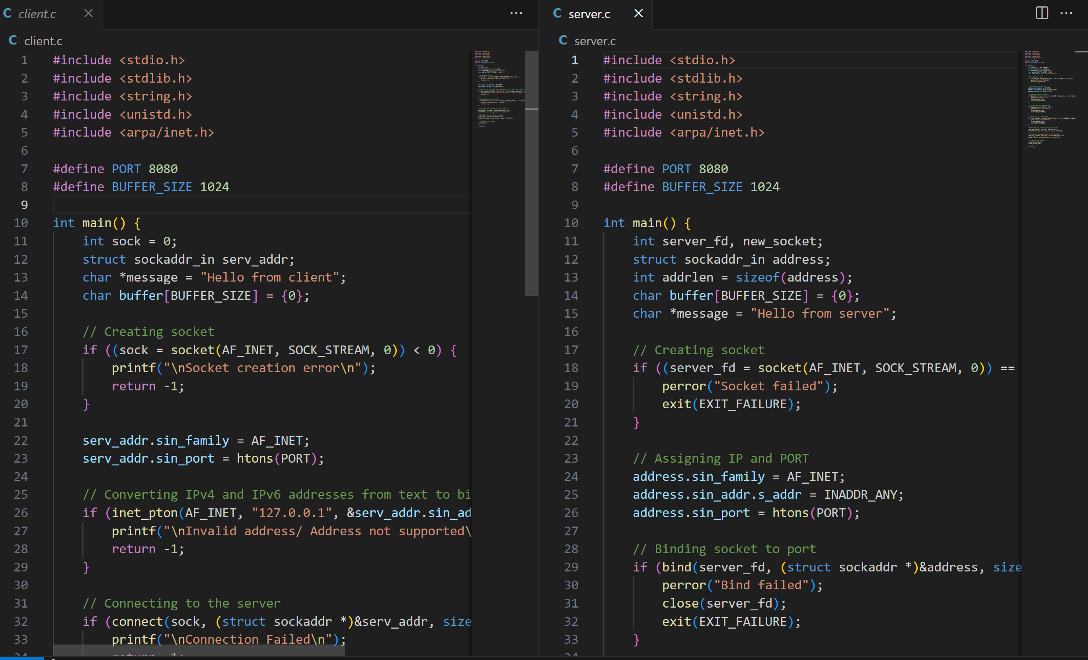
Output:
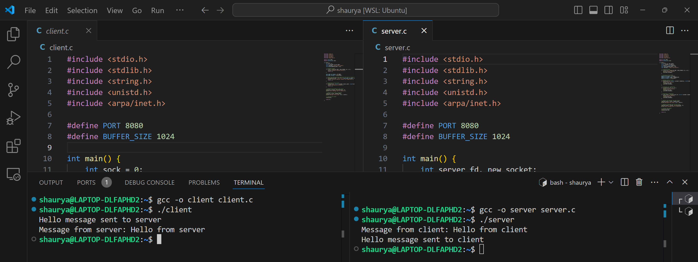

Experiment No. 9

Aim : Implement a UDP client program that sends a message to a UDP server
program. Implement the corresponding UDP server program that receives the message
and displays it.

Theory:
UDP (User Datagram Protocol) is a connectionless protocol that allows for fast, efficient communication between hosts. Unlike TCP, UDP does not establish a connection before data transmission, which makes it faster but less reliable. However, UDP is often used for applications where speed is critical, such as video streaming, DNS queries, and online gaming
.In this experiment, we will:
- Implement a UDP server that listens for incoming messages on a specified port.
- Implement a UDP client that sends a message to the server.
- The server will respond to the client after receiving a message.

Algorithm:
UDP Server:
- Create a socket using socket() function with AF_INET for IPv4 and SOCK_DGRAM for UDP.
- Set the server address (sin_family, sin_port, and sin_addr).
- Bind the socket to the specified port using bind().
- Enter an infinite loop to continuously receive messages from clients using recvfrom().
- Print the message received from the client.
- Respond to the client using sendto().
- Continue until manually stopped.

UDP Client:
- Create a socket using socket() function with AF_INET and SOCK_DGRAM.
- Set the server's address to send data to.
- Prompt the user to enter a message.
- Send the message to the server using sendto().
- Wait for a response from the server using recvfrom().
- Print the server's response.
- Repeat until the program is manually terminated.
Compilation & Execution:
Compile the server program:
- gcc udp_server.c -o udp_server
- Compile the client program:
- gcc udp_client.c -o udp_client
- Run the server program:
- ./udp_server
The server will start listening on port 8080 for incoming messages from the client.
- Run the client program:
- ./udp_client
The client will prompt the user to enter a message, which will be sent to the server. The server will respond with a message, and the client will display the response.

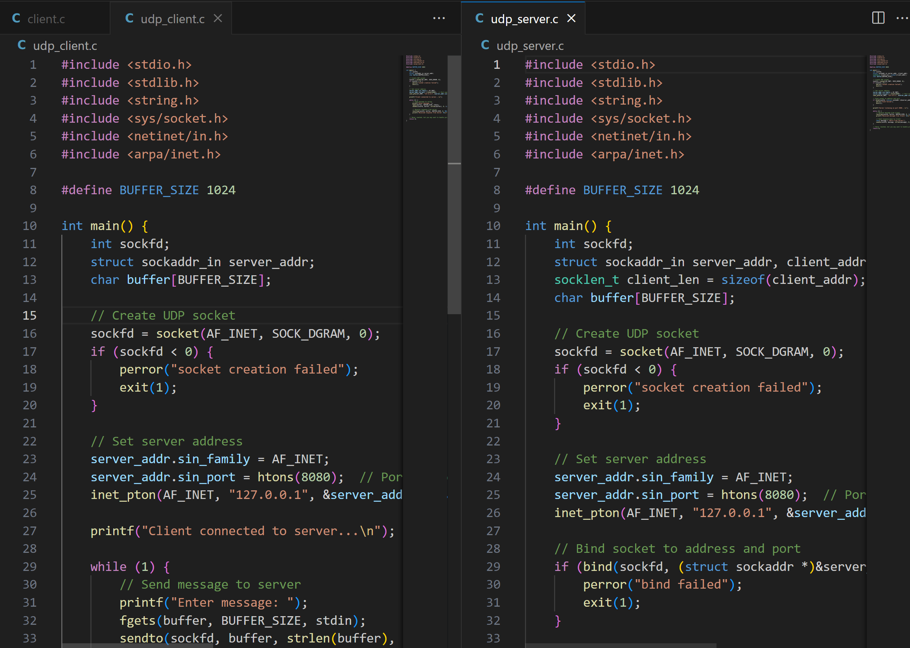

Output:

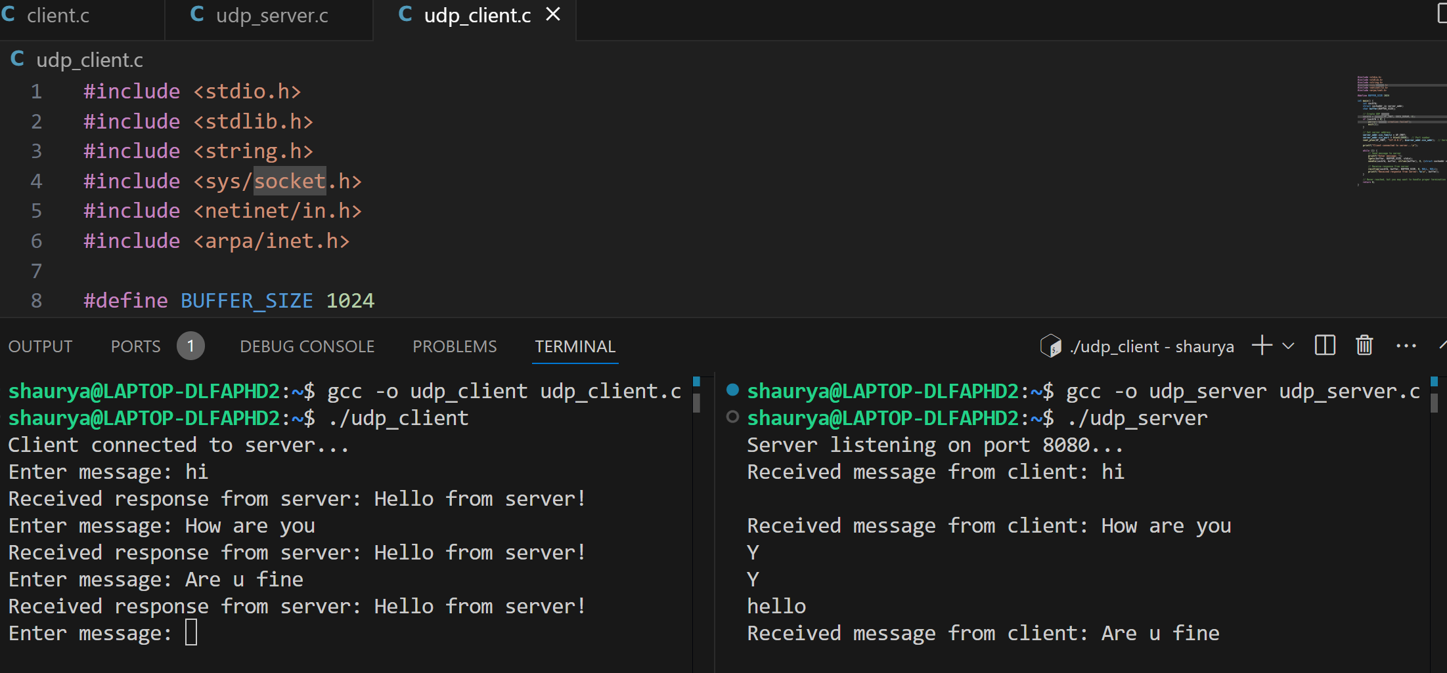

Experiment No.10

Aim: Static Routing-Configure static routes on multiple routers to enable
communication between different networks. Test the connectivity by pinging
between hosts in different networks.

Procedure:-
Step1) First connect all the PC’s ,switches , routers and wires as given in the below figure.First Connect the routers by the dotted wires Router 0’s GigaBitEthernet 0/0 with Router 1’s GigaBitEthernet 0/0 .Then connect the routers with switchs and at last connect PC’s with switches.
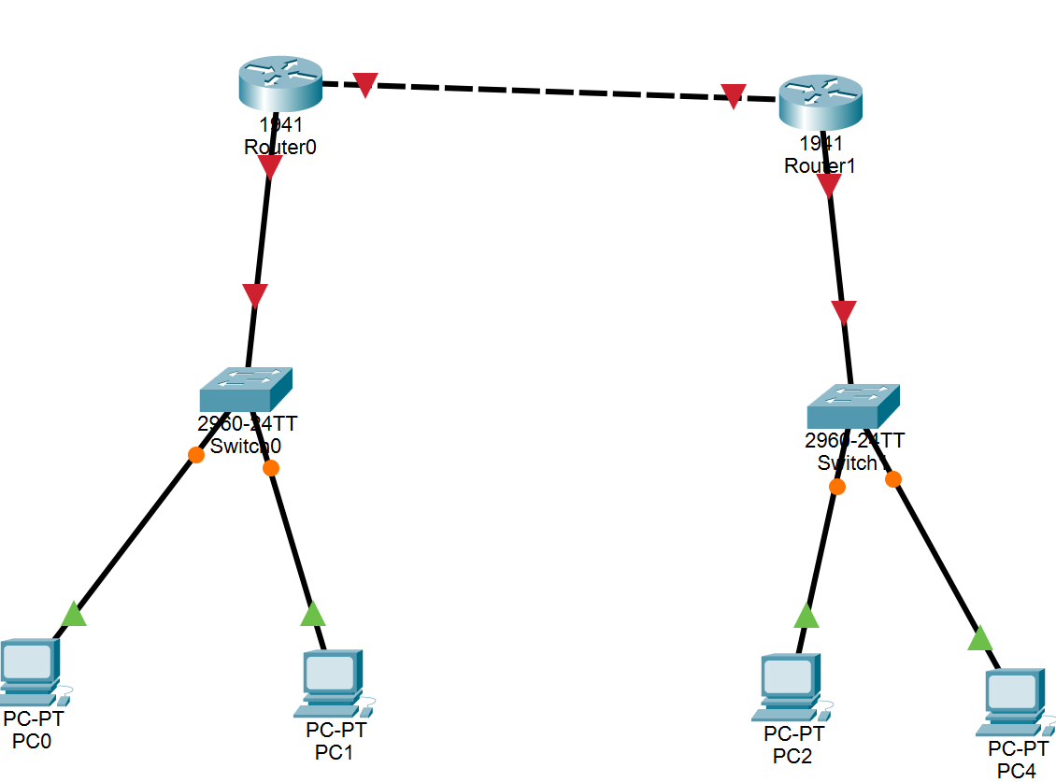

Step 2) Now give all the connections a IP as given in the diagram below.
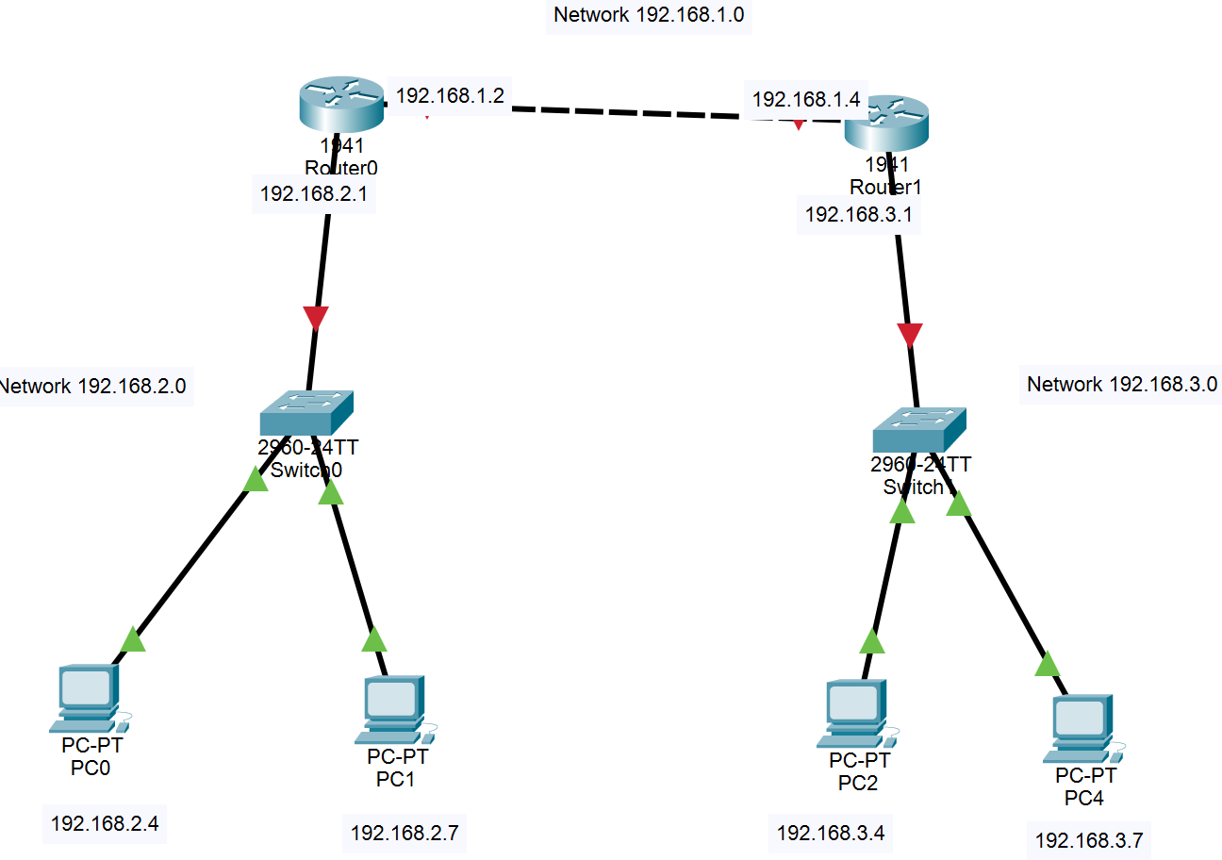

i)First give the IP between the routers
Firstly open Router 0 -> Config -> GigabitEthernet 0/0 (as connection of Router 0 GigabitEthernet 0/0 is with the Router 1’s GigabitEthernet 0/0 and the network b/w them is 192.168.1.0) -> Switch on the Port Status -> IP congig :- 192.168.1.2 -> Click Enter.
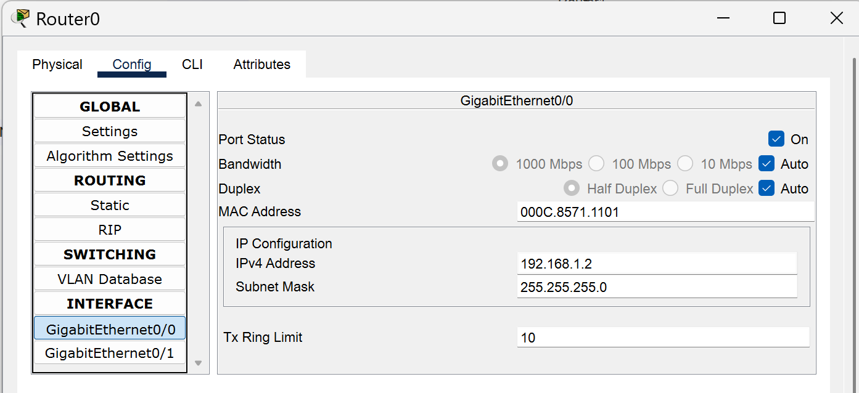

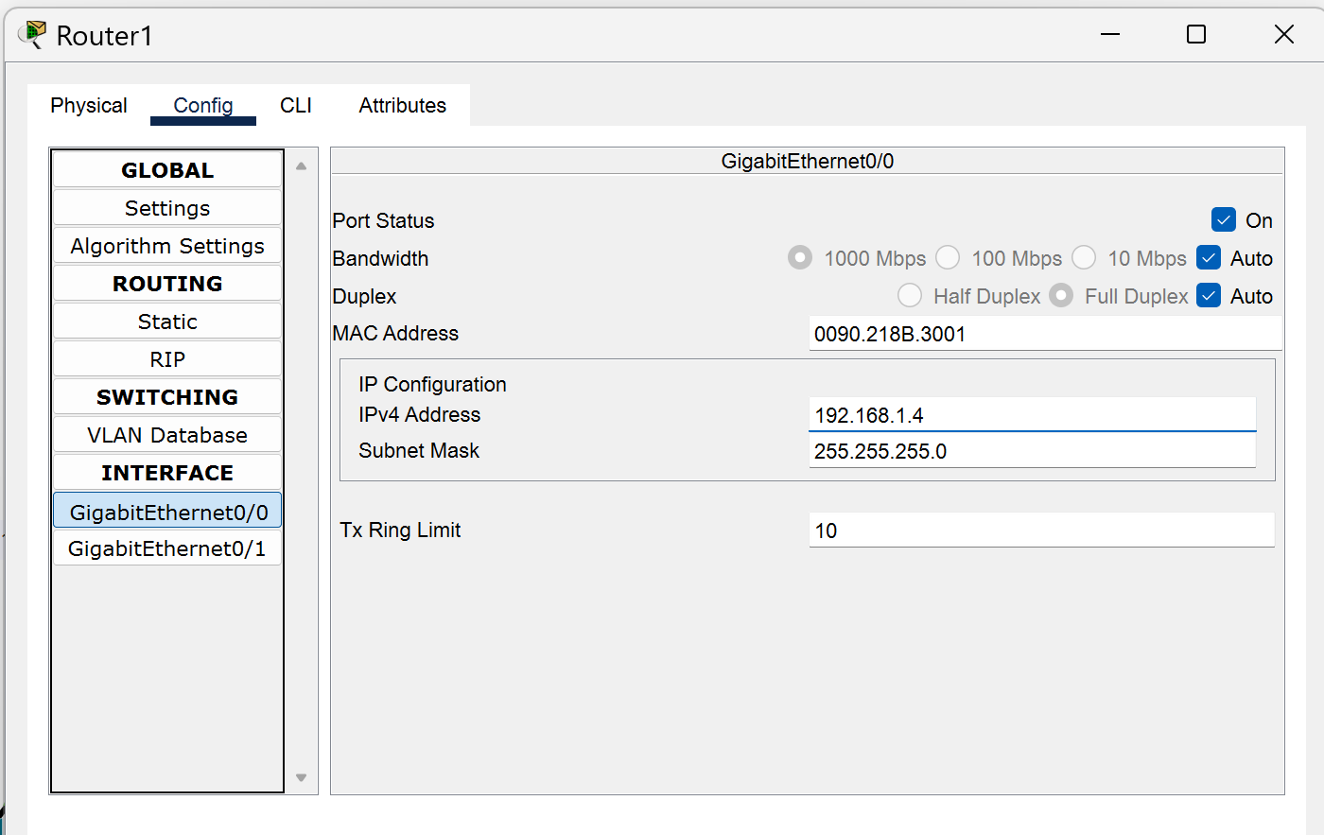
Similarly open Router 1-> Config -> GigabitEthernet 0/0 (as connection of Router 0 GigabitEthernet 0/0 is with the Router 1’s GigabitEthernet 0/0 and the network b/w them is 192.168.1.0) -> Switch on the Port Status -> IP congig :- 192.168.1.4 -> Click Enter.

ii)Now give ip to Router to the Switch Junction .
For Left side network :-
Open Router 0 -> Config -> GigabitEthernet 0/1 (as the switch is connected with the GigabitEthernet 0/1) -> Turn on the Port Status -> IP config – 192.168.2.1 -> Click Enter .Which will act as the Default gateway for the PC connected to that network.

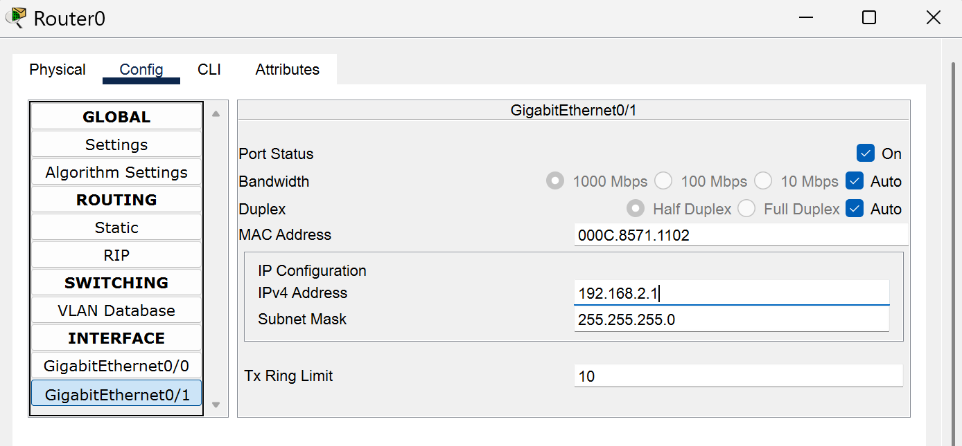

For Right side network :-
Open Router 1 -> Config -> GigabitEthernet 0/1 (as the switch is connected with the GigabitEthernet 0/1) -> Turn on the Port Status -> IP config – 192.168.3.1 -> Click Enter. Which will act as the Default gateway for the PC connected to that network.
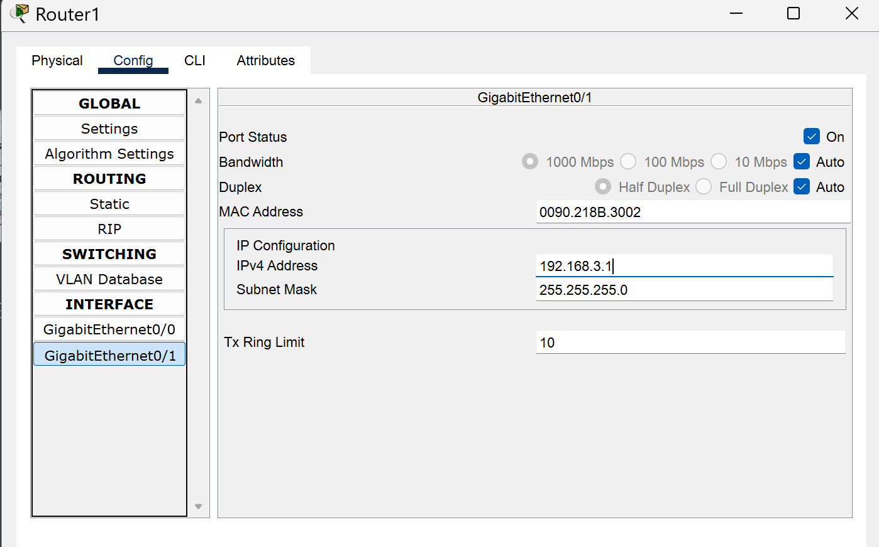

Now give IP addressing to the respective PC’s according to their network .
For ex:- PC 0 -> Desktop -> IP Config -> IP addr- 192.168.2.4 -> Default Gateway – 192.168.2.1 and do same for rest of the PC by carefully entering the IPs
And the default gateway according to the network.

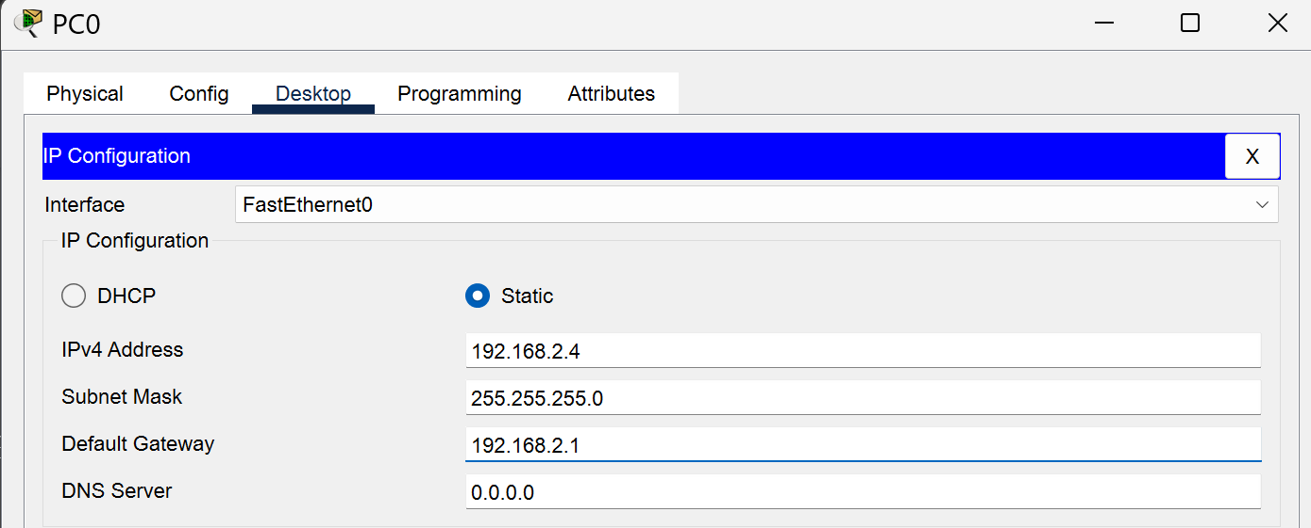

Step 3) Now do the router’s configuration so that they know each other’s network(network in which they are connected to with switches)and the next hop to reach each other.
I) Now go to the Router 0 -> Configure -> Static -> Network : 192.168.3.0 -> Mask : 255.255.255.0 -> Next Hop : 192.168.1.4 -> Add
(To tell Router 0 that there exist a network 192.168.3.0 where u can reach by going to the hop 192.168.1.4)
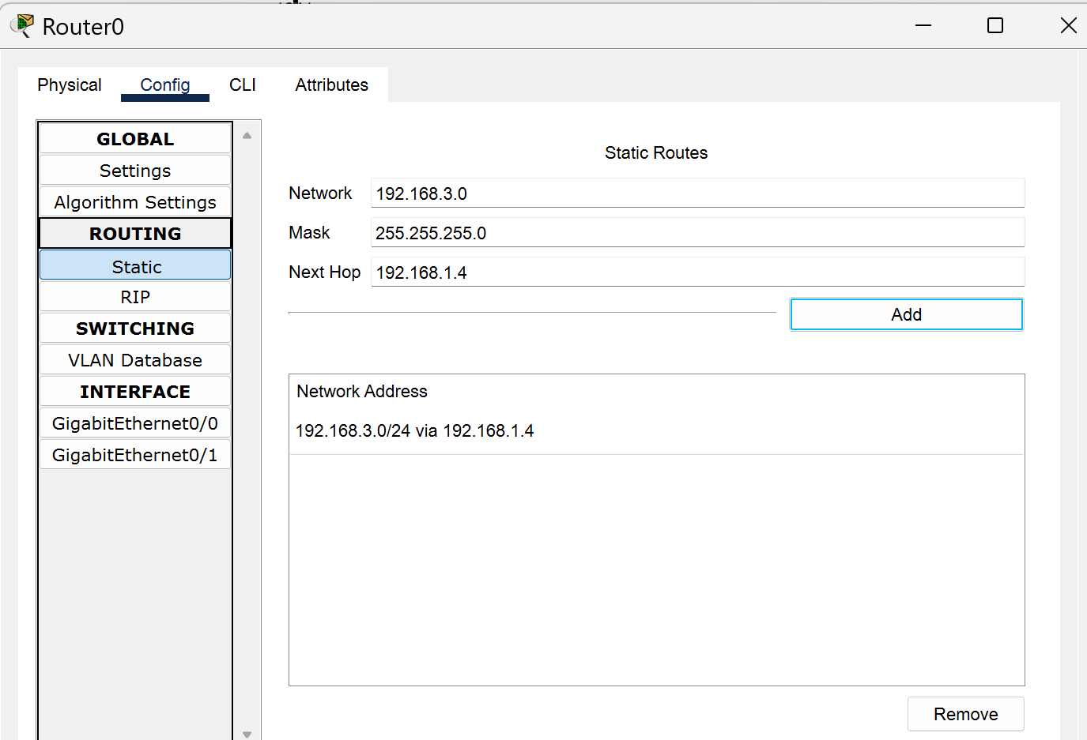

II) Now go to the Router 1 -> Configure -> Static -> Network : 192.168.2.0 -> Mask : 255.255.255.0 -> Next Hop : 192.168.1.2 -> Add
(To tell Router 1 that there exist a network 192.168.2.0 where u can reach by going to the hop 192.168.1.2)

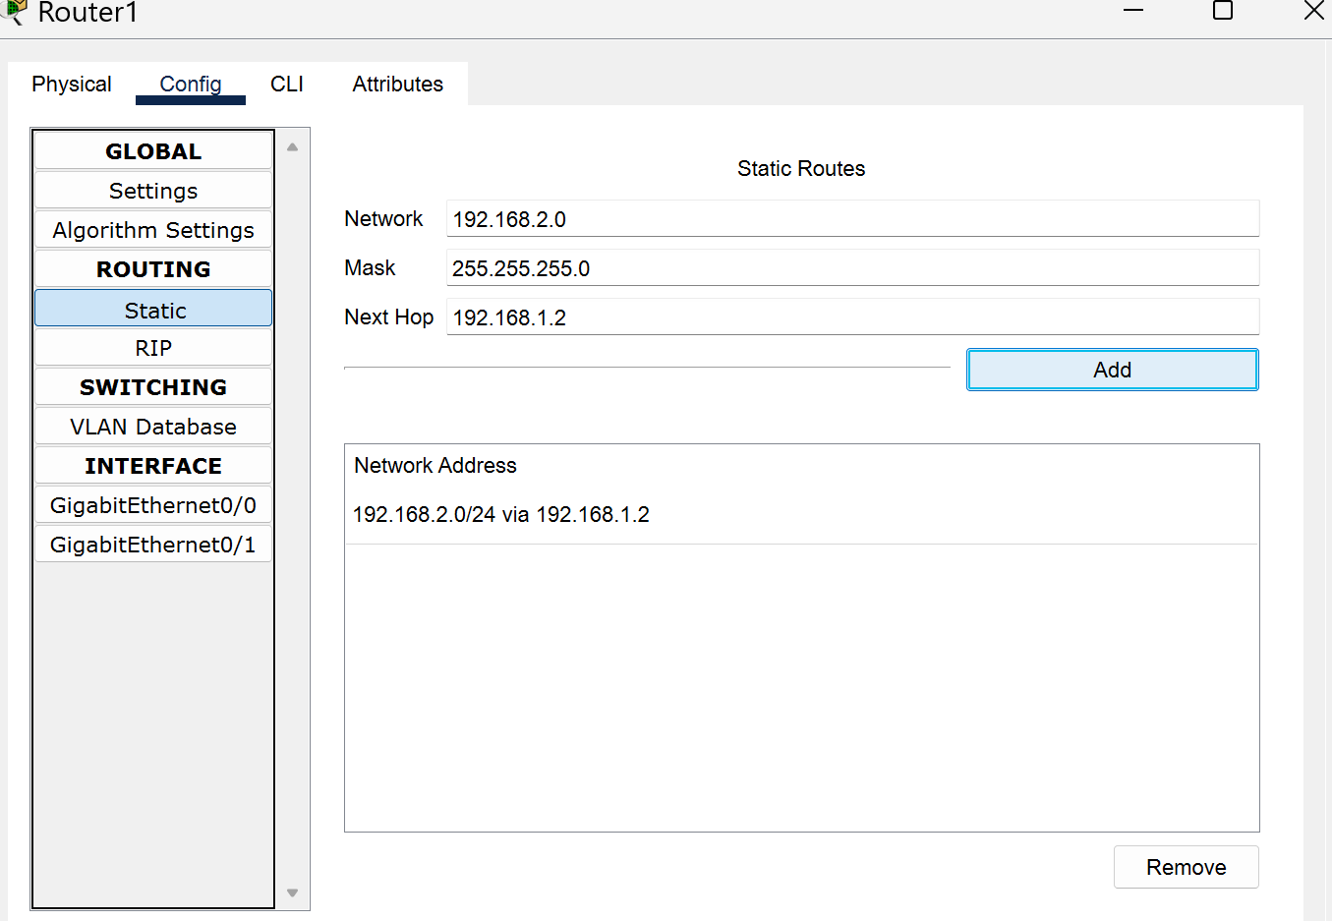

Step 4) Now send a packet from the PC 0 to PC2 .Its successful which tells that static routing was implemented successfully.
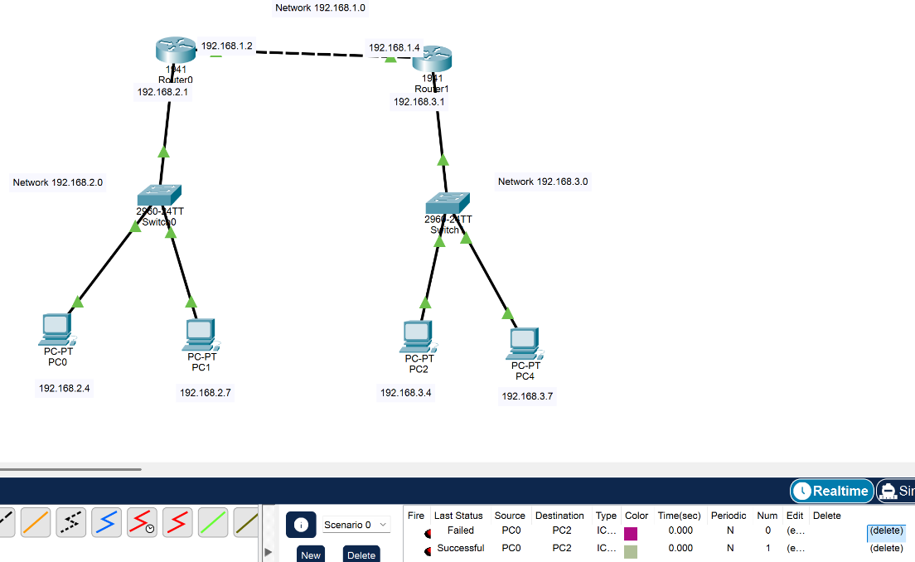

Result :- Successfully implemented the Static Routing.

Experiment No.11

Aim: Dynamic Routing (RIP): Configure routers to use the Routing Information Protocol (RIP) for dynamic routing. Enable RIP on the interfaces connected to different networks and verify that routes are being learned and propagated. Test the connectivity between hosts in different networks. (Using packet Tracer)

Procedure:-
Step1) First connect all the PC’s ,switches , routers and wires as given in the below figure.First Connect the switches with the PC’s ( Connect the Switch FastEthernet 0/1, FastEthernet 0/2,…..so on with the PC’s in each network leaving the FastEthernet 0/0 for the connection with router.
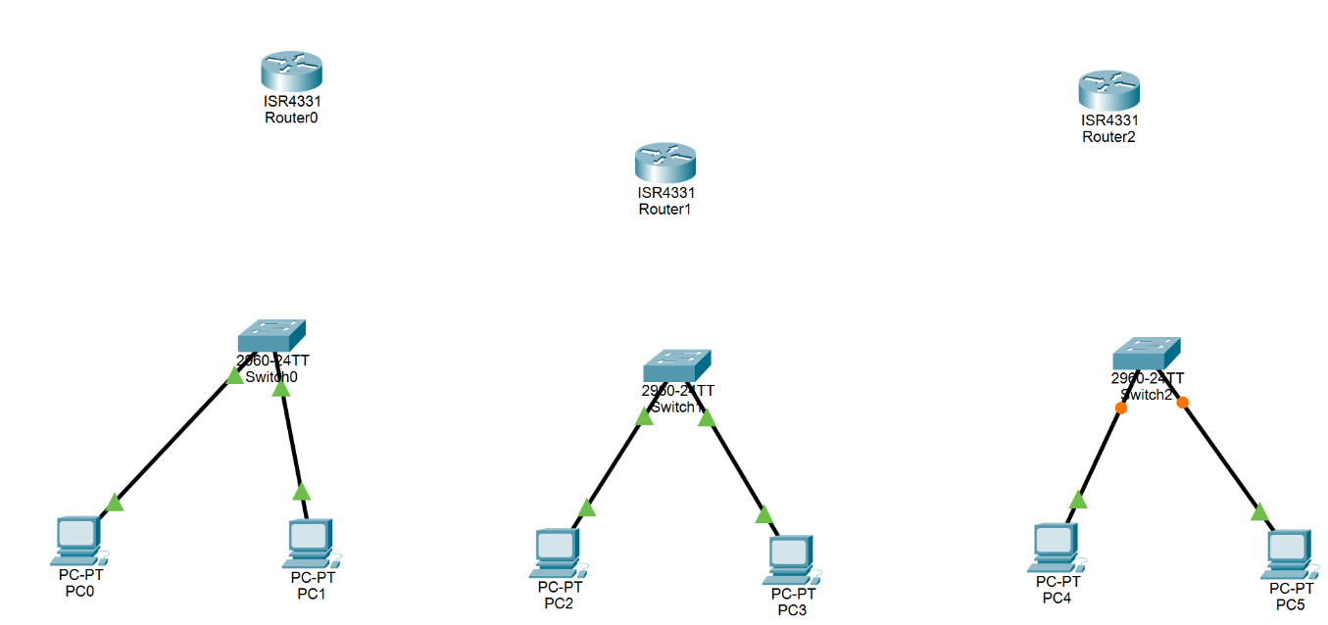

Step 2) Now click on each router and do for all router .
Open Router0 (4331)->Physical -> Switch off -> NIM-T2 tap and drag and drop ->switch on .

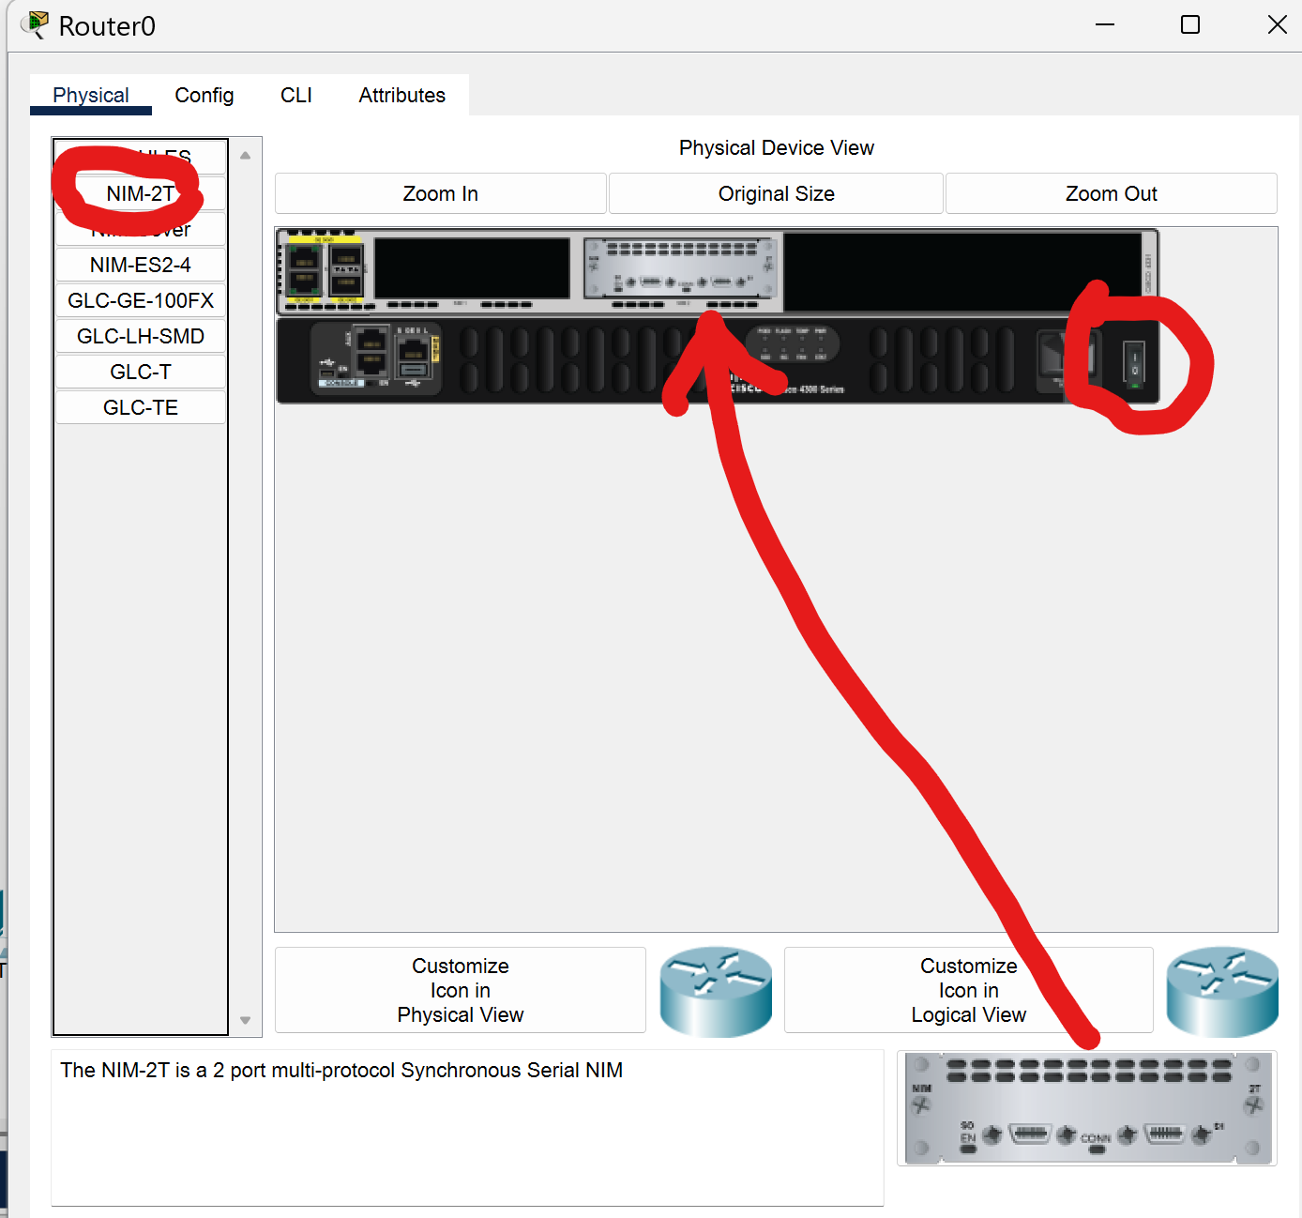

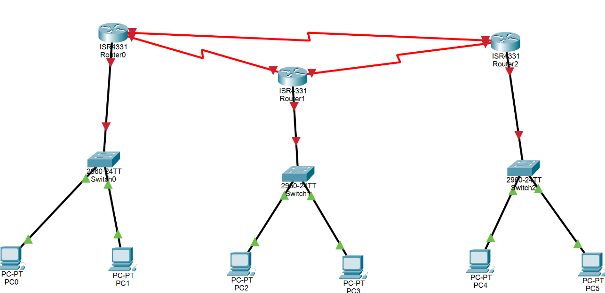
Step 3) Connect the serial 0 of Router0 with serial 0 of Router 1 && similarly serial 1 of Router 0 and serial 0 of Router 2 && similarly serial 1 of Router 1 to the serial 1 of Router 2 .And also the gigabit ethernet connection (Downward network connection with switch)also.

Step 4) Now assign ips to all the networks like this:-

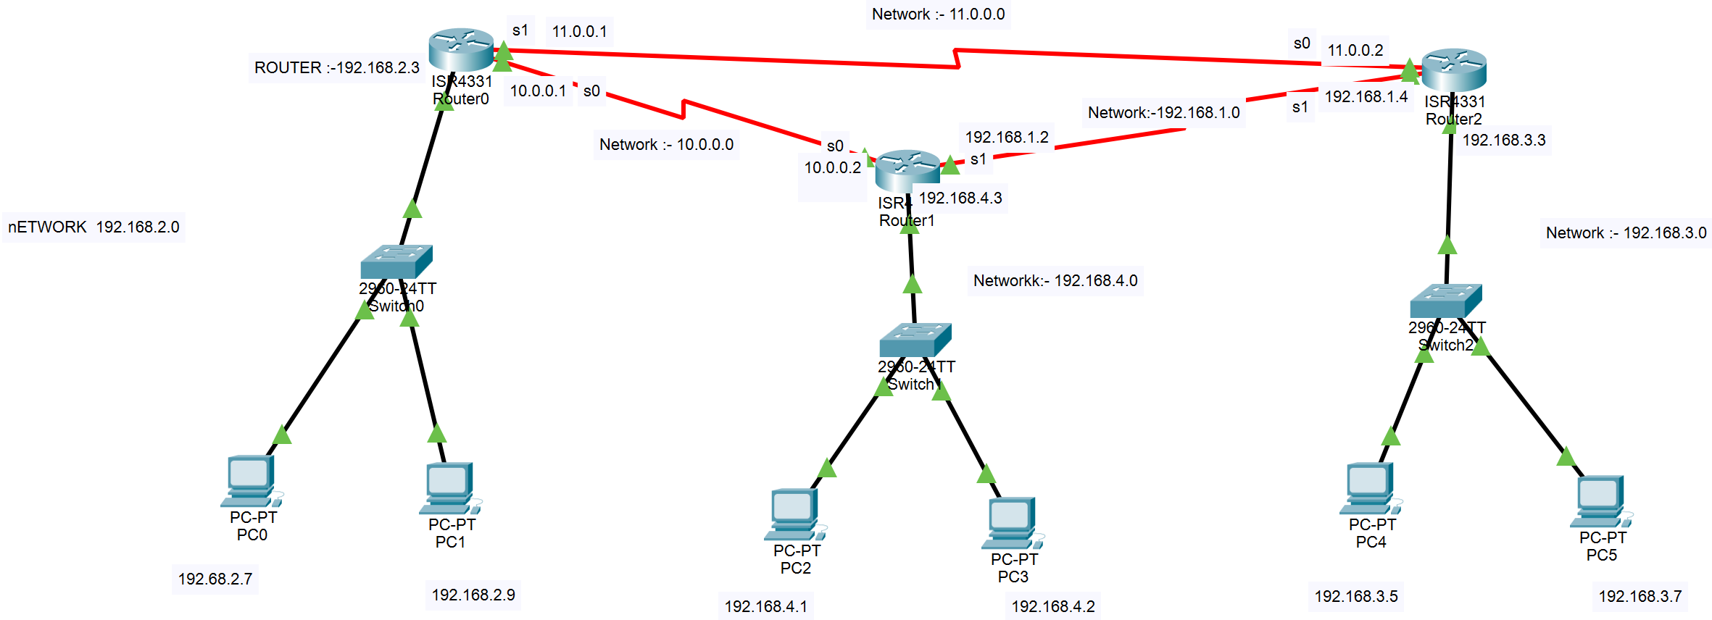
1)First do the IP addressing between the routers Serial connections.
i)Firstly do IP address b/w Router 0 and Router 1 (connected by Serial 0 and Serial 0 respectively).
Router 0 -> Config ->Serial 0/2/0 -> Port Status ON ->IP config: 10.0.0.1 -> Enter
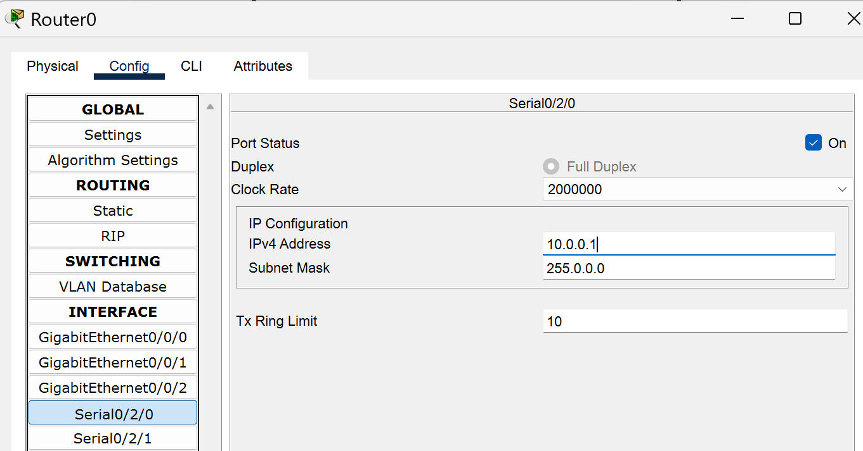

Router 1 -> Config ->Serial 0/2/0 -> Port Status ON ->IP config: 10.0.0.1 -> Enter
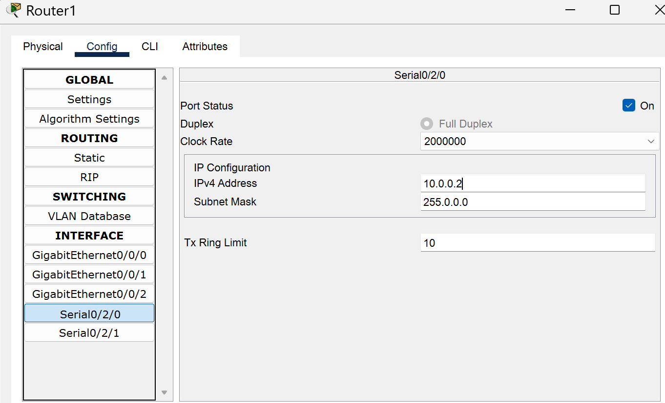

ii) Now do IP address b/w Router 0 and Router 2 (connected by Serial 1 and Serial 0 respectively).
Router 0 -> Config ->Serial 0/2/1 -> Port Status ON ->IP config: 11.0.0.1 -> Enter
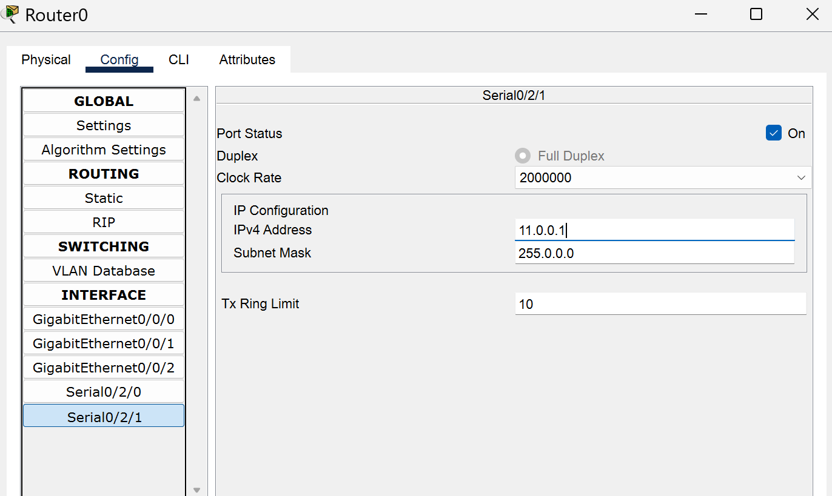

Router 2 -> Config ->Serial 0/2/0 -> Port Status ON ->IP config: 11.0.0.1 -> Enter
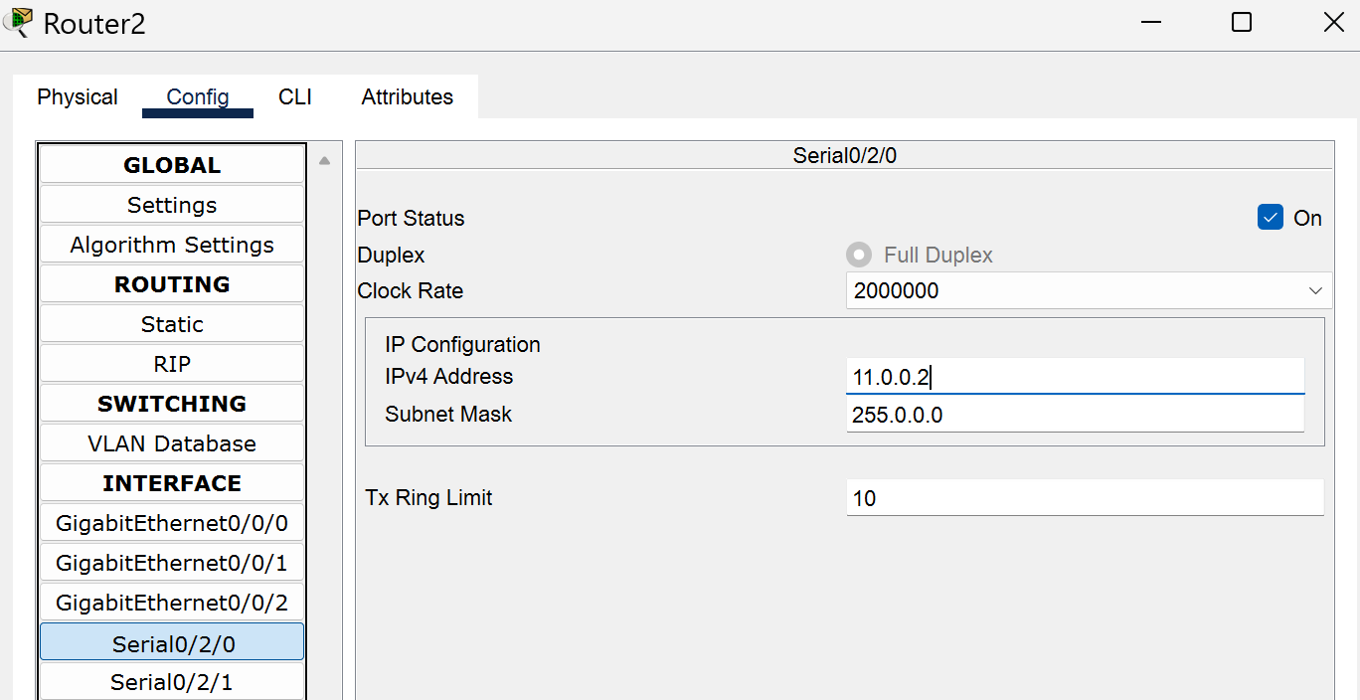

iii)Now between Router 1 and Router 2 (connected by Serial 1 and Serial 1 respectively.)
Router 1 -> Config ->Serial 0/2/1 -> Port Status ON ->IP config: 192.168.1.2 -> Enter

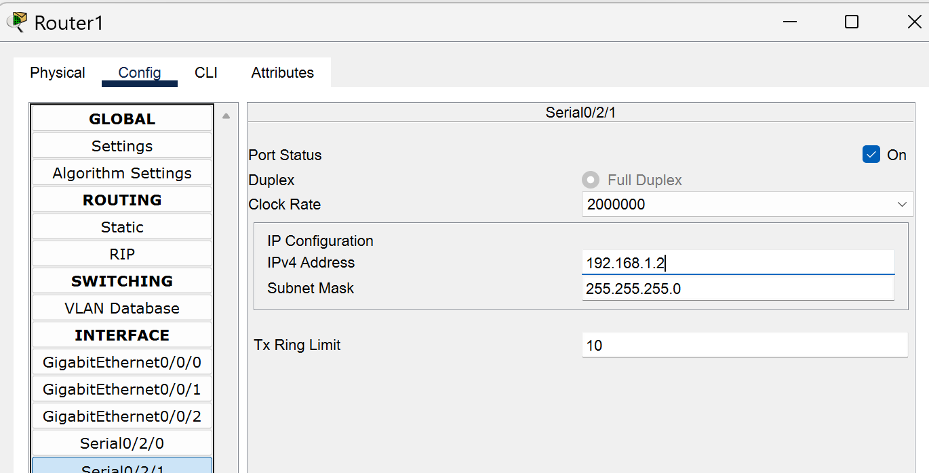

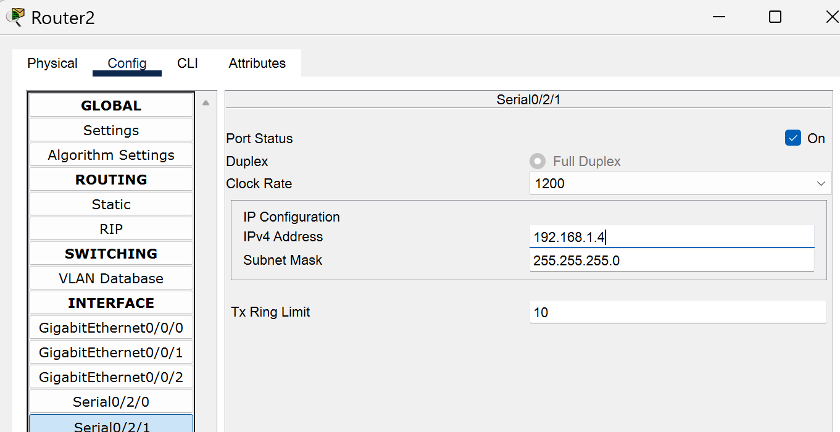
Router 2 -> Config ->Serial 0/2/1 -> Port Status ON ->IP config: 192.168.1.4 -> Enter

2) Now do the IP addressing of the Gateway network (Networks below Routers which are connected to the switches):-
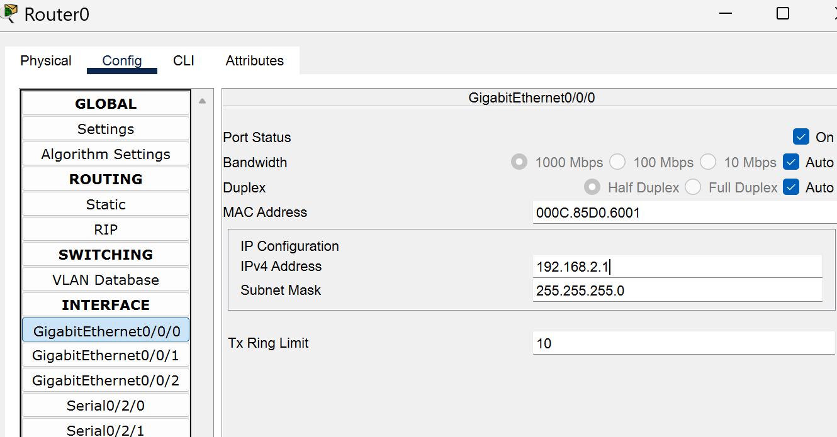
i)Router 0->Config -> GigabitEthernet -0/0/0 -> Port Status ON -> Ip config : 192.168.2.1 (It acts as a gateway for the 192.168.2.0 Network devices)

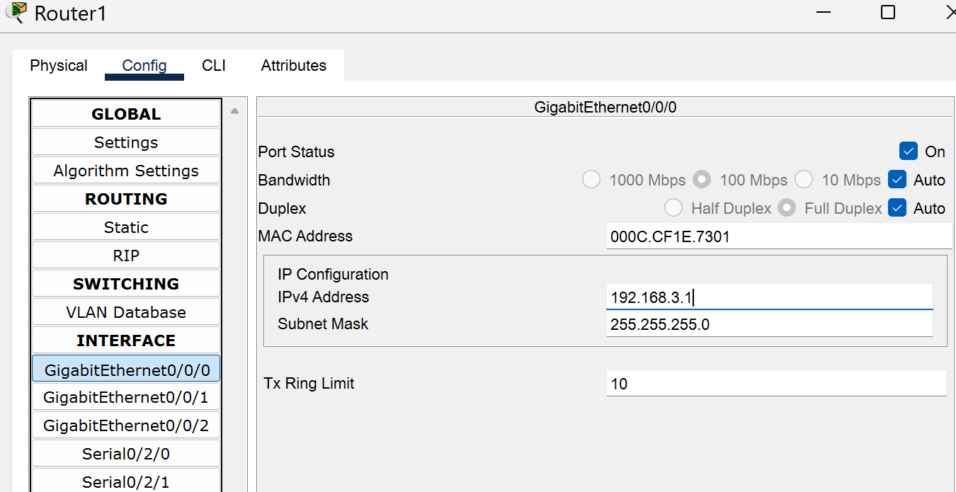
ii)Router 1->Config -> GigabitEthernet -0/0/0 -> Port Status ON -> Ip config : 192.168.3.1 (It acts as a gateway for the 192.168.3.0 Network devices)

iii) Router 2->Config -> GigabitEthernet -0/0/0 -> Port Status ON -> Ip config : 192.168.4.1 (It acts as a gateway for the 192.168.4.0 Network devices)
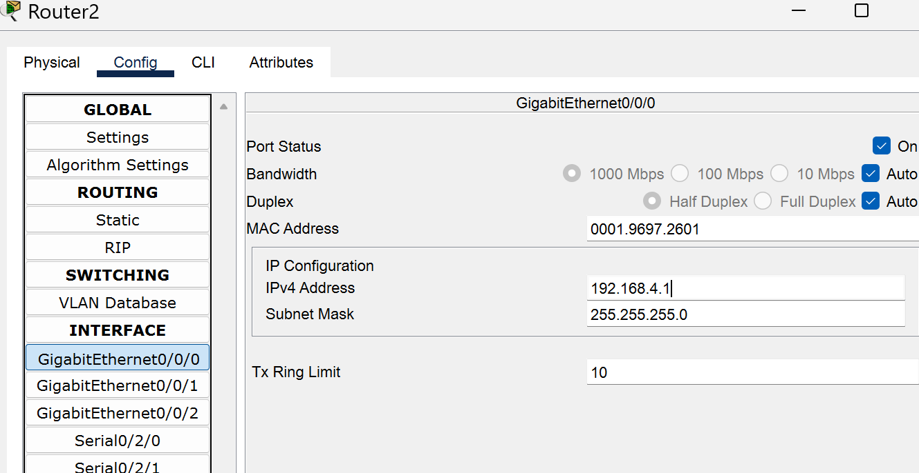

Step 5) Now do the IP addressing of all the PC’s of all the Networks accordingly.
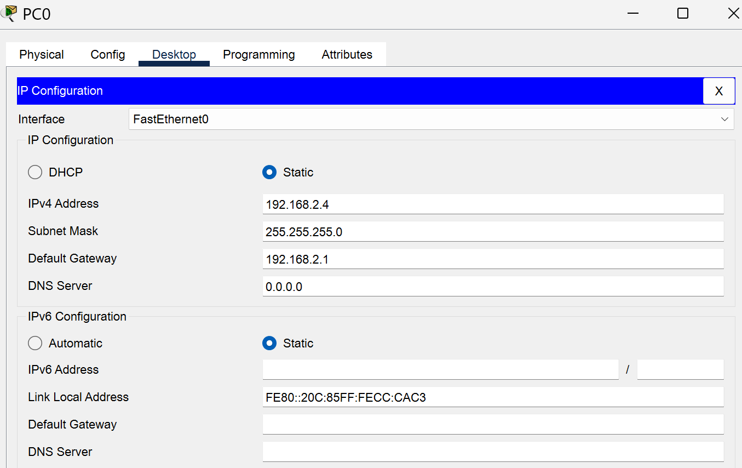
For ex:- PC 0 ->Desktop->IP config -> IP addr: 192.168.2.4 ->click Enter ->Default Gateway(Accord to the network) :192.168.2.1 -> OK

Step 6)Now one by one open all the Routers and do the below step.
Router 0->Config ->RIP ->Add all the networks ( 10.0.0.0 , 11.0.0.0 , 192.168.1.0 ,192.168.2.0 , 192.168.3.0 ,192.168.4.0 )
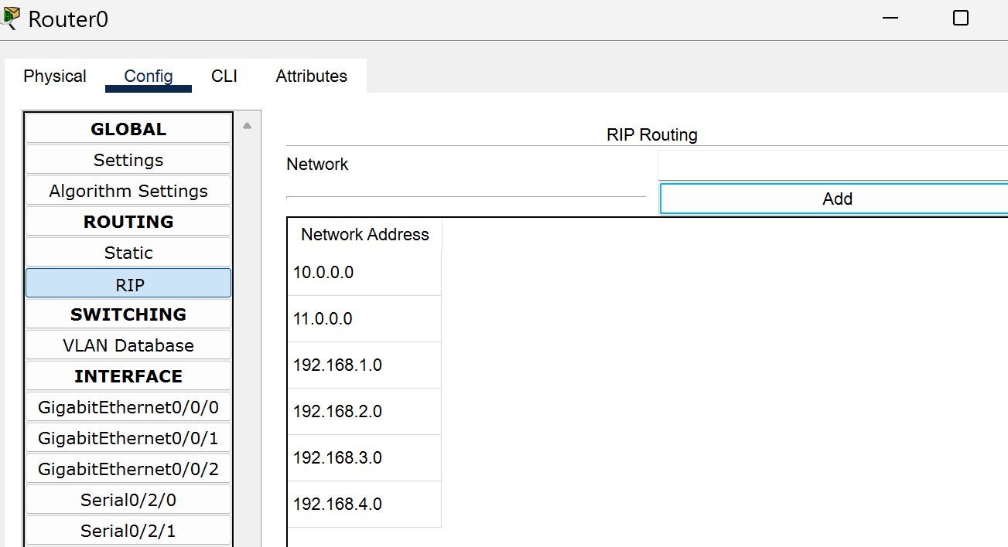

Router 1->Config ->RIP ->Add all the networks ( 10.0.0.0 , 11.0.0.0 , 192.168.1.0 ,192.168.2.0 , 192.168.3.0 ,192.168.4.0 )
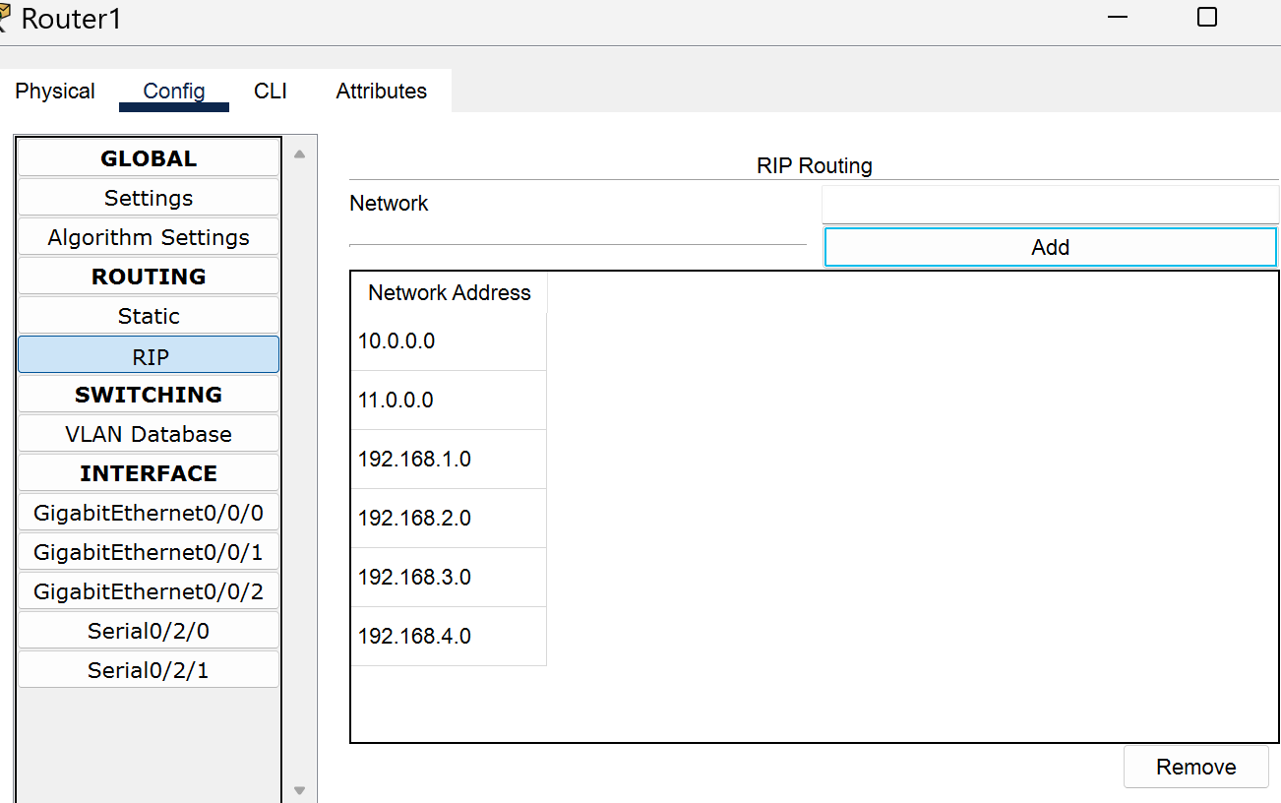

Router 2->Config ->RIP ->Add all the networks ( 10.0.0.0 , 11.0.0.0 , 192.168.1.0 ,192.168.2.0 , 192.168.3.0 ,192.168.4.0 )
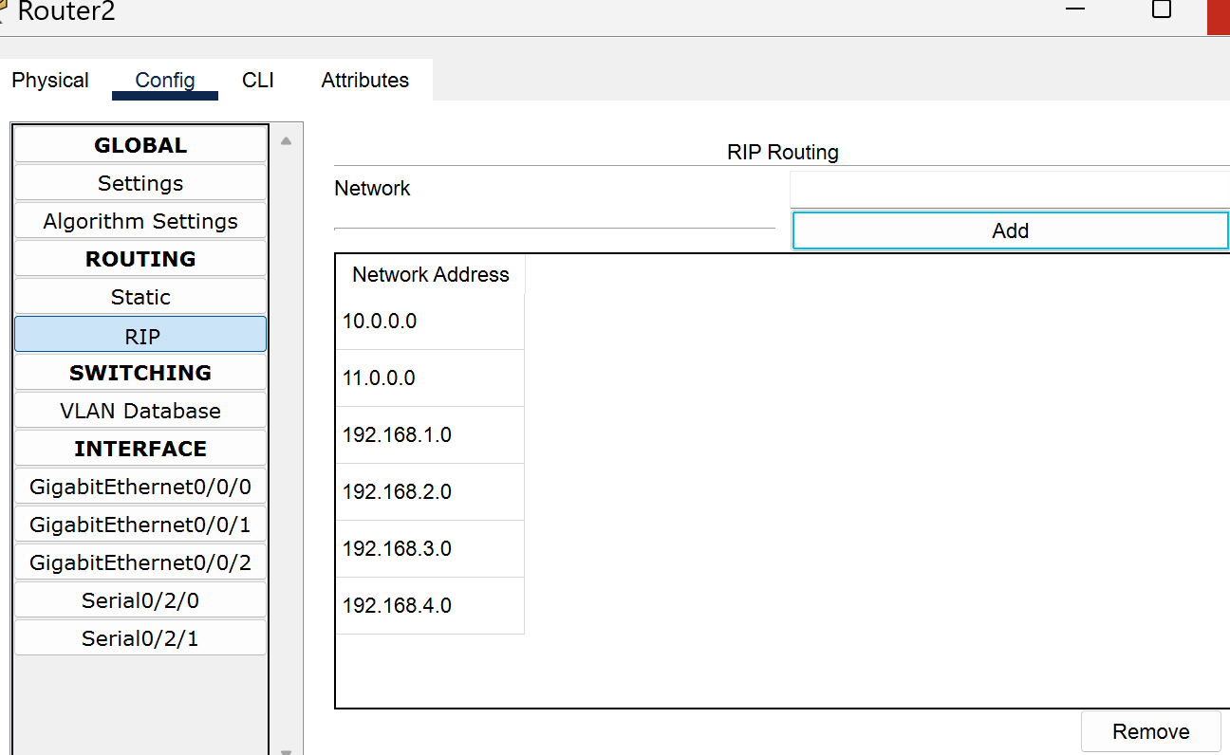

Step 7) Now try to send the packets from PC 0 to PC 2 ,u can see that in first go it failed but in second attempt it became successful .Similarly try to send packet from PC 0 to PC 4 , u can see that in first go it failed but in second attempt it became successful.
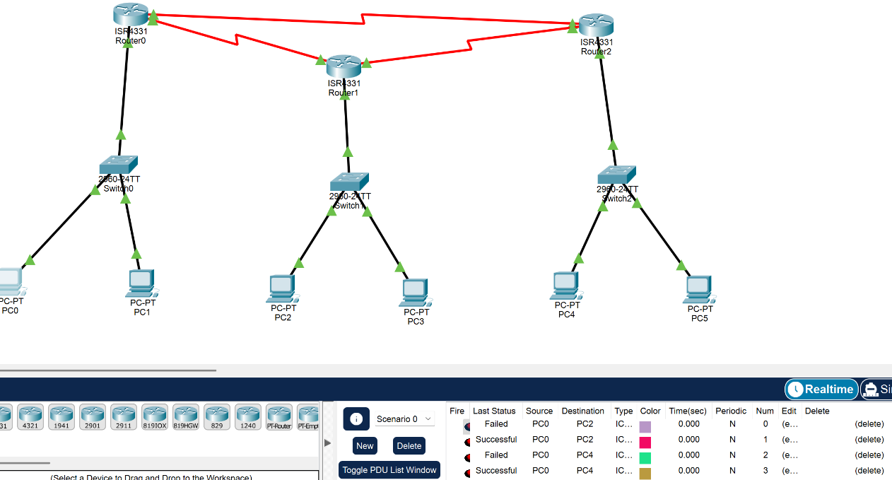

Result: We successfully implemented RIP .

Experiment - 12

Aim : To implement routing using OSPF .
Procedure :

Step 1) Connect the network as shown .
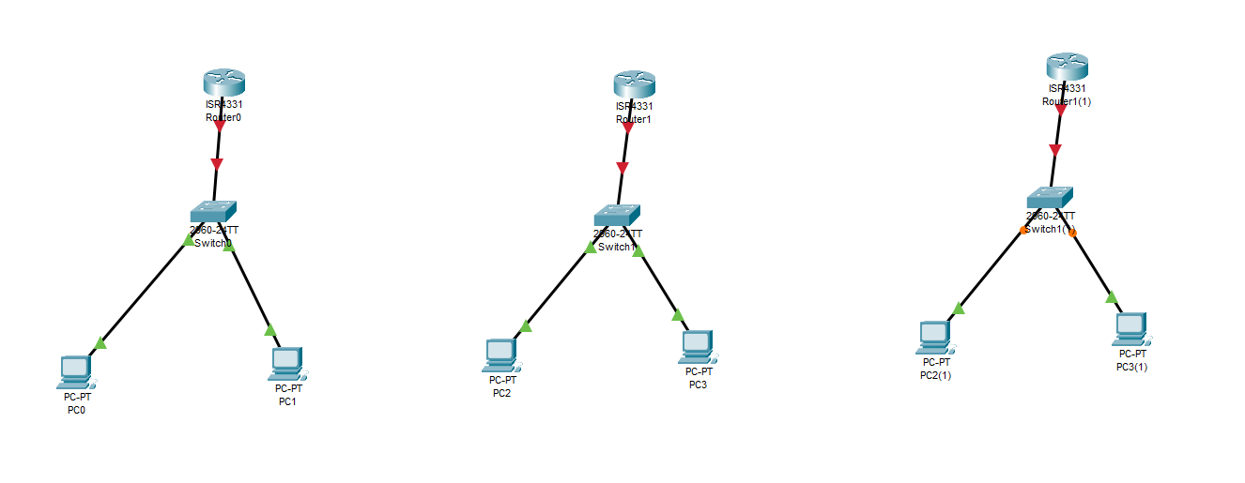

Step 2) Now open the router by clicking on it . Then in physical window we can see a switch. Turn the switch off and drop the serial NIM in the router . Then turn the switch back on .
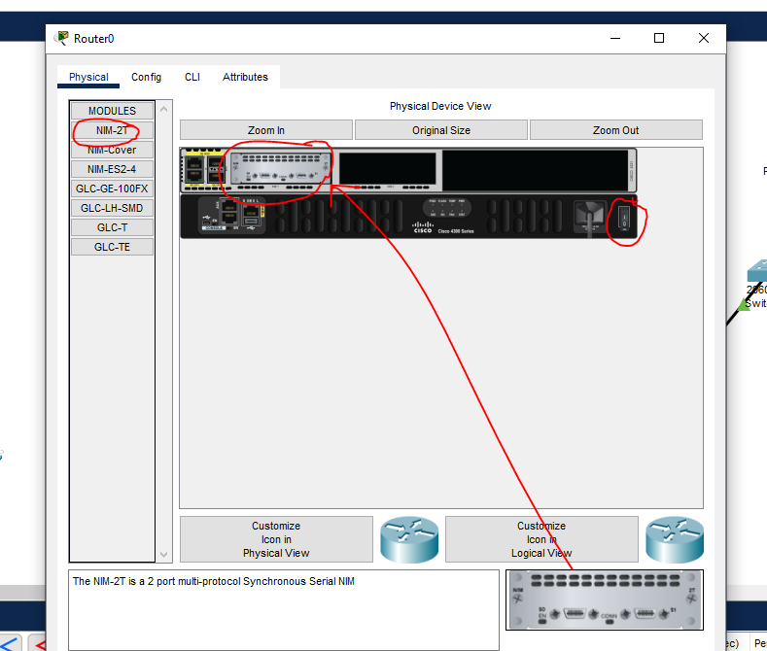

Step 3) Now assign IP’s to all the pc’s in the network and the routers in the same networks .
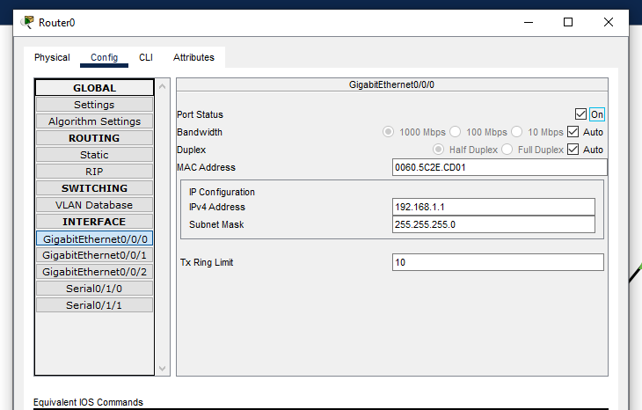

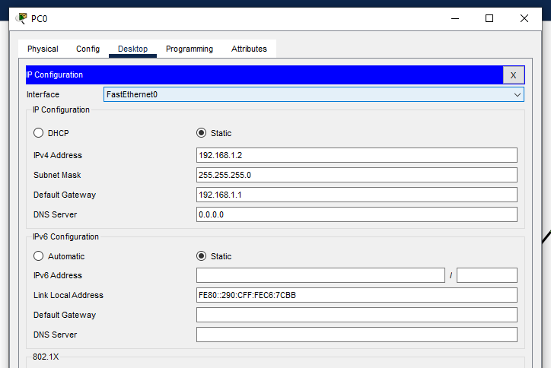

Do this for all the routers and pc’s .

Step 4) Now do the connection between the Router 1 ,2,3 using the Serial DCE red wire using the Serial Ports of the routers by:-
i)First do connection of Router 1 and 2 by connecting Serial Port 1/0 of router 1 with Serial Port of 0/1/0 of router 2.
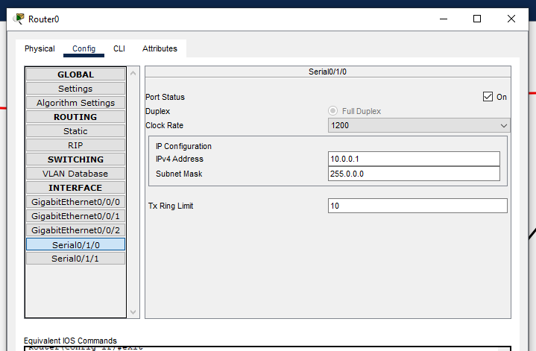

Then connect serial port of router 2 port 1/0 with serial port of router 1 port 1/0.
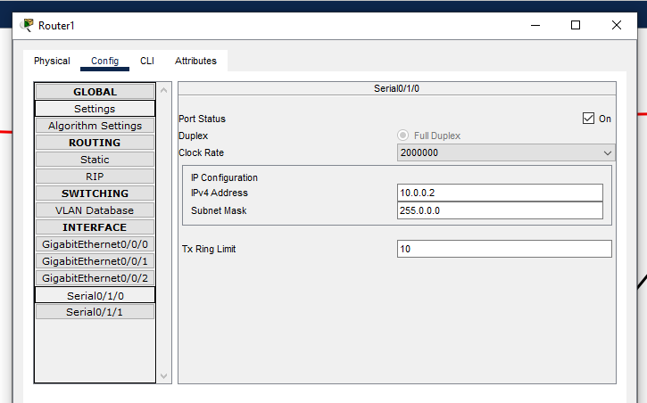

Now connect serial port 1/1 of router 2 with serial port 1/1 of router 3 .
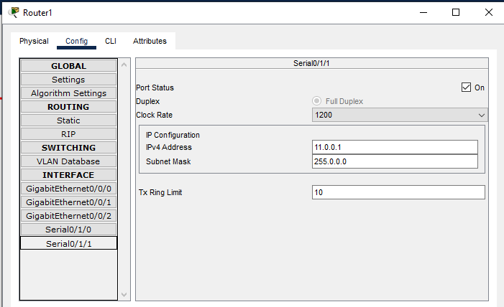

Finally connect serial port 1/1 of router 3 with serial port 1/1 of router 2.
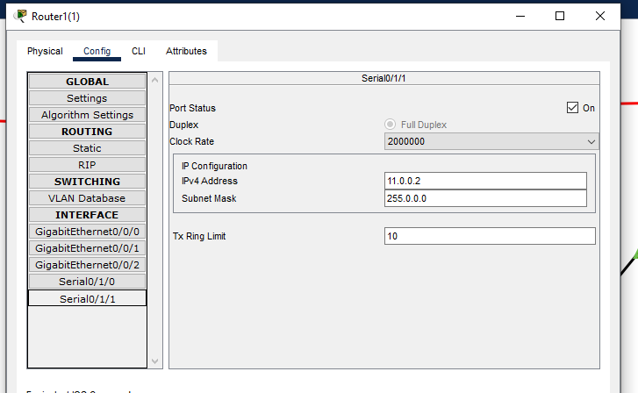
ii)Then do the ip addressing of the serial ports. as labelled above the connection .
iii)Turn on the port status

Step 5) Configure all routers CLI :
i) open router 1 CLI :-
exit
exit
exit
[Enter]
enable
configure terminal
router ospf 1
network 192.168.1.0 0.0.0.255 area 0
network 10.0.0.0 0.0.0.3 area 0
end
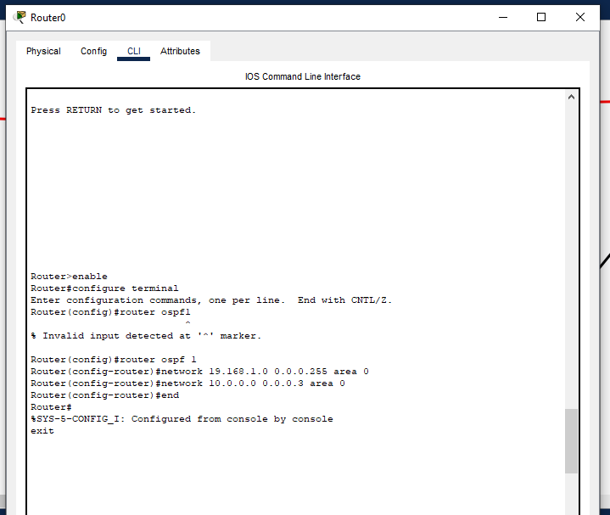

ii)Now open router 2 CLI :-
exit
exit
exit
[Enter]
enable
configure terminal
router ospf 1
network 192.168.2.0 0.0.0.255 area 0
network 10.0.0.0 0.0.0.3 area 0
network 11.0.0.0 0.0.0.3 area 0
end
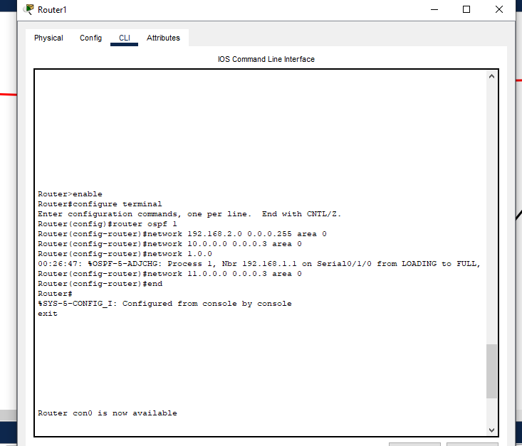

iii)Now open router 3 CLI :-
exit
exit
exit
[Enter]
enable
configure terminal
router ospf 1
network 192.168.3.0 0.0.0.255 area 0
network 11.0.0.0 0.0.0.3 area 0
end
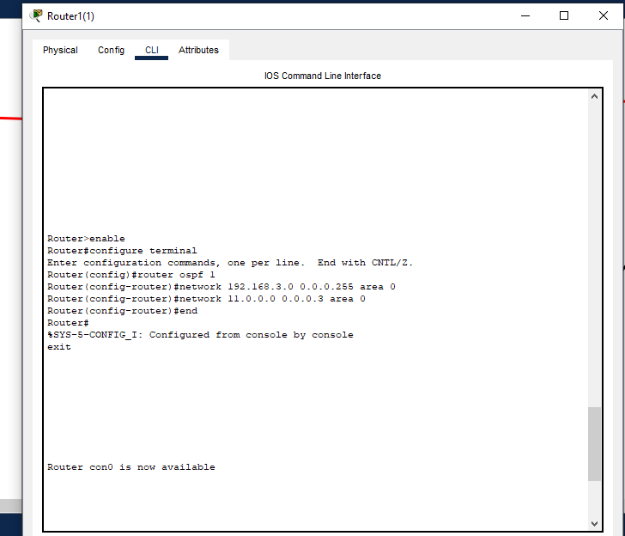

Step 6) Send a packet from pc 0 to pc 2 until successful.
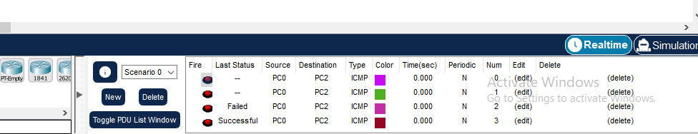

Result : We successfully implemented OSPF routing .

