Experiment 6

Aim : Create a table Employee(id,name,age) and use case statement on the age column and display output when the case statement is satisfied and when it is not satisfied .

Procedure :
Step 1 : We create the table employee .
CREATE table employee(e_id int , name varchar(255) , age int ,
PRIMARY KEY(e_id));

Step 2 : Insert some values in the table
INSERT INTO employee(e_id,name,age)
VALUES
(1,'Arthur',32),
(2,'John',28),
(3,'Lenny',23),
(4,'Dutch',40);
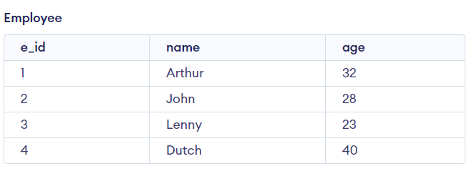
This is the table we will work on .

Step 3 : Now implement the case statement on the table
SELECT name , age ,
CASE
WHEN age = 40 THEN 'Very Old'
WHEN age > 30 THEN 'Old'
WHEN age < 30 AND age > 25 THEN 'Prime'
WHEN age < 25 THEN 'Young'
END AS RDR2
FROM employee ;

Step 4 : Now when we execute the case statement we get the following output
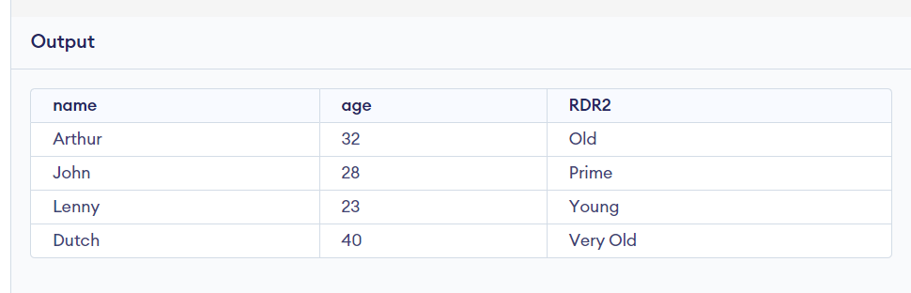
This is the output where the case statement is satisfied .

Step 5 : Now for case statement not satisfied we execute the following sql code on the existing table
SELECT name , age ,
CASE
WHEN age = 45 THEN 'Very Old'
WHEN age > 100 THEN 'Old'
WHEN age < 1 AND age > 100 THEN 'Prime'
WHEN age < 1 THEN 'Young'
END AS RDR2
FROM employee ;
Step 6 : Now as we can see the conditions are such that the case statement will not be satisfied even once and should return an empty RDR2 column .
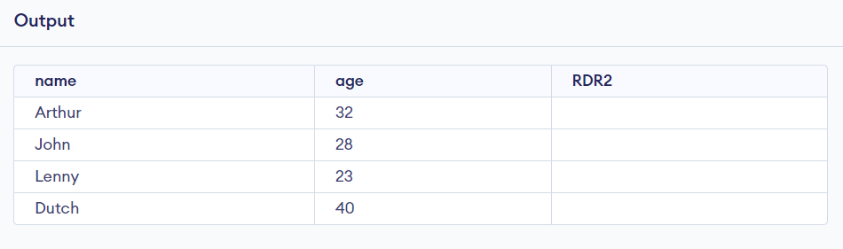
We have the expected output with the RDR2 column empty as the corresponding age value did not satisfy the conditions of case statement .

Experiment 7

Aim : Create a table student(s_id,name,age) and another table course(s_id,c_id,c_name).
Use case statement where
If s_id < 10 -> Section – A
s_id > 10 Section – B
i) Find details of those students who are enrolled in at least one course .
ii) Find out details of those students who are enrolled in more than one course .

Procedure :
Step 1 : First we create the two tables student and course
CREATE TABLE student(
s_id int PRIMARY KEY,
name VARCHAR(50),
age int
);

CREATE TABLE course (
s_id int,
c_id int,
c_name VARCHAR(50),
FOREIGN KEY(s_id) REFERENCES student(s_id)
);

Step 2 : Now insert values in the two tables
INSERT into student(s_id , name , age)
VALUES
(1,'John',18),
(2,'Jill',18),
(11,'Jamal',19),
(12,'Jason',18);

INSERT into course(s_id , c_id , c_name)
VALUES
(1,101,'CPP'),
(1,102,'Java'),
(2,103,'C'),
(11,101,'CPP'),
(12,104,'WEB');

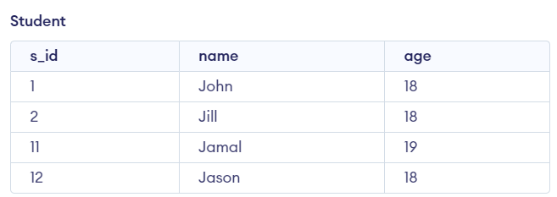
This is the created student table .

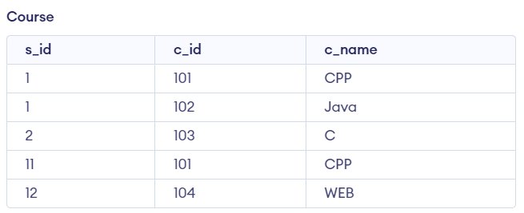
This is the created course table .
Step 3 : Now to implement the case statement for section .
SELECT
s_id,
name,
age,
CASE
WHEN s_id < 10 THEN 'Section A'
WHEN s_id > 10 THEN 'Section B'
END AS section
FROM student;
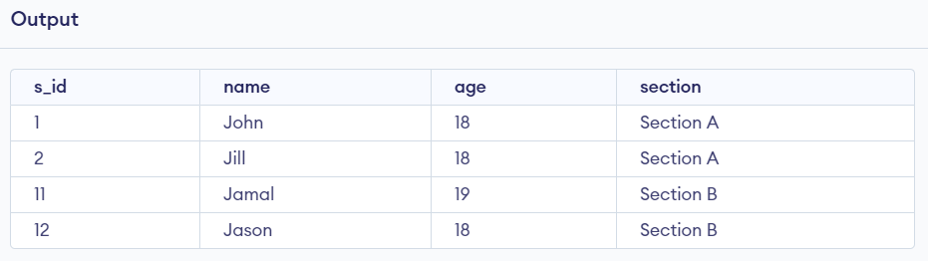
This is the output for the case statement query .

Step 4 : Now to find out the details of the students who are enrolled in at least one course
SELECT
student.s_id,
student.name,
student.age,
CASE
WHEN student.s_id < 10 THEN 'Section A'
ELSE 'Section B'
END AS section
FROM student
JOIN course ON student.s_id = course.s_id
GROUP BY student.s_id, student.name, student.age;
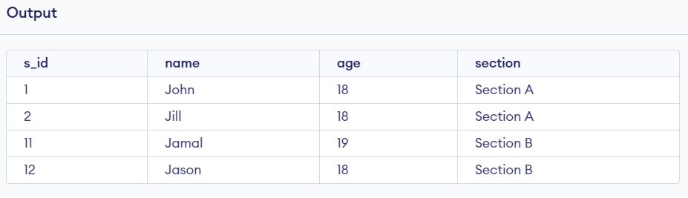
This is the output for the first query as this contains the details of all the students who have at least one course .

Step 5 : Now to find the details of students enrolled in more than one courses
To find students enrolled in more than one course, use a HAVING clause to filter students with more than one course.
SELECT
student.s_id,
student.name,
student.age,
CASE
WHEN student.s_id < 10 THEN 'Section A'
ELSE 'Section B'
END AS section
FROM student
JOIN course ON student.s_id = course.s_id
GROUP BY student.s_id, student.name, student.age
HAVING COUNT(course.c_id) > 1;
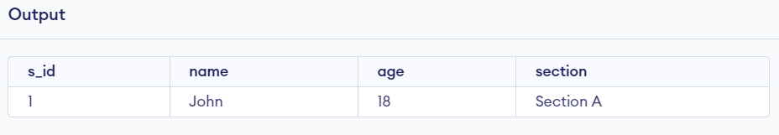
This is the output that displays students enrolled in more than one courses .

Experiment 8

Aim : To Create a Trigger query for the following table so that no new row can be inserted or any existing row can be Updated or Deleted.

Procedure :
Step 1 : We create the table Students .
CREATE table Students(s_id int ,Name varchar(255),Age int,Course varchar(255));
Step 2 : Insert some values in the Students table
INSERT INTO Students(s_id,Name,Age,Course)
VALUES ('101','Yogesh','23','Btech');
VALUES ('102','Shaurya','19','Btech');
VALUES ('103','Rahul','18','BCA');
VALUES ('104','Shivansh','20','MCA');
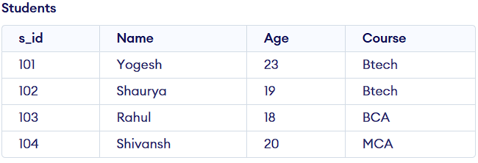

Step 3 : Now implement the case statement on the table
CREATE OR REPLACE TRIGGER restrict_changes
BEFORE INSERT OR UPDATE OR DELETE ON Students
FOR EACH ROW
BEGIN
RAISE_APPLICATION_ERROR (-20001, 'You cannot INSERT, UPDATE, or DELETE this table');
END;

Step 4: To Test one Query for example we try to insert data then what will be the output.

Input:-
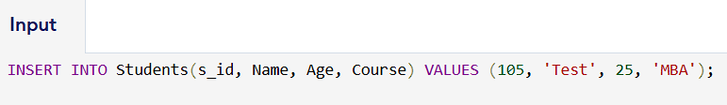
INSERT INTO Students(s_id, Name, Age, Course) VALUES (105, 'Test', 25, 'MBA');
Output:-
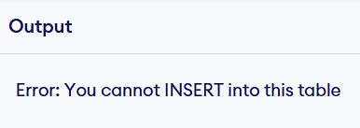

Experiment 9

Aim : Create two table Student(s_id,name,marks) and Grade(grade,min_marks,max_marks). The output table shows- those student who have receive less than grade 8,(name,marks,grade) in descending order and if 2 student have same grade then their arrangement is in descending order on the basis of alphabetical order.

Procedure :
Step 1 : We create the table employee .
CREATE table Student (s_id int , name varchar(255) , marks int , PRIMARY KEY(s_id));
CREATE table Grades (grade int, min_m int, max_m int, PRIMARY KEY(grade));
CREATE table Output(name varchar(255),marks int ,grade int);

Step 2 : Insert some values in the Student table
INSERT INTO Student(s_id,name,marks)
VALUES
('101','Yogesh','80'),
('102','Shaurya','70'),
('103','Shivansh','90'),
('104','Shurya','50');
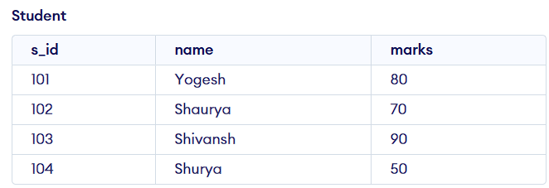
Insert some values in the Grades table
INSERT INTO Grades(grade,min_m,max_m) VALUES('1','0','9');
INSERT INTO Grades(grade,min_m,max_m) VALUES('2','10','19');
INSERT INTO Grades(grade,min_m,max_m) VALUES('3','20','29');
INSERT INTO Grades(grade,min_m,max_m) VALUES('4','30','39');
INSERT INTO Grades(grade,min_m,max_m) VALUES('5','40','89');
INSERT INTO Grades(grade,min_m,max_m) VALUES('6','50','69');
INSERT INTO Grades(grade,min_m,max_m) VALUES('7','60','69');
INSERT INTO Grades(grade,min_m,max_m) VALUES('8','70','79');
INSERT INTO Grades(grade,min_m,max_m) VALUES('9','80','99');
INSERT INTO Grades(grade,min_m,max_m) VALUES('10','90','100');
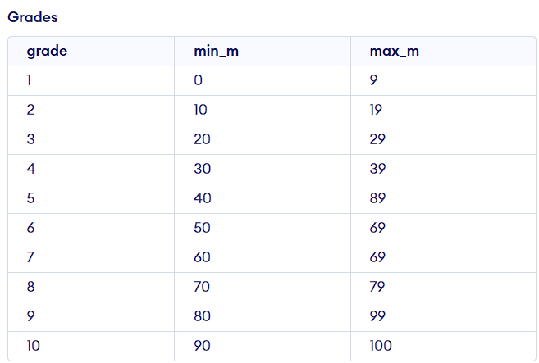

Step 3 : Now implement the case statement on the table Output
INSERT INTO Output (name, marks, grade)
SELECT
Student.name,
Student.marks,
Grades.grade
FROM
Student
JOIN
Grades
ON
Student.marks BETWEEN Grades.min_m AND Grades.max_m
WHERE
Grades.grade < 8
ORDER BY
Grades.grade DESC,
Student.name DESC;

Step 4 : Now when we execute the case statement we get the following output
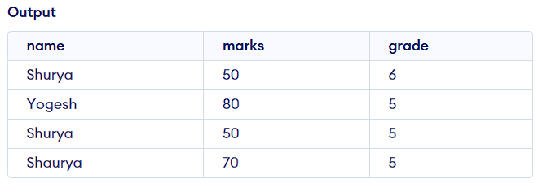
This is the output where the case statement is satisfied .

Experiment 10

Aim:- You are given sales (sid, pid,quantity,sale_date,total_price) table and a products (pid,pname,category,unit_price) table.
i)Calculate the revenue generated from the sales for each of the product category.
ii)Find out the product category having the highest avg unit_price.

Solution:-

- First create the table sales and products.
CREATE TABLE products (
pid int ,pname varchar(256) ,category varchar(256),unit_price int,Primary Key(pid)
);

INSERT INTO produts VALUES (101, 'Mix pulse', 'Food',120);
INSERT INTO produts VALUES (102, 'ix Veg', 'Food',70);
INSERT INTO produts VALUES (103, 'Iron Press', 'Electronics',1500);
INSERT INTO produts VALUES (104, 'Geyser', 'Electronics',5200);
INSERT INTO produts VALUES (105, 'Toothpaste', 'General',25);
INSERT INTO produts VALUES (106, 'Brush', 'General',10);

CREATE TABLE sales (
sid int ,pid int ,quantity int ,sale_date Date ,total_price int,Primary Key(sid), foreign key(pid) references products(pid)
);

INSERT INTO sales VALUES (1, 102, 3, TO_DATE('2024-01-20', 'YYYY-MM-DD'), 210);
INSERT INTO sales VALUES (2, 104, 1, TO_DATE('2024-01-20', 'YYYY-MM-DD'), 5200);
INSERT INTO sales VALUES (3, 106, 2, TO_DATE('2024-03-22', 'YYYY-MM-DD'), 20);
INSERT INTO sales VALUES (4, 102, 1, TO_DATE('2024-03-23', 'YYYY-MM-DD'), 70);
INSERT INTO sales VALUES (5, 101, 2, TO_DATE('2024-04-24', 'YYYY-MM-DD'), 240);

products sales
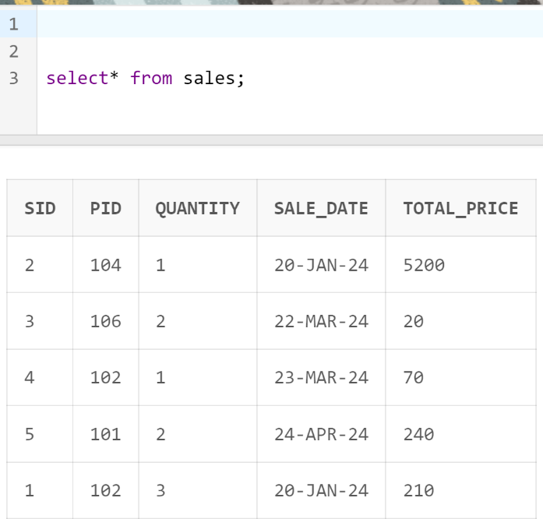
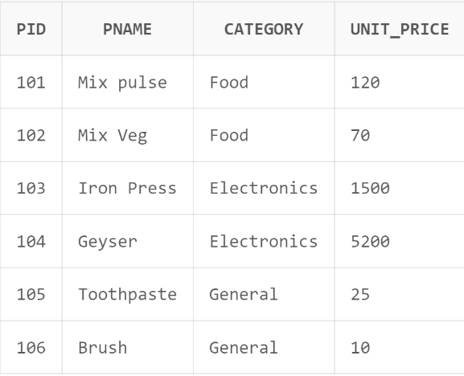

i)
SELECT SUM(sales.total_price) AS total_sales, products.category
FROM sales
JOIN products
ON sales.pid = products.pid
GROUP BY products.category;
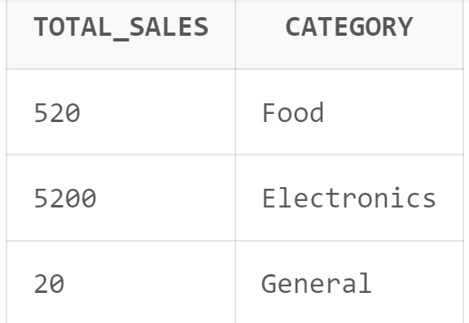

ii)
select category,avg_unit_price
from (
select category,avg(unit_price)as avg_unit_price
from products
group by category
order by avg_unit_price desc
)
where ROWNUM=1;

