Assignment 4

Q1. Illustrate the properties of virtual function and write a program to show its application.
Ans) Virtual functions are member functions of a class that are declared with the virtual keyword. Virtual functions allow for polymorphism, which is the ability of different objects to respond to the same method call in different ways.

Properties of virtual functions:

1)Virtual functions are dynamically bound, meaning that the function that is called is determined at runtime, based on the type of the object that is calling the method. This is in contrast to static binding, where the function that is called is determined at compile time, based on the type of the object that is declared.
2)Virtual functions can be overridden by derived classes. This allows for different derived classes to implement the same virtual function in different ways.
3)Virtual functions are slower than non-virtual functions, due to the overhead of dynamic binding. However, the performance difference is typically negligible.

#include <iostream>

using namespace std;

class Animal {
public:
virtual void speak() {
cout << "Animal makes a sound" << endl;
}
};

class Dog : public Animal {
public:
void speak() {
cout << "Dog barks" << endl;
}
};

class Cat : public Animal {
public:
void speak() {
cout << "Cat meows" << endl;
}
};

int main() {
Animal* myAnimal;
Dog dog;
Cat cat;

myAnimal = &dog;
myAnimal->speak(); // Calls Dog's speak() method

myAnimal = &cat;
myAnimal->speak(); // Calls Cat's speak() method

return 0;
}

Q2)WAP in C++ to find largest element in array using class template?
Ans) #include<iostream>
#define max 10;
using namespace std;
class large
{
protected:
int arr[max],lar=0,i;
public:
large()
{
cout<<"Enter 10 elements:";
for(i=0;i<max;i++)
{
cin>>arr[i];
}
}
void findlarge()
{
lar=arr[0];
for(int i=0;i<max;i++)
{
if(lar<arr[i])
{
lar=arr[i];
}
}
cout<<"The largest of the all elementsis:"<<lar;
}
};
int main()
{
large obj;
obj.findlarge();
return 0;
}
Q3. WAP in C++ to store 20 numbers in a file and separate even and odd numbers in two different files and display data of each file.
Ans) #include <iostream>
#include <fstream>

using namespace std;

int main() {
ofstream numbersFile("numbers.txt"); // Open file to store the original numbers
ofstream evenFile("even.txt"); // Open file to store even numbers
ofstream oddFile("odd.txt"); // Open file to store odd numbers

// Read 20 numbers from the user
int num;
for (int i = 0; i < 20; i++) {
cout << "Enter number " << i + 1 << ": ";
cin >> num;

numbersFile << num << endl; // Write the number to the original file

if (num % 2 == 0) { // Check if the number is even
evenFile << num << endl; // Write the number to the even file
} else { // Check if the number is odd
oddFile << num << endl; // Write the number to the odd file
}
}

numbersFile.close(); // Close the original file
evenFile.close(); // Close the even file
oddFile.close(); // Close the odd file

// Read and display the contents of the even file
ifstream evenInput("even.txt");
cout << "\nEven numbers: ";
while (evenInput >> num) {
cout << num << " ";
}
evenInput.close();

// Read and display the contents of the odd file
ifstream oddInput("odd.txt");
cout << "\nOdd numbers: ";
while (oddInput >> num) {
cout << num << " ";
}
oddInput.close();

return 0;
}
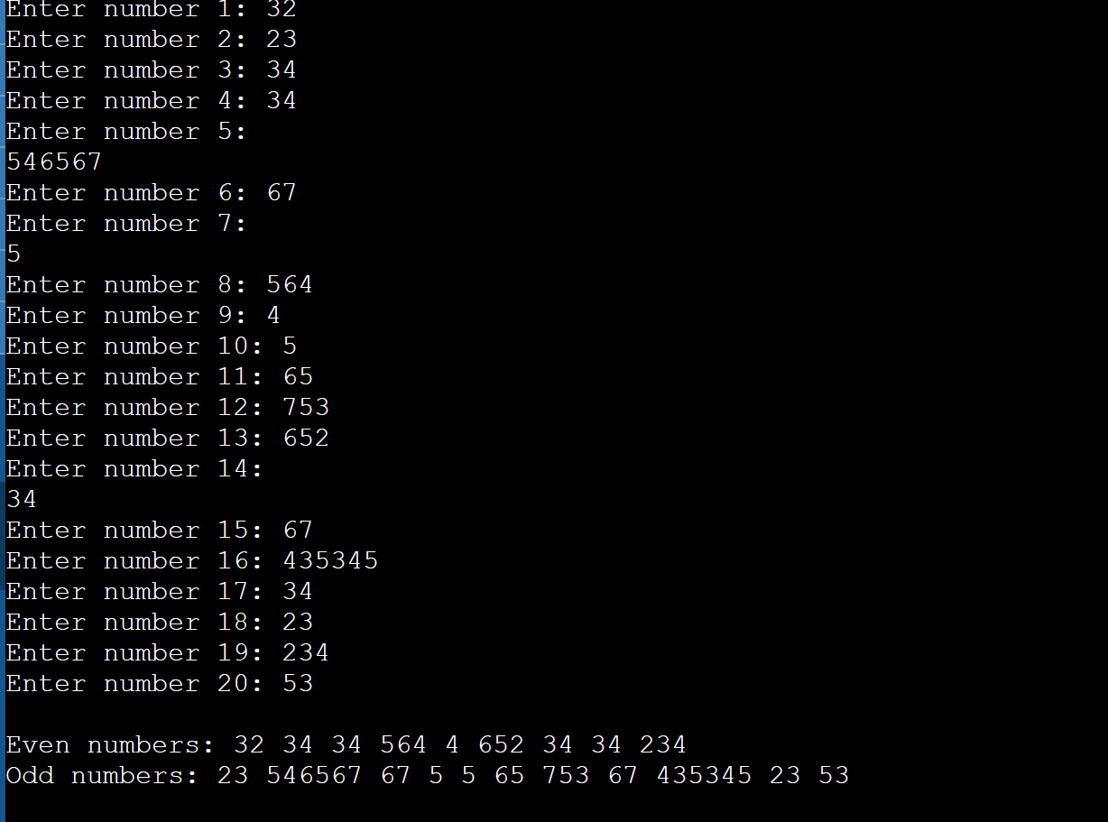
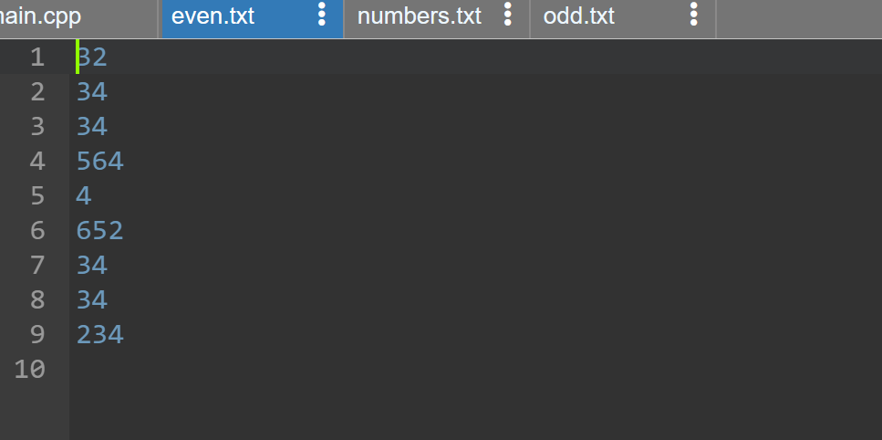
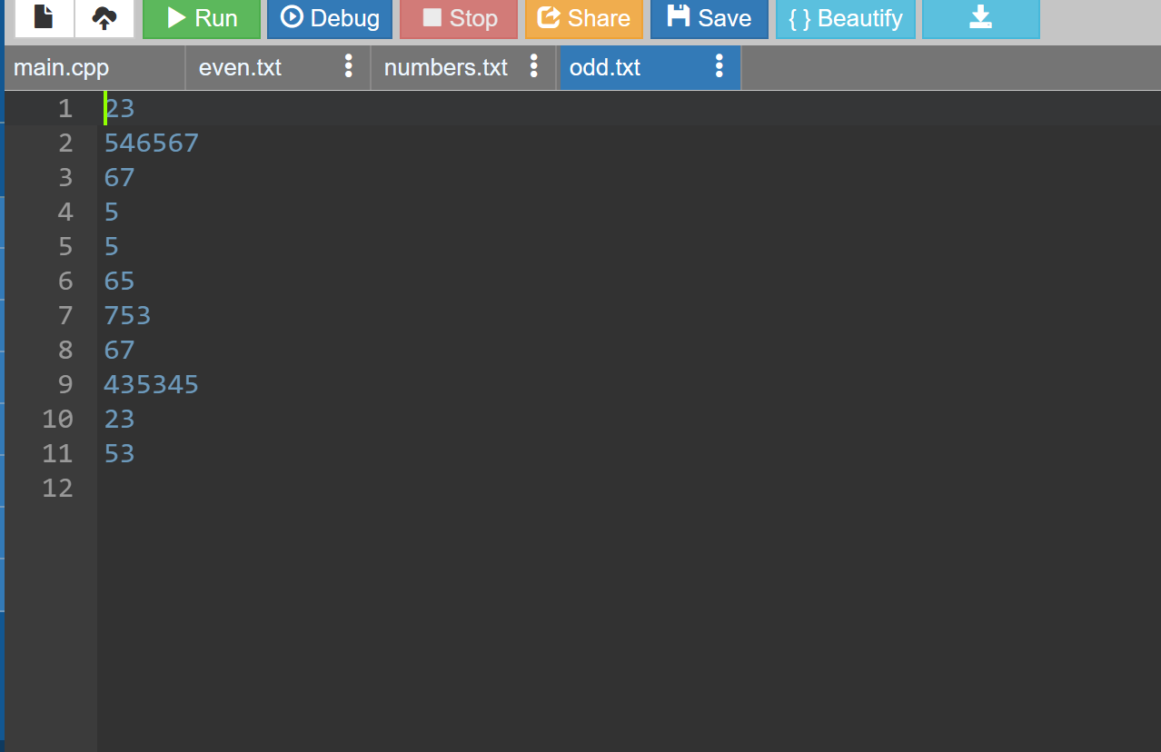
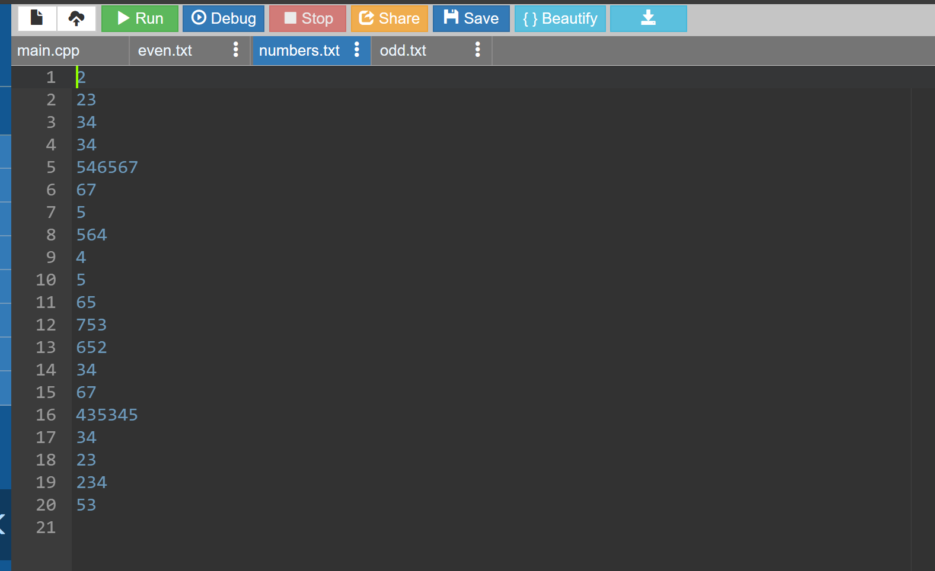

Q4. WAP to create a vector and perform multiple operation on it like insertion, deletion,
delete an element of particular location, insertion at a specific position, size of vector etc.
#include <iostream>
#include <vector>
using namespace std;
int main() {
vector<int> numbers; // Create an empty vector
// Insert elements into the vector
numbers.push_back(10);
numbers.push_back(20);
numbers.push_back(30);
// Display the vector
cout << "Vector: ";
for (int i = 0; i < numbers.size(); i++) {
cout << numbers[i] << " ";
}
cout << endl;
// Insert an element at a specific position
numbers.insert(numbers.begin() + 1, 15); // Insert 15 at position 1

// Display the vector after inserting an element
cout << "Vector after inserting 15 at position 1: ";
for (int i = 0; i < numbers.size(); i++) {
cout << numbers[i] << " ";
}
cout << endl;
// Delete an element at a particular location
numbers.erase(numbers.begin() + 2); // Delete the element at position 2
// Display the vector after deleting an element
cout << "Vector after deleting the element at position 2: ";
for (int i = 0; i < numbers.size(); i++) {
cout << numbers[i] << " ";
}
cout << endl;
// Get the size of the vector
cout << "Size of the vector: " << numbers.size() << endl;
return 0;
}

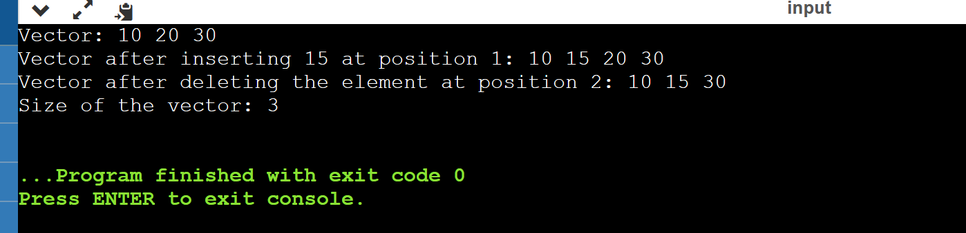

Q5. What do you mean by sequential container? WAP to show multiple operations on list.

#include <iostream>
#include <list>

int main() {
// Create a list
std::list<int> myList;

// Add elements to the list
myList.push_back(1);
myList.push_back(2);
myList.push_back(3);

// Display the elements in the list
std::cout << "Elements in the list: ";
for (const auto& element : myList) {
std::cout << element << " ";
}
std::cout << std::endl;

// Insert an element at the beginning
myList.push_front(0);

// Display the elements after inserting at the beginning
std::cout << "After inserting at the beginning: ";
for (const auto& element : myList) {
std::cout << element << " ";
}
std::cout << std::endl;

// Remove the last element
myList.pop_back();

// Display the elements after removing the last element
std::cout << "After removing the last element: ";
for (const auto& element : myList) {
std::cout << element << " ";
}
std::cout << std::endl;

// Insert an element at a specific position (in this case, after the first element)
auto it = myList.begin();
++it; // Advance the iterator to the second element
myList.insert(it, 4);

// Display the elements after inserting at a specific position
std::cout << "After inserting at a specific position: ";
for (const auto& element : myList) {
std::cout << element << " ";
}
std::cout << std::endl;

return 0;
}
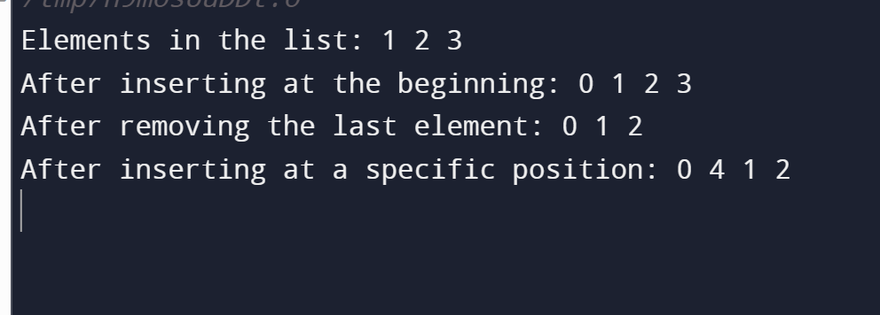

Q6) WAP in C++ to make simple calculator using function template.
Ans) #include<iostream>
#include<string.h>
using namespace std;
void Template(char op)
{
float a,b;
cout<<"Enter two numbers:";
cin>>a>>b;
if(op=='+')
{
cout<<a+b;
}
else if(op=='-')
{
cout<<a-b;
}
else if(op=='*')
{
cout<<a*b;
}
else if(op=='/')
{
cout<<a/b;
}
else
{
cout<<"Invalid Operator";
}

};
int main()
{
char ch;
int choice=0;
while(1)
{
cout<<"1.+\n2.*\n3./\4.-\nEnter ur choice:";
cin>>ch;
Template(ch);
cout<<"\nDo u want to continue or not:";
cin>>choice;
if(ch==0)
{
break;
}
}
return 0;
}
