CodeShield Context Aware Security Drift Analyzer
Review 3 Report
Team Members
1. Shaurya Rawat (23BCE0615)
2. Vibhor Kataria (23BCE0962)
3. Abhinav Singh (23BCE0589)
Project Guide: Dr. Padma Priya R

Abstract
CodeShield is a deterministic security drift analyzer. It compares an approved application baseline with values read from a public Git repository, a local repository, a web form, or a REST request. The Java 21 and Spring Boot prototype inspects Maven, Gradle, Dockerfile, and Docker Compose files. It checks six types of drift, calculates a context-based priority score, and stores the expected state, observed state, evidence, remediation, and review status. The project test suite completed 11 tests successfully. The current 120-case benchmark was also executed against the production drift-detection and scoring services. CodeShield matched all 120 expected rule sets, with 181 true positives, no false positives, and no false negatives. Precision, recall, and F1 were therefore 100% on this controlled dataset. Binary drift accuracy was 100%, compared with 80% for a majority-class baseline, an improvement of 20 percentage points. Because the benchmark was generated from the same six rule specifications, these results measure implementation correctness rather than real-world generalization.
Keywords security drift, container configuration, baseline comparison, repository scanning, explainable risk scoring

1 Introduction

1 1 Problem
A secure application can become less secure after deployment when its runtime version, container user, network exposure, image, or dependencies change. CodeShield defines security drift as a difference between an approved application baseline and a later observation. It records the difference as evidence; it does not automatically label the difference as an exploitable vulnerability.

1 2 Objective and Scope
The objective is to build an understandable tool that accepts real repository links, compares supported configuration with a saved baseline, and produces traceable findings. The current implementation supports public HTTPS repositories, local directories, browser input, and REST requests. It does not yet support private repository credentials, live host agents, Kubernetes, SBOM analysis, automatic remediation, or production authentication.
- Store an application baseline with ownership, criticality, and approved values.
- Extract supported evidence without changing the scanned repository.
- Detect six security drift categories with stable, explainable rules.
- Prioritize findings using asset criticality, exposure, and exploitation context.
- Keep scan history, evidence, remediation, and finding status.

2 Relevant Work
Recent container-security research covers container threats, isolation, misconfiguration, dependency reachability, software supply chains, SBOM use, and runtime protection [1]-[10]. These studies show that exposed services, powerful container capabilities, unpatched libraries, and weak configuration can create serious risk. They also show that a version or configuration difference is not enough to prove exploitability.
CodeShield addresses a narrower problem. It connects an application-specific approved baseline with observed project configuration and explains each mismatch. It does not replace image scanners, reachability analysis, SBOM platforms, hardware isolation, or runtime defenses. Its contribution is the integrated baseline-to-observation workflow and the evidence retained for review.
Table 1 Position of CodeShield relative to related work
Research area | Typical focus | CodeShield role
Container security | Threats, isolation, and attacks | Checks selected identity, mount, network, and image fields
Misconfiguration | Invalid or exposed cloud configuration | Compares observed values with an approved application baseline
Supply chain | Vulnerabilities, reachability, and SBOMs | Records version and image drift; does not prove reachability
Runtime protection | Monitoring or enforcement | Detects and prioritizes; does not enforce controls

3 Methodology

3 1 System Design
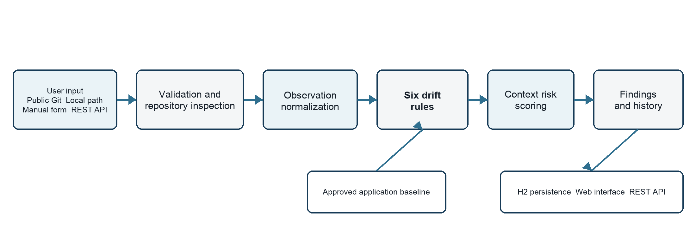
Figure 1 Implemented CodeShield processing architecture
The same processing path is used for repository scans and manually supplied observations. Input is validated, normalized into a ScanRequest, compared with the selected ApplicationAsset baseline, scored, and saved as a ScanRun with related findings. The web interface and REST API read the stored results.

3 2 Processing Steps
1. Register a baseline and submit a repository URL, local path, web form, or REST request.
2. Validate the source and inspect the supported project files.
3. Normalize the extracted values into one observation model.
4. Run the six drift rules and calculate each finding's score and severity.
5. Store and display the scan, evidence, remediation, and review status.

3 3 Drift Rules and Scoring
Table 2 Implemented drift rules
Rule | Trigger | Base risk
CS RUNTIME 001 | Java version differs from the baseline | 30
CS NETWORK 001 | An internal database is observed as public | 52
CS CONTAINER 001 | Container user differs from the baseline | 42 root; 25 other
CS CONTAINER 002 | Docker socket is mounted | 58
CS SUPPLY 001 | Image digest differs or is unpinned | 38
CS DEPENDENCY 001 | Dependency version differs | 48 exploited; 24 other

The score is the base rule risk plus a criticality weight, 15 points for Internet exposure, and 18 points for known exploitation evidence, capped at 100. Scores below 40 are Low, 40-64 are Medium, 65-84 are High, and 85-100 are Critical. The score is a review priority, not an exploit probability.

4 Experimental Results

4 1 Test Suite
The standard Maven suite completed 11 tests with no failures, errors, or skipped tests. The tests cover the web and API layer, all six drift rules, risk-scoring boundaries, repository evidence extraction, and invalid-source rejection.

4 2 Accuracy on the Current Dataset
The current workbook contains 120 specification-derived cases: 24 compliant cases and 96 drift cases with 181 expected findings. Every case was executed through the actual DriftDetectionService and RiskScoringService. The predicted rule set, rule score, maximum score, and highest severity were compared with the workbook labels.
Table 3 Benchmark accuracy results
Measure | Result
Exact rule-set accuracy | 120 of 120 cases 100.0%
Binary drift accuracy | 120 of 120 cases 100.0%
Finding classification | 181 TP 0 FP 0 FN 539 TN
Micro precision recall and F1 | 100.0% 100.0% 100.0%

No earlier CodeShield release has a measured benchmark score, so improvement is reported against a transparent majority-class baseline. A classifier that always predicts drift is correct for 96 of 120 cases, or 80.0%. CodeShield reaches 100.0% binary accuracy on the same cases, an improvement of 20.0 percentage points. This comparison is useful for context but is not a claim about an earlier project version. Rule scores also matched for all 181 findings, and the highest severity matched for all 120 cases.
Table 4 Per-rule finding results
Rule | TP | FP | FN | Precision | Recall | F1
Runtime | 31 | 0 | 0 | 100% | 100% | 100%
Network | 31 | 0 | 0 | 100% | 100% | 100%
Container user | 29 | 0 | 0 | 100% | 100% | 100%
Docker socket | 30 | 0 | 0 | 100% | 100% | 100%
Image digest | 31 | 0 | 0 | 100% | 100% | 100%
Dependency | 29 | 0 | 0 | 100% | 100% | 100%
Micro total | 181 | 0 | 0 | 100% | 100% | 100%

The benchmark was generated from the same six rule definitions used by the application. The 100% result therefore shows that the implementation follows its specification and that the scoring logic is internally consistent. It does not establish accuracy on unknown real-world repositories, parser coverage, exploitability, or performance. Those questions require independently labeled repositories and runtime observations.

4 3 Repository and Clean Start Checks
Two public repositories were scanned through the full clone, extraction, normalization, rule, score, and persistence path. Spring Petclinic produced five differences with a maximum score of 82. The Adaptive LLM repository produced two differences with a maximum score of 72. These are baseline differences, not confirmed vulnerabilities. A separate clean-start test used an empty database and confirmed that the application, history page, scan pages, and asset API do not depend on hardcoded demonstration data.

5 Conclusions
CodeShield provides a complete prototype workflow for storing approved application intent, scanning supported project configuration, detecting six classes of drift, assigning a transparent priority, and keeping evidence for review. It accepts real public repository URLs and does not rely on fixed sample results.
On the current controlled benchmark, the implementation achieved 100% exact rule-set accuracy, precision, recall, F1, score agreement, and severity agreement. Binary accuracy improved by 20 percentage points over the 80% majority-class baseline. The result is strong evidence of rule-engine correctness, but the specification-derived dataset prevents a claim of real-world generalization. The next evaluation should use independently labeled repositories and runtime snapshots, measure parser coverage and scan time, and include examples that the rule authors did not generate.
Future engineering work can add authenticated private repositories, read-only runtime collectors, SBOM and vulnerability sources, access control, and production-grade persistence while keeping the current deterministic and explainable design.

References
[1] O. Jarkas, R. Ko, N. Dong, and R. Mahmud, A Container Security Survey Exploits Attacks and Defenses, ACM Computing Surveys, vol. 57, no. 7, Art. 170, 2025. Verified source
[2] P. Deng, L. Zhang, Y. Meng, et al., ChainFuzz Exploiting Upstream Vulnerabilities in Open Source Supply Chains, in 34th USENIX Security Symposium, 2025. Verified source
[3] Z. Jia, C. Yang, P. Feng, et al., Impact Assessment of Third Party Library Vulnerabilities through Vulnerability Reachability Analysis, Computers and Security, vol. 157, Art. 104546, 2025. Verified source
[4] Q. Zhou, W. Cao, X. Jia, et al., RContainer A Secure Container Architecture through Extending ARM CCA Hardware Primitives, in NDSS Symposium, 2025. Verified source
[5] Y. Li, C. Zhang, J. Zhu, et al., VulShield Protecting Vulnerable Code Before Deploying Patches, in NDSS Symposium, 2025. Verified source
[6] H. Kermabon-Bobinnec, Y. Jarraya, L. Wang, et al., Phoenix Surviving Unpatched Vulnerabilities via Accurate and Efficient Filtering of Syscall Sequences, in NDSS Symposium, 2024. Verified source
[7] D. Choi, H. Seo, K. Kim, et al., Uncovering Threats in Container Systems A Study on Misconfigured Container Components in the Wild, IEEE Access, vol. 12, pp. 192931 to 192945, 2024. Verified source
[8] T. Rankovic, F. Siljic, J. Tomic, G. Sladic, and M. Simic, Misconfiguration Prevention and Error Cause Detection for Distributed Cloud Applications, in IEEE SISY, 2024. Verified source
[9] T. Stalnaker, N. Wintersgill, O. Chaparro, et al., BOMs Away Inside the Minds of Stakeholders, in ICSE, 2024. Verified source
[10] Y. He, R. Guo, Y. Xing, et al., Cross Container Attacks The Bewildered eBPF on Clouds, in 32nd USENIX Security Symposium, 2023. Verified source

