CodeShield Context Aware SecOps Platform for Detecting Application Infrastructure Security Drift
Short Project Report
Cybersecurity and DevSecOps | October 2026

Executive Summary
CodeShield is a security platform that detects differences between an application's approved baseline and the configuration found in its repository or deployed environment. It combines repository evidence with supplied observations from containers, dependencies, hosts, and networks. The platform produces prioritized findings that state what was expected, what was observed, why the difference matters, and how to correct it.
The implemented application combines a read-only local repository scanner, manual and API-based runtime evidence input, deterministic drift rules, and transparent risk scoring. Findings retain their evidence source and can be marked open, resolved, or accepted. The system runs as a Spring Boot web application with an embedded database and Docker support.
Area | Project definition
Primary goal | Detect security drift between application intent and runtime reality
Main inputs | Maven, Gradle, Dockerfile and Compose files plus supplied runtime observations
Main output | Explainable findings with evidence, risk score and remediation guidance
Implemented platform | Java 21, Spring Boot 3.3, Thymeleaf, Spring Data JPA and H2

Problem and Objectives
An application can be secure in source control but unsafe after deployment. A database intended for an internal network may become publicly reachable, a container may run as root, or the deployed library version may differ from the approved SBOM. These changes may result from configuration edits, emergency fixes, image replacement, or infrastructure maintenance.
CodeShield has four practical objectives:
- Store an approved application baseline covering versions, exposure, image identity and container user.
- Extract evidence from Maven, Gradle, Dockerfile and Docker Compose configuration without modifying the repository.
- Apply explainable rules to identify meaningful mismatches between the two models.
- Prioritize each mismatch using exposure, reachability, exploitability and asset importance.

How CodeShield Differs
Dimension | Conventional scanner | CodeShield
Analysis scope | Usually one layer or data source | Connects application, container, host, dependency and network evidence
Decision basis | Reports a vulnerability or misconfiguration | Checks whether the observed state violates application intent
Prioritization | Often dominated by severity scores | Adds exposure, reachability, privilege, asset importance and compensating controls
Explanation | Describes the isolated alert | Records expected state, observed state, evidence and recommended correction
Ongoing use | Runs periodic independent scans | Tracks drift and verifies remediation through re-scanning

Illustrative Finding
A configuration file declares Redis as an internal service, while the Docker and network collectors observe port 6379 published on all host interfaces. CodeShield correlates these facts and reports a trust-boundary violation. The finding identifies the expected private access, the observed public exposure, the affected asset, the supporting evidence, and the recommended action to remove the host mapping or restrict network access.

Project Scope
CodeShield is designed for authorized security monitoring and complements existing source, dependency and container scanners. It can consume their results as evidence, while its own responsibility is to correlate that evidence with the deployed environment.
- Inspect only registered applications, hosts and container environments.
- Use read-only collection wherever possible and preserve evidence timestamps.
- Detect and report drift without automatically changing production systems.
- Require a human decision for exceptions and disruptive remediation.

System Architecture
The architecture separates evidence collection from analysis and decision-making. Read-only collectors and authenticated agents gather facts. The Spring Boot control plane schedules work, manages access, stores evidence, and exposes findings. The correlation engine compares normalized intent and runtime models before the risk engine prioritizes the result.
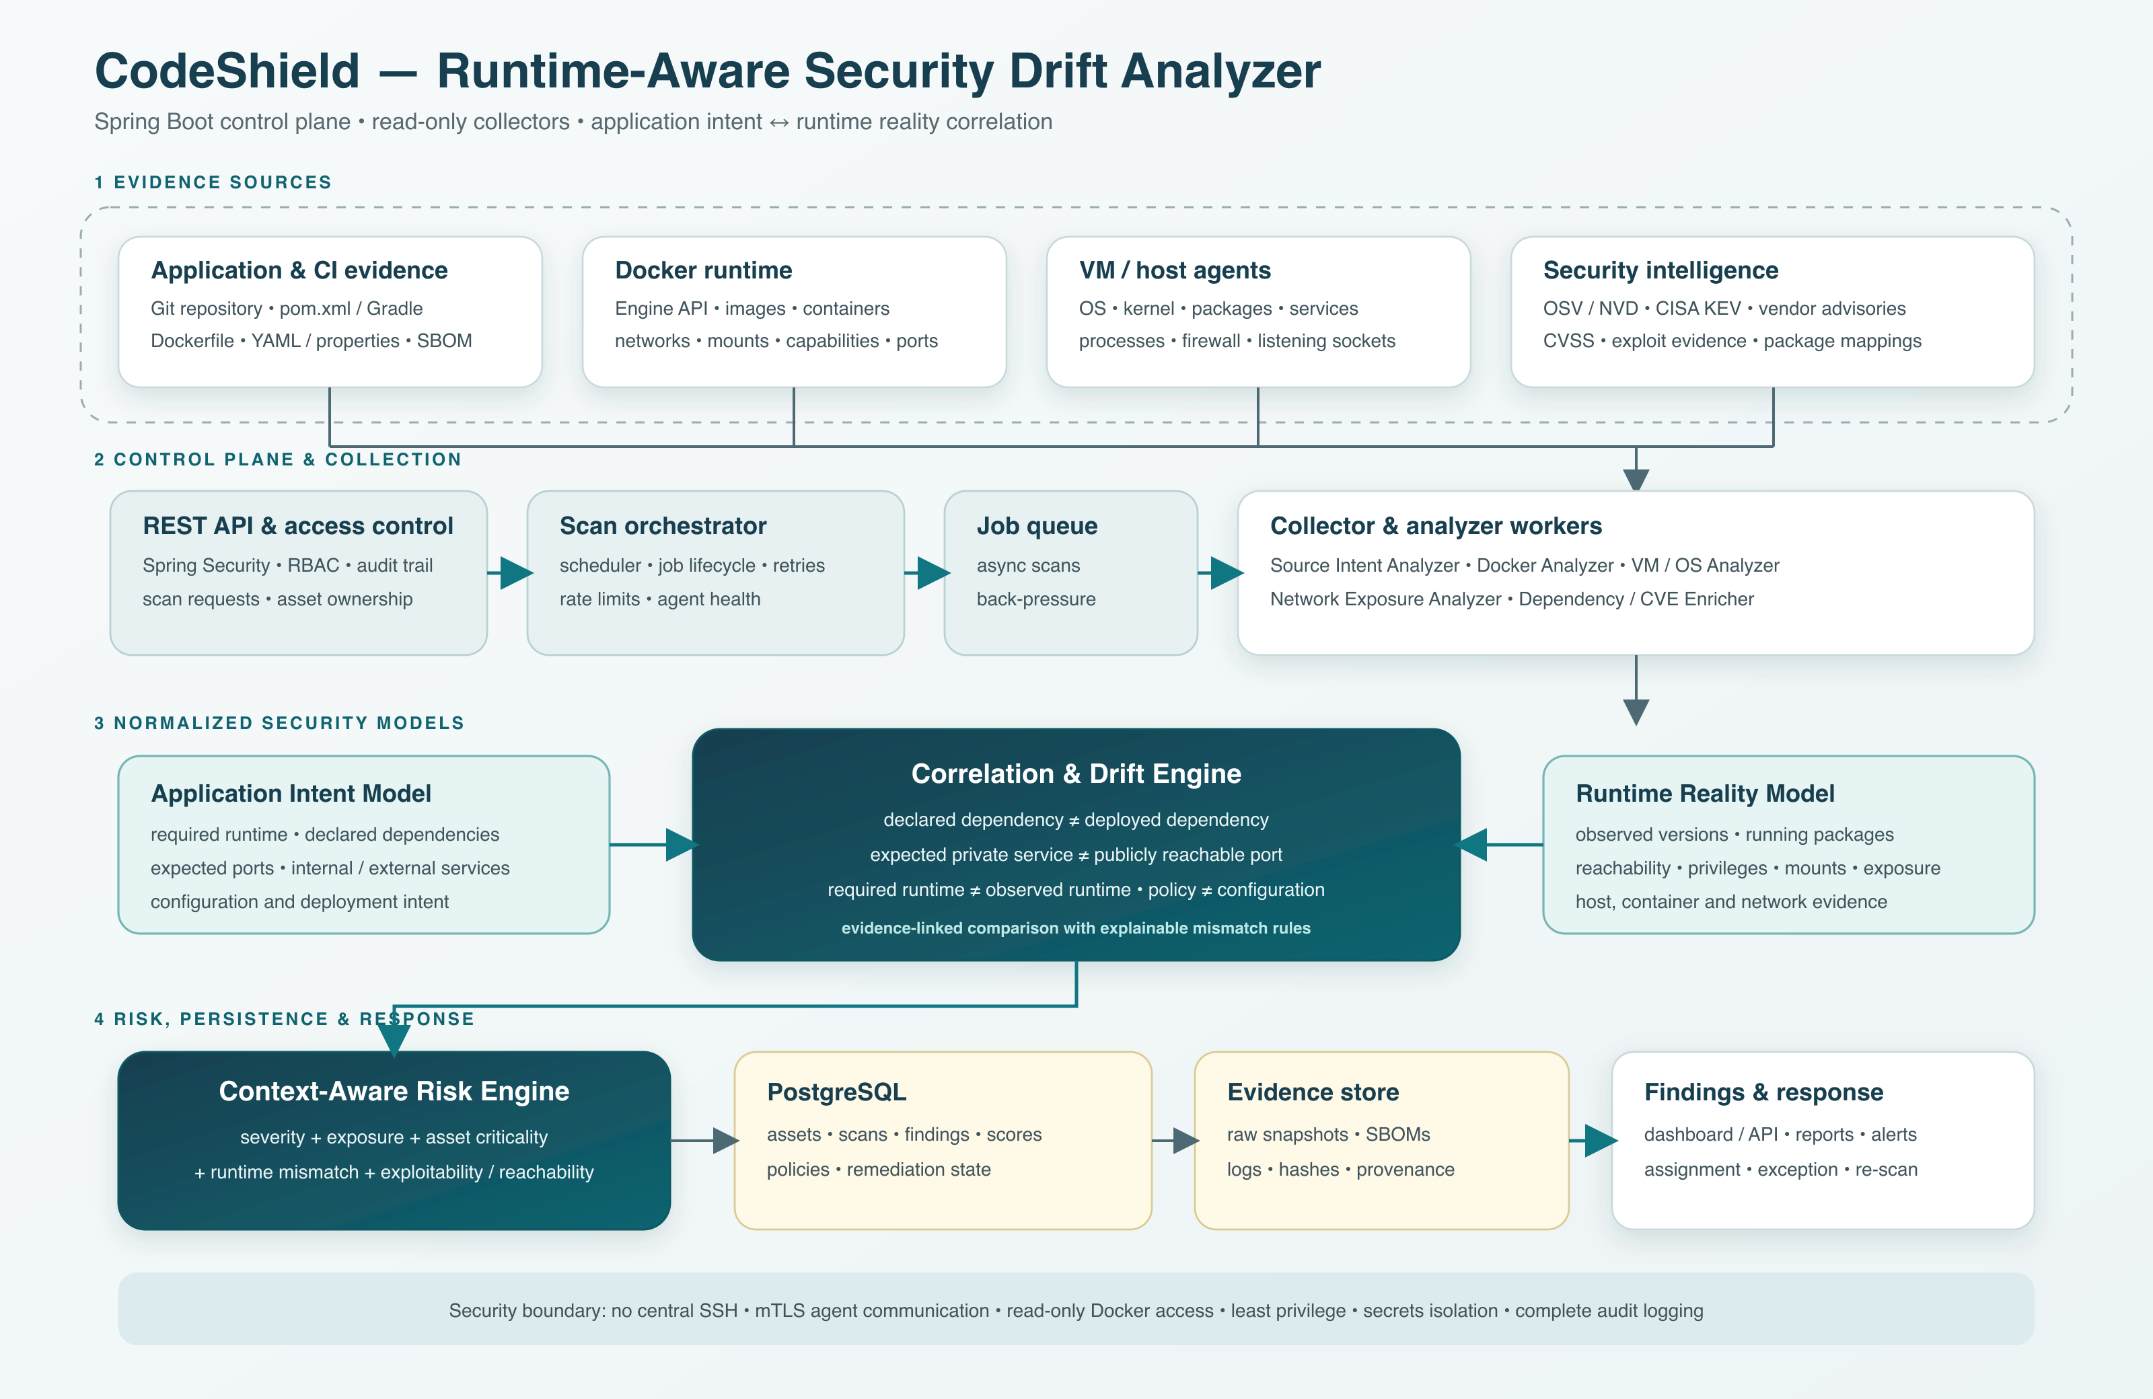
Figure 1 CodeShield system architecture
Layer | Responsibility
Evidence collection | Reads source and deployment artifacts; queries Docker; receives host, OS and network observations.
Normalized models | Converts raw inputs into comparable application intent and runtime reality facts.
Correlation engine | Applies deterministic drift rules and preserves the evidence behind each decision.
Risk engine | Combines severity with exposure, criticality, mismatch, reachability, privilege and controls.
Findings workflow | Supports dashboards, reports, ownership, exceptions, remediation status and re-scans.

Context Aware Risk Logic
The first version should use transparent rules rather than machine learning. A finding receives more weight when the affected asset is important, the service is externally exposed, the vulnerable code is reachable, or the runtime has excessive privileges. Verified controls such as network restrictions or compensating authentication may reduce the final score. CVSS remains an input, but it does not determine priority by itself.
Expected state | Observed state | Result
Java 21 required | Java 17 running | Runtime compatibility and patching risk
Database intended to be internal | Database port publicly reachable | Network trust-boundary violation
Non-root container expected | Container runs as root | Excessive runtime privilege
Approved image digest | Different digest running | Deployment integrity drift
Dependency version X declared | Version Y deployed | Dependency or SBOM drift

Implemented Scope
The current application implements the correlation workflow with focused evidence sources and explainable rules. It avoids automated remediation and machine learning so every finding can be traced to an explicit comparison.
- Register application baselines with ownership, criticality and approved configuration.
- Inspect local repositories for Maven, Gradle, Dockerfile and Docker Compose evidence.
- Accept runtime observations through a browser form or JSON API.
- Detect Java, dependency, exposure, container-user, Docker-socket and image-integrity drift.
- Score findings using rule risk, application criticality, Internet exposure and exploit context.
- Display evidence, expected and observed states, remediation, workflow status and scan history.
- Persist data in H2 and run locally or through Docker Compose.

Security Design
Boundary | Implemented control
Repository access | Read only supported configuration files and never modify the target repository.
Path handling | Normalize and validate repository paths before inspection.
File scope | Ignore generated directories and reject configuration files larger than one megabyte.
Runtime data | Record the evidence source and keep repository findings separate from live-host claims.
Remediation | Provide guidance and workflow status without changing the scanned system.
Deployment | Run the application container as a non-root user and mount scanned repositories read only.

Evaluation Plan
Evaluation should use controlled deployments with seeded drift cases and a known ground truth. Each case should represent a realistic mismatch, such as a publicly exposed internal service, an unapproved image digest, an incorrect runtime version, or an unnecessary privilege.
- Measure precision, recall and false-positive rate for each drift category.
- Compare alert quality before and after application context is added.
- Measure dependency matching and network exposure classification accuracy.
- Record scan duration, agent overhead, stale-evidence behavior and re-scan consistency.

Current Result
CodeShield now scans real local repositories, converts supported configuration into comparable evidence, and applies the same drift and risk engine used for submitted runtime observations. Automated tests cover repository extraction, rule detection, risk scoring, web pages and JSON endpoints. The accompanying literature review workbook provides the research foundation for container security, software supply-chain risk, vulnerability prioritization, SBOM analysis, runtime monitoring and configuration drift.

Project Deliverables
- Runnable Spring Boot source code with web interface, REST API, database and Docker support.
- CodeShield System Architecture in PNG and editable SVG formats.
- CodeShield Literature Review with ten recent and verified papers in Excel format.
- CodeShield README with detailed architecture, modules, security boundaries and implementation scope.

