Game Design Document

Fill up the following document

1. Write the title of your project.

Doraemon Mouse Run

1. What is the goal of the game?

Doraemon has to reach to Nobita without colliding with the mouse

1. Write a brief story of your game.

Nobita is lost in the forest you have to reach to him without colliding with the mice.

1. Which are the playing characters of this game?

* Playing characters are the ones who respond to the user based on the input from the user.
* Cars, monkeys, dinos, wizards, etc., are the playing characters in the game.

|  |  |  |
| --- | --- | --- |
| Number | Character Name | What can this character do? |
| 1 | Doraemon | Run,jump |
| 2 |  |  |
| 3 |  |  |
| 4 |  |  |
| 5 |  |  |
| 6 |  |  |
| 7 |  |  |
| 8 |  |  |

1. Which are the Non-Playing Characters of this game?

* Non-Playing characters are the ones that don't have an action or behavior when the user interacts with the game.
* Hurdles, stones, bananas, coins, etc., are non-playing characters in the game.

|  |  |  |
| --- | --- | --- |
| Number | Character Name | What can this character do? |
| 1 | Mouse | Spawn randomely |
| 2 | Platform | Spawn randomely |
| 3 |  |  |
| 4 |  |  |
| 5 |  |  |
| 6 |  |  |
| 7 |  |  |
| 8 |  |  |

Draw your imagination of this game. What does this game look like?

* Draw the game either on your computer or on paper.
* Add images of the game scenes to show each of the playing and non-playing characters at least once.

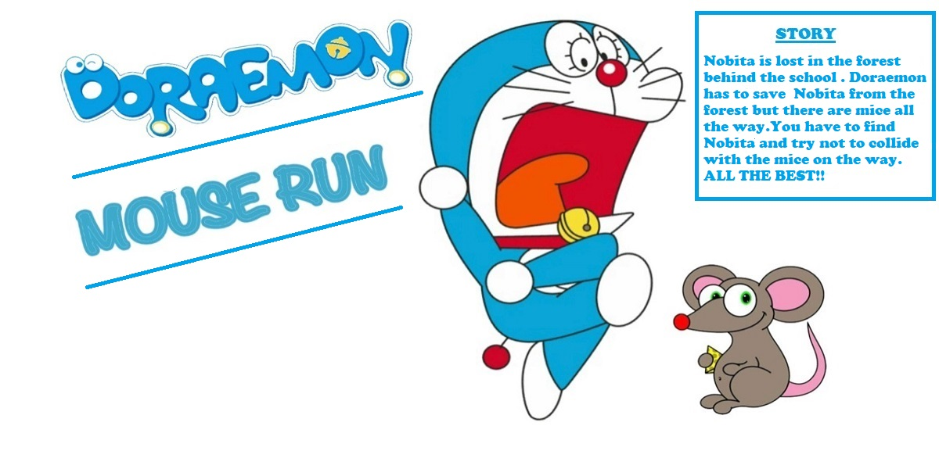

How do you plan to make your game engaging?

Making it with nice controls , nice animation and no bugs