Jawahar Navodaya Vidyalaya , Kurukshetra

https://lh6.googleusercontent.com/Di5ViJDRN4cvgS5iv6G0JV0qLYF8dZpx4zlv36nc_3zZISx1CVOAYJsgONzz7O1WaN3Rg6zSm0dvKc2QnTCp507_-r0A8KCu5mvH1hmnq4AYsKrym5ocIw-yfan8FY62C5Ry9lcO



**JKC Calculator**

02.December.2019

**(_-)(</>)**

{Shaurya Sharthak}

[Guidance of Mr. Vedpal Chahal]

(P.G.T Computer Science)

 J.N.V Kurukshetra

**Overview**

This Model Is Based On Python Programming Language

It Does Complex Calculations Very Fast and Great User Friendly

This Model Is Developed By Mr. Shaurya Sharthak Under The Careful Guidance Of Mr. Vedpal Chahal

This Model Is Designed To Help Researcher and Scientists To Carefully Calculate Their Complex Calculations Easily With 15-digit Double Precision JKC Calculator

**Features**

1. Highly Precise (Upto 15 Digits)
2. Easily available (Open source and Is available at ***{https://www.github.com/Shauryajnvkkr/JKC-Calculator***}
3. Performs complex calculations very Easily
4. Highly user Friendly
5. Cross Platform Software
6. Neat and Clean and No load on System

**System Requirements**

1. 1GB RAM
2. 20MB FREE SPACE
3. PYTHON {FOR LINUX AND MACINTOSH OPERATING SYSTEM}
4. YOUR WILL
5. NOTE :- PLZ. BE CAREFUL WHILE USING IT BECAUSE IT IS CASE SENSITIVE

**SCREENSHOTS OF THE PROGRAM**

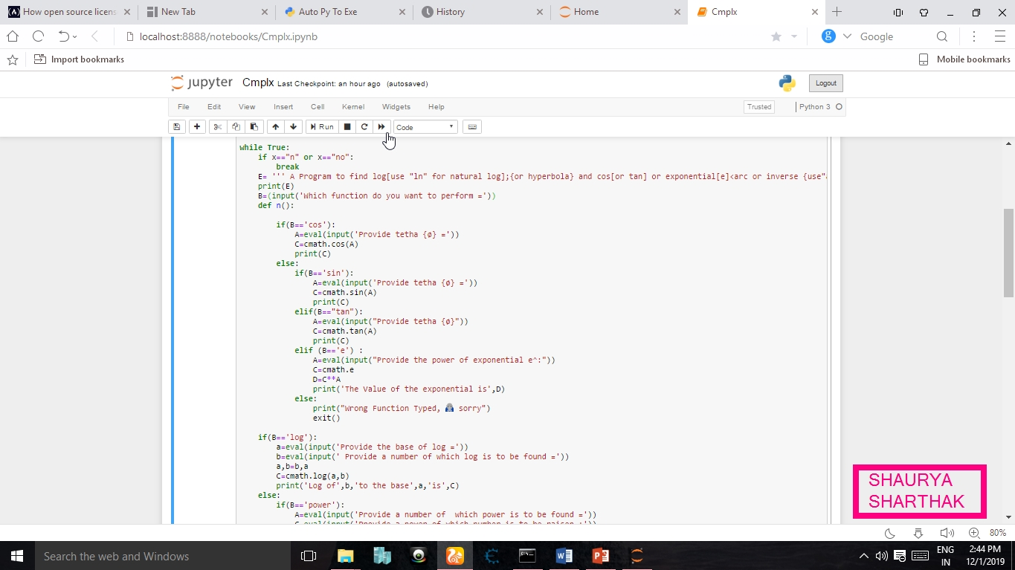

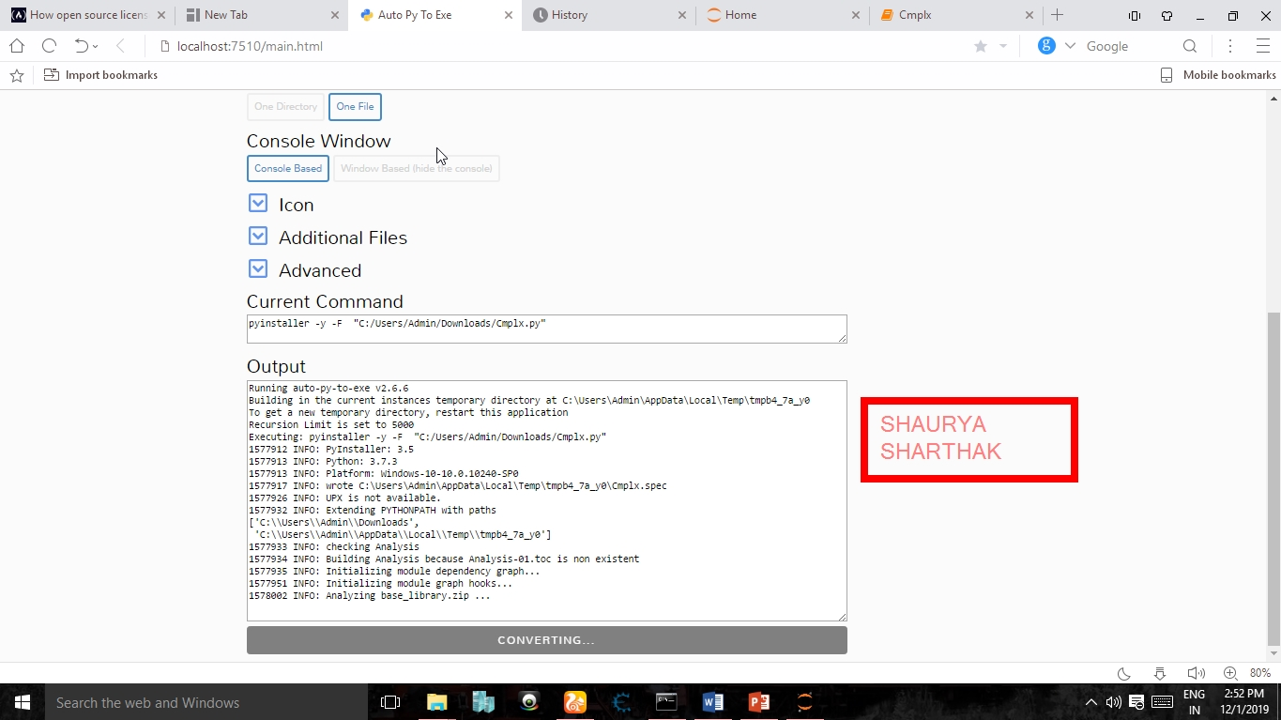

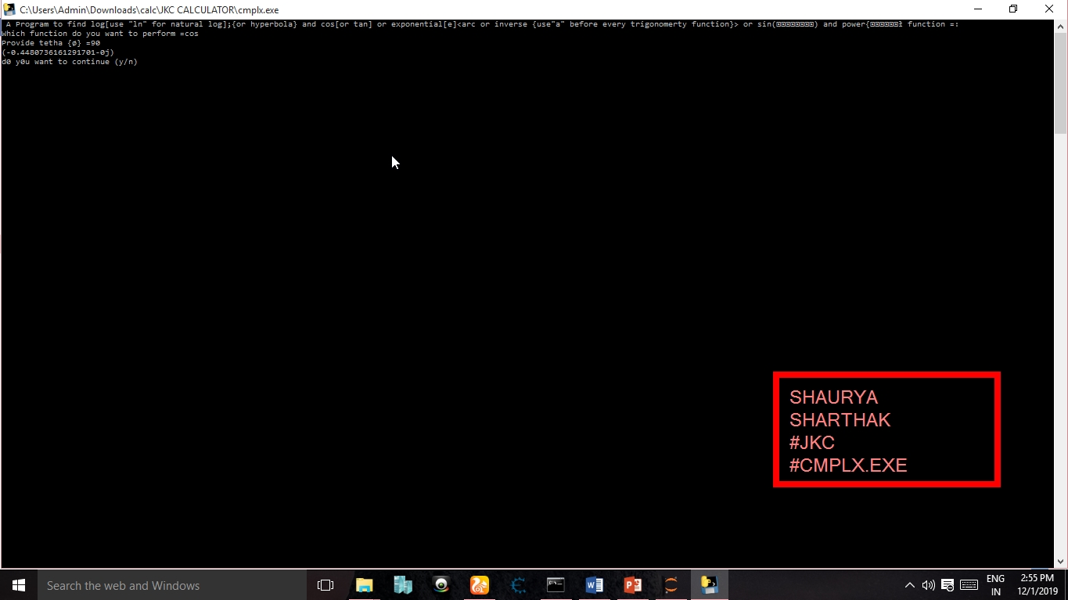

**<Acknowledgement>**

**This project is licensed by Shaurya under mit license**

**I would like to thank my father (mr. kumar amit roy ) and my mother (mrs. Nikita kumari)**

**I would also like to thank mr. vedpal chahal for his superb support**