

Network Routing Report for FinTec Inc.

Module: MOD003262 TRI2 F01CAM

Word Count:
1740
Contents
INTRODUCTION 5
NETWORK DESIGN 6
EXISTING 6
PROPOSED 6
VLAN 6
ROUTING 7
ROUTING PROTOCOL 7
OSPF 7
London (Router ID: 2.2.2.2): 7
Liverpool (Router ID 4.4.4.4): 7
Leeds (15.15.15.15): 7
Leicester (Router ID: 12.12.12.12): 7
STATIC ROUTING 8
London: 8
Liverpool: 8
Leicester: 9
Leeds: 9
TESTING 9
IP ADDRESSING 9
SWITCHING AND DHCP IMPLEMENTATION 10
VLAN 10
PORT SEGMENTATION 11
London: 11
Liverpool: 12
Leicester: 12
Leeds: 13
ROUTER-ON-A-STICK 14
Liverpool: 14
Commands: 14
Configuration: 14
London: 14
Leeds: 15
Leicester: 15
TESTING 15
DHCP 16
SETUP CONFIGURATIONS: 16
DHCP SERVERS: 16
London: 16
Liverpool: 17
Leicester: 17
Leeds: 18
ROUTER CONFIGURATION: 18
London: 18
Liverpool: 19
Leicester: 19
Leeds: 19
TESTING END DEVICES: 20
London: 20
At VLAN 30: 20
At VLAN 40: 20
At VLAN 50: 20
Liverpool: 21
At VLAN 30: 21
At VLAN 40: 21
At VLAN 50: 21
Leicester: 22
At VLAN 30: 22
At VLAN 40: 22
At VLAN 50: 22
Leeds: 23
At VLAN 30: 23
At VLAN 40: 23
At VLAN 50: 23
ACL AND SECURITY 24
ACL 24
CONFIGURATION OF LONDON ROUTER: 24
TESTING 24
SECURITY 25
SSH ENABLING AND TELNET RESTRICTION. 25
Leeds: 25
Switch 25
Router 25
London: 26
Switch 26
Router 26
Liverpool: 26
Switch 26
Router 27
Leicester: 27
Switch 27
Router 27
PASSWORD ESTABLISHMENT: 28
London: 28
Switch 28
Router 28
Liverpool: 29
Switch 29
Router 29
Leicester: 29
Switch 29
Router 30
Leeds: 30
Switch 30
Router 30
DISABLING UNUSUED PORTS. (Grant, 2022) 31
SETUP 31
London 31
Liverpool 31
Leicester 33
Leeds 34
TESTING 35
Password Testing 35
London 35
Liverpool 35
Leicester 35
Leeds 36
SSH Testing 36
London: 36
Telnet Disable 36
SSH 36
Liverpool: 36
Telnet Disable 36
SSH 37
Leicester: 37
Telnet Disable 37
SSH 37
Leeds: 37
Telnet Disable 37
SSH 38
Port status check 38
London 38
Liverpool 39
Leicester 39
Leeds 40
COMPLETE IP ADDRESING TABLE 41
APPENDIX 43
REFERENES 53

INTRODUCTION
This report shows the enhancements needed for Fintech’s current Network topology which aligns to their requirements and security concerns as mentioned in the assignment details.

It proposes a better Network design consisting of Switches/Routers for inter-VLAN and inter-Site communication as well as DHCP servers at each site.

The network is further strengthened via required ACLs, security measures and adequate routing strategies.

At required sections, testing of the applied infrastructure has been clearly tested and displayed.

A full IP addressing table and an appendix section with further miscellaneous outputs and screenshots are provided at the end of the report.

NETWORK DESIGN

EXISTING
Existing Fintech Network highlights problems like scalability, security and adaptability due to its lack of proper VLANs using Switches, no DHCP implementation using Servers or Routers.

PROPOSED
    - Use of one Layer 2 Switches for VLAN segmentation and Router for inter VLAN and inter site communication.

    - Internet access only allowed at the London site and any attempts to connect to the internet through other sites is blocked by suitable ACLs

    - Use of a DHCP Server at each site to automate the assignment of IP addresses to end devices.

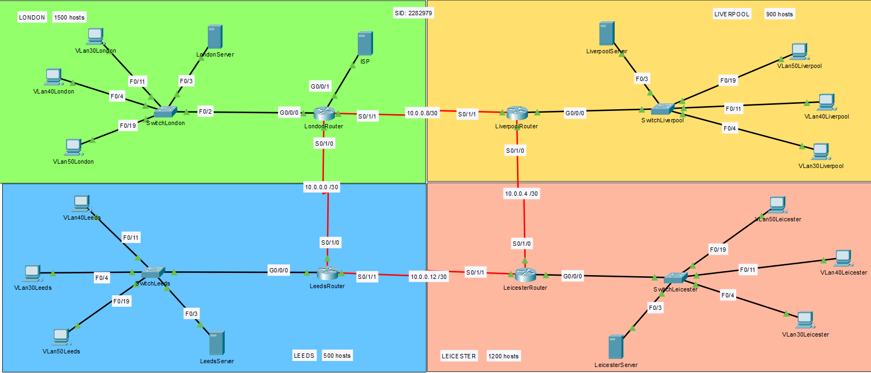

VLAN
Three VLANs will be established per site:

    - VLAN 30 - Finance
    - VLAN 40 - Executive
    - VLAN 50 - Employees

Each VLAN’s port segmentation is managed by a Layer 2 Switch while inter-VLAN routing is handled by a Router using techniques like OSPF routing and Router-on-Stick these will allow VLANs to communicate with each other while maintaining the security which comes with this segmentation (Zenarmor, 2023). These configurations and commands are later shown in the report.

ROUTING

ROUTING PROTOCOL
The communication lines between these cities would need to be dynamic, scalable and fast when it comes to routing, hence the OSPF (Open Shortest Path First) protocol is chosen (Mikac, 2024). In the event of OSPF failure, static routing has been implemented on each site to ensure proper communication.

OSPF

London (Router ID: 2.2.2.2):

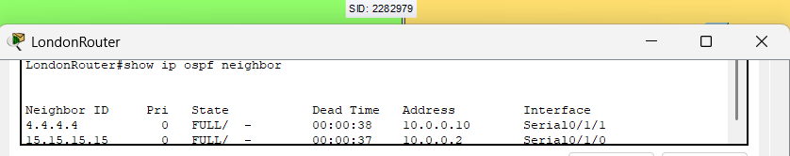

Liverpool (Router ID 4.4.4.4):

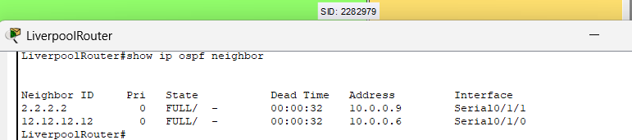

Leeds (15.15.15.15):

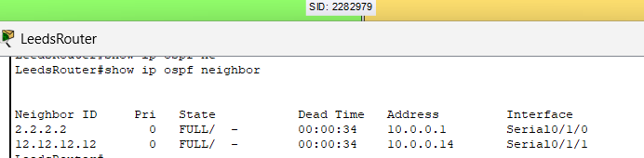

Leicester (Router ID: 12.12.12.12):

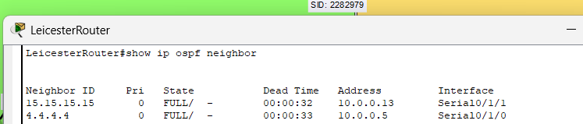

STATIC ROUTING

On the event of OSPF failure, Static routing would take over (Pepelnjak, 2020). The configurations of all static routes are shown below:

London:
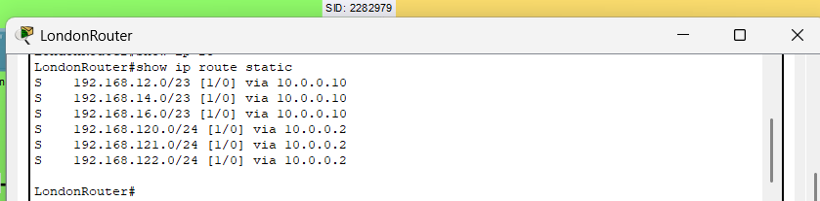

Liverpool:
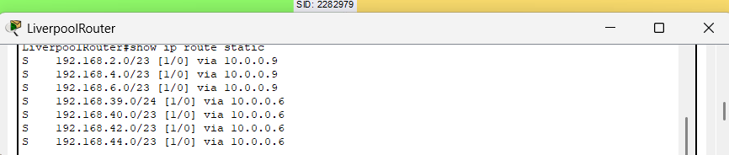

Leicester:
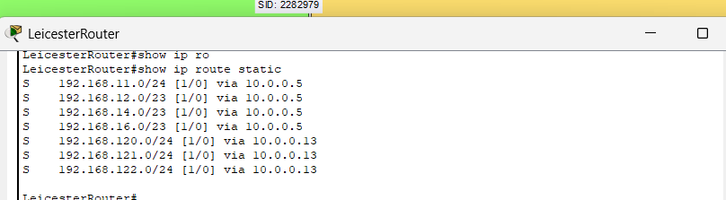

Leeds:
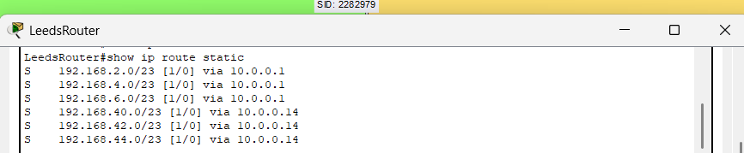

TESTING

Communication Verification between sites:

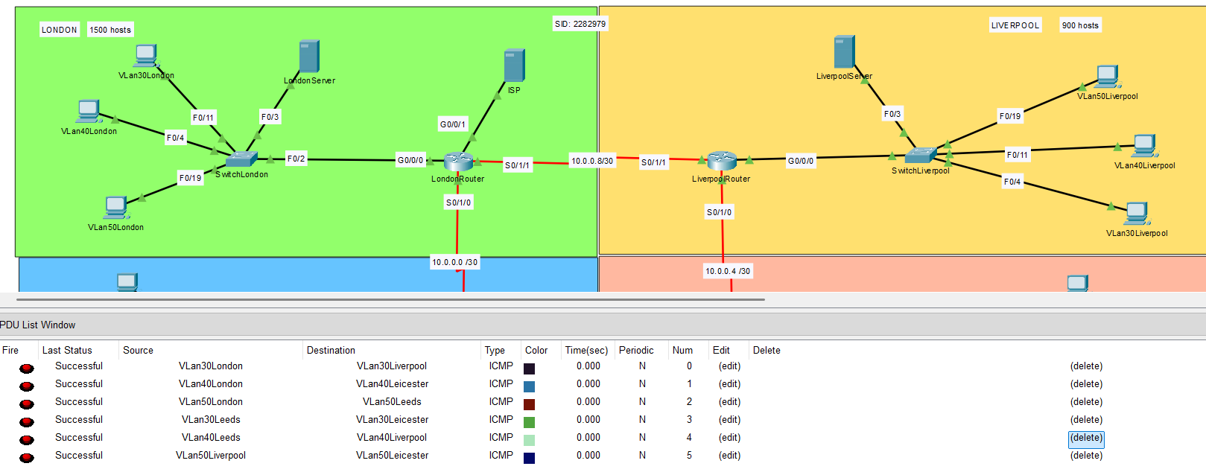

IP ADDRESSING
    - The IP addressing scheme has been curated as per each site’s requirement of total hosts and thus the number of VLANs per site (RIPE.Net, n.d.).
    - On Each Site’s Router, a VLAN Sub interface has been configured for Router-On-a-Stick (Explained later in the Switching Section).
    - Below is the Table that maps the IP addresses per site per VLAN and justification (Need of hosts and hosts available).
(A full list of IP addresses for all the interfaces and components is provided at the end of the Report.)

Site | VLAN | Network Address | Subnet Mask | Default Gateway | Hosts per VLAN Needed | Hosts Available
London  1500 hosts | 30 | 192.168.2.0 | /23 | 192.168.2.1 | 500 | 510
London  1500 hosts | 40 | 192.168.4.0 | /23 | 192.168.4.1 | 500 | 510
London  1500 hosts | 50 | 192.168.6.0 | /23 | 192.168.6.1 | 500 | 510
Liverpool  900 hosts | 30 | 192.168.12.0 | /23 | 192.168.12.1 | 300 | 510
Liverpool  900 hosts | 40 | 192.168.14.0 | /23 | 192.168.14.1 | 300 | 510
Liverpool  900 hosts | 50 | 192.168.16.0 | /23 | 192.168.16.1 | 300 | 510
Leicester  1200 hosts | 30 | 192.168.40.0 | /23 | 192.168.40.1 | 400 | 510
Leicester  1200 hosts | 40 | 192.168.42.0 | /23 | 192.168.42.1 | 400 | 510
Leicester  1200 hosts | 50 | 192.168.44.0 | /23 | 192.168.44.1 | 400 | 510
Leeds  500 hosts | 30 | 192.168.120.0 | /24 | 192.168.120.1 | 167 | 254
Leeds  500 hosts | 40 | 192.168.121.0 | /24 | 192.168.121.1 | 167 | 254
Leeds  500 hosts | 50 | 192.168.122.0 | /24 | 192.168.122.1 | 167 | 254

SWITCHING AND DHCP IMPLEMENTATION

VLAN

VLANs assigned:

- VLAN 30: Finance

- VLAN 40: Executive
- VLAN 50: Employees

PORT SEGMENTATION

Ports Assigned per Switch for Each VLAN:

VLAN | Switch Ports
30 | Fast Ethernet 0/4-0/10
40 | Fast Ethernet 0/11-0/17
50 | Fast Ethernet 0/18-0/24

Table A

All VLANs were assigned equal number of ports per switch.
Ports Fa0/0-0/4 were used for other configurational settings like Connecting to DHCP server, to router etc.

Below shown are the port segmentations on each site which correlate to Table A given above and trunk ports configured:

London:

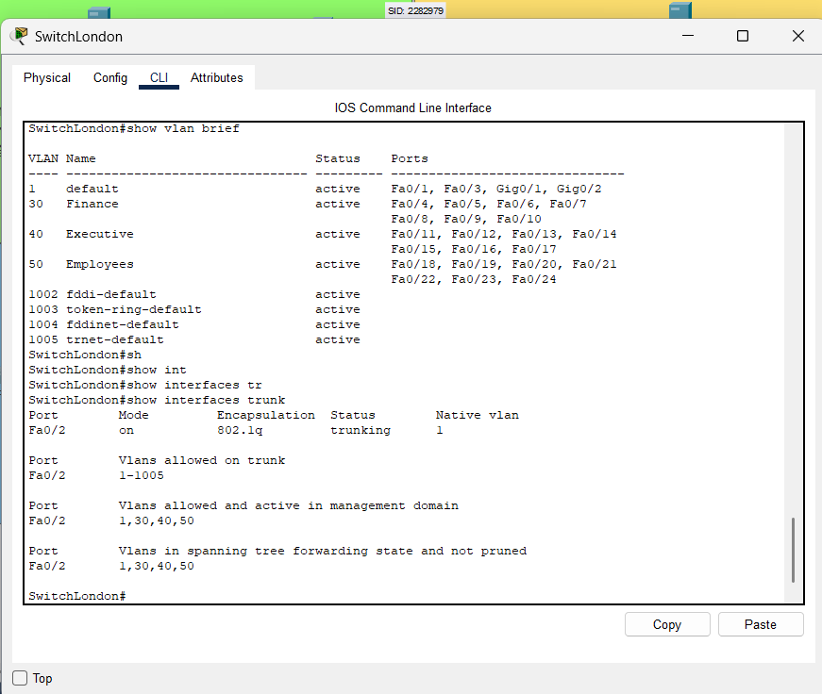

Liverpool:

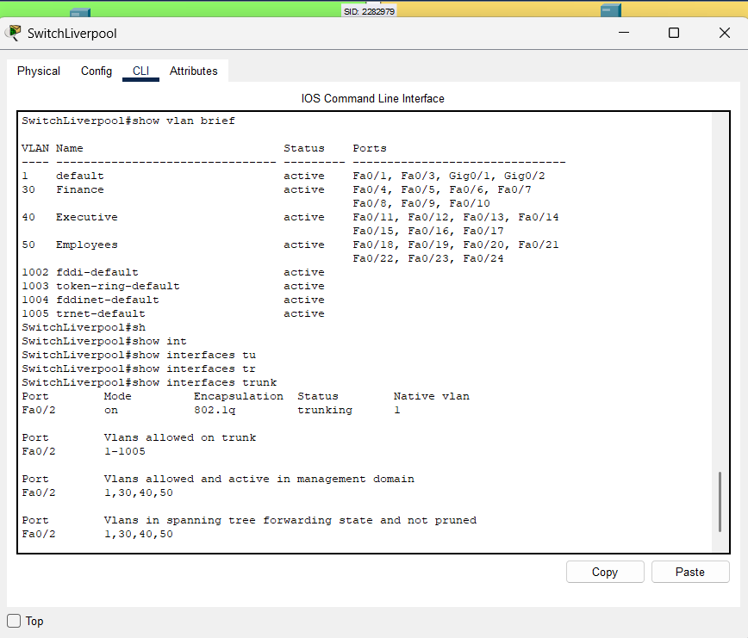

Leicester:

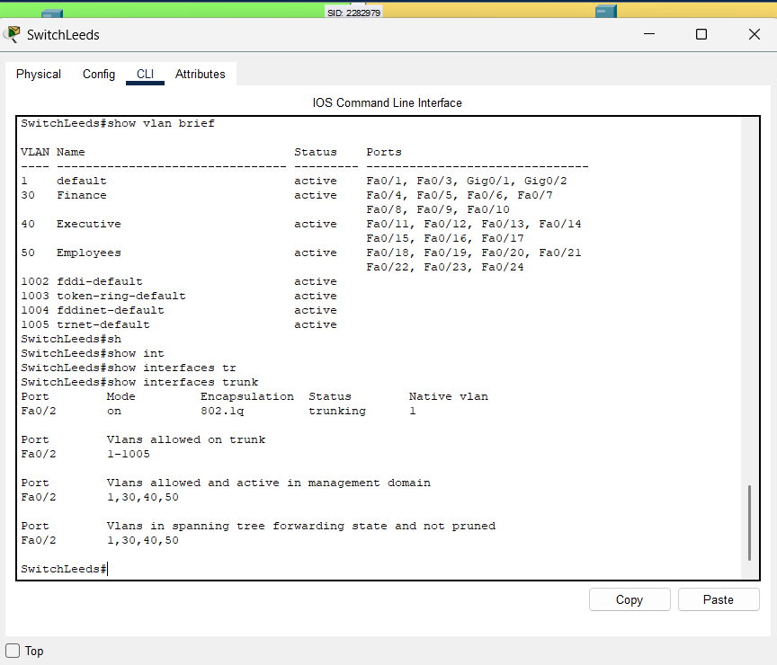

Leeds:

ROUTER-ON-A-STICK

Inter-VLAN routing has been set up via Router sub-interfaces using Router-on-a-stick to ensure communication between devices in different VLANs (Cisco Networking Academy, 2020).

Liverpool:

Commands:
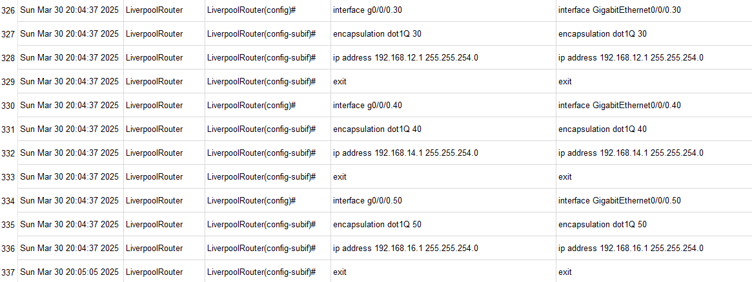

Configuration:
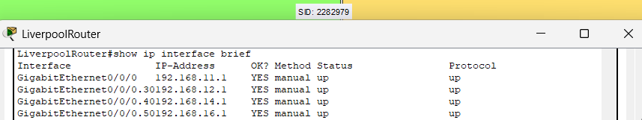

Similarly for all other Sites, the configurations are:

London:
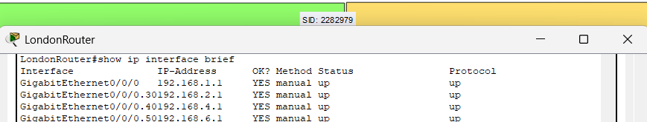

Leeds:
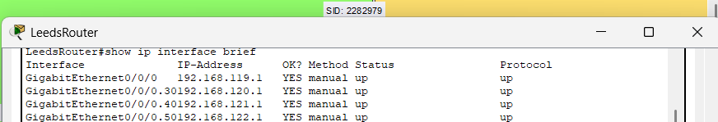

Leicester:
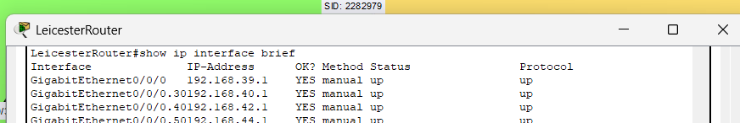

TESTING
Communication between VLANs in each LAN:
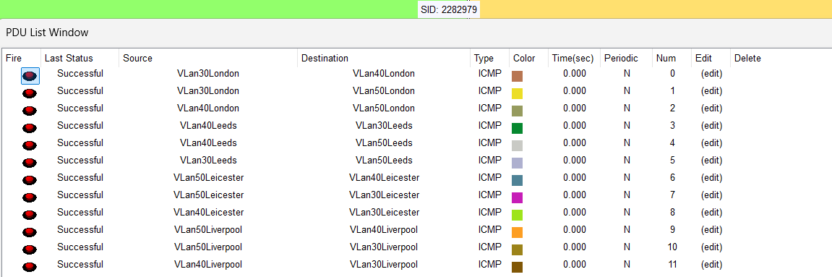

DHCP
DHCP helps in assigning the IP addresses to end devices automatically, saving both time and manpower. (Microsoft, 2021)

In the new network design, each site has a separate Server to implement DHCP (IBM, 2023)
, using suitable addressing pools and proper Router configuration necessary.

SETUP CONFIGURATIONS:

DHCP SERVERS:

London:

Pools start from 192.168.2, 192.168.4.2, 192.168.6.2 to exclude addresses like 192.168.4.1 as they have been configured as Default gateways for these VLANs.

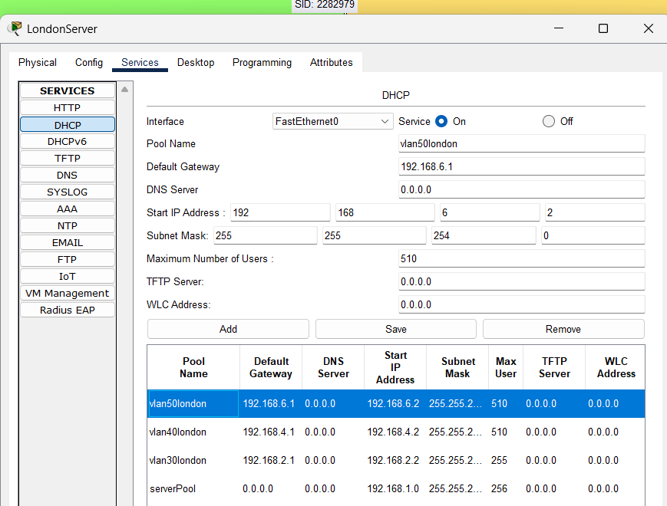

Liverpool:

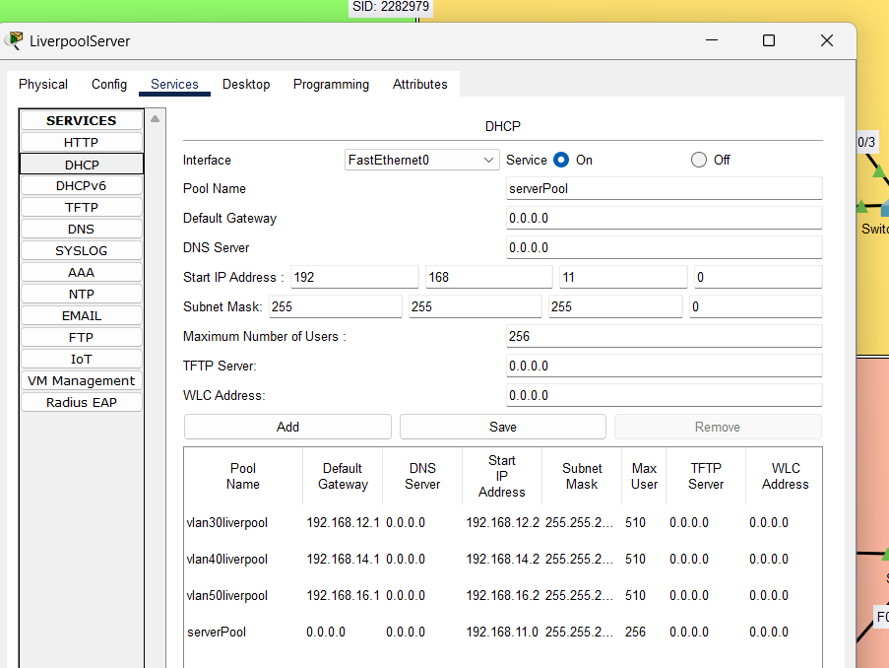

Leicester:

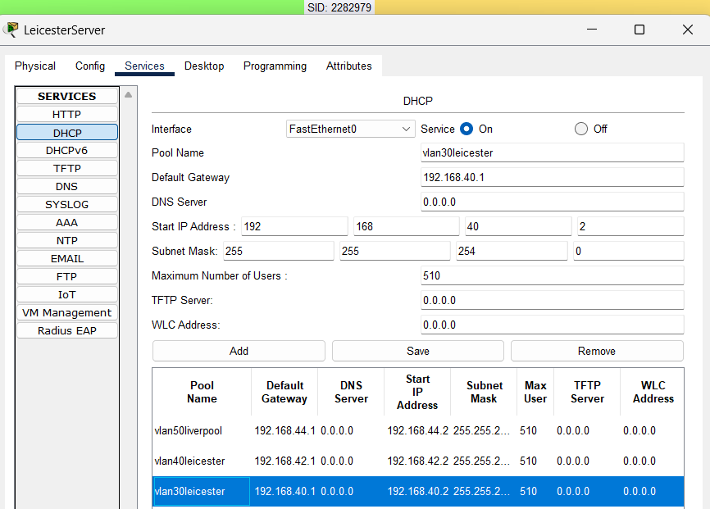

Leeds:

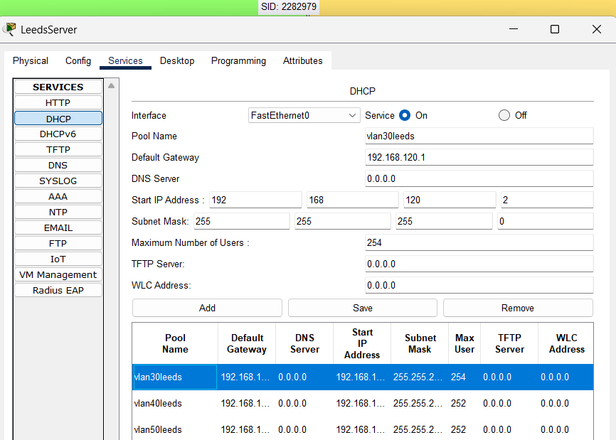

ROUTER CONFIGURATION:

Applying the helper address for each sub-interface.

London:

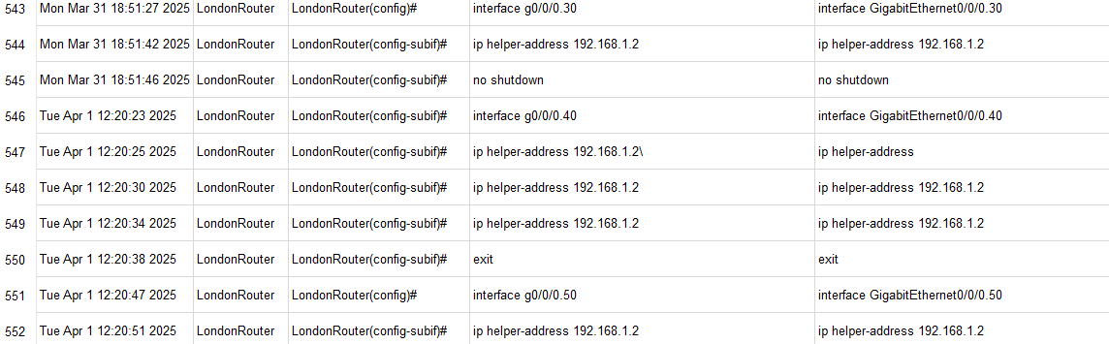

Liverpool:

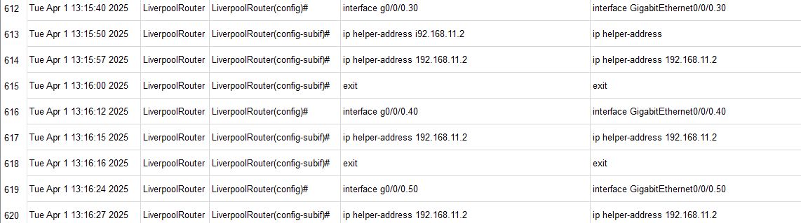

Leicester:

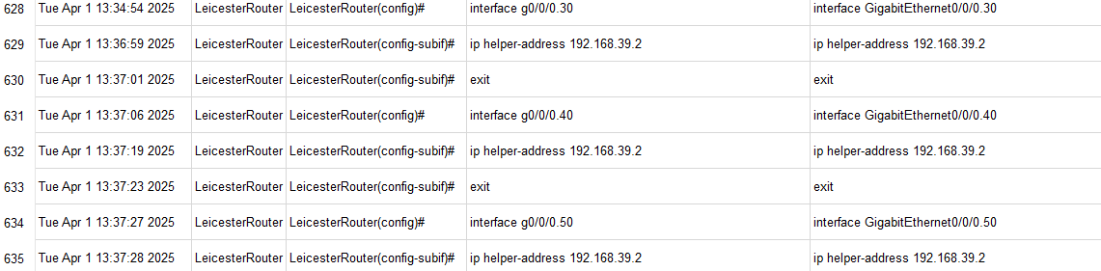

Leeds:

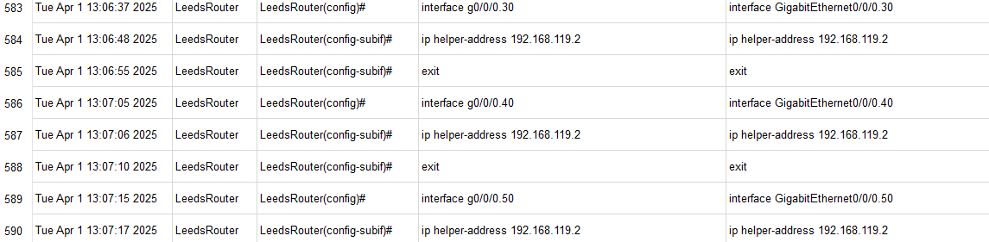

TESTING END DEVICES:

London:

At VLAN 30:

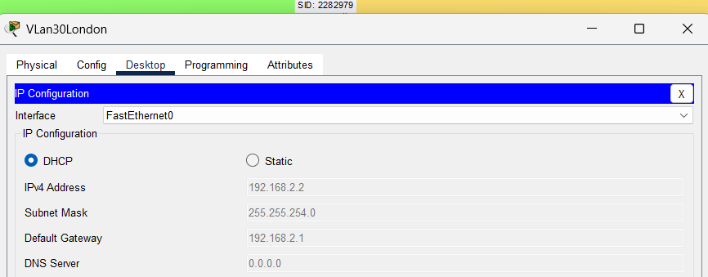

At VLAN 40:

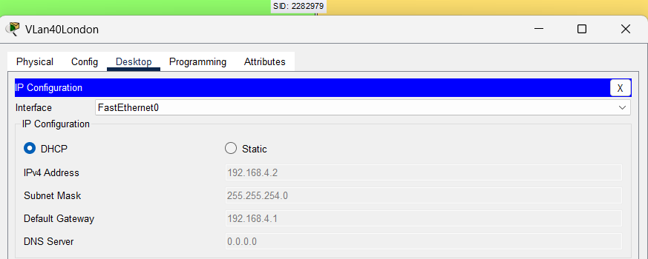

At VLAN 50:

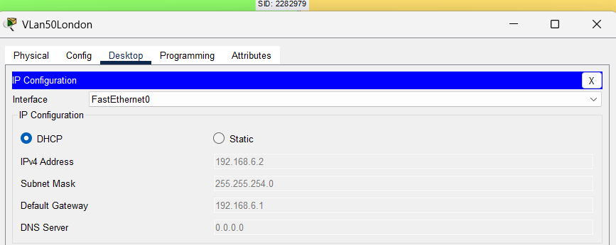

Liverpool:

At VLAN 30:
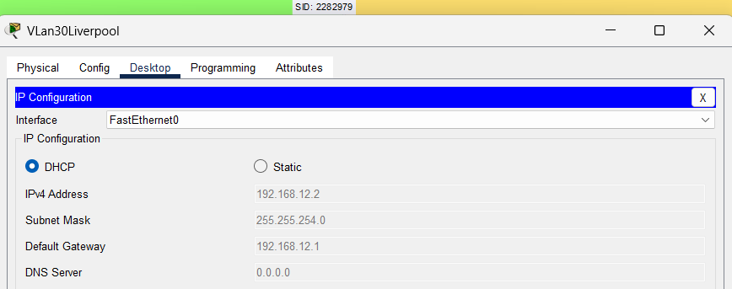

At VLAN 40:

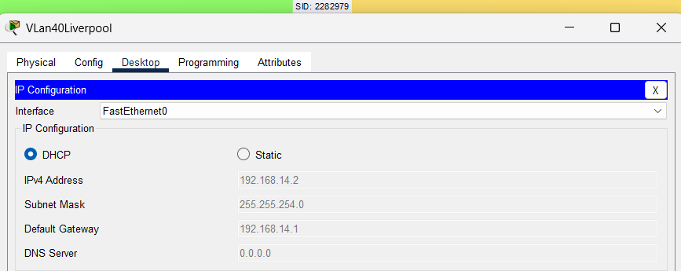

At VLAN 50:

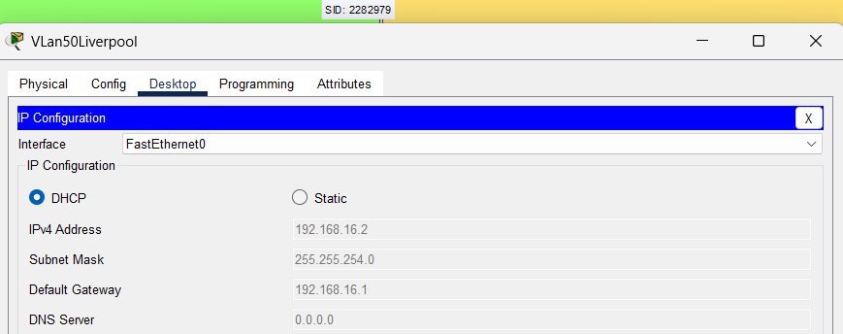

Leicester:

At VLAN 30:

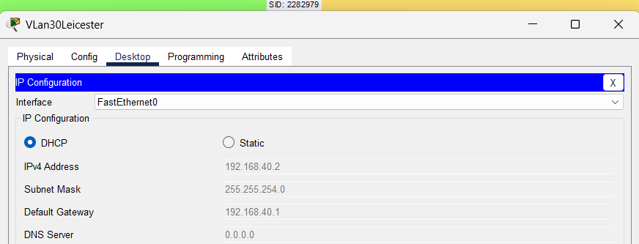

At VLAN 40:

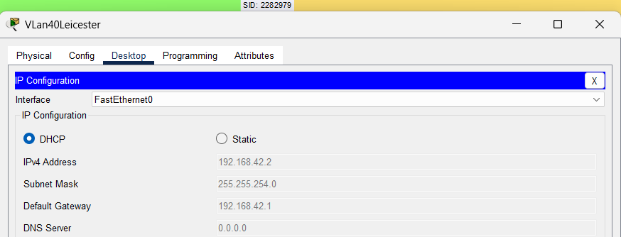

At VLAN 50:

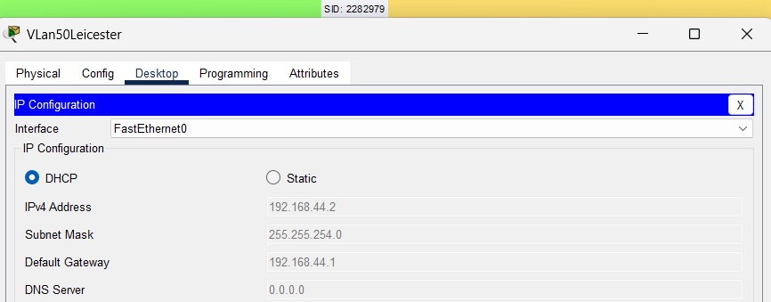

Leeds:

At VLAN 30:

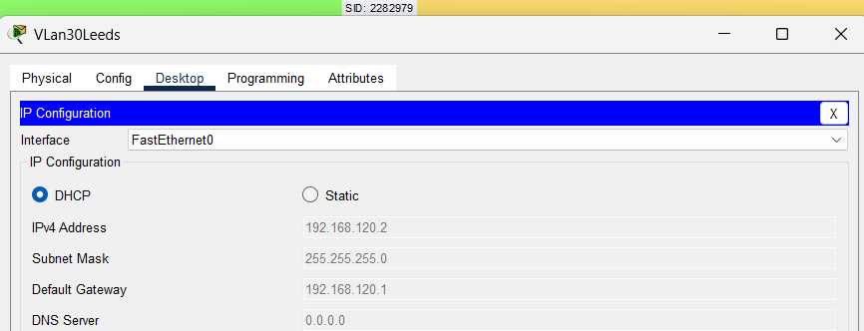

At VLAN 40:

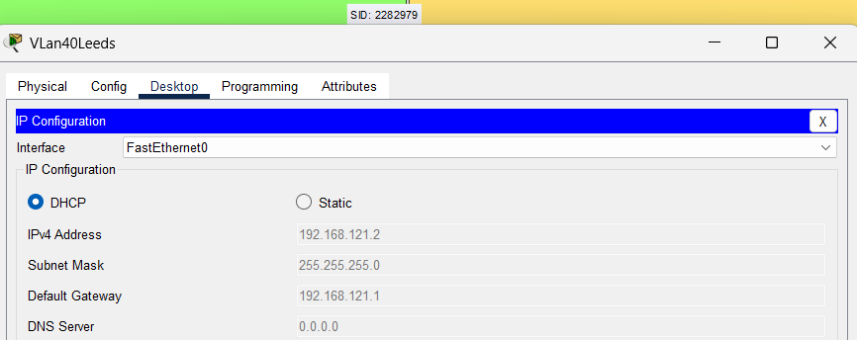

At VLAN 50:

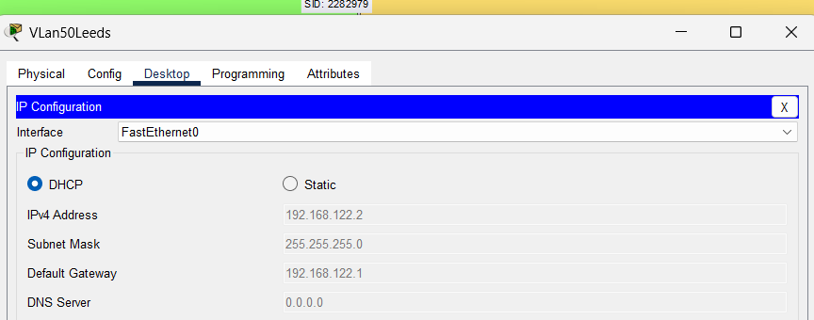

ACL AND SECURITY

ACL
An Access Control List (ACL) is a set of rules that controls which data can enter or leave a network device.
It helps filter traffic based on things like IP addresses, protocols, or ports (Fortinet, 2025)

In context of the current configuration, these ACLs will help to prevent sites other than London from accessing the Internet.

The required ACL is set on the London Router’s interface G0/0/1 (which is directly connected to the ISP server) to adequately filter out network packets.

CONFIGURATION OF LONDON ROUTER:

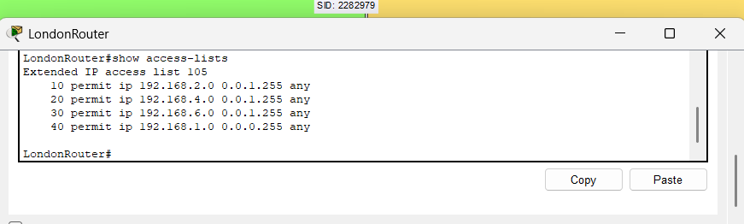

TESTING:

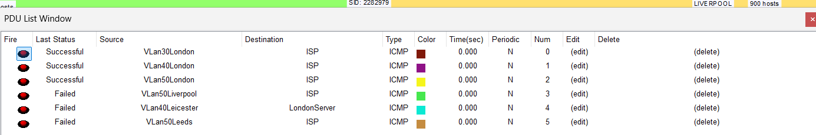

SECURITY
In the proposed network, the following would be applied to the network devices for enhanced security:

SSH ENABLING AND TELNET RESTRICTION.

Telnet communicates via plain text, whereas SSH is encrypted, hence more secure (Loshin, 2021).

Leeds:

Switch

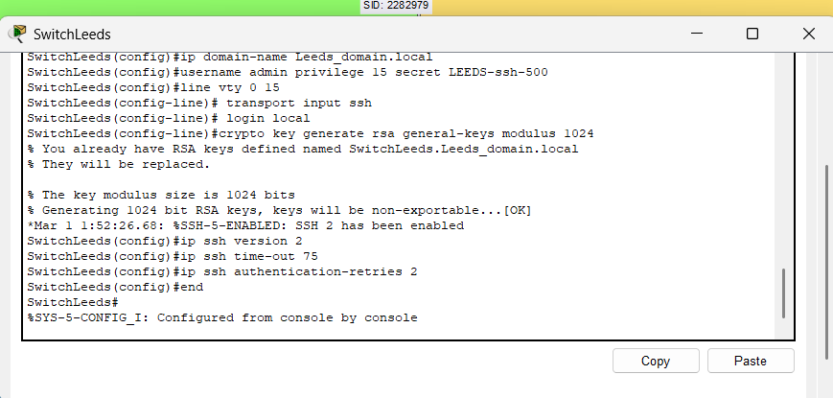

Router

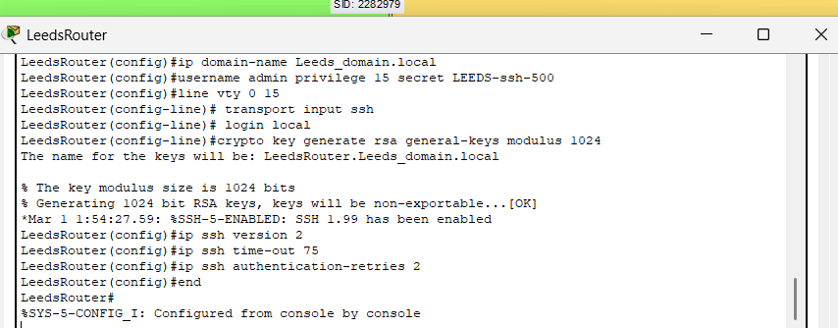

London:

Switch

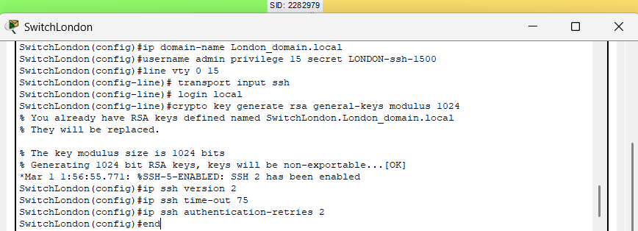

Router

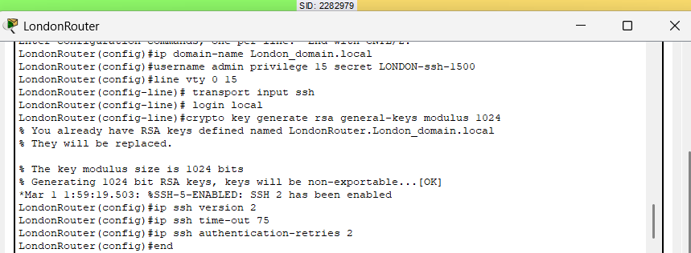

Liverpool:

Switch

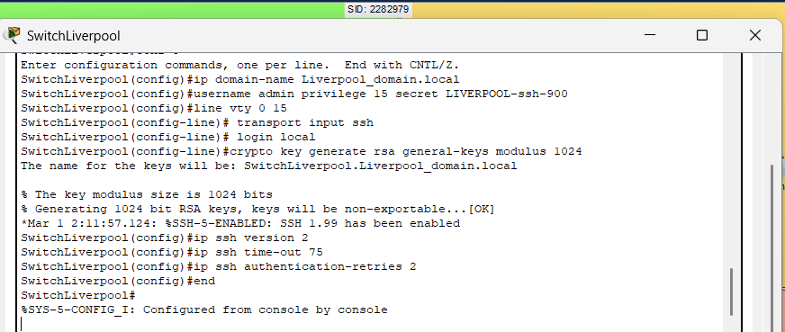

Router

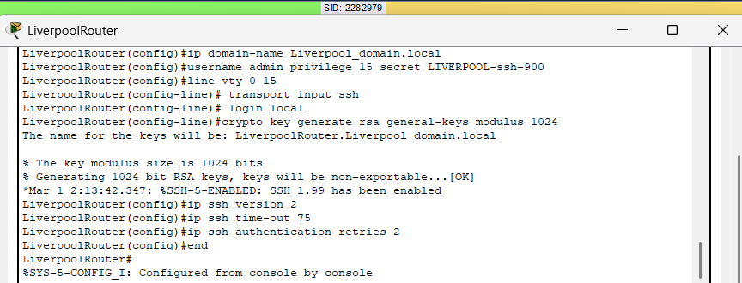

Leicester:

Switch

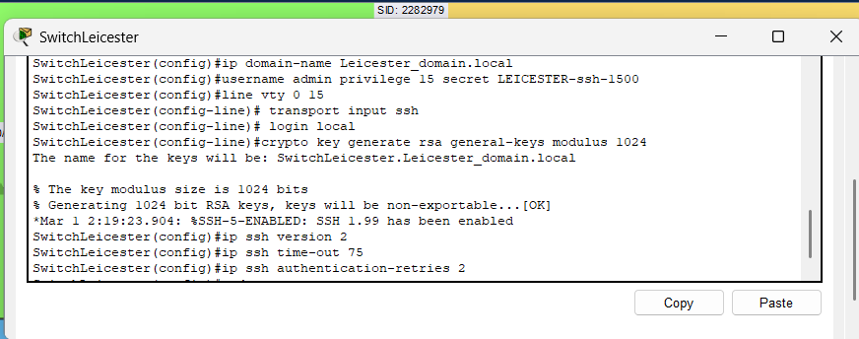

Router

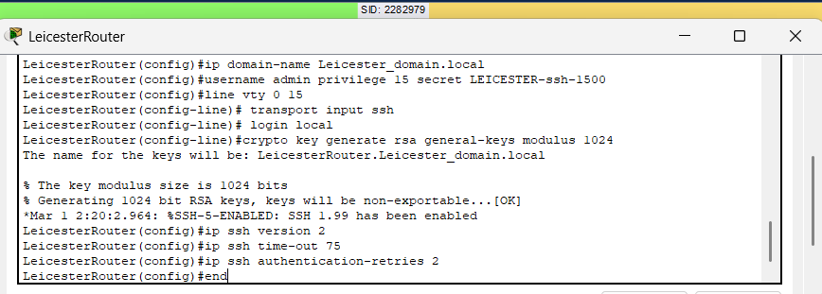

PASSWORD ESTABLISHMENT:
System Line Passwords of at least 6 characters (Grassi et al., 2017), Password Encryption and Banner setting.

London:

Switch

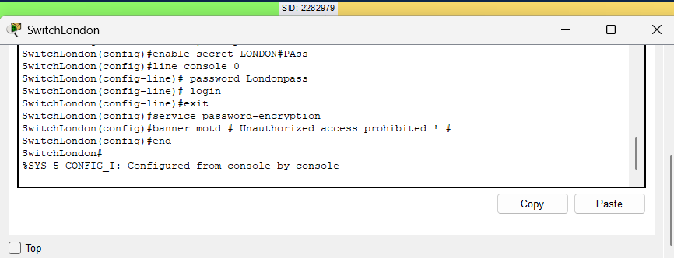

Router

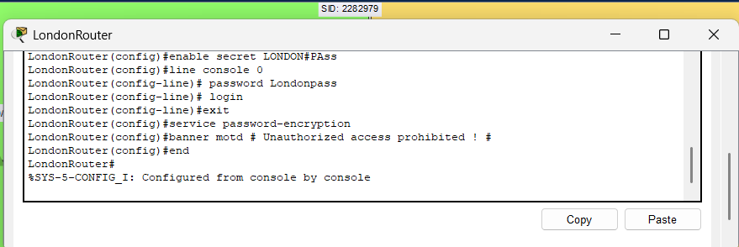

Liverpool:

Switch

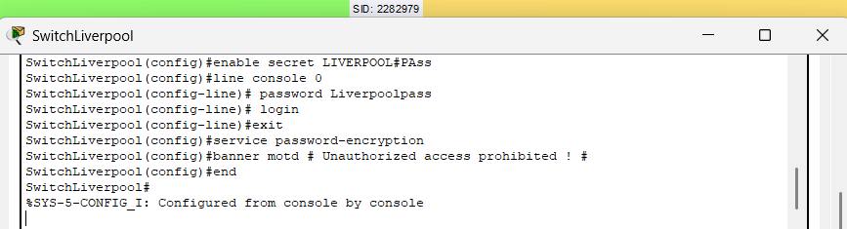

Router

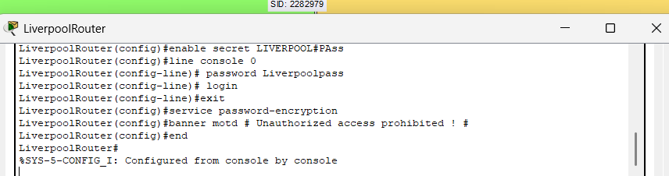

Leicester:

Switch

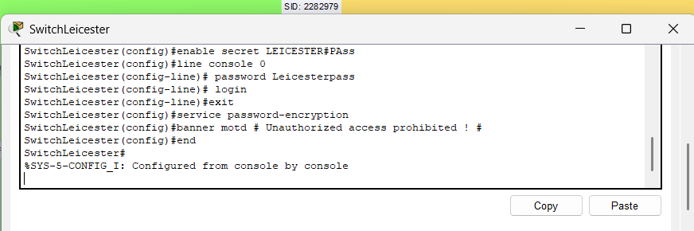

Router

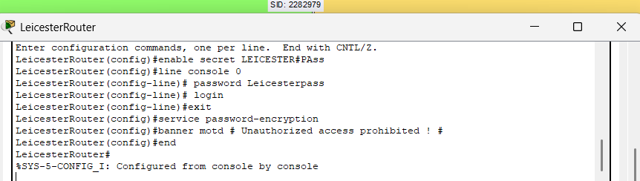

Leeds:

Switch

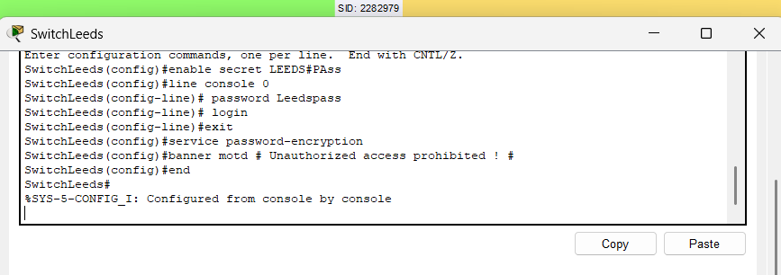

Router

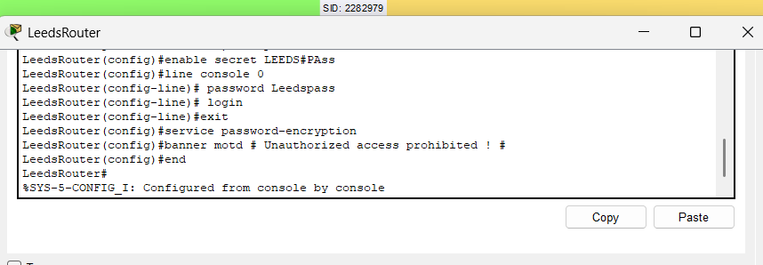

DISABLING UNUSUED PORTS. (Grant, 2022)

SETUP

London

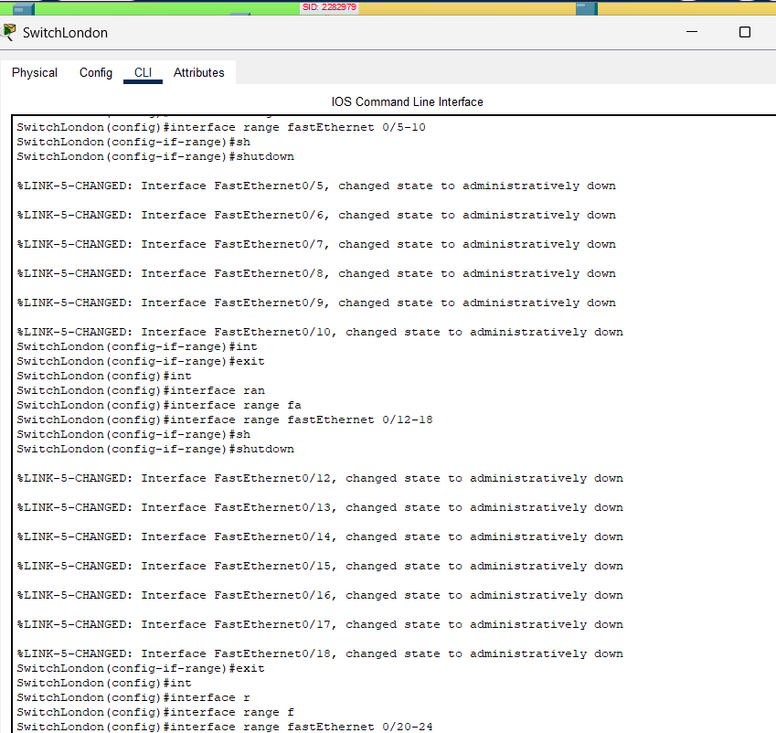

Liverpool

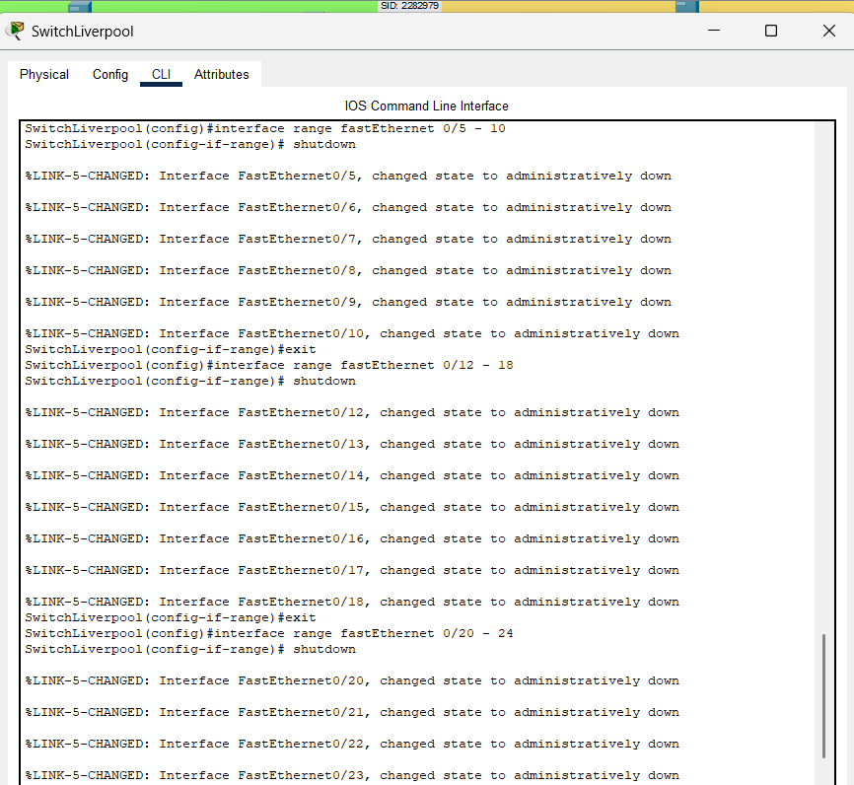

Leicester

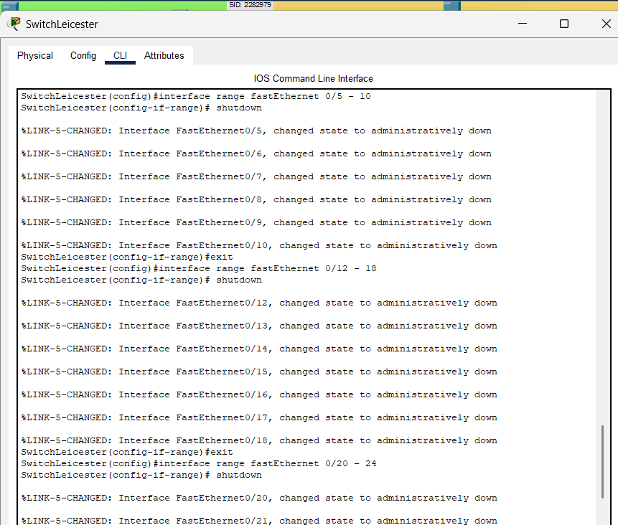

Leeds

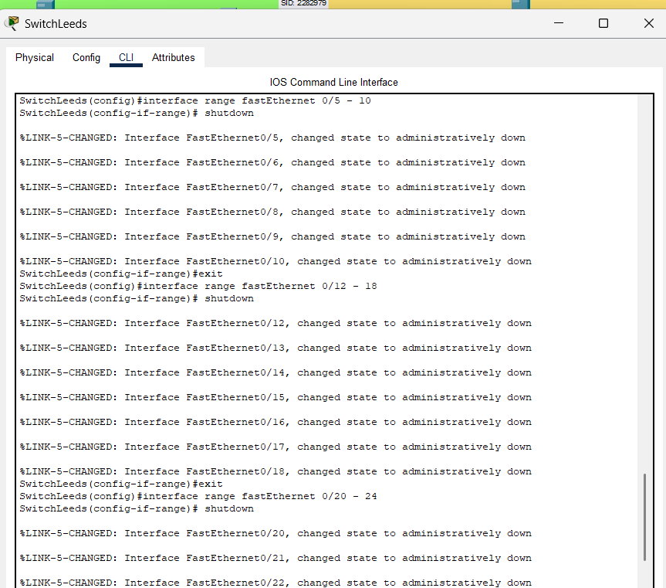

TESTING

Password Testing

London

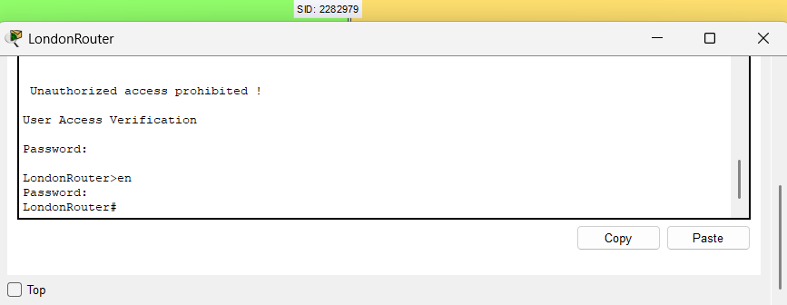

Liverpool

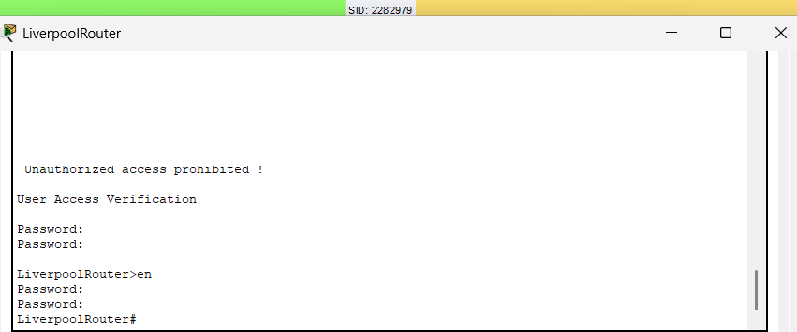

Leicester

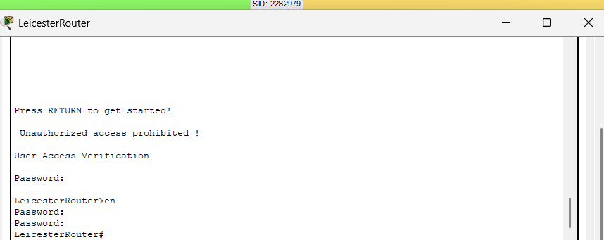

Leeds

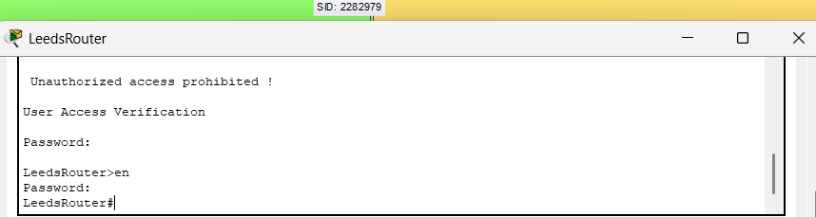

SSH Testing

London:

Telnet Disable

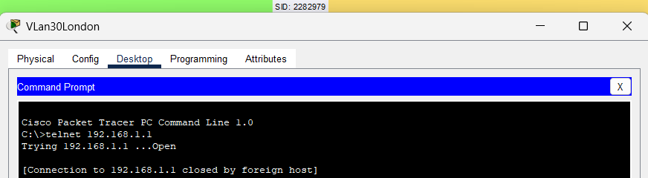

SSH
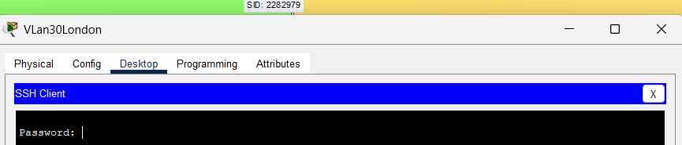

Liverpool:

Telnet Disable

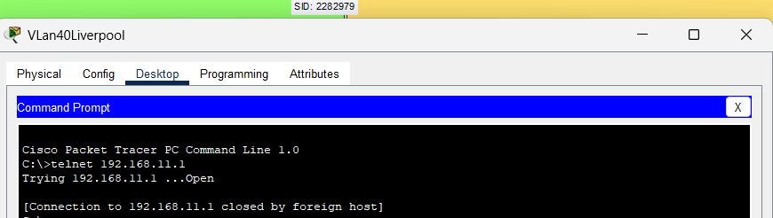

SSH

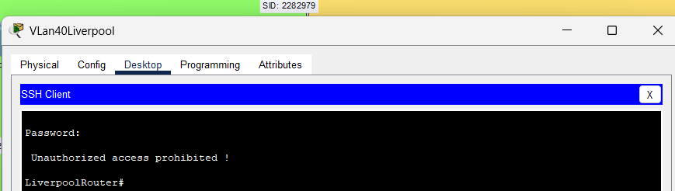

Leicester:

Telnet Disable

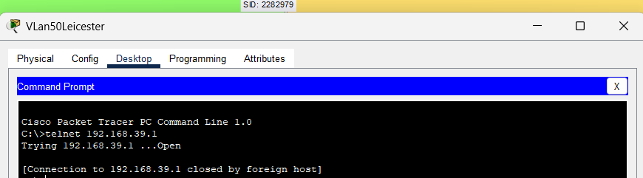

SSH

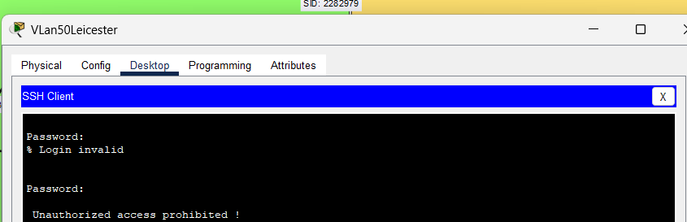

Leeds:

Telnet Disable

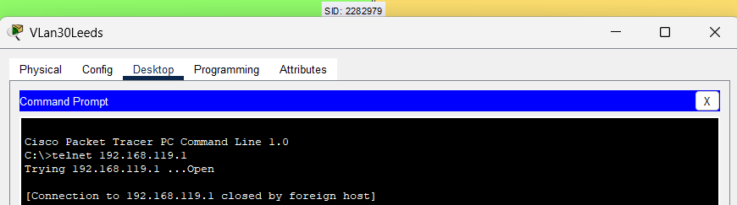

SSH

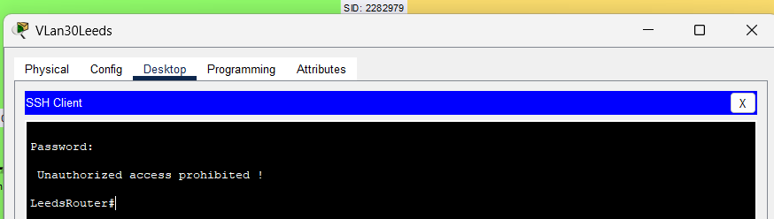

Port status check

London

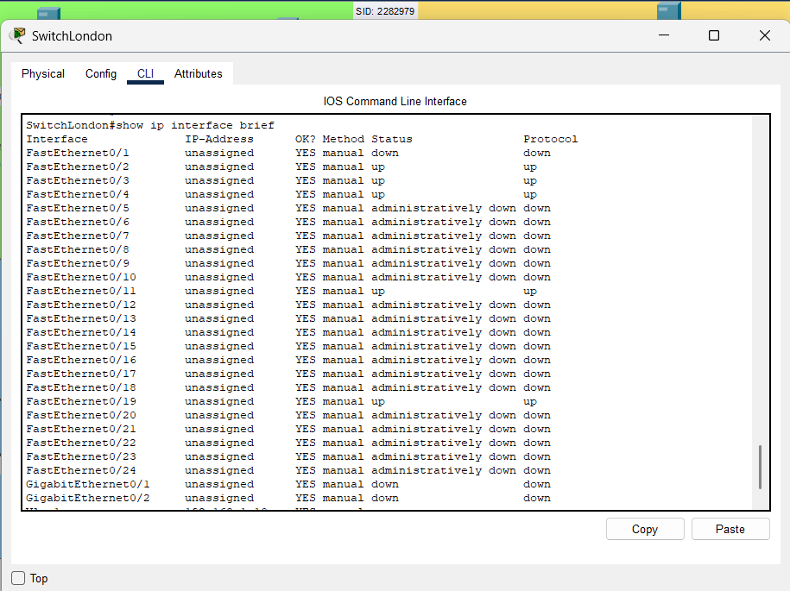

Liverpool

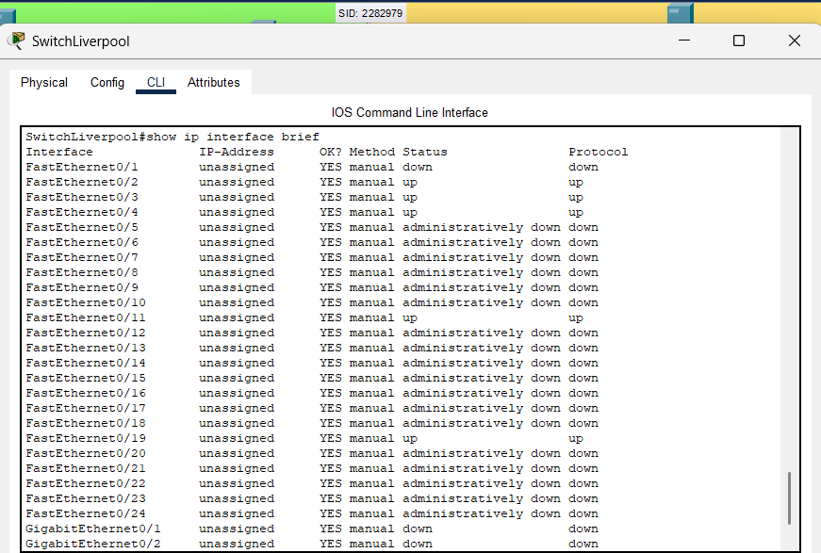

Leicester

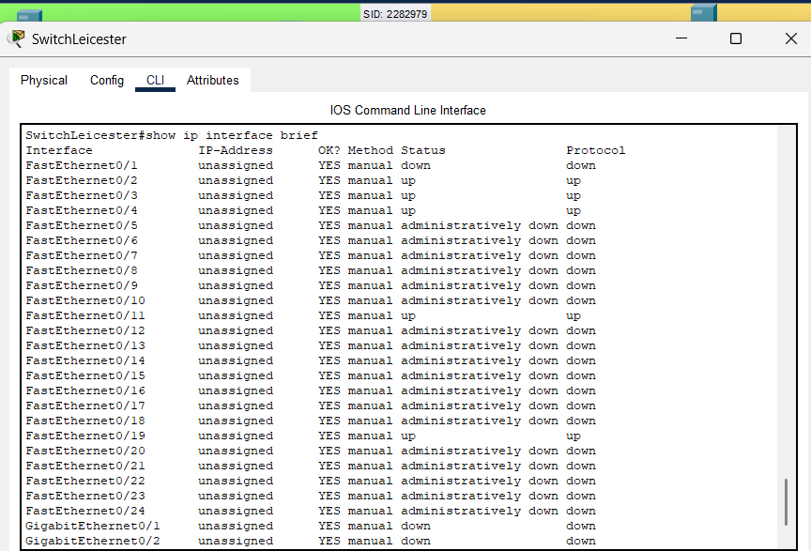

Leeds

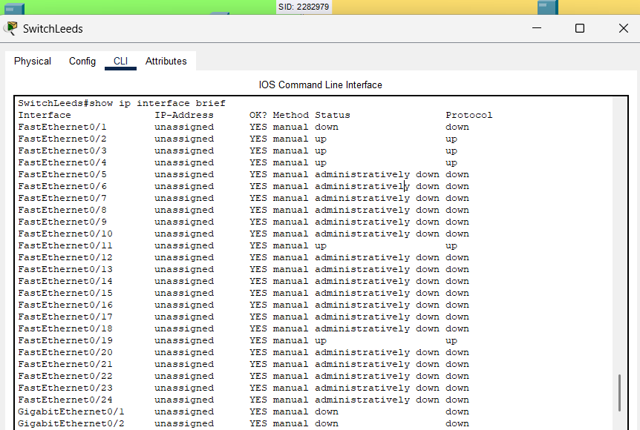

COMPLETE IP ADDRESING TABLE

Device | Interface | IP address
LondonRouter | G0/0/1 | 15.12.4.1 /30
 | G0/0/0 | 192.168.1.1 /24
 | S0/1/1 | 10.0.0.9 /30
 | S0/1/0 | 10.0.0.1 /30
 | G0/0/0.30 | 192.168.2.1/23
 | G0/0/0.40 | 192.168.4.1/23
 | G0/0/0.50 | 192.168.6.1/23
LiverpoolRouter | G0/0/0 | 192.168.11.1 /24
 | S0/1/1 | 10.0.0.10 /30
 | S0/1/0 | 10.0.0.5 /30
 | G0/0/0.30 | 192.168.12.1/23
 | G0/0/0.40 | 192.168.14.1/23
 | G0/0/0.50 | 192.168.16.1/23
LeicesterRouter | G0/0/0 | 192.168.39.1 /24
 | S0/1/1 | 10.0.0.14 /30
 | S0/1/0 | 10.0.0.6 /30
 | G0/0/0.30 | 192.168.40.1/23
 | G0/0/0.40 | 192.168.42.1/23
 | G0/0/0.50 | 192.168.44.1/23
LeedsRouter | G0/0/0 | 192.168.119.1 /24
 | S0/1/1 | 10.0.0.13 /30
 | S0/1/0 | 10.0.0.2 /30
 | G0/0/0.30 | 192.168.120.1/24
 | G0/0/0.40 | 192.168.121.1/24
 | G0/0/0.50 | 192.168.122.1/24
LondonServer | F0/0 | 192.168.1.2 /24
LiverpoolServer | F0/0 | 192.168.11.2 /24
LeedsServer | F0/0 | 192.168.119.2 /24
LeicesterServer | F0/0 | 192.168.39.2 /24
ISP | F0/0 | 15.12.4.2 /30
VLan30London | F0/0 | DHCP
VLan40London | F0/0 | DHCP
VLan50London | F0/0 | DHCP
VLan30Liverpool | F0/0 | DHCP
VLan40Liverpool | F0/0 | DHCP
VLan50Liverpool | F0/0 | DHCP
VLan30Leicester | F0/0 | DHCP
VLan40Leicester | F0/0 | DHCP
VLan50Leicester | F0/0 | DHCP
VLan30Leeds | F0/0 | DHCP
VLan40Leeds | F0/0 | DHCP
VLan50Leeds | F0/0 | DHCP

APPENDIX

Show Running Config commands for Network Devices:

- London

- Switch

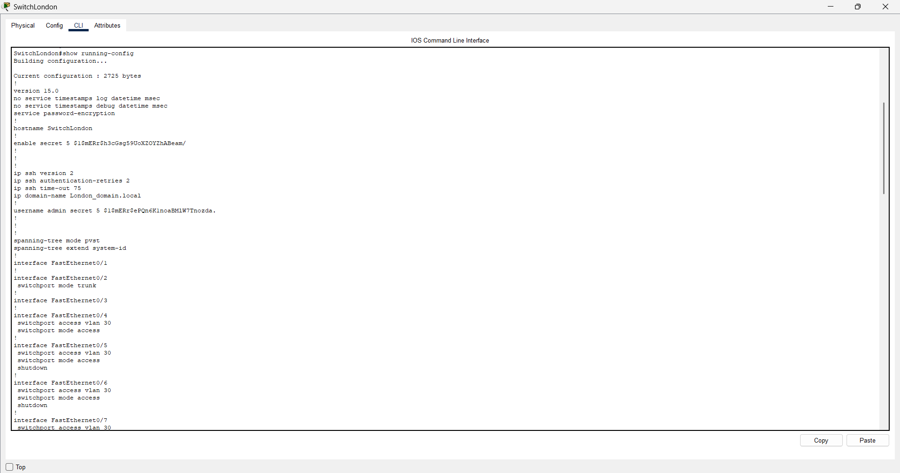

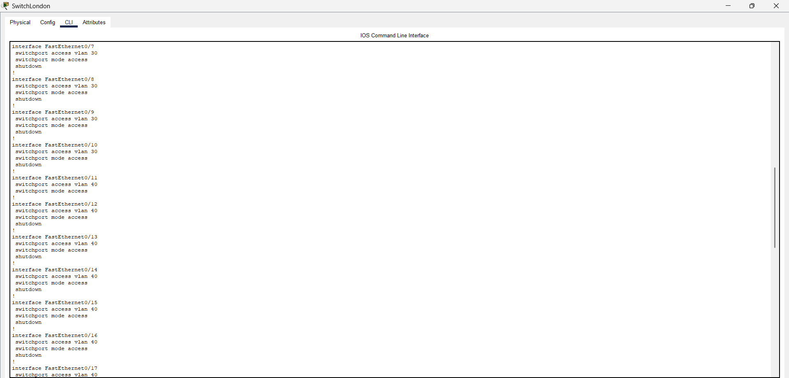
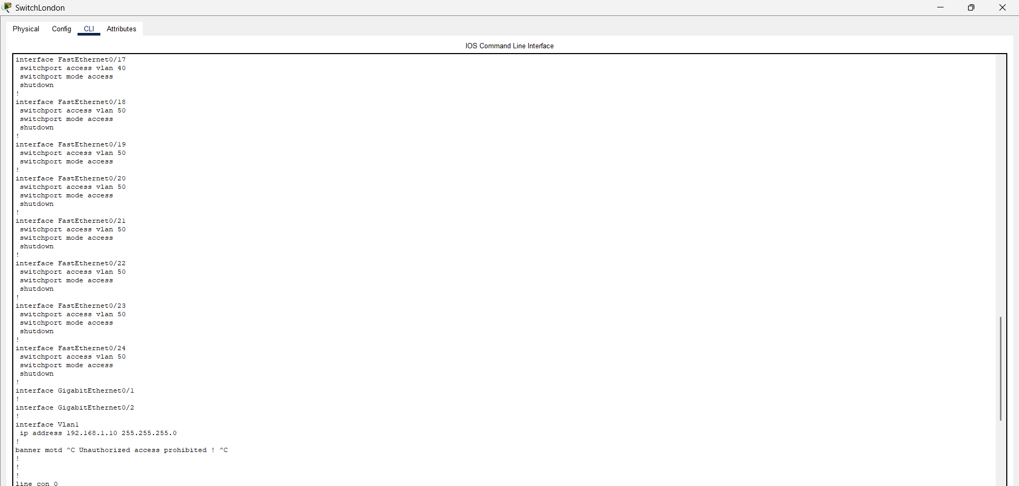

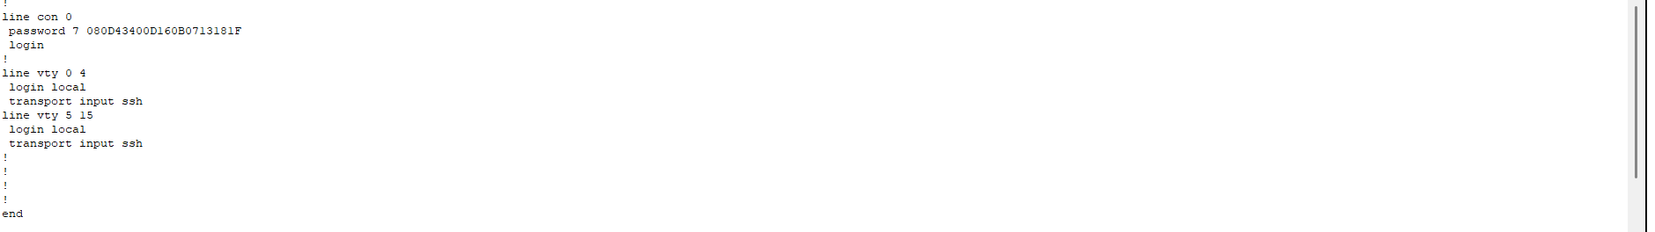

- Router

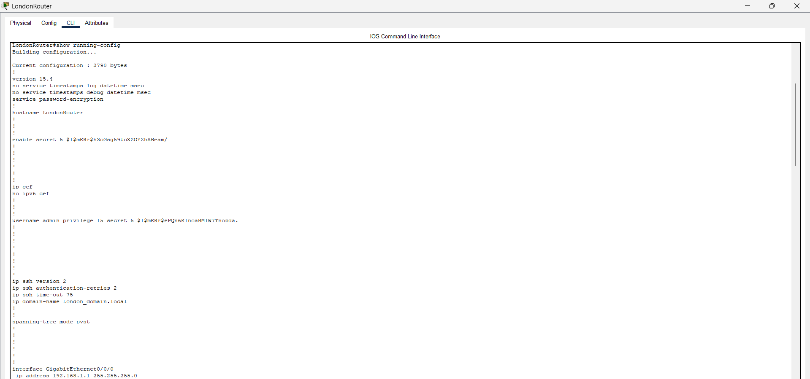

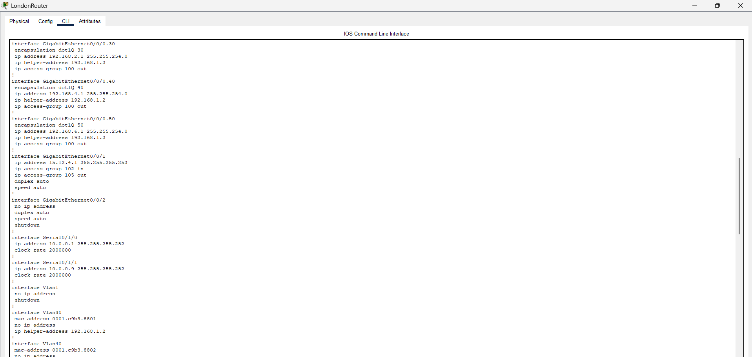

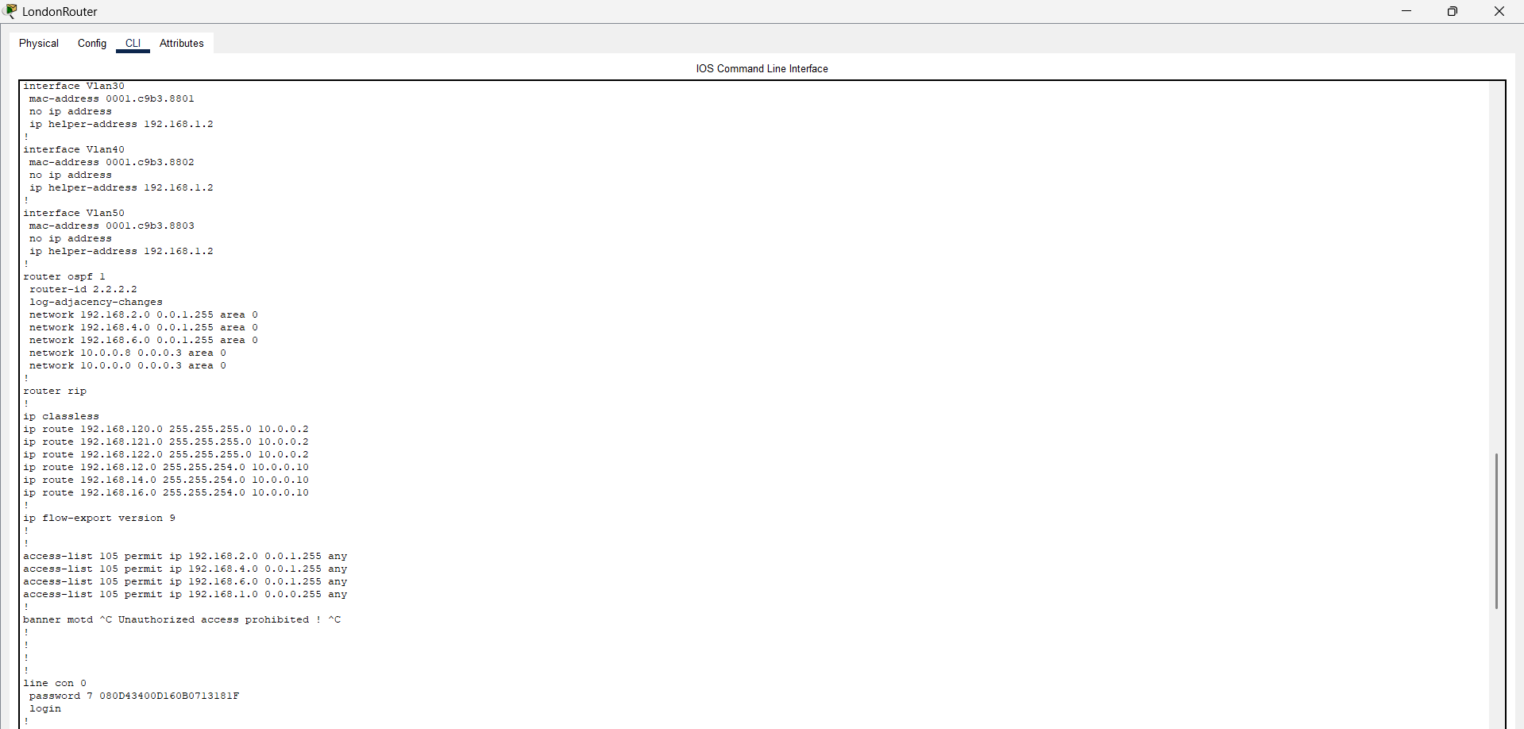

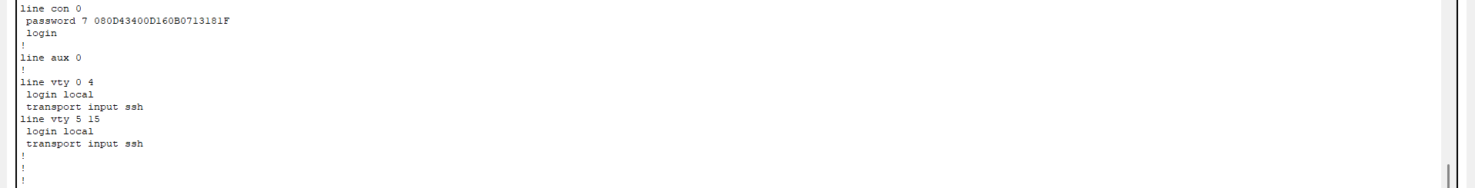

- Liverpool

- Switch

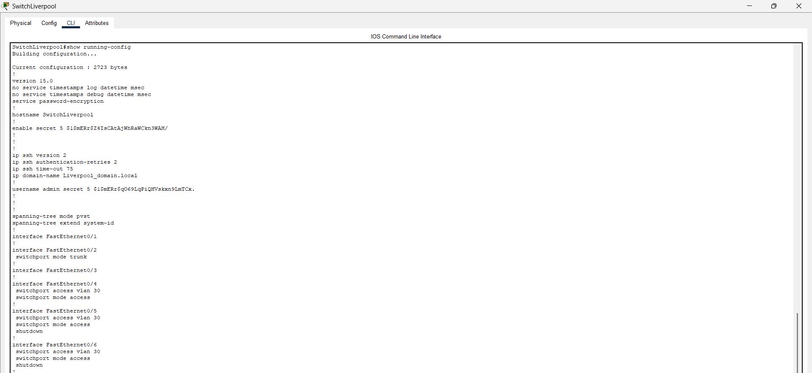

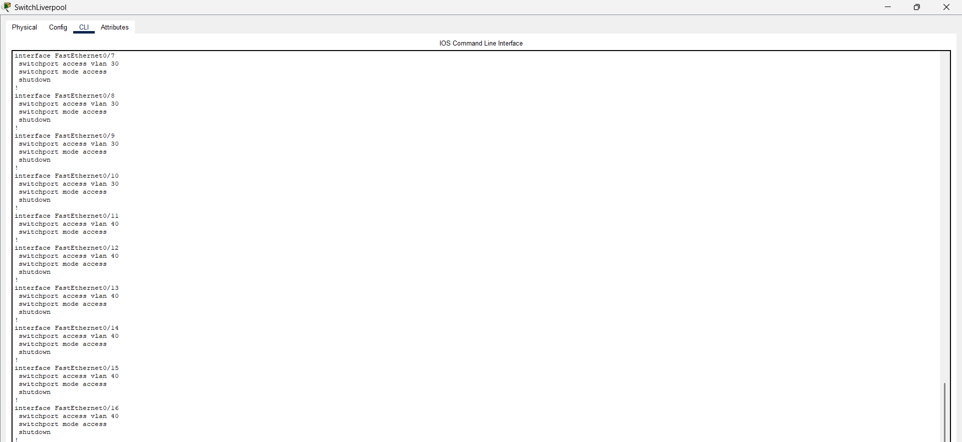

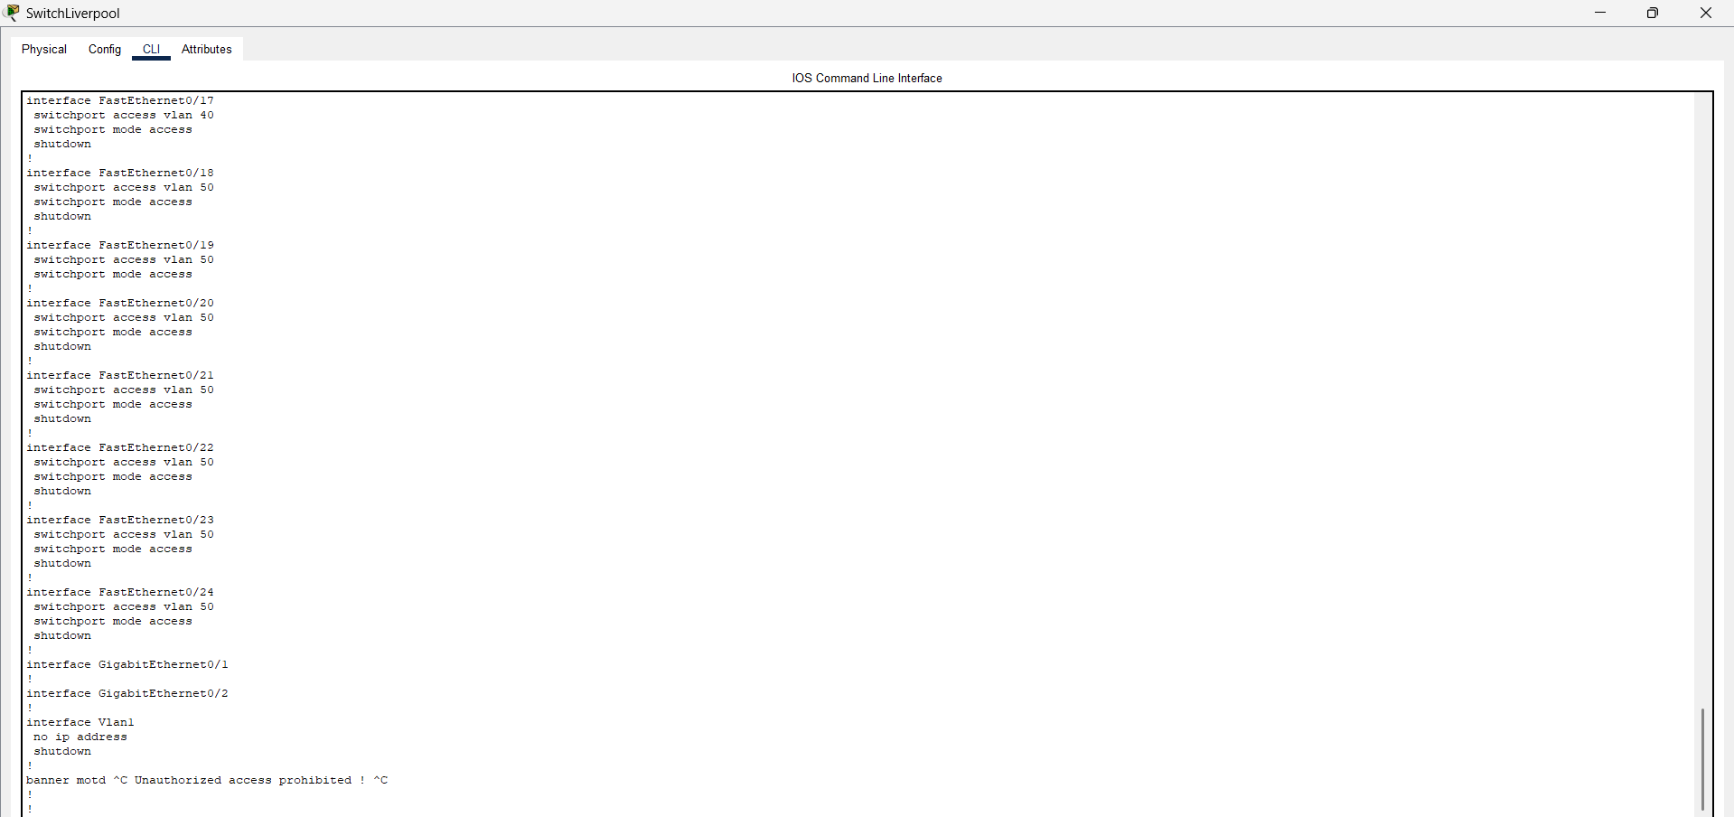

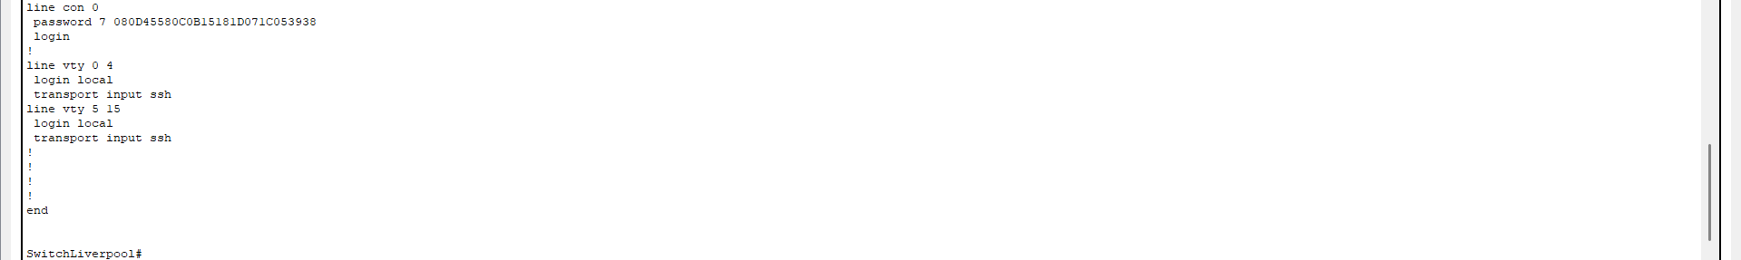

- Router

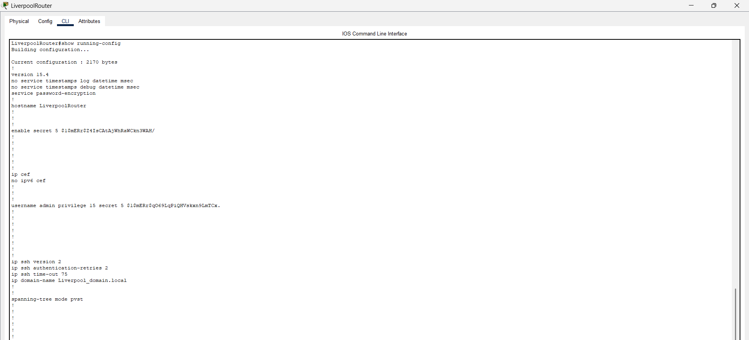

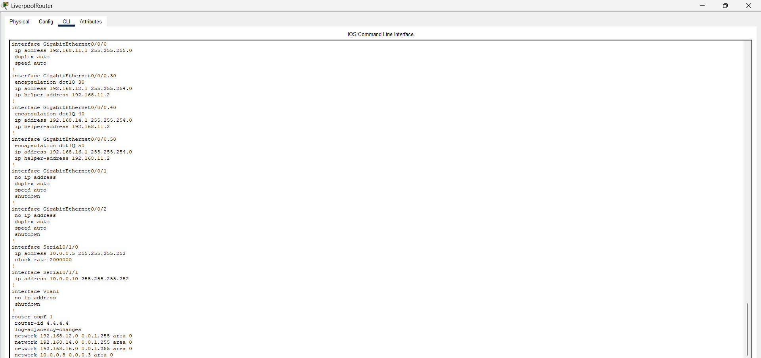

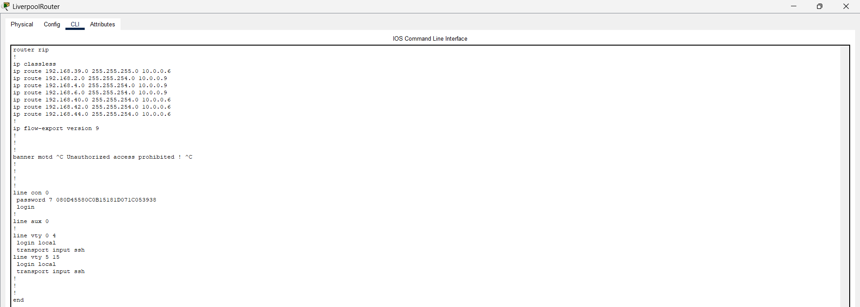

- Leicester

- Switch

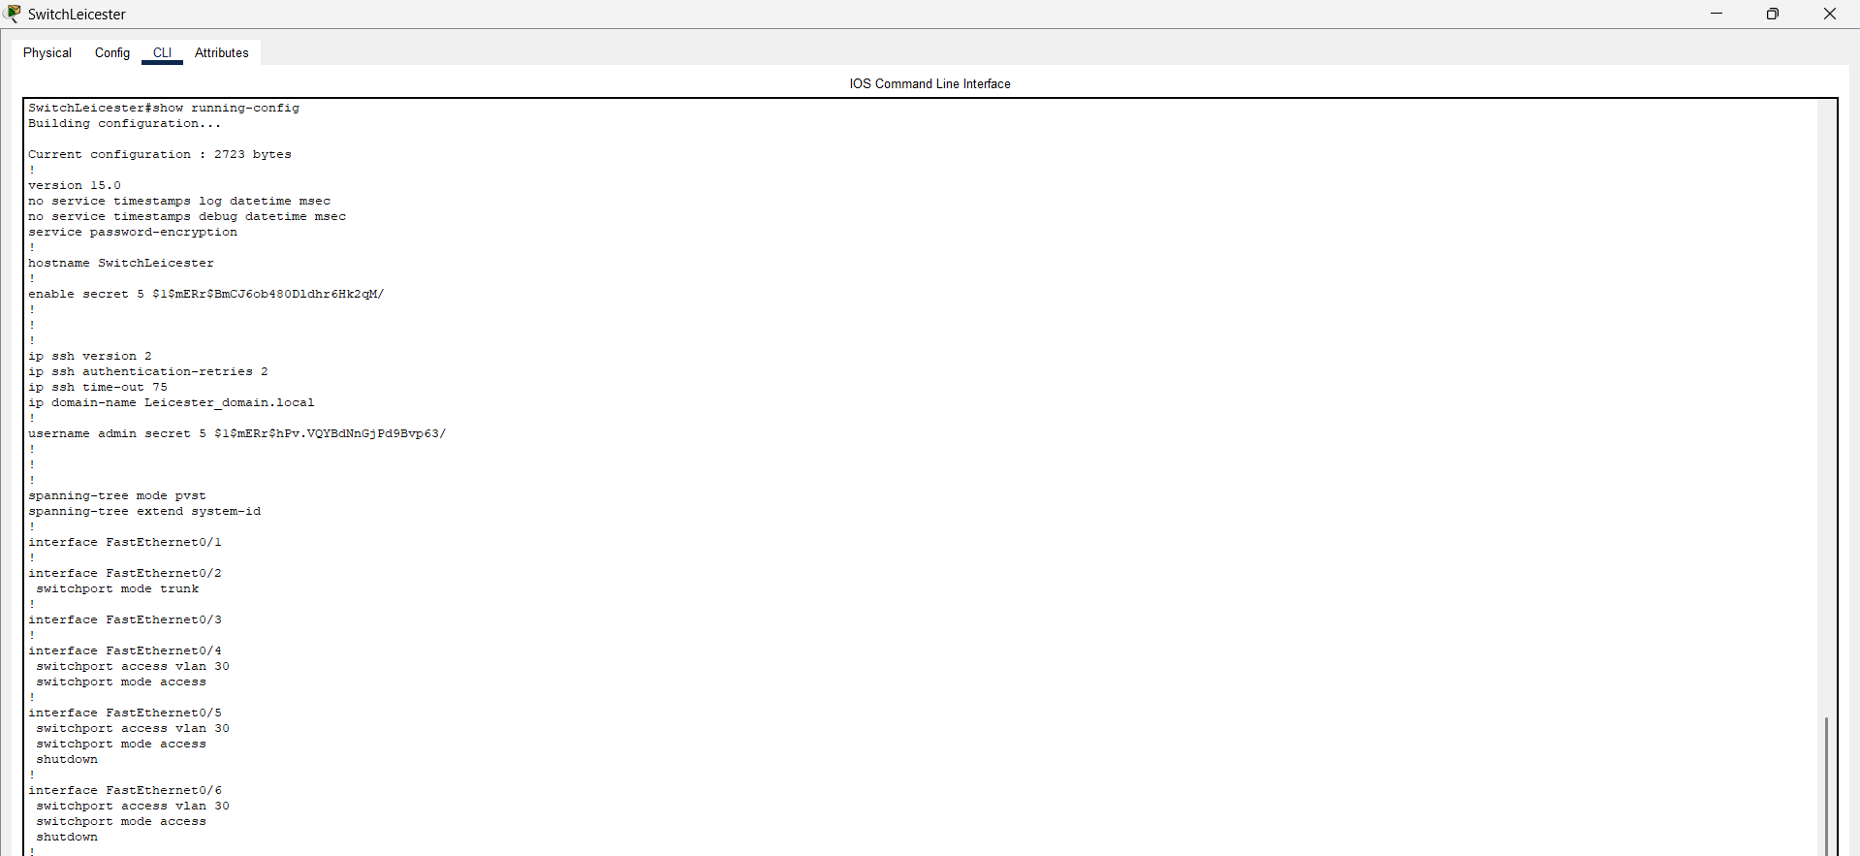

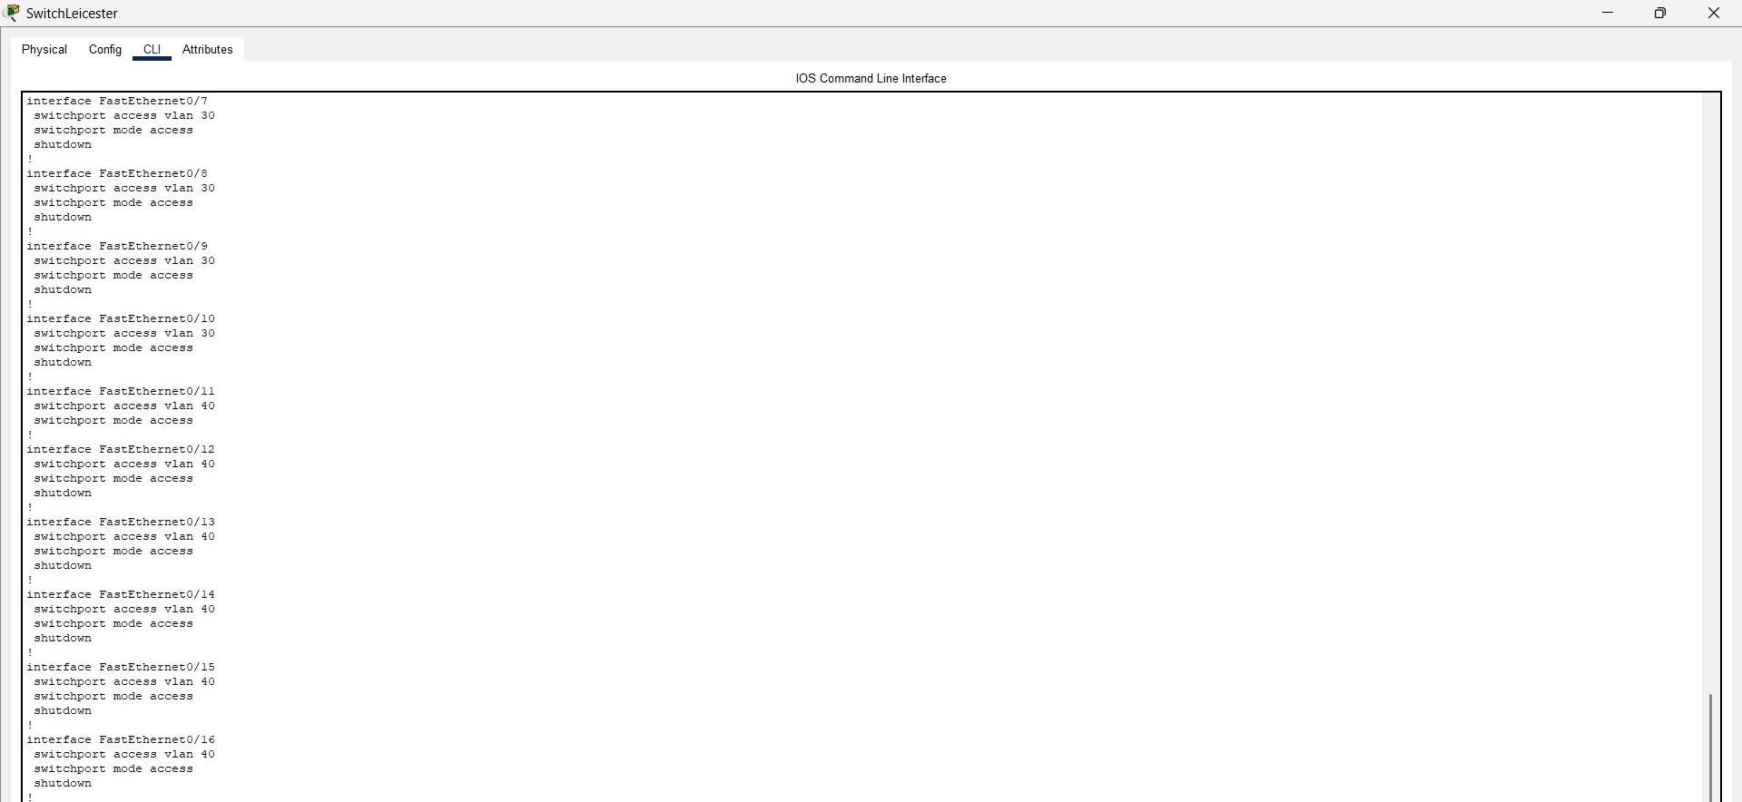

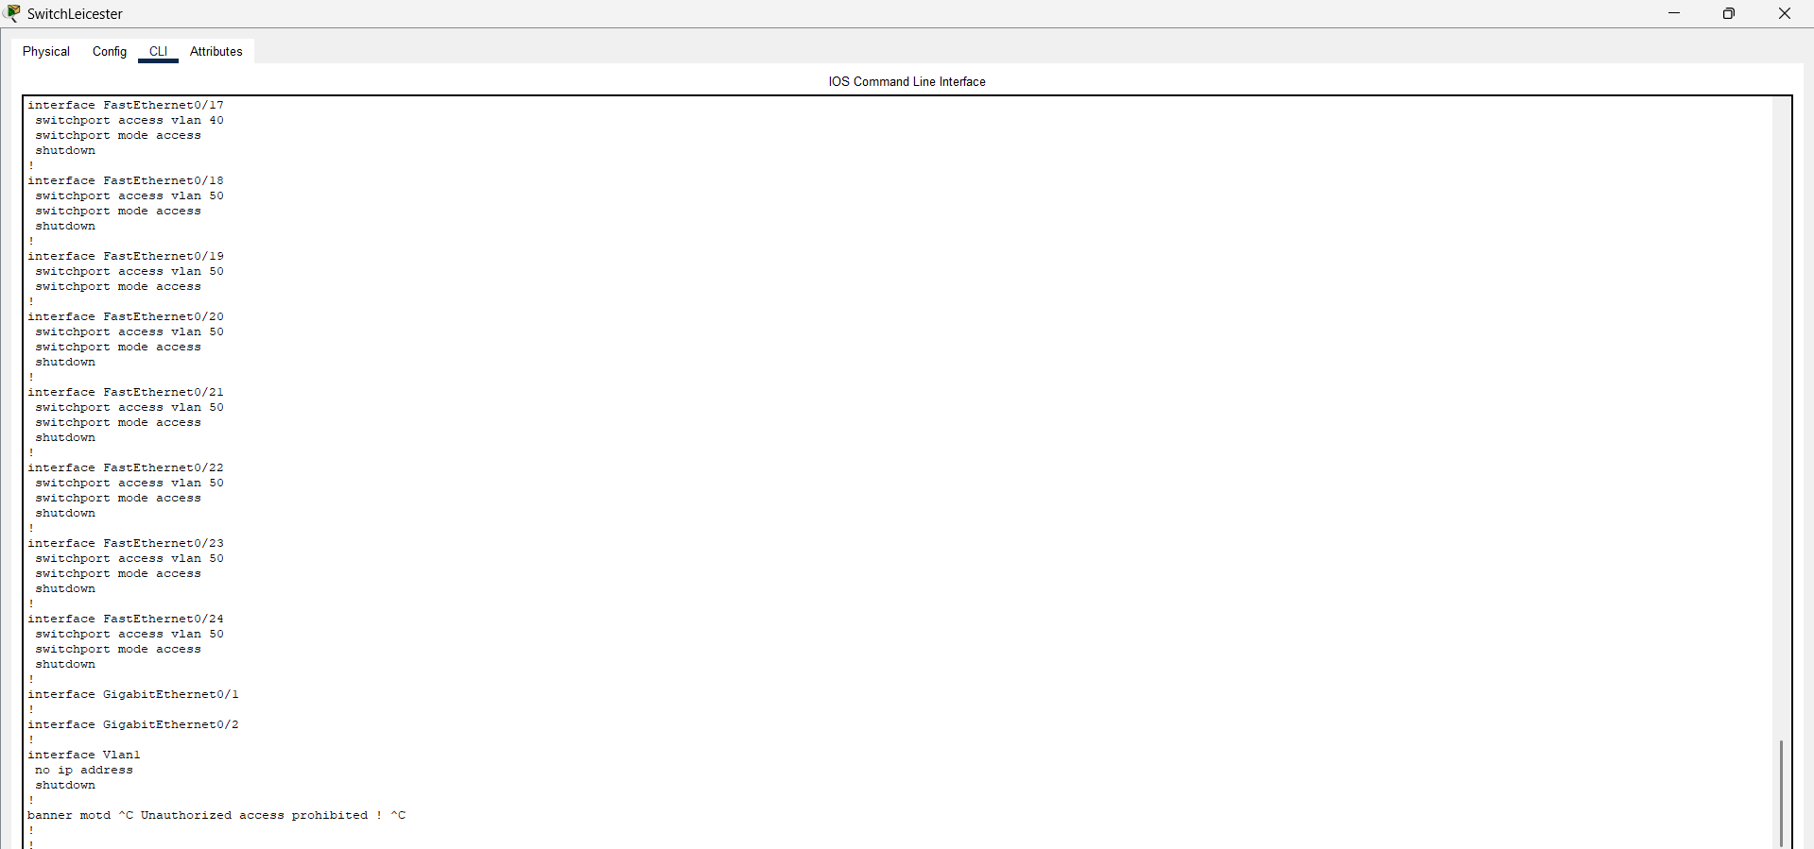

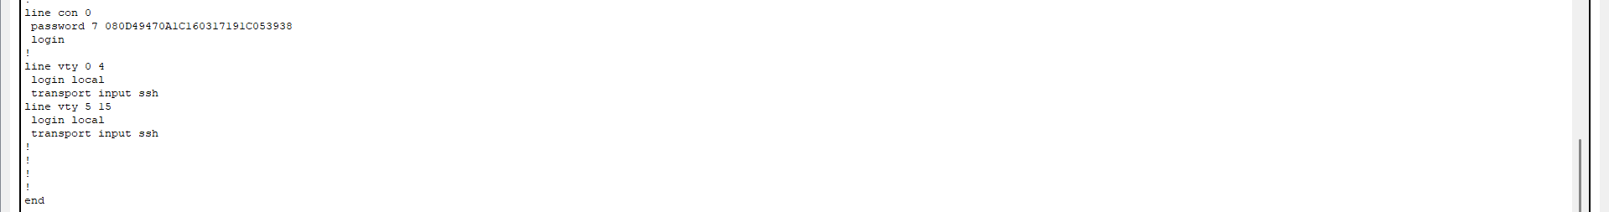

- Router

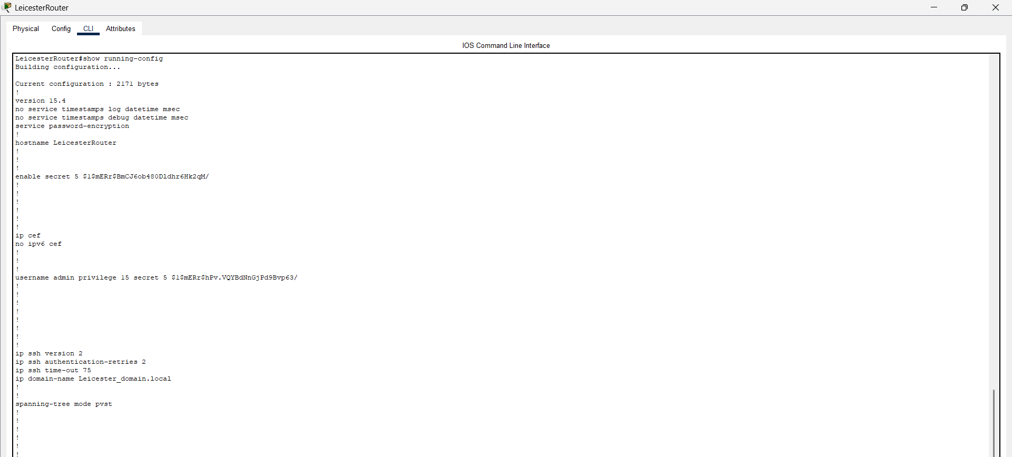

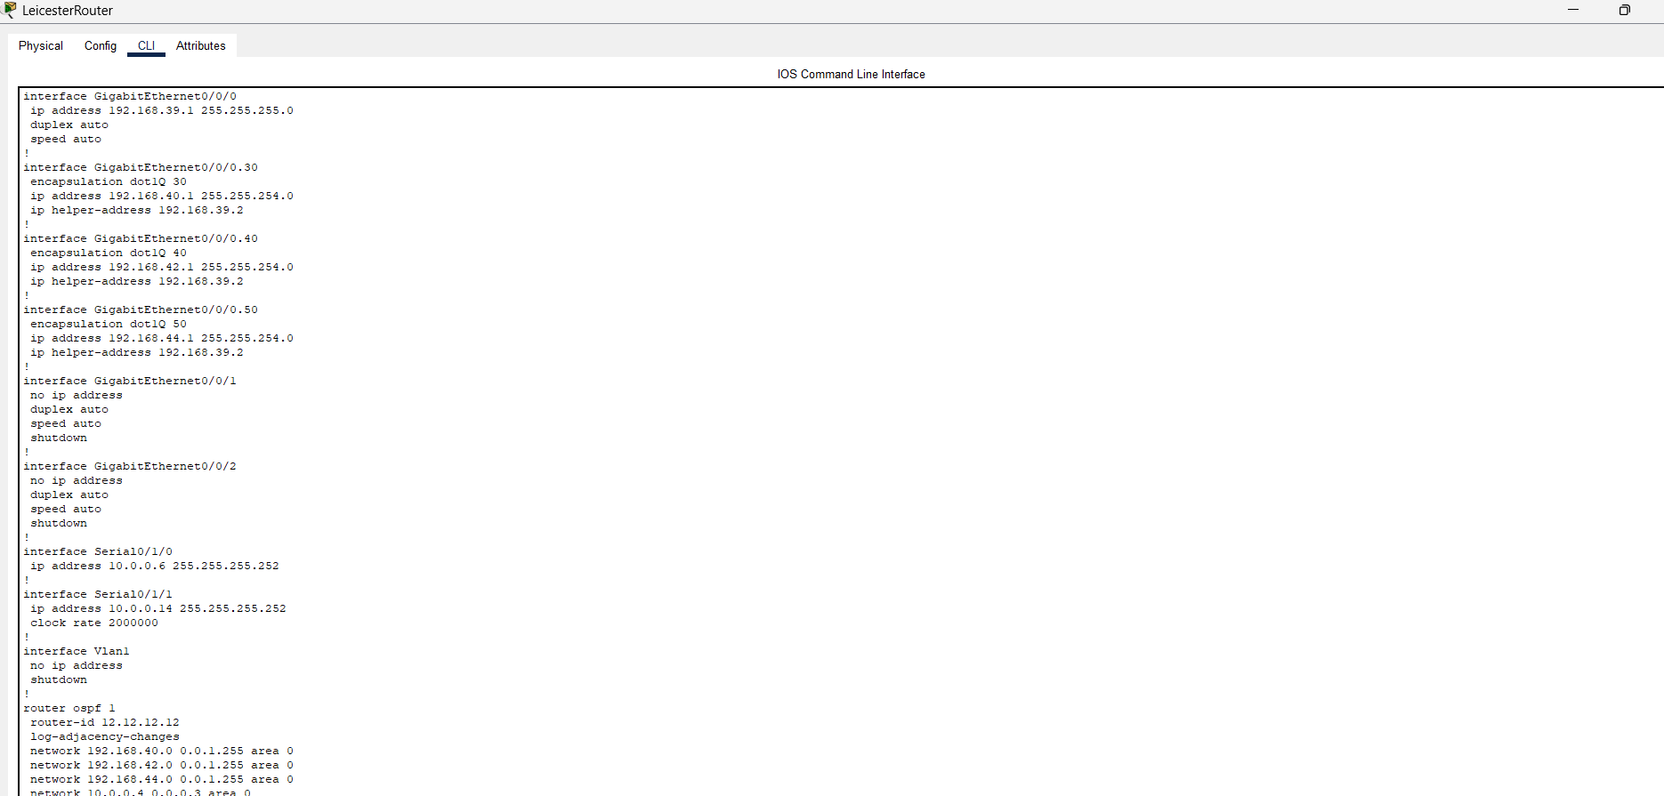

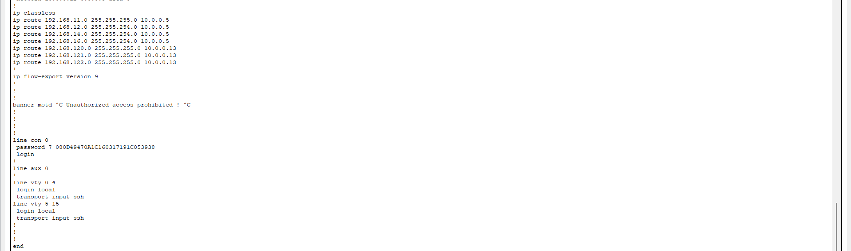

- Leeds

- Switch

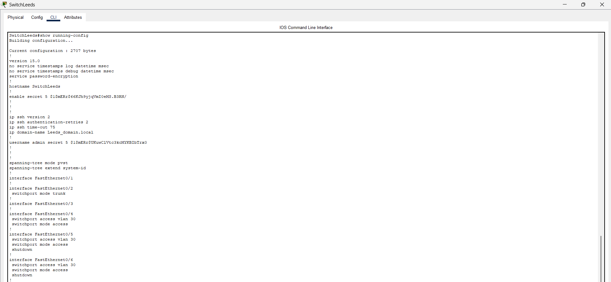

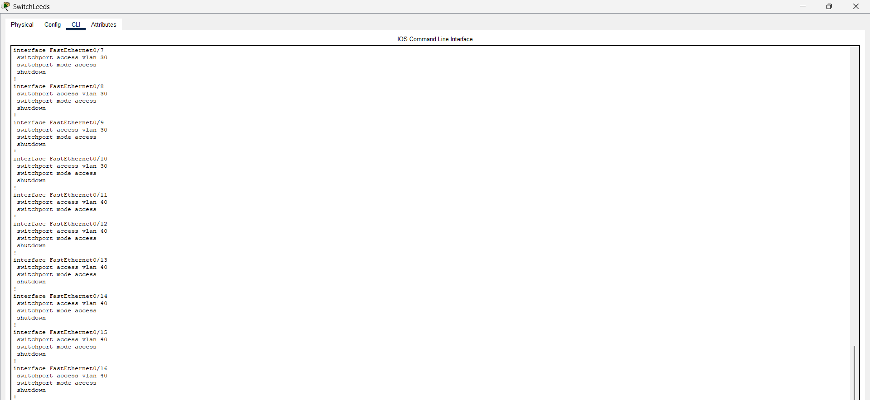

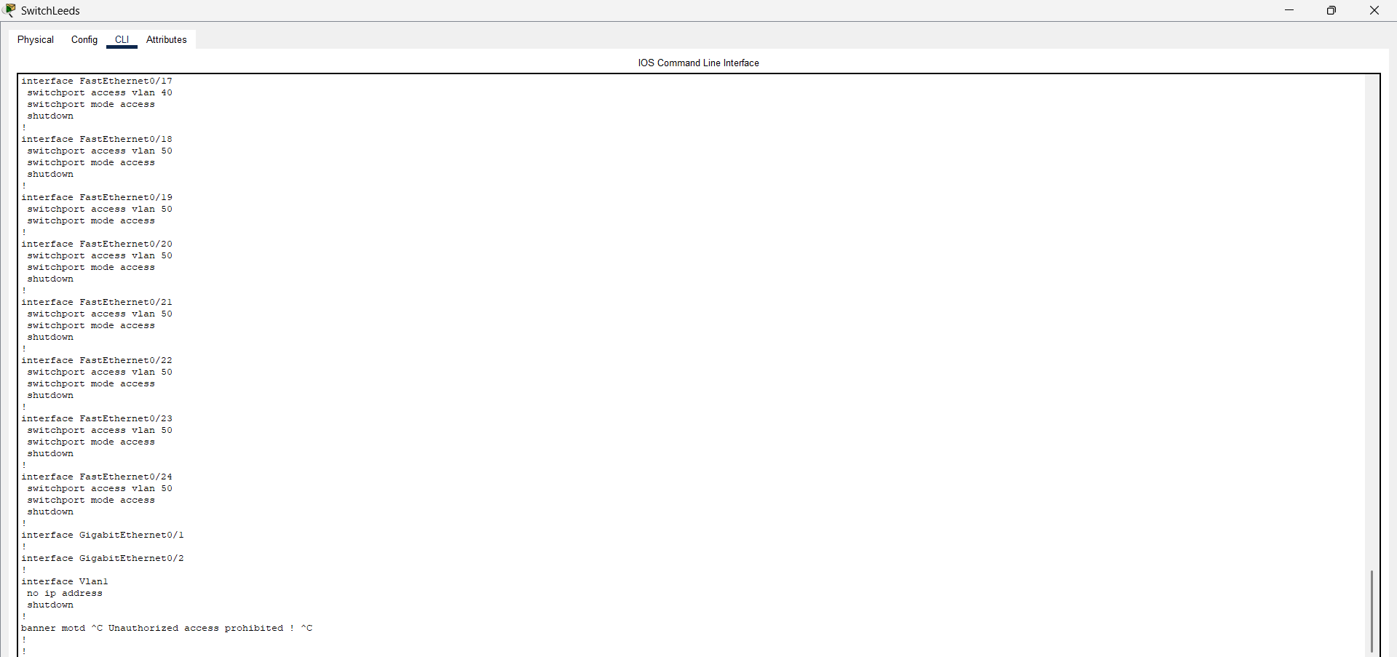

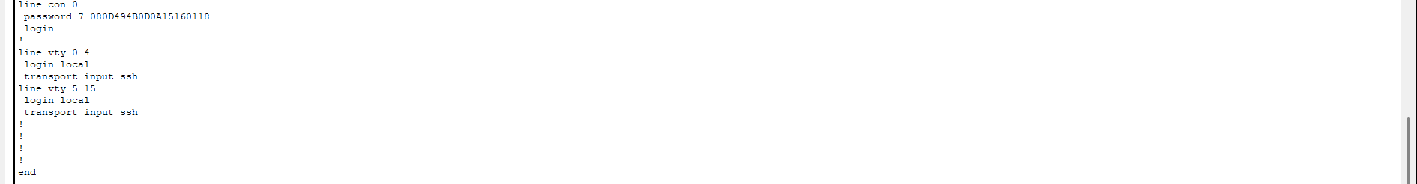

- Router

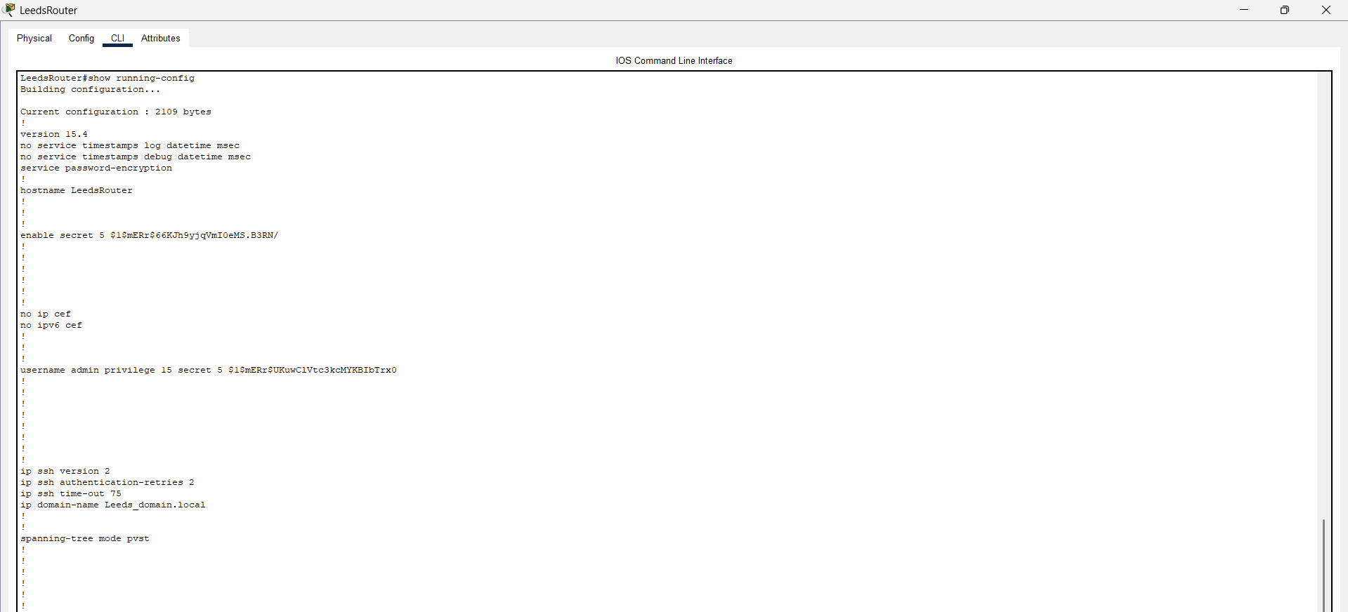

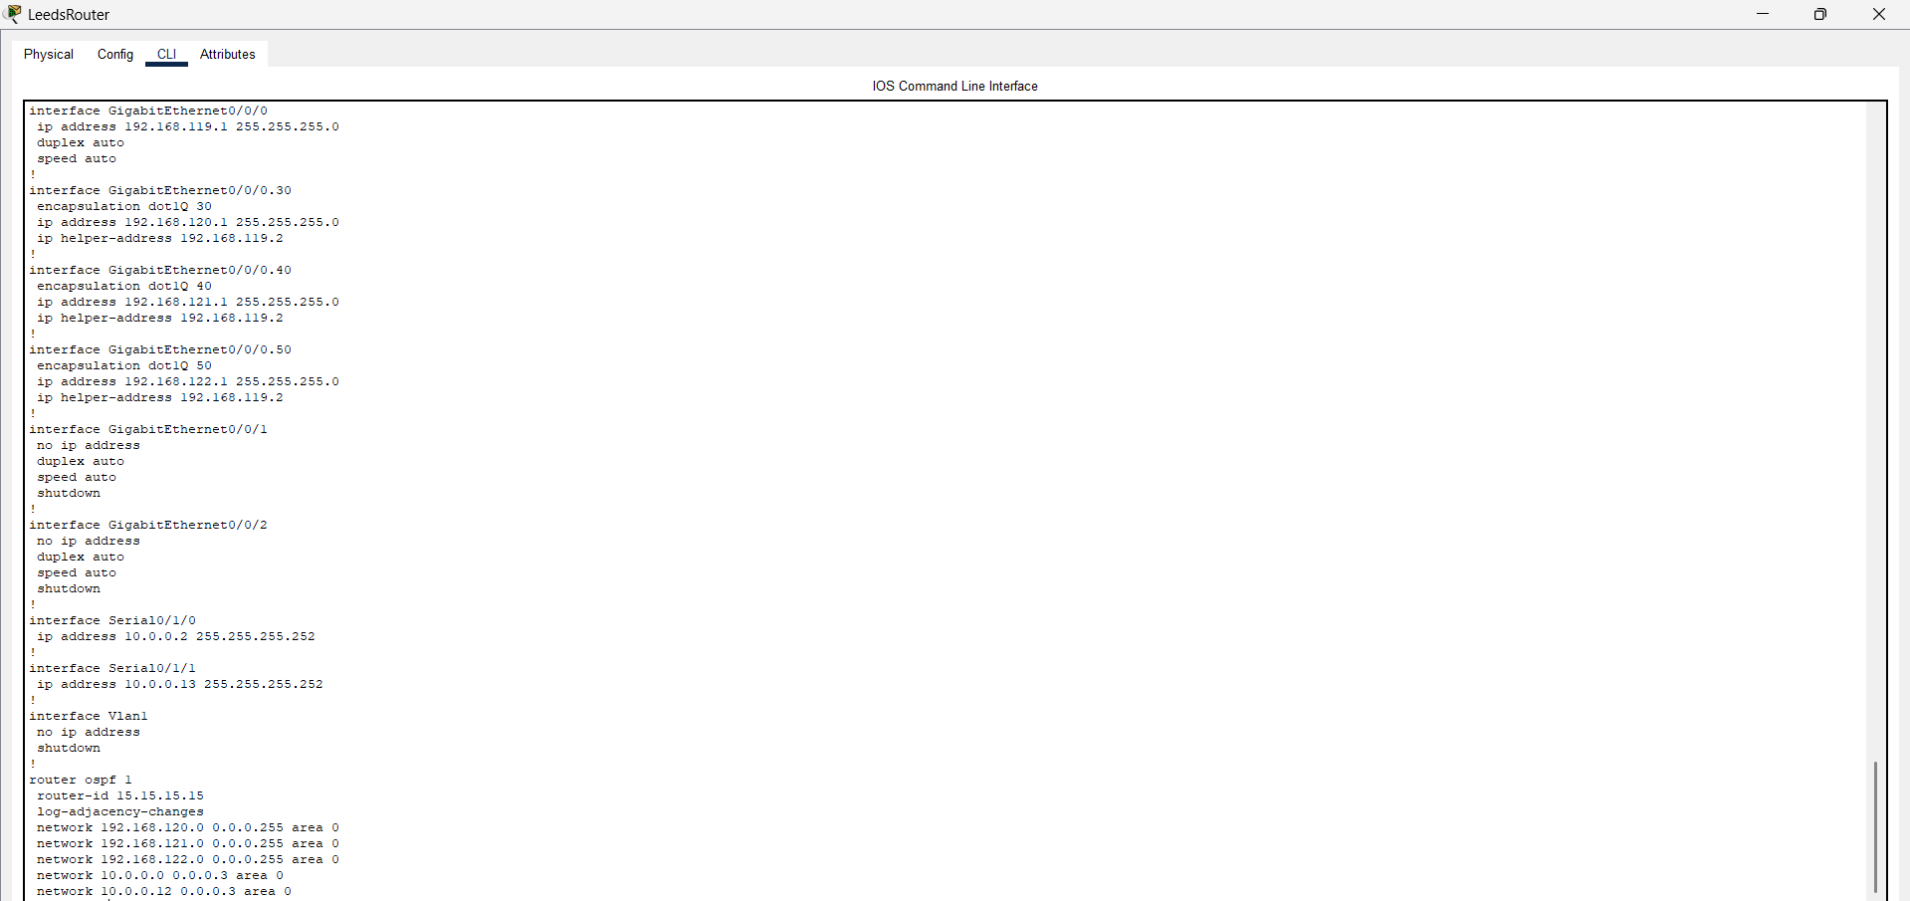

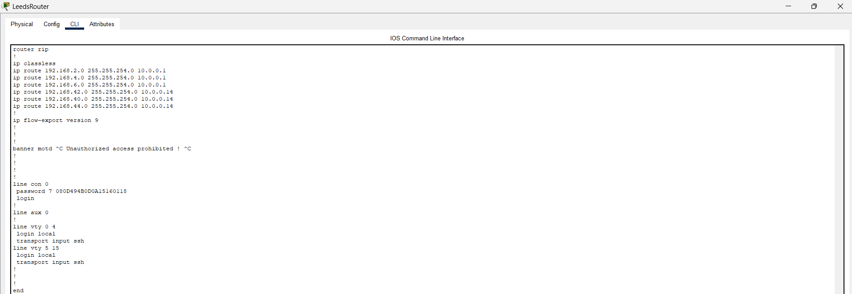

REFERENES

- Cisco Networking Academy (2020). Inter-VLAN Routing Operation (4.1) > Inter-VLAN Routing | Cisco Press. [online] www.ciscopress.com. Available at: https://www.ciscopress.com/articles/article.asp?p=3089357&seqNum=4.

- Fortinet (2025). What Is a Network Access Control List (ACL)? [online] Fortinet. Available at: https://www.fortinet.com/uk/resources/cyberglossary/network-access-control-list [Accessed 5 Apr. 2025].

- Grassi, P.A., Fenton, J.L., Newton, E.M., Perlner, R.A., Regenscheid, A.R., Burr, W.E., Richer, J.P., Lefkovitz, N.B., Danker, J.M., Choong, Y.-Y., Greene, K.K. and Theofanos, M.F. (2017). Digital identity guidelines: authentication and lifecycle management. NIST Special Publication 800-63B, [online] (800-63B). https://doi.org/10.6028/nist.sp.800-63b

- IBM (2023). IBM i. [online] Ibm.com. Available at: https://www.ibm.com/docs/en/i/7.3.0?topic=dhcp-network-topology-considerations [Accessed 7 Apr. 2025].
- Loshin, P. (2021). What is SSH (Secure Shell)? Definition from SearchSecurity. [online] SearchSecurity. Available at: https://www.techtarget.com/searchsecurity/definition/Secure-Shell [Accessed 6 Apr. 2025].
- Microsoft (2021). Dynamic Host Configuration Protocol (DHCP). [online] learn.microsoft.com. Available at: https://learn.microsoft.com/en-us/windows-server/networking/technologies/dhcp/dhcp-top [Accessed 5 Apr. 2025].

- Mikac, E. (2024). What is OSPF (Open Shortest Path First) Protocol? [online] CBT Nuggets. Available at: https://www.cbtnuggets.com/blog/technology/networking/what-is-ospf.

- Pepelnjak, I. (2020). What Exactly Happens after a Link Failure? «ipSpace.net blog. [online] Ipspace.net. Available at: https://blog.ipspace.net/2020/12/what-happens-after-link-failure/ [Accessed 5 Apr. 2025].
- RIPE.net (n.d.). Understanding IP Addressing and CIDR Charts. [online] RIPE Network Coordination Center. Available at: https://www.ripe.net/about-us/press-centre/understanding-ip-addressing/ [Accessed 7 Apr. 2025].
- Zenarmor (2023). What is VLAN? How to Implement, Secure, and Manage - zenarmor.com. [online] www.zenarmor.com. Available at: https://www.zenarmor.com/docs/network-basics/what-is-vlan [Accessed 5 Apr. 2025].

