Phase 0

Tech Talk

Applications Development Project 1

|  |  |
| --- | --- |
| Student Numbers | Surname and Initials |
|  |  |
|  |  |
|  |  |
|  |  |
|  |  |
|  |  |

Table of Contents

Introduction____________________________________2

Overview of the chosen project_____________________2

Problem Statement_______________________________3

User Requirements_______________________________3

Prototype_______________________________________4

Conclusion______________________________________9

Referencing_____________________________________9

**Introduction**

Tracking of assets owned by an organisation can be problematic. This problem can be worse when it comes to larger Departments like the Department of Information Technology at the Durban University of Technology(DUT). Our Group, Tech Talk, consisting of 6 members whom specialise in programing were approached by DUT, which is an institution of Higher Education, in the hopes that we can develop a Web based Application that will help with the maintenance of all their office equipment through tracking, allocation and other variety that will be explained in more detail further down.

We will be using Web-based Application, Microsoft internet information server and Microsoft SQL server to create the application as well as the Database that will be linked to the form.

**Overview of the chosen Project**

Tech Talk will be designing and Implementing a Web-Based Assets Management System which will be used by DUT’s Department of Information Technology. The application will be designed to allow the Staff Admins to capture information of assets that arrive at Dut into the Server Asset Database. They will then be able to allocate assets to a specific staff member. The application will also allow the Staff Admin to update, archive, view, filter and search the records of the allocated assets. The Head of the Department will be able to view all these records of new assets that arrive at Dut and the allocation of these assets.

**Problem Statement**

Dut’s Department of Information Technology has a problem with managing assets such as laptops, desktops, and furniture that arrive at Dut which need to be given assets numbers. Then the assets are assigned to certain office and staff members.

**Users Requirements**

* Adding assets that arrive to Dut to the Assets Database and assigning each assets a unique Asset Number.
* Allocating assets to staff members.
* Updating assets that have been allocated to staff members.
* Search all records of Assets or assets that are assigned to staff members.
* Filter all records of Assets or assets that are assigned to staff members.
* Archive records of assets that are assigned to staff members.

**Prototype (GUI Screen Design)**

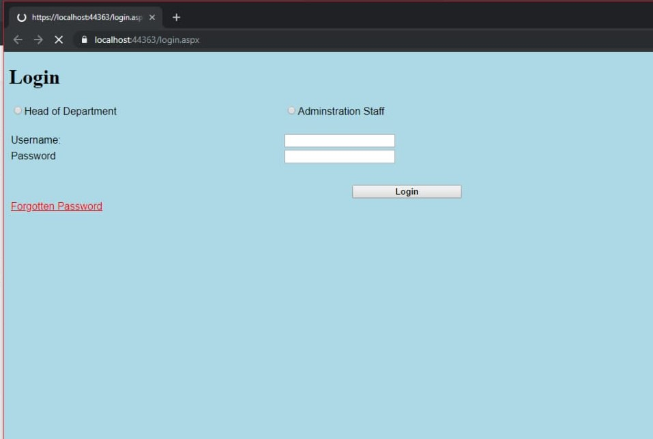

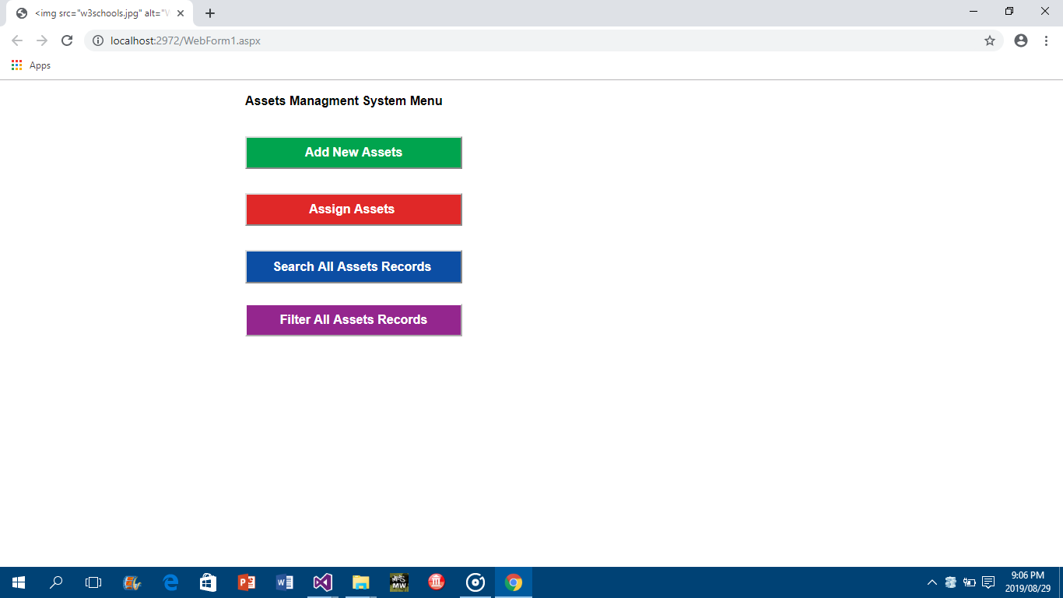

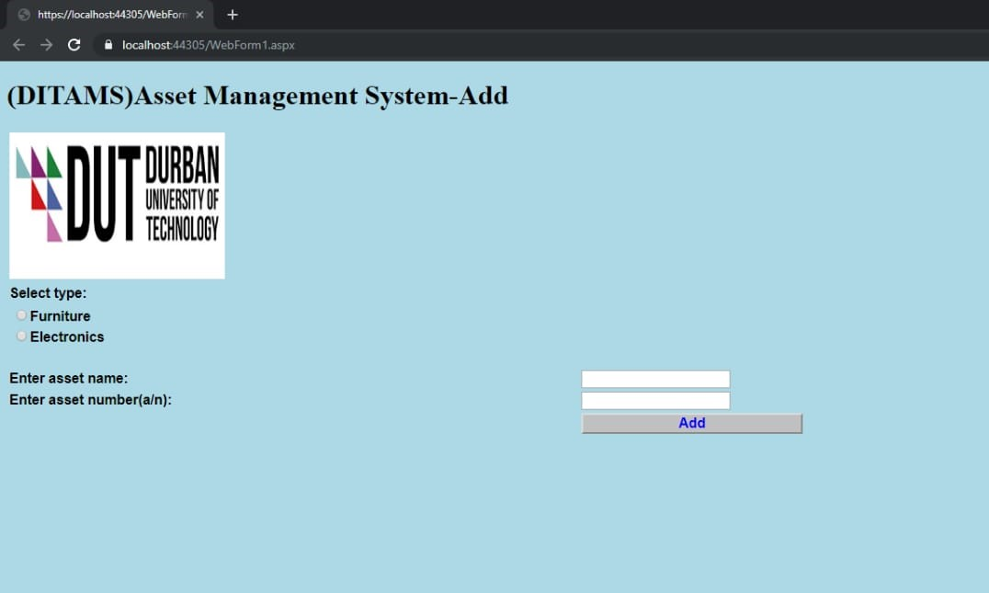

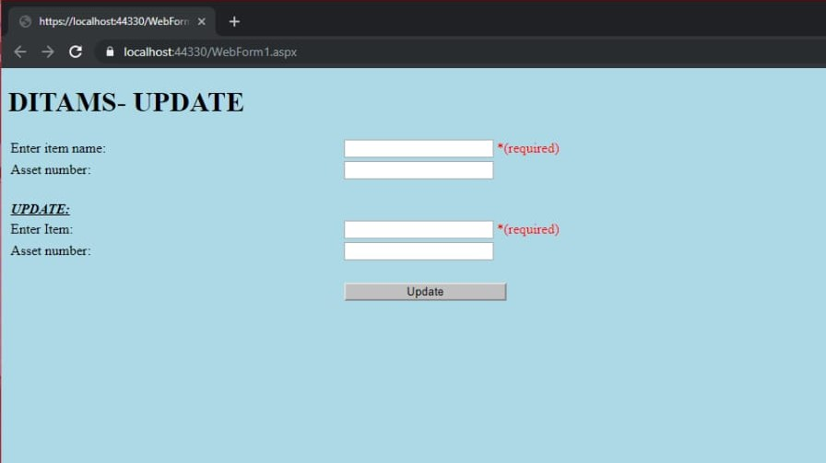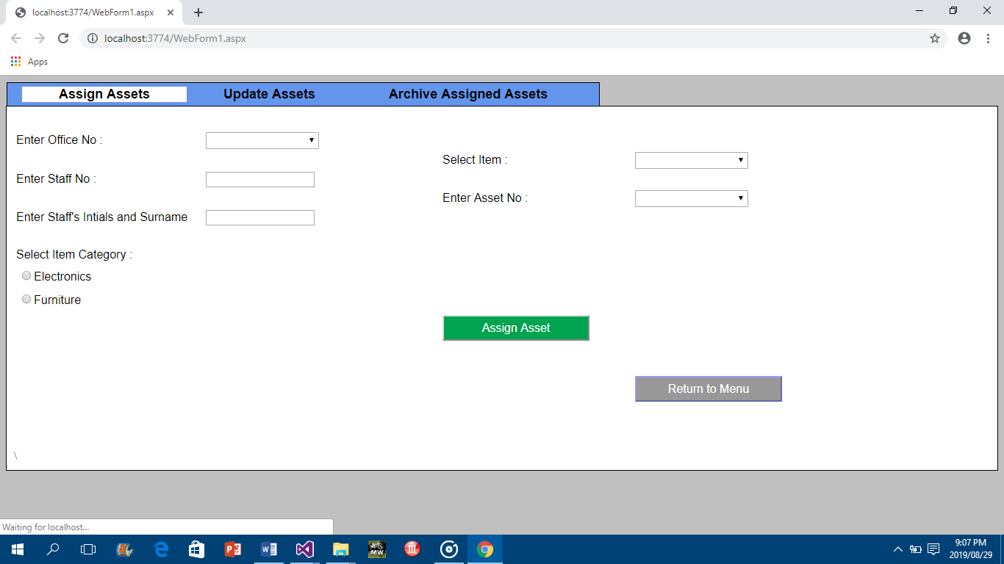

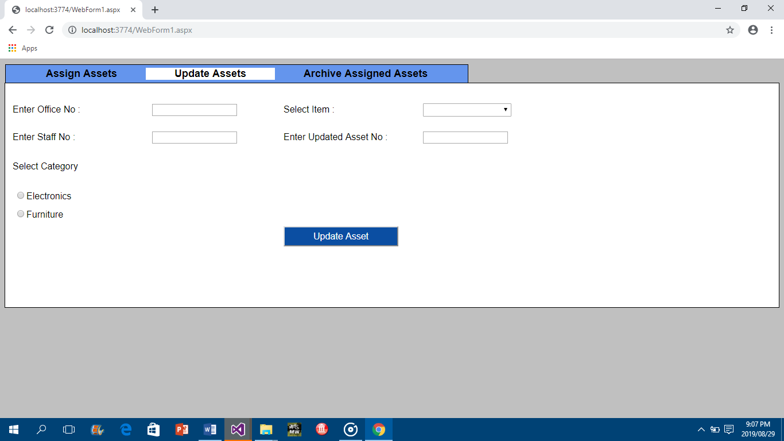

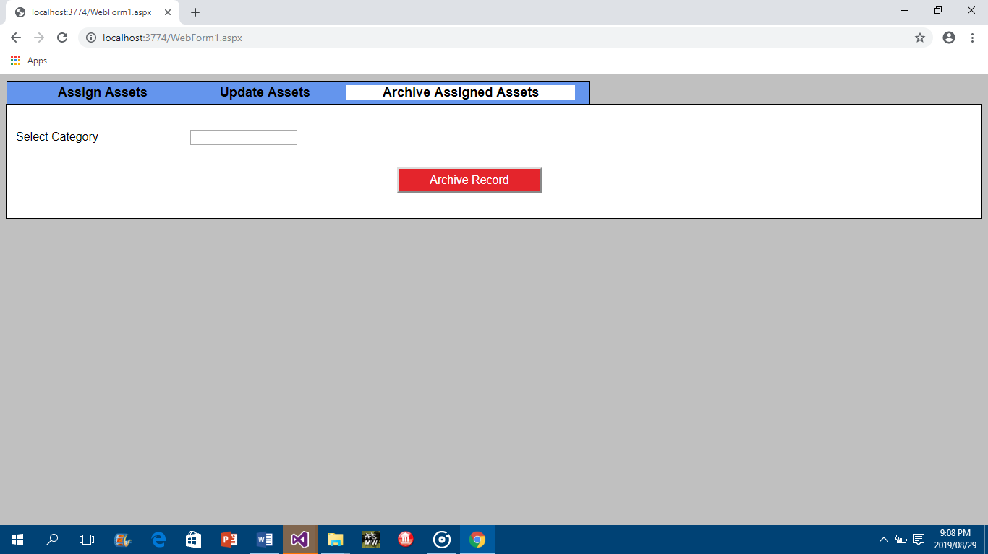

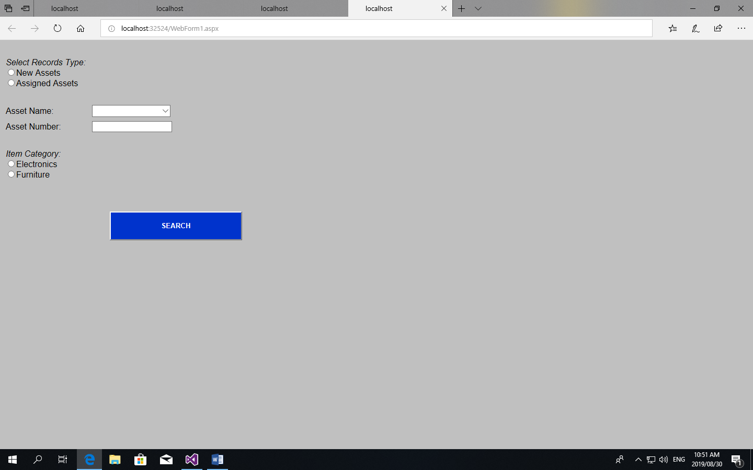

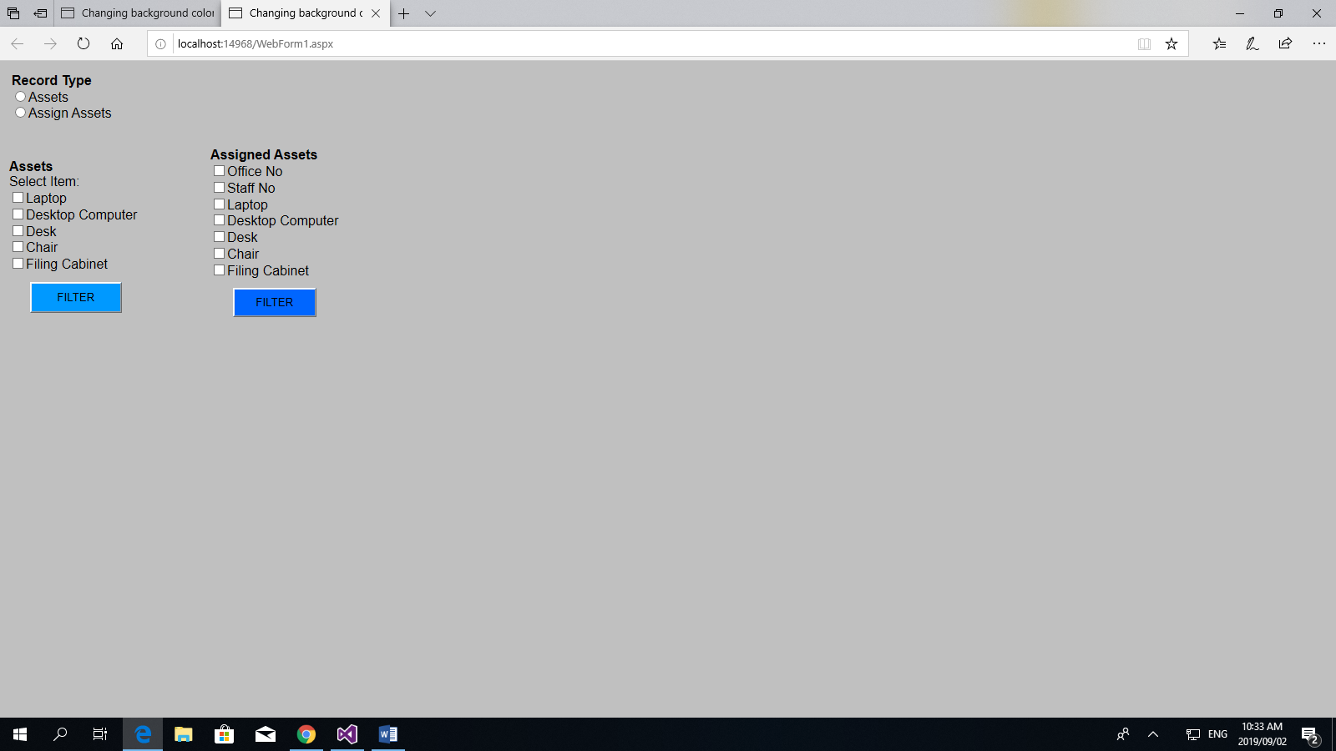

**Conclusion**

As we proceeded with phase 0 of our DITMAS Website Project we found that we had a lot of problems when it came to designing the GUI for the project. We had minor issues when it came to adding certain features to the GUI, such as images and creating Tab sheets we used online research to helped us find way to solve these problems. We referred to W3School website that explained how to work with these features and functions. We also found that the current User requirements and GUI will have to change as we move further into the project.

**Referencing**

<https://www.w3schools.com/html/html_images.asp>

<https://www.w3schools.com/howto/howto_js_tab_header.asp>