TripTrek : Intelligent Travel Planning Using Palm’s Chat-Bison-001

Contents

1. Introduction 1

1.1. Project Overview 1

1.2. Objectives 1

2. Project Initialization and Planning Phase 1

2.1. Problem Statement 1

2.2. Project Proposal (Proposed Solution) 2

2.3. Initial Project Planning 2

3. Data Collection and Preprocessing Phase 3

3.1. Data Collection Plan and Raw Data Sources Identified 3

3.2. Data Quality Report 3

3.3. Data Preprocessing 3

4. Model Development Phase 3

4.1. Model Selection Report 3

4.2. Initial Model Training Code, Model Validation and Evaluation Report 3

5. Model Optimization and Tuning Phase 3

5.1. Tuning Documentation 3

5.2. Final Model Selection Justification 3

6. Results 3

6.1. Output Screenshots 3

7. Advantages & Disadvantages 11

8. Conclusion 12

9. Future Scope 12

10. Appendix 13

10.1. Source Code 13

10.2. GitHub & Project Demo Link 15

# Introduction

## Project Overview

TripTrekk aims to revolutionize the travel planning experience by leveraging cutting-edge AI technology. Our platform empowers users to move beyond the burden of researching and piecing together itineraries, allowing them to focus on the joy of discovery and creating lasting travel memories.

## Objectives

TripTrekk's primary objective is to transform travel planning by:

* Generating personalized itineraries tailored to user preferences, budget constraints, and travel styles through AI.
* Simplifying the process with features like integrated flight search and cost-conscious planning tools.
* Providing a user-friendly platform that streamlines trip planning and saves valuable time.

# Project Initialization and Planning Phase

## Problem Statement

Traditional travel planning can be a time-consuming and overwhelming process, often involving:

* Extensive research and sifting through countless options
* Difficulty finding itineraries that perfectly match user desires
* Overlooking hidden gems or cost-effective opportunities

## Project Proposal (Proposed Solution)

TripTrekk addresses these challenges by approaching the problem statement by utilizing a combination of cutting-edge technologies to deliver its core functionalities:

* Large Language Models (LLMs): At its heart, TripTrekk utilizes Google Generative AI's text-bison-001 LLM. This powerful language model acts as the engine for itinerary generation. By processing user input and travel preferences, the LLM can generate creative text formats that translate into comprehensive and informative trip plans.
* Machine Learning: While the current scope focuses on LLM-based generation, future iterations may incorporate machine learning techniques for specific tasks. For example, machine learning models could be trained to recommend activities or restaurants based on user preferences and historical data.
* API Integrations: TripTrekk integrates with external APIs to expand its functionalities and provide valuable travel data.
  + Amadeus API integration allows for real-time flight searches within the platform, streamlining the travel planning process.
  + Currency conversion APIs can be used to provide up-to-date exchange rates for users budgeting across international destinations.

TripTrekk addresses the challenges by offering a user-friendly platform that:

* Generates personalized itineraries using AI-powered large language models (LLMs)
* Integrates real-time flight search functionality through the Amadeus API
* Provides features like currency conversion for budget-conscious planning
* Evolves and improves with user reviews and recommendations for future iterations

## Initial Project Planning

**2.3 Initial Project Planning**

The initial project planning phase involves outlining the key milestones, defining the project scope, identifying necessary resources, and setting timelines. Key activities in this phase include:

* Defining user personas and use cases.
* Creating a detailed project timeline with specific milestones and deadlines.
* Identifying required tools and technologies such as Google Cloud, Gemini, and Streamlit.
* Establishing a project team with defined roles and responsibilities.

**3. Data Collection and Preprocessing Phase**

**3.1 Data Collection Plan and Raw Data Sources Identified**

The data collection plan involves identifying relevant data sources necessary for the project. Raw data sources include:

* Travel itineraries and user preferences data.
* Real-time flight data from the Amadeus API.
* Historical travel data for training the model.

**3.2 Data Quality Report**

A data quality report is essential to ensure the reliability of the collected data. It includes:

* Data accuracy checks.
* Handling missing data.
* Ensuring data consistency across different sources.

**3.3 Data Preprocessing**

Data preprocessing steps include:

* Cleaning and normalizing data.
* Converting raw text data into structured formats suitable for model input.
* Splitting data into training and testing sets.

**4. Model Development Phase**

**4.1 Model Selection Report**

The model selection report details the criteria used to choose the appropriate AI and machine learning models. For this project:

* Google Generative AI's text-bison-001 model is selected for generating travel itineraries.
* Future iterations may explore additional models for specific tasks like activity recommendations.

**4.2 Initial Model Training Code and Model Validation and Evaluation Report**

Initial model training involves:

* Writing code to train the model on the collected and preprocessed data.
* Validating the model using a subset of the data.
* Evaluating the model's performance using metrics like accuracy, precision, and recall.

**5. Model Optimization and Tuning Phase**

**5.1 Tuning Documentation**

Model tuning documentation includes:

* Hyperparameter tuning to optimize model performance.
* Iterative testing and refinement to improve accuracy and reliability.
* Documenting the tuning process and results.

**5.2 Final Model Selection Justification**

The final model selection is justified based on:

* Performance metrics from the evaluation phase.
* The model's ability to meet project objectives.
* Practical considerations like computational efficiency and scalability.

# 6.Results

## 6.1Output Screenshots

Example 1:

Example 2:

Example 3:

# 7.Advantages & Disadvantages

**Advantages:**

* Personalized trip itineraries tailored to user preferences
* Integrated flight search and cost-conscious planning tools
* User-friendly platform for a streamlined travel planning experience

**Disadvantages:**

* Reliance on user input accuracy for optimal results
* LLM limitations in understanding complex user preferences (future improvement area)
* Potential bias in suggestions based on LLM training data (future mitigation strategies needed)

# 8.Conclusion

TripTrekk is a promising AI-powered travel planning platform that has the potential to streamline the travel planning process for users. By leveraging advanced AI and machine learning techniques, TripTrekk can provide users with personalized itineraries that save them time and money. With ongoing development and enhancements, TripTrekk can become an essential tool for travelers of all types.

# 9.Future Scope

* Integrate booking functionalities for flights, accommodations, and activities.
* Implement real-time travel updates on weather, events, or disruptions.
* Expand language support for a broader user base.
* Continuously improve the LLM's ability to personalize itineraries based on user data and travel trends.
* Develop a mobile app for on-the-go trip planning
* Implement sentiment analysis to incorporate user reviews and feedback into itinerary generation.

# 10.Appendix

## Source Code

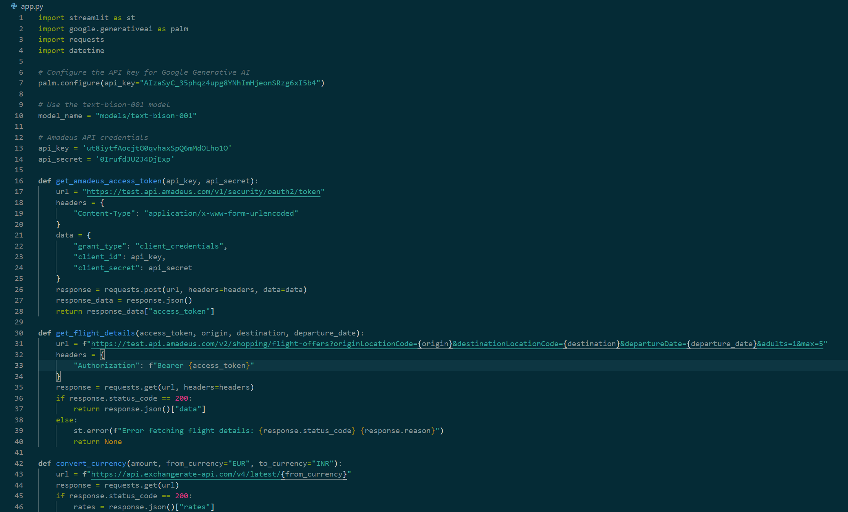

## GitHub & Project Demo Link