

University of Westminster

4COSCOO6C

Software Development

Documentation Report and Test Plan Report.

Coursework Details :

Module Leader : Mr. Guhanathan Poravi

Assignment Number : 1

Assignment Type : Individual

Issue Date : 6th March 2024 Submission

Deadline : on or before 18th of March 2024

Student Details :

Student Name : Ravichandran Shavinkar

Student ID : 20233155

UOW number : w2083094

# 1 . Abstract

The report that Mr. Guhanathan Poravi assigned for the 4COSC006C Software Development module contains documentation for a Python personal finance tracker that is list-based and uses JSON serialization. The documentation investigates the problem statement and uses the Python programming language to come up with a solution. Test cases are used for internal testing, and the report also includes the validations.

# 2 . Acknowledgement

I would like to express my sincere gratitude and advice over the course of this project to Mr. Salman Faraj. His knowledge, support, and criticism were crucial to its eventual completion. I sincerely appreciate his assistance and inquiring. I also want to acknowledge the assistance and encouragement received from my friends and colleagues who helped with this project, whether directly or indirectly. This project would not have been possible without your combined efforts, and I am sincerely appreciative of the chance to collaborate with such gifted people. I appreciate your contributions, everyone.

# Table of figures

**Figure 1 coding** 24

# Tables

**Table 1 test execution** 31

# Task 1- Pseudo Code

BEGIN

#Global list

Initialize transactions to []

FUNCTION add_transactions ()

DISPLAY “Enter Transaction Details”

GET amount from user as input.

GET category from user as input.

GET type (“Income or Expense”) from user as input.

GET date(“DD-MM-YYYY”) from user as input.

Set transaction to [amount, category, type, date]

Add transaction to transactions

DISPLAY “Transactions Added Successfully”

ENDFUNCTION

FUNCTION view_transactions ()

IF transactions list is empty THEN

PRINT “No transactions to view”

ELSE

DISPLAY “Transactions are listed below”

FOR view_ transaction in transactions DO

DISPLAY “Amount:” , view_ transaction [0]

DISPLAY “Category:” , view_ transaction [1]

DISPLAY “Type:” , view_ transaction [2]

DISPLAY “Date:” , view_ transaction [3]

NEXT transaction

ENDIF

ENDFUNCTON

FUNCTION update_transaction ()

IF transactions list is empty THEN

PRINT “No transactions were found to update”

ELSE

PRINT “Enter transactions index to update”

GET index from user input

IF index is valid THEN

PRINT “Enter new transactions details”

GET correct amount from user input

GET correct category from user input

GET correct type (“Income or Expense”) from user input

GET correct date (“DD-MM-YYYY”) from user input

Set transactions[index] to [correct amount, correct category, correct type, correct date]

save_transactions ()

DISPLAY “Transaction Updated Successfully”

ELSE

PRINT “Invalid index to process”

ENDIF

ENDIF

ENDFUNCTION

FUNCTION delete_transaction ()

IF transactions list is empty THEN

DISPLAY “Transactions list is empty to be deleted”

ELSE

Prompt for index of transactions to delete

GET index from user input

IF index is valid THEN

Delete transactions[index]

save_transactions ()

PRINT “Transaction deleted successfully”

ELSE

PRINT “Invalid index to process”

ENDIF

ENDIF

ENDFUNCTION

FUNCTION display_summary ()

Set total_income to 0

Set total_expense to 0

FOR transaction in transactions DO

IF transaction[2] == “ Income” THEN

total_income = total_income + transaction[0]

ELSE

total_expense = total_expense + transaction[0]

ENDIF

NEXT transaction

IF total_ income > total_expense THEN

Compute Net_income = total_income - total_expense

ELSE

Compute Net_expense = total_ expense - total_ income

ENDIF

PRINT total_income

PRINT total_ expense

IF total_ income > total_expense THEN

PRINT Net_income

ELSE

PRINT Net_expense

ENDIF

ENDFUNCTION

FUNCTION save_transactions ()

OPENFILE “transactions.json” for WRITE as F1

Serialize the transactions list to JSON

WRITE the serialized JSON data to F1

CLOSEFILE F1

DISPLAY “Successfully saved”

ENDFUNCTION

FUNCTION load_transactions ()

OPENFILE “transactions.json” for READ as F1

Deserialize the transactions list to python

CLOSEFILE F1

DISPLAY “Successful”

ENDFUNCTION

FUNCTION main_menu ()

load_transactions ()

WHILE True DO

PRINT “Personal Finance Tracker”

PRINT “1. Add Transaction”

PRINT “2. View Transaction”

PRINT “3. Update Transaction”

PRINT “4. Delete Transaction”

PRINT “5. Display Summary”

PRINT “6. Exit”

Prompt for choice as input

GET choice from user input

IF choice == 1 THEN

add_transactions ()

ELSE IF choice == 2 THEN

view_transactions ()

ELSE IF choice == 3 THEN

update_transactions ()

ELSE IF choice == 4 THEN

delete_transactions ()

ELSE IF choice == 5 THEN

display_summary ()

ELSE IF choice == 6 THEN

PRINT “Exiting the program and saving….”

ELSE

PRINT “Invalid choice. Please try again”

ENDIF

ENDIF

ENDIF

ENDIF

ENDIF

ENDIF

ENDWHILE

ENDFUNCTION

main_menu ()

END

# Task 2 - Solution

## 2.1- A brief synopsis

-With the use of a JSON file for transaction storage, this Python application tracks personal finances. A summary of incomes and expenses is also displayed, and there are options for adding, viewing, editing and removing transactions. A command-line interface made available by the main_menu () function allows users to interact with the tracker.

## 2.2 - Python Code

import json

transactions = [] #Global list to store transactions.

#File handling functions

def load_transactions():

try:

file = open("transactions.json" , "r+") #Opening the file in read mode.

transactions = json.load (file) #loads the data to the file

file.close () #Closing the opened file

except FileNotFoundError:

print("File 'transactions.json' is unavailable")

return

def save_transactions(): #Function used to save the processed transactions in json file.

file = open("transactions.json","w") #Opening the json file in write mode.

json.dump(transactions,file) #Stores the transactions data in json file.

file.close() #Closing the opened file

return

#Feature implementations

def add_transaction(): #permits user to add a new transaction

while True:

print("Enter the Transactions Details")

while True: #looping until user inputs a valid number for amount

try:

Amount = int(input("Enter the amount :"))

if Amount >= 0: #checks if the amount is a whole number

break #exits the loop when the user inputs a valid amount

else:

print("Amount should be a whole number")

except ValueError: #finds for valuerror if amount is non-integer

print("Amount is always an integral value")

Category = input("Enter a category :")

while True:

Type = input("Enter the type(\"Income or Expense\") :")#User should input either Income or Expense

if Type != "Income" and Type != "Expense": #checks if input type is neither Income and Expense

print("Type should be either \"Income\" or \"Expense\". Please try again!")

else:

break

Date = input("Enter the date in (YYYY-MM-DD) :") #User should input date in YYYY-MM-DD format

transaction =[Amount, Category, Type, Date] #Stores the added transaction to the transaction list

transactions.append(transaction) #Combines the transaction list with empty transactions list

print("Transactions Added Successfully.")

break

return

def view_transactions(): #permits user to view the added transactions

if transactions == []: #checks whether the transactions list is empty

print("No transactions to view")

else:

print("\nTransactions are listed below\n")

for view_transaction in transactions: #used to iterate over the transactions list and access values using index

print("Amount :",view_transaction[0] , end=' , ') #end is used print amount,category,type and date on the same line

print("Category :",view_transaction[1] , end=' , ')

print("Type :",view_transaction[2] , end=' , ')

print("Date :",view_transaction[3])

return

def update_transaction(): #Defining the function to update a transaction

try:

if transactions == []: #checks whether the transactions list is empty

print("No transactions were found to update")

else:

while True: #looping until user inputs a valid number for index

try:

index = int(input("Enter the specific index to update:"))

if index < 0 or index >= len(transactions): #checks for index whether it lies between 0 and (len(transactions)-1)

print("\nInvalid index to update.\n")

continue #continue to next loop when invalid index is entered

else:

break #stops the loop when user enters a valid index

except:

print("\nInvalid input. Index is an integral value.\n")

continue #continue to next loop when non_integral index is entered

while True: #looping until user inputs a valid number for amount

try:

correctAmount = int(input("Enter the correct amount :"))

if correctAmount >= 0: #checks if the amount is a whole number

break #exits the loop when the user inputs a valid amount

else:

print("Amount should be a whole number")

except ValueError: #finds for valuerror if amount is non-integer

print("Amount is always an integral value")

correctCategory = input("Enter a correct category :")

while True:

correctType = input("Enter the correct type(\"Income or Expense\") :")#User should input either Income or Expense

if correctType != "Income" and correctType != "Expense": #checks if input type is neither Income and Expense

print("Type should be either \"Income\" or \"Expense\". Please try again!")

else:

break #exits the loop when "Income" or "Expense" is entered

correctDate = input("Enter the correct date(YYYY-MM-DD) :")

transactions[index] = [correctAmount, correctCategory, correctType, correctDate] #updates the corrected details in the transactions list at the specified index

save_transactions() #function is called to save the updated transaction to the file

print("Transaction updated successfully")

except:

print("Invalid index to update")

return

def delete_transaction(): #allows user to delete an existing transaction

if transactions == []: #checks whether the transactions list is empty

print("Transactions list is empty to be deleted")

else:

while True: #looping until user inputs a valid number for index

try:

index = int(input("Enter the specific index to delete :")) #prompts the user to input the specified index to be deleted

if index < 0 or index >= len(transactions): #checks for index whether it lies between 0 and (len(transactions)-1)

print("\nInvalid index to delete.\n")

continue #continue to next loop when invalid index is entered

else:

break #stops the loop when user enters a valid index

except:

print("\nInvalid input. Index is an integral value.\n")

continue #continue to next loop when non_integral index is entered

del transactions[index] #deletes the transaction at the specified index of the transactions list

save_transactions() #save the transactions to the file after deleting

print("Transaction deleted successfully")

return

def display_summary(): #displays the summary of transaction details

total_income = 0

total_expense = 0

for transaction in transactions: #iterates each transaction from transactions list

if transaction[2] == "Income": #checks the type at the index 2 whether its Income or Expense

total_income = total_income + transaction[0] #adds the amount at the index 0 to total_income

else:

total_expense = total_expense + transaction[0] #adds the amount at the index 0 to total_expense

if total_income > total_expense:

Net_income = total_income - total_expense

else:

Net_expense = total_expense - total_income

print("Total income:",total_income)

print("Total expense:",total_expense)

if total_income > total_expense:

print("Net income",Net_income)

else:

print("Net expense",Net_expense)

return

def main_menu(): #starting code of the program

try:

load_transactions() #Load transactions at the start. If the file doesn't exist then goes to exception block

except:

save_transactions()

load_transactions()

while True: #enters an endless loop to prompt input an option from the user

try:

print("\nPersonal Finance Tracker")

print("1. Add Transaction")

print("2. View Transactions")

print("3. Update Transaction")

print("4. Delete Transaction")

print("5. Display Summary")

print("6. Exit")

choice = int(input("Enter your choice: ")) #converts the variable 'choice' from string to integer

if 1 <= choice <= 6: #checks if the choice is inside the range

pass #if it lies within the range then goes to the next part of the loop

else:

print("Enter a number between 1 and 6")

except ValueError:

print("Enter an input that is an integer")

continue #continues to next iteration when user inputs a non-integral value

if choice == 1: #checks if the choice equal to 1

add_transaction() #calls the add_transaction() function adds a transaction

elif choice == 2:

view_transactions() #at choice '2 'calls the view_transaction() function views a transaction

elif choice == 3:

update_transaction() #at choice '3' calls the update_transaction() function updates a transaction

elif choice == 4:

delete_transaction() #at choice '4' calls the delete_transaction() function deletes a transaction

elif choice == 5:

display_summary()#at choice '5' calls the display_summary() function shows the income or expense

elif choice == 6:

save_transactions() #at choice '6' calls the save_transactions() function to save and exit the program

print("Transaction saved successfully") #Displays the message after storing the data successfully.

print("Exiting program.")

break

else:

print("Invalid choice. Please try again.")

return

if __name__ == "__main__":

main_menu()

# if you are paid to do this assignment please delete this line of comment

## 2.3 - Python Code Statements

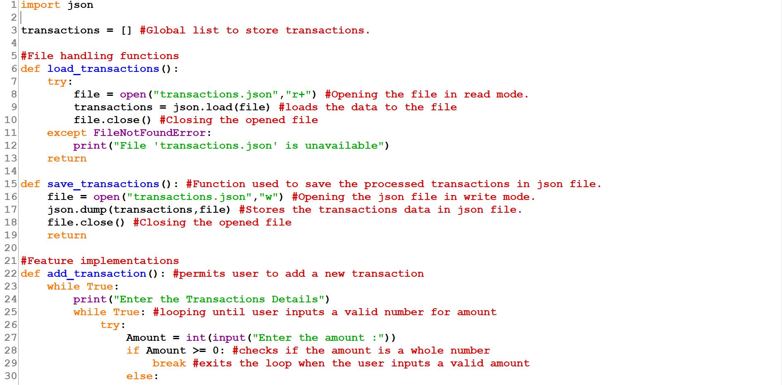

**Figure 1 coding**

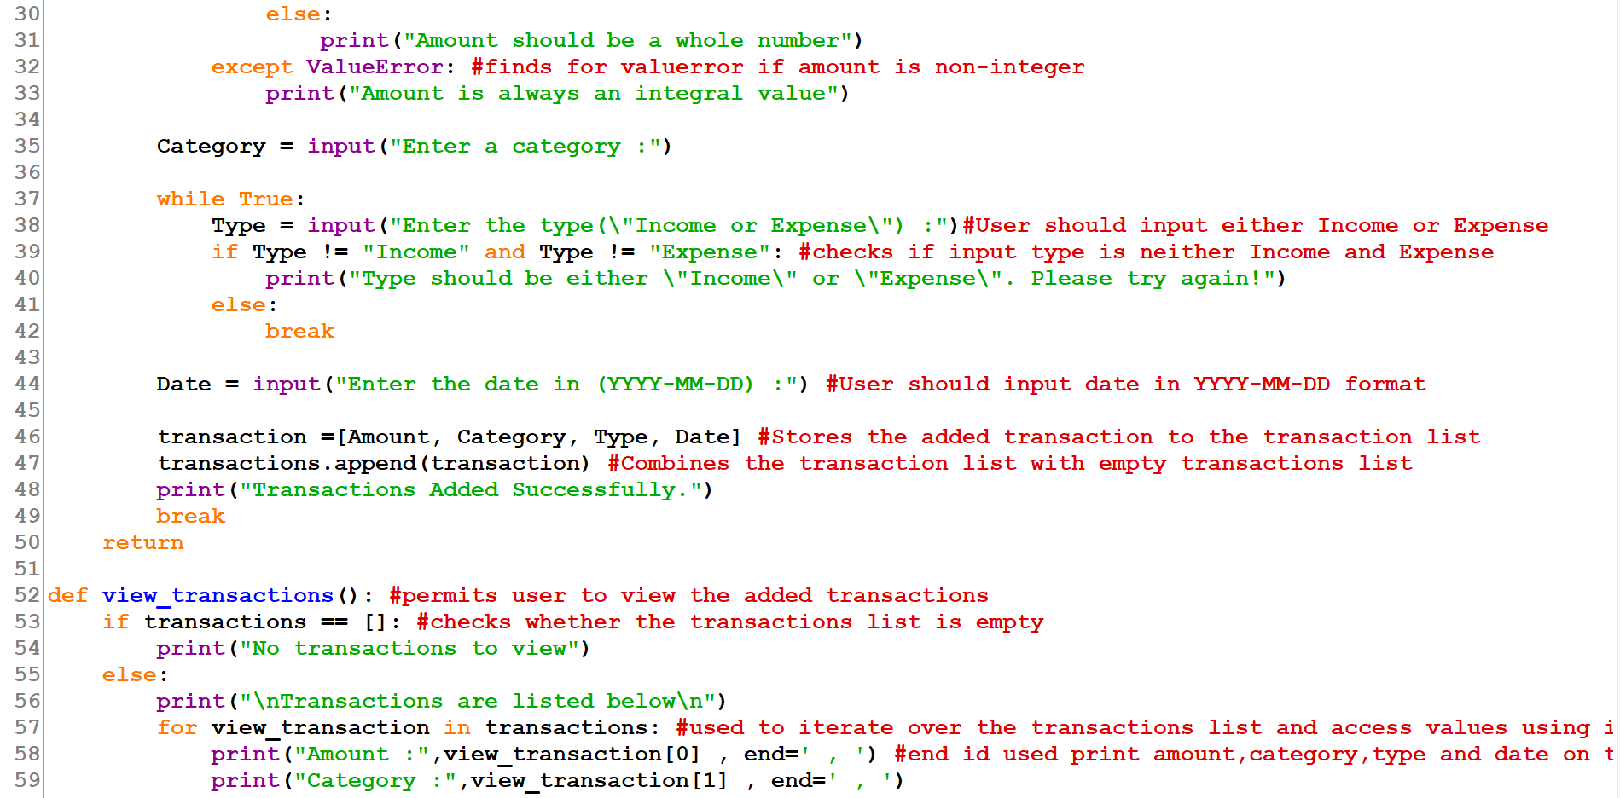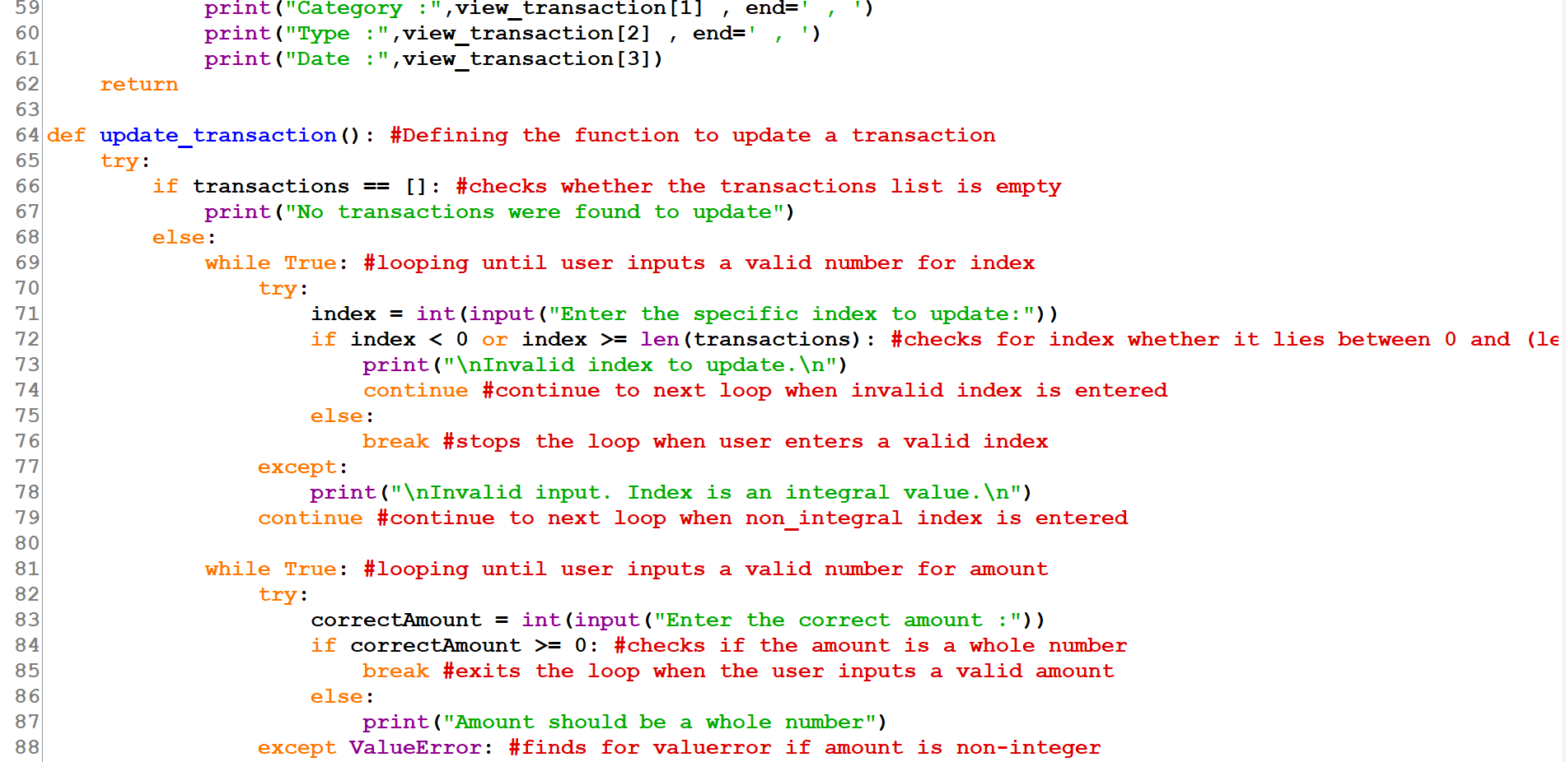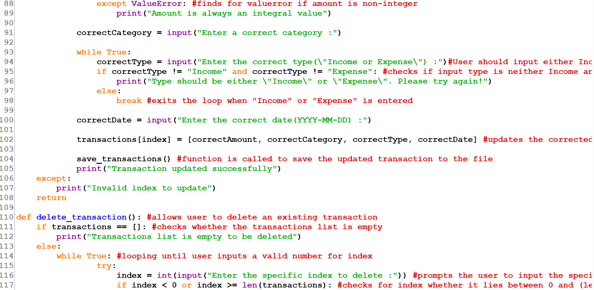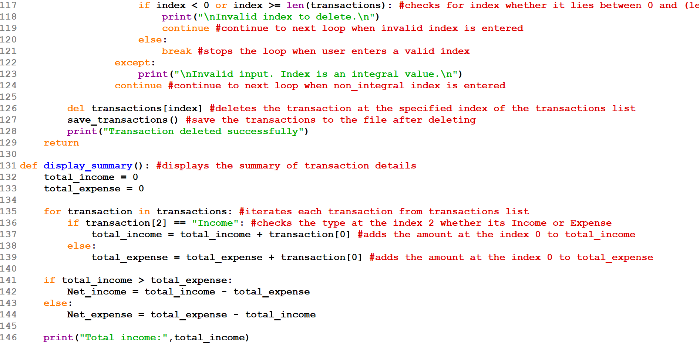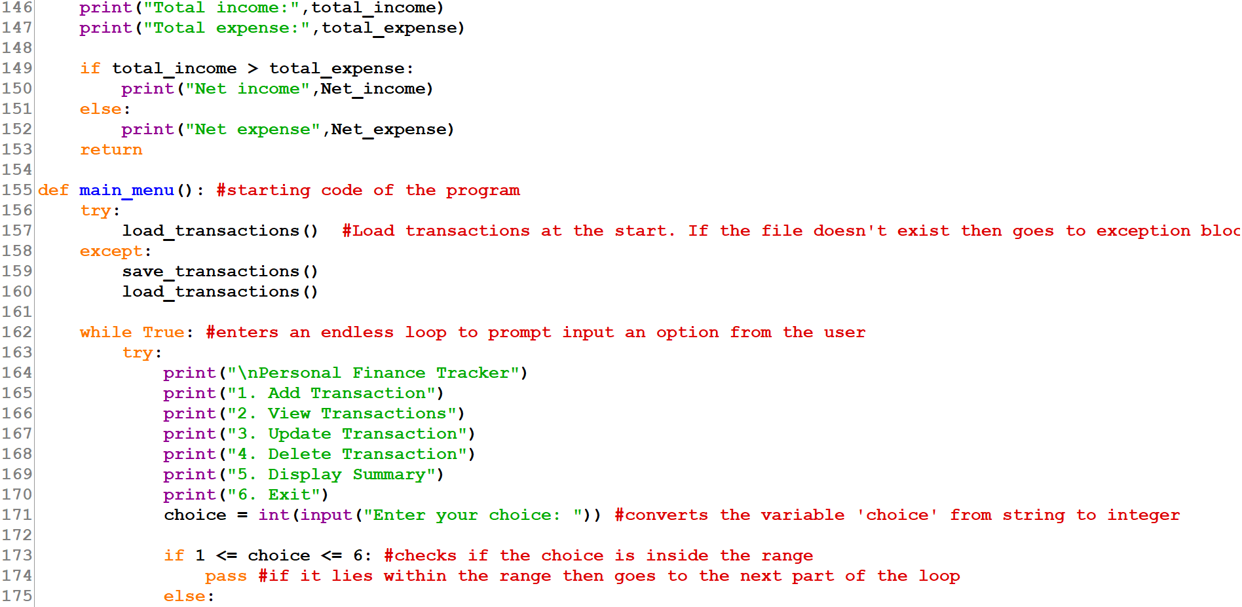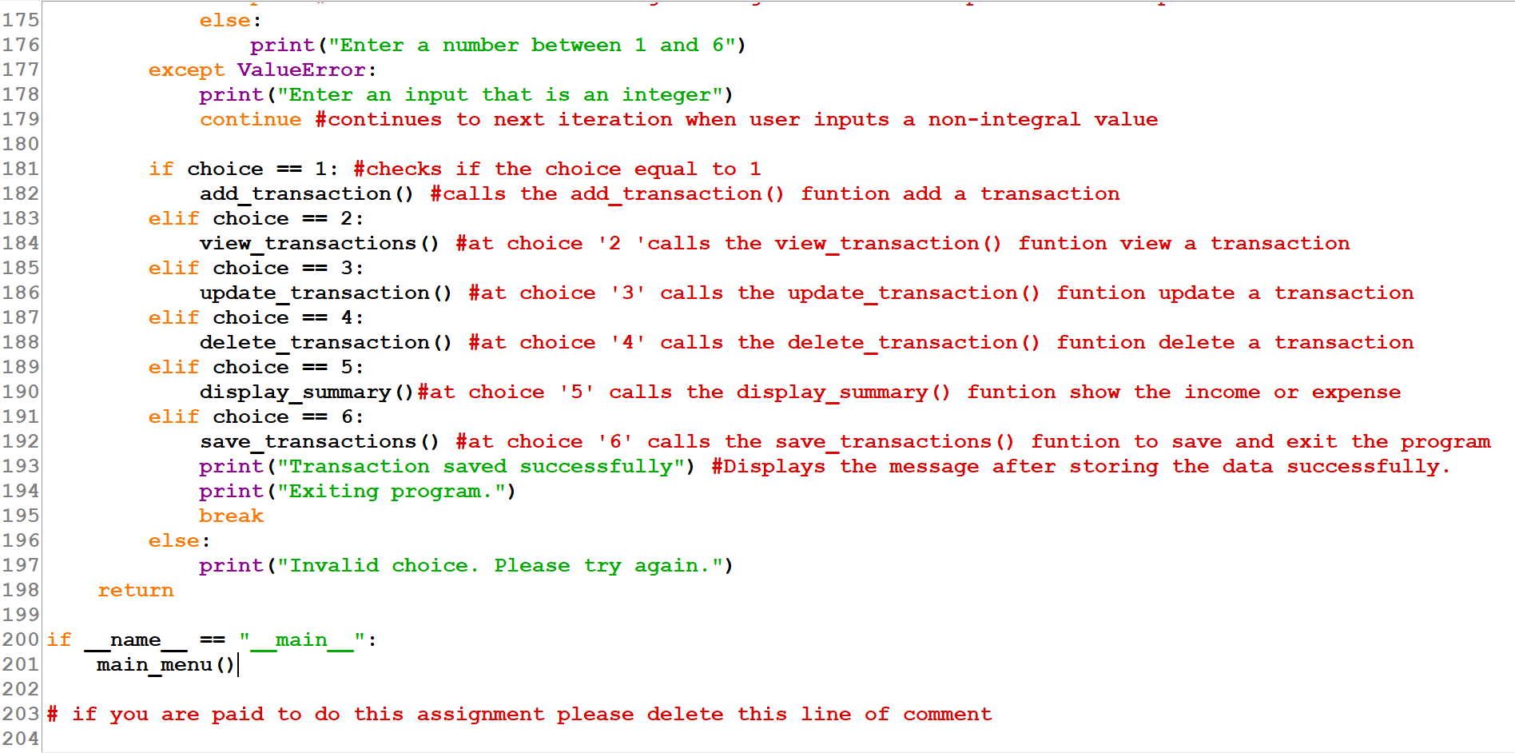

# Task 3 - Test Plan and Execution

## 3.1 - Test Plan

There are 8 functions defined to implement pseudo code

File handling functions

1. def load_transactions()

2. def save_transactions():

Feature implementations

3.def add_transaction():

4.def view_transactions():

5.def update_transaction():

6.def delete_transaction():

7.def display_summary():

8.def main_menu():

The code comprises a main function called def main_menu(). This function includes all other feature implementations. File handling functions are contained in feature implements.   
Thus, I've decided to set up six test cases.

Inside the main function which is main_menu() it has six choices to run the test plan. See below code

if choice == 1: #checks if the choice equal to 1

add_transaction() #calls the add_transaction() funtion adds a transaction

elif choice == 2:

view_transactions() #at choice '2 'calls the view_transaction() funtion views a transaction

elif choice == 3:

update_transaction() #at choice '3' calls the update_transaction() funtion updates a transaction

elif choice == 4:

delete_transaction() #at choice '4' calls the delete_transaction() funtion deletes a transaction

elif choice == 5:

display_summary()#at choice '5' calls the display_summary() funtion shows the income or expense

elif choice == 6:

save_transactions() #at choice '6' calls the save_transactions() funtion to save and exit the program

print("Transaction saved successfully") #Displays the message after storing the data successfully.

print("Exiting program.")

break

else:

print("Invalid choice. Please try again.")

## 3.2. Test Execution

**Table 1 test execution**

|  |  |  |  |  |  |
| --- | --- | --- | --- | --- | --- |
| Test Cases | Description | Inputs | Expected Outputs | Actual Outputs | Test Status |
| 1 | add_  transaction | amount, category,  type,  date | Transactions  .json file is created and stores the transactions list | Yes. Actual output was same as expected output | Test PASS |
| 2 | view_  transaction |  | Able to view all the transactions of the transactions list | Same as the expected output | Test PASS |
| 3 | update_  transaction | Input index to update a list.  correct Amount, correct category,  correct type,  correct date | Updates list at the specified index of transactions list | Transaction updated successfully | Test PASS |
| 4 | delete_  transaction | Input index to remove a list | Removes list at the specified index of transactions list | Transaction deleted successfully | Test PASS |
| 5 | display_  summary | No input | total_income, total_expense, net_income or net_expense | Outputs the total_income, total_expense, net_income or net_expense | Test PASS |
| 6 | main_menu | Input the choice to select an option (1-6) | Runs the program throughout prompting the user to input a choice and exits . | Same as the expected output | Test PASS |

# Task 4. Screenshots of Test outputs

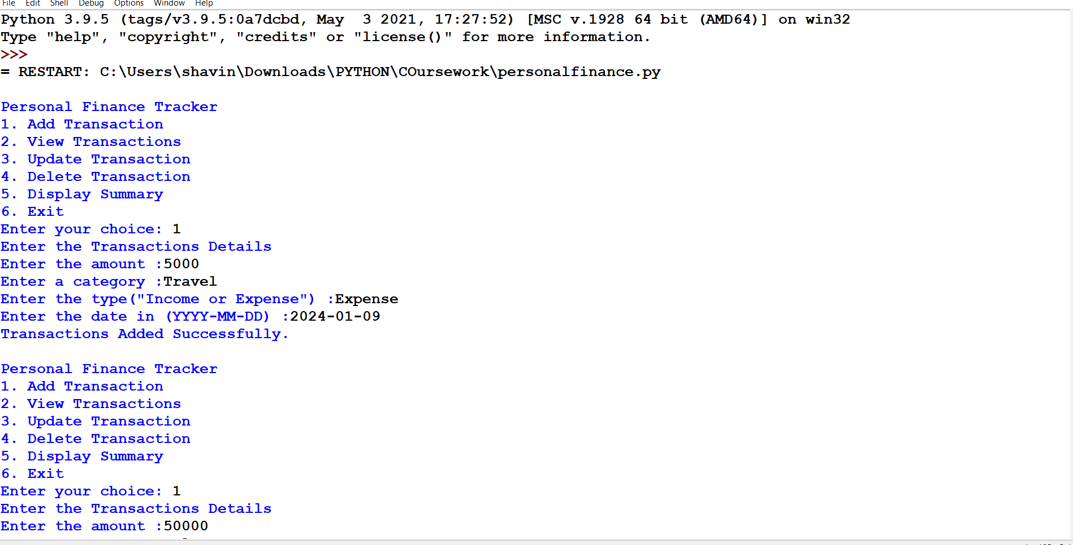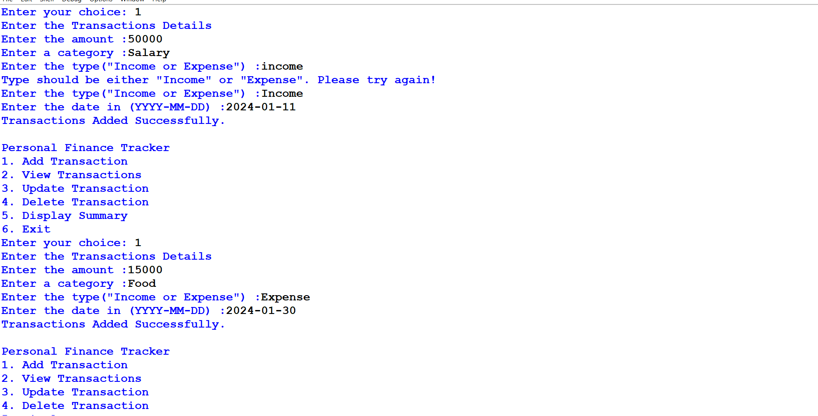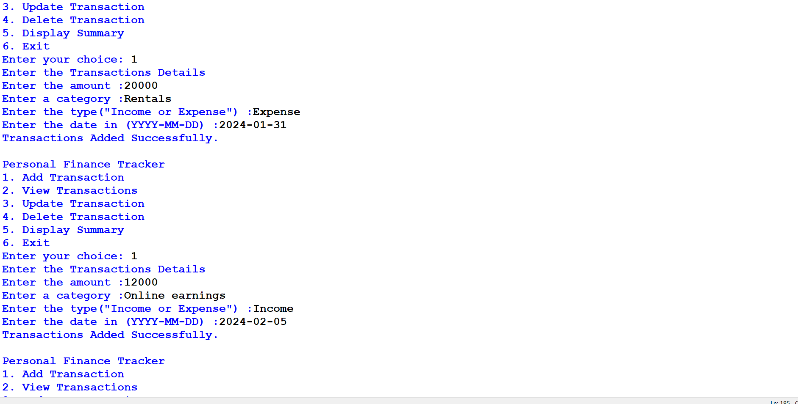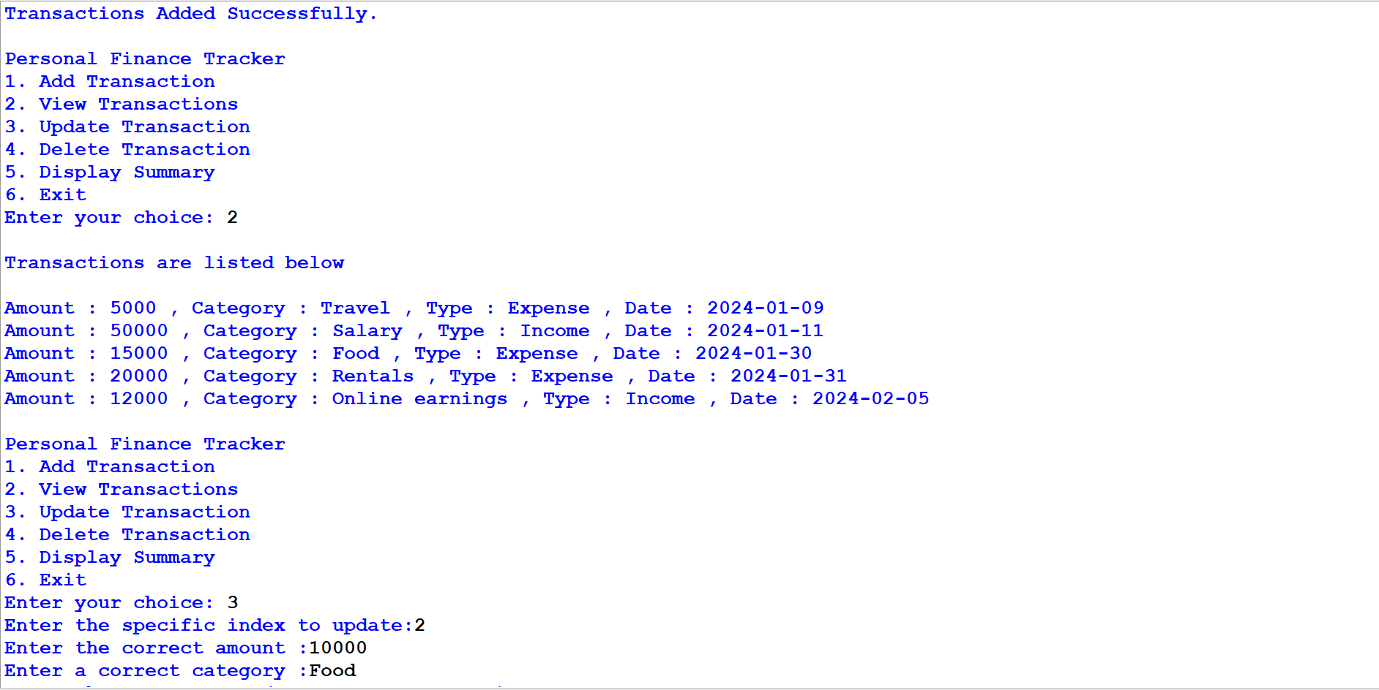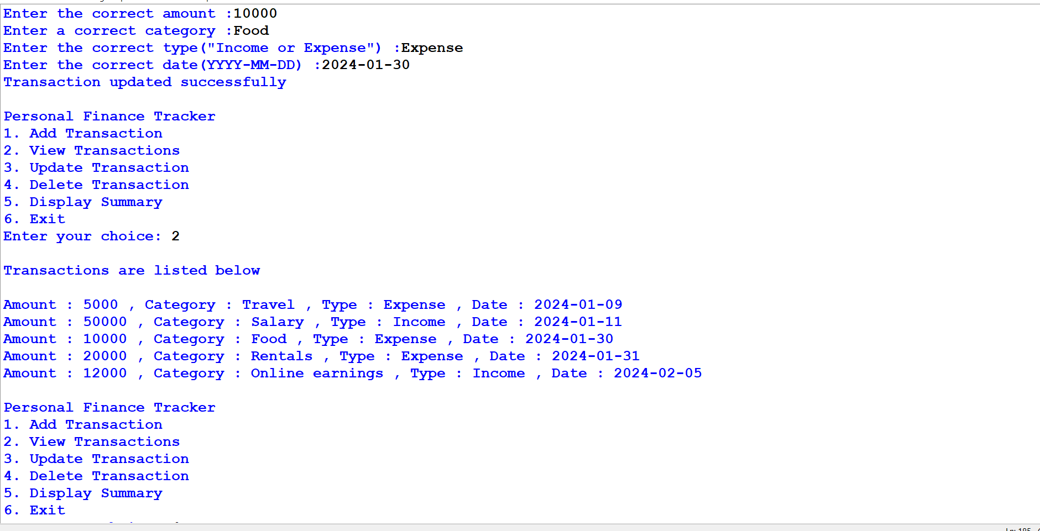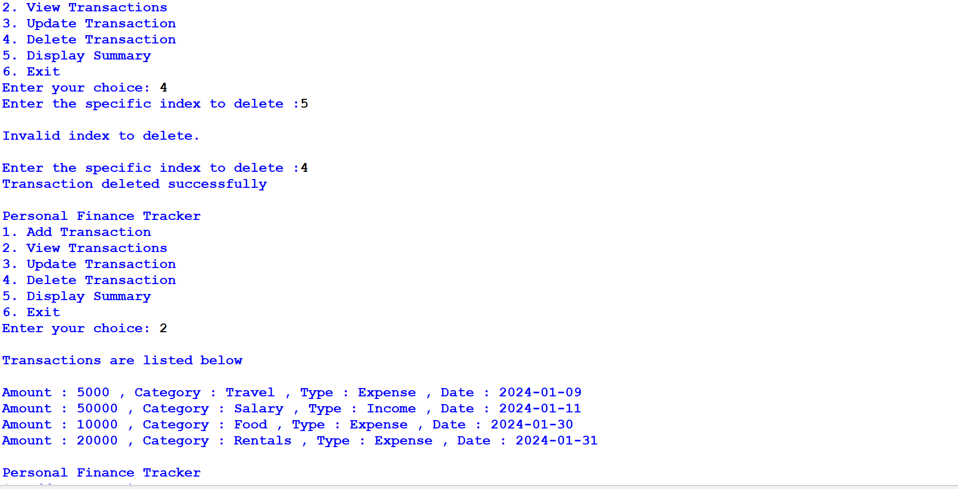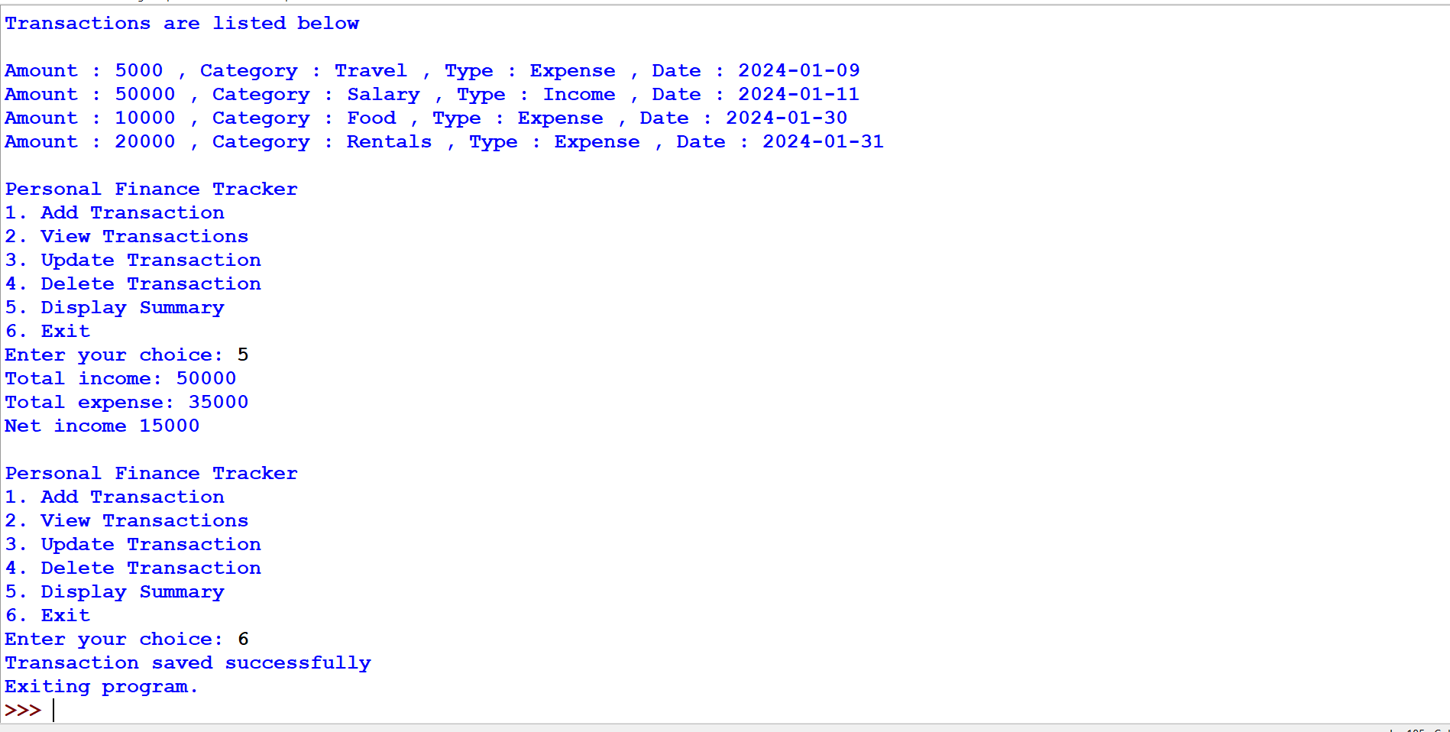

4.1 Text file Output