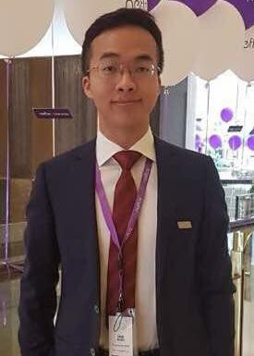

**01/Education**

Shengyi Zhang

*Hard work,*

*Self-driven, Enthusiasm*

**Basic information**

Age: 25

Birth: 1994/11/02

Nationality: China

University: USTC

Education: 2011/7-2015/6

Bachelor of Science

# Contact

Mobile: +86-17376560156

Mail: gggshaw007@gmail.com

Wechat: Syzhang7

# Professional Skills

Python web crawler/pandas

JavaScript Vue.js/React

MySQL/Excel

HTTP 5/CSS 3

# Career objective

Data Scientist

**2011/7—2015/6**

**University of Science and Technology of China**

# Geophysics, Bachelor of Science

* Curriculum GPA: 3.57/4.3, ranked 16th out of 85
* Bronze Prize for excellent students for three consecutive years.
* Math and Computer Science courses took:
* Calculus; Linear Algebra; Introduction to Tensor Analysis;
* Stochastic Processes; Probability and Statistics;
* Introduction to Computer Science; Computer Programs Design;
* Computational Methods; Data Structures and Database;

**02/Internship Experience**

Algorithm intern in Anhui Geological Exploration Company in 2016.

* Applied geophysical algorithms to an engineering software.

**03/Work Experience**

**TPLINK MEA FZE—2015/7-2017/7**

**Product Manager (Dubai）**

* Utilized Python to manipulate and clean sales data.
* Created a visual analysis tool for sales tracking.
* Was voted as the best and most popular employee out of 20.

**HIKVISION MEA—2017/8-2018/6**

**Product Manager (Turkey & Pakistan & Iraq)**

* Used a web crawler to collect information, generated reports
* Made proper strategies based on data, touched $0.8M sales in Q1.

**04/Side Projects**

1. Built an online navigation system and a mobile canvas tool for my little brother.
2. Used web spiders to collect information about popular movies and collected data from recruitment websites.
3. Created an online study note system by Django.

For details, visit: **http://syizhang.com/Front-end/Resume/**

**05/Courses took online**

1. Operating System by Ravindrababu Ravula from YouTube
2. Algorithms, Machine Learning by HsuanTienLin, Deep Learning for Business; Applied AI with Deep Learning from Coursera.