Dr. Carolina Aguirre de Martínez
The vision behind the most exclusive smiles in Mexico and the world


Professional Profile
With more than 30 years of experience in aesthetic dentistry and modern oral rehabilitation, Dr. Carolina Aguirre de Martínez has become one of the most influential and visionary figures in smile design worldwide. From Puerto Cancún, the epicenter of luxury in Latin America, she introduced in Mexico a groundbreaking technique: veneers without grinding, without pain, and without anesthesia, achieving a complete smile transformation in just three hours.

International Experience & Background
• Founder and Director of a high-aesthetics dental clinic in Puerto Cancún.
• Dentist, Fundación Universitaria San Martín (Colombia).
• Specialization in Modern Oral Rehabilitation, Pontificia Universidad Javeriana (Colombia).
• Trainer of dentists across Mexico and Latin America, with specialized courses and international conferences.
• Strategic adviser to business leaders, investors, and government figures in Mexico and abroad.
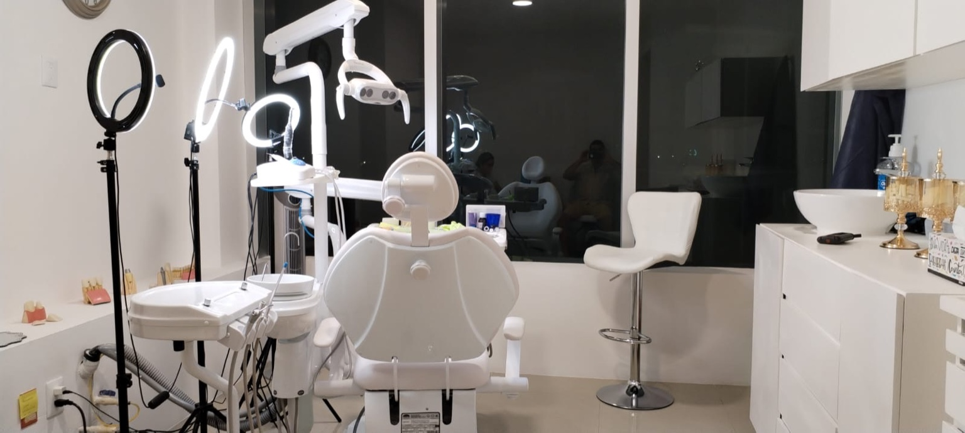

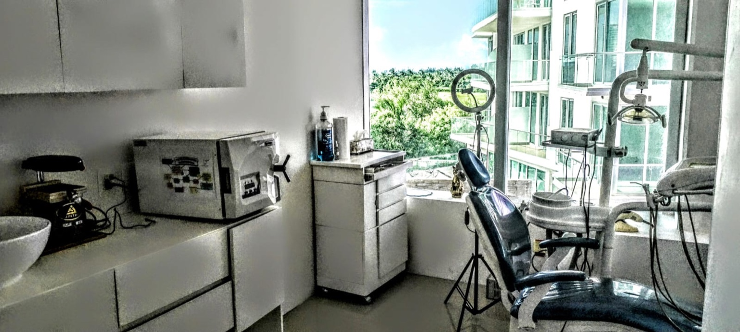

International Patients & Prestige Figures
International celebrities, high-level entrepreneurs, and government officials from the Americas, Europe, and the Middle East trust Dr. Carolina Aguirre. Her patients come from Israel, France, Italy, Spain, the United Kingdom, the United States, Canada, and multiple states across Mexico.
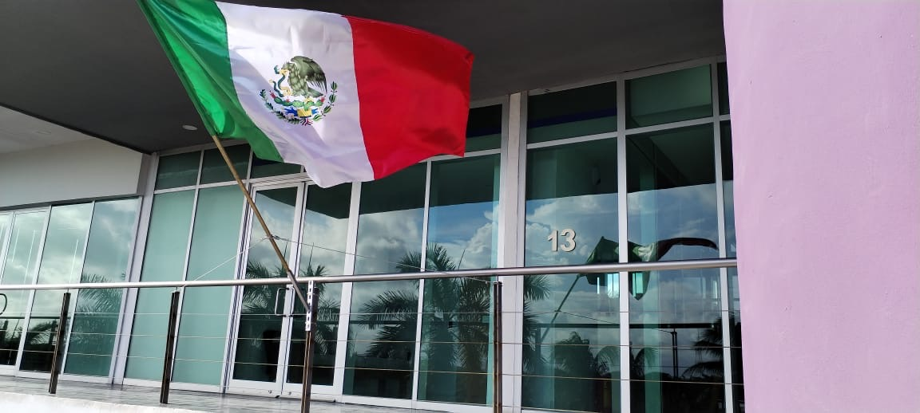

Recognitions & Professional Contributions
✔ Pioneer in the no-grinding, painless, anesthesia-free veneer technique.
✔ Over 30 years of experience in aesthetic dentistry and modern oral rehabilitation.
✔ Creator of innovative trends in smile design.
✔ Visionary leader integrating aesthetic dentistry with wellness, luxury, and lifestyle.
“To transform smiles and lives through aesthetic excellence, innovation, and professional training, inspiring new generations of dentists to reach the highest international standards.”

VIP Contact
WhatsApp: +52 984 114 5997
Email: drcarolinaaguirre@gmail.com
Location: Puerto Cancún · Quintana Roo · Mexico
Scan the QR to book your VIP appointment:


