BCSE308L – Course Project

Agent-Aware Networking: In-Network Classification and Differentiated QoS for AI-Agent Traffic on a P4 Programmable Data Plane

Submitted in partial fulfillment of the requirements for the Course in

Bachelor of Technology

in

Computer Science and Engineering with Specialization in Data Science

by

24BDS0390 | SHASHANK BHAT M
24BDS0406 | ANANYA GANESAN
24BDS0419 | JOBIN JOHN

Under the Supervision of
DR.YOGANAND S.
Assistant Professor Senior Grade-2
Centre for Artificial Intelligence and Research (CFAIR)

October 2026

DECLARATION

We hereby declare that the project entitled “Agent-Aware Networking: In-Network Classification and Differentiated QoS for AI-Agent Traffic on a P4 Programmable Data Plane” submitted by us, for the award of the course BCSE308L in Computer Science and Engineering to VIT is a record of bonafide work carried out by us under the supervision of Dr. Yoganand S.
We further declare that the work reported in this project has not been submitted and will not be submitted, either in part or in full, for the award of any other courses in this institute or any other institute or university.

Place : Vellore Date :
Signature of the Candidates

SHASHANK BHAT M (24BDS0390)
ANANYA GANESAN (24BDS0406)
JOBIN JOHN (24BDS0419)

CERTIFICATE

This is to certify that the project entitled “Agent-Aware Networking: In-Network Classification and Differentiated QoS for AI-Agent Traffic on a P4 Programmable Data Plane” submitted by SHASHANK BHAT M (24BDS0390), ANANYA GANESAN (24BDS0406) and JOBIN JOHN (24BDS0419), School of Computer Science and Engineering, VIT, for the course BCSE308L – Computer Networks, in partial fulfilment of the requirements of the Bachelor of Technology in Computer Science and Engineering with Specialization in Data Science, is a record of bonafide work carried out by them under my supervision during Fall Semester 2026-2027, as per the VIT code of academic and research ethics.

The contents of this report have not been submitted and will not be submitted either in part or in full, for the award of any other courses in this institute or any other institute or university. The project fulfills the requirements and regulations of the University and in my opinion meets the necessary standards for submission.

Place : Vellore
Date :

Signature of the Guide

Examiner(s)

ACKNOWLEDGEMENTS

We are deeply grateful to the management of Vellore Institute of Technology (VIT) for providing us with the opportunity and resources to undertake this project. The institution's commitment to a conducive learning environment, and the computing infrastructure it provides, enabled us to take a research idea from a proposal to a working programmable-switch prototype.

Our thanks to Dr. Jaisankar N, the Dean of the School of Computer Science and Engineering (SCOPE), for unwavering support and encouragement. The Dean's leadership and vision, and the school's emphasis on academic excellence and innovation, have been a constant source of motivation for us.

We express our profound appreciation to Sendhil Kumar K S, the Head of the Department for insightful guidance and continuous support. The department's collaborative and supportive atmosphere, and its constructive feedback at each review, have been invaluable in shaping the direction of this project.

We are immensely thankful to our project guide, Dr. Yoganand S, Assistant Professor Senior Grade-2, Centre for Artificial Intelligence and Research (CFAIR), for dedicated mentorship and invaluable feedback throughout the BCSE308L Computer Networks course. The questions raised at every review about our design choices and our evidence pushed us to tie each claim in this report to a measured result, and that guidance has enriched our overall academic experience.

Thank you all for your contributions and support.

SHASHANK BHAT M ANANYA GANESAN JOBIN JOHN

TABLE OF CONTENTS

Sl.No | Contents | Page No.
 | Abstract | xi
1. | INTRODUCTION | 1
 | 1.1 Background | 1
 | 1.2 Motivations | 1
 | 1.3 Scope of the Project | 2
2. | PROJECT DESCRIPTION AND GOALS | 4
 | 2.1 Literature Review | 4
 | 2.2 Research Gap | 5
 | 2.3 Objectives | 6
 | 2.4 Problem Statement | 6
 | 2.5 Project Plan | 6
3. | TECHNICAL SPECIFICATION | 8
 | 3.1 Requirements | 8
 | 3.2 Feasibility Study | 9
 | 3.3 System Specification | 10
 | 3.3.1 Hardware Specification | 10
 | 3.3.2 Software Specification | 10
4. | DESIGN APPROACH AND DETAILS | 11
 | 4.1 System Architecture | 11
 | 4.2 Data-Plane Pipeline | 12
 | 4.3 Feature Arithmetic | 13
 | 4.4 Classifier Compilation | 14
 | 4.5 QoS Treatments and Human Protection | 14
 | 4.6 Control Plane | 15
 | 4.7 Frozen Contracts and Race Conditions | 16
5. | METHODOLOGY AND TESTING | 18
 | 5.1 Module Description | 18
 | 5.2 Testing | 19
6. | PROJECT DEMONSTRATION | 21
 | 6.1 One-Command Offline Pipeline | 21
 | 6.2 Live BMv2 Packet Run | 21
 | 6.3 Live Dashboard | 22
 | 6.4 Running the Mininet Evaluation | 22
7. | RESULT AND DISCUSSION | 23
 | 7.1 Compiled Data-Plane Resources | 23
 | 7.2 Live Switch Verification | 24
 | 7.3 Classifier Accuracy on the Synthetic Corpus | 24
 | 7.4 Per-Profile Analysis | 25
 | 7.5 Effect of the Fan-Out Extraction Fix | 25
 | 7.6 Browser-Agent Diagnosis | 26
 | 7.7 Feature Importance | 27
 | 7.8 Discussion and Threats to Validity | 28
 | 7.9 Pending Evaluation | 28
8. | CONCLUSION | 30
 | 8.1 Future Work | 30
9. | REFERENCES | 31
 | APPENDIX A – SAMPLE CODE | 32

List of Figures

Figure No. | Title | Page No.
2.1 | Project phases over the fifteen-week course and their current status | 7
4.1 | Three-layer architecture of Agent-Aware Networking and the per-packet data-plane pipeline | 11
4.2 | The choke_v1 Mininet evaluation topology | 12
6.1 | Live BMv2 packet run: forwarding, CPU clone and register state after one ClientHello | 21
7.1 | Register memory by array in the compiled agent_aware program | 23
7.2 | Held-out recall per class at the 6, 16 and 64 packet checkpoints | 24
7.3 | Held-out predictions by generating profile, all checkpoints, row-normalised | 25
7.4 | Session-grouped recall for feature ablations and a higher-capacity forest | 27
7.5 | Gini feature importance of the depth-8 tree | 28

List of Tables

Table No. Title Page No.
2.1 Comparison with related approaches 5
2.2 Integration milestones and status 7
3.1 Functional requirements and implementation status 8
3.2 Non-functional requirements and targets 9
3.3 Principal project risks and mitigations 10
3.4 Hardware specification 10
3.5 Software specification 10
4.1 Frozen feature vector 13
4.2 Per-class QoS treatments 15
4.3 Meter presets as a share of the bottleneck link 15
4.4 Frozen P4 ↔ controller interface 16
4.5 Race conditions and edge cases with design answers 17
5.1 Project modules and ownership 18
5.2 Test levels and tools 20
6.1 Decoded CPU header of the punted ClientHello 22
6.2 Live verification checks 22
7.1 Resources of the compiled agent_aware program 23
7.2 Held-out precision / recall per class and checkpoint 24
7.3 Held-out recall per workload profile 25
7.4 Previous versus corrected model 26
7.5 Session- and flow-grouped cross-validation 26
7.6 Pending measurements and their plan 29

List of Abbreviations

A2A Agent-to-Agent protocol
AF Assured Forwarding (DSCP class)
ALPN Application-Layer Protocol Negotiation
API Application Programming Interface
BMv2 Behavioral Model version 2 (P4 software switch)
CDN Content Delivery Network
CI Continuous Integration / Confidence Interval
CIR Committed Information Rate
CM Count-Min (sketch)
CPU Central Processing Unit (controller port)
CS Class Selector (DSCP class)
CV Cross-Validation
DRR Deficit Round Robin
DSCP Differentiated Services Code Point
ECN Explicit Congestion Notification
EWMA Exponentially Weighted Moving Average
FIFO First In, First Out
FR Functional Requirement
HTB Hierarchical Token Bucket
IAT Inter-Arrival Time
JA4 TLS ClientHello fingerprint (JA4+ family)
MCP Model Context Protocol
ML Machine Learning
NFR Non-Functional Requirement
P4 Programming Protocol-independent Packet Processors
PIR Peak Information Rate
PTF Packet Test Framework
QoS Quality of Service
RMW Read-Modify-Write
SDN Software-Defined Networking
SNI Server Name Indication
TCP Transmission Control Protocol
TLS Transport Layer Security
UDP User Datagram Protocol
WAF Web Application Firewall

Symbols and Notations

Δ Inter-arrival gap of a flow, in microseconds
μ IAT EWMA mean (iat_ewma_us)
σ IAT EWMA mean absolute deviation (iat_var_ewma)
α EWMA weight, 1/8 (shift of 3 bits)
>> Logical right shift (division by a power of two)
θ Decision-tree split threshold
b(θ) Largest integer k with float32(k) ≤ θ
C[r][j] Count-min sketch counter, row r, column j
h_r Hash function of sketch row r
N Number of flow slots (65,536)
K Consecutive agreeing sweeps before an override (3)
Q_hi, Q_lo Congestion set / clear thresholds (64 / 16 packets)

ABSTRACT

More than half of today's internet traffic is generated by automated clients, and AI agents (language-model programs that browse the web, call tools over the Model Context Protocol (MCP) and fan out parallel requests) have become a third traffic category alongside humans and classic bots. Inside the network these agents are invisible. Their packets are TLS on port 443, so a switch queues fifty machine-paced tool calls together with a person's video call, and the human's tail latency absorbs the burst. Bot detection today runs at the HTTP/CDN edge and can only allow or block, while DiffServ marks traffic by port and application rather than by who generated it.
This project, Agent-Aware Networking, builds a programmable switch that recognises AI-agent traffic per packet inside the forwarding pipeline and, in the same pass, gives it a differentiated transport treatment. A P4_16 program for the BMv2 software switch parses Ethernet, IPv4, TCP, UDP and a bounded TLS ClientHello. It keeps per-flow timing, size and byte-ratio state in 65,536 register slots and a two-epoch count-min sketch of per-source fan-out. Each packet is classified as HUMAN, AGENT_INTERACTIVE, AGENT_BULK or UNKNOWN by a depth-8 decision tree compiled into eight range-match tables, and the class selects a DSCP marking, a strict-priority queue, an ECN threshold and a two-rate meter. A data-plane human-protection mode tightens the agent meters under congestion without a controller round trip. A Python SDN controller pushes versioned, idempotent policy, receives rate-limited first-packet punts for JA4 fingerprinting and refines labels through a hysteresis-guarded reclassification sweep. The design is fail-open: uncertainty lowers a flow's service class and never blocks it.
All three P4 programs compile with p4c; the full pipeline uses 33 tables and about 3.45 MiB of register state. A live BMv2 run verified byte-exact forwarding, the CPU punt header, TLS metadata extraction (four extensions, ALPN h2), the fan-out sketch and a controller override that re-marked the flow to DSCP 34. On a seeded synthetic corpus of 4,094 flows, the compiled switch tables agreed with the trained tree on all 2,283 held-out rows, and cross-validated macro-F1 was 0.805 ± 0.015. Tool-calling (MCP) agents were recognised with 98.1% recall and bulk agents with 99–100%, but browser-driven agents were read as human in 74.9% of cases; a session-grouped diagnosis shows that per-flow features cannot separate them. The four-baseline Mininet evaluation of human tail latency (target: at least 30% lower p99 at under 5% added per-packet latency) is fully scripted and awaits the Linux testbed run. The host test suite passes 479 tests.
Keywords: P4, programmable data plane, in-network machine learning, AI agents, Model Context Protocol, quality of service, DiffServ, decision tree, SDN.

CHAPTER 1

INTRODUCTION

1.1 Background
A network switch has two halves. The control plane is the software that decides how traffic should be handled: it runs routing protocols, talks to an SDN controller and writes forwarding tables on a timescale of milliseconds to seconds. The data plane, or forwarding plane, is the pipeline every packet physically traverses: headers are parsed, looked up in match-action tables, rewritten and placed in an output queue, all within nanoseconds to microseconds. For most of the internet's history the data plane was fixed silicon whose behaviour could only be configured, not programmed.
Programmable data planes changed this. The P4 language [1] describes a switch's parser, match-action stages and deparser in a target-independent way, and the same program can run on a hardware ASIC or on the BMv2 behavioural-model software switch [22]. Within the pipeline a P4 program can keep state in register arrays, count and rate-limit traffic with meters, compute hashes and clone packets to a controller. These primitives are enough to compute simple per-flow statistics at line rate, and a line of research has shown that trained classifiers such as decision trees can be mapped onto match-action tables so that inference happens inside the switch itself [2]–[6].
Quality of Service (QoS) machinery is older. Differentiated Services (DiffServ) [8], [9] carries a six-bit Differentiated Services Code Point (DSCP) in the IPv4 header that selects a per-hop behaviour, such as a priority queue or a scheduler weight. Explicit Congestion Notification (ECN) [10] lets a queue mark packets instead of dropping them, so senders slow down before loss occurs. These mechanisms work well when the network knows which traffic deserves which treatment, which in practice means classifying by port number, application signature or a marking set by the end host.
AI agents break that assumption. An agent is a program, usually driven by a large language model, that acts on a user's behalf: it browses web pages through a real browser, calls tools exposed over the Model Context Protocol (MCP) [20], or talks to other agents. Its traffic is TLS 1.3 [11] on port 443, the same as a person's. The ClientHello that opens a TLS connection is still sent in plaintext, and fingerprints of it such as JA4 [14] can distinguish a Python HTTP stack from a browser. An agent that drives Chromium, however, presents exactly the fingerprint a human's Chromium does. What remains different is behaviour: machine-paced timing, synchronised fan-out of parallel requests and the shape of structured request/response exchanges.
This project combines these threads. It asks whether a programmable switch can compute behavioural features of each flow at line rate, decide whether the traffic is generated by a human or by an agent, and use that decision immediately to choose the packet's queue, marking and rate limit, all in a single pass through the pipeline.

1.2 Motivations
The traffic mix of the internet has changed structurally. The 2026 Imperva Bad Bot Report [13] finds that 53% of internet traffic is automated: 40% from malicious bots and 13% from benign automation, with human traffic down to 47%. The same report identifies AI agents as a new category alongside traditional good and bad bots: they interact directly with applications and APIs, run real browsers with valid fingerprints and imitate human interaction patterns, and AI-driven bot attacks grew 12.5 times in 2025, from about 2 million to 25 million blocked attacks per day. That figure measures attacks, not all agent traffic, but it shows how quickly automated, machine-paced load is growing.
The concrete networking harm is queueing. Consider an agent that fires fifty parallel MCP tool calls across the same access link that carries a person's video call. Every switch on the path sees fifty-one TLS flows to port 443 and places them in the same queue. The agent's requests arrive in a synchronised burst; the human's packets wait behind it, and that waiting time is the 99th-percentile latency spike the person experiences as a frozen frame. The network cannot protect traffic that it cannot distinguish.
Existing tools do not close this gap. Commercial agent and bot detection operates at the HTTP or CDN edge: it terminates TLS, sees only the traffic routed through it, reacts on request timescales and offers allow, block or rate-limit verdicts. Cooperative schemes such as HTTP Message Signatures [12], which underpin signed-agent proposals, require the agent to identify itself and are visible only where TLS is terminated. DiffServ, on the other hand, can act at line rate but only on information it can see in headers, and nothing in an agent's headers says agent.
A switch-resident classifier coupled to QoS has a useful deployment property: it needs no new protocol, no cooperation from end hosts and no internet-wide adoption. One device at a choke point, such as a campus gateway, an enterprise edge or the switch in front of an API or model-serving cluster, protects its own domain as soon as it is installed. Because the action is a service class rather than a verdict, a misclassification degrades a flow's priority instead of blocking it, which makes the system safe to deploy even while its classifier is imperfect.

1.3 Scope of the Project
The project delivers a working prototype on the BMv2 software switch in a Mininet emulation, an offline machine-learning pipeline that produces the switch's classifier, an SDN controller that installs and refines policy, a traffic and evaluation harness for a four-baseline comparison, and this report together with an IEEE-format paper. The following are in scope:
- Per-packet parsing of Ethernet, IPv4, TCP and UDP, plus shallow, bounded parsing of a TLS ClientHello on a flow's first payload packet.
- Per-flow behavioural features computed in data-plane registers with fixed-point arithmetic, and a count-min sketch of new flows per source.
- A depth-limited decision tree, trained offline and compiled mechanically to range-match tables, producing one of four two-bit class labels.
- Per-class DSCP rewrite, priority queue, ECN threshold and metering, with a congestion-triggered human-protection preset.
- A controller for policy installation, first-packet punts with JA4 fingerprinting, and periodic reclassification and state aging.
- A Mininet evaluation topology (choke_v1), four baselines (FIFO, port-based DiffServ, fair queueing, application-layer rate limiter), metrics with confidence intervals, and a live dashboard.
Several things are explicitly out of scope. The system performs no blocking or security enforcement of any kind; it only assigns service classes. It runs on BMv2 emulation rather than Tofino hardware. It discriminates traffic classes, not individual agent products. It does not parse IPv6 or QUIC (UDP flows still receive timing and size features). DSCP markings are meaningful only within the deploying domain, because they are commonly bleached at administrative boundaries. Finally, the deployment model is a single box at a choke point, not an internet-scale architecture.
CHAPTER 2

PROJECT DESCRIPTION AND GOALS

2.1 Literature Review
The related work falls into three streams: detecting automated and agent traffic at the application layer, running machine-learning inference inside programmable switches, and coupling an in-network classification to a forwarding or scheduling action. The project sits at the intersection of the three.

2.1.1 Agent and Bot Detection at the Application Layer
TLS fingerprinting identifies the client software stack from fields that the ClientHello sends in clear text even under TLS 1.3 [11]: the offered cipher suites, extensions, supported groups and ALPN values. JA4 [14] is a widely deployed fingerprint family that normalises these fields into a stable string. It separates scripted clients built on Python, Go or Node libraries from browsers, but it cannot separate a human's Chromium from an agent that drives the same Chromium build, and Encrypted Client Hello will progressively hide parts of the handshake. Cooperative identification takes the opposite approach: the agent signs its requests with HTTP Message Signatures [12] so that a server or CDN can verify who it is. This is precise but works only for agents that opt in and only where TLS is terminated. Commercial bot-management products combine such signals with behavioural analytics at the edge, and their actions are allow, block, challenge or rate-limit.

2.1.2 In-Network Machine Learning
Xiong and Zilberman [2] showed with IIsy that common classifiers, including decision trees, can be mapped onto the match-action pipeline of a programmable switch, so that classification is a by-product of table lookups. pForest [3] extended the idea to random forests over flow-level features that are updated as packets arrive, switching models as a flow progresses. Mousika [4] distils a complex teacher model into a binary decision tree that fits in switch tables, and gives the per-level table encoding this project adopts. Planter [5] automates the mapping of several model families to P4 targets, and NetBeacon [6] uses multi-phase models over flow features computed in the data plane to classify traffic efficiently at line rate. Together these works establish that tree-based inference over integer flow features is practical in switch hardware, and they highlight the recurring difficulty that the switch must compute features with shifts and saturating integer arithmetic rather than floating point.

2.1.3 Coupling Classification to Action
Classical QoS provides the action vocabulary. DiffServ [8], [9] defines per-hop behaviours selected by DSCP; Deficit Round Robin [16] approximates fair queueing with O(1) work per packet; ECN [10] signals congestion without loss. ACC-Turbo [7] is the closest precedent for coupling an in-network classification to a scheduling action: it clusters traffic aggregates in the data plane and deprioritises suspicious clusters to mitigate pulse-wave DDoS attacks. Its trigger is attack aggregates, not agent identity. Count-min sketches [15] are the standard way to approximate per-key counts in bounded memory and are used here for per-source fan-out. Mininet [17] and scikit-learn [18] are the standard emulation and learning tools, and web-workload models such as SURGE [19] and traces such as MAWI [21] provide realistic human traffic. Table 2.1 summarises how the representative approaches compare with this project.
Table 2.1: Comparison with related approaches
Method / source | Approach | Limitation for this problem | How this project differs
JA4 fingerprinting [14] | Hash of plaintext ClientHello fields | Browser-driving agents look identical to humans; no QoS action | Uses TLS metadata as one tree input, not the anchor; adds timing and fan-out
HTTP Message Signatures [12] | Agent signs requests; edge verifies | Opt-in; visible only behind TLS termination | Works on any packet at the switch; signature check optional
Edge bot management | Behavioural analytics at CDN/WAF | Terminates TLS; allow/block only; request timescale | Per-packet in the forwarding path; service class, never block
IIsy [2], Mousika [4], Planter [5] | Classifiers mapped to switch tables | Generic application classes; no agent trigger | Agent/human classes keyed to QoS in the same pass
pForest [3], NetBeacon [6] | Flow-feature models in the data plane | Classification is the end product | Label drives DSCP, queue, ECN and meter immediately
ACC-Turbo [7] | In-network clustering + scheduling | Keyed on DDoS aggregates, not agent identity | Keyed on agent behaviour; fail-open service classes
DiffServ [8], [9] | DSCP per-hop behaviours | Classifies by port/application | Classifies by who generates the traffic

2.2 Research Gap
Each ingredient of the system exists in isolation. Agent fingerprinting exists at the application layer, in-network ML exists for generic traffic classes, and QoS queues are decades old. What does not exist is the coupling: a switch that recognises this is an AI-agent flow and, in the same pipeline pass, changes how the packet is serviced. The gap can be stated along four axes against which every design decision in the project was tested:
- Location. Classification happens in the forwarding plane, per packet, at line rate, without terminating TLS and for traffic beyond HTTP, rather than at the application edge.
- Action. The output is a transport treatment (queueing, scheduling, ECN and admission control), not access control. A wrong label lowers a service class; it never blocks.
- Trigger. The trigger is agent and MCP identity specifically, not generic application classes and not the prioritisation of GPU-cluster AI workloads.
- Features. Agent-specific behavioural fingerprints (machine pacing, fan-out, flow shape) are keyed directly to the QoS action in the same pipeline.
A second, empirical gap emerged during the project: published network-only agent attribution is far weaker than attribution that uses browser signals, and no public dataset contains labelled packet-level traffic from autonomous agents. Part of the contribution is therefore an honest characterisation of which agent behaviours are separable from per-flow, line-rate features and which are not (Section 7.6).

2.3 Objectives
- Classify every packet as HUMAN_INTERACTIVE, AGENT_INTERACTIVE, AGENT_BULK or UNKNOWN inside a P4 pipeline, using a decision tree of depth at most 8 compiled to switch tables.
- Apply the class's QoS treatment in the same pass: DSCP rewrite, strict-priority queue, per-class ECN threshold and two-rate meter.
- Protect human traffic under congestion through a data-plane human-protection mode with hysteresis, with no controller round trip in the reaction path.
- Guarantee fail-open behaviour: classification uncertainty or failure never blocks or drops human or interactive-agent traffic.
- Make the switch's classifier provably identical to the trained model through a bit-exact feature mirror and an automated equivalence gate.
- Build a reproducible evaluation that targets at least 30% lower human p99 latency than the best of four baselines at under 5% added per-packet latency.
- Characterise honestly which kinds of agent traffic are and are not separable with per-flow features.

2.4 Problem Statement
Existing QoS machinery (DiffServ, port and application classification, endpoint-set DSCP) cannot recognise AI-agent traffic, because agents use real browsers, valid TLS fingerprints and standard ports. Existing agent detection (signed agents, edge bot management) operates only at the HTTP/CDN edge, terminates TLS, sees only the traffic routed through it, reacts on request timescales and offers only allow, block or rate-limit actions.
Problem. Design and implement a programmable-switch pipeline that, for every packet crossing a choke-point link, (i) computes behavioural flow features with integer, line-rate-computable arithmetic and bounded state, (ii) assigns a traffic class with an offline-trained classifier compiled into match-action tables, and (iii) applies a class-specific transport treatment in the same pipeline pass, such that human interactive traffic keeps low tail latency during agent bursts, interactive agents are not starved, and no packet is ever blocked because of classification uncertainty.

2.5 Project Plan
The project ran over a fifteen-week course in six phases: lock-in of scope and contracts (week 0), survey and environment set-up (weeks 1–2), design freeze (weeks 3–5), prototype construction (weeks 6–10), evaluation (weeks 11–13) and paper and demonstration (weeks 14–15). Fig. 2.1 shows the plan and the current state. Work was divided among three developers by subsystem (data plane, control plane and ML, harness and evaluation), coordinated through frozen interface contracts, twice-weekly integration syncs and one task ID per pull request.
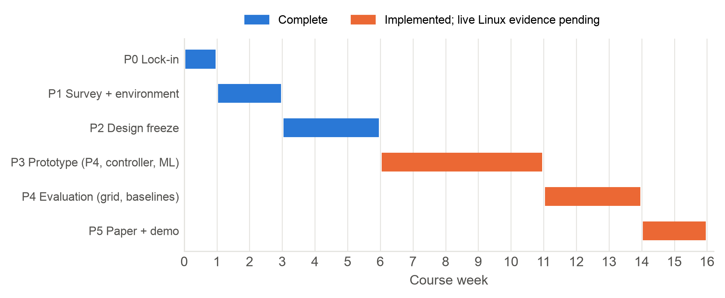
Fig. 2.1: Project phases over the fifteen-week course and their current status
Integration was organised around six milestones, listed in Table 2.2. Their status is reported against each milestone's definition of done; code that is complete and host-tested but has not yet run on the Linux Mininet testbed is reported as pending, not as done.
Table 2.2: Integration milestones and status
Milestone | Definition of done | Status (28 Oct 2026)
M1 Skeleton | l2fwd P4 + choke_v1 topology + one iperf3 flow end to end | l2fwd compiles; launcher built; BMv2 container run passed; Linux iperf3 run pending
M2 Features | Feature registers live; controller dumps them | Registers compiled and read live from BMv2 (proto_meta, sketch); tshark cross-check pending
M3 Corpus + tree | Labelled corpus; tree trained; equivalence gate green | Done on the synthetic corpus (2,283/2,283); real-agent corpus pending
M4 Classification | Tree tables in the pipeline; P/R measured on live replay | Tables compiled into agent_aware.p4; live replay P/R pending
M5 QoS | Action stage, queues, protection mode; centerpiece demo | Compiled; override to DSCP 34 verified live; queue experiment pending
M6 Baselines + grid | All four baselines runnable; full evaluation | Adapters and configs built; measured runs pending

CHAPTER 3

TECHNICAL SPECIFICATION

3.1 Requirements
Requirements were written as a short software requirements specification before implementation and frozen together with the interface contracts. Table 3.1 lists the functional requirements and how each is realised; Table 3.2 lists the non-functional targets. Status is stated against evidence in the repository.

3.1.1 Functional Requirements
Table 3.1: Functional requirements and implementation status
ID | Requirement | Realisation | Status
FR-1 | Parse Eth/IPv4/TCP/UDP; TLS ClientHello on first payload packet | parser.p4, bounded to 16 extensions | Verified live
FR-2 | Per-flow feature state in registers | features.p4, 65,536 slots | Verified live
FR-3 | Per-source fan-out via count-min sketch | 4 × 4,096, two epochs | Verified live
FR-4 | Classify into 4 labels with a compiled tree | tbl_tree_l0..l7 + override | Compiled; simulated 100%
FR-5 | Per-class DSCP, queue, ECN, meter | tbl_class_action, meters | Compiled; DSCP live
FR-6 | Human-protection mode with hysteresis | Egress flag 64/16, presets | Compiled
FR-7 | Rate-limited punts; JA4; Web Bot Auth | Clone session 1, M_PUNT, ja4.py | JA4 done; WBA pending
FR-8 | Entropy-shift reclassification, hysteresis | reclassifier.py, K = 3 | Host-tested
FR-9 | Safe flow-state aging | 5 s idle reclaim; override aging | Host-tested
FR-10 | Train depth ≤ 8 tree; compile to tables | train.py, compile_tree.py | Done
FR-11 | Agent/human traffic harness, labelled pcaps | MCP target, runners, replay | Built; captures pending
FR-12 | Evaluation grid, seeds, CIs | run_experiment.py, metrics.py | Built; runs pending
FR-13 | Live per-class dashboard | dashboard/ server + UI | Host-tested

3.1.2 Non-Functional Requirements
Table 3.2: Non-functional requirements and targets
ID | Target | How it is verified | Status
NFR-1 | ≥ 30% lower human p99 than best baseline under agent bursts | assert_anchor_targets over 5-seed grid | Pending live grid
NFR-2 | < 5% added per-packet latency | Full pipeline vs l2fwd on same host | Pending
NFR-3 | Agent-interactive not starved | Meter red → ECN only; completion times | Designed; pending
NFR-4 | Per-class precision/recall reported | Offline report; live replay | Offline done
NFR-5 | State scaling toward 100k flows | Collision counter; 1k→100k sweep | Pending
NFR-6 | Fail-open: never drop or block on uncertainty | Parser path, UNKNOWN default, tests | Met
NFR-7 | Reproducible: seeded, scripted, config-driven | Seeds, config hash, one command | Met
NFR-8 | No payload reassembly | Single-segment ClientHello only | Met

3.2 Feasibility Study

3.2.1 Technical Feasibility
Every feature the classifier consumes is computable with operations a switch supports: additions, comparisons, shifts by constants, hashes and register reads and writes. Division is replaced by shifts by the floor of a base-2 logarithm, and every accumulator saturates instead of wrapping. The tree has at most eight levels, so it maps to eight sequential range-match tables. The complete program was compiled with p4c for the BMv2 v1model target and exercised packet by packet in a live switch (Chapter 6), which establishes feasibility on the emulation target. Feasibility on Tofino-class hardware (stage counts, register memory per stage) is plausible from the resource numbers in Section 7.1 but is not claimed.

3.2.2 Economic Feasibility
The entire stack is open source: P4 compiler and BMv2, Mininet, Python and scikit-learn. Development runs on a laptop with Docker for the P4 compiler. The Linux evaluation host is a single cloud virtual machine (Ubuntu 22.04, 4 vCPU, 8 GiB RAM), whose cost for the planned runs is small. No switch hardware is purchased. In deployment, the approach adds no per-host software and no new protocol; it is a program for a switch that a site may already own.

3.2.3 Operational Feasibility
The system is a single box at a choke point and is incrementally deployable: it improves its own domain without cooperation from senders, receivers or other networks. The controller is optional for correctness. If it is down, the compiled tree still classifies every packet, and policy can be re-pushed idempotently at any time. Because the action is a service class, the worst outcome of a misclassification is the service a flow would have received without the system (best effort), never a block.
Table 3.3: Principal project risks and mitigations
Risk | Impact | Mitigation
No labelled agent traffic exists | Cannot train or evaluate | Seeded generator with real ClientHellos; real framework runners for capture
Train/serve skew (float vs integer) | Switch disagrees with model | Bit-exact Python mirror; 100% equivalence gate in CI
P4 cannot loop over TLS extensions | Parser blocks or overruns | Bounded parse (16 extensions); fail-open to UNKNOWN
BMv2 software timing jitter | Noisy latency results | 10–50 Mbps links; relative overhead vs l2fwd; pinned cores
Linux toolchain unavailable on macOS | No live evidence on laptop | Docker p4c and BMv2 container; EC2 Linux host

3.3 System Specification

3.3.1 Hardware Specification
Table 3.4: Hardware specification
Component | Specification | Purpose
Development host | Apple-silicon laptop, macOS, Docker | Coding, host tests, P4 compile in container
Linux evaluation host | AWS EC2, Ubuntu 22.04 x86_64, ≥ 4 vCPU, 8 GiB RAM, 40 GiB disk | Mininet + BMv2 runs
Emulated switch | BMv2 simple_switch, 3 priority queues, CPU port 255 | Data plane under test
Emulated links | Bottleneck 20 Mbps (10–50 configurable), 1 ms | Queueing dominates CPU artefacts
Future target | Tofino-class P4 switch ASIC | Out of scope (future work)

3.3.2 Software Specification
Table 3.5: Software specification
Layer | Software | Notes
Data plane | P4_16, v1model architecture | agent_aware.p4, l2fwd.p4, diffserv.p4
Compiler | p4c-bm2-ss (p4lang/p4c Docker image) | All three programs compile
Switch | BMv2 simple_switch | Built with priority queueing; --priority-queues 3
Emulation | Mininet | choke_v1 topology, owned launcher
Control plane | Python controller (Thrift CLI + AF_PACKET) | Python 3.9-compatible; Ryu design
ML | Python 3.11, scikit-learn, NumPy, pandas | Depth-8 DecisionTreeClassifier
Traffic | Scapy, iperf3, tcpreplay, MCP HTTP target | Agent runners, human replay
Baselines | Linux tc (HTB, netem, DRR), nginx | Fair queueing, app limiter
Measurement | tshark, pandas, matplotlib | Two-tap pcap latency joins
Quality | pytest, PTF, Ruff, GitHub Actions | Lint, tests, p4c, equivalence gate

CHAPTER 4

DESIGN APPROACH AND DETAILS

4.1 System Architecture
The system has three layers (Fig. 4.1). The data plane is a P4 program running on BMv2 that handles every packet: it parses headers, updates the flow's features, looks the feature vector up in the compiled tree tables and applies the class's treatment. The control plane is a Python SDN controller that installs policy, receives punted packets and refines classifications. The offline ML layer generates and labels traffic, extracts features with the switch's own arithmetic, trains the tree, compiles it into table entries and proves that the compiled tables reproduce the model exactly.
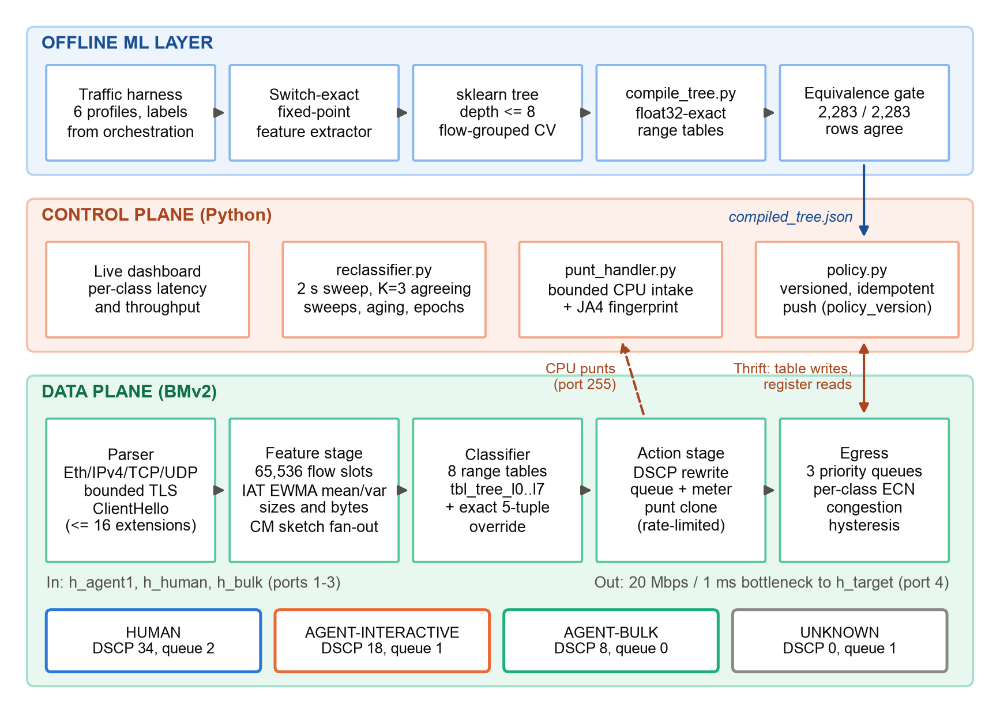
Fig. 4.1: Three-layer architecture of Agent-Aware Networking and the per-packet data-plane pipeline
The central design rule is that the per-packet decision never leaves the switch. The controller refines decisions, through exact-match overrides and reclassification, but the pipeline can always classify and act on its own. If the controller is down, the system degrades to the compiled tree; it never breaks. The congestion reaction is likewise local to the data plane: the egress stage sets a congestion flag and the ingress meters switch to the protective preset on the next packet.
Fig. 4.2 shows the evaluation topology, choke_v1. Three sender hosts (an agent host, a human host and a background bulk host) and a target host running an MCP server and web application attach to one BMv2 switch. The switch-to-target link is the bottleneck, 20 Mbps with 1 ms delay by default and configurable between 10 and 50 Mbps, so that queueing rather than the software switch's CPU dominates latency. The controller reaches the switch over Thrift on port 9090 and through CPU port 255.
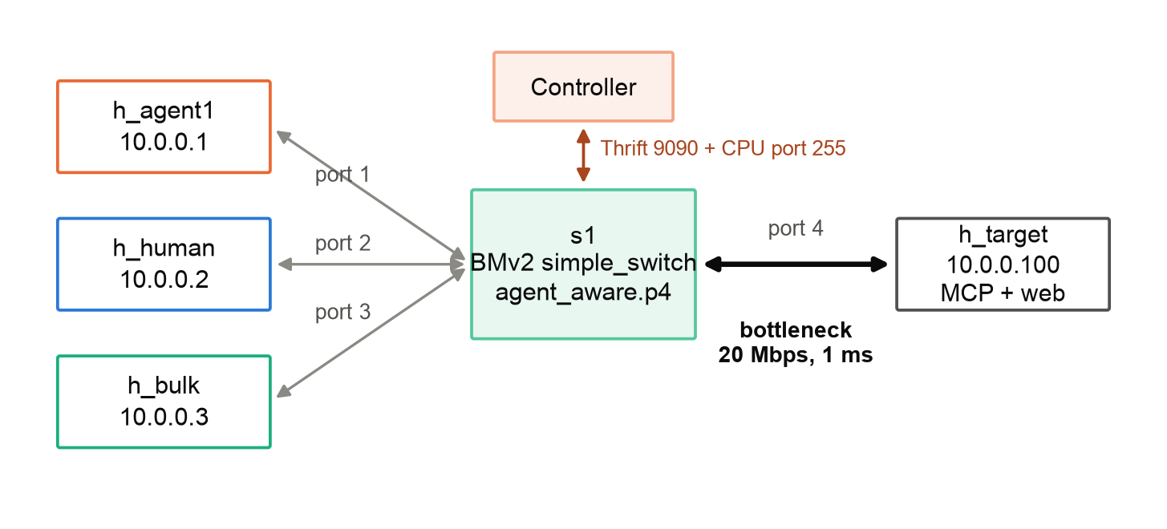
Fig. 4.2: The choke_v1 Mininet evaluation topology

4.2 Data-Plane Pipeline

4.2.1 Parser
The parser walks Ethernet, IPv4 and then TCP or UDP. If a TCP payload begins with a TLS handshake record (0x16 0x03) and this is the flow's first observed payload packet, it parses the ClientHello shallowly: it skips the variable-length session ID, cipher-suite and compression vectors by their declared lengths and visits at most sixteen extensions, recording the extension count and the class of the first ALPN protocol (none, HTTP/1.1, h2 or other). Every length is checked against the remaining bytes. P4 parsers cannot loop unboundedly, so the extension walk is unrolled; a list longer than the bound sets a truncation bit. Non-IPv4 frames, fragments with a non-zero offset, missing layer-4 headers and malformed ClientHellos all follow the documented fail-open path: the packet skips the feature stage, is classified UNKNOWN and is forwarded best-effort with no register writes.

4.2.2 Feature Stage
A canonical, direction-independent 5-tuple key is hashed twice with different salts. The first hash selects one of N = 65,536 flow slots; the second is an ownership tag. If the slot's stored tag differs from the packet's, there are two cases. When the slot has been idle for more than 5 s it is stale: every per-slot register is reset and the slot is claimed for the new flow, so no flow inherits another's state. Otherwise a live flow owns the slot: the packet is marked feature-invalid, the owner's state is left untouched, a collision counter is incremented and the packet is classified by an exact override if one exists, else UNKNOWN. For an owned slot the stage updates timing EWMAs, byte counters in each direction, the sizes of the first eight packets and, on a new-flow claim, the source's count-min sketch row counters. All read-modify-write sequences are wrapped in @atomic blocks.

4.2.3 Classifier Stage
During a warm-up of six packets the class is UNKNOWN unless an override exists. After warm-up the feature vector is evaluated by eight range-match tables, tbl_tree_l0 to tbl_tree_l7, one per tree level (Section 4.4). The resulting label is stored in reg_flow_class so that the controller can read it. An exact 5-tuple match in tbl_flow_override, installed by the controller, always takes precedence over the tree; this is the reclassification hook.

4.2.4 Action and Egress Stages
tbl_class_action maps the label to a DSCP value, a queue priority and a meter index. Agent classes are metered by two-rate meters; a red result marks ECN Congestion Experienced on ECN-capable packets, and only AGENT_BULK packets may be dropped on red. HUMAN and AGENT_INTERACTIVE packets are never dropped by a meter. The first packet of a newly claimed flow with a parsed ClientHello, or a packet landing in a low-confidence leaf, is cloned to the CPU port through tbl_punt_filter and a global punt meter. In egress, the dequeue depth drives a congestion flag with hysteresis: it is set at 64 packets and cleared at 16, so the flag cannot flap at a single threshold. While the flag is set, per-class ECN thresholds apply and the agent meters use the protective preset.

4.3 Feature Arithmetic
The classifier consumes ten features in a frozen order (Table 4.1). They come from four feature families: inter-packet timing, burst and fan-out structure, packet size and flow shape, and TLS handshake metadata. Everything is unsigned, fixed-point and saturating, and every division is a shift.
Table 4.1: Frozen feature vector
# | Feature | Bits | Definition | Family
0 | iat_ewma_us | 32 | EWMA of inter-arrival gap, μs (Eq. 4.3) | Timing
1 | iat_var_ewma | 32 | EWMA of |Δ − μ| (Eq. 4.4) | Timing
2 | pkt_count | 32 | Packets seen in the flow | Shape
3 | mean_pkt_size_up | 16 | Upstream bytes >> floor(log2 count) | Size
4 | updown_ratio_x100 | 16 | 100·up >> floor(log2 down) | Shape
5 | first8_size_bucket | 8 | Bitmask: first 8 packets ≥ 128 B | Size
6 | fanout_new_flows | 16 | Sketch min: new flows/source, epoch | Burst
7 | tls_ext_count | 8 | ClientHello extensions (≤ 16) | TLS
8 | tls_alpn_class | 8 | First ALPN: none/h1/h2/other | TLS
9 | flow_age_ms | 32 | (now − first_ts) >> 10 | Shape

The slot and tag are computed from the canonical key k with two salts, and the timing gap is clamped before it is narrowed to 32 bits:
slot = CRC32(k ‖ 0) mod N, tag = CRC32(k ‖ 1) (4.1)
Δ = min((t_now − t_last) mod 2^48, 2^32 − 1) (4.2)
The mean and the mean absolute deviation of the gap are exponentially weighted with α = 1/8, implemented as a right shift by three bits. The deviation is taken against the pre-update mean, so each register is read once per packet:
μ ← μ + ((Δ − μ) >> 3) (4.3)
σ ← σ + ((|Δ − μ| − σ) >> 3) (4.4)
The first packet of a flow and same-timestamp bursts (Δ = 0) skip the update. Size and ratio features replace division by a shift by the floor of the base-2 logarithm of the denominator, and flow age is expressed in 1.024 ms units:
mean_pkt_size_up = bytes_up >> ⌊log2(pkt_count)⌋ (4.5)
updown_ratio_x100 = (100 · bytes_up) >> ⌊log2(bytes_down)⌋ (4.6)
flow_age_ms = (t_now − t_first) >> 10 (4.7)
Fan-out counts new flows per source in a count-min sketch [15] of four rows of 4,096 16-bit counters. Two sketches alternate as epochs; the controller flips the active epoch every second and clears the retired one only after the flip settles, so a packet racing the flip reads data at most one epoch stale:
fanout(src) = min over r = 0..3 of C_e[r][h_r(src)] (4.8)
A Python reference, common/feature_math.py, implements the same arithmetic bit for bit, including the subtle difference that P4 shifts a magnitude and then applies the sign (truncation toward zero) whereas Python's shift of a negative number floors. The offline extractor runs every training packet through this mirror, so the model is trained on exactly the values the switch will compute.

4.4 Classifier Compilation
The decision tree is trained with scikit-learn [18], limited to depth 8 and class-weighted, and compiled with the per-level encoding of Mousika and IIsy [2], [4]. Each tree level becomes one table (level 0 is tbl_tree_l0, level 7 is tbl_tree_l7) whose key is the current node identifier plus all ten features, each matched as a range. Each internal node contributes two entries, one per child, whose ranges encode the accumulated constraints on the path; the action is either tree_next (set the next node identifier) or tree_leaf (set the class). Levels 0 to 7 hold at most 2, 4, 8, …, 256 entries, so the eight tables have a combined capacity of 510 entries.
A subtle source of train/serve skew was found and fixed. scikit-learn casts inputs to 32-bit floats before comparing them with a 64-bit threshold θ. Above 2^24, consecutive integers are no longer representable in float32, so the switch boundary that reproduces the model is not floor(θ). The compiler emits instead
b(θ) = max{ k ∈ ℤ : float32(k) ≤ θ } (4.9)
which, for example, yields 16,777,217 where the floor gives 16,777,216. Two further checks run at training time. A path-coverage check asserts that every root-to-leaf path tests at least one timing or burst feature, so no leaf is reachable on the up/down byte ratio alone (which degrades when only one direction crosses the switch). Leaves whose class purity is below 0.85 are marked low-confidence and trigger a punt with reason 2 instead of a hard label. Finally, verify_equivalence.py simulates the BMv2 range tables in Python and requires 100% label agreement with the sklearn tree on the held-out set; this gate runs in CI.

4.5 QoS Treatments and Human Protection
Table 4.2 gives the frozen treatment of each class. HUMAN_INTERACTIVE receives the highest strict priority and the AF41 code point. AGENT_INTERACTIVE, latency-sensitive tool calls, receives good but bounded service: the middle queue and a meter. AGENT_BULK, crawling and batch transfers, receives the lowest queue, the tightest ECN threshold and the only meter that may drop. UNKNOWN, including every packet on the fail-open path, receives best-effort DSCP 0 in the middle queue, which is exactly the service the packet would get without the system.
Table 4.2: Per-class QoS treatments (frozen contract)
Class (2-bit) | DSCP | Queue priority | Meter | ECN threshold | Drop on red
0 UNKNOWN | 0 (best effort) | 1 | none | none | never
1 HUMAN_INTERACTIVE | 34 (AF41) | 2 (highest) | none | 48 packets | never
2 AGENT_INTERACTIVE | 18 (AF21) | 1 | M_AI | 24 packets | never (ECN mark)
3 AGENT_BULK | 8 (CS1) | 0 (lowest) | M_AB | 8 packets | yes

The meters are two-rate meters whose committed and peak rates are expressed as percentages of the bottleneck link and scaled by the controller when it pushes policy (Table 4.3). Both presets are installed at start-up; the data-plane congestion flag selects between them, so the protective reaction needs no controller round trip. Punts are limited separately to 100 packets per second with a burst of 20, which protects the controller from a punt storm.
Table 4.3: Meter presets as a share of the bottleneck link (burst 15,000 B)
Preset | M_AI CIR | M_AI PIR | M_AB CIR | M_AB PIR | Selected when
Normal | 50% | 80% | 30% | 60% | Congestion flag clear
Protective | 20% | 25% | 10% | 15% | Queue depth ≥ 64 until ≤ 16

4.6 Control Plane
Policy push. On start-up the controller reads the policy_version register. It then clears and refills every table it owns (class actions, meter presets, punt filter and tree entries from compiled_tree.json) and writes the new version last. A push interrupted by a crash therefore leaves the old version in place and the next start re-pushes over it; restarts are safe at any time. BMv2 CLI sessions are batched and serialised by a lock, and any rejection reported by BMv2 is detected and raised.
Punt handler. Cloned packets arrive with an 8-byte CPU header (flow hash, class, reason, ingress port, padding). Intake is bounded, and each frame is validated before use. For first-packet punts the handler computes the full JA4 fingerprint of the ClientHello, with GREASE values removed; when the fingerprint strongly indicates a non-browser stack it can install an exact override toward AGENT_INTERACTIVE. Punts are refinements: losing one loses refinement, never correctness.
Reclassifier. Every two seconds the controller bulk-reads the class, timing, packet count and timestamp register arrays (one Thrift read per array, never per slot), recomputes each active flow's label with the same compiled tree and compares it with the current class. An override is installed only after K = 3 consecutive agreeing sweeps, which prevents class flapping near a threshold. Because the sweep reads registers while the data plane writes them, it re-reads packet counts and skips slots whose count moved too far during the read (a torn snapshot). The same loop validates slot ownership, forgets state when a slot is reused, ages out idle overrides and flips the sketch epoch every second. The controller is implemented as a standalone Python daemon that speaks the BMv2 Thrift CLI and reads CPU frames over AF_PACKET; it follows the Ryu-style SDN design and keeps controller code Python 3.9-compatible.
Table 4.4: Frozen P4 ↔ controller interface
Object | Kind | Role
tbl_tree_l0 … tbl_tree_l7 | Range tables | Compiled decision tree, one table per level
tbl_flow_override | Exact 5-tuple table | Controller refinement; wins over the tree
tbl_class_action | Exact table | Class → DSCP, queue priority, meter
tbl_punt_filter | Table | Punt eligibility, rate-limited by M_PUNT
reg_flow_key / reg_flow_class | Registers | Slot ownership tag / current label
reg_last_ts, reg_first_ts | Registers (48-bit) | Timestamps for IAT and age
reg_iat_ewma, reg_iat_var_ewma | Registers | Timing EWMAs
reg_pkt_count, reg_bytes_up/down | Registers | Counters (saturating)
reg_first_sizes, reg_proto_meta | Registers | First-8 sizes; TLS metadata
reg_cm_sketch_0/1, reg_epoch_flag | Registers | Fan-out sketch and active epoch
reg_congestion_flag, reg_collision_ctr | Registers | Protection mode; collisions
policy_version | Register | Idempotent policy versioning

4.7 Frozen Contracts and Race Conditions
Three developers built the data plane, controller and ML pipeline in parallel. To keep them compatible, every shared name and value (class labels and treatments, table, register and action names, feature order and bit widths, the CPU header layout, label and compiled-tree schemas and the experiment configuration) is defined once in common/contracts.py and imported everywhere; P4 header declarations are generated from it and checked in CI. Changing a frozen contract requires team approval.
Concurrency and edge cases were treated as first-class design inputs. Table 4.5 lists the twenty hazards identified in the design, each with its design answer; each has a corresponding test or measurement, and code that touches flow state cites the relevant item in a comment.
Table 4.5: Race conditions and edge cases with design answers
# | Hazard | Design answer
1 | Flow-slot hash collision | Ownership tag; collider is UNKNOWN; collision counter
2 | Register RMW races | @atomic around every read-modify-write
3 | Counter / timestamp wraparound | Saturating arithmetic; 48-bit delta clamped
4 | Controller reads torn state | Skip slots whose count moved during the sweep
5 | Controller restart, duplicate push | Idempotent upserts; version written last
6 | Punt storm | Global punt meter, 100 pkt/s; punts are optional
7 | Congestion-flag flapping | Hysteresis 64 / 16 packets; egress-only writer
8 | Class flapping near a threshold | K = 3 agreeing sweeps; override TTL; low-conf. punt
9 | Train/serve skew | Bit-exact mirror; 100% equivalence gate in CI
10 | Sketch epoch-flip race | Two epochs; clear only after the flip settles
11 | Stale slot inheritance | Reset all slot registers before claiming
12 | First-packet Δ garbage | Skip IAT update when count = 1 or Δ = 0
13 | Retransmission / reordering | Accepted noise, same at train and serve time
14 | Asymmetric visibility | Every tree path must test a timing/burst feature
15 | Fragments, non-IPv4, bad TLS | Fail-open: UNKNOWN, no register writes
16 | Meter starving interactive agents | Red → ECN mark only; only bulk may drop
17 | Evasion by human-like pacing | Self-penalising; measured in evasion experiment
18 | BMv2 performance artefacts | Low link rates; overhead relative to l2fwd
19 | Concurrent experiment runs | Host lock; append-only, config-hash directories
20 | Ground-truth label leakage | Labels from orchestration only, never traffic

CHAPTER 5

METHODOLOGY AND TESTING
The methodology combined contract-first design, test-first implementation and incremental compilation of the P4 code. The frozen contracts were written and reviewed before any subsystem code. Each task carried a definition of done with mandatory edge-case tests, and P4 was generated in small increments (one table or control block at a time), each compiled before the next was written. This section describes the modules and then the testing strategy.

5.1 Module Description
Table 5.1: Project modules and ownership
Module | Description | Owner | Lines of code
MOD-01 | Shared contracts, fixed-point math, choke_v1 topology | All | 701
MOD-02 | P4 headers and TLS-aware bounded parser | Ananya | 1,420 (all P4)
MOD-03 | P4 feature registers, sketch, classifier wiring, QoS | Ananya | (in MOD-02)
MOD-04 | Controller: switch API, policy, punts/JA4, reclassifier | Shashank | 1,477
MOD-05 | ML: extractor, training, tree compiler, equivalence | Shashank | 1,915
MOD-06 | Harness: Mininet runtime, MCP target, runners, replay | Jobin | 2,013
MOD-07 | Evaluation, baselines, metrics, plots, dashboard | Jobin | 2,660 + 307

5.1.1 MOD-01 Shared Contracts and Topology
common/contracts.py defines the TrafficClass enumeration, the ClassTreatment of each class, every table, register and action name, the feature order and widths, the CPU header, label and compiled-tree schemas, meter presets and experiment configuration limits. common/feature_math.py is the bit-exact Python mirror of the P4 arithmetic (saturation, shift division, EWMA steps, ClientHello metadata, slot and sketch hashes). harness/topology.py is the single source of truth for the choke_v1 hosts, ports and bottleneck. A generator produces P4 header declarations from the contracts, and CI fails if they drift.

5.1.2 MOD-02 and MOD-03 P4 Data Plane
p4src/headers.p4 and parser.p4 implement the Ethernet/IPv4/TCP/UDP parser and the bounded ClientHello parse with fail-open transitions. features.p4 implements slot hashing, ownership and idle reclaim, timing and byte updates, first-eight sizes and the two-epoch sketch. classifier.p4 contains the generated tbl_tree_l* declarations (spliced in by the tree compiler), the override table and class-action table. qos.p4 and qos_egress.p4 implement metering, ECN marking, the congestion flag with hysteresis and CPU-header emission for clones. agent_aware.p4 composes these includes into the top-level program; l2fwd.p4 is the minimal forwarding baseline and diffserv.p4 the static port-based DiffServ baseline.

5.1.3 MOD-04 Controller
controller/switch_api.py wraps the BMv2 CLI: batched sessions serialised by a lock, validated command builders, bulk register reads and detection of every 'Invalid' rejection. policy.py builds and pushes the versioned policy. punt_handler.py receives CPU frames with bounded intake and validates their headers; ja4.py computes JA4 strings. reclassifier.py implements the sweep with ownership validation, torn-read detection, K = 3 hysteresis, aging and epoch scheduling. app.py runs these as a daemon with an explicit command-line interface.

5.1.4 MOD-05 Machine-Learning Pipeline
ml/extract_features.py replays packets through the shared fixed-point mirror and emits a feature row at each checkpoint (6, 16 and 64 packets). harness/synthetic_traffic.py generates six seeded workload profiles with real captured ClientHellos. ml/train.py trains the depth-8, class-weighted tree with flow-grouped five-fold cross-validation and a 20% held-out split, enforces path coverage and writes a report. ml/compile_tree.py produces compiled_tree.json and the generated P4 declarations; ml/verify_equivalence.py is the CI gate; ml/diagnose_browser.py runs the session-grouped diagnosis of Section 7.6.

5.1.5 MOD-06 Traffic Harness
harness/runtime.py launches an owned BMv2 Mininet network with the correct number of priority queues, programs forwarding through the switch API and cleans up only what it owns. harness/mcp_target/ is a real MCP Streamable-HTTP server (protocol revision 2025-03-26) with bounded tools that logs every tool call with timing. harness/agents/ contains runner adapters for Browser Use, Playwright, AutoGen and Claude with MCP; harness/human/ replays human traces with their original timing; capture.py writes orchestration-derived labels, so ground truth never comes from inspecting the traffic being classified.

5.1.6 MOD-07 Evaluation, Baselines and Dashboard
eval/run_experiment.py plans the configuration grid, takes an exclusive host-wide lock, creates append-only output directories named by configuration hash, seed and cell, and passes the cell to the workload through environment variables. eval/pcap_metrics.py joins packets between an ingress and an egress tap after normalising DSCP, ECN, TTL and checksums, producing per-packet latency. eval/metrics.py computes p50/p95/p99 latency, throughput, tool-call completion and per-class precision/recall, aggregates seeds with 95% Student-t intervals and asserts the headline anchors. eval/baselines/ implements the FIFO, DiffServ, fair-queueing (seeded hashing into Linux DRR buckets) and nginx application-limiter runtimes. dashboard/ serves a live per-class latency and throughput view.

5.2 Testing
Testing follows five levels (Table 5.2). Every edge case in Table 4.5 that can be exercised on the host has a pytest case; those that need a live switch have PTF cases recorded for the Linux environment.
Table 5.2: Test levels and tools
Level | Tool | What is tested
Unit (Python) | pytest | JA4 vectors, feature math vs hand-computed cases, compiler round trip, metrics, controller logic
Unit (P4) | PTF on BMv2 | Parser corner cases, slot ownership and aging, EWMA, punt meter, congestion hysteresis
Property | pytest + simulator | Equivalence of sklearn tree and simulated tables on held-out, random and boundary vectors
Integration | BMv2 / Mininet smoke | Policy push, forwarding, CPU clone, registers, override marking
System | run_experiment.py | Five-seed sanity configurations per system; full grid

On 28 October 2026 the host suite reported 479 tests passed and 1 skipped (the PTF module, which requires a Linux BMv2 instance). The suite contains 324 test functions across 41 test modules; parametrisation expands them to 479 cases. Ruff lint and format checks, the generated-header drift check and validation of the seeded experiment configurations also pass. Selected edge-case tests are:
- Feature mirror: hand-computed fixed-point worked examples at 6, 16 and 64 packets; saturation at field maxima; 48-bit timestamp wrap; truncation-toward-zero of negative EWMA steps.
- Equivalence: all held-out rows, 10,000 random vectors including values above 2^24, and probes at every split boundary; a deliberately tampered boundary is detected.
- Controller: restart mid-push leaves the old version; duplicate pushes are idempotent; BMv2 rejections raise; overrides require three agreeing sweeps; torn snapshots and reused slots reset the hysteresis chain; epoch scheduling never clears the active sketch.
- Punts: malformed and truncated frames, GREASE handling in JA4, bounded intake under floods.
- Evaluation: hand-checked latency/throughput from a crafted two-tap pcap; loss, reordering and window semantics; duplicate seeds, failed runs and missing measurements rejected rather than silently averaged; concurrent runs blocked by the host lock.
Continuous integration runs Ruff, pytest on Python 3.11 and on Python 3.9 for the controller and its shared imports, the P4 compile, the PTF suite where available and the equivalence gate on every pull request.
CHAPTER 6

PROJECT DEMONSTRATION
The demonstration has two parts: a one-command offline pipeline that goes from traffic to verified switch tables, and a live run of the compiled P4 program in a BMv2 switch that shows the data plane and controller working together on real packets.

6.1 One-Command Offline Pipeline
Running results/demo/run_demo.sh from the repository root executes five steps in about 11 seconds with seed 1, and produces the same model hash on every run: (1) generate the seeded synthetic traffic corpus with real captured ClientHellos and extract features with the switch-exact mirror; (2) train the depth-8 tree with flow-grouped cross-validation; (3) compile it to range-table entries and generated P4 declarations; (4) verify that the simulated switch tables reproduce the tree on every held-out row; and (5) show the switch-side artefacts and restart-safe policy push. The figures of Chapter 7 are produced from the same artefacts.

6.2 Live BMv2 Packet Run
The compiled agent_aware program was run in a BMv2 simple_switch with three veth ports (1 for the sender, 4 for the target and 255 for the CPU), Thrift on port 9090 and three priority queues. The controller code pushed the policy and forwarding entries and configured clone session 1 to the CPU port. A 156-byte TLS ClientHello from 10.0.0.1:40000 to 10.0.0.100:443 was then injected on port 1 (Fig. 6.1).
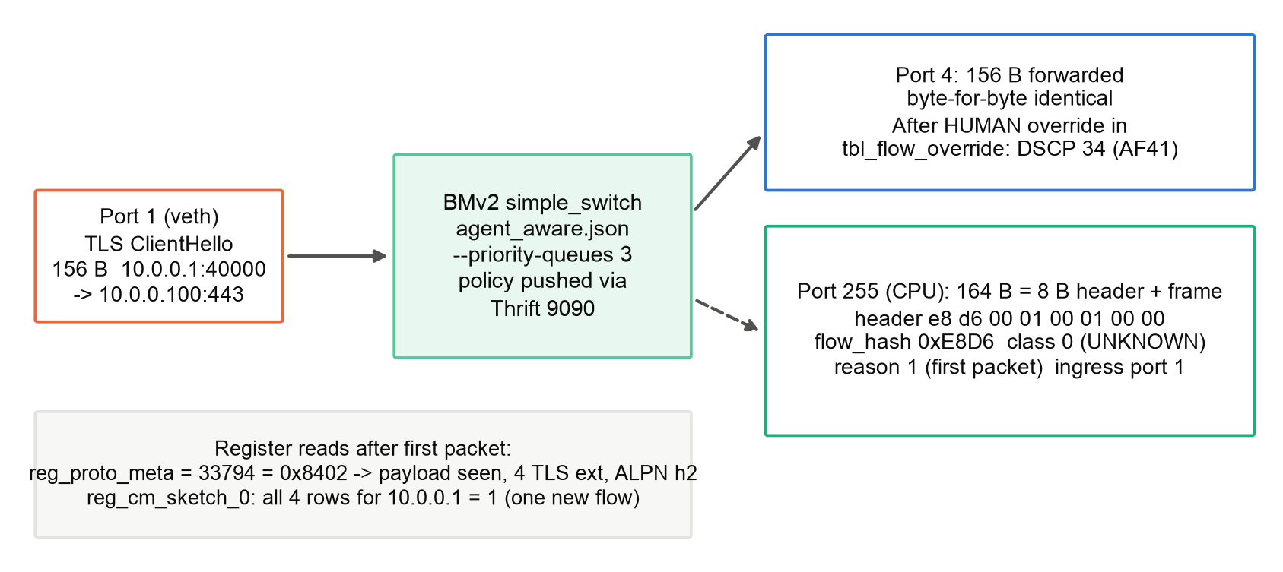
Fig. 6.1: Live BMv2 packet run: forwarding, CPU clone and register state after one ClientHello
The packet left port 4 byte-for-byte identical to the input, and a 164-byte copy reached the CPU port: the 8-byte CPU header followed by the original frame. Table 6.1 decodes the header. The class is UNKNOWN because the flow is in its warm-up period, and the reason is a first-packet punt, which is exactly the frame the controller's JA4 path consumes.
Table 6.1: Decoded CPU header of the punted ClientHello
Field | Width | Bytes | Value | Meaning
flow_hash | 16 bit | e8 d6 | 0xE8D6 | Slot hash of the flow
class | 8 bit | 00 | 0 | UNKNOWN (warm-up)
reason | 8 bit | 01 | 1 | First-packet punt
ingress_port | 16 bit | 00 01 | 1 | Sender port
pad | 16 bit | 00 00 | 0 | Alignment

Register reads and a second packet then verified the feature stage and the controller override path (Table 6.2).
Table 6.2: Live verification checks
Check | Expected | Observed | Result
Forwarding to port 4 | Identical 156-byte frame | Identical 156-byte frame | Pass
CPU clone to port 255 | 8-byte header + frame | 164 bytes, header e8d6 00 01 0001 0000 | Pass
reg_proto_meta[slot] | Payload seen, 4 ext., ALPN h2 | 33794 = 0x8402 | Pass
Sketch rows for 10.0.0.1 | All four rows = 1 | 1, 1, 1, 1 | Pass
HUMAN override, next packet | DSCP 34 (AF41) | DSCP 34 | Pass

The run also exposed a runtime requirement that unit tests could not: simple_switch defaults to a single priority queue, while the frozen treatments use three. Without the flag every class would share one queue and any queueing experiment would be invalid. The Mininet launcher now derives the queue count from the contracts and passes --priority-queues 3.

6.3 Live Dashboard
dashboard/server.py serves a small web page (index.html, app.js, style.css) that plots per-class latency and throughput while an experiment runs, so the centerpiece demonstration can show human latency staying flat while an agent burst is shaped. The server and UI are covered by host tests; the live demonstration with measured traffic is part of the pending Linux evaluation.

6.4 Running the Mininet Evaluation
On the Linux host the pinned toolchain is installed, BMv2 is rebuilt with priority queueing, and the three P4 programs are compiled. The integrated smoke run and the five-seed sanity runs are then launched through the experiment runner, which archives the exact inputs, compiled pipeline and hashes with every run:
make dev-env && make build && make lint && make test
sudo env AAN_COMPILED_TREE=results/fanout_fix_20261028/compiled_tree.json \
.venv/bin/python -m eval.run_experiment eval/configs/review_1_smoke.yaml \
--execute .venv/bin/python -m eval.workload
# then sanity_ours.yaml, sanity_fifo.yaml, sanity_diffserv.yaml, sanity_fairq.yaml
python -m eval.metrics --runs RUN_DIR_1 ... RUN_DIR_5 --output aggregate.json

Each sanity configuration runs the choke_v1 topology at 20 Mbps for 30 seconds with a 30% agent share and low burst intensity, over seeds 1 to 5.
CHAPTER 7

RESULT AND DISCUSSION
This chapter reports what has been measured: the compiled data-plane resources, the live switch verification and the classifier's behaviour on the seeded synthetic corpus, followed by a diagnosis of its main weakness. Results that require the Linux Mininet testbed (tail latency, overhead and scaling) have not yet been measured and are listed with their measurement plan in Section 7.9. No number in this chapter is estimated or simulated beyond what is stated.

7.1 Compiled Data-Plane Resources
All three top-level P4 programs (l2fwd, agent_aware and diffserv) compile with p4c-bm2-ss. Table 7.1 summarises the agent_aware artefact.
Table 7.1: Resources of the compiled agent_aware program
Resource | Value
Match-action tables | 33
Actions | 52
Parser states | 28
Meter arrays | 3 (M_AI, M_AB, M_PUNT)
Register arrays | 17, totalling 3,620,872 bytes (≈ 3.45 MiB)
Flow slots | 65,536 (≈ 55 bytes of state per slot, incl. sketch)
Tree-table capacity | 510 entries (2 + 4 + … + 256)
Installed tree entries | 64 (l0: 2, l1: 2, l2: 4, l3: 6, l4: 8, l5: 12, l6: 14, l7: 16)

Fig. 7.1 breaks down register memory. The first-eight packet sizes dominate (1 MiB, eight 16-bit entries per slot), followed by the two 48-bit timestamps. The sketch costs only 64 KiB for both epochs. The trained tree uses 64 of the 510 available table entries, so model size is far from the table limit. These are BMv2 numbers; mapping them onto a hardware pipeline's per-stage register memory is future work.
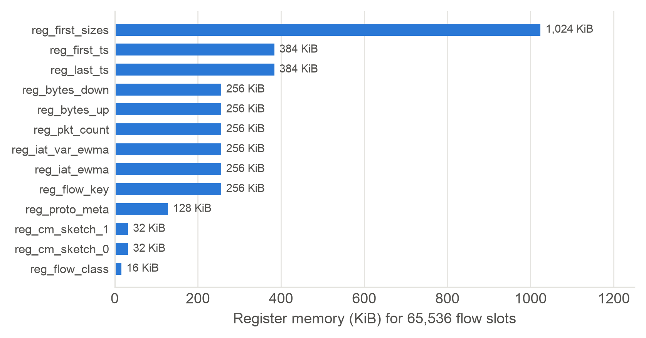
Fig. 7.1: Register memory by array in the compiled agent_aware program

7.2 Live Switch Verification
The live BMv2 run of Section 6.2 verified, on real packets, the parts of the pipeline that do not depend on traffic volume: byte-exact forwarding, the CPU clone and its header layout, TLS metadata extraction (payload-seen bit, four extensions, ALPN h2 packed as 0x8402), per-source sketch counting in all four rows and the controller-installed override taking precedence over the tree to set DSCP 34. Together with the compile results, this establishes that the integrated data plane and controller interoperate. It does not establish classifier accuracy at line rate or queueing behaviour under load, which require the Mininet bottleneck runs.

7.3 Classifier Accuracy on the Synthetic Corpus
Because no public dataset contains labelled packet-level traffic from autonomous agents, the classifier was developed on a seeded synthetic corpus. Six workload profiles (human browsing, human video call, agent browser, agent MCP tools, agent crawler and agent ingest) were generated with 40 clients each (240 sessions, seed 1), giving 4,094 flows and 11,393 checkpoint rows at 6, 16 and 64 packets. Real captured TLS ClientHellos were used, and every packet went through the switch-exact feature extractor. 20% of flows were held out, giving 2,283 held-out checkpoint rows. These numbers describe the workload model, not live traffic.
The trained tree has depth 8 and 33 leaves. Five-fold cross-validation grouped by flow gave macro-F1 0.805 ± 0.015 (folds 0.824, 0.784, 0.809, 0.817 and 0.791). The compiled tables returned the same class as the trained tree on all 2,283 held-out rows (0 mismatches), so the switch reproduces the model exactly. Table 7.2 and Fig. 7.2 give held-out precision and recall per checkpoint.
Table 7.2: Held-out precision / recall per class and checkpoint (support in brackets)
Checkpoint | HUMAN P / R | AGENT_INTERACTIVE P / R | AGENT_BULK P / R
6 packets | 0.510 / 0.914 (58) | 0.946 / 0.626 (139) | 0.998 / 1.000 (622)
16 packets | 0.400 / 0.902 (51) | 0.813 / 0.426 (122) | 0.998 / 0.989 (622)
64 packets | 0.459 / 1.000 (17) | 1.000 / 0.333 (30) | 1.000 / 1.000 (622)

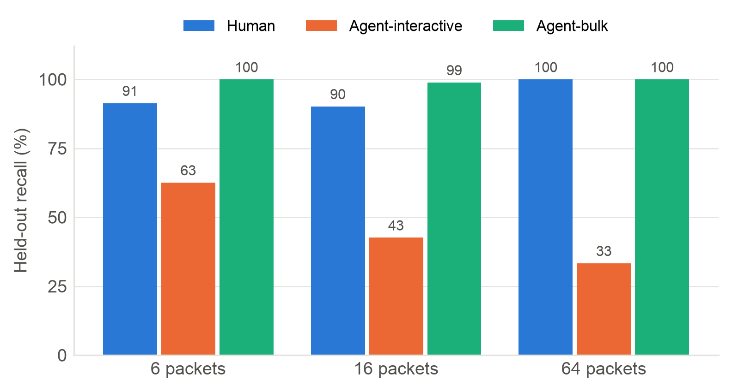
Fig. 7.2: Held-out recall per class at the 6, 16 and 64 packet checkpoints
Bulk agent traffic is recognised almost perfectly, and human traffic has high recall (90–100%) but low precision (0.40–0.51). The low human precision and the falling AGENT_INTERACTIVE recall are two views of the same error: interactive agents predicted as human. The per-profile analysis locates it precisely.

7.4 Per-Profile Analysis
Fig. 7.3 breaks the held-out predictions down by the workload profile that generated each flow, which is the ground truth. Table 7.3 lists the same results.
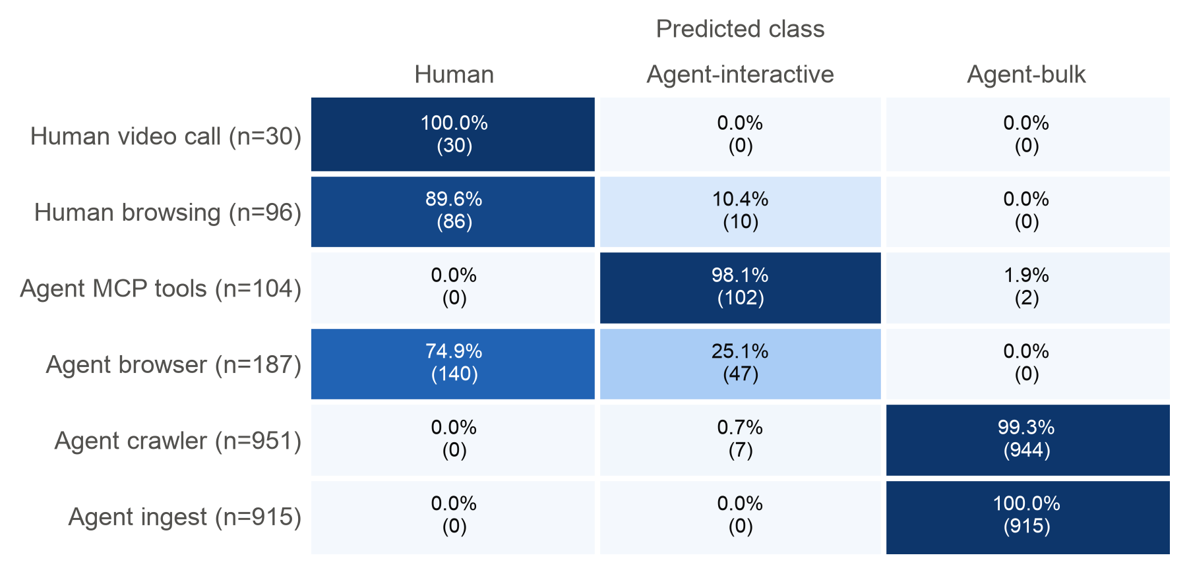
Fig. 7.3: Held-out predictions by generating profile, all checkpoints, row-normalised (counts in brackets)
Table 7.3: Held-out recall per workload profile (all checkpoints)
Profile | True class | Correct / total | Recall | Main error
Human video call | HUMAN | 30 / 30 | 100% | —
Human browsing | HUMAN | 86 / 96 | 89.6% | 10 → AGENT_INTERACTIVE
Agent MCP tools | AGENT_INTERACTIVE | 102 / 104 | 98.1% | 2 → AGENT_BULK
Agent browser | AGENT_INTERACTIVE | 47 / 187 | 25.1% | 140 → HUMAN
Agent crawler | AGENT_BULK | 944 / 951 | 99.3% | 7 → AGENT_INTERACTIVE
Agent ingest | AGENT_BULK | 915 / 915 | 100% | —

Tool-calling agents separate well: their Python HTTP stack has a distinct ClientHello and their requests are machine-paced. Browser-driven agents are the entire problem: 74.9% of their held-out rows are predicted HUMAN, because they present the same Chromium fingerprint and, within the first 64 packets of a flow, human-like pacing. Overall, 7.9% of human rows were classified as agents.

7.5 Effect of the Fan-Out Extraction Fix
During the audit a bug was found in the synthetic extractor: the fan-out value computed at the 6-packet checkpoint was reused at 16 and 64 packets, epochs were anchored to absolute rather than capture-relative time, and fan-out counted scheduled rather than actual flow starts. Three regression tests were written, failed, and then passed after the fix, which changed 951 feature rows and left every other column identical. Table 7.4 compares the previous and corrected models, including a fresh generation seed (5) that was never used for training or tuning.
Table 7.4: Previous versus corrected model
Measure | Previous | Corrected
Held-out AGENT_INTERACTIVE recall, 6 / 16 / 64 pkts | 61.2% / 42.6% / 33.3% | 62.6% / 42.6% / 33.3%
Held-out browser-agent recall, all checkpoints | 26.2% | 25.1%
Held-out humans classified as agents | 9.5% | 7.9%
Fresh seed 5: MCP-tool recall | 85.4% | 96.5%
Fresh seed 5: browser-agent recall | 19.9% | 18.7%
Compiled-table equivalence | — | 2,283 / 2,283

The fix substantially improved generalisation for tool-calling agents on unseen data (85.4% to 96.5%) and reduced human false positives, but did not help browser agents, which confirms that their misclassification is not an extraction artefact.

7.6 Browser-Agent Diagnosis
To understand the browser problem, the corpus was re-evaluated with grouping by orchestration session rather than by flow, using an explicit flow-to-session mapping from the generator (never inferred from flow identifiers). Grouping by session is the honest test: with flow grouping, flows of the same session can appear in both training and validation folds. Seeds 1–3, five folds and a 20% session-held-out split were used, with four predeclared feature sets and a 100-tree random forest as a diagnostic of model capacity (the forest is never deployed). Table 7.5 gives the mean results and Fig. 7.4 plots the session-grouped ones.
Table 7.5: Session- and flow-grouped cross-validation (mean of seeds 1–3)
Grouping | Model / features | Browser agent R | Human browsing R | MCP agent R | Macro-F1
Flow | Full depth-8 tree | 37.89% | 86.38% | 98.88% | 0.8066
Session | Full depth-8 tree | 35.85% | 77.12% | 97.11% | 0.7538
Session | Tree without TLS | 34.10% | 74.95% | 95.19% | 0.7336
Session | Tree without fan-out | 41.43% | 76.02% | 67.80% | 0.7309
Session | Timing + fan-out + age | 60.96% | 48.92% | 62.29% | 0.6720
Flow | 100-tree forest | 79.96% | 65.76% | 98.88% | 0.8674
Session | 100-tree forest | 65.44% | 46.09% | 98.96% | 0.7808

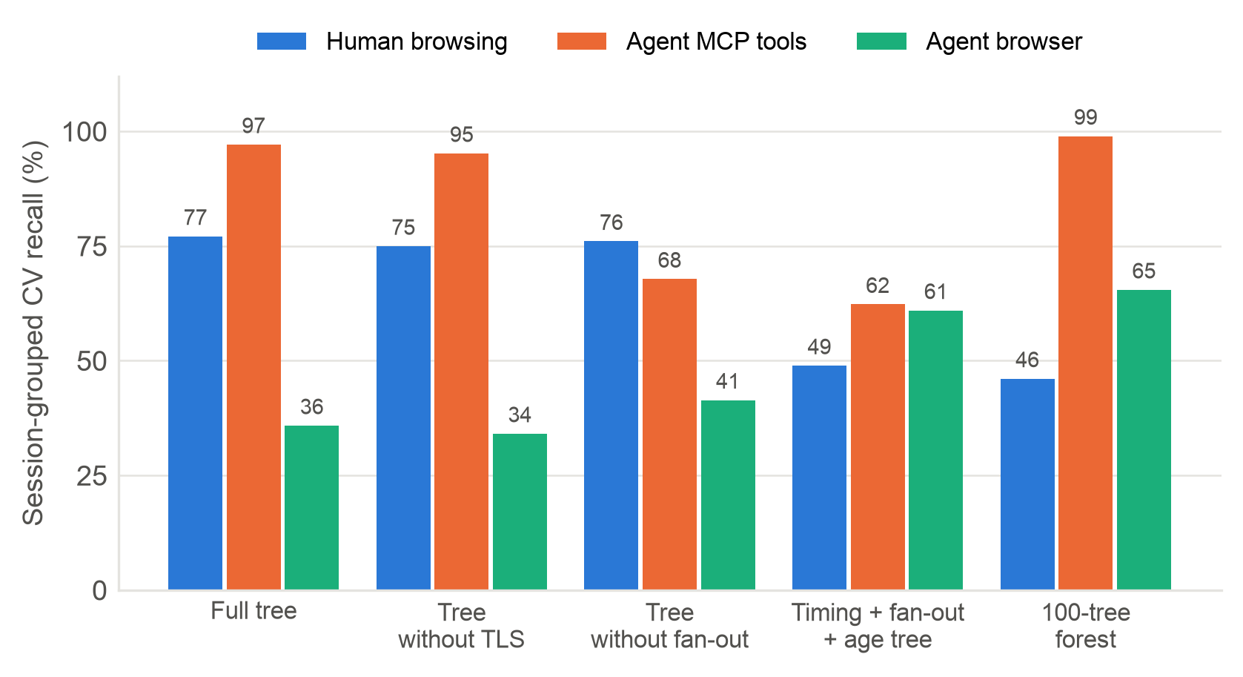
Fig. 7.4: Session-grouped recall for feature ablations and a higher-capacity forest
Three observations follow. First, flow grouping is optimistic: the forest's browser-agent recall falls by 14.5 percentage points when sessions are separated, and its human-browsing recall drops to 46.09%. More model capacity is therefore not a demonstrated fix. Second, the ablations trade one error for another: removing fan-out costs MCP recall (97.11% to 67.80%), and a timing-only tree raises browser recall to 60.96% only by misclassifying half of human browsing. Third, the session-held-out results vary sharply with the split: browser recall was 36.76%, 0.52% and 33.78% for seeds 1, 2 and 3, while MCP recall stayed at 100%, 97.83% and 100%.
The generator explains why. Both browser profiles share the same Chromium ClientHello, with (tls_ext_count, tls_alpn_class) = (7, 0) in every row, and their median IAT EWMA at 64 packets is 467 μs versus 471.5 μs. Human and agent browsing differ mainly in the think time between pages, and each page opens new connections, so a flow's own history rarely contains that gap. The fan-out sketch counts new flows per source in the current epoch and carries no session history. The conclusion is that browser-driven agents are not separable from human browsing with per-flow, line-rate features alone, whereas tool-calling agents are. Cross-flow session features are the natural next step, but they would change the frozen feature contract and should be justified first on real, independently labelled browser sessions.

7.7 Feature Importance
Fig. 7.5 shows the tree's Gini importances. Fan-out dominates (0.649), followed by TLS extension count (0.174), the first-eight size bucket (0.062) and the IAT mean (0.059). Packet count and the up/down ratio carry no importance in this model; the latter is consistent with the path-coverage rule that no decision may rest on the ratio alone.
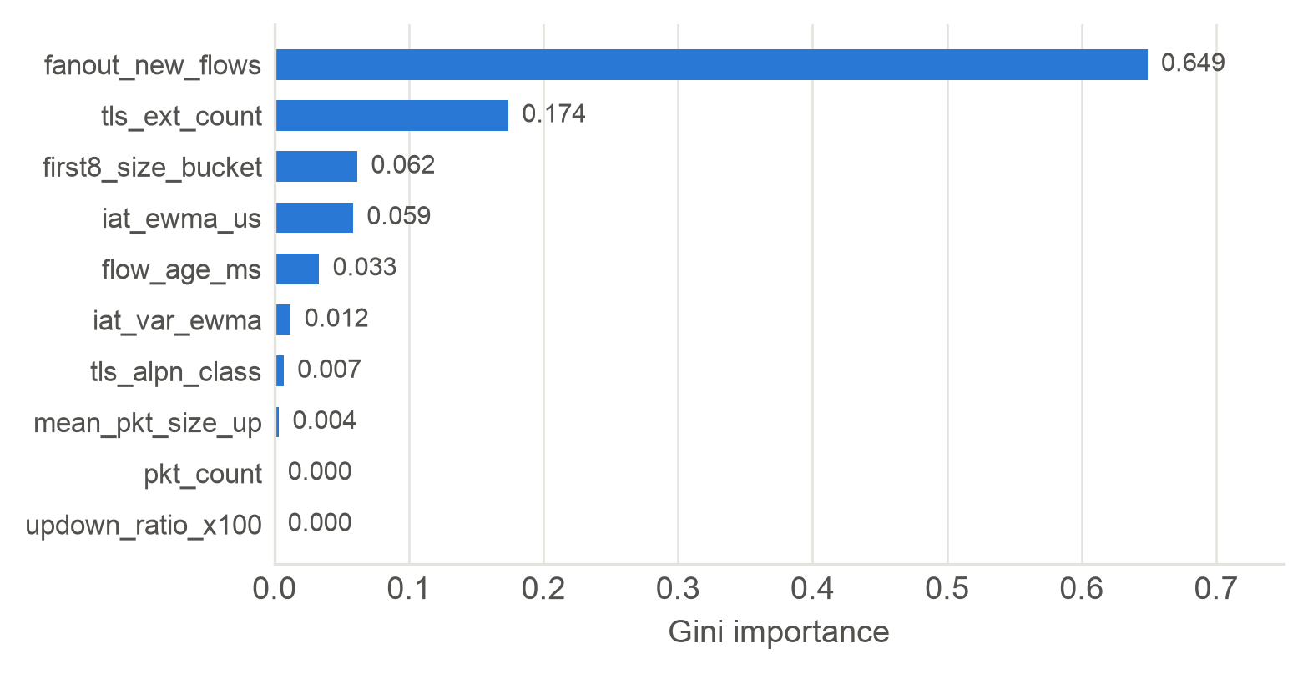
Fig. 7.5: Gini feature importance of the depth-8 tree

7.8 Discussion and Threats to Validity
The results support three claims. The data plane is buildable: the full pipeline compiles, fits comfortably in table capacity and works on live packets, including the controller refinement path. The switch reproduces the model exactly: the equivalence gate removes train/serve skew as a source of error, which is a recurring problem in in-network ML. And agent traffic is partly separable at line rate: tool-calling and bulk agents are recognised with high recall, while browser-driven agents are not.
The fail-open design matters for that last point. A browser agent misread as human receives human treatment, which is no worse than the status quo without the system, and the controller's JA4 and reclassification paths can still refine it later. Conversely, the 7.9% of human rows read as agents would receive a lower class and are the error that most directly threatens the human-protection objective; it must be measured on real traffic.
The main threats to validity are as follows. (i) Synthetic data: the corpus models behaviour with generator assumptions, not measured human or agent distributions; the profile separability partly reflects those assumptions. (ii) Evaluation grouping: flow-grouped scores are optimistic, as Section 7.6 shows; model selection should use session- and framework-separated splits. (iii) Software switch: BMv2 timing is not hardware timing, which is why links are slowed to 10–50 Mbps and overhead will be reported relative to l2fwd. (iv) TLS visibility: post-quantum key shares make recent browsers' ClientHellos span two TCP segments, so the single-segment parser reads them as having no TLS metadata; this must be aligned between parser and extractor. (v) Scope of DSCP: markings are meaningful only inside the deploying domain.

7.9 Pending Evaluation
The evaluation harness, baselines, metrics and anchor assertions are implemented, but the measured runs have not yet been executed on the Linux testbed. Table 7.6 lists what remains and how each will be measured. Until these runs complete, the project makes no claim about tail-latency reduction, overhead or scaling.
Table 7.6: Pending measurements and their plan
Experiment | Metric | Target | Method
Sanity grid (5 systems × 5 seeds) | Human p50/p95/p99, throughput | ≥ 30% lower p99 vs best baseline | choke_v1, 20 Mbps, 30 s, 30% agents
Overhead | Added per-packet latency | < 5% vs l2fwd | Same host and load, pinned cores
Non-starvation | Tool-call completion time | No starvation | Target-side call log
Line-rate accuracy | Per-class P/R from switch verdicts | Report | Labelled replay, register reads
State scaling | Collisions, accuracy, memory | Toward 100k flows | 1k → 100k flow sweep
Evasion | Accuracy and agent slowdown | Self-penalising | Human-like think time
Real corpus | Recall on real frameworks | Report | Browser Use, Playwright, AutoGen, Claude + MCP

CHAPTER 8

CONCLUSION
This project designed and built Agent-Aware Networking, a programmable-switch pipeline that classifies every packet as human, interactive agent, bulk agent or unknown and, in the same pass, applies a class-specific transport treatment. The data plane computes ten behavioural and handshake features with saturating fixed-point arithmetic in 65,536 flow slots and a two-epoch fan-out sketch, evaluates a depth-8 decision tree compiled into eight range tables, and applies DSCP marking, strict-priority queueing, ECN and metering, with a data-plane human-protection mode. A Python controller installs versioned policy, fingerprints first packets with JA4 and refines labels with a hysteresis-guarded sweep. The whole design is fail-open, and twenty race conditions and edge cases were addressed explicitly.
The measured outcomes are these. All three P4 programs compile; the full pipeline uses 33 tables and about 3.45 MiB of register state, and the trained tree occupies 64 of 510 table entries. A live BMv2 run verified forwarding, the CPU punt path, TLS metadata extraction, sketch counting and a controller override that re-marked a flow to DSCP 34. The compiled tables reproduce the trained tree on 2,283 of 2,283 held-out rows. On the synthetic corpus, tool-calling agents are recognised with 98.1% recall and bulk agents with 99–100%, while browser-driven agents are mostly read as human; a session-grouped diagnosis shows that this limit comes from per-flow features, not from model capacity. The host suite passes 479 tests.
The project's headline question, whether this coupling lowers human tail latency by at least 30% against four baselines at under 5% added latency, is fully instrumented but not yet answered; the Linux testbed runs are the immediate next step.

8.1 Future Work
- Execute the five-system, five-seed Mininet grid and the overhead, starvation, scaling and evasion experiments, and report effect sizes with confidence intervals.
- Capture real traffic from the Browser Use, Playwright, AutoGen and Claude-with-MCP runners and human traces, retrain, and evaluate on session- and framework-separated splits.
- Investigate cross-flow session features for browser-driven agents, justified on real data before any change to the frozen feature contract.
- Handle multi-segment (post-quantum) ClientHellos consistently in the parser and the extractor.
- Add Web Bot Auth verification on plaintext deployments, and port the pipeline to a Tofino-class hardware target.
CHAPTER 9

REFERENCES
[1] P. Bosshart et al., “P4: Programming protocol-independent packet processors,” ACM SIGCOMM Comput. Commun. Rev., vol. 44, no. 3, pp. 87–95, 2014.
[2] Z. Xiong and N. Zilberman, “Do switches dream of machine learning? Toward in-network classification,” in Proc. ACM HotNets, 2019, pp. 25–33.
[3] C. Busse-Grawitz, R. Meier, A. Dietmüller, T. Bühler, and L. Vanbever, “pForest: In-network inference with random forests,” arXiv:1909.05680, 2019.
[4] G. Xie, Q. Li, Y. Dong, G. Duan, Y. Jiang, and J. Duan, “Mousika: Enable general in-network intelligence in programmable switches by knowledge distillation,” in Proc. IEEE INFOCOM, 2022.
[5] C. Zheng et al., “Automating in-network machine learning,” arXiv:2205.08824, 2022.
[6] G. Zhou, Z. Liu, C. Fu, Q. Li, and K. Xu, “An efficient design of intelligent network data plane,” in Proc. USENIX Security Symp., 2023.
[7] A. G. Alcoz, M. Strohmeyer, V. Lenders, and L. Vanbever, “Aggregate-based congestion control for pulse-wave DDoS defense,” in Proc. ACM SIGCOMM, 2022.
[8] K. Nichols, S. Blake, F. Baker, and D. Black, “Definition of the Differentiated Services Field (DS Field) in the IPv4 and IPv6 Headers,” RFC 2474, IETF, 1998.
[9] S. Blake et al., “An Architecture for Differentiated Services,” RFC 2475, IETF, 1998.
[10] K. Ramakrishnan, S. Floyd, and D. Black, “The Addition of Explicit Congestion Notification (ECN) to IP,” RFC 3168, IETF, 2001.
[11] E. Rescorla, “The Transport Layer Security (TLS) Protocol Version 1.3,” RFC 8446, IETF, 2018.
[12] A. Backman, J. Richer, and M. Sporny, “HTTP Message Signatures,” RFC 9421, IETF, 2024.
[13] Thales/Imperva, “2026 Imperva Bad Bot Report,” 2026.
[14] J. Althouse, “JA4+ network fingerprinting,” FoxIO, 2023. [Online]. Available: https://github.com/FoxIO-LLC/ja4
[15] G. Cormode and S. Muthukrishnan, “An improved data stream summary: The count-min sketch and its applications,” J. Algorithms, vol. 55, no. 1, pp. 58–75, 2005.
[16] M. Shreedhar and G. Varghese, “Efficient fair queuing using deficit round-robin,” IEEE/ACM Trans. Netw., vol. 4, no. 3, pp. 375–385, 1996.
[17] B. Lantz, B. Heller, and N. McKeown, “A network in a laptop: Rapid prototyping for software-defined networks,” in Proc. ACM HotNets, 2010.
[18] F. Pedregosa et al., “Scikit-learn: Machine learning in Python,” J. Mach. Learn. Res., vol. 12, pp. 2825–2830, 2011.
[19] P. Barford and M. Crovella, “Generating representative web workloads for network and server performance evaluation,” in Proc. ACM SIGMETRICS, 1998, pp. 151–160.
[20] Model Context Protocol Specification, rev. 2025-03-26. [Online]. Available: https://modelcontextprotocol.io/specification
[21] K. Cho, K. Mitsuya, and A. Kato, “Traffic data repository at the WIDE project,” in Proc. USENIX Annu. Tech. Conf., FREENIX Track, 2000.
[22] p4lang, “Behavioral Model (BMv2) simple_switch,” GitHub. [Online]. Available: https://github.com/p4lang/behavioral-model
APPENDIX A

SAMPLE CODE
The listings below are copied verbatim from the project repository. Comments of the form §7.n refer to the race-condition items of Table 4.5.
Listing A.1: Fixed-point EWMA update (common/feature_math.py)
def saturate(value: int, bits: int) -> int:
"""Clamp a non-negative value to an unsigned `bits`-wide field (section 7.3)."""
if value < 0:
raise ValueError(f"fixed-point values are unsigned, got {value}")
return min(value, (1 << bits) - 1)

def floor_log2(value: int) -> int:
"""Return the highest set bit index: the P4 shift that stands in for `/ value`."""
if value <= 0:
raise ValueError(f"floor_log2 requires a positive value, got {value}")
return value.bit_length() - 1

def timestamp_delta_us(now_us: int, earlier_us: int) -> int:
"""Return the 48-bit wrapping difference clamped to 32 bits (section 7.3)."""
return saturate((now_us - earlier_us) % (1 << TIMESTAMP_BITS), 32)

def ewma_step(current: int, sample: int) -> int:
"""Apply `current += (sample - current) >> EWMA_SHIFT` on unsigned registers.

P4 shifts the magnitude, then applies the sign, which truncates toward zero; Python's `>>`
on a negative difference floors instead, hence the two branches.
"""
if sample >= current:
return current + ((sample - current) >> EWMA_SHIFT)
return current - ((current - sample) >> EWMA_SHIFT)

def iat_update(iat_ewma: int, iat_var_ewma: int, delta_us: int) -> tuple[int, int]:
"""Update the IAT mean and mean-absolute-deviation EWMAs for one non-zero gap.

The deviation is taken against the pre-update mean so P4 reads each register once.
"""
deviation = abs(delta_us - iat_ewma)
return ewma_step(iat_ewma, delta_us), ewma_step(iat_var_ewma, deviation)

Listing A.2: Slot claim with full reset and collision handling (p4src/features.p4)
action claim_slot() {
reg_flow_key.read(owner, (bit<32>) meta.flow_hash);
reg_pkt_count.read(count, (bit<32>) meta.flow_hash);
reg_last_ts.read(last_ts, (bit<32>) meta.flow_hash);
gap = standard_metadata.ingress_global_timestamp - last_ts;
meta.slot_owned = 1;
meta.new_flow = 0;
if (count == 0 || (owner != meta.flow_tag && gap > (bit<48>) IDLE_TIMEOUT_US)) {
// §7.11: reset EVERY per-slot field before ownership publication.
reg_first_ts.write((bit<32>) meta.flow_hash, standard_metadata.ingress_global_timestamp);
reg_last_ts.write((bit<32>) meta.flow_hash, standard_metadata.ingress_global_timestamp);
reg_iat_ewma.write((bit<32>) meta.flow_hash, 0);
reg_iat_var_ewma.write((bit<32>) meta.flow_hash, 0);
reg_pkt_count.write((bit<32>) meta.flow_hash, 0);
reg_bytes_up.write((bit<32>) meta.flow_hash, 0);
reg_bytes_down.write((bit<32>) meta.flow_hash, 0);
reg_proto_meta.write((bit<32>) meta.flow_hash, 0);
reg_flow_class.write((bit<32>) meta.flow_hash, CLASS_UNKNOWN);
reg_first_sizes.write((bit<32>) meta.flow_hash * FIRST_SIZE_COUNT + 0, 0);
reg_first_sizes.write((bit<32>) meta.flow_hash * FIRST_SIZE_COUNT + 1, 0);
reg_first_sizes.write((bit<32>) meta.flow_hash * FIRST_SIZE_COUNT + 2, 0);
reg_first_sizes.write((bit<32>) meta.flow_hash * FIRST_SIZE_COUNT + 3, 0);
reg_first_sizes.write((bit<32>) meta.flow_hash * FIRST_SIZE_COUNT + 4, 0);
reg_first_sizes.write((bit<32>) meta.flow_hash * FIRST_SIZE_COUNT + 5, 0);
reg_first_sizes.write((bit<32>) meta.flow_hash * FIRST_SIZE_COUNT + 6, 0);
reg_first_sizes.write((bit<32>) meta.flow_hash * FIRST_SIZE_COUNT + 7, 0);
reg_flow_key.write((bit<32>) meta.flow_hash, meta.flow_tag);
count = 0;
meta.new_flow = 1;
} else if (owner != meta.flow_tag) {
// §7.1: a live collision never mutates the owner's state.
meta.slot_owned = 0;
meta.feature_valid = 0;
reg_collision_ctr.read(collision_count, 0);
reg_collision_ctr.write(0, collision_count |+| 1);
}
}

Listing A.3: Egress congestion hysteresis and ECN marking (p4src/qos_egress.p4)
// P3.13/P3.9: included inside EgressPipeline.apply.
if (standard_metadata.instance_type == 32w1) {
hdr.cpu_header.setValid();
hdr.cpu_header.flow_hash = meta.flow_hash;
hdr.cpu_header.class = (bit<8>) meta.traffic_class;
hdr.cpu_header.reason = meta.punt_reason;
hdr.cpu_header.ingress_port = meta.original_ingress_port;
hdr.cpu_header.pad = 0;
} else {
// §7.7: only egress updates the congestion flag, with separate set/clear thresholds.
@atomic {
reg_congestion_flag.read(meta.congestion, 0);
if (standard_metadata.deq_qdepth >= (bit<19>) CONGESTION_HIGH_PACKETS) {
meta.congestion = 1;
reg_congestion_flag.write(0, 1);
} else if (standard_metadata.deq_qdepth <= (bit<19>) CONGESTION_LOW_PACKETS) {
meta.congestion = 0;
reg_congestion_flag.write(0, 0);
}
}
if (meta.congestion == 1 && meta.ecn_threshold != 0 && hdr.ipv4.isValid() &&
standard_metadata.deq_qdepth >= (bit<19>) meta.ecn_threshold &&
(hdr.ipv4.diffserv & 8w3) != 0) {
hdr.ipv4.diffserv = (hdr.ipv4.diffserv & 8w252) | 8w3;
}
}

Listing A.4: Float32-exact tree boundary (ml/compile_tree.py)
def left_upper_bound(threshold: float) -> int:
"""Return the largest integer k with `float32(k) <= threshold`.

sklearn casts inputs to float32 before comparing with the float64 threshold, so above 2**24
`floor(threshold)` is not the switch-side boundary that reproduces its decisions (7.9).
"""
bound = math.floor(threshold)
while np.float32(bound + 1) <= threshold:
bound += 1
while bound >= 0 and np.float32(bound) > threshold:
bound -= 1
return bound

Listing A.5: Idempotent, versioned policy push (controller/policy.py)
def push_policy(api: SwitchApi, link_mbps: int, tree: CompiledTree | None) -> int:
"""Push the full policy, then advance policy_version.

Safe at any time (section 7.5): owned tables are cleared before being filled, meters and
registers are overwritten, and the version is written last, so a push cut short by a crash
leaves the old version and the next start re-pushes over it.

Args:
api: Switch boundary.
link_mbps: Bottleneck rate from the experiment config; scales the meter presets.
tree: Compiled classifier, or None before one exists (every flow stays UNKNOWN).

Returns:
The policy version now stored on the switch.

Raises:
SwitchApiError: If BMv2 rejects any command.
ValueError: If link_mbps is outside the contract range.
"""
(current,) = api.read_register(POLICY_VERSION_REGISTER, 0)
if tree is None:
LOGGER.warning("no compiled tree; all flows classify as UNKNOWN (fail-open)")
api.execute(policy_commands(link_mbps, tree))
version = current + 1
api.execute([register_write_command(POLICY_VERSION_REGISTER, 0, version)])
LOGGER.info("pushed policy version %d (model %s)", version, tree.model_hash if tree else "-")
return version

Listing A.6: Reclassifier hysteresis and torn-read guard (controller/reclassifier.py)
def _process_slot(self, snapshot: RegisterSnapshot, slot: int, state: _TrackedFlow) -> None:
flow = state.observation.flow
# §7.1/7.11: validate ownership before any evidence, classification, or aging action.
if snapshot.value(FLOW_KEY_REGISTER, slot, 32) != flow.tag:
self._forget(slot)
return
before = _cell(snapshot.counts_before, slot, 32)
after = _cell(snapshot.counts_after, slot, 32)
# §7.4: torn/reset views break the consecutive-sweep chain and never relabel.
if after < before or after - before > _TORN_PACKET_THRESHOLD:
state.reset_candidate()
return
first_ts = snapshot.value(FIRST_TIMESTAMP_REGISTER, slot, TIMESTAMP_BITS)
last_ts = snapshot.value(LAST_TIMESTAMP_REGISTER, slot, TIMESTAMP_BITS)
if state.first_timestamp is not None and state.first_timestamp != first_ts:
# §7.11: same key reused after timeout still denotes a fresh flow generation.
state.evidence = None
state.activity = None
state.idle_sweeps = 0
state.reset_candidate()
self._desired.pop(flow, None)
state.first_timestamp = first_ts
activity = (after, last_ts)
state.idle_sweeps = state.idle_sweeps + 1 if state.activity == activity else 0
state.activity = activity
# §7.8/7.11: sticky evidence and behavioral overrides expire with the idle owner.
if state.idle_sweeps >= _IDLE_SWEEPS:
self._forget(slot)
return
if state.evidence is not None:
self._desired[flow] = state.evidence
state.reset_candidate()
return
if before < WARMUP_PACKETS:
state.reset_candidate()
return
features = snapshot.features(slot, flow)
decision = classify(self._tree, features).traffic_class
current = self._desired.get(
flow, TrafficClass(snapshot.value(FLOW_CLASS_REGISTER, slot, 2))
)
if decision == current:
state.reset_candidate()
return
if state.candidate == decision:
state.agreeing_sweeps += 1
else:
state.candidate = decision
state.agreeing_sweeps = 1
# §7.8: only three consecutive agreeing, usable snapshots may refine a flow class.
if state.agreeing_sweeps >= _AGREEING_SWEEPS:
self._desired[flow] = decision
state.reset_candidate()

