Agent-Aware Networking: In-Network Classification and Differentiated QoS for AI-Agent Traffic on a P4 Data Plane

Shashank Bhat M  School of Computer Science and Engineering  Vellore Institute of Technology  Vellore, India  email address | Ananya Ganesan  School of Computer Science and Engineering  Vellore Institute of Technology  Vellore, India  email address
Jobin John  School of Computer Science and Engineering  Vellore Institute of Technology  Vellore, India  email address | Yoganand S  Centre for Artificial Intelligence and Research (CFAIR)  Vellore Institute of Technology  Vellore, India  email address

Abstract—Automated clients now generate more than half of Internet traffic, and AI agents that drive real browsers or fire bursts of Model Context Protocol (MCP) tool calls are a growing share of it. On a shared bottleneck these machine-paced bursts wait in the same queue as human interactive traffic, yet QoS keys on ports and applications, and agent detection runs at the HTTP edge with only allow/block actions. We present Agent-Aware Networking, a P4₁₆ pipeline for the BMv2 software switch that labels every packet as human, agent-interactive, agent-bulk or unknown and, in the same pass, applies a per-class DSCP marking, strict-priority queue, ECN threshold and two-rate meter, failing open to best effort under uncertainty. Ten fixed-point features, including a count-min fan-out sketch and bounded TLS ClientHello fields, feed a depth-8 decision tree compiled into eight range-match tables, and a controller refines labels through versioned policy, rate-limited punts and hysteresis-guarded overrides. The pipeline compiles to 33 tables with 3.45 MiB of state for 65,536 flows, and a live BMv2 run verified forwarding, CPU punts, TLS metadata, sketch updates and override-driven DSCP rewriting. Float32-exact tree compilation gives 100% train/serve agreement (2,283/2,283 rows). On a seeded synthetic corpus, MCP tool-calling agents are separable per flow (98.1% recall) while browser-driven agents are not (25.1%), because they share the Chromium handshake and human-like per-flow timing; post-quantum ClientHellos of 1.5–1.9 kB further erode single-packet TLS features.
Keywords—P4, programmable data plane, in-network machine learning, quality of service, AI agents, traffic classification, Model Context Protocol

Introduction
The traffic mix of the Internet has changed. The 2026 Imperva Bad Bot Report [1] estimates that 53% of Internet traffic is now automated (40% from malicious bots and 13% from benign automation) and identifies AI agents as a distinct category that runs real browsers with valid fingerprints. Agents built on the Model Context Protocol (MCP) [2] issue structured tool calls over HTTPS, often many of them in parallel.
Consider an agent that fires 50 parallel MCP tool calls across the same access link as a human video call. Every switch on the path sees 51 TLS flows on port 443 and serves them from one queue; the human’s packets wait behind a machine-paced burst, and that queueing delay is the tail-latency spike the user perceives. Differentiated Services [3], [4] could protect the call, but markings are set by port, application or end host, none of which distinguishes an agent from a person. Commercial agent detection terminates TLS at a CDN or web application firewall, sees only the traffic routed through it, reacts at request timescales, and can only allow, block or rate-limit.
We ask whether the forwarding plane itself can recognize agent traffic per packet and act on that recognition in the same pipeline pass, with transport-level treatment rather than access control. The guiding rule is that a misclassification may degrade a flow’s service class but never blocks it. This paper makes four contributions:
- A characterization of AI-agent traffic as an in-network class with ten features that a switch computes at line rate using only shifts and saturating integer arithmetic.
- A P4 architecture that couples a compiled decision tree to per-class DSCP, priority queueing, ECN and metering, with a data-plane congestion mode that tightens agent meters without a controller round trip, and a control loop that refines labels with hysteresis.
- A train/serve equivalence method (a bit-exact mirror of the switch arithmetic, float32-exact range boundaries and a CI gate) and verification of the pipeline on a live BMv2 switch.
- An evaluation on a seeded synthetic corpus showing that tool-calling and bulk agents are separable per flow while browser-driven agents are not, with ablations under session-grouped validation.
The work yields seven findings:
- F1 One-pass coupling is practical: the pipeline compiles to 33 tables with about 55 B of state per flow, the tree uses 64 of 510 table entries, and a live BMv2 run verified it end to end.
- F2 In-network trees need float32-exact boundaries; with them and a bit-exact feature mirror, switch and model agree on 100% of held-out rows.
- F3 Tool-calling (MCP) agents are separable per flow: 98.1% held-out recall (96.5% on an unseen seed); bulk agents reach 99.3–100%.
- F4 Browser-driven agents are not (25.1% recall); added model capacity only trades errors, and flow-grouped validation overstates browser recall.
- F5 Burst fan-out dominates the model (importance 0.649); computing it per checkpoint raised unseen-seed MCP recall from 85.4% to 96.5%.
- F6 Post-quantum ClientHellos (1,536–1,899 B) exceed one TCP segment, so a switch sees only part of the handshake.
- F7 BMv2 defaults to one priority queue; strict-priority QoS needs --priority-queues 3.
Section II reviews related work, Section III presents the design and Section IV the implementation. Section V reports the evaluation, Section VI develops the findings and Section VII concludes with future scope.

Background and Related Work

In-Network Machine Learning
P4 [5] lets a switch pipeline be programmed as parsers and match-action tables. IIsy [6] showed that classical classifiers can be mapped onto match-action tables; pForest [7] runs random forests with phase-dependent feature sets; Mousika [8] distills models into binary decision trees that fit switch resources; Planter [9] automates the mapping of several model families; and NetBeacon [10] addresses multi-phase, flow-level inference and feature storage at scale. Our tree-to-range-table compilation follows this recipe but targets a new trigger, agent identity, and couples the label directly to queueing.
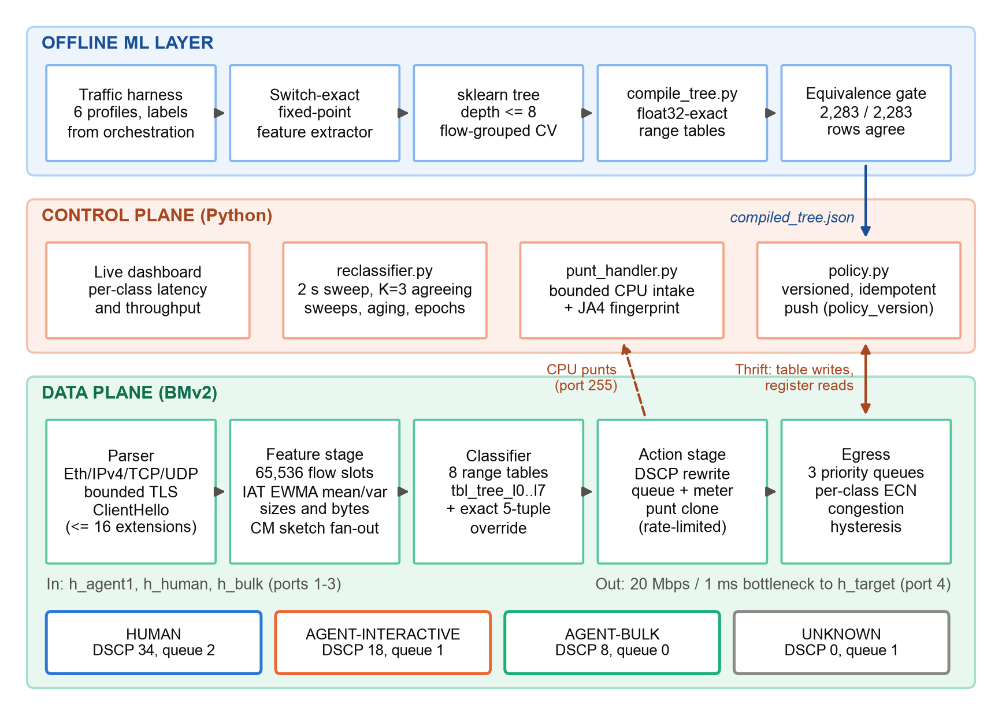
Fig. 1. Agent-Aware Networking architecture. Every packet is parsed, featurized, classified and treated inside the switch; the controller only installs policy and refines labels, and the offline layer trains and verifies the tree.

Classification-to-Action in the Data Plane
ACC-Turbo [11] is the closest precedent for acting on in-network classification: it clusters traffic aggregates inside the switch and deprioritizes suspicious clusters to mitigate pulse-wave DDoS attacks. Its trigger is attack aggregates; ours is per-flow agent identity, and our action space (DSCP, priority, ECN [12] and meters) is chosen so that no class is ever rejected.

Agent and Bot Detection
Bot-management services classify at the HTTP edge using browser signals, behavior and TLS fingerprints such as the JA4 family [13]; cryptographic schemes such as Web Bot Auth build on HTTP Message Signatures [14]. Both require TLS termination or client cooperation. The TLS 1.3 ClientHello [15] is still sent in the clear, so a switch can read some handshake metadata, but an agent that drives Chromium presents a browser-identical handshake. We therefore treat TLS fields as one input, never as the anchor of the decision.

QoS Mechanisms
DiffServ marks the DS field and maps codepoints to per-hop behaviors; fair queueing such as deficit round robin [16] isolates flows from one another but is blind to who generated them. Both serve as baselines in our evaluation.

System Design

Architecture
Fig. 1 shows three layers. The data plane, a P4₁₆ v1model program on the BMv2 simple_switch [17], parses, updates flow state, classifies and acts on every packet. The control plane, a Python controller attached over Thrift and a CPU port, installs policy and refines labels. An offline layer trains the tree and compiles it into table entries. The per-packet decision never leaves the switch: if the controller fails, the compiled tree keeps classifying, degraded but never broken.
All names and values shared across modules (class codes, treatments, table and register names, feature order and bit widths, the CPU header layout and the label schema) are frozen in one contract module that is imported by the P4 header generator, the controller, the ML pipeline and the evaluation code.

Parser and Fail-Open Path
The parser accepts Ethernet, IPv4, TCP and UDP. When a TCP payload begins with a TLS handshake record on the flow’s first payload packet, it walks the ClientHello shallowly: at most 16 extensions, each length checked, recording the extension count and the class of the first ALPN protocol (none, HTTP/1.1, h2 or other). P4 parsers cannot loop without bound, so the walk is unrolled and stops at the limit. Non-IPv4 frames, fragments, missing L4 headers and malformed handshakes take a fail-open path: class UNKNOWN, best-effort forwarding and no register writes.

Line-Rate Features
A flow is its 5-tuple. A CRC hash selects one of 65,536 register slots, and a second hash with a different salt is stored as an ownership tag. A packet whose tag mismatches a live slot (idle for less than 5 s) is a collision: it leaves the slot untouched, falls back to an override or UNKNOWN, and increments a collision counter. A stale slot is reset completely before it is claimed, so a new flow never inherits another flow’s history.
For an inter-arrival time d in microseconds, the switch keeps exponentially weighted moving averages of the mean m and deviation v with a shift of 3 (α = 1/8):
m ← m + ((d − m) >> 3) (1)
v ← v + ((|d − m| − v) >> 3) (2)
The update is skipped for a flow’s first packet and for d = 0, and every counter saturates instead of wrapping. Per-direction byte counters give the mean upstream packet size and an up/down byte ratio scaled by 100; the first eight packet sizes form a bitmask of large (≥128 B) packets; and flow age is (t − t₀) >> 10, in units of about a millisecond.
Burst structure is captured by a count-min sketch [18] of 4 rows × 4,096 16-bit counters, incremented per source address only when a new flow claims a slot. The fan-out of source s is
f(s) = min_{i} C_{i}[h_{i}(s)]. (3)
Two sketch epochs alternate every second, so the data plane always writes the active epoch while the controller clears the retired one. The resulting ten-feature vector is: IAT EWMA mean and deviation, packet count, mean upstream size, up/down ratio, first-eight size bitmask, fan-out, TLS extension count, ALPN class and flow age. Every read-modify-write sequence sits in an @atomic block, and flows are labeled UNKNOWN during a 6-packet warm-up.

Tree Compilation and Train/Serve Equivalence
The classifier is a scikit-learn [19] decision tree of depth at most 8, trained with class weights on vectors produced by a Python mirror that reimplements the switch arithmetic bit for bit. Each tree level becomes one range-match table, tbl_tree_l0 to tbl_tree_l7, keyed on the current node identifier and the ten features; a hit either advances the node or emits the leaf class. A training-time check asserts that every root-to-leaf path tests at least one timing or burst feature, so asymmetric routing that saturates the up/down ratio cannot by itself produce a label.
Compilation exposed a subtle skew: scikit-learn compares float32(x) ≤ θ, so for integers above 2²⁴ the correct switch boundary is not ⌊θ⌋. The compiler therefore emits the largest integer k with float32(k) ≤ θ (for example 16,777,217 rather than 16,777,216). A continuous-integration gate simulates the BMv2 tables and requires 100% label agreement with the trained tree on held-out rows, random vectors including values above 2²⁴, and split-boundary probes; it detects a single tampered boundary.

QoS Action and Human Protection
The class-action table maps each class to the treatment in Table I. Human traffic receives the highest strict priority and AF41; agent-interactive traffic receives the middle queue and a two-rate meter; agent-bulk traffic receives the lowest queue and a tighter meter. Only agent-bulk packets may be dropped on a red meter result. Agent-interactive packets are ECN-marked instead, so classification never starves an interactive agent, and UNKNOWN traffic receives best effort.
- Per-Class Treatments
Class | DSCP | Queue | Meter CIR–PIR (% of link) normal / protective | ECN (pkts)
Human | 34 (AF41) | 2 (high) | none | 48
Agent-interactive | 18 (AF21) | 1 | 50–80 / 20–25 | 24
Agent-bulk | 8 (CS1) | 0 (low) | 30–60 / 10–15 | 8
Unknown | 0 (BE) | 1 | none | none

Egress reads the dequeue queue depth and maintains a congestion flag with hysteresis: it is set at 64 packets and cleared at 16. While the flag is set, agent meters switch to the protective preset, which caps the aggregate agent share of the link. Both presets are preinstalled, so the reaction is local to the data plane and needs no controller round trip.

Control Plane
At startup the controller reads a policy_version register and, if it differs from the expected value, pushes class actions, meter presets and tree entries as idempotent upserts before writing the new version, so a restart is safe at any time. The first packet of a flow with a parsed ClientHello is cloned to CPU port 255 with an 8-byte header (flow hash, class, reason and ingress port) through a punt meter capped at 100 packets/s; a dropped punt loses refinement, never correctness. The punt handler computes a JA4 fingerprint and may install an exact 5-tuple entry in tbl_flow_override, which always wins over the tree. A reclassifier bulk-reads the register arrays every 2 s, re-evaluates active flows and installs or changes an override only after K = 3 consecutive agreeing sweeps; slots whose packet count advanced during the read are skipped as torn. The same sweep ages overrides and flips the sketch epochs.

Race Conditions and Edge Cases
The design enumerates 20 hazards, each with a mechanism and a test: slot collisions, read-modify-write atomicity, counter and timestamp wraparound, torn sweeps, controller restarts, punt storms, congestion-flag and class flapping, train/serve skew, epoch-flip races, stale-slot inheritance, first-packet IAT, retransmission noise, asymmetric visibility, malformed packets, meter starvation, evasion, software-switch jitter, concurrent experiment runs and label leakage. Ground-truth labels come only from orchestration (which generator produced a flow), never from inspecting the traffic.

Implementation
The system comprises about 10,500 lines of source and 5,970 lines of tests: P4 1,420; controller 1,477; ML 1,915; shared contracts and arithmetic 701; evaluation 2,660; traffic harness 2,013; and dashboard 307. P4 is compiled with p4c-bm2-ss in the p4lang/p4c container, and three top-level programs compile: the full agent_aware pipeline, a minimal l2fwd program that serves as the FIFO baseline and the overhead reference, and a port-based DiffServ baseline that shares the same queues and meters. The controller is a Python 3.9-compatible standalone Thrift and AF_PACKET daemon, and the ML and evaluation code use Python 3.11.
- Resources of the Compiled Pipeline
Resource | Value
Match-action tables / actions | 33 / 52
Parser states | 28
Register arrays | 17 (3,620,872 B)
Flow slots | 65,536 (≈55 B per slot)
Count-min sketch | 2 epochs × 4 × 4,096 × 16 bit
Meter arrays | 3 (agent-int., agent-bulk, punt)
Tree entries (used / capacity) | 64 / 510

Table II summarizes the compiled agent_aware program. Per-flow state costs about 55 bytes per slot, or 3.45 MiB for 65,536 slots including both sketch epochs, and the trained tree occupies 64 of the 510 tree-table entries (F1). A suite of 479 passing host tests covers the arithmetic mirror, compiler round trips, controller restart and torn-read handling, punt parsing, JA4 vectors and metric computation, and runs with lint checks on every change.

Evaluation

Evaluation Framework and Testbed
We built a reproducible evaluation framework around the choke_v1 topology, which attaches an agent host, a human host and a background host to ports 1–3 of one BMv2 switch in Mininet [20]. The switch-to-target link (port 4) is the bottleneck at 20 Mbps with 1 ms delay (configurable from 10 to 50 Mbps), low enough that queueing rather than software-switch CPU dominates delay. The framework provides adapters for four baselines on the same topology: FIFO (the l2fwd program), DiffServ with static port-based marking and the same queues, per-flow fair queueing (seeded hashing into Linux deficit-round-robin buckets [16]) and an application-layer rate limiter (nginx in front of the target behind a FIFO switch). The experiment runner takes an exclusive host lock, writes append-only result directories named by configuration hash and seed, and enforces at least five seeds per cell. A two-tap adapter joins packets captured at ingress and egress into per-packet latencies, and the metrics module computes per-class p50, p95 and p99 latency, throughput and tool-call completion with 95% Student-t intervals over seeds. The design targets are encoded as executable assertions: at least 30% lower human p99 than the best baseline, and less than 5% added per-packet latency relative to l2fwd.
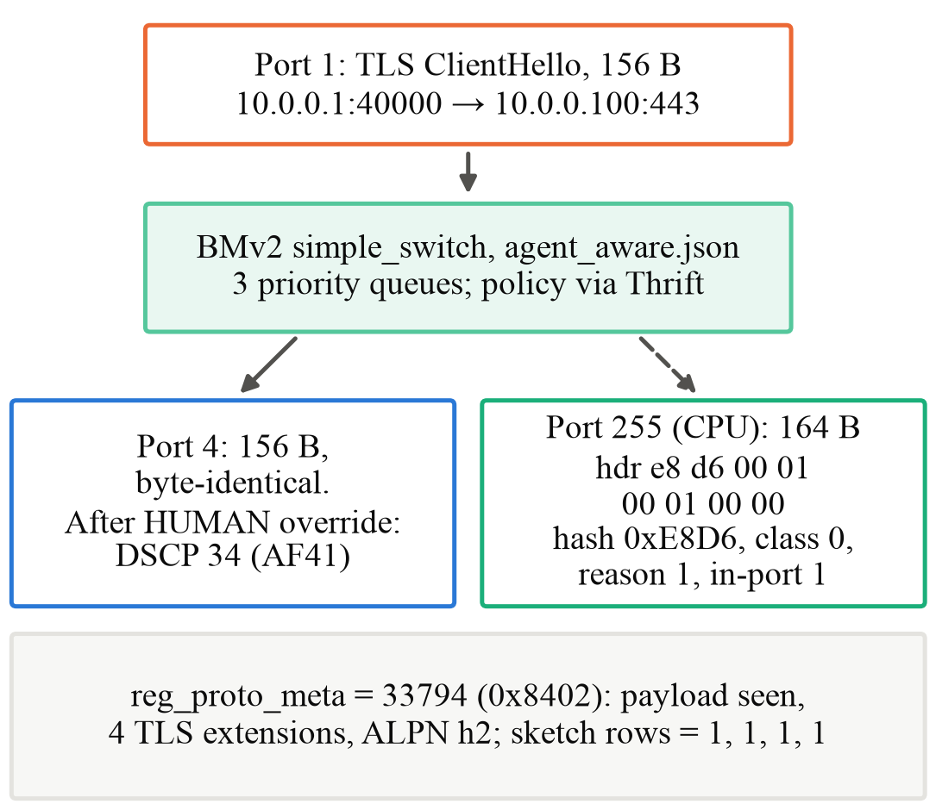
Fig. 2. Live BMv2 run: one ClientHello is forwarded unchanged, cloned to the CPU port with the 8-byte punt header, and recorded in the flow’s protocol and sketch registers.

Live Data-Plane Verification
We ran the compiled pipeline on BMv2 with veth ports 1, 4 and 255, pushed policy through the controller’s switch interface and injected a 156-byte TLS ClientHello from 10.0.0.1:40000 to 10.0.0.100:443 (Fig. 2). The packet left port 4 byte-for-byte identical and was cloned to the CPU port as 164 bytes: the frame preceded by the 8-byte header e8 d6 00 01 00 01 00 00, i.e., flow hash 0xE8D6, class 0 (UNKNOWN during warm-up), reason 1 (first packet) and ingress port 1. The protocol-metadata register of the flow’s slot read 33,794 (0x8402): payload seen, four TLS extensions and ALPN h2, and all four count-min rows for the source read 1. After the controller installed an exact HUMAN override, the next packet left with DSCP 34. The run also exposed a deployment requirement: simple_switch defaults to a single priority queue, so our launcher derives and passes --priority-queues 3 (F7).

Classification on a Synthetic Corpus
No public dataset contains labeled packet traces of autonomous agents, so we generate a seeded packet-level corpus with six profiles (human browsing, human video call, browser-driven agent, MCP tool-calling agent, crawler and bulk ingest), each with 40 clients, using real captured ClientHellos and web-workload structure in the spirit of SURGE [21]. Every packet passes through the switch-exact feature mirror, and features are taken at checkpoints of 6, 16 and 64 packets. The corpus contains 4,094 flows and 11,393 checkpoint rows, of which 20% of flows (2,283 rows) are held out.
The depth-8 tree has 33 leaves and reaches a five-fold, flow-grouped cross-validated macro-F1 of 0.805 ± 0.015. Table III and Fig. 3 give held-out precision and recall. Bulk agents are recognized almost perfectly and humans are rarely missed (recall 0.90 to 1.00), but human precision is low (0.40 to 0.51) because many interactive agents are predicted human, and agent-interactive recall falls from 0.63 at 6 packets to 0.33 at 64. Fig. 4 shows that this error comes almost entirely from one profile: 74.9% of browser-agent rows are predicted human, whereas MCP tool-calling agents are recognized with 98.1% recall, crawlers 99.3%, bulk ingest 100% and human video calls 100%. Only 7.9% of human rows are labeled as agents. Fan-out dominates the feature importance (0.649), followed by the TLS extension count (0.174).
- Held-Out Precision / Recall by Checkpoint
Packets | Human | Agent-interactive | Agent-bulk
6 | 0.51 / 0.91 | 0.95 / 0.63 | 1.00 / 1.00
16 | 0.40 / 0.90 | 0.81 / 0.43 | 1.00 / 0.99
64 | 0.46 / 1.00 | 1.00 / 0.33 | 1.00 / 1.00

Validation also caught a feature-extraction bug: the generator reused the fan-out value from the 6-packet checkpoint at 16 and 64 packets. After the fix (951 rows changed), evaluated on a freshly generated corpus with an unseen seed, MCP-agent recall rose from 85.4% to 96.5%, while browser-agent recall stayed near 19% (19.9% versus 18.7%).
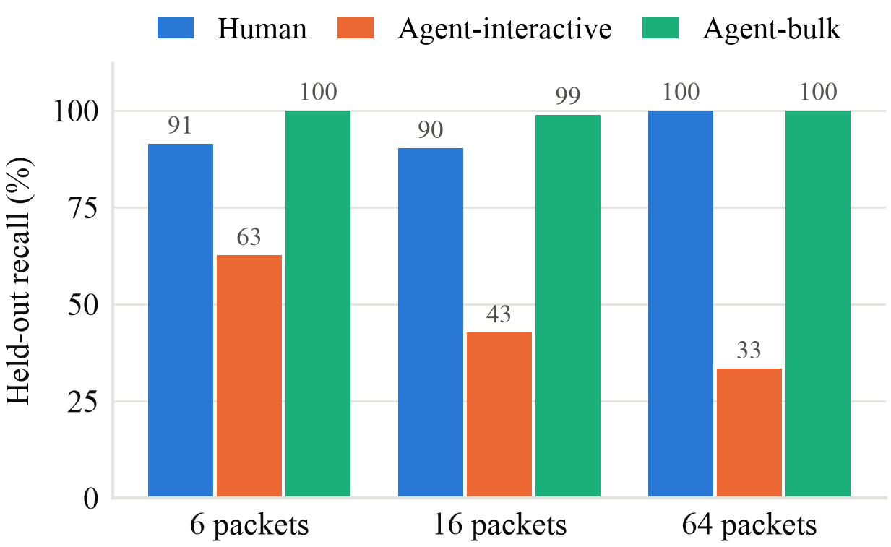
Fig. 3. Held-out recall per class at the 6-, 16- and 64-packet checkpoints (synthetic corpus, seed 1).

Browser-Agent Diagnosis
To test whether more capacity or other features would fix browser agents, we repeated training under three seeds with whole client sessions, not just flows, held out (Table IV, Fig. 5). Grouping by flow is optimistic because flows from the same session share behavior: the full tree’s human-browsing recall drops from 86.4% to 77.1% once sessions are separated. A 100-tree random forest raises browser-agent recall to 65.4% but cuts human-browsing recall to 46.1%. Removing TLS features changes little; removing fan-out costs MCP recall (97.1% to 67.8%); and a timing, fan-out and age tree trades human errors for browser recall. On reserved sessions the full tree’s browser recall ranged from 0.5% to 36.8% across seeds.
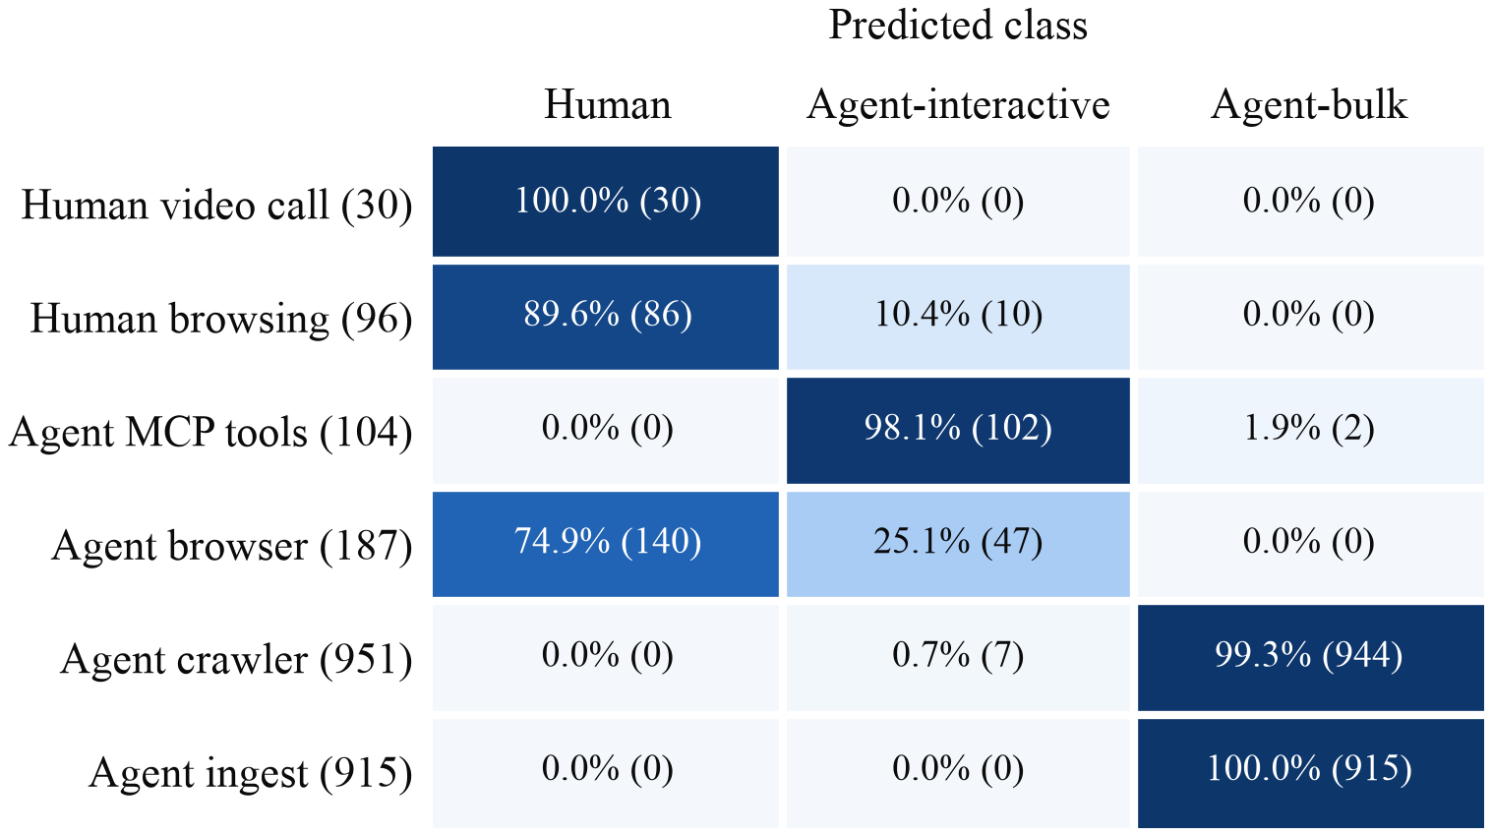
Fig. 4. Held-out confusion by generating profile (row-normalized, all checkpoints; counts in parentheses). Browser-driven agents are mostly read as human.
- Browser Diagnosis: Flow- vs Session-Grouped CV (Recall %)
Grouping, model | Browser agent | Human browsing | MCP agent | Macro-F1
Flow, tree | 37.9 | 86.4 | 98.9 | 0.807
Session, tree | 35.9 | 77.1 | 97.1 | 0.754
Flow, forest | 80.0 | 65.8 | 98.9 | 0.867
Session, forest | 65.4 | 46.1 | 99.0 | 0.781

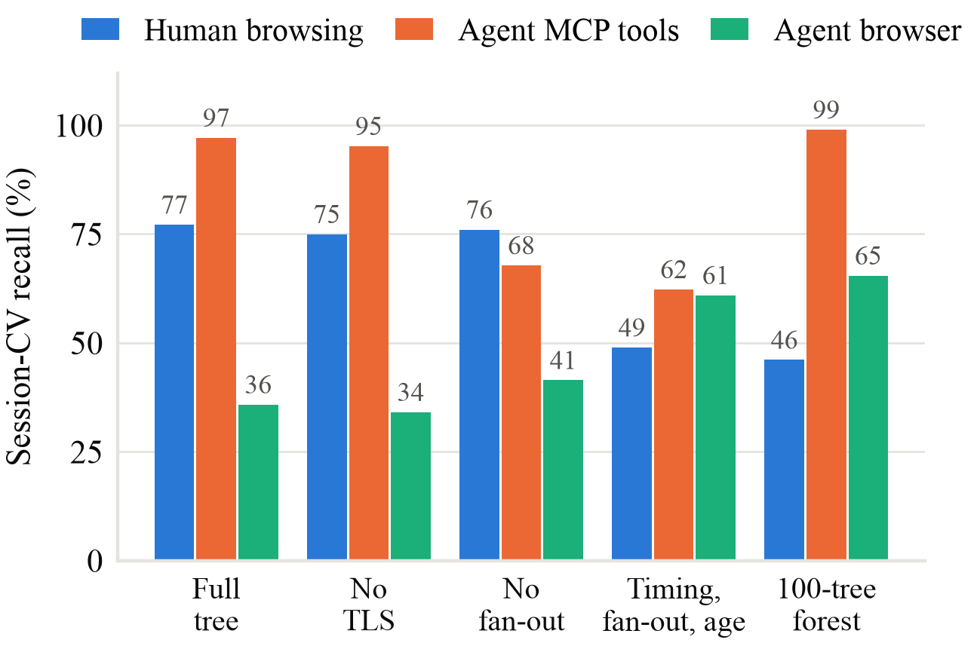
Fig. 5. Session-grouped cross-validation recall for feature ablations and a random forest (means over three seeds).

Findings and Lessons
Exactness is part of the model (F2). A tree trained in scikit-learn is defined by float32 comparisons, while the switch compares integers; above 2²⁴ the two disagree unless each boundary is compiled as the largest integer k with float32(k) ≤ θ. Together with a bit-exact mirror of the switch arithmetic, this makes the compiled tables, not the trained model, the artifact under test: they agree on all 2,283 held-out rows, and the equivalence gate detects a single altered boundary.
Per-flow features do not identify browser agents (F4). Both browser profiles carry identical TLS feature values (extension count 7, ALPN class none), and their median IAT averages at 64 packets are 467 and 471.5 µs. The difference between a person and an agent browsing lies between page loads, that is, across flows and outside any single flow’s history. Added capacity only moves errors between classes, and flow-grouped validation overstates the forest’s browser recall by 14.5 points, so session-grouped validation is essential for this problem. Tool-calling agents, whose HTTP client stack and parallel request structure differ, are separable (F3), and burst fan-out carries most of that signal (F5).
Post-quantum TLS splits the handshake (F6). Hybrid post-quantum key shares enlarge the ClientHello. Among the handshakes we captured, Chrome 154 sends 1,899 B and Python 3.11 with OpenSSL 3.6.2 sends 1,536–1,539 B, all above a 1,460-B MSS; only curl with LibreSSL (301 B) fits in one segment. A parser that reads the first payload packet therefore sees only the extensions carried in the first segment. Together with Encrypted Client Hello, which hides the server name, this erodes handshake fingerprints as a data-plane signal and favors the timing and burst features the classifier already relies on.
Software-switch defaults matter (F7). BMv2’s simple_switch starts with a single priority queue, so every class shares one FIFO and a strict-priority experiment silently measures nothing. Our launcher derives the queue count from the class treatments and passes --priority-queues 3.
Scope. The prototype targets BMv2, a functional reference switch; latency is defined relative to the l2fwd program on the same host, and the @atomic annotations record what a hardware target requires. The data plane depends on the controller for neither forwarding nor classification. DSCP markings are meaningful inside the deploying domain, so the design targets a single device at a choke point such as a campus gateway or the leaf in front of an API cluster. An agent can imitate human think time, but doing so makes it as slow as a human, which is the service the network would have given it anyway.

Conclusion and Future Scope
We built and verified a P4 pipeline that couples an in-switch agent classifier to transport QoS in a single pass, with a fail-open design, a bit-exact train/serve path and a control loop that refines rather than replaces the switch’s decision. The compiled tables match the trained model exactly, and a live BMv2 run confirmed the parser, flow state, CPU punt and override paths. On a seeded synthetic corpus, tool-calling and bulk agents are separable per flow while browser-driven agents are not, and post-quantum handshakes reduce what a switch can learn from one packet.
Future scope extends this work in four directions. Running the Mininet four-baseline grid (agent share 10–90%, three burst intensities, five seeds) will quantify human p99 protection against the ≥30% target and per-packet overhead against the <5% target, together with state scaling to 100k flows and the cost of timing evasion. A labeled corpus captured from real agent frameworks (Browser Use, Playwright, AutoGen and MCP clients) and human traces such as MAWI [22] will validate the classifier beyond synthetic workloads. Session-level, cross-flow features target browser agents, and a multi-segment ClientHello parse targets post-quantum handshakes. Finally, a Linux PTF packet-test suite, Web Bot Auth verification, a Ryu port of the controller, a Tofino hardware target and IPv6/QUIC support broaden the deployment.

Acknowledgment
The authors thank the School of Computer Science and Engineering (SCOPE) and the Centre for Artificial Intelligence and Research (CFAIR), Vellore Institute of Technology, for the facilities and academic support provided for this work under the BCSE308L Computer Networks course.

References
- Thales/Imperva, “2026 Imperva Bad Bot Report,” 2026.
- Model Context Protocol Specification, rev. 2025-03-26. [Online]. Available: https://modelcontextprotocol.io/specification
- K. Nichols, S. Blake, F. Baker, and D. Black, “Definition of the Differentiated Services Field (DS Field) in the IPv4 and IPv6 headers,” RFC 2474, IETF, 1998.
- S. Blake et al., “An architecture for differentiated services,” RFC 2475, IETF, 1998.
- P. Bosshart et al., “P4: Programming protocol-independent packet processors,” ACM SIGCOMM Comput. Commun. Rev., vol. 44, no. 3, pp. 87–95, 2014.
- Z. Xiong and N. Zilberman, “Do switches dream of machine learning? Toward in-network classification,” in Proc. ACM HotNets, 2019, pp. 25–33.
- C. Busse-Grawitz, R. Meier, A. Dietmüller, T. Bühler, and L. Vanbever, “pForest: In-network inference with random forests,” arXiv:1909.05680, 2019.
- G. Xie, Q. Li, Y. Dong, G. Duan, Y. Jiang, and J. Duan, “Mousika: Enable general in-network intelligence in programmable switches by knowledge distillation,” in Proc. IEEE INFOCOM, 2022.
- C. Zheng et al., “Automating in-network machine learning,” arXiv:2205.08824, 2022.
- G. Zhou, Z. Liu, C. Fu, Q. Li, and K. Xu, “An efficient design of intelligent network data plane,” in Proc. USENIX Security Symp., 2023.
- A. G. Alcoz, M. Strohmeyer, V. Lenders, and L. Vanbever, “Aggregate-based congestion control for pulse-wave DDoS defense,” in Proc. ACM SIGCOMM, 2022.
- K. Ramakrishnan, S. Floyd, and D. Black, “The addition of Explicit Congestion Notification (ECN) to IP,” RFC 3168, IETF, 2001.
- J. Althouse, “JA4+ network fingerprinting,” FoxIO, 2023. [Online]. Available: https://github.com/FoxIO-LLC/ja4
- A. Backman, J. Richer, and M. Sporny, “HTTP message signatures,” RFC 9421, IETF, 2024.
- E. Rescorla, “The Transport Layer Security (TLS) protocol version 1.3,” RFC 8446, IETF, 2018.
- M. Shreedhar and G. Varghese, “Efficient fair queuing using deficit round-robin,” IEEE/ACM Trans. Netw., vol. 4, no. 3, pp. 375–385, 1996.
- p4lang, “Behavioral Model (BMv2) simple_switch,” GitHub. [Online]. Available: https://github.com/p4lang/behavioral-model
- G. Cormode and S. Muthukrishnan, “An improved data stream summary: The count-min sketch and its applications,” J. Algorithms, vol. 55, no. 1, pp. 58–75, 2005.
- F. Pedregosa et al., “Scikit-learn: Machine learning in Python,” J. Mach. Learn. Res., vol. 12, pp. 2825–2830, 2011.
- B. Lantz, B. Heller, and N. McKeown, “A network in a laptop: Rapid prototyping for software-defined networks,” in Proc. ACM HotNets, 2010.
- P. Barford and M. Crovella, “Generating representative web workloads for network and server performance evaluation,” in Proc. ACM SIGMETRICS, 1998, pp. 151–160.
- K. Cho, K. Mitsuya, and A. Kato, “Traffic data repository at the WIDE project,” in Proc. USENIX Annu. Tech. Conf., FREENIX Track, 2000.

