**Problem Statement :** Design following diagram.

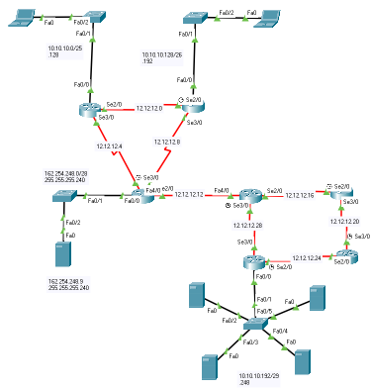

**IP Calculation:**

CSE: 70, CE: 60, Server: 4 (Network Address: 10.10.10.0/24)

Router- Router: 8 (12.12.12.0/30). DNS Server: 162.254.248.9 [255.255.255.240]

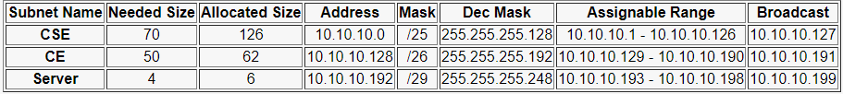

**Server Setup :**

Select server[uap, cse, ce, admin, main].

Go to Desktop > IP Configuration.

Insert IPv4 address and Default Gateway according to the note.

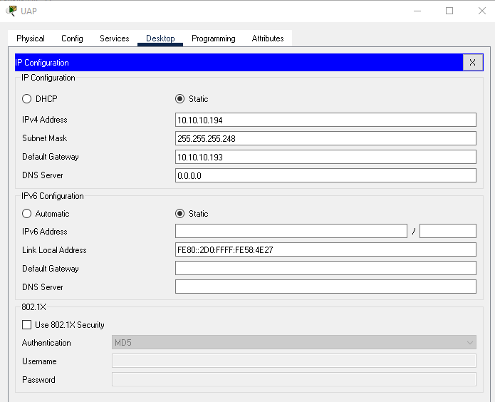

And we are done for server setup.

**PC/Laptop Configuration :**

Now we will configure our PC according to our excel note

Select a PC to configure.

Desktop > IP Configuration.

Inset IPv4 address, default gateway, DNS server according to the note.

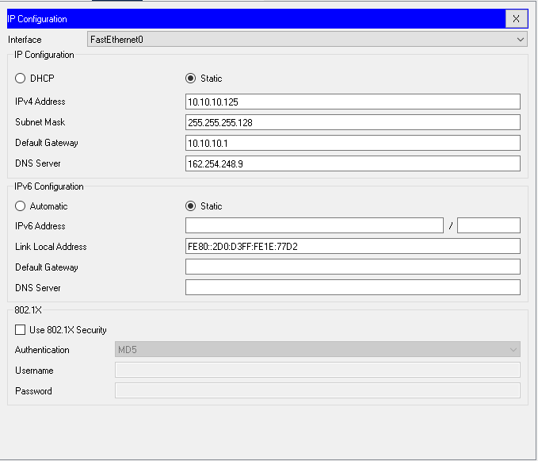

**DNS Configuration :**

Select server. Then Services > DNS

Then click ADD button and you can see the added Name below.

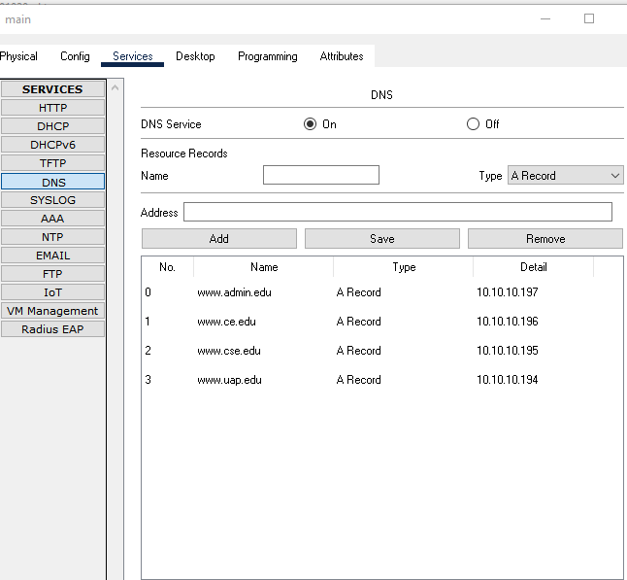

**Password**

enable

conf t

enable se 19101020

line console 0

pass 19101020

line vty 0 4

pass 19101020

**OSPF Configuration :**

Now we have to establish OSPF configuration to establish a successful communicative connection between all used routers.

Select a router. Then CLI there comes a box where we need to write some code.

Follow the steps:

conf t

router ospf 020

network 10.10.10.8 0.0.0.3 area 19101020

network 10.10.10.20 0.0.0.3 area 19101020

network 10.10.10.16 0.0.0.3 area 19101020

network 192.168.7.0 0.0.0.255 area 19101020

network 192.168.8.0 0.0.0.255 area 19101020

end

Do this work for all routers according to the table below:

After configuring all routers, we can check using [show ip route] to confirm that all networks are connected.

You can check, if all networks are connected or not, using “show ip route”.

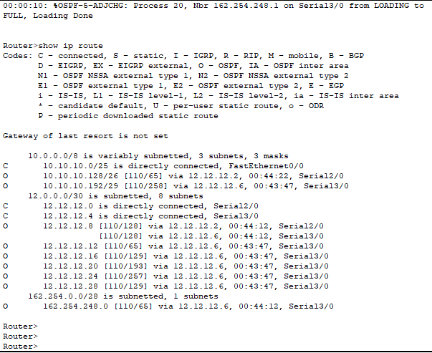

if everything is ok, we are good to go for web search.

