**Problem Statement :** Design following diagram.

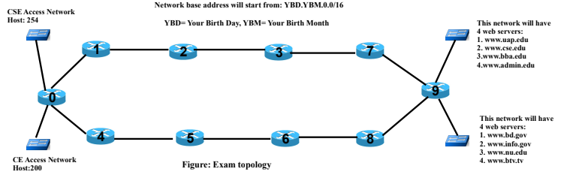

**IP Calculation:**

Birthday: 02/01/2000

Given IP: 2.1.0.0/16

Subnetmask: 255.255.0.0

Starting IP: 2.1.0.0

Total number of network: 15

Ip addresses: **2.1.0.0** to **2.15.0.0**

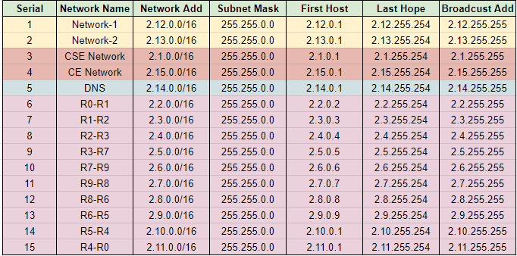

Now we will note down necessary information IP-addresses and use it for network setup.

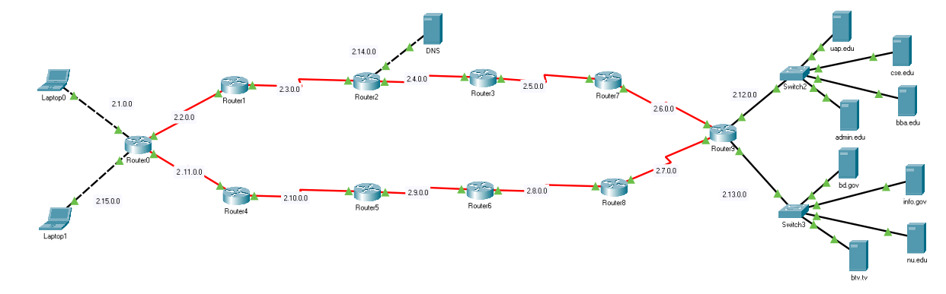

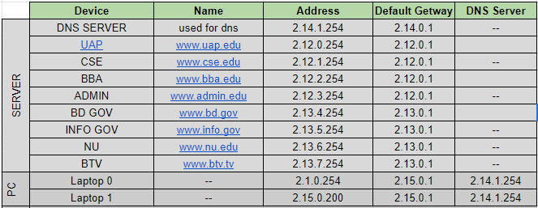

**Server Setup :**

Select server[uap, cse, bba, admin, bd.gov, info.gov, nu, btv.tv].

Go to Desktop > IP Configuration.

Insert IPv4 address and Default Gateway according to the note.

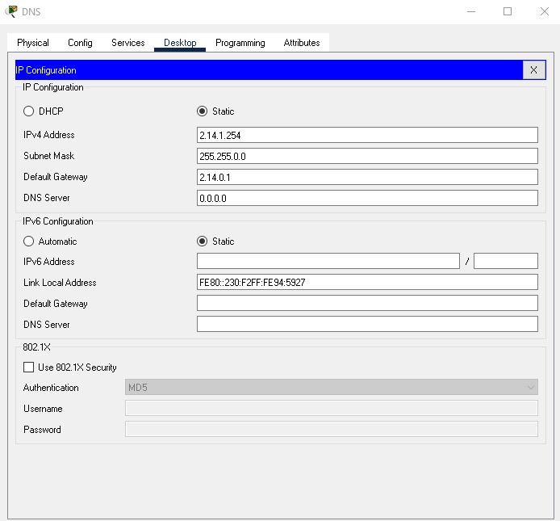

And we are done for server setup.

**PC/Laptop Configuration :**

Now we will configure our PC according to our excel note

Select a PC to configure.

Desktop > IP Configuration.

Inset IPv4 address, default gateway, DNS server according to the note.

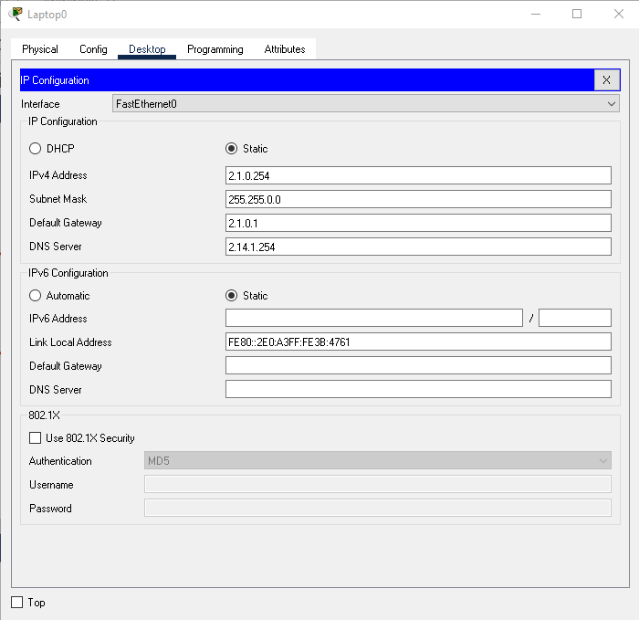

**DNS Configuration :**

Select west server & east server. Then Services > DNS

ON the DNS. Then enter the Name and addresses of UAP,CSE,BBA,ADMMIN,BD,INFO,NU,BTV according to the table.

Then click ADD button and you can see the added Name below.

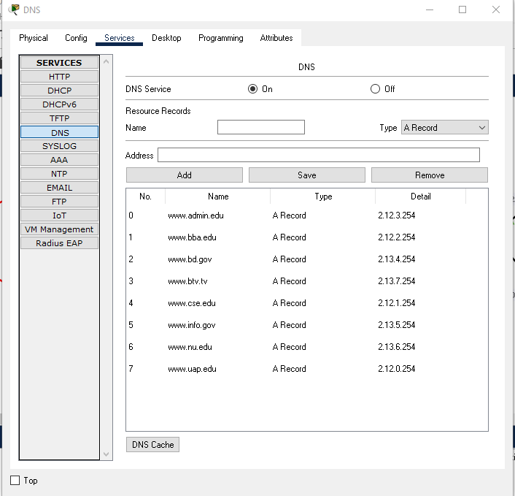

**RIP VERSION-2 Configuration :**

Now we have to establish RIP version-2 configuration to establish a successful communicative connection between all used routers.

Select a router. Then CLI there comes a box where we need to write some code.

Follow the steps:

**enable**

**conf t**

**router rip**

**version 2**

**no auto summary**

**network 2.11.0.0**

**network 2.10.0.0**

**End**

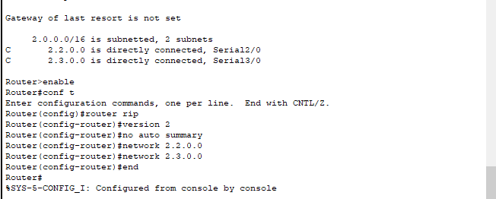

Do this work for all routers according to the table below:

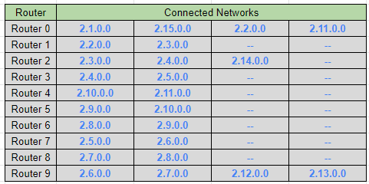

After configuring all routers, we can check using [show ip route] to confirm that all networks are connected.

You can check, if all networks are connected or not, using “show ip route”.

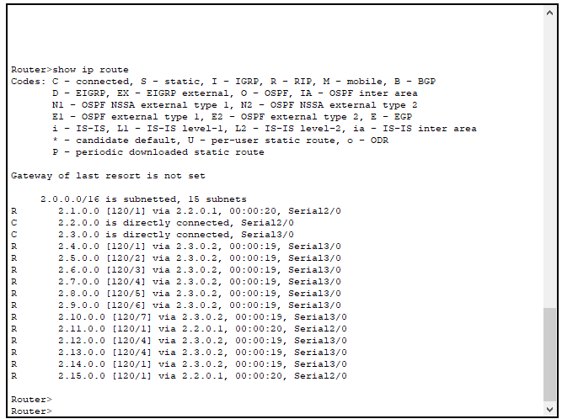

if everything is ok, we are good to go for web search.

