Sources of information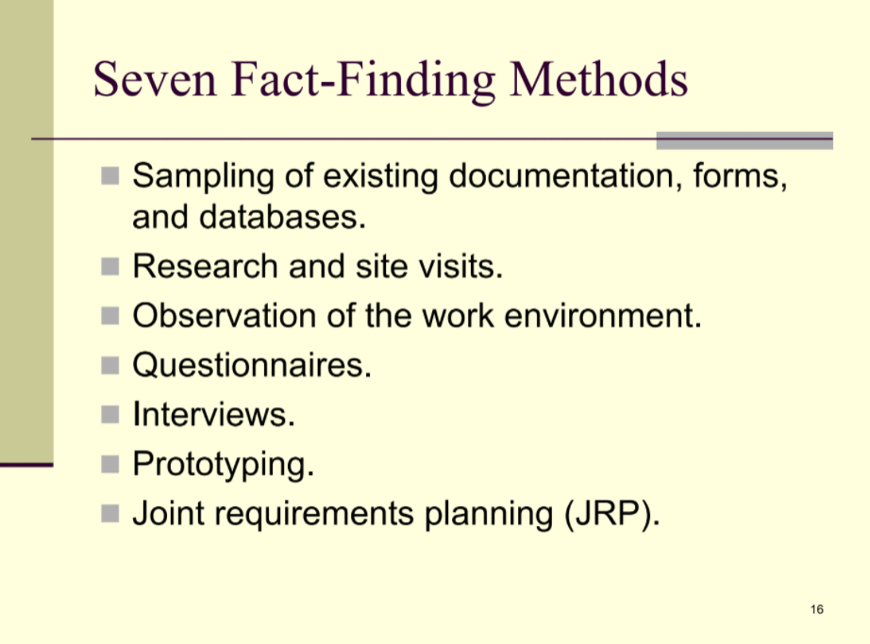

.

**Fact-Finding Tools / information gathering tools:** The formal process of using research, meeting, interviews, questionnaires, sampling, and other techniques to collect information about system problems, requirements & preferences. It is also called information gathering or data collecting.

**7-Fact-Finding Methods:

1. Sampling of existing documentation, forms & databases.
   1. ** Process of collecting a representative sample of documents, forms & records. Such as:
      1. Organization chart
      2. Memos and other documents that describe the problem
      3. Standard operating procedures for current system
      4. Completed of databases
      5. Flowchart & other system documentation
2. Research & site visits :

Take ideas from other similar documents & papers.

1. Observation of the work environment
   1. **A fact finding technique wherein the systems analyst either participates in or watches person perform activities to learn about the system.
   2. Work sampling- a fact finding technique that involves a large number of observations taken at random intervals.
   3. Guidelines:
      1. Determine the who, what, where, when, why, and how of observation
      2. Obtain permission from appropriate supervisors.
      3. Keep a low profile.
      4. Take notes
      5. Review observation notes
      6. Don’t interrupt the individuals at work
      7. Don’t focus heavily on trivial activities
      8. Don’t make assumptions.
2. Questionnaires
   1. **A special-purpose document that allows the analyst to collect information and opinions from respondents. There will be 2 part:
   2. Free format questionnaires---- designed to offer the respondent greater latitude in the answer.
   3. Fixed format questionnaires--- containing questions that require selecting an answer from predefined available responses.
   4. Types:
      1. Multiple choice questions
      2. Rating questions
      3. Ranking questions
3. Interviews
   1. **A fact-finding technique whereby the system analysts collect information from individuals through face-to-face interaction.
   2. Types: such as
      1. Unstructured interview- conducted with only a general goal or subject in mind
      2. Structured interview- has a specific set of questions to ank
      3. Closed-ended question- a question that restricts answers to either specific or short & direct responses
   3. Procedure
      1. Select interviewees
      2. Prepare for the interview
      3. Conduct the interview
      4. Follow up on the interview
   4. Here we will work on
      1. Find, Verify & Clarify facts
      2. Generate enthusiasm
      3. Get the end-user involved
      4. Identify requirements
      5. Collect ideas & opinions
4. Prototyping-- the act of building a small-scale, representative or working model of the user’s requirements in order to discover or verify those requirements.
5. Joint requirements planning-- a process whereby highly structured group meetings are conducted for the purpose of analyzing problems and defining requirements.
   1. Participants:
      1. Sponsor
      2. Facilitator
      3. Users and managers
      4. Scribes
      5. IT staff
   2. Steps to plan JRP session
      1. Selecting a location
      2. Selecting the participants
      3. Preparing the agenda

• Who is a system analyst?

A system analyst is a very important person for an organization who uses system analysis and design techniques to solve system or business problems. He analyzes, designs and implements systems to fulfill organization needs. System analyst conducts system study, identifies requirements & determines the procedures to achieve system objectives. In the IT industry, system analysts figure out how to solve a problem by linking different computers and specifying what platform, protocols, software hardware and communication medium can be used to solve a problem.

• Role and Responsibilities of a system analyst

1. Research and evaluate new technology

2. Identify the organizational needs

3. Analyze costs and benefits

4. Add new functionality to systems

5. System analysis, design, upgradation, implementation, maintenance.

• What does a system analyst do?

1. Change agent: System analyst evaluates the current system and as well as researches for new future updates for better system development

2. Architect: System analyst is the architect of the system

3. Motivator: System analyst is motivator who motivates his team to work properly and do their best

• Qualities of system analyst

1. Knowledge of the organization

2. Knowledge of computer hardware and system

3. Problem solving and critical thinking

4. Analytical skills

5. Motivator skill

6. Good understanding , communication and teaching abilities