**Feasibility Study:** Measure of how beneficial or practical an information system will be to an organization.

5 major dimensions: Economic, Technical, operational, schedule and legal

1. Economy feasibility:
2. System’s cost & benefits
3. Development and operating cost and compare with expected financial benefits of the system
4. Tangible Benefits: Terms of monthly or annual savings
5. Intangible Benefits
6. Cost-effectiveness analysis
7. Payback, net present value, return on investment, internal rate of return
8. Cost benefit analysis report

b. Technical feasibility:

1. Concerned with technology to be used in the system
2. Access whether technology to be used in the system is available or not
3. Lack of technical feasibility

c. Operational feasibility:

1. Measure of “How well the proposed solution will work in the organization”
2. How internal and external customers will react to it.

d. Schedule feasibility:

1. Weather the system can be completed on time
2. What if the system can’t be delivered in time(loss of customers_ out of business)
3. Problem of going over schedule

e. Legal feasibility:

1. Concerned with legal issues
2. Should not violate in the country where it will be used
3. If there were any political repercussions of using the system

Conflict between proposed system and legal requirement

**Project feasibility:** Feasibility analysis guides an organization in determining whether to proceed with the project. It also identifies the important risks associated with the project that must be managed if the project is approved

As with the system request, each organization has its own process and format for the feasibility analysis, but most include techniques to assess three areas: “Technical feasibility, Economic feasibility & Organization feasibility”. The results of evaluating these three feasibility factors are combined into a feasibility study deliverable that is submitted to the approval committee at the end of project initiation.

1. **Technical Feasibility:**  We can build this project
   1. Familiarity with application
   2. Familiarity with technology
   3. Project Size
   4. Compatibility
2. **Economic feasibility:** Should we build it?
   1. Development Cost
   2. Annual operating costs
   3. Annual benefits
   4. Intangible benefits and costs

[Technical Feasibility Familiarity with application low The Thomas House of](https://www.coursehero.com/file/p2fotq4/Technical-Feasibility-Familiarity-with-application-low-The-Thomas-House-of/)

According to the Project Management Institute, the term project stakeholder refers to, "an individual, group, or organization, who may affect, be affected by, or perceive itself to be affected by a decision, activity, or outcome of a project."

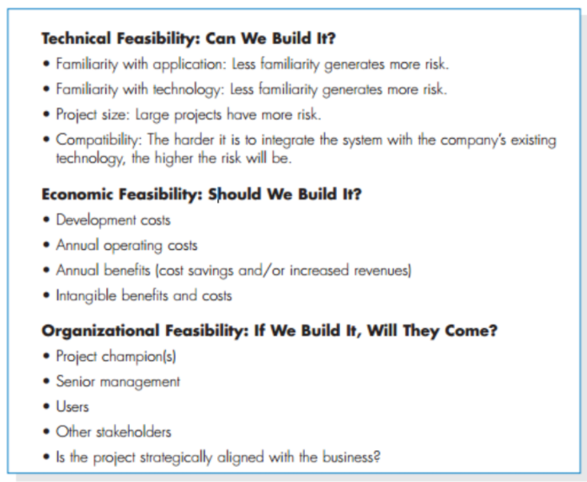

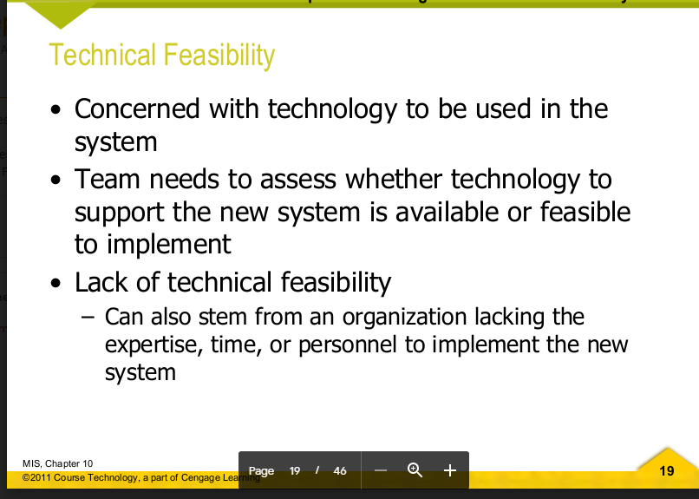

Ei table just amader nijeder hishab er jonne

| Component | Place 1 | Place 2 | Place 3 | Place 4 | Average |
| --- | --- | --- | --- | --- | --- |
| Usual fee range of guide |  |  |  |  |  |
| Usual percentage from guide |  |  |  |  |  |
| Management cost |  |  |  |  |  |
| Development cost | 40K without blog | 7.5K for blog site | 50K for all |  | 50K |
| Maintenance cost  Per year | 9K |  | 26K |  |  |
| Server cost per year | included |  | included |  |  |
| Advertisements costs | Fb- 100K people 68K taka | Insta- 100K people 68K taka | Youtube:  Channel of  100K-500K 70K taka per video | Newspapers and magazines:  About 10 lakh  To run a front page ad 4 days 🥴 |  |

---

| **Website Feature** | **Upfront Website Cost** | **In taka** |
| --- | --- | --- |
| **Website Domain** | $12 - $60 | 1K-5K |
| **Website Hosting** | $35 - $600 | 3K-50K |
| **SSL Certificate** | $0 - $200 | 0-15K |
| **Website Template or Theme** | $0 - $200 | 0-15K |
| **Ecommerce Functionality** | $20 - $24K | 1500-2040000 |
| **Website Content** | $0 - $5K | 0-425K |
| **Apps and Integrations** | $0 - $100 | 0-8.5K |
| **SEO and Marketing** | $0 - $90 |  |

*add point to talk about search engine optimization in maintenance portion.

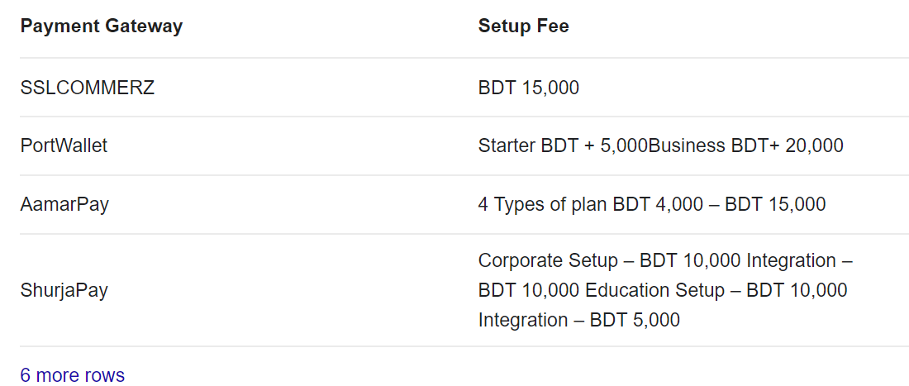

https://devathon.com/top-10-best-payment-gateways-bangladesh/

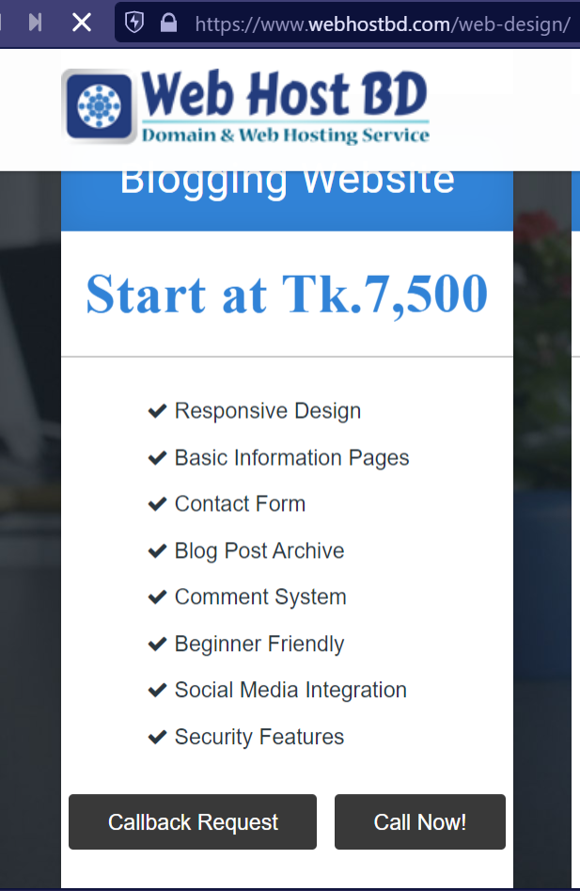

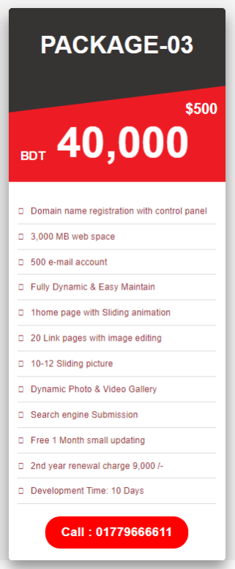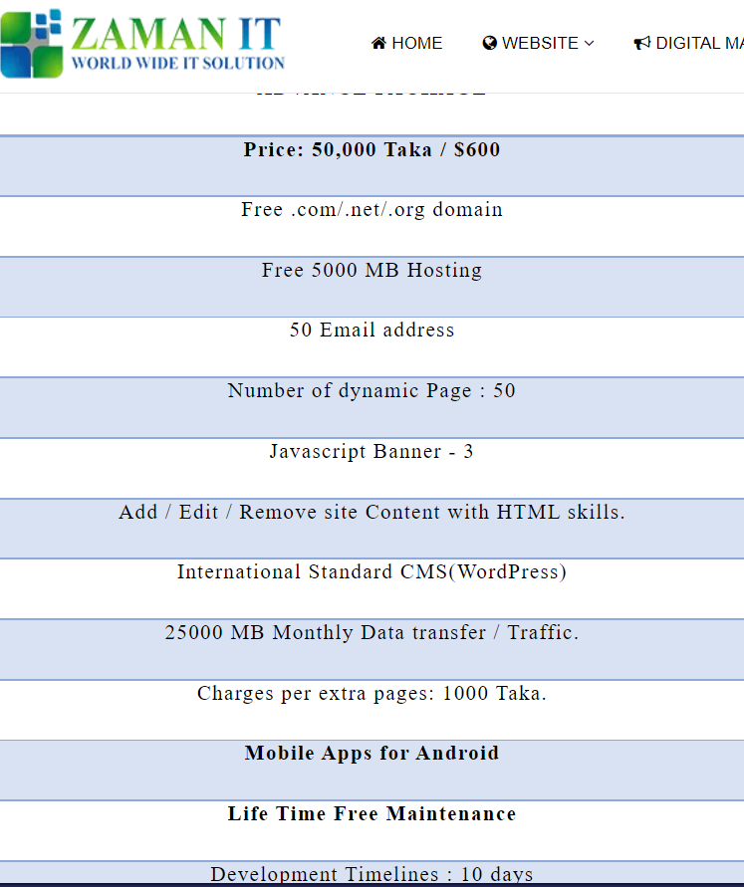

Good morning everyone. I’m Shawan and today i’m gonna describe a Use case diagram. Before that I will go through the signs and their meaning.