

**UNIVERSITY OF ASIA PACIFIC**

**Department of Computer Science & Engineering**

Assignment

**Course Title –**  Numerical Methods Lab

**Course Code –** CSE 314

|  |  |
| --- | --- |
| **Submitted by:**  Shawan Das.  ID –19101020  Section –A1 | **Submitted To:**  Nadeem Ahmed  Assistant Professor,  University of Asia Pacific |

**Date of Submission –**  17-04-2022

**Bisection Method Algorithm:**

# Consider, f(x) = x2 +5x -10

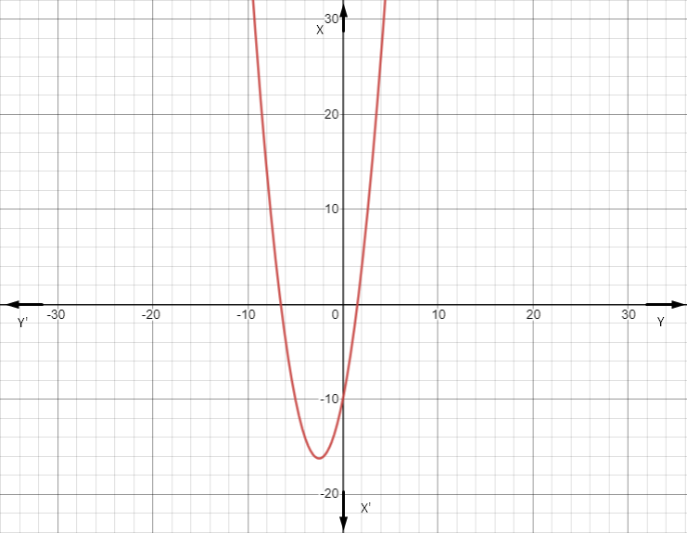

For the 2nd degree equation f(x) has 2 root value.

For bisection method we need 2 initial guesses.

1) Between -9 and -2.

1. Between 0 and 2.

Considering initial guess xl= -9 and xu= -2

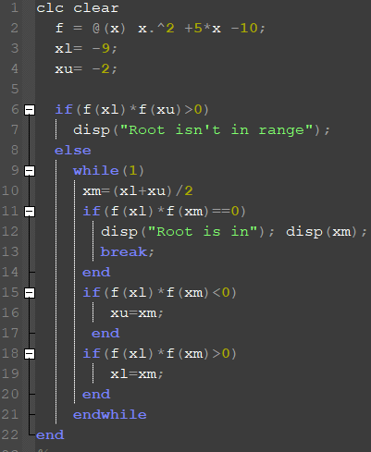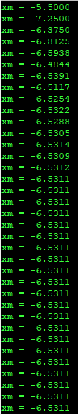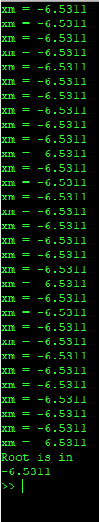

The first root found in -6.5311 . It needed around 16 iterations.

Now for the 2nd root consider initial guesses xl=0; xu=2;

And the root was found in 1.5331 after round 14 iteration.

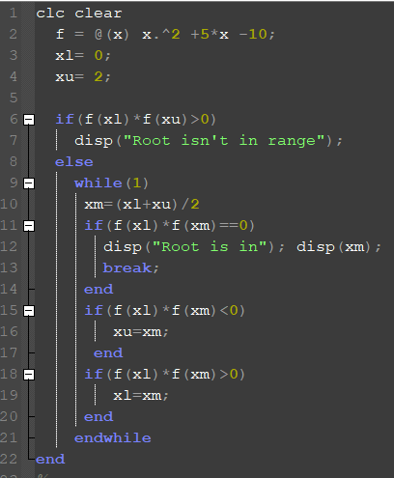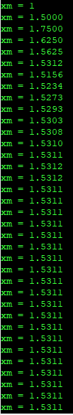

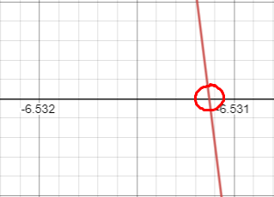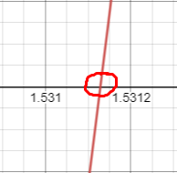

Root points

**Newton Raphson Method Algorithm:**

# Consider, f(x) = x2 +5x -10



In Newton Raphson method, we need only one initial guess close to the root value.   
Let’s consider the initial guess x0 = -8

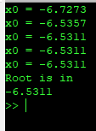Implementing Newton Raphson method and 5 iteration, we get

The root is in -6.5311

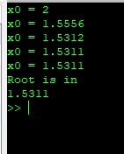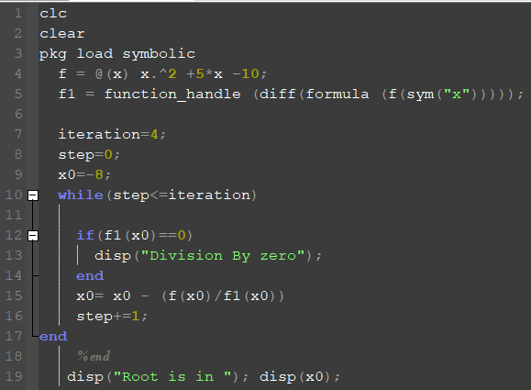

Initial Guess, x0 = 4 - we get

Its takes only 4 iterations, to find the root value.

Which is 1.5311 .

**Comparative Analysis:**

|  |  |
| --- | --- |
| **Bisection Method** | **Newton Raphson Method** |
| Took much more iteration to find the root in f(x) each time | Performed 5 iteration but found the closer to root value in 4 iteration. |
| Converges slow | Converge faster than “Bisection Method”. |
| If we take initial guesses closer to root value, it converges more faster | Any guesses closer to the root point converges fast. And needed only one initial guess to perform this method which is much better than the Bisection method because the Bisection method needed 2 initial guesses. |

**Ans of 2:**

Provided code,

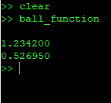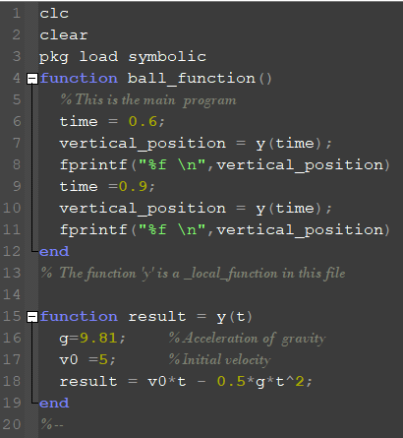

1. 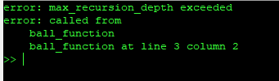Remove “function” from “function ball_function()” which is the wrong way to call a function.
2. 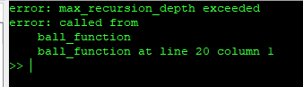Change “function ball_function()” to “function ball_func()”.

It will give an error in line 20 where I have called the ball_function(). It occurs because there is no function called ball_function().

1. 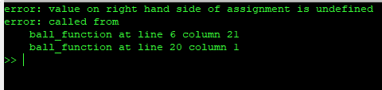Change “function result = y(t)” to “function y(t)”.

There will be an error in line-6. because here vertical_position = y(time) is expecting a returned value from function y(t). so there must be a return type for function y(t).

1. 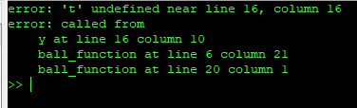Change “function result = y(t)” to “function result = y()”. There will be 2 errors in line-6 and line-16. Line-6 will give error because function result=y() have no such formal parameter to pass. But in line-6 we are calling this function with a parameter y(time). And another error occurs in line-16 because the variable t wasn’t declared in the function.
2. 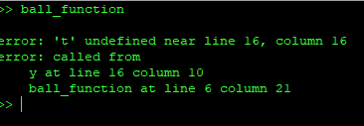There will be an error in line-6. because function result=y(t) is expecting a parameter, but when we are calling the function y(t), we didn’t pass any parameter. For that it will give an error.