

***Department of Computer Science & Engineering***

**Course Title –** Software Engineering

**Course Code –** CSE 322

**Section** - A1

Diagrams Part - 1

***Laptop Recommendation system using NLP***

**Date of Submission –** March 23, 2022



Entity Relationship Diagram

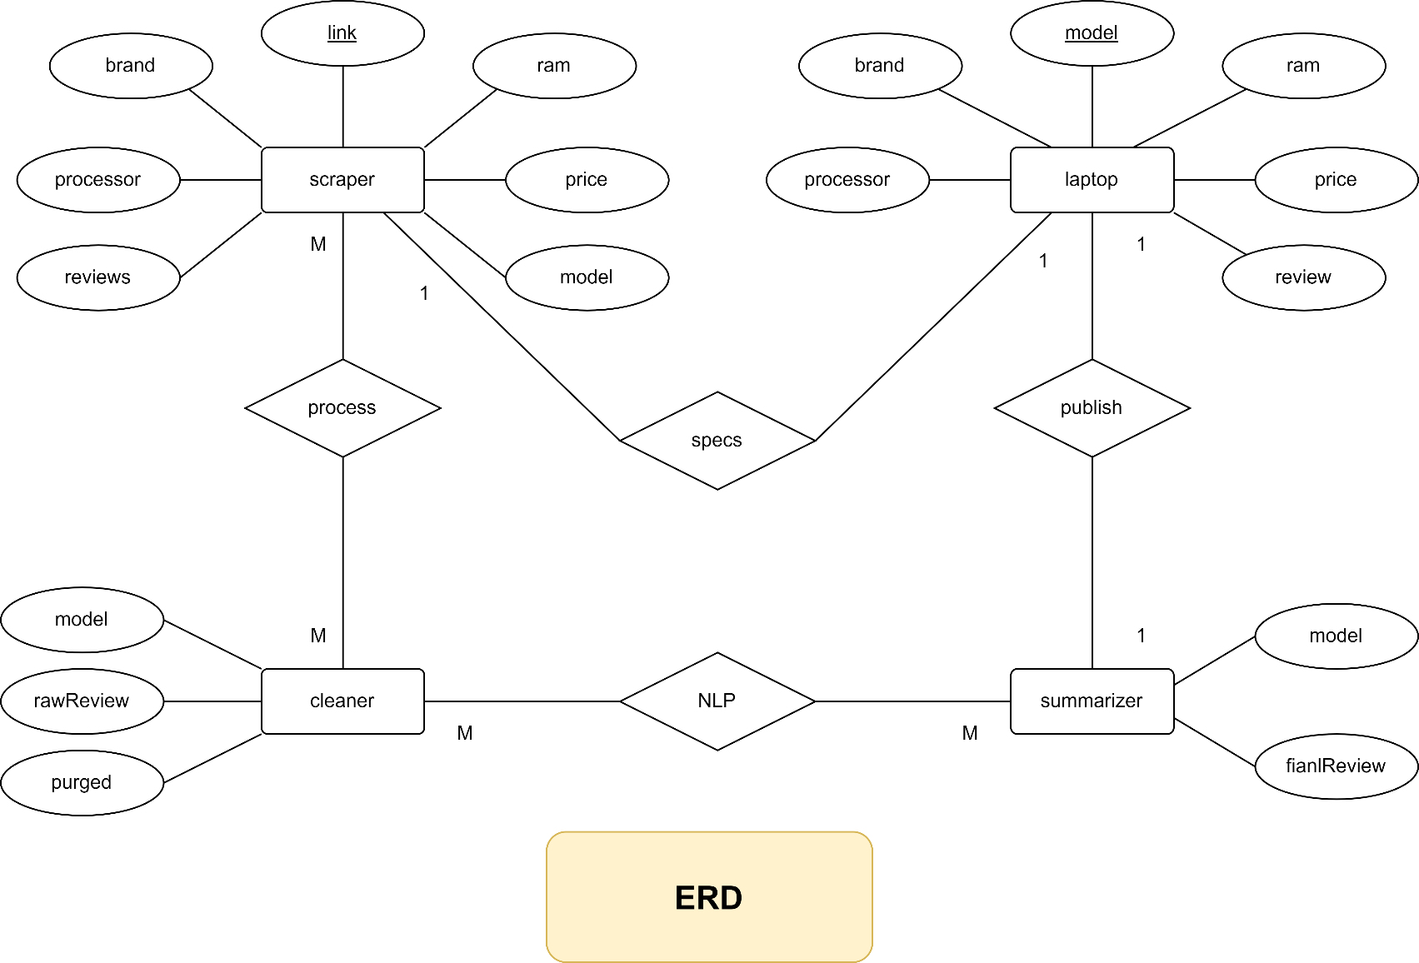

Use Case Diagram

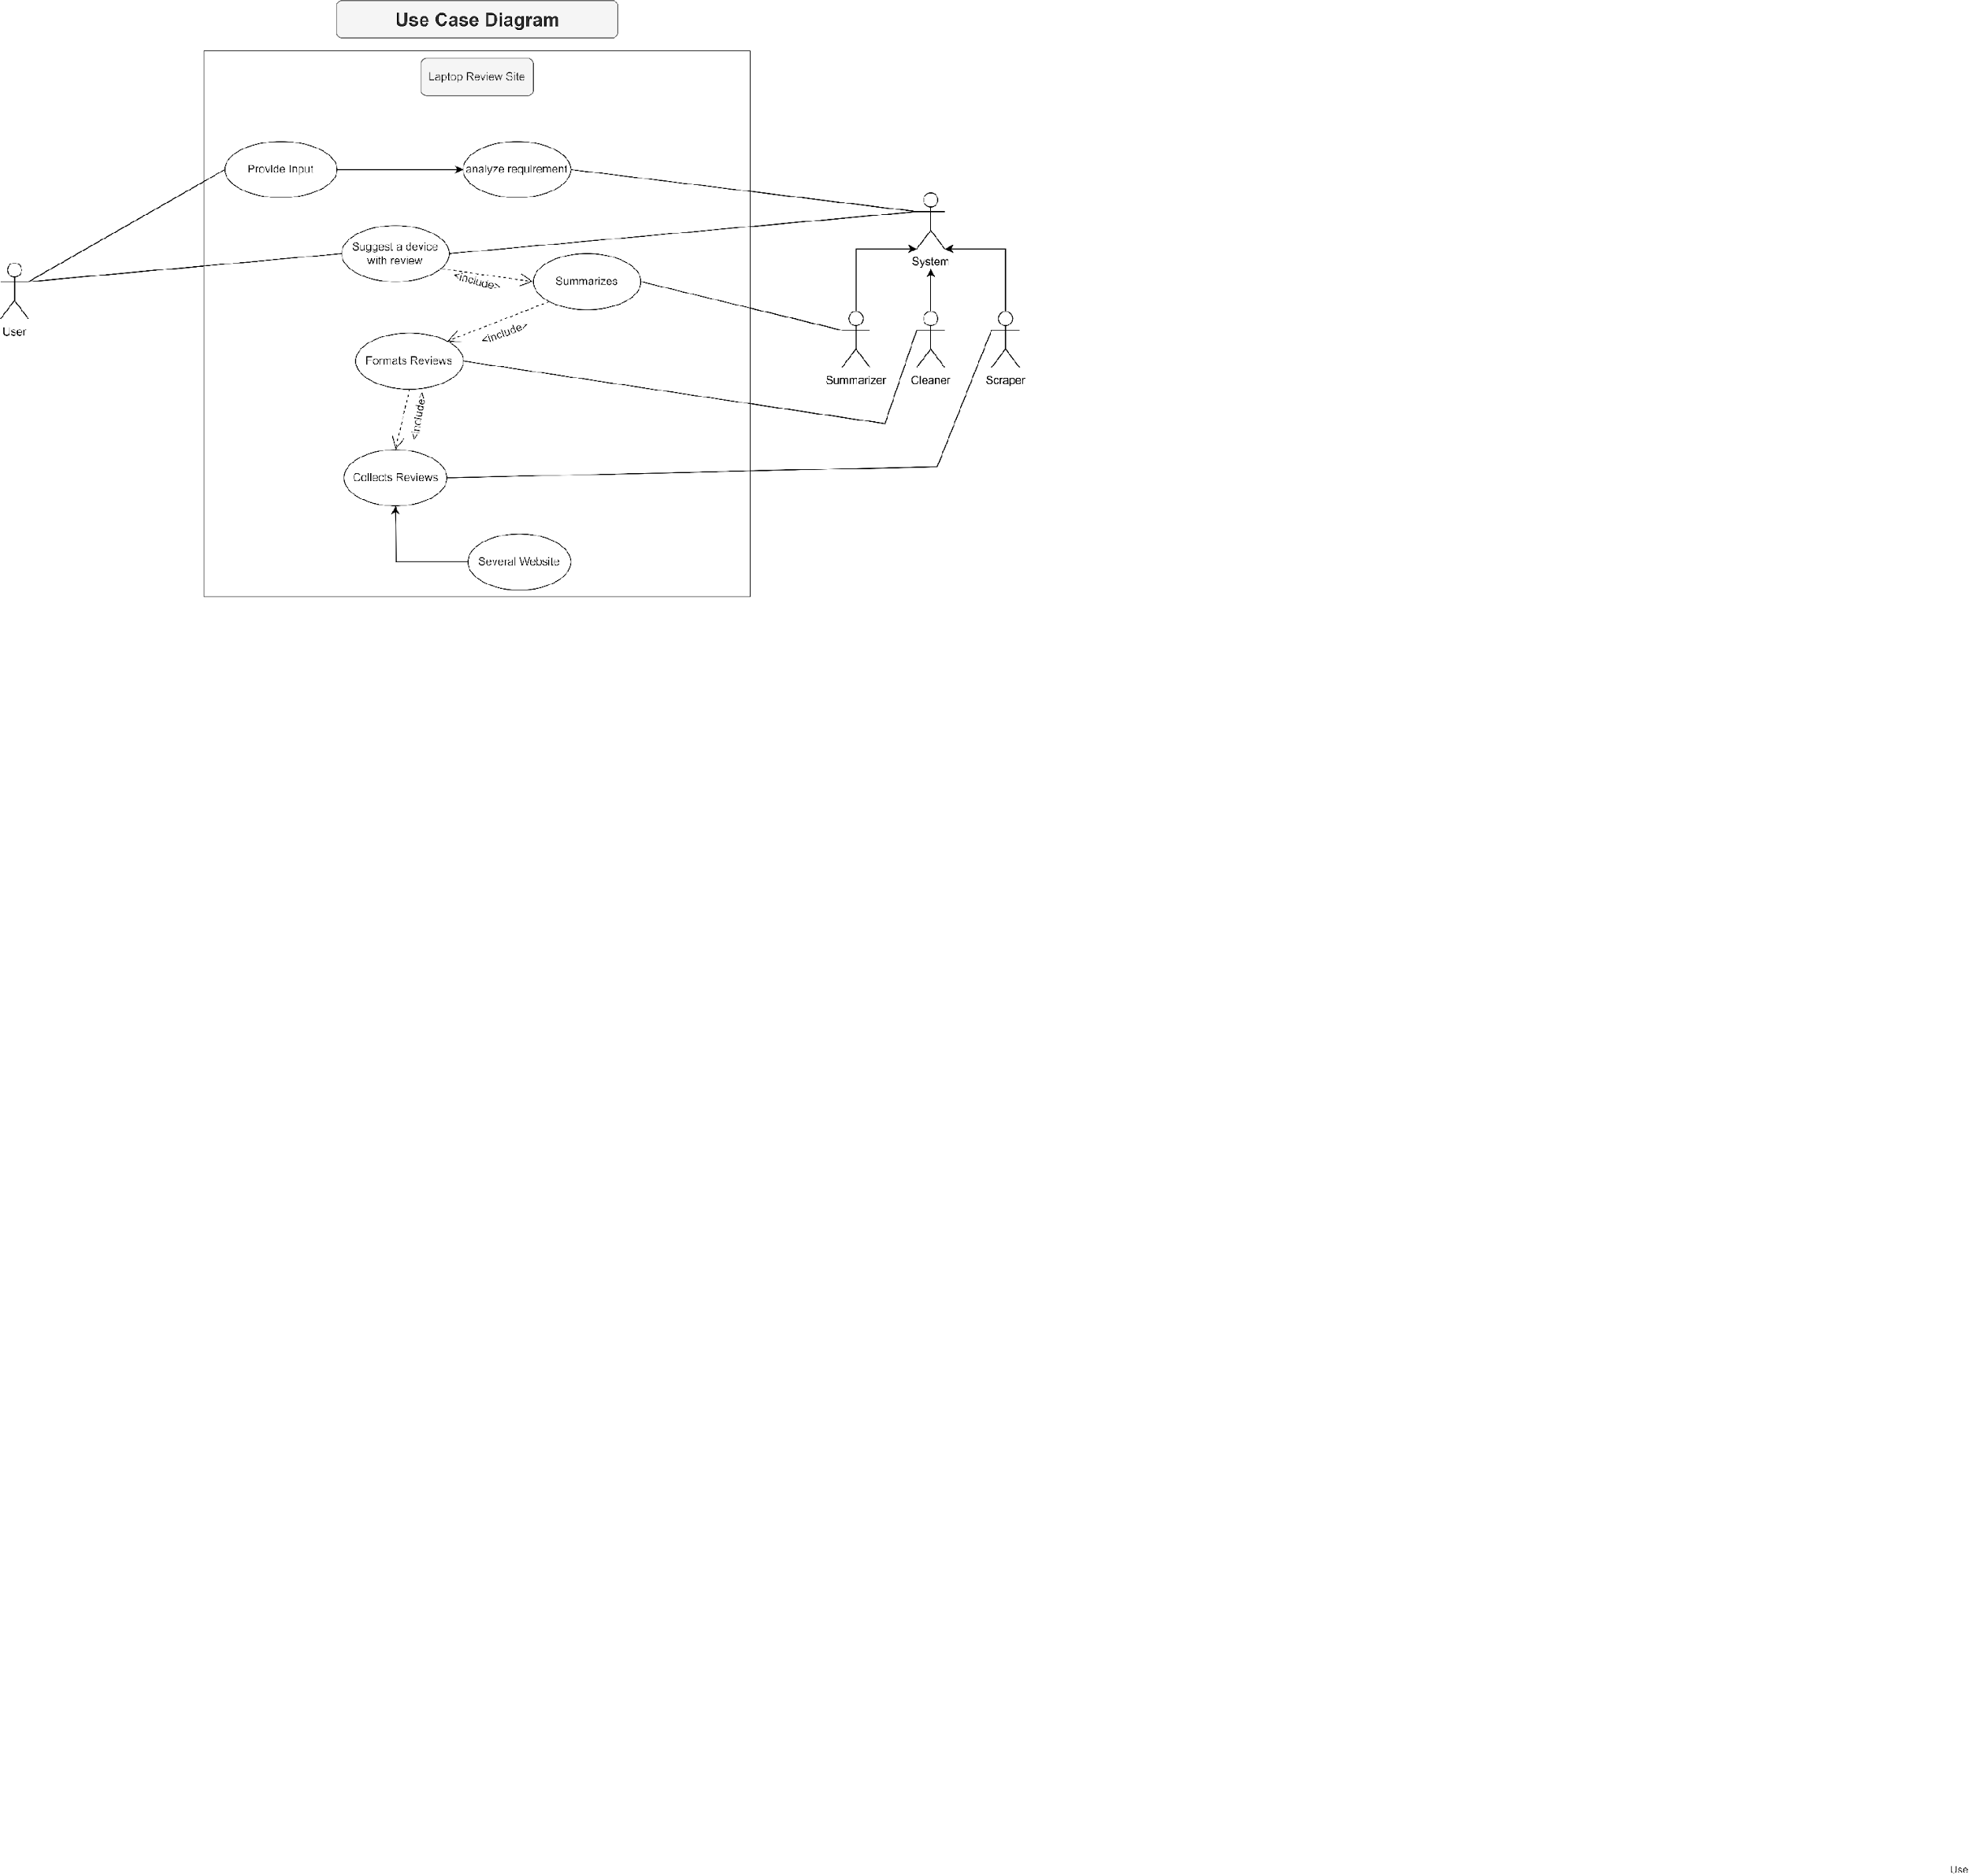

Activity Diagram

