

**UNIVERSITY OF ASIA PACIFIC**

**Department of Computer Science & Engineering**

**Course Title –**  Artificial INtelligence and Expert Systems.

**Course Code –**  CSE-403.

**Topic –** Knowledge Representation & Reasoning(KRR): First order Predicate Logic(FOPL)

| Submitted by  Shawan Das.  ID –19101020  SectSection –A | Submitted To  Dr. Nasima Begum  University of Asia Pacific |
| --- | --- |

**Date of Submission –**  24–10–2022

**Problem Statement:**

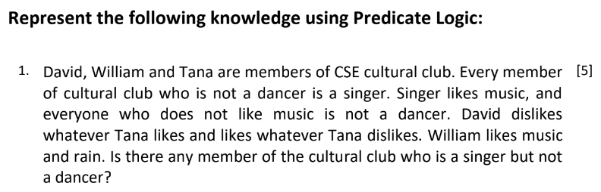

**Solution:**

Note: Cultural Club - cc

Dancer - d

Singer - s

Music - m

Rain - r

Likes - l

1. David, William & Tanah are members of Cultural Club(CC)

Representation:

cc(David);

cc(William);

cc(Tanah)

1. Every member of Cultural club who is not a dancer, is a sinder

Representation:

∀ *n* ( cc(x) ^ ~ d(*n*) ) => s(*n*)

1. Singer likes music, and everyone who does not like music is not a dancer

Representation:

∀ *n* ( s(*n*) => c(*n*, music) ^ ∀ *n* ( ~ l (*n*, music) => ~ d(*n*) ) )

1. David dislike Whatever Tanah likes and likes whatever Tanah dislikes

Representation:

∀ *n* ( l (Tanah, *n*)=> ~ l(David, *n*) ^ ∀ *n*(~l (Tanah, *n* )=> l(David, *n*) )

1. William likes music and rain

Representation:

l (Willam, m);

L (William, r)

1. Is there any member of the Cultural Club who is a singer but not a Dancer?

Ǝ *n* ( cc (*n*) ^ s(*n*) ^ ~d(*n*))