# **DOOR HANDLE SANITIZER**

A MINI PROJECT

REPORT

*Submitted by*

**NAME OF THE STUDENTS**

S SHAWIN KRISHNA – 1NH18EE740

SMD ADIL – 1NH18EE745

PAVAN KUMAR- 1NH18EE744

*In partial fulfilment for the award of the degree of*

BACHELOR OF ENGINEERING

IN

ELECTRICAL AND ELECTRONICS ENGINEERING

**Bonafide Certificate**

This is to Bonafide that the mini project report entitled “**Door Handle Sanitizer**” submitted by **S. Shawin Krishna, S.Md.Adil, S.V.Pavan Kumar**, Department of Electrical and Electronics Engineering, New Horizon College of Engineering, Bangalore in partial fulfilment for the award of the degreeof Bachelor of Engineering , is a record of bonafide work carried out by him/her under my supervision, as per the NHCE code of academic and research ethics.

The contents of this report have not been submitted and will not be submitted either in part or in full, for the award of any other degree or diploma in this institute or any other institute or university. The project report fulfils the requirements and regulations of the institution and in my opinion meets the necessary standards for submission.

|  |  |
| --- | --- |
| Guide Name  **Dr.R. Mohan Das** | **Dr. Mahesh.M**  **HoD** |

**Acknowledgement**

With immense pleasure and deep sense of gratitude, I wish to express my sincere thanks to my supervisor **Dr.R. MOHAN DAS**, Associate Professor, Department of Electrical and Electronics Engineering, New Horizon College of Engineering, without her/his motivation and continuous encouragement, this mini project would not have been successfully completed.

I am grateful to the Chairman of New Horizon Educational Institution, **Dr. Mohan Manghnani** for motivating me to carry out research in the NHCE and for providing me with infrastructural facilities and many other resources needed for my project work.

I express my sincere thanks to **Dr.Mahesh** HoD, Department of Electrical and Electronics Engineering, New Horizon College of Engineering for his kind words of support and encouragement.

I wish to extend my profound sense of gratitude to my parents for all the sacrifices they made during my project and providing me with moral support and encouragement whenever required.

Date:25-01-21

Place: BANGALORE

YOUR NAME(s)

S. SHAWIN KRISHNA

SMD.ADIL

PAVAN KUMAR

**ABSTRACT:**

In these difficult times it's an extreme got to save ourselves from various harmful bacteria and viruses which are a threat to mankind. I would to thank to this COVID-19 situation because people became more conscious of the importance of cleanliness & hygiene and have started giving importance to non-public and environmental sanitation. Cleaning and disinfection help to scale back the incidences of healthcare associated infections.

In the coming years there will be a serious need for various methods of eliminating biological organisms that are harmful to health and that we will need different methods of sanitation to try to do so. In our daily lives we encounter various contact surfaces like door knobs which have great possibility of containing harmful bacteria.

Thus, we've come up with a replacement door knob sanitizing device which may be installed in various public places which treats the door knobs/handles to form it bacteria free. Improving rates of hand hygiene compliance (HHC) has been shown to scale back nosocomial disease. We compared the HHC for a standard wall-mounted unit and a completely unique sanitizer-dispensing door handle device during a hospital inpatient ultrasound area. HHC increased 24.5%-77.1% (P < .001) for the exam room with the sanitizer-dispensing door handle, whereas it remained unchanged for the other rooms. Technical improvements sort of a sanitizer-dispensing door handle can improve hospital HHC.

**DOOR HANDLE SANITIZER**

**INDEX:**

1. Introduction
2. Literature survey
3. Components
4. Components Description
5. Working of Project
6. Circuit Diagram
7. Hardware picture
8. Conclusion
9. Applications
10. Advantages and Dis-advantages
11. Reference

**INTRODUCTION:**

Environmental cleaning and disinfection are crucial factors of a complete approach so on alter healthcare-associated infections, specifically in crowded places where there's infinite contact with door knobs/handles. however, research evaluating the effectiveness of progressed cleansing interventions have shown that about five–30% of surfaces stay contaminated, because of the shortage of current disinfectant strategies. there has been masses of interest inside the occasion of powerful and more complete environmental disinfection strategies.

general door handles are regularly hotspots for bacteria, public handles particularly. because of the common and inevitable use of most door handles, it may frequently be predicted that micro-organism are gift. Many elements determine the suitability and population of bacteria. The fabric of the deal with itself contributes to the enlargement of bacteria, with most door handles being built with stainless steel those are pretty appropriate houses for micro-organism. The material affects the time bacteria can live on door handles, however greater consequently the temperature and humidity of the surrounding air, relying on these bacteria can thrive anywhere from some hours to three weeks.

A vital think about the bacterial boom and unfold is that the place of the take care of. An internal deal with on a not often opened closet will have substantially fewer bacteria than the handles in the course of a busy public lavatory because of the frequency of touch with human’s fingers. Door handles in places where elderly human beings or immune compromised people common should be cleaned frequently.

massive amounts bacteria are deposited on the door deal with publicly bathrooms and washrooms. Albeit you'll make an effort to thoroughly wash your palms earlier than leaving, you're quite likely going to get to the touch the handle all over again. although you are easy, the one that touched it earlier than you will have simply blown their nose.

Washing arms frequently is really not enough to forestall this sort of germ breeding on door handles from going on. dangerous micro-organism or viruses will nonetheless get to your arms and likely inflicting infections to you.

With this invention there is supplied a door deal with device this is positioned on ward doorways or bathroom doors that once operated robotically sprays an alcohol primarily based or equal disinfectant on the hand and on the door deal with. This movement will tend to make the operator rub their arms collectively to help evaporation of the disinfectant thereby supporting private and public hygiene assisting to reduce illness and disease amongst patients and as a result the general public whilst getting into a health center wards or leaving bathrooms.

The motion of running the door take care of creates a pivotal motion of the cope with at one end and consequently the alternative give up having a leg, which operates without delay, or indirectly a replaceable canister of disinfectant. The device is capable of working in any function throughout an angle of 300 and sixty ranges and have to easily replace any present door handles.

we've used similar technology in constructing our device which can also disinfect the door knobs/handles and correctly prevent the unfold of micro-organism through door knobs/handles. This tool will help us to lessen the unfold of health-care associated infections to an honest extent.

**Literature survey:**

* WHO guidelines on hand hygiene in health care: first global patient safety challenge, clean care is safer care. Geneva [Switzerland]: World Health Organization Press.
* Chagpar A, Banez C, Lopez R, Cafazzo JA. Challenges of hand hygiene In healthcare: the development of a tool kit to create supportive processes and environments.

**Components:**

|  |  |
| --- | --- |
| **NAMES** | **QUANTITY** |
| Servo motor | 1 |
| Cell holder | 1 |
| Arduino | 1 |
| Jumper wires | 1 |
| Battery | (2-4)5V |

**Components Description:**

* **Servo Motor:**

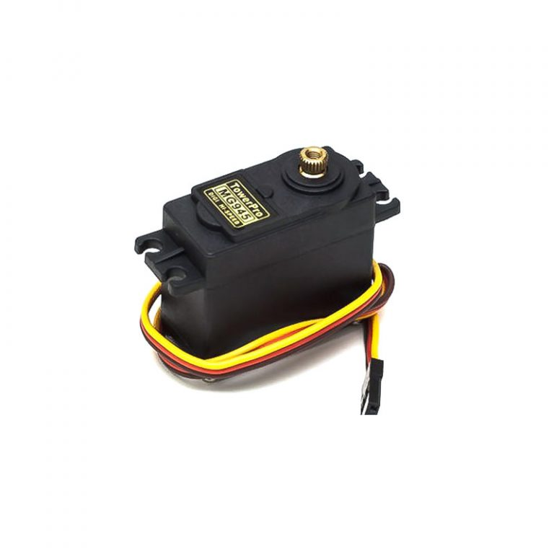

A servomotor can also be a positioner or linear actuator that lets in for precise manage of angular or linear function, pace and acceleration. It consists of the right motor coupled to a sensor for position comments. It additionally requires a distinctly sophisticated controller, frequently an obsessive module designed specifically to be used with servomotors.

Servomotors are not a specific magnificence of motor, even though the time period servomotor is normally used to invite a motor appropriate for use throughout a closed loop . A servomotor may also be a closed-loop servomechanism that uses position remarks to control its movement and final position. The enter to its manipulate could also be a signal (both analogue or digital) representing the position commanded for the output shaft.

The motor is paired with some kind of function encoder to offer role and pace remarks. in the only case, simplest the location is measured. The measured position of the output is compared to the command position, the external enter to the controller. If the output function differs from that required, an error signal is generated which then reasons the motor to rotate in either direction, as needed to carry the output shaft to the ideal position. due to the fact the positions approach, the mistake signal reduces to 0 and as a result the motor stops.

The very handiest servomotors use position-best sensing via a potentiometer and bang-bang control of their motor; the motor constantly rotates at complete pace (or is stopped). this sort of servomotor is not broadly applied in commercial motion manipulate; however, it forms the idea of the simple and reasonably-priced servos used for radio-controlled models.

greater sophisticated servomotors use optical rotary encoders to degree the velocity of the output shaft and a variable-speed drive to control the motor speed. each of these improvements, normally alongside a PID manage algorithm, allow the servomotor to be brought to its commanded position speedier and more precisely, with less overshooting.

Servomotors are commonly used as a excessive-performance alternative to the stepper motor. Stepper cars have a few inherent potentials to manipulate position, as they have got integrated output steps. This regularly lets in them for use as an open-loop position manipulate, without any feedback encoder, as their force signal specifies the number of steps of motion to rotate, other than this the controller need to 'know' the placement of the stepper motor on strength up. consequently, on first energy up, the controller will be given to spark off the stepper motor and switch it to a recognized function, e.g. until it activates an stop restrict switch. this may be determined while switching on an inkjet printer; the controller will circulate the ink jet carrier to the extreme left and right to exercise session the highest positions. A servomotor will straight away cope with whatever attitude the controller instructs it to, irrespective of the preliminary position at strength up.

There has been increasing reputation in closed loop stepper automobiles in current years. They act like servomotors however have a few differences of their software control to induce easy movement. the foremost gain of a closed loop stepper motor is it’s notably low value. There’s additionally no need to track the PID controller on a closed-loop stepper system.

The shortage of remarks of a stepper motor limits its performance, due to the fact the stepper motor can best drive a load it truly is nicely inside its ability, otherwise overlooked steps under load may motive positioning errors and for this reason the device may additionally have to be restarted or recalibrated. The encoder and controller of a servomotor are a further value, but they optimise the performance of the overall device (for all of pace, strength and accuracy) relative to the potential of the important motor. With large systems, where a strong motor represents an growing share of the gadget fee, servomotors have the gain.

* **Cell holder:**

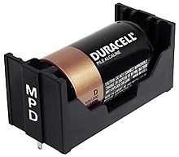

A battery holder is one or extra cubicles or chambers for holding A battery. For dry cells, the holder ought to also make contact with the battery terminals. For wet cells, cables are regularly related to the battery terminals, as is determined in cars or emergency lights equipment.

A battery holder is both a plastic case with the form of the housing moulded as a compartment or compartments that accepts A battery or batteries, or a separate plastic holder it really is mounted with screws, eyelets, glue, double-sided tape, or different manner.

Battery holders may have a lid to hold and protect the batteries or could even be sealed to save you damage to circuitry and additives from battery leakage. Coiled spring wire or flat tabs that press in opposition to the battery terminals are the two most typical techniques of creating the electric connection inner a holder. outside connections on battery holders are generally made via contacts with pins, floor mount feet, solder lugs, or wire leads.

where the battery is expected to last over the life of the products, no holder is crucial, and a tab welded to the battery terminals are regularly at once soldered to a circuit board.

* **Arduino:**

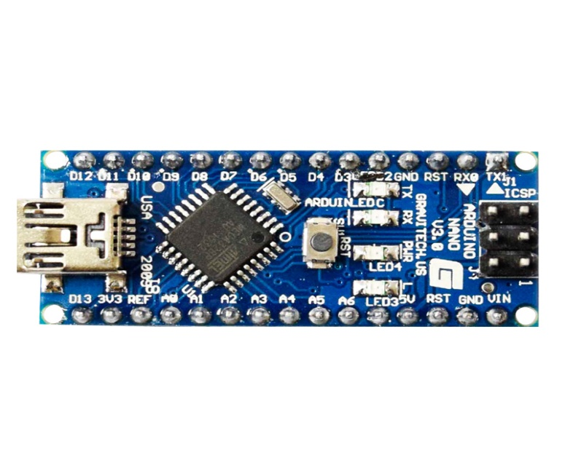

Arduino is an open-source platform used for building electronics tasks. Arduino includes each a bodily programmable circuit board (frequently noted as a microcontroller) and a hint of software, or IDE (incorporated development surroundings) that runs for your pc, used to put in writing and upload code to the physical board.

The Arduino platform has grow to be pretty fashionable people just starting out with electronics, and permanently cause. in contrast to maximum precedingprogrammable circuit forums, the Arduino doesn't need a separate piece of hardware (referred to as a

programmer) so on load new code onto the board -- you'll sincerely use a USB cable. additionally, the Arduino IDE makes use of a simplified version of C++, making it easier to searching for out bent application**.** eventually, Arduino provides an ordinary form factor

that breaks out the functions of the micro-controller right into a more on hand package. Arduino forums are capable of read inputs - light on a sensor, a finger on a button, or a Twitter message - and switch it into an output - activating a motor, turning on an LED, publishing something on line. you may inform your board what to adopt to to through sending a group of commands to the microcontroller on the board. to adopt to to so you use the Arduino programming language (based totally on Wiring), and hence the Arduino software program (IDE), supported Processing.

through the years Arduino has been the brain of thousands of initiatives, from ordinary items to complicated clinical instruments. A international community of makers - students, hobbyists, artists, programmers, and specialists - has gathered round this open-source platform, their contributions have brought up to an superb amount of handy understanding which may be of fantastic assist to beginners and professionals alike.

Arduino turned into born on the Ivrea interplay layout Institute as an clean tool for fast prototyping, aimed closer to students without a historical past in electronics and programming. As quickly because it reached a much wider community, the Arduino board began converting to adapt to new desires and demanding situations, differentiating its offer from simple 8-bit boards to merchandise for IoT applications, wearable, 3D printing, and embedded environments. All Arduino boards are absolutely open-source, empowering customers to make them independently and sooner or later adapt them to their specific desires. The software, too, is open-source, and it's developing via the contributions of users worldwide.

* **Jumped wire:**

A jump twine (also known as jumper wire, or jumper) is an electrical cord, or institution of them at some point of a cable, with a connector or pin at every give up (or occasionally without them – definitely "tinned"), which is generally wont to interconnect the additives of a breadboard or different prototype or check circuit, internally or with different system or components, without soldering.

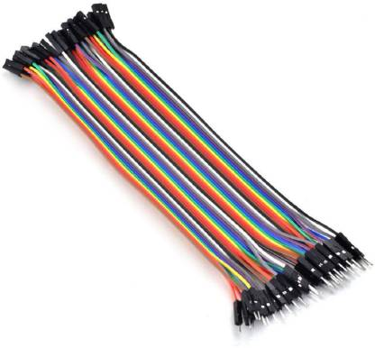

character leap wires are outfitted by using putting their "give up connectors" into the slots supplied throughout a breadboard, the header connector of a circuit card, or a bit of gadget.

**Working:**

A door cope with sanitizer for disinfecting a door handle comprising: a supply of liquid or gaseous disinfectant; a nozzle fluidly connected to the supply configured to convey liquid or gaseous disinfectant from the source to the nozzle and for shelling out the liquid or gaseous disinfectant onto the manage; and an influence circuit for inflicting the liquid or gaseous disinfectant to be conveyed to the cope with in intervals, wherein the durations are aware of an outside condition and as a result the comments circuit if freed from any guide activation.

An apparatus proximate the deal with of a door for meting out germicide onto the manage and into the atmosphere surrounding the manage comprising: a pressurized supply of germicide having a generally closed, pressure actuated valve; a valve actuating means for exerting a pressure on the valve enough to actuate the valve and launch the germicide, the valve actuating method comprising: a nozzle fluidly related to the valve for transporting the germicide from the valve into the environment surrounding the deal with; aautomatically driven arm or meeting related to the valve, the nozzle, or each, operable to provide the force at the valve; and an impact circuit for activating the valve actuating means in periods, in which the intervals are conscious of an external condition.

A method for sanitizing a door cope with of a door comprising the stairs of: mounting a dispenser unit proximate the door take care of; and spraying a germicide in an atomized mist or liquid form from the dispenser onto the door take care of in response to an event freed from any manual activation.

A door deal with sanitizer for disinfecting a door deal with comprising a supply of liquid or gaseous disinfectant a nozzle fluidly linked to the supply configured to bring liquid or gaseous disinfectant from the supply to the nozzle and for doling out the liquid or gaseous disinfectant onto the handle; and a manage circuit for inflicting the liquid or gaseous disinfectant to be conveyed to the deal with in durations, in which the intervals are attentive to an external circumstance and the manipulate circuit if freed from any guide activation.

An apparatus proximate the deal with of a door for shelling out germicide onto the take care of and into the ecosystem surrounding the handle comprising a pressurized source of germicide having a usually closed, pressure actuated cost . a valve actuating manner for exerting a force at the valve enough to actuate the valve and launch the germicide, the valve actuating way comprising a nozzle fluidly linked to the valve for transporting the germicide from the valve into the surroundings surrounding the manage ,a mechanically pushed arm or meeting related to the valve, the nozzle, or both, operable to produce the pressure on the valveand a control circuit for activating the valve actuating manner in intervals, in which the intervals are conscious of an external situation.

a method for sanitizing a door cope with of a door comprising the stairs of:mounting a dispenser unit proximate the door handle and spraying a germicide in an atomized mist from the dispenser onto the door handle in response to an occasion freed from any manual activation.

**Circuit diagram:**

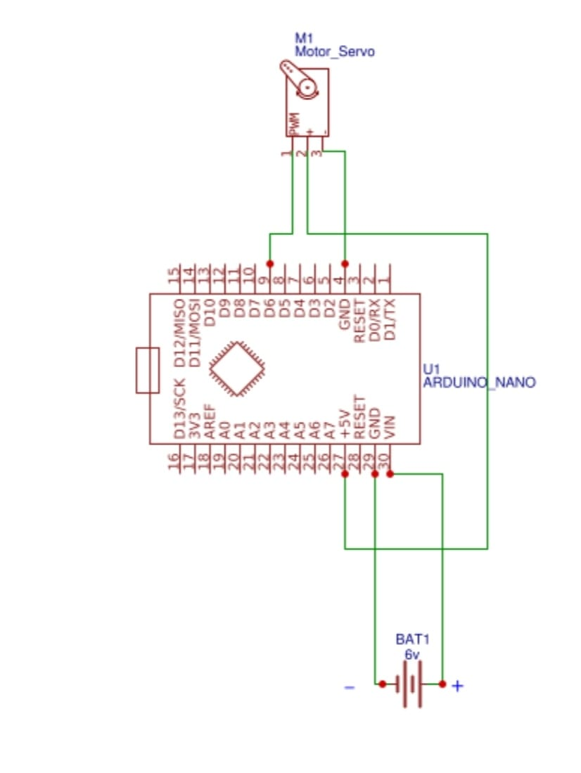

**Hardware picture:**

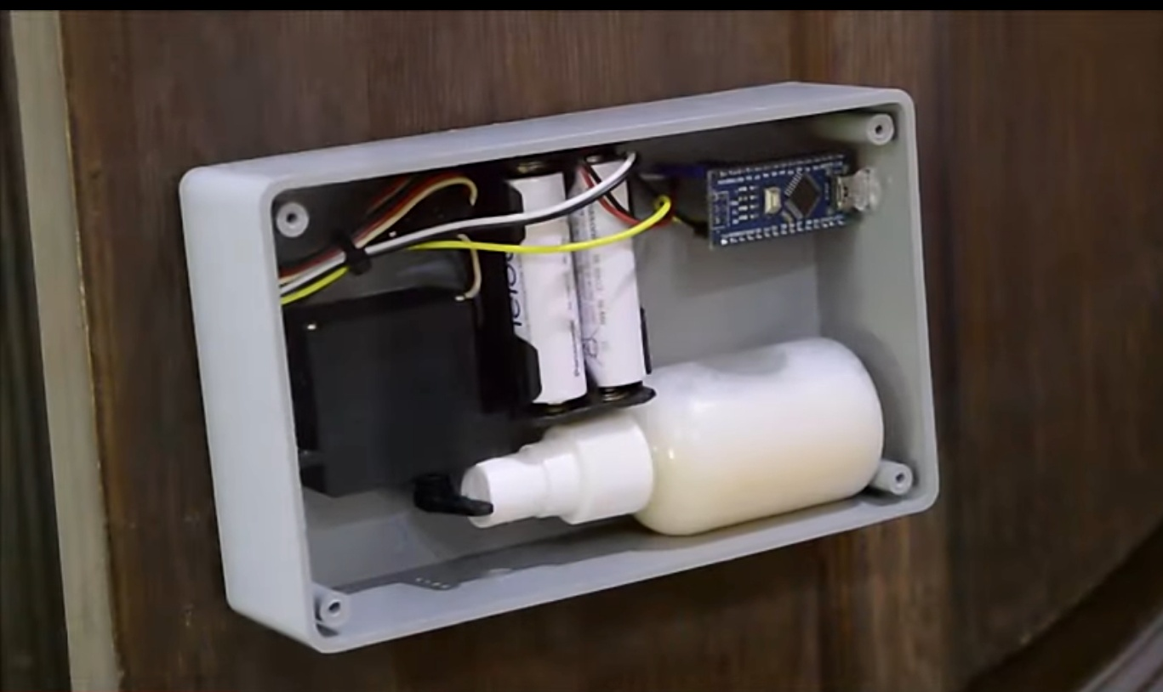

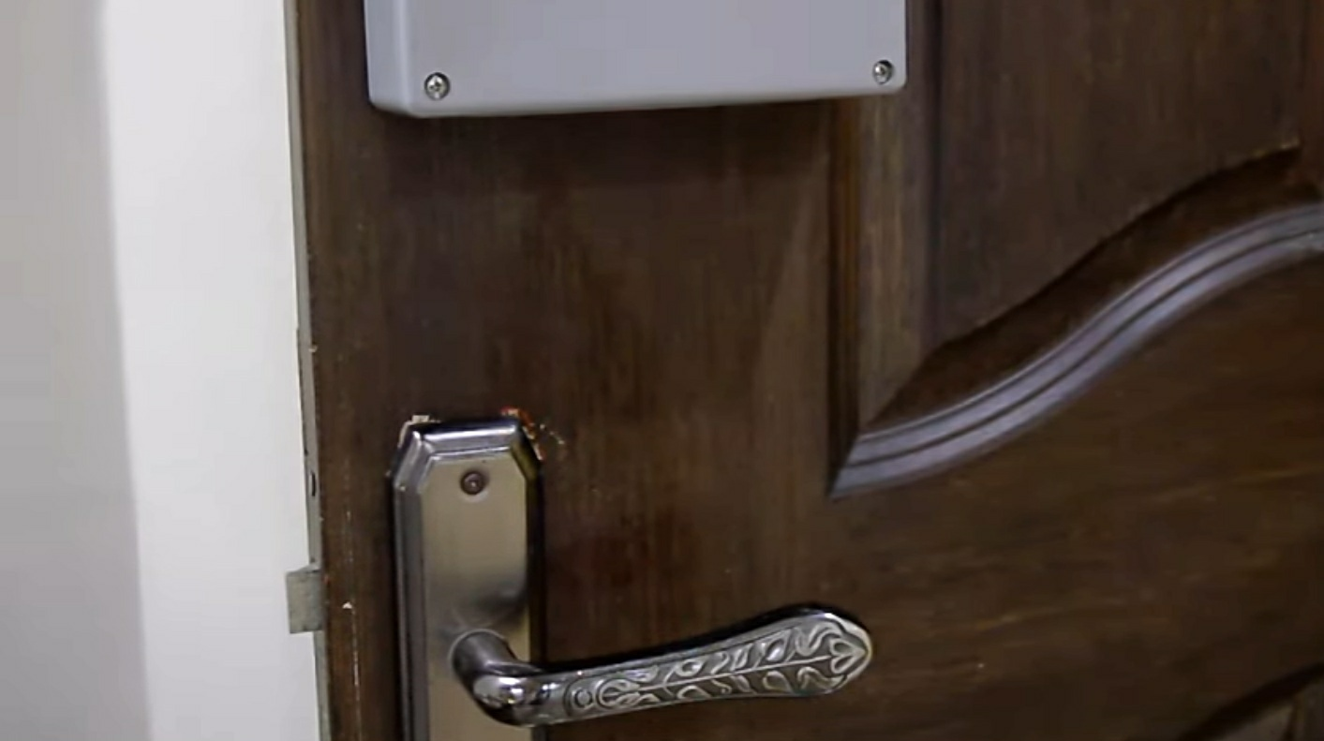

**Program:**

#include”lowpowerr.h”

#include<servo.h>

Servo myservo; //create servo object to control a servo

Int sleepcounter;

Void setup()

{

Myservo.attach(9); //attaches the servo on pin 9 to the servo object

}

Void loop()

{

//0.5hours = 30min*60sec = 1800sec

//1800s/8s =255

For(sleepcounter = 255; sleepcounter>0; sleepcounter--)

{

Lowpower.powerdown(SLEEP_8S,ADC_OFF,BOD_OFF);

}

myservo.write(0); //sets the servo portion according to

delay(1000); //waits for the servo to get there

myservo.write(60); //sets the servo position according to the scaled value

delay(1000);

}

**Applications:**

• Door handle Sanitizers are especially utilized in hospitals and restrooms.

• according to the existing situation it is being used in lots of locations like shops, business enterprise, and so on.

**Advantages:**

• Activated with the aid of hand movement under the machine. No need to the touch some thing.

• offers possibility now not to sanitise handle in case you do not wish to. (hypersensitive reaction)

• Sprays out horizontally to the aspect which permits exclusive sorts of handle to best sprayed without the need to trade existing door handles.

• Can spray each handle and palms if required.

• Very first-class spray, low utilization of sanitizer fluid.

• makes use of widespread sanitising fluids.

• Low price and simple to put in.

**Disadvantages:**

* It consumes more battery life.
* It’s not operated by current.

**Result and discussion:**

**Result:**

As a result of this, the cope with or knobs of the door are often sanitized robotically on every occasion the man or woman touches it. The suggested task would be a absolutely helpful venture for India additionally as specific nations to defend their households, pals, residents to save you the unfold of the virus thru door gates. because of the considerable use of the door deal with the aid of users at public places, there is a higher opportunity of transmission of COVID-19 virus. consequently, the mentioned mission/system may additionally help to cut back the danger of spreading the COVID-19 virus.

**Discussion:**

We determined a dating among how often and how many people go door thresholds and the variety of micro-organism deposited on door handles. This finding helps the requirement for hand hygiene each time doorways thresholds are crossed. these important moments in capability microbial transmission are more and more known as goal for high effect interventions

**Future plans:**

The In future, we are able to commercialize the product. we are going to connect with public houses, for instance shopping center, lodge, clinic and public toilet wherein have better threat to unfold out contamination. We additionally desire that can comprise with Dyson to sell this product at some point of this opposition.

**Conclusion:**

The mentioned challenge could also be implemented in those areas in which there is a large crowd and possibilities of contamination are pretty. therefore, it are frequently utilized in educational establishments, houses, hospitals, and workplaces, and so forth. to forestall the spread of micro-organism and virus. This product isn't the same as the available products in the marketplace as it's predicated on sensing and rotating approach i.e. whilst the IR sensor senses the hand, the servo rotates and pulls the take care of sanitizer toward it rather than in advance reported project. it pushes the spring downwards.

Through this project, a non-public can decide how IR sensors, servo vehicles paintings if they ought to make it at their domestic and this is frequently often pretty price-powerful. The prototype of the pronounced product is whilst an inflamed character touches the door, after which the virus gets connected to the door cope with. At that point, this product will help to sanitize the door handle

At present, the earth is dealing with a tough time of corona virus pandemic due to the fact there is no vaccine to prevent until date. subsequently, every effective step taken for the duration of this path is extremely crucial. in the route of the research discipline to hunt out the precautions, we've got verified an automated door handle sanitizer supported Arduino Nano, IR sensor, and servo motor to sanitize the deal with or knob of the door this is employed by way of many oldsters.

because of this, the handle or knobs of the door are frequently sanitized mechanically every time the person touches it. The pronounced mission might be a really useful project for India also as distinct nations to guard their households, pals, citizens to save you the unfold of the virus thru door gates. due to the full-size use of the door cope with the aid of customers at public locations, there may be a higher chance of transmission of COVID-19 virus. therefore, the mentioned challenge/device may also assist to cut back the risk of spreading the COVID-19 virus.

**Reference:**

* World Health Organization. Naming the coronavirus disease (COVID-19) and the virus that causes it. ed, 2020.
* L. Morawska, J. W. Tang, W. Bahnfleth, P. M. Bluyssen, A. Boerstra, G. Buonanno, et al. How can airborne transmission of COVID-19 indoors be minimised?. Environment international, vol. 142, p. 105832, 2020. [https://doi.org/10.1016/j. envint.2020.105832](https://doi.org/10.1016/j.%20envint.2020.105832)
* M. Alzyood, D. Jackson, H. Aveyard, and J. Brooke. COVID-19 reinforces the importance of hand washing. Journal of Clinical Nursing, 2020. https://doi. org/10.1111/jocn.15313
* M. Alzyood, D. Jackson, J. Brooke, and H. Aveyard. An integrative review exploring the perceptions of patients and healthcare professionals towards patient involvement in promoting hand hygiene compliance in the hospital setting. Journal of clinical nursing, vol. 27, pp. 1329-1345, 2018. <https://doi.org/10.1111/jocn.14305>
* B. Allegranzi, L. Conway, E. Larson, and D. Pittet. Status of the implementation of the World Health Organization multimodal hand hygiene strategy in United States of America health care facilities. American journal of Infection Control, vol. 42, pp. 224-230, 2014. https://doi.org/10.1016/j. ajic.2013.11.015 [6] D. S. C. Lam, R. L. M. Wong, K. H. W