**BACHELOR OF ENGINEERING**

**IN**

**ELECTRICAL AND ELECTRONIC ENGINEERING**

**“MINI PROJECT REPORT”**

**TITLE: SIMPLE INVERTER**

DONE BY: GUIDE:

* SHAWIN KRISHNA S - 1NH18EE740 Mr. MOHAN DAS
* BELLEM SREEKANTH REDDY – 1H18EE706
* S M ADIL – 1NH18EE745
* RAMESHARAJA – 1NH19EE411

**DEPARTMENT OF ELECTRICALAND ELETRONICS ENGINEERING**

CERTIFICATE

Certified that the mini project work entitled “SIMPLE INVERTER” carried out by **Shawin Krishna S – 1NH18EE740, Bellam Sreekanth Reddy – 1NH18EE706, S M D Adil – 1NH18EE745, Ramesharaja – 1NH19EE411** are bonafede students of New Horizon College of Engineering submitted the report in completion of project at department of Electrical and electronics engineering, New Horizon College of engineering during the academic year 2019-2020. It is certified that all the correction/suggestions indicated for internal assessment have been incorporated in the report deposited in the department library. The project report has been approved as it satisfied the academic requirements’ in respect of project work prescribed for said degree.

Project guide: HOD - EEE

Name of the guide Dr. S Ramkumar

Mr. Mohan Das

**SIMPLE INVERTER**

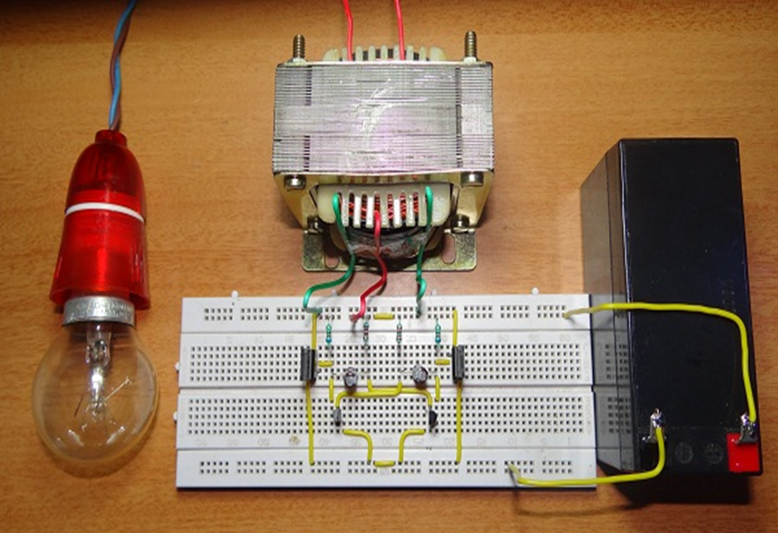

**ACKNOWLEDGEMENT**

We have taken efforts in this project. However, it would not been possible without the kind support and help of our term and teacher. We would like to extend our sincere thanks to all of them.

We are highly indebted to our project guide Mr. Mohan Das for their guidance and constant supervision as well as for providing necessary information regarding the project and also for their support in completing the project.

We would like to express our gratitude towards our parents and all those who have helped us directly and indirectly for their kind co-operation and encouragement which helped us in completing the project.

Finally, we would like to thank God for giving us an opportunity to study in this institution.

**INTRODUCTION**

This report focuses on DC to AC power inverters, which aim to efficiently transform a DC power source to a high voltage AC source, similar to power that would be available at an electrical wall outlet. Inverters square measure used for several applications, as in things wherever low voltage DC sources like batteries, solar panels or fuel cells must be converted so that devices can run off of AC power. One example of such a state of affairs would be changing electric power from a lead-acid accumulator to run a laptop computer, TV or telephone.

The method, within which the low voltage DC power is inverted, is completed in 2 steps. The first being the conversion of the low voltage DC power to a high voltage DC supply, and therefore the second step is being the conversion of the high DC supply to an AC waveform using pulse width modulation. Another methodology to finish the required outcome would be to initial convert the low voltage DC power to AC, and then use a electrical device to spice up the voltage to one hundred twenty volts.

This project centered on the primary methodology represented and specifically the transformation of a high voltage DC supply into an AC output. Of completely various DC­AC inverters on the market nowadays there square measure primarily 2 different types of AC output generated: changed undulation, and pure undulation.

A changed undulation may be seen as a lot of a sq. wave than a circular function wave; it passes the high DC voltage for such as amounts of your time therefore that the typical power and rms voltage square measure constant as if it were a undulation. These kinds of inverters square measure less expensive than pure undulation inverters and thus square measure enticing alternatives.

Pure undulation inverters, on the opposite hand, turn out a undulation output the image of the ability initiating of AN wall socket. These devices square measure able to run a lot of sensitive devices that a changed undulation could cause injury to such as: optical maser printers, laptop computer computers, power tools, digital clocks and medical equipment.

This form of AC power additionally reduces sounding noise in devices like fluorescent lights and runs inductive masses, like motors, quicker and quieter because of the low harmonic distortion.Inverter is a device which is used to convert DC current to AC current. Inverter is required at a place where to get AC power supply from the mains.

An inverter circuit converts the DC power to AC power. Inverters are classified into two types they are quasi or modified inverters and true sine wave inverter. The power which we got from the inverter can be used for an electric appliance like Mobile phones, television, Computers, etc. The Step-up transformer can be used to create main voltages from resulting AC. The inverter that is implemented in this following circuit gives a square wave inverter and it works with the devices which do not require pure sine wave of AC.

**ABSTRACT**

The common basic idea in every inverter circuit is to produce an oscillation. This can be done using the given DC and apply these oscillations across the primary coil of the transformer by amplifying the given current. Depending upon the number of turns in primary coil as well as in the secondary coils the primary voltage is then stepped up to a higher voltage.

This project is presented using an impedance source power inverter. it is called as a controlled method for implementing DC- AC conversion.

The impedance source inverter gives a unique impedance network for coupling the inverter main circuit to the power source.

**INVERTER HISTORY:**

Motor inverter was the earliest inverter, which was developed in World War 2 to serve the needs. The Redi – line was one of the popular eras in those times. This inverter was the only way to convert the DC to AC. This inverter requires 30 amps of current to turn it on.

In 1979, the first 1000 watt modified sine wave which was used in ambulance was introduced by vanner. This inverter works on true RMS regulation and power transistor. A few years later 2200W and 3000W inverter was produced. The 24v to 12v battery was also sold during the year 1983.

Stat power Technologies Corporation which is a British company and its headquarters is in Columbia. This company manufactures MSW inverters which were designed using high frequency. In 1995, a new inverter along with charger was invented. It gives us pure sine wave.

In 1997, the products of Vanner were not useful in RV industries as the company focused on industrial applications.

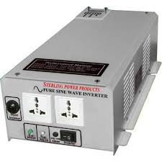

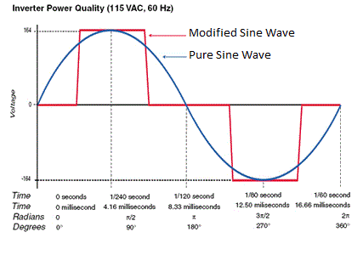

**Problem Statement**

In the market of power inverters, there are several decisions. They vary from the terribly high-ticket to the terribly cheap, with variable degrees of quality, efficiency, and power output capability on the approach. Prime quality combined with high potency exists, although it's usually at a high financial value.

As an example, Simplex America manufactures a 600 W, pure undulation inverter; the value is $2892. Meantime Go Power manufactures a 600 W electrical converter with a changed undulation output (closer to a sq. wave); this model solely fetches $693. The high finish pure undulation inverters tend to include terribly high-ticket, high power capable digital parts.

The changed undulation units are often terribly economical, as there's not abundant process being performed on the output wave shape, however this leads to a wave shape with a high range of harmonics, which may have an effect on sensitive instrumentality like medical monitors. Several of the bottom devices output a sq. wave, maybe a rather changed sq. wave, with the right RMS voltage, and shut to the proper frequency.

Our goal is to fill a distinct segment that looks to be lacking within the power inverters market, one for a reasonably economical, cheap electrical converter with a pure undulation output.

Utilizing PWM and analog parts, the output are a clean sinusoid, with little or no shift noise, combined with the cheap producing that comes with AN analog approach.

**Background**

DC and AC Current

DC power is just the applying of a gradual constant voltage across a circuit leading to a continuing current. A battery is that the commonest supply of DC transmission as current flows from one finish of a circuit to the opposite.

Most digital electronic equipment nowadays is escape of DC power because it carries the flexibility to supply either a continuing high or constant low voltage, facultative digital logic to method code executions. Traditionally, electricity was initial commercially transmitted by Thomas Alva Edison, and was a DC line. However, this electricity was low voltage, because of the shortcoming to accelerate DC voltage at the time, and therefore it had been unable of transmission power over long distances.

P=VIV==IRI2R

As is seen within the equations on top of, power loss is derived from the electrical current square and also the resistance of a cable. When the voltage is enhanced, the present decreases and at the same time the ability loss decreases exponentially; thus high voltage transmission reduces power loss. For this reasoning electricity was generated at power stations and delivered to homes and businesses through AC power.

Alternating current, unlike DC, oscillates between 2 voltage values at a nominal frequency, and its ever dynamical current and voltage makes it straightforward to improve or down the voltage. For high voltage and long distance transmission things all that's required to improve or down the voltage may be a electrical device. Developed in 1886 by William Stanley boy, the electrical device created long distance electrical transmission victimization AC power potential.

Electrical transmission has thus been principally primarily based upon AC power, supply most yanked homes with a one hundred twenty V AC supply. It ought to be noted that since 1954 there are several high voltage DC transmission systems enforced round the globe with the appearance of DC/DC converters, permitting the straightforward stepping up and down of DC voltages.

Like DC power, there exist several devices like power tools, radios and TV’s that break out of AC power. It is thus crucial that each types of electricity transmission exist; the planet can not be power-driven with one easy type. It then becomes an important matter for there to exist simple ways that to rework DC to AC power Associate in Nursing the other way around in an economical manner.

Without this ability individuals are going to be restricted to what electronic devices they use reckoning on the electricity supply offered. Electrical AC/DC converters and DC/AC inverters permit individuals this freedom in transferring electrical power between the two.

**SPECIFICATION OF COMPONENTS:**

**BREAD BOARD:**

A breadboard is a construction base for prototyping of physics. Originally the word referred to a literal bread board, a polished piece of wood used for slicing bread. [1] In the 1970s the solderless breadboard (a.k.a. plug board, a terminal array board) became obtainable and today the term "breadboard" is usually wont to visit these.

Because the solder less board doesn't need bonding, it is reusable. This makes it straightforward to use for making temporary prototypes and experimenting with circuit style. For this reason, solderless breadboards are fashionable students and in technological education.

Older breadboard types did not have this property. A strip board (Vero board) and similar prototyping computer circuit boards, that area unit wont to build semi-permanent soldered prototypes or one-offs cannot easily be reused. A variety of electronic systems could also be prototyped by victimization breadboards, from tiny analog and digital circuits to complete central process units (CPUs).

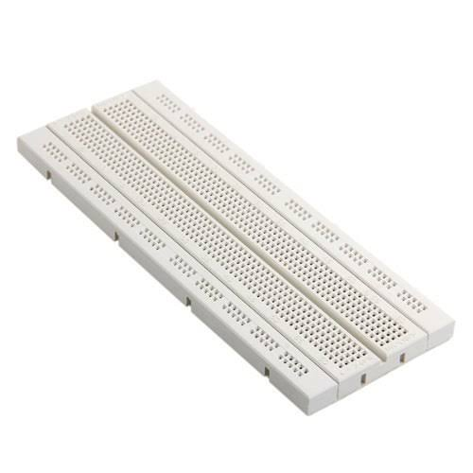

**RESISTOR:**

Resistor is a thing which resists to the flow of current and also acts as voltage dividers. Resistance is mostly used in this range when more power rating high value resistors are available. Resistors are also called as “passive devices”. They also contain source of power or amplification. It only attenuates or reduces the voltage signal which passes through the resistor. Resistance is the opposition to the substance which offers the flow of electric current. The unit of resistance is said to be “ohm”.

The behavior of a perfect electrical device is set by the connection such as by Ohm's law:

V=I.R

Ohm's law states that the voltage (V) across an electrical device is proportional to the present (I), where the constant of proportionality is the resistance (R). For example, if a 300 ohm resistor is attached across the terminals of a 12 volt battery, then a current of 12 / 300 = 0.04 amperes flows through that resistor.

Practical resistors even have some inductance and capacitance that have an effect on the relation between voltage and current in AC circuits.

The ohm (symbol: Ω) is that the SI unit of resistance, named after Georg Simon Ohm. An ohm is adore a V per ampere. Since resistors area unit such as and made over a awfully giant vary of values, the derived units of milliohm (1 mΩ = 10−3 Ω), kilo ohm (1 kΩ = 103 Ω), and resistance unit (1 MΩ = 106 Ω) also are in common usage.

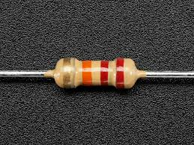

**CAPACITOR:**

Capacitors are used in Oscillatory AC circuits or timing circuits. Capacitors are also used as filters. It is used to store energy. A capacitor can store electric energy when disconnected from its charging circuit, so it can be used like a temporary battery, or like other types of rechargeable energy storage system.

Capacitors area unit usually utilized in electronic devices to keep up power offer whereas batteries area unit being modified. (This prevents loss of information in volatile memory.)

An electrical condenser will facilitate conversion of mechanical energy of charged particles into electrical energy and store it. In case of filters which are needed are the capacitances of the capacitor as well as the input supply frequency in order to get the capacitive resistance. A capacitor has a maximum rating of 2.2uf, and the maximum voltage that the capacitor can sustain is 25V. 2.2uf is its capacitance rating.

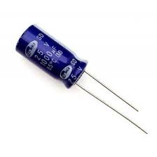

**TRANSISTOR:**

A transistor is a semiconducting device which is used to switch or amplify electrical power and electronic signals. It consists of semiconducting materials that has at least three terminals for connecting it with an external circuit. If a current or voltage applied to one pair of the transistor’s terminals, the current is controlled through another pair of terminals. We can also say that the controlled output power can be higher than that of the controlling input power.

Transistors are the key active elements in much all trendy natural philosophy. Many therefore think about the semiconductor device to be one in all the best inventions of the twentieth century.

The MOSFET (metal–oxide–semiconductor field-effect transistor), also known as the MOS transistor, is by far the most widely used transistor, used in applications ranging from computers and electronics to communications technology such as smartphones.

The MOSFET has been thought of to be the foremost vital semiconductor device, presumably the foremost vital invention in natural philosophy, and the birth of modern electronics. The MOS transistor has been the basic building block of contemporary digital natural philosophy since the late twentieth century, paving the method for the digital age.

The US Patent and Trademark Office call it a "groundbreaking invention that remodeled life and culture round the world". Its importance in today's society rests on its ability to be factory-made employing a extremely automatic method (semiconductor device fabrication) that achieves astonishingly low per-transistor costs.

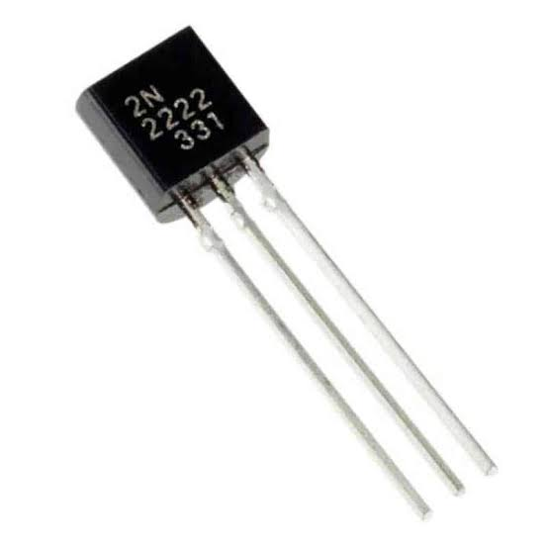

**TRANSFORMER:**

A transformer is said to be a passive electrical device. A transformer can transfer electrical energy between two or more circuits. A small change of magnitude transformers are often utilized in electronic and electrical devices wherever the voltage boosting is needed.

But these days within the fashionable device, power electronic circuits square measure additional oftentimes used as a result of weight and dimension. As we tend to told already, big power transformer is employed as generating transformer for stepping up the generated power to the next voltage level for economical transmission functions.

A transformer has a coil with varying current that produces a varying magnetic flux. In turn it also induces a varying electromotive force across a second coil. Electrical energy is transferred without the metallic connection to the two coils, between the two circuits. The step-up transformer will convert 12v DC to 220v AC. In this we have used a step up transformer

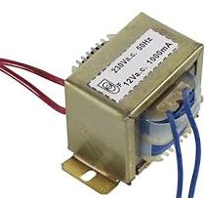

**MOSFET:**

The MOSFET gave here act as a field-effect transistor. It is fabricated by the controlled oxidation of a semiconductor and also has an insulated gate, typically silicon. The determination of the electrical conductivity of the device is done by the voltage of the covered gate. The ability to change the conductivity with the given amount of applied voltage is used for the amplification of signals and also switching electronic signals. MOSFET – Metal Oxide Semiconductor Field Effect Transistor

A power MOSFET may be a specific kind of metal–oxide–semiconductor FET (MOSFET) designed to handle vital power levels. Compared to the other power semiconductor devices, such as an insulated-gate bipolar transistor (IGBT) or a thermistor, its main advantages are high switching speed and good efficiency at low voltages.

It shares with the IGBT associate degree isolated gate that produces it straightforward to drive. They can be subject to low gain, typically to a degree that the gate voltage has to be more than the voltage in check.

The design of power MOSFETs was created doable by the evolution of MOSFET and CMOS technology, developed for producing integrated circuits within the Sixties. The power MOSFET shares its operational principle with its low-power counterpart, the lateral MOSFET.

The power MOSFET, which is commonly used in power electronics, was adapted from the standard MOSFET and commercially introduced in the 1970s.

The MOSFET used here is IRF 630.

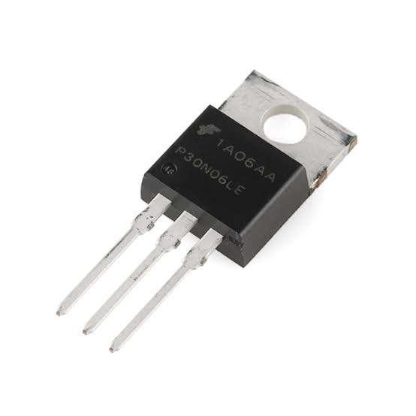

**CIRCUIT DIAGRAM:**

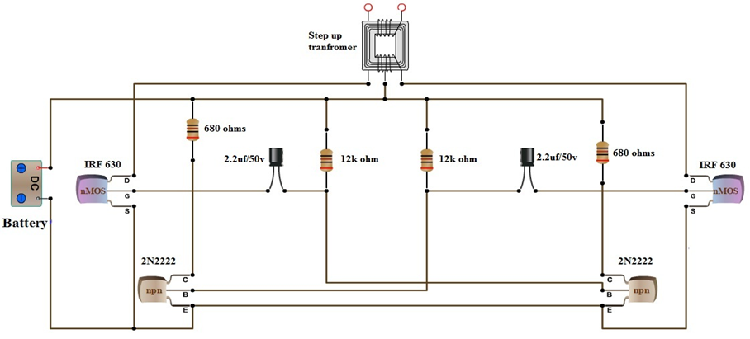

**WORKING:**

Here, DC supply is a 12V battery. The inverter will change it into AC 220V, 50Hz to use any appliances. The inverter does make energy. But the battery is energy or source. We have noticed as follows. The energy out of the battery is always approximately equal to using the energy of load.

For example, the load requires 10W at 220V AC. So, the battery needs to give the power about 10W at 12V. Also, the battery can give the current. According to Ohm’s Law, We can find the current of battery should has, is P/V = I or 10W / 12V = 0.8A.

While inverter is working It will always lose energy inside it. The battery should have the power more than 1A.first important thing is the transformer. The most common type of transformer is the laminated core, 12V-CT-12V. Normally, the 220V winding is primary.

Then, 12V is secondary, the output is 12V. But this turns The 12V winding is input or primary. The output or secondary is 220V winding instead. The 12V from the positive terminal of the battery comes to the center tap (CT) of 12V winding. Now it is the primary coil. The two ends of the coil (A and B point) are connected to the 2 ways switch to the ground. Now, the current flows into the transformer alternately look like AC voltage.

According to the theory of transformers the electromagnetic field swells and collapses. And then, a current will be inducted into the secondary, 220V winding, which it causes AC voltage 220V 50Hz. The voltage is prepared to be provided to the varied sorts of electrical instrumentality that need AC 220 potential unit operational.

Choosing transformer in inverter

As above in Ohm’s Law, the transformer can increase the voltage step-up. But the output current always decreased to lower levels. The circuit used here can be classified into three parts they are amplifier, oscillator and transformer.

The required frequency for the oscillator is 50Hz of AC supply. It is possible to achieve by building an A stable multivibrator that can produces a square wave at a frequency of 50Hz. The circuit consists of R1, R2, R3, R4, C1, C2, T1 and T2.

Each transistor that is given in the circuit produces inverting square waves. The frequency can be decided by the values of R1, R2 and C1 (R4, R3 and C2 are identical). The frequency formula for square wave generated is given as

F=1/ (1.38*R2*C1)

The inverting signals from the oscillator are used to amplify the power MOSFETs M1 and M2. The step-up transformer will receive the amplified signals with its center tap connected to 12V DC.

To convert 12V to 220V the turn’s ratio of the transformer must be 1:19. The transformer is designed in such a way to combine both the inverting signals to generate a 220V alternating square wave as an output.

The loads up to 40w can be powered by using a12v DC battery. The design given here is inefficient to increase the capacity of the inverter. To increase its efficiency the number of MOSFETs must be increase.

**ADVANTAGES:-**

* The circuit is made with a Simple design.
* The number of parts count is also low.
* It saves more space.
* It also avoids noise pollution.
* It also has the capacity of fast transient response.
* The construction of this circuit is cheap.
* About 30 per cent to 50 per cent cheaper to run as it consumes less power compared to AC.
* Voltage variation is not caused by compressor.
* It keeps same room temperature.
* Effectual cooling and heating.
* Can be used for solar panels.
* Apart from savings in monthly electricity bill, there will be savings on fuel if used on alternative generator.
* The extra amount paid for an inverter AC gets retrieved in electricity bills within a few months.
* This is eco-friendly.
* Secure for domestic wiring due to less power usage.

**DISADVANTAGES:-**

* When the input – output difference is large, it gives low efficiency.
* Low efficiency will give significant heat dissipation.
* It is not capable exclusively for step-down operation.
* If room is not covered, power in-take increases and also the electricity bill.
* Efficiency decreases if room temperature is extremely hot (over 45 degrees C).
* Models too powerful for the room size may run frequent short cycles to achieve the target temperature. This can result in the room getting too cold or too hot; inadequate dehumidification (that is, not drying the air enough, making the room feel less comfortable); increased power usage and running costs; and wear and tear on the system
* Underpowered models may have to run more often at maximum output and dry the air too much

**APPLICATIONS:**

* Cars and other vehicles use this circuit to charge small batteries.
* It can also be useful to drive low power AC motors.
* This circuit is also used in solar power.
* Power inverters are devices which might convert current of DC kind into that of AC.
* They come all told shapes and sizes, from low power functions like powering a automobile radio to it of backing up a building just in case of power failure.
* Inverters are available many alternative varieties, differing in value, power, potency and purpose.
* The purpose of a DC/AC power electrical converter is often to require DC power provided by electric battery, like a twelve potential unit lead-acid accumulator, and rework it into a 120 potential unit AC power supply operative at sixty cycle, emulating the facility out there at a standard house electric outlet.
* Power inverters square measure used nowadays for several tasks like powering appliances in an exceedingly automobile like cell phones, radios and televisions. They also come in handy for consumers who own camping vehicles, boats and at construction sites where an electric grid may not be as accessible to hook into.
* Inverters allow the user to provide AC power in areas where only batteries can be made available, allowing portability and freeing the user of long power cords.
* On the market today are two different types of power inverters, modified sine wave and pure sine wave generators. These inverters differ in their outputs, providing varying levels of efficiency and distortion that can affect electronic devices in different ways.
* A modified sine wave is similar to a square wave but instead has a “stepping” look to it that relates more in shape to a sine wave. This can be seen in Figure a pair of that displays however a changed undulation tries to emulate the undulation itself. The wave shape is straightforward to provide as a result of it's simply the merchandise of shift between three values at set frequencies, thereby leaving out the more complicated circuitry needed for a pure sine wave.
* The changed undulation electrical converter provides an inexpensive and simple answer to powering devices that require AC power. It will have some drawbacks as not all devices work properly on a changed undulation, products such as computers and medical equipment are not resistant to the distortion of the signal and should be break out of a pure undulation power supply.

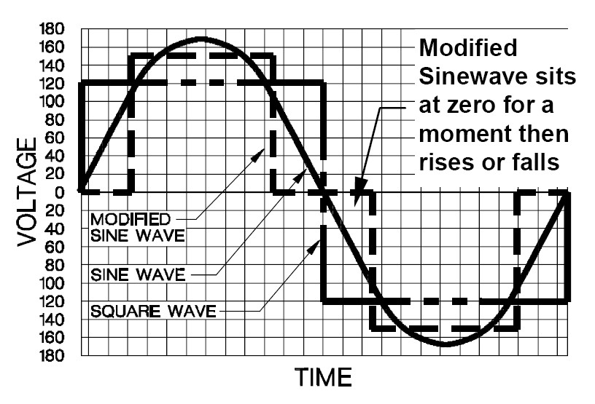

* Pure wave inverters are ready to simulate exactly the AC power that's delivered by a wall outlet. Usually sine wave inverters are more expensive than modified sine wave generators due to the added circuitry. This cost, however, is formed up for in its ability to produce power to any or all AC electronic devices, permit inductive hundreds to run quicker and quieter, and reduce the audible and electrical noise in audio instrumentation, TV’s and fluorescent lights.

**CONCLUSION**

The high-frequency AC link single-phase DC-AC converter which is hoping to apply for the household DSG system or the UPS has been commonly used the symmetrical control scheme to control the output voltage. The operation principle and some features of symmetrical control scheme and have pointed out the some problem which is an increase of conduction losses and therefore the soft-switching operation vary have a limitation by load.

This downside will be resolved to use the secondary phase-shifted PWM management theme. Therefore, we have proposed a switching pattern which is inverter mode and rectifier mode at the secondary phase-shifted PWM control into the high-frequency AC link single-phase DC-AC converter.

We have been confirmed that the proposed scheme can be controlled satisfactorily in the inductive load or the capacitor-input by simulating analysis. Thus, the secondary phase-shifted PWM control scheme have elucidated applicable to the high-frequency AC link single-phase DC-AC converter. To confirm the reduction of conduction losses in the proposed scheme, let us calculate the conduction loss generating the high-frequency AC link single-phase DC-AC converter with secondary phase-shifted PWM control and symmetrical control scheme and compare them and perform the consideration.

The result show that all conduction losses generating the high-frequency AC link single-phase DC-AC converter was reduced to 81% by performing the secondary phase-shifted PWM control comparing with the symmetrical control. Especially, the proposed schemes have elucidated drastic reduction of conduction losses generating high-frequency inverter and transformer.

For this reason, the high-frequency AC link single-phase DC-AC converter seem to be suitable for the dispersed storage and generation system inverter such as used the power storage system or used both. The proposed scheme, high-frequency AC link single-phase DC-AC converter with secondary phase-shifted PWM control scheme can be not only reduced conduction losses but also performed the soft-switching operation in all switching regardless of the load state

Therefore, to apply the secondary phase-shifted PWM control scheme is effective for the high-frequency AC link single-phase DC-AC converter system realizing achieving small size and light weight, enhancing control performance and efficiency.

Thus the simple inverter has been designed in such a way that it converts DC current to AC current by using a 12v battery and a Centre tapped transformer. Thus we conclude that we can glow the bulb for a certain period of time.