Warehouse GIS Subsystem — Technical Documentation
Spatial Architecture, Feature Reference & Integration Guide

v1.0 | April 2026

1 — Executive Summary
The Warehouse GIS subsystem transforms a conventional Warehouse Management System into a spatially-aware platform. Rather than treating warehouse locations as abstract codes in a database, the system anchors every physical location to a real-world coordinate system, enabling administrators to reason about storage rules in terms of geography — not just business logic. The result is a living floor plan that enforces storage constraints automatically as stock movements happen.
Administrators start by uploading an SVG floor plan exported from CAD software. They then draw polygons directly on a 2D map to associate each physical shelf, bay, or aisle with its logical counterpart in the WMS layout tree. On top of that spatial foundation they can define named zones — each carrying violation rules that either block or warn when incompatible products are placed inside them — and import hazard buffer polygons produced by safety engineers in ArcGIS Pro. Every time a stock movement is requested, the platform runs a three-step spatial pipeline against PostGIS to enforce those rules in real time.
The technology stack is designed for reliability and incremental adoption. The backend runs on Spring Boot with Hibernate Spatial exposing PostGIS geometry operations through JPA repositories. The frontend is a React single-page application that embeds the ArcGIS JavaScript SDK 4, giving users a responsive, interactive 2D map experience without requiring any GIS expertise. GeoServer sits alongside PostGIS to provide standards-based WMS layers for tenants who want to consume spatial data in external GIS tools such as ArcGIS Pro.

2 — System Architecture
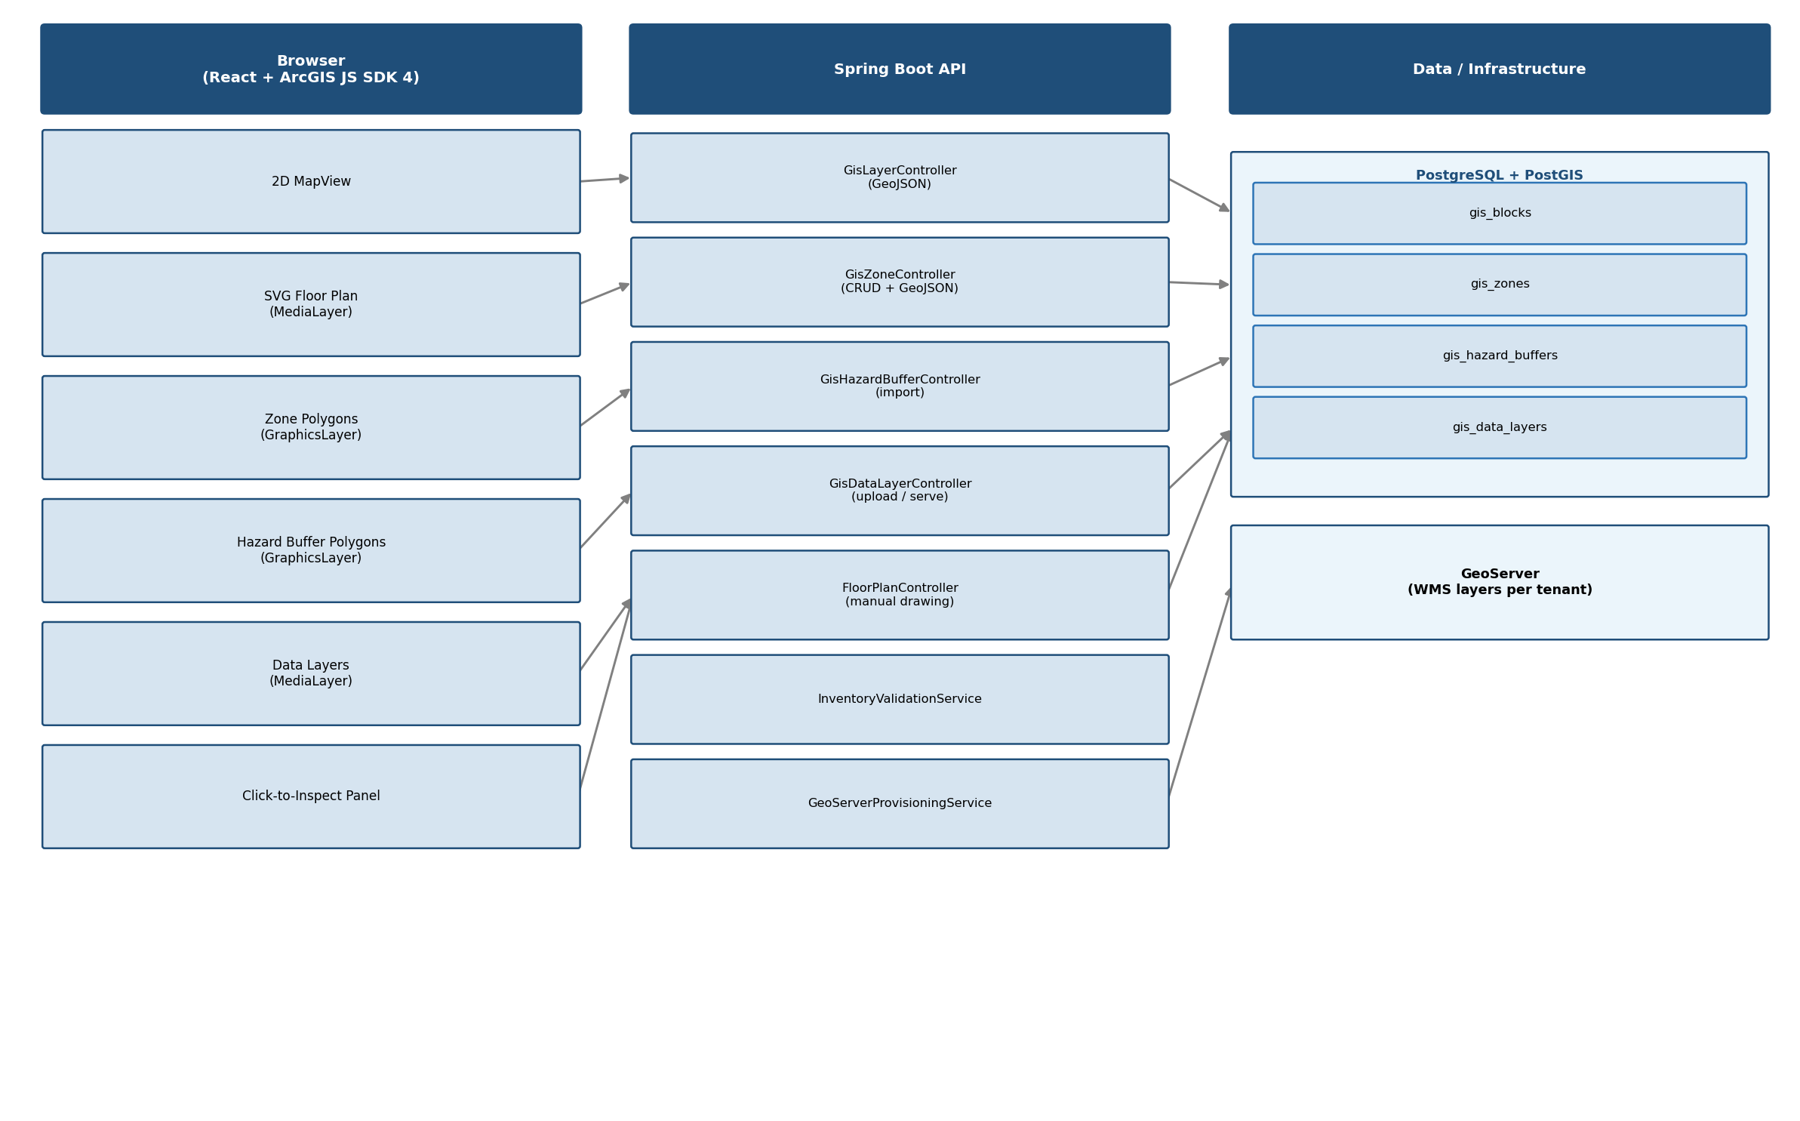
The system follows a clean three-tier separation. The browser layer is built entirely with React components that embed an ArcGIS JS SDK 4 MapView. Spatial data arrives as standard GeoJSON from REST endpoints, which the SDK renders as GraphicsLayer or MediaLayer overlays on a 2D map. Interaction is intentionally lightweight: the SDK handles pan, zoom, and click-to-inspect while React manages application state and API calls.
Spring Boot sits in the middle, exposing a set of focused REST controllers — one each for floor plan management, GIS blocks, zones, hazard buffers, and data layers. All spatial persistence flows through PostGIS via JPA repositories that execute native SQL functions such as ST_Intersects and ST_Contains. GeoServer is provisioned automatically when new tenant workspaces are created, ensuring that WMS layers are always in sync with the underlying PostGIS tables.

3 — Floor Plan Base Layer
Data Flow
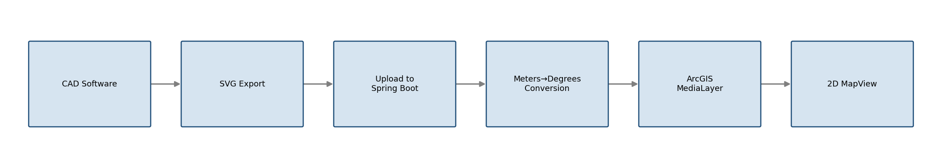
The first step in making a warehouse spatially aware is placing its floor plan on a real coordinate system. Administrators upload an SVG floor plan exported from CAD software. The system converts physical dimensions (meters) into geographic coordinates (EPSG:4326) using the approximation that 1 degree ≈ 111 km. This is an equatorial approximation and works well for indoor/warehouse contexts where the coordinate span is small (typically < 0.01°), but administrators working at higher latitudes should be aware that longitude spans compress as latitude increases. The anchor is configured per-deployment and the SVG is anchored at a configurable lat/lon. The SVG is rendered as a georeferenced MediaLayer on the ArcGIS 2D map, giving the team an accurate visual backdrop before they draw any location polygons.
Application Configuration (application.yml)
warehouse:
gis:
anchor-lat: 0.0
anchor-lon: 0.0
width-meters: 100.0
length-meters: 60.0

TypeScript — Coordinate Conversion
const lonSpan = widthMeters / 111_000;
const latSpan = lengthMeters / 111_000;
const warehouseExtent = new Extent({
xmin: anchorLon, ymin: anchorLat,
xmax: anchorLon + lonSpan, ymax: anchorLat + latSpan,
spatialReference: { wkid: 4326 },
});

4 — GIS Blocks (Location Polygons)
Data Flow
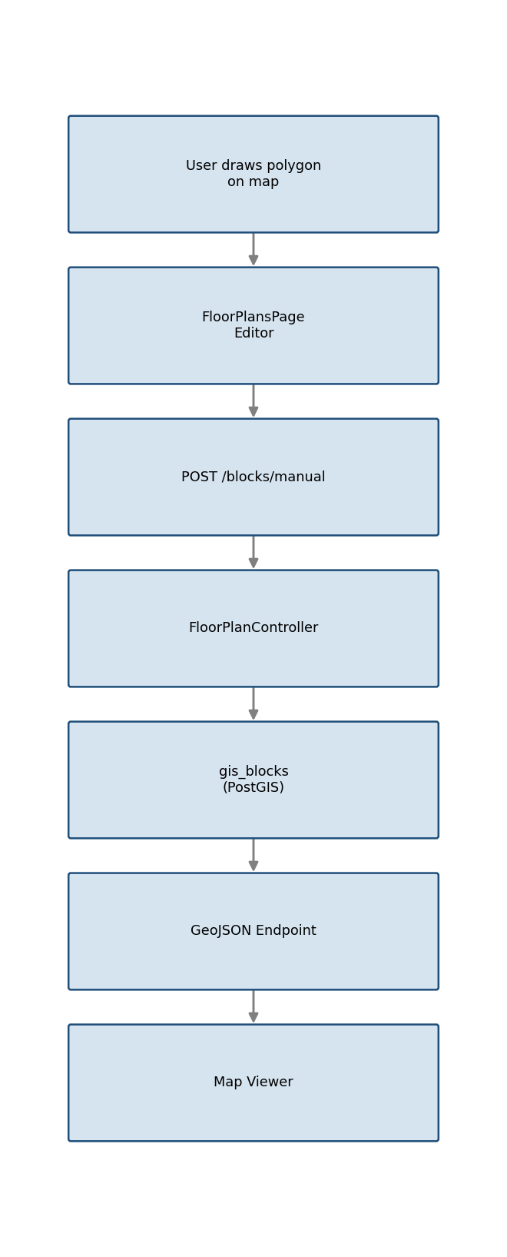
The logical warehouse layout tree — Warehouse → Zone → Aisle → Bay → Shelf — carries no spatial data by default. Administrators bridge this gap by opening the Floor Plans editor and drawing a polygon on the map for each physical location. Once drawn, the polygon is submitted to the backend which stores it as a GisBlock entity, linking a PostGIS Polygon geometry to the corresponding layoutBlockId. Locations that have no GIS block are treated gracefully: all spatial checks are simply skipped, so partially mapped warehouses continue to work without errors.
GisBlock.java — JPA Entity
@Entity
@Table(name = "gis_blocks")
public class GisBlock {

@Id
private UUID id;

@Column(name = "layout_block_id", nullable = false)
private UUID layoutBlockId;

@Column(name = "template_name", nullable = false, length = 100)
private String templateName;

@Column(length = 200)
private String label;

@Column(name = "position_path")
private String positionPath;

@Column(name = "depth", nullable = false)
private int depth;

@Column(columnDefinition = "GEOMETRY(Polygon, 4326)", nullable = false)
private Polygon geometry;

@Column(name = "centroid_geom", columnDefinition = "GEOMETRY(Point, 4326)")
private Point centroidGeom;

@Column(name = "created_at", nullable = false, updatable = false)
private Instant createdAt;

@Column(name = "updated_at", nullable = false)
private Instant updatedAt;
}

FloorPlanController.java — saveManualBlock()
@PostMapping("/blocks/manual")
@PreAuthorize("hasAuthority(...GIS_FLOOR_PLAN_MANAGE)")
public ResponseEntity<?> saveManualBlock(
@PathVariable String tenantSlug,
@RequestBody ManualGisBlockRequest request,
Authentication authentication) {

tenantAccessPolicy.assertTenantAccess(authentication, tenantSlug);
List<List<Double>> exteriorCoords = request.getRings().get(0);
Coordinate[] coordinates = new Coordinate[exteriorCoords.size()];
for (int i = 0; i < exteriorCoords.size(); i++) {
List<Double> pt = exteriorCoords.get(i);
coordinates[i] = new Coordinate(pt.get(0), pt.get(1));
}
GeometryFactory gf = new GeometryFactory(new PrecisionModel(), 4326);
Polygon polygon = gf.createPolygon(gf.createLinearRing(coordinates));
Point centroid = polygon.getCentroid();
centroid.setSRID(4326);

GisBlock gisBlock = gisBlockRepository
.findByLayoutBlockId(request.getLayoutBlockId())
.orElseGet(GisBlock::new);

gisBlock.setLayoutBlockId(request.getLayoutBlockId());
gisBlock.setGeometry(polygon);
gisBlock.setCentroidGeom(centroid);
gisBlock = gisBlockRepository.save(gisBlock);
return ResponseEntity.ok(Map.of("id", gisBlock.getId()));
}

useEditorState.ts — savePolygon()
const savePolygon = useCallback(
async (layoutBlockId: string, fullCode: string) => {
if (!pendingPolygon) return;
const depth = availableBlocks.find((b) => b.id === layoutBlockId)?.depth ?? 0;
await api.post(`/${slug}/gis/blocks/manual`, {
layoutBlockId,
templateName: pendingPolygon.templateName,
label: fullCode,
positionPath: fullCode,
depth,
rings: pendingPolygon.rings,
});
await fetchExistingPolygons(pendingPolygon.templateName);
setPendingPolygon(null);
},
[slug, pendingPolygon, availableBlocks, fetchExistingPolygons]
);

5 — GeoJSON Endpoints
The frontend receives all spatial data as standard GeoJSON FeatureCollections from REST endpoints. This keeps the client-side code decoupled from the database schema: the SDK simply reads a FeatureCollection and renders it onto the map without knowing anything about the underlying JPA entities. Two primary endpoints feed the map viewer.
Leaf Location Query (GisBlockRepository.java)
@Query(value = """
SELECT b.* FROM gis_blocks b
WHERE b.layout_block_id NOT IN (
SELECT DISTINCT lb.parent_id
FROM layout_blocks lb
WHERE lb.parent_id IS NOT NULL
)
""", nativeQuery = true)
List<GisBlock> findLeafGisBlocks();

Zones GeoJSON Endpoint (GisZoneController.java)
@GetMapping(value = "/geojson", produces = MediaType.APPLICATION_JSON_VALUE)
@PreAuthorize("hasAuthority(...GIS_ZONES_VIEW)")
@Transactional(readOnly = true)
public ResponseEntity<String> getZonesGeoJson(
@PathVariable String tenantSlug,
Authentication authentication) {
tenantAccessPolicy.assertTenantAccess(authentication, tenantSlug);
List<GisZone> zones = gisZoneRepository.findAllByOrderByCreatedAtAsc();
return ResponseEntity.ok(buildZoneFeatureCollection(zones));
}

6 — Zone Management
Zone Lifecycle
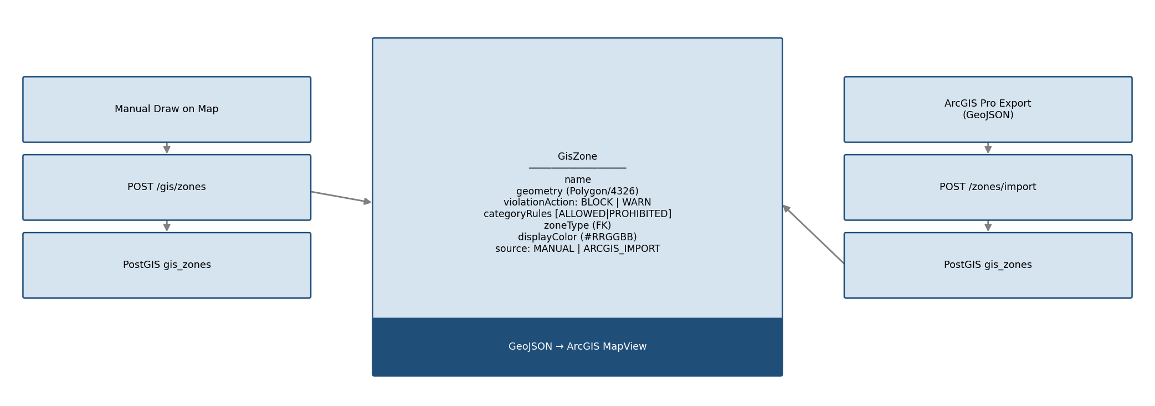
Zones are named polygon areas that carry storage rules. Each zone has a violation action of either BLOCK or WARN: a BLOCK zone prevents the stock movement outright, while a WARN zone raises an advisory that operators can choose to override. Within each zone, category rules explicitly list which product categories are ALLOWED or PROHIBITED, giving administrators fine-grained control over what can be stored where.
Zones can be created in two ways. Administrators with the GIS_ZONES_MANAGE permission can draw a polygon directly on the map and submit it through the web UI, which calls the create endpoint. GIS analysts working in ArcGIS Pro can export a GeoJSON FeatureCollection and upload it through the import API, which batch-inserts all features in a single transaction. Both paths produce identical GisZone entities in PostGIS.
GisZone.java — JPA Entity
@Entity
@Table(name = "gis_zones")
public class GisZone {

@Id private UUID id;

@Column(nullable = false, length = 200)
private String name;

@Column(columnDefinition = "GEOMETRY(Polygon, 4326)", nullable = false)
private Polygon geometry;

/** BLOCK | WARN */
@Column(name = "violation_action", nullable = false, length = 20)
private String violationAction;

/** MANUAL | ARCGIS_IMPORT */
@Column(nullable = false, length = 20)
private String source;

@ManyToOne(fetch = FetchType.LAZY)
@JoinColumn(name = "zone_type_id")
private ZoneType zoneType;

@Column(name = "display_color", length = 7)
private String displayColor;

@OneToMany(mappedBy = "zone", cascade = CascadeType.ALL, orphanRemoval = true)
private List<GisZoneCategoryRule> categoryRules = new ArrayList<>();
}

GisZoneController.java — createZone()
@PostMapping
@PreAuthorize("hasAuthority(...GIS_ZONES_MANAGE)")
@Transactional
public ResponseEntity<ZoneResponse> createZone(
@PathVariable String tenantSlug,
@Valid @RequestBody ZoneRequest request,
Authentication authentication) {
tenantAccessPolicy.assertTenantAccess(authentication, tenantSlug);

GisZone zone = GisZone.builder()
.name(request.name())
.description(request.description())
.geometry(ringsToPolygon(request.coordinates()))
.violationAction(request.violationAction())
.source(request.source() != null ? request.source() : "MANUAL")
.zoneType(resolveZoneType(request.zoneTypeId()))
.displayColor(normalizeDisplayColor(request.displayColor()))
.build();

GisZone saved = gisZoneRepository.save(zone);
saved = applyRules(saved, request.categoryRules());
return ResponseEntity.ok(toResponse(saved));
}

GisZoneController.java — importZones()
@PostMapping("/import")
@PreAuthorize("hasAuthority(...GIS_ZONES_MANAGE)")
@Transactional
public ResponseEntity<List<ZoneResponse>> importZones(
@PathVariable String tenantSlug,
@RequestBody GeoJsonImportRequest importRequest,
Authentication authentication) {
tenantAccessPolicy.assertTenantAccess(authentication, tenantSlug);

List<ZoneResponse> created = importRequest.features().stream()
.map(feature -> {
GisZone zone = GisZone.builder()
.name(feature.properties().name())
.geometry(ringsToPolygon(extractRings(feature.geometry())))
.violationAction(feature.properties().violationAction() != null
? feature.properties().violationAction() : "BLOCK")
.source("ARCGIS_IMPORT")
.build();
return toResponse(gisZoneRepository.save(zone));
})
.toList();

return ResponseEntity.ok(created);
}

7 — Hazard Buffers
Import & Enforcement Flow
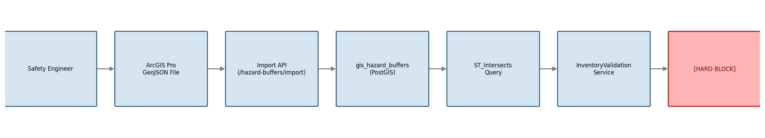
Hazard buffers are hard-block danger zones that mark areas of the warehouse where certain hazard types may never be stored. Unlike zones, which can be configured to warn instead of block, a hazard buffer violation is always a hard stop — there is no override mechanism. This makes them suitable for safety-critical boundaries such as blast radii, flammable material exclusion zones, and chemical incompatibility areas.
Buffers are always imported from ArcGIS Pro GeoJSON files rather than drawn manually. This ensures there is an auditable trail back to a certified safety analysis: each import batch receives a unique batchId UUID and the original filename is stored alongside the geometry. Safety engineers export a GeoJSON FeatureCollection from ArcGIS Pro and upload it through the web interface; Spring Boot parses the features, resolves the hazard type codes, and persists each buffer in one transaction.
GisHazardBuffer.java — JPA Entity
@Entity
@Table(name = "gis_hazard_buffers")
public class GisHazardBuffer {

@Id private UUID id;

@Column(nullable = false, length = 200)
private String name;

@Column(nullable = false, length = 20)
private String source; // always "ARCGIS_IMPORT"

@Column(columnDefinition = "GEOMETRY(Polygon, 4326)", nullable = false)
private Polygon geometry;

@Column(columnDefinition = "TEXT")
private String notes;

@Column(name = "import_batch_id")
private UUID importBatchId;

@Column(name = "source_filename", length = 255)
private String sourceFilename;

@Column(name = "imported_at", nullable = false)
private Instant importedAt;

@ManyToMany
@JoinTable(name = "gis_hazard_buffer_restricted_hazard_types",
joinColumns = @JoinColumn(name = "hazard_buffer_id"),
inverseJoinColumns = @JoinColumn(name = "hazard_type_id"))
private List<HazardType> restrictedHazardTypes = new ArrayList<>();
}

GisHazardBufferController.java — importGeoJson()
@PostMapping(value = "/import", consumes = MediaType.MULTIPART_FORM_DATA_VALUE)
@PreAuthorize("hasAuthority(...GIS_HAZARD_BUFFERS_MANAGE)")
public ResponseEntity<HazardBufferService.ImportResult> importGeoJson(
@PathVariable String tenantSlug,
@RequestParam("file") MultipartFile file,
Authentication auth) {
tenantAccessPolicy.assertTenantAccess(auth, tenantSlug);
return ResponseEntity.ok(hazardBufferService.importGeoJson(file, tenantSlug));
}

ST_Intersects Query (GisHazardBufferRepository.java)
@Query(value = """
SELECT hb.* FROM gis_hazard_buffers hb
JOIN gis_hazard_buffer_restricted_hazard_types rht
ON rht.hazard_buffer_id = hb.id AND rht.hazard_type_id = :hazardTypeId
WHERE ST_Intersects(hb.geometry,
(SELECT geometry FROM gis_blocks
WHERE layout_block_id = :layoutBlockId LIMIT 1))
ORDER BY hb.name ASC, hb.id ASC
""", nativeQuery = true)
List<GisHazardBuffer> findMatchingBuffersForLocation(
@Param("layoutBlockId") UUID layoutBlockId,
@Param("hazardTypeId") UUID hazardTypeId);

8 — Spatial Rule Enforcement
Three-Step Validation Pipeline
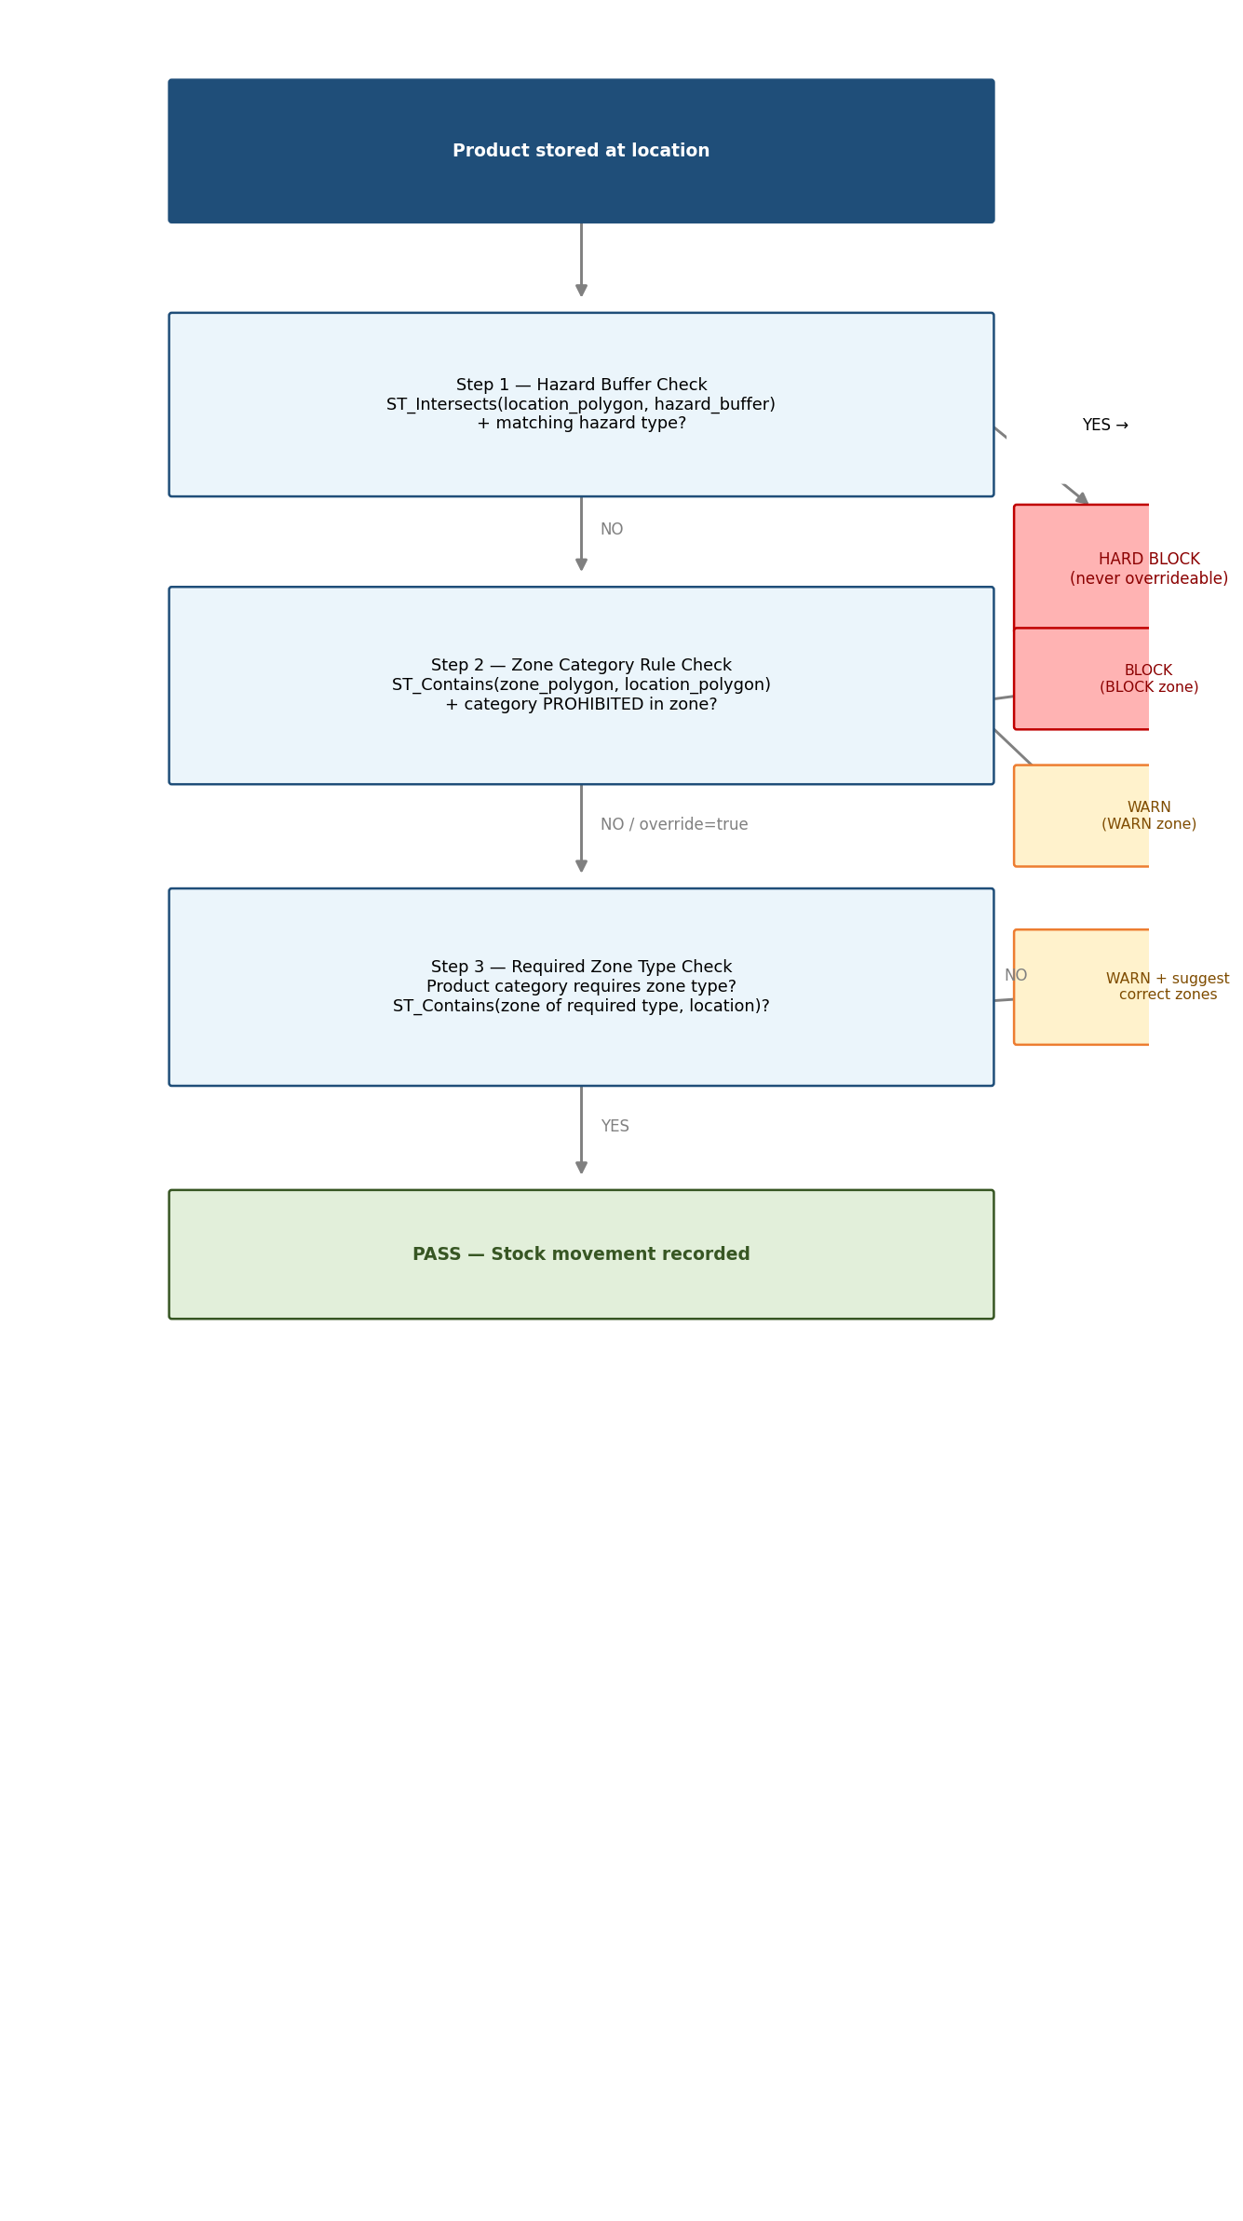
Spatial rule enforcement is the operational core of the GIS subsystem. Every time a stock movement is requested — whether through a put-away operation or an inventory transfer — Spring Boot runs the three-step pipeline above before committing the movement. The orchestrator is InventoryValidationService, which holds the steps in strict order: hazard-buffer first, then zone category rules, then required-zone checks.
If a location has no GIS block on record, the service returns immediately without checking anything. This graceful-degrade behaviour means warehouses can be migrated incrementally: unmapped locations simply pass through without errors until an administrator draws their polygon on the map. Once a polygon exists, the full spatial pipeline applies.
InventoryValidationService.java — assertLocationAllowsProduct()
@Transactional(readOnly = true)
public void assertLocationAllowsProduct(
UUID locationId, Product product, boolean zoneOverride) {

// No GIS block → no spatial context, skip all checks.
if (gisBlockRepository.findByLayoutBlockId(locationId).isEmpty())
return;

// Step 1: Hazard-buffer check (always a hard BLOCK).
assertNoHazardBufferViolation(locationId, product);

// Step 2: Zone category-rule check (BLOCK or WARN depending on zone config).
UUID categoryId = product.getCategory() != null
? product.getCategory().getId() : null;
gisZoneValidationService.assertLocationAllowsProduct(
locationId, categoryId, zoneOverride);

// Step 3: Required-zone check (WARN only, reached only if steps 1-2 pass).
assertRequiredZoneSatisfied(locationId, product);
}

Step 1 — Hazard Buffer Enforcement
private void assertNoHazardBufferViolation(UUID locationId, Product product) {
HazardType hazardType = product.getHazardType();
if (hazardType == null || "NONE".equals(hazardType.getCode()))
return;

List<GisHazardBuffer> matchingBuffers =
geometryService.findMatchingHazardBuffers(locationId, hazardType.getId());

if (!matchingBuffers.isEmpty()) {
GisHazardBuffer first = matchingBuffers.get(0);
List<HazardType> restricted =
new ArrayList<>(first.getRestrictedHazardTypes());
throw StorageRuleViolationException.hazardBufferBlock(first, restricted);
}
}

Step 3 — Required Zone Type Enforcement
private void assertRequiredZoneSatisfied(UUID locationId, Product product) {
ProductCategory category = product.getCategory();
if (category == null) return;

ZoneType required = category.getRequiredZoneType();
if (required == null) return;

boolean satisfied =
geometryService.isLocationWithinZoneType(locationId, required.getId());
if (!satisfied) {
List<GisZone> suggested =
geometryService.findZonesByZoneType(required.getId());
throw StorageRuleViolationException.requiredZoneWarn(required, suggested);
}
}

ST_Contains Query (GisZoneRepository.java)
// Find zones whose polygon spatially contains the location block:
@Query(value = """
SELECT z.* FROM gis_zones z
WHERE ST_Contains(z.geometry,
(SELECT geometry FROM gis_blocks
WHERE layout_block_id = :layoutBlockId))
""", nativeQuery = true)
List<GisZone> findZonesContainingLocation(
@Param("layoutBlockId") UUID layoutBlockId);

// Check whether any zone of a required type contains the location:
@Query(value = """
SELECT COUNT(*) > 0 FROM gis_zones z
WHERE z.zone_type_id = :zoneTypeId
AND ST_Contains(z.geometry,
(SELECT geometry FROM gis_blocks
WHERE layout_block_id = :layoutBlockId LIMIT 1))
""", nativeQuery = true)
boolean existsZoneOfTypeContainingLocation(
@Param("layoutBlockId") UUID layoutBlockId,
@Param("zoneTypeId") UUID zoneTypeId);

9 — Data Layers (Heatmap Overlays)
Upload & Rendering Flow
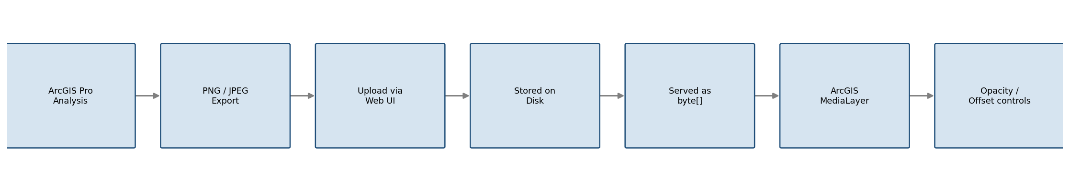
Data layers are static image overlays that provide visual context on top of the warehouse map — density heatmaps, historical traffic patterns, or any other raster analysis produced in ArcGIS Pro and exported as a PNG or JPEG. They are purely presentational: they do not participate in validation logic and have no effect on stock movements. Their value is operational awareness, letting warehouse managers overlay analytical data on the live floor plan without switching tools.
Administrators upload image files through the web interface. Spring Boot validates the content type, stores the file on disk, and records the metadata in the gis_data_layers table. The image is served back to the browser as a raw byte array with the correct Content-Type header, which the ArcGIS SDK loads as a MediaLayer spanning the full warehouse extent. Users can toggle layer visibility, adjust opacity, and drag the image to fine-tune its position relative to the floor plan.
GisDataLayerController.java — upload()
@PostMapping(consumes = MediaType.MULTIPART_FORM_DATA_VALUE)
@PreAuthorize("hasAuthority(...GIS_DATA_LAYERS_MANAGE)")
public ResponseEntity<GisDataLayerService.DataLayerSummary> upload(
@PathVariable String tenantSlug,
@RequestParam("name") String name,
@RequestParam("file") MultipartFile file,
Authentication auth) {
tenantAccessPolicy.assertTenantAccess(auth, tenantSlug);
return ResponseEntity.ok(dataLayerService.upload(tenantSlug, name, file));
}

@GetMapping("/{id}/image")
public ResponseEntity<byte[]> getImage(
@PathVariable String tenantSlug,
@PathVariable UUID id,
Authentication auth) {
tenantAccessPolicy.assertTenantAccess(auth, tenantSlug);
ImageData imageData = dataLayerService.serveImage(id, tenantSlug);
return ResponseEntity.ok()
.contentType(imageData.mediaType())
.body(imageData.bytes());
}

10 — Data Model Reference
The following table summarises the four PostGIS tables that underpin the GIS subsystem. All geometry columns use EPSG:4326 (WGS 84 geographic coordinates) to keep the data compatible with ArcGIS JS SDK 4, which defaults to that spatial reference.
Table | Key Columns | PostGIS Type | Purpose
gis_blocks | layout_block_id, geometry, centroid_geom, depth | Polygon, Point (4326) | Location polygons
gis_zones | name, geometry, violation_action, zone_type_id | Polygon (4326) | Storage zone polygons
gis_hazard_buffers | name, geometry, import_batch_id | Polygon (4326) | Danger zone polygons
gis_data_layers | name, file_path, media_type | — | Heatmap image metadata

11 — Spatial Query Reference
Every geometry operation in the system flows through PostGIS. The table below lists the PostGIS functions in use and where each one appears in the Spring Boot layer.
Operation | PostGIS Function | Used In
Find buffers intersecting a location | ST_Intersects | GisHazardBufferRepository
Find zones containing a location | ST_Contains | GisZoneRepository
Check required zone type | ST_Contains | GisZoneRepository
Leaf block identification | Subquery (NOT IN parent_ids) | GisBlockRepository

