**GOOGY’S ADVENTURE**

**LEVEL EDITOR**

**User Manual**

**Copyright ©2016-2019 Shawn Fenner.**

**All rights reserved.**

Table of Contents

[Introduction 2](#_Toc27166099)

[Getting Started 3](#_Toc27166100)

[Features 5](#_Toc27166101)

[File 5](#_Toc27166102)

[Palette 5](#_Toc27166103)

[Edit 6](#_Toc27166104)

[Tools 7](#_Toc27166105)

[Advanced 7](#_Toc27166106)

[Help 8](#_Toc27166107)

[Interacting with Objects 8](#_Toc27166108)

[Placing Objects 8](#_Toc27166109)

[Moving Objects 9](#_Toc27166110)

[Deleting Objects 9](#_Toc27166111)

[Special Objects 9](#_Toc27166112)

[Doors 10](#_Toc27166113)

[Moving Platforms 10](#_Toc27166114)

[Patrolling Enemies 10](#_Toc27166115)

[Treasure Chests 10](#_Toc27166116)

[Preferences 11](#_Toc27166117)

[Difficulty Settings 11](#_Toc27166118)

[Navigation 12](#_Toc27166119)

[Hotkeys 13](#_Toc27166120)

# Introduction

Welcome to Googy’s Adventure Level Editor, the software that allows you to construct your own level designs packed with menacing meanies, intricate passageways, and a treasure trove of fantastic items. Select a theme, from the pleasant forests, to the scorchingly hot desert, to the frantic city, to even the far reaches of outer space! And with the ability to easily resize levels and view level statistics, you can fine-tune your creation to your liking!

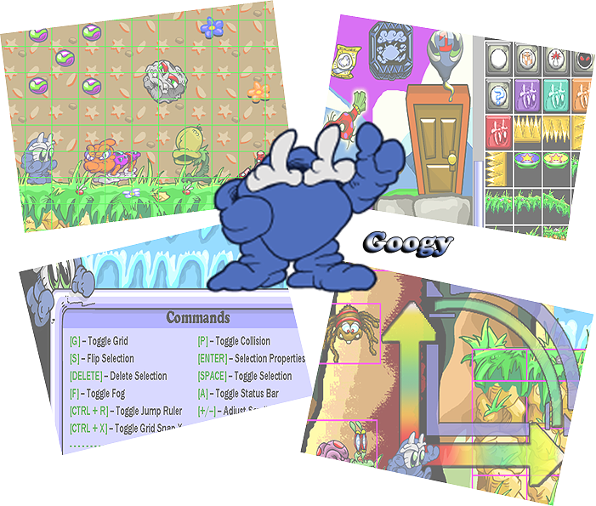

# Getting Started

To start Googy’s Adventure Level Editor, double-click on its icon 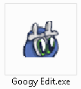 or select its icon and press the ENTER key.

The editor will start and you will be presented with the login screen. See .

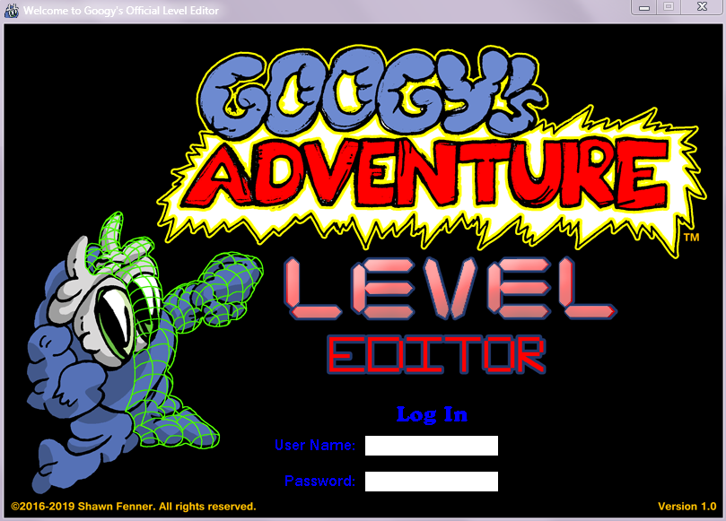

Figure 1 – Login Screen

To begin using Googy’s Adventure Level Editor, enter the username and password that accompanied the editor and then press the ENTER key. You will be presented with the main screen. See .

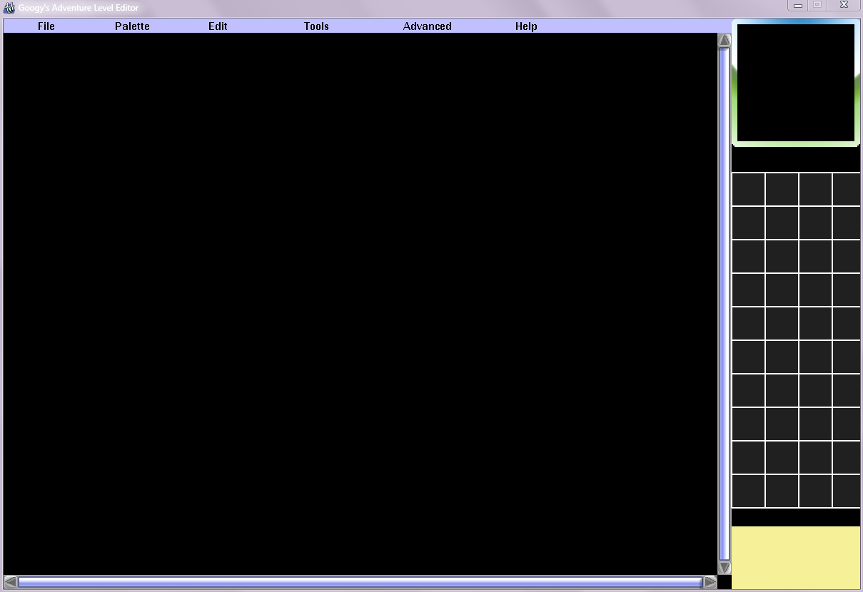

Figure 2 – Main Screen

The main screen is where level building occurs. Please see the next section to learn about all of the exciting features Googy’s Adventure Level Editor offers.

# Features

The menu bar located at the top of the main screen allows you to easily access all of the editor’s features. See .



Figure 3 – Menu Bar

## File

* **New:** create a new level.
* **Open:** load an existing level. Level files have the .glf extension (e.g. SampleLevel.glf).
* **Save:** save the current level. If the level has never been saved before, you will be required to give it a name.
* **Save As:** give a name to the current level and save it.
* **Export:** export the level to a format readable by the Googy's Adventure mobile application.
* **Preferences:** open the preferences dialog. See the section on for more information about customizing the editor.
* **Quit:** close Googy's Adventure Level Editor. If you made changes to a level without saving it, you will also be prompted to save it.

## Palette

Game objects are categorized into different palettes depending on their characteristics. The different palettes are:

* **Terrain:** objects walkable by Googy and other characters. Terrain includes platforms, bridges, item boxes, and Googy Blocks.
* **Doodads1:** pieces of art that add interest and additional detail to a level, such as plants, signs, and mushrooms. Doodads have no collision with Googy or other characters but cannot be placed on top of each other unless object collision is disabled. See the section on features for information on disabling object collision.
* **Doodads2:** similar to Doodads1 in that these doodads have no collision. Includes background such as walls and waterfalls.
* **Items:** beneficial items that grant Googy points or other bonuses when he obtains them. Includes marbles, 1-up balloon, and invulnerability scarf.
* **Enemies:** hostile characters that damage Googy and impede his progress.
* **Misc:** non-level-specific objects including start location, exit sign, door, and treasure chest.

Warning_smaller.pngTIP! Only one start location can be placed per level. In order to save a level, place a start location. To follow good game design, ensure there are no enemies near the start location that would attack unprepared players.

* **Emblems:** permanent items that once obtained can be equipped by Googy (up to three at a time) to grant special bonuses such as higher jumping, faster movement, or the ability to shoot fireballs.

Warning_smaller.pngTIP! Emblems are very powerful and rewarding items that add new dimensions to gameplay. Reward the player with one after the player uncovers a secret area or gets through a particularly challenging area.

## Edit

* **Properties:** opens the level properties dialog, where you can adjust the level background and color, size, and win condition.
* **Googy Blocks:** opens the Googy Blocks dialog. There are four different colors of Googy Blocks: purple; teal; orange; and red. Unchecking each box will cause the editor to display the corresponding block transparently, simulating as if the player has not found the corresponding color’s switch and thus will fall through the block.
* **Fog:** opens the fog dialog box. Fog is drawn as a colored overlay over the level and all of its objects. Adjust each color’s slider to change the fog’s color. Fog is disabled by default.

## Tools

* **Level Info:** displays information regarding level size, win condition, and object quantities.
* **Jump Ruler:** displays an on-screen ruler showing Googy's jump arc. The green arc indicates Googy’s normal jump arc while the blue arc indicates Googy’s jump arc with the Higher Jump emblem boost applied.

Warning_smaller.pngTIP! The jump ruler is the perfect tool for determining if Googy can cross a far gap successfully or an extra platform is needed to get him across.

* **Status Bar Lock:** locks the status bar in place so it is always visible when scrolling around the level, as is the case when playing the actual Googy’s Adventure game.
* **Show Entire Level:** shows a zoomed-out view of the entire level, including all of its objects. Very useful for examining the entire level at once.

## Advanced

* **Snap to Grid - X:** align objects horizontally to the editor’s grid. Enabled by default.
* **Snap to Grid - Y:** align objects vertically to the editor’s grid. Enabled by default.
* **Difficulty:** changes the difficulty setting. See the section on for more information on placing objects specific to a particular difficulty setting.
* **Ignore Collision:** object collision is ignored; objects that would normally collide no longer do so.
* **Delete Type:** deletes all objects of the currently selected palette. Confirm or cancel your decision in the accompanying dialog.

Warning_smaller.pngTIP! Use this option if you want to try a different assortment of enemies or items in a level. Save a different version of the same level name and then delete all of objects of your chosen categories. That way you can try something new and still go back to your old level design if you choose.

* **Delete Invalid:** deletes all invalidly placed or loaded objects from the level. Invalid objects appear as a .
* **Delete All:** deletes all objects of every category from the level.

## Help

* **Commands:** displays all available hotkeys and their corresponding functions. See the section on for the complete listing.
* **About:** displays copyright information.

# Interacting with Objects

## Placing Objects

To place an object in a level, first select an object from the palette box on the right side of the screen. See . The selected object will then appear on your cursor. Click in the level to place your object.

Warning_smaller.pngTIP! Change the direction of an object by pressing the S key. Only enemies and the start location can have their direction changed.

Warning_smaller.pngTIP! If an object cannot be placed at a location, make sure it isn’t colliding with an existing object (it will appear in red). Either place the new object in a new location, delete the existing object, or turn collision off and place the new object.

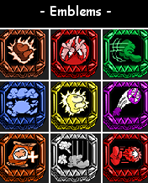

Figure 4 – Palette Box

## Moving Objects

To move an object, first make sure its corresponding palette is selected (for example, if you want to select an enemy, first select the enemies palette). Next, click the object to select it and drag the mouse to move the object to the desired location.

## Deleting Objects

To delete an object, first make sure its corresponding palette is selected. Next, click the object to select it and press the DELETE key to delete it.

# Special Objects

Certain objects such as doors, moving platforms, and treasure chests have special properties that can be changed at any time. These objects are known as *special objects*. When you select a special object, its collision display will blink, indicating it has properties that can be changed. Press the ENTER key to open the properties dialog. See .

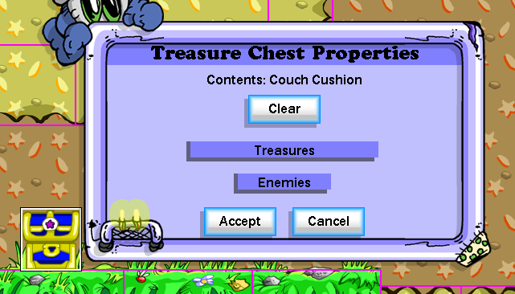

Figure 5 – Properties Dialog

Refer to each object below to learn about its properties.

## Doors

* **Copy Link Color:** set the selected door’s frame and panel colors to those of the door it is linked with.

Warning_smaller.pngTIP! Make sure doors that are linked together have the same color scheme to help players remember where doors will take them.

* **Link:** allows you to specify an exit door for Googy to appear when he walks through the selected door.
* **Frame Color:** the color of the door’s frame.
* **Panel Color:** the color of the door’s panel.
* **Active Locks:** set which locks are active on this door. If Googy does not have the corresponding key(s), he cannot open this door.

## Moving Platforms

* **Set Patrol Point:** set the location where the platform will move to before it moves back to its original location.

## Patrolling Enemies

* **Set Patrol Point:** set the location where the enemy will move to before it moves back to its original location. Flying enemies often have this option.

## Treasure Chests

* **Clear:** removes the treasure from the treasure chest.
* **Treasures:** select a treasure to give Googy when he opens the treasure chest.
* **Enemies:** select an enemy to appear when Googy opens the treasure chest.

# Preferences

Googy’s Adventure Level Editor can be customized for a more intuitive user experience:

* **Grid Line Size:** change the line width of the editor’s grid.
* **Large Grid Color:** change the color of the primary grid lines.
* **Small Grid Color:** change the color of the secondary grid lines.
* **Collision Display:** change the collision display of objects to either solid or wireframe.
* **Palette Display Size:** set the palette display size to either small or large; small palettes show more objects at a time but in less detail.
* **Auto Save Backup:** a backup file is created every 5, 10, 20, or 30 minutes or never. Backup files have the word “\_backup” appended to their filename.

# Difficulty Settings

In Googy’s Adventure, there are two difficulty settings: normal and hard. By default, objects appear in both difficulty settings. To make an object appear exclusively in a particular difficulty setting, follow the steps below:

1. Select the object.
2. Select a difficulty setting:
   * Press the N key for normal or the H key for hard.
   * Alternatively, select Advanced > Difficulty: Normal or Advanced > Difficulty: Hard.
3. Right-click on the selected object to make it appear exclusively in that difficulty setting. The selected object will have the name of the difficulty appear over it. See .

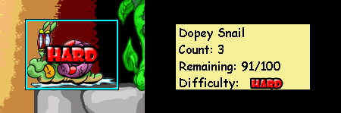

Figure 6 – Enemy will only appear on hard difficulty.

Warning_smaller.pngTIP! Use the difficulty setting feature to include more enemies in the hard version of a level. This practice ensures more of a challenge for advanced players and makes the level more forgiving for beginners playing the game on normal difficulty.

# Navigation

Levels can be navigated and scrolled using several methods:

* Press the up/down arrow keys to scroll the level vertically and the left/right arrow keys to scroll the level horizontally.
* Click the arrows located at the ends of each scroll bar.
* Drag an object to the edge of the main window.
* Drag the mouse around in the mini map.

Navigation speed can be increased/decreased by pressing the +/- keys, respectively.

# Hotkeys

Googy’s Adventure Level Editor features numerous hotkeys to improve user efficiency. Hotkeys can be viewed within the editor by selecting Help > Commands.

**File Options:**

* **CTRL + N:** create a new level.
* **CTRL + O:** open an existing level.
* **CTRL + S:** save the level.
* **CTRL + SHIFT + S:** provide a name for the level and save it.
* **CTRL + Q:** quit the application.

**Object Options:**

* **SPACE:** toggle object selection in the current palette.
* **P:** toggle collision display.
* **S:** flip object direction (start location and enemies only).
* **ENTER:** display properties for the currently selected object. Only blinking objects have properties to display.
* **DELETE:** delete the currently selected object.
* **CTRL + X:** toggle object horizontal alignment to the editor’s grid.
* **CTRL + Z:** toggle object vertical alignment to the editor’s grid.

**Palette Visibility:**

* **T:** make the terrain palette visible.
* **CTRL + T:** toggle the visibility of all terrain objects.
* **D:** make the doodad1 palette visible.
* **CTRL + D:** toggle the visibility of all doodad1 objects.
* **I:** make the item palette visible.
* **CTRL + I:** toggle the visibility of all item objects.
* **E:** make the enemy palette visible.
* **CTRL + E:** toggle the visibility of all enemy objects.
* **M:** make the miscellaneous palette visible.
* **CTRL + M:** toggle the visibility of all miscellaneous objects.
* **B:** make the emblem palette visible.
* **CTRL + B:** toggle the visibility of all emblem objects.

**Miscellaneous:**

* **G:** toggle the grid display.
* **F:** toggle the display of fog. Fog must be enabled for fog to be displayed.
* **A:** toggle the display of the status bar.
* **CTRL + R:** toggle the display of the jump ruler.
* **+/-**: increase or decrease scroll speed, respectively.