Turbo Book Manager

Software Requirements Specification

May 13, 2018

Shawn Fenner

Dustin Fenner

Project Managers

Prepared for

MIS 301 VA Business Software Development

Nicholas Caporusso

Spring 2018

# Revision History

|  |  |  |  |
| --- | --- | --- | --- |
| **Date** | **Description** | **Author(s)** | **Comments** |
| 02/19/2018 | Version 0.01 | Shawn Fenner, Dustin Fenner | First SRS Documentation |
| 03/05/2018 | Version 0.02 | Shawn Fenner, Dustin Fenner | UML Diagram added to section 4. |
| 03/26/2018 | Version 0.03 | Shawn Fenner, Dustin Fenner | Screenshots and descriptions of user interfaces added to section 3. |
| 05/13/2018 | Version 0.04 | Shawn Fenner,  Dustin Fenner | Final SRS revision. |

# Document Approval

The following Software Requirements Specification has been accepted and approved by the following:

|  |  |  |  |
| --- | --- | --- | --- |
| **Signature** | **Printed Name** | **Title** | **Date** |
| Shawn Fenner | Shawn Fenner | Project Manager | 05/13/2018 |
| Dustin Fenner | Dustin Fenner | Project Manager | 05/13/2018 |
|  |  |  |  |

**Table of Contents**

Revision History ii

Document Approval ii

1. Introduction 1

1.1 Purpose 1

1.2 Scope 1

1.3 Definitions, Acronyms, and Abbreviations 1

1.4 Overview 2

2. General Description 2

2.1 Product Perspective 2

2.2 Product Functions 2

2.3 User Characteristics 3

2.4 General Constraints 3

2.5 Assumptions and Dependencies 3

3. Specific Requirements 4

3.1 External Interface Requirements 4

3.1.1 User Interfaces 4

3.1.2 Hardware Interfaces 10

3.1.3 Software Interfaces 10

3.1.4 Communications Interfaces 10

3.2 Functional Requirements 11

3.2.1 Login in to use Turbo Book Manager 11

3.2.2 Adding a book to the store’s inventory system 11

3.2.3 Deleting a book from the store’s inventory system 12

3.2.4 Editing a book already in the store’s inventory system 13

3.2.5 Using a filter to limit the number of books displayed 13

3.2.6 Generating a report based on book usage 14

3.3 Non-functional requirements 15

3.3.1 Performance 15

3.3.2 Reliability 15

3.3.3 Availability 15

3.3.4 Security 15

3.3.5 Maintainability 15

3.4 Logical Database requirements 16

4. Analysis Models 17

4.1 Use Case Diagram 17

5. Change Management Process 18

# 1. Introduction

This section provides a detailed overview of the content contained within this SRS document as well as its overall purpose, the scope of the project, and pertinent definitions and abbreviations necessary to understanding the business software.

## 1.1 Purpose

This document’s purpose is to provide detailed information regarding the functionality of the Turbo Book Manager business software including its features, user interface, and limitations. This document is intended for both the software developers of this program and the bookstore employees that will be using the program on a daily basis.

## 1.2 Scope

“Turbo Book Manager” is a desktop software application that users can use to manage an inventory of books for their bookstore. It serves as an interface to modifying the contents of a database that contains all of the data regarding a bookstore’s inventory of books.

Using the Turbo Book Manager interface, users can add books to the database by supplying parameters for book data or can select books from the entire list of books and edit or remove them from the database. Turbo Book Manager also allows users to view all book data from within the database in unsorted or sorted form based on a user-specified sort condition pertaining to particular book data, such as sorting books alphabetically in ascending order by title or by sorting books numerically by price in descending order.

Users can also view books with a filter so the software only shows certain books that meet the filter criteria, such as books above a certain price point. A detailed report describing book purchasing statistics can also be generated by the software and made available to employees for viewing.

The goals and benefits of using Turbo Book Manager include being able to quickly and efficiently manipulate a bookstore’s book data for numerous books and in an easy-to-use manner while also providing capabilities to present and interpret book data to improve the way in which a bookstore operates in regard to purchasing and sales decisions.

## 1.3 Definitions, Acronyms, and Abbreviations

|  |  |
| --- | --- |
| **Term** | **Definition** |
| Book Data | Data describing a book’s characteristics. Includes ISBN, title, author(s), publication date, edition number, category, cover image, price, discount percentage, sales price, and remaining inventory. |
| Database | A structured set of data held in a computer system that allows the data to be easily accessed, manipulated, and updated. |
| Filter | Used to constrain the list of books presented to the user based on user-specified conditions. |
| Input Field | A rectangular shaped object in which the user enters text into in order to provide the software with data for processing. |
| Stakeholder | A person other than a developer of the system who interacts with the system. |
| User | A person whom interacts with the software; most likely a bookstore manager or employee that has been granted access to use the software. |

## 1.4 Overview

The remainder of this SRS document contains four additional sections and appendices. Section two provides a general overview of functions available to the Turbo Book Manager software, as well as constraints the software must abide by and the stakeholders involved. The third section offers a more detailed explanation of what the Turbo Book Manager is capable of. Software, hardware, and other necessary requirements are also specified. The fourth section includes diagrams pertaining to requirements specified earlier in this document.

Section five describes the process that will be used in the updating and subsequent approval of the SRS document as the project advances and scope or requirements change. The purpose of the appendices is to provide additional software documentation that may not have been covered in the aforementioned sections; the appendices will be expanded on as needed.

# 2. General Description

This section of the SRS document provides an overview of the system and its primary functionality, including intended users and software design constraints and dependencies; this section does not state specific software requirements.

## 2.1 Product Perspective

Turbo Book Manager consists of two parts. The first part is a desktop application. It enables the user(s) to consistently keep track of inventory and update it as necessary. This inventory takes the form of data that must be entered, stored, and retrieved. This is where communication with the second part occurs. As is the case with many other software applications, Turbo Book Manager achieves this through constant connection with a database.

## 2.2 Product Functions

By interacting with the user interface, users can perform various functions provided by the Turbo Book Manager software in order to manage an inventory of books. The software performs actions on behalf of the user’s actions and alters the database containing the book data accordingly. The following list details the functions available to users and what action the function performs:

* Add Book: Allows users to add a new book to the database containing user-supplied book data.
* Remove Book: Allows users to remove selected books and all of their corresponding book data from the database.
* Edit Book: Allows users to edit the data of a selected book contained within the database.
* View Inventory: Allows users to view the data for all of the books contained within the database.
  + Viewable data can be sorted based on conditions set forth by the user.
  + Viewable data can be filtered based on conditions set forth by the user.
* Generate Report: Allows users to create a generated report detailing sales statistics for books contained within the database.

## 2.3 User Characteristics

Users of Turbo Book Manager are either bookstore managers or other employees granted access to use the software and need to manipulate and/or analyze a bookstore’s inventory.

## 2.4 General Constraints

Turbo Book Manager must be designed for use on a desktop computer (no mobile devices). The software requires a minimum amount of disk space to be installed in order to function adequately on a user’s machine, which is yet to be determined. Developers shall favor ease-of-use and optimal performance over a heavily designed, resource-intensive interface.

## 2.5 Assumptions and Dependencies

Because Turbo Book Manager will be built using various web technologies, including JavaScript, CSS, and PHP, computers using the software are assumed to have installed one of the latest versions of a popular web browser and a constant internet connection.

# 3. Specific Requirements

## 3.1 External Interface Requirements

### 3.1.1 User Interfaces

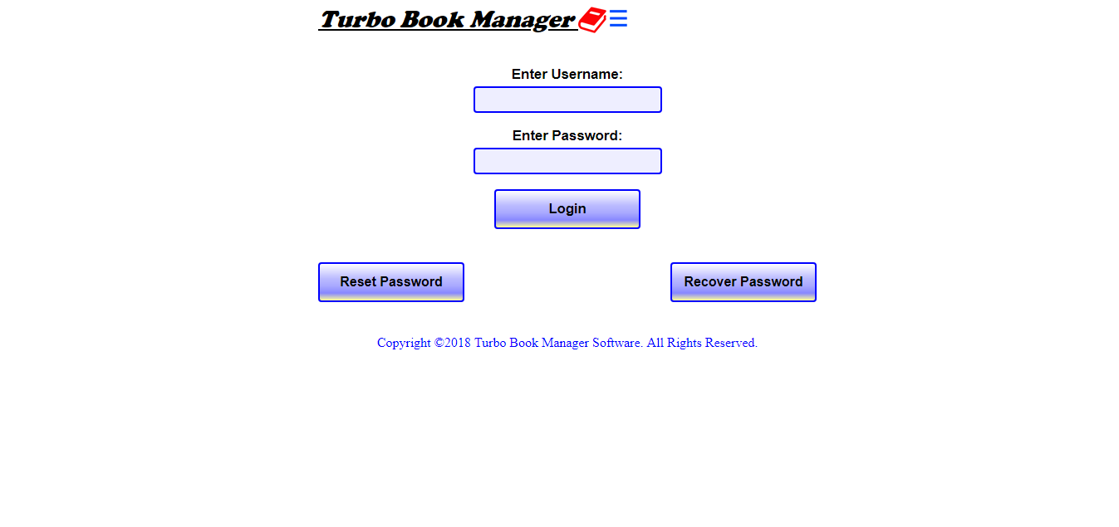

Figure 3.1.1 – Login Screen

This section of the app contains user interface elements that involve managing a user’s access to the system. It includes common fields that allow the entering of a username and password and a login button that submits the information into the app where it will be verified. Also present are buttons (“Reset Password” and “Recover Password”) that transfer the user to new sections of the app.

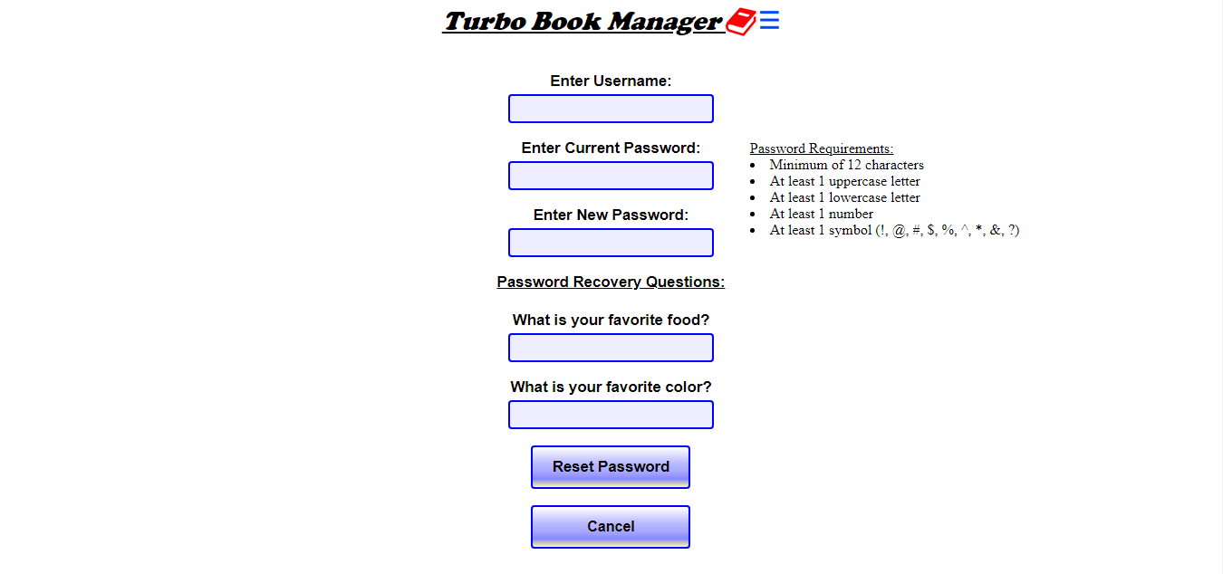

Figure 3.1.2 – Reset Password Screen

On this page the user may reset his password. The user interface includes various input fields that accept user input. The “Enter Username” and “Enter Current Password” boxes are meant for the user to enter account information for verification purposes. The boxes related to password recovery (“What is your favorite food?” and “What is your favorite color?”) are meant to aid the user if his password is forgotten; when recovering a password this data must be entered to verify identity. The button “Reset Password” allows the user to confirm the choice to reset the password. The “Cancel” button allows the user to abandon the process and return to the login screen.

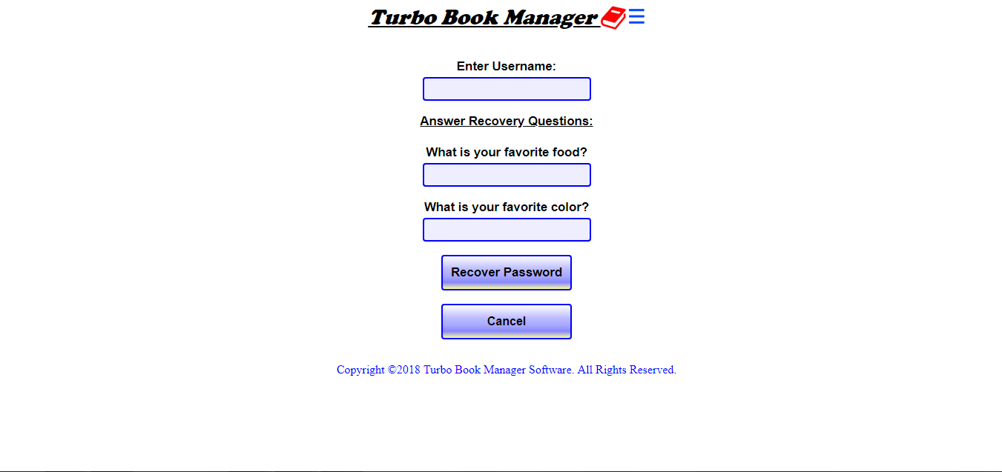

Figure 3.1.3 – Recover Password Screen

On this page the user may recover a forgotten password. The user interface includes various input fields that accept user input. These fields are meant for the user to input data to verify his identity within the system. The “Recover Password” button acts as the way to verify the user input and does so by submitting this data to the system where it will be checked to see if there is a match. The “Cancel” button allows the user to abandon the process and return to the login screen.

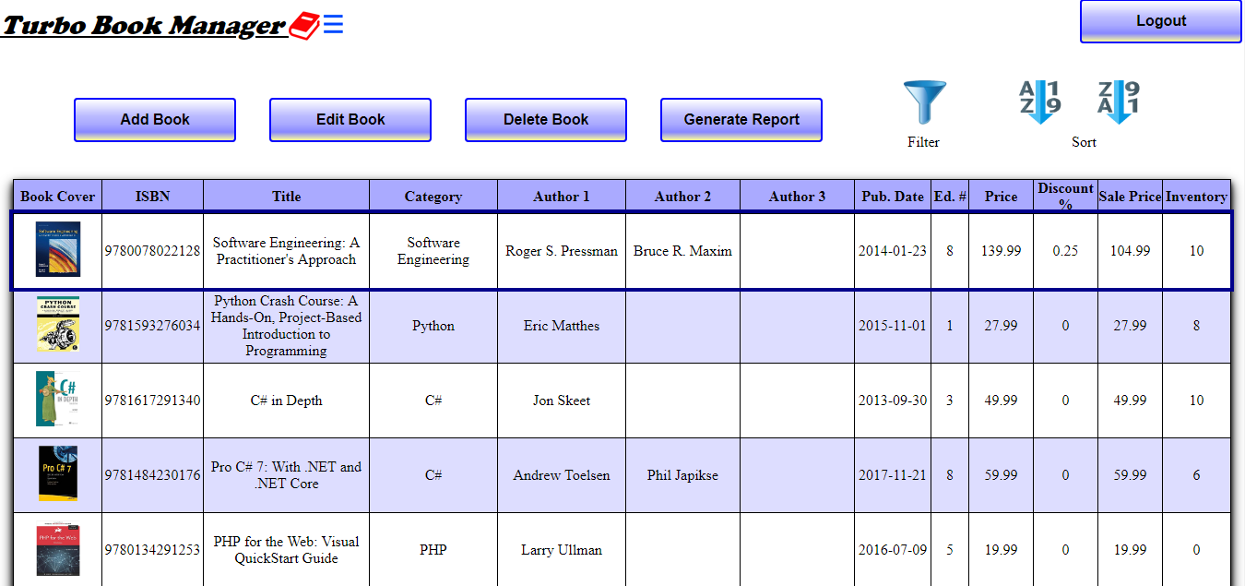

Figure 3.1.4 – Main Screen

This is the primary section of the app. It displays all of the data regarding books the store is currently selling. The controls allow the user various options for manipulating data. The two sort buttons cause the data to be displayed either lowest-to-highest (default) or highest-to-lowest. The filter button button opens another screen with an interface that allows the user to decide which data will be displayed. The “Add Book” button opens a screen where the user may enter information on a new book.

The “Edit Book” button opens a screen where the user may, after clicking a row of data from the table, edit the book’s data. The “Delete Book” button opens a screen where the user may, after clicking a row of data from the table, delete the book from the system. The “Generate Report” button opens a dialog that enables the user to generate a report in PNG format. The “Logout” button logs the user out of the system and returns him to the login page of the app.

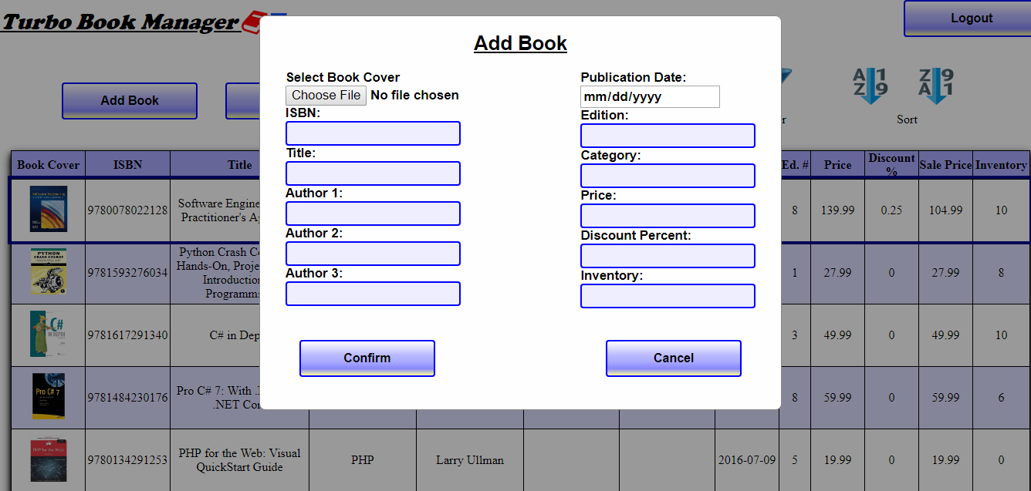

Figure 3.1.5 – Add Book Screen

The Add Book screen presents multiple input boxes for which to enter information on a new book. The “Browse…” button in particular enables the user to search his system for an image file to represent the book’s cover and the dropdown menu for publication date enables the user to either manually enter the date or move through a calendar format to select the date. The “Confirm” button submits the information to the system; the book will then appear in the table. The “Cancel” button removes the Add Book screen from the display without saving any of the data the user may have entered.

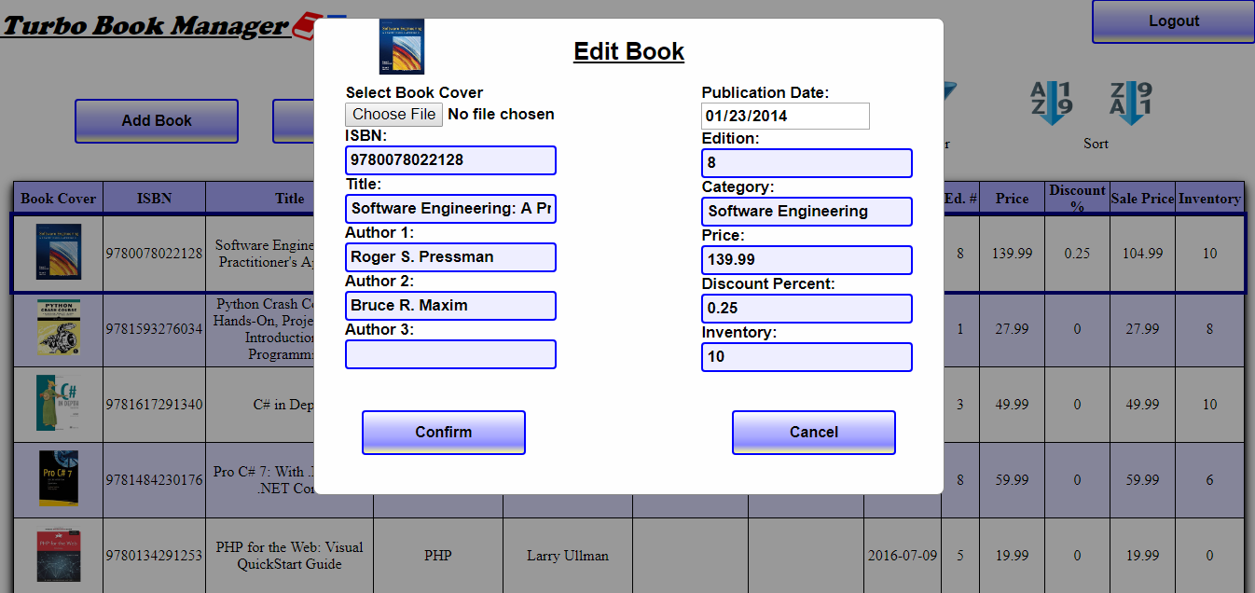

Figure 3.1.6 – Edit Book Screen

Similar to the Add Book Screen except the input fields are pre-filled with data from the currently selected book. The user may make changes to any field. The “Confirm” button executes the changes to the data in the system. The “Cancel” button removes the Edit Book screen from the display without saving any of the changes the user may have made.

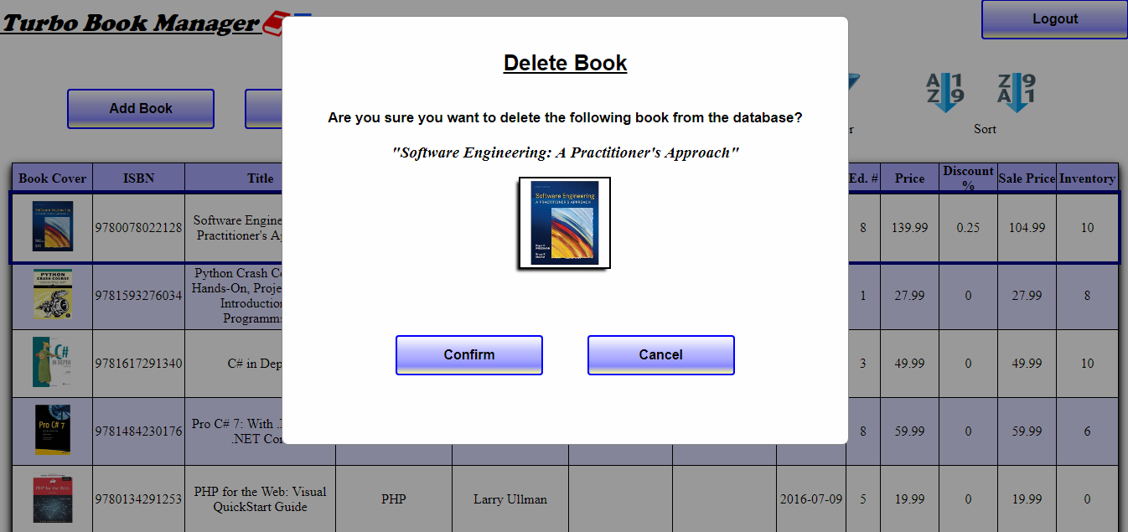

Figure 3.1.7 – Delete Book Screen

The Delete Book screen acts as a confirmation screen in which the user may either click on the “Confirm” button to delete the book from the system or the “Cancel” button to remove the Delete Book screen from the display without any other effect.

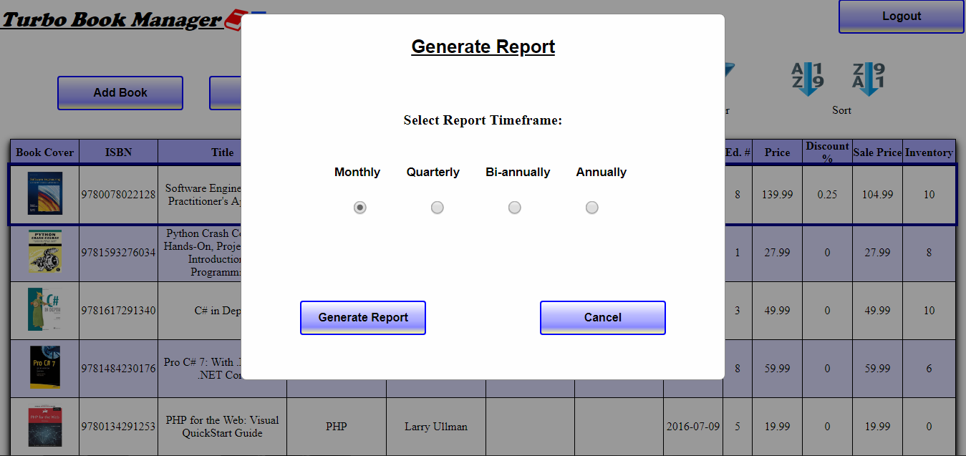

Figure 3.1.8 – Generate Report Screen

The Generate Report screen’s interface allows the user to select a period of time from which to generate a report on sales data. The four radio buttons each correspond to a specific timeframe and only one may be selected at a time.

The “Monthly” option will cause the report generated to display sales data for the current month. The “Quarterly” option will cause the report generated to display sales data for each quarter of the current year. The “Bi-Monthly” option will cause the report generated to display sales data for each half of the current year. The “Annually” option will cause the report generated to display sales data for all months of the current year. The “Confirm” button generates the report in PNG file format. The “Cancel” button removes the Generate Report screen from the display.

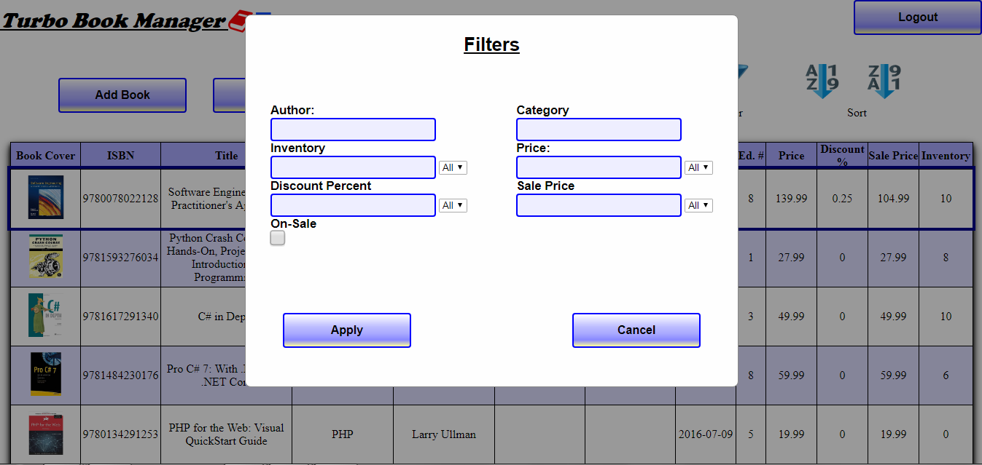

Figure 3.1.9 – Filter Screen

The filter dialog’s interface features various inputs for manipulating which data is displayed in the main screen’s table. The drop-down options for “Inventory,” “Price,” “Discount Percent,” and “Sale Price” allow the use of comparison operators to filter data. The “On-Sale” checkbox filters data based on whether it has been marked down in price. The “Apply” button causes the user’s filter choices to take effect. The “Cancel” button prevents any filter options the user may have entered from taking effect and removes the filter dialog from the screen.

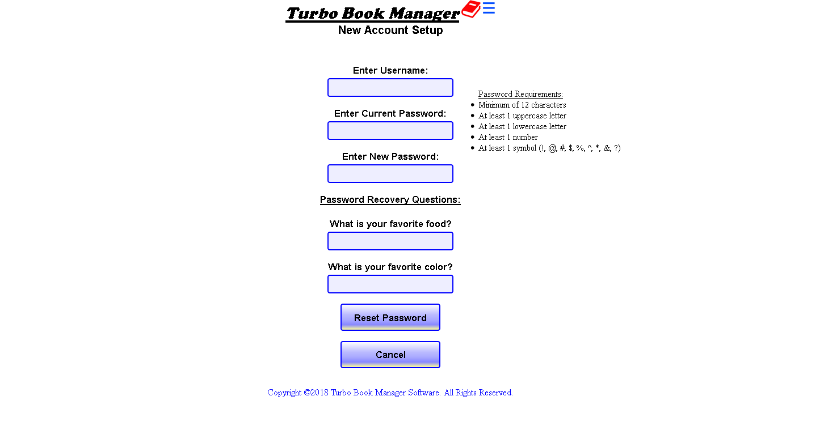

Figure 3.1.10 – New Account Setup Screen

This page allows a new user to create a new password and answers to password recovery questions. The user interface includes various input fields that accept user input. The “Enter Username” and “Enter Current Password” boxes are meant for the user to enter account information for verification purposes. The boxes related to password recovery (“What is your favorite food?” and “What is your favorite color?”) are meant to aid the user if his password is forgotten; when recovering a password this data must be entered to verify identity. The button “Reset Password” allows the user to confirm the choice to reset the password. The “Cancel” button allows the user to abandon the process and return to the login screen.

### 3.1.2 Hardware Interfaces

The only hardware that Turbo Book Manager interfaces with is that of the computer itself and connected input devices of a keyboard and mouse.

### 3.1.3 Software Interfaces

The only software that Turbo Book Manager interfaces with is that of the operating system that runs it.

### 3.1.4 Communications Interfaces

Turbo Book Manager communicates with a database which contains all of the book data.

## 3.2 Functional Requirements

### 3.2.1 Login in to use Turbo Book Manager

3.2.1.1 Introduction

Upon starting the Turbo Book Manager software, the software must present the user with a login screen (see figure 3.1), which displays the software logo, two input fields each with an accompanying label describing their purpose, and three buttons.

3.2.1.2 Inputs

There are three inputs that shall be required in order for a user to login and be granted access to the use of the Turbo Book Manager software. Two of those inputs require a user to type text into them in order for the user to specify a username and password. The third input is a button that the user must click to send the login data for processing. A “Reset Password” button allows a user to reset a password. A “Recover Password” button allows a user to recover a forgotten password.

3.2.1.3 Processing

The software shall process the user provided username and password when the user has clicked the button titled “Login.” The software must ensure the username and password correspond to those of a valid user account before granting the user access to the software.

3.2.1.4 Outputs

When logging to the software, the software must present the user with the primary software interface (see figure 3.2). When resetting a password, a user must be presented with a screen listing the steps on how to reset the password. When recovering a password, a user must be presented with a screen listing steps on how to recover the password.

3.2.1.5 Error Handling

If the username and/or password provided by the user do not match a correct username/password combination, the Turbo Book Manager software must not grant the user access to the software and must instead display a message on the startup screen informing the user that the information

the user entered is invalid.

### 3.2.2 Adding a book to the store’s inventory system

3.2.2.1 Introduction

A user must be able to add a new book to the book store’s inventory by providing book data for it.

3.2.2.2 Inputs

There must be various input fields available to the user in order for the user to provide book data for the new book. There also must be a button that allows the user to submit the book data to the software for processing (see figure 3.3).

3.2.2.3 Processing

The software must process the book data and ensure the data for all required input fields is provided and that a duplicate value for the ISBN does not already exist in the database.

3.2.2.4 Outputs

The software must present feedback to the user in the form of a message stating that the book was successfully added to the database.

3.2.2.5 Error Handling

If the user does not provide book data for all of the required input fields, the software must provide a message to the user stating which input fields have been left empty and must be filled. In the event that the user provides an ISBN that already exists in the database, the software must display a message to the user stating the error.

### 3.2.3 Deleting a book from the store’s inventory system

3.2.3.1 Introduction

A user shall be able to remove a book currently in the book store’s inventory by following a few steps.

3.2.3.2 Inputs

No actual inputting of text is required to delete a book. Instead, to accomplish this task, a user must click on the row pertaining to the book and then click the “Delete Book” button. Afterward, clicking the “Confirm Delete” button that appears on-screen via a dialog confirms the decision.

3.2.3.3 Processing

The software must correctly process the user’s request to delete the book data from the inventory following the user’s decision. Or, if the user decides against the action and clicks the “Cancel” button, the software should correctly take no action and remove the confirm deletion prompt from the screen.

3.2.3.4 Outputs

The software must present feedback to the user in the form of a message stating that the book was successfully deleted from the database.

3.2.3.5 Error Handling

If the user does not select a book prior to clicking the delete button, the software must provide a message to the user stating that the user must first select a book.

### 3.2.4 Editing a book already in the store’s inventory system

3.2.4.1 Introduction

A user must be able to edit the book data of a book already in the database.

3.2.4.2 Inputs

To update the book data of a book, a user must click on the row pertaining to the desired book and then click the “Edit Book” button. A dialog must then appear which displays input fields for all of the various book data pertaining to the selected book. There must also be two additional buttons included in that dialog: one containing the text “Accept Changes” and the other containing the text “Cancel.” The first button must save the changes a user made to the selected book’s book data and the other must discard those changes.

3.2.4.3 Processing

When a user clicks the “Accept Changes” button, the software must close the dialog containing the selected book’s book data and then update the corresponding book data in the database.

3.2.4.4 Outputs

A message must be displayed stating the changes were made successfully.

3.2.4.5 Error Handling

If a user enters invalid data into any of the input fields or leaves a required input field blank, a message must be displayed stating which input fields must be corrected and the reason for the error.

### 3.2.5 Using a filter to limit the number of books displayed

3.2.5.1 Introduction

A user must be able to limit how many books are displayed on screen by selecting from a list of filters and then specifying a corresponding filter condition. The list of filters that must be available are listed here along with the data that must be supplied in order for the filter to act upon:

* Author: display only books whose author matches a certain author.
* Category: display only books whose category matches a certain category.
* Price: display only books whose price is less than, less than or equal to, greater than, greater than or equal to, or equal to a certain price.
* Discount %: display only books whose discount percentage is less than, less than or equal to, greater than, greater than or equal to, or equal to a certain discount percentage.
* On Sale: display only books whose discount percentage is above zero (on sale) or equal to zero (not on sale).
* Sale Price: display only books whose sale price is less than, less than or equal to, greater than, greater than or equal to, or equal to a certain sale price.
* Inventory: display only books whose inventory amount is less than, less than or equal to, greater than, greater than or equal to, or equal to a certain inventory amount.

3.2.5.2 Inputs

There must be a button a user can click to open a dialog that contains various filters to choose from. The graphic for the button must be the commonly recognized filter graphic (see figure 3.2). The dialog that opens must have input fields for each of the above listed filters.

3.2.5.3 Processing

The software must retrieve books from the database that only match the specified filter criteria.

3.2.5.4 Outputs

The software must only display books that match the specified filter criteria.

3.2.5.5 Error Handling

If a user provides invalid or no data for a selected filter, the software must notify the user of the error.

### 3.2.6 Generating a report based on book usage

3.2.6.1 Introduction

A user must be able to view a report detailing book usage over a specified period of time.

3.2.6.2 Inputs

There must be a button for a user to click to generate the report. This opens a dialog in which a user must select a timeframe to base the report on (monthly; quarterly; bi-annually; annually).

3.2.6.3 Processing

The software must create a report by compiling monthly sales data for each book over a series of months based on the specified timeframe.

3.2.6.4 Outputs

The software exports the report as an HTML file which can be viewed in a web browser. The HTML file will be saved to the same directory as the software, in a folder entitled “Reports.” The filename of the generated report must include what type of report it is. The software must display a message to the user stating the report has been successfully generated.

3.2.6.5 Error Handling

If the software cannot generate the report, an error message must be displayed to the user stating there was a problem and that the request could not be completed.

## 3.3 Non-Functional Requirements

### 3.3.1 Performance

Adding, removing, or updating book data must be processed in less than one second. Processing a detailed report of purchasing statistics should be no more than three seconds for larger inventories (300 books).

### 3.3.2 Reliability

The software must also function as the user intended and must be free of glitches.

### 3.3.3 Availability

Turbo Book Manager must be available to use any time of the day.

### 3.3.4 Security

Turbo Book Manager must require a password be provided by the user before the user can interact with the software. A password helps prevent unauthorized access from employees that do not have permission to access the bookstore’s inventory. The software must log the user out of the system after ten minutes of inactivity for security purposes, although this is the default duration and can be configured manually by the user.

### 3.3.5 Maintainability

Turbo Book Manager’s code must be written in such a way as to easily and efficiently allow new features to be added.

## 3.4 Logical Database Requirements

A database must be used to store the book data for all of the books in the bookstore’s inventory. To maintain data retention, a backup copy of the database must be created on a daily basis. The storage capability of the database must be able to store a minimum of approximately 500 different books.

The following lists the table columns required to represent the book data and the corresponding data types and the various constraints used to enforce data integrity on those columns:

Cover Image: VARCHAR(300)

ISBN: VARCHAR(13) – UNIQUE, NOT NULL

Title: VARCHAR(120) – NOT NULL

Category: VARCHAR(20) – NOT NULL

Author 1: VARCHAR(40) – NOT NULL

Author 2: VARCHAR(40) – DEFAULT “” (empty string)

Author 3: VARCHAR(40) – DEFAULT “” (empty string)

Publication Date: DATE – NOT NULL

Edition Number: VARCHAR(1) – DEFAULT 1

Price: float – NOT NULL

Discount %: FLOAT – DEFAULT 0.0

Inventory: SMALLINT(3) – DEFAULT 0

ID: SMALLINT(6) – PRIMARY KEY

janSales: FLOAT – DEFAULT 0.0

febSales: FLOAT – DEFAULT 0.0

marSales: FLOAT – DEFAULT 0.0

aprSales: FLOAT – DEFAULT 0.0

maySales: FLOAT – DEFAULT 0.0

junSales: FLOAT – DEFAULT 0.0

julSales: FLOAT – DEFAULT 0.0

augSales: FLOAT – DEFAULT 0.0

sepSales: FLOAT – DEFAULT 0.0

octSales: FLOAT – DEFAULT 0.0

novSales: FLOAT – DEFAULT 0.0

decSales: FLOAT – DEFAULT 0.0

# 4. Analysis Models

**4.1 Use Case Diagram**

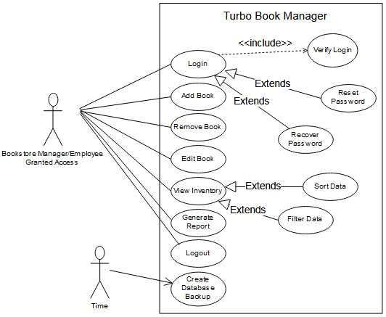

Figure 4.1 - Turbo Book Manager UML Case Diagram

This diagram illustrates the general use cases of the Turbo Book Manager software and the actors that will interact with the system. As the diagram shows, the actor, whether it is the bookstore manager or an employee who has been granted some type of access to the software, may login, add a book, remove a book, edit a book, view the store’s inventory, generate a report, or log out of the system.

This diagram also illustrates certain important relationships between use cases. The base use case *login* for example is dependent on the *verify login* use case. Additionally, the *reset password* and *recover password* use cases extend the behavior of the login use case. The *sort data* and *filter data* use cases extend the base use case *view inventory*. The actor *time* and the *create database backup* use case refer to the automatic daily creation of backup database files.

# 5. Change Management Process

When the project’s scope or requirements change, either project manager can submit these changes for review and if agreed upon, will be listed in the revision history and the SRS will be updated accordingly.