# Adding an Employee

1. Click on Add Employee then chose what kind of employee you want to add

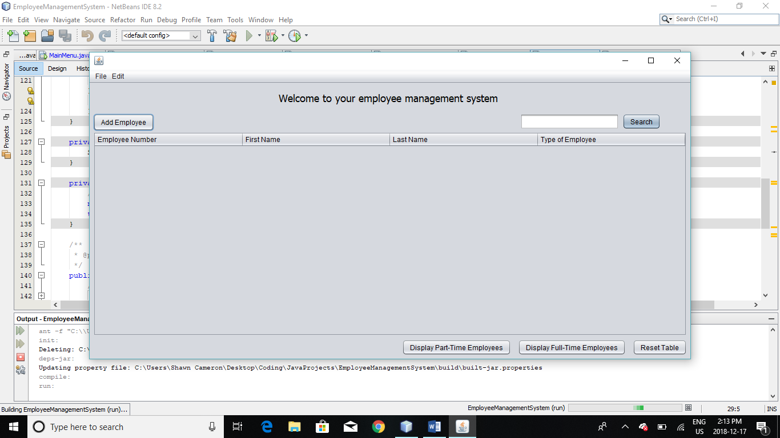

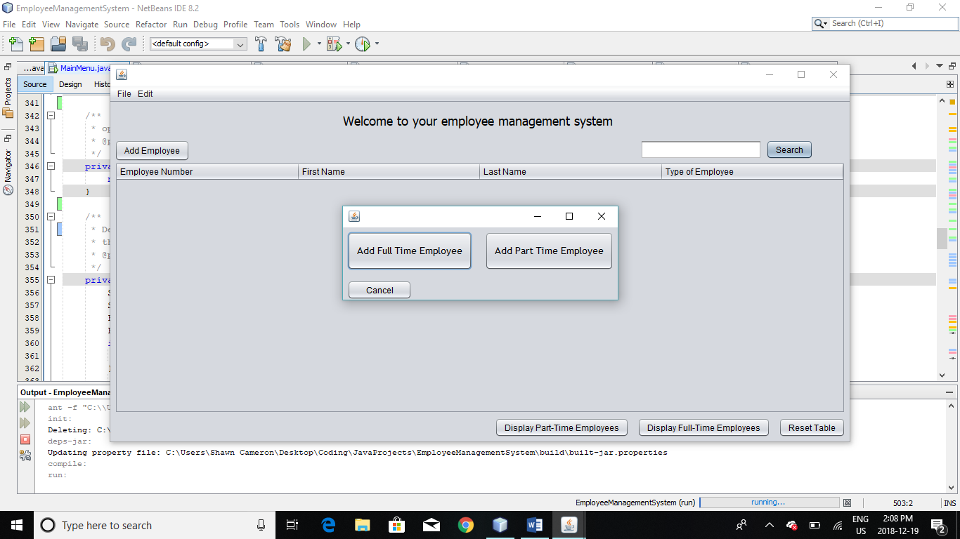

1. Fill out the information then click Add Employee to add them to the table.

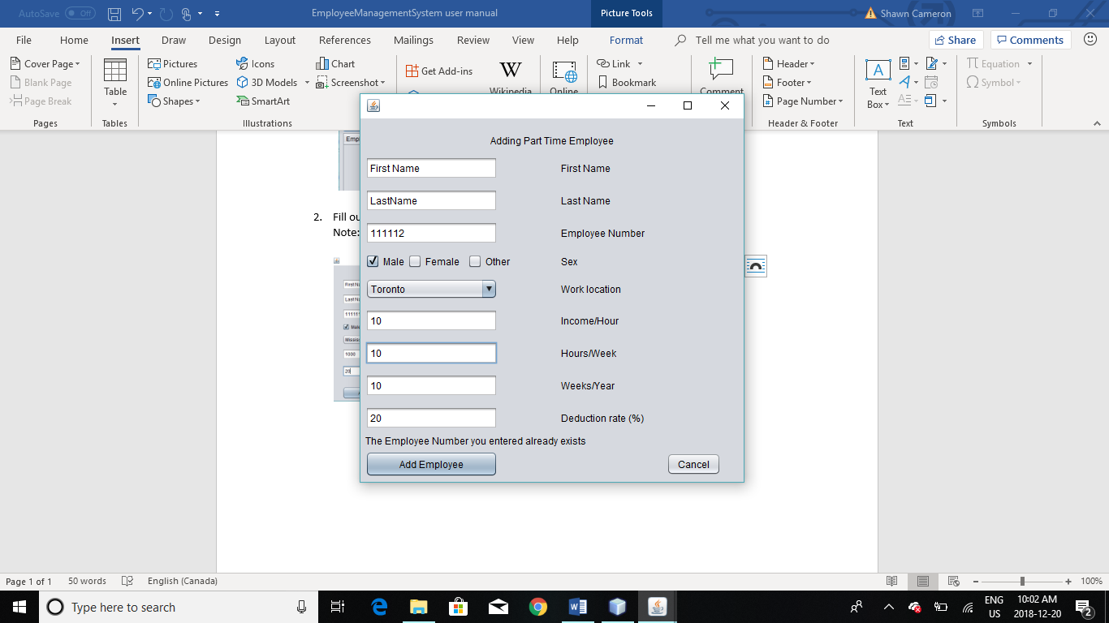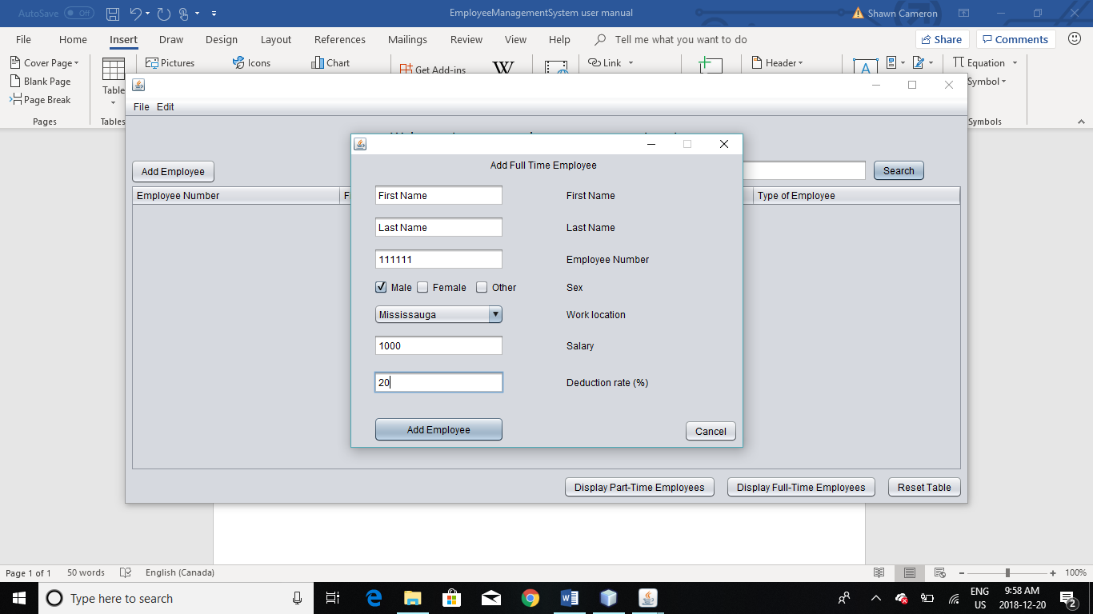Note: you will not be able to add them to the system if information is not valid or the employee number already exists.

1. Your employees will be displayed in the main screen.

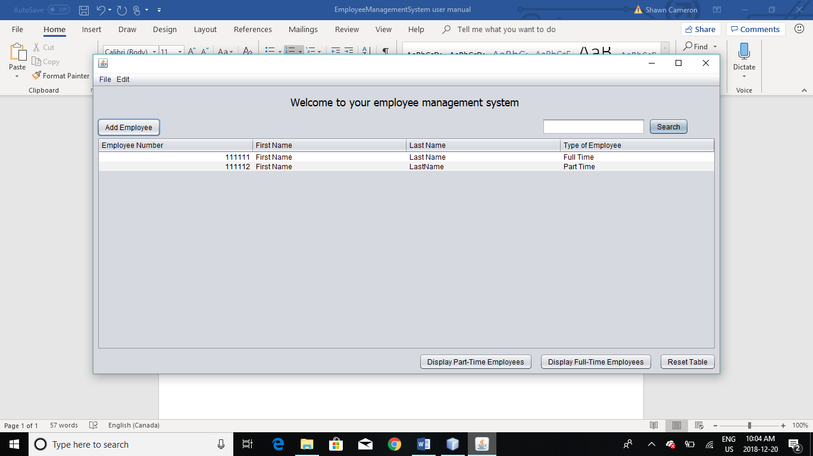

# Searching and Displaying Employees

## Searching

1. Use the search bar in your main menu page to filter the list of employees.
2. Press search to apply the filter to the list.

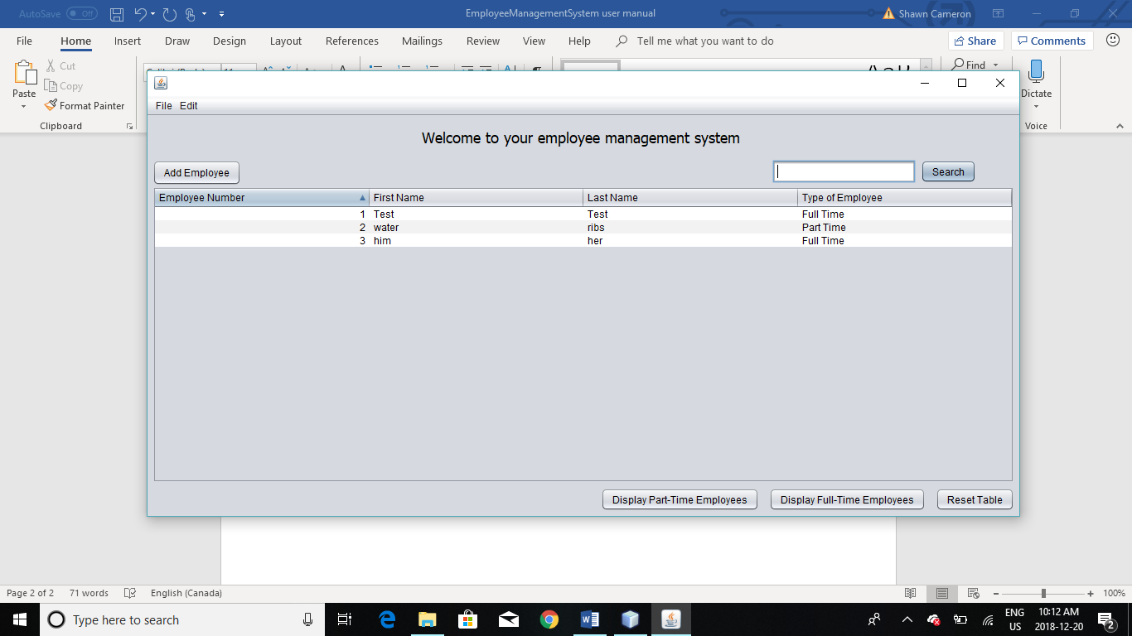

Before pressed

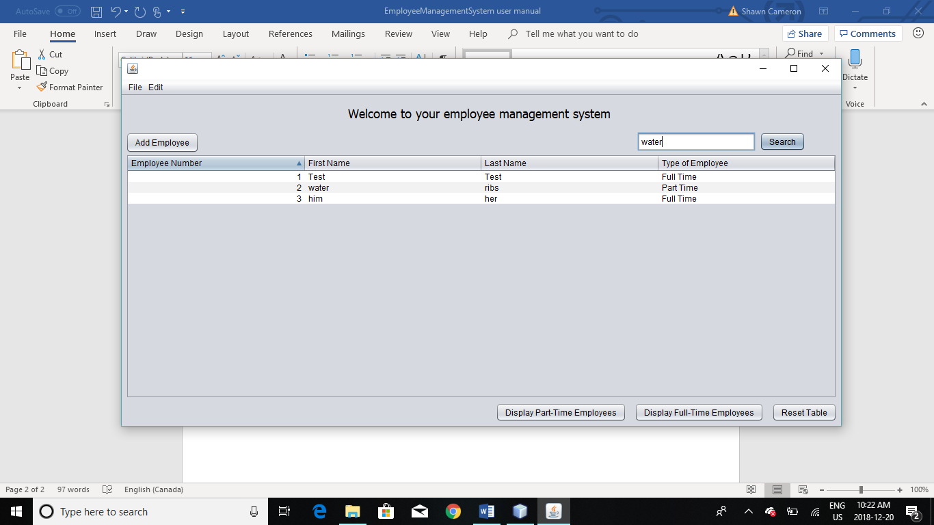

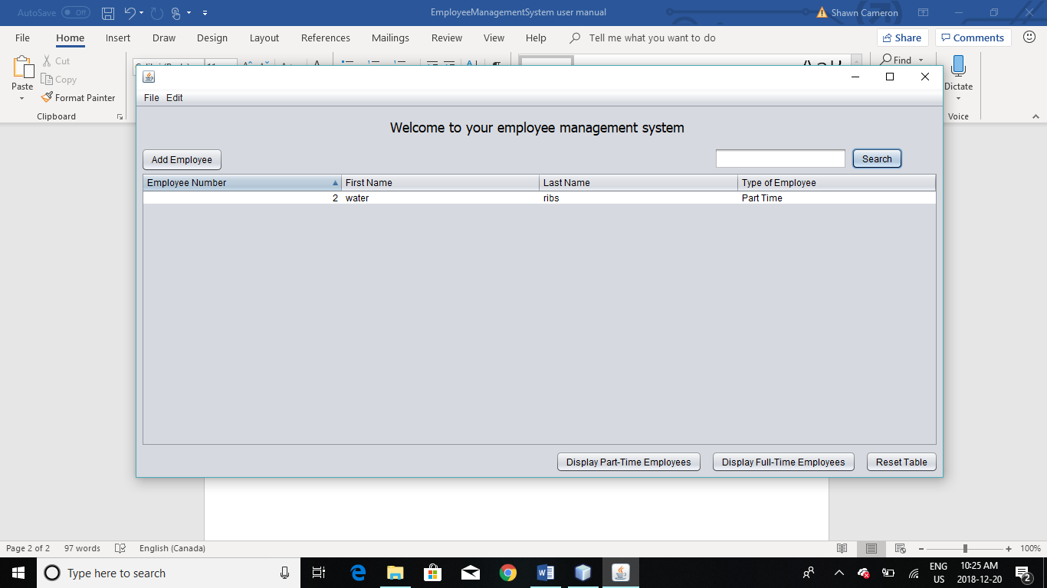After pressed

1. Use the Display Only buttons when you want to display your full-time employees or your half-time employees.

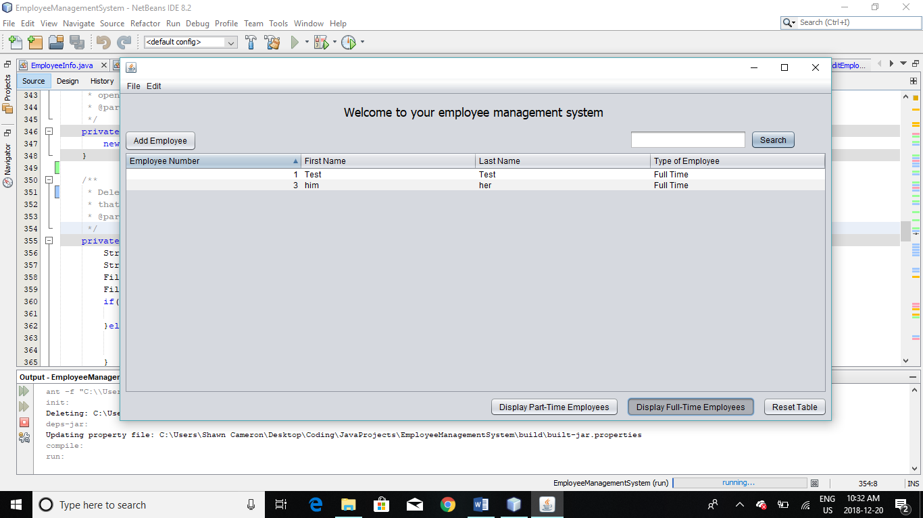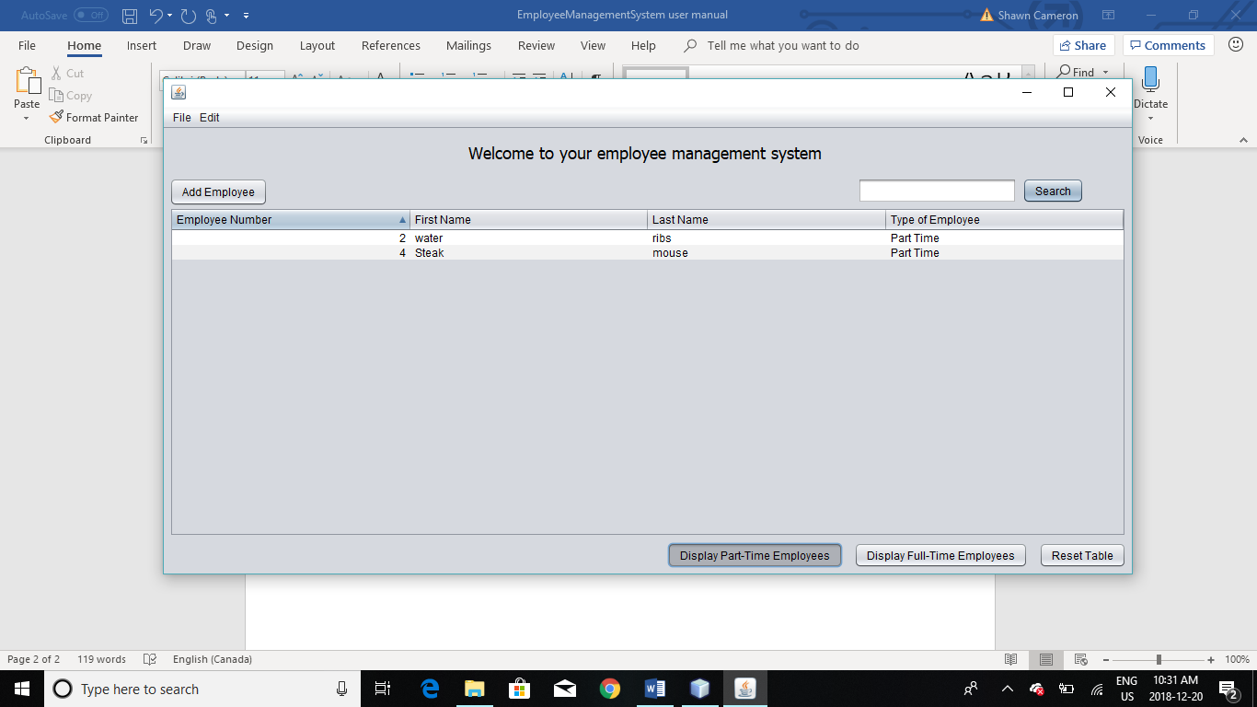

1. Click on Reset Table when you want to redisplay all the employees.

## Displaying Employees

1. 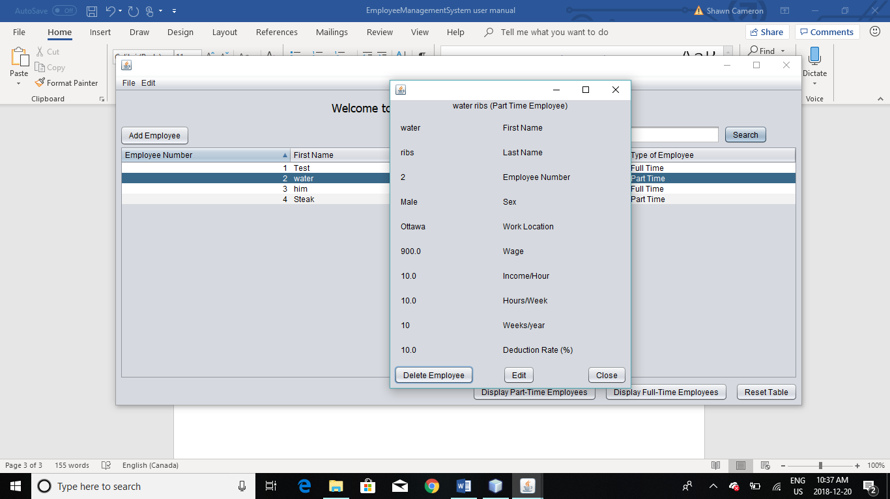From the Main Menu page, double click the employee’s row in the table to check all the information on them.
2. Click on Delete Employee to remove them from the system.

# Editing Employees

1. Click edit from the display employee page to bring up the edit employee page.
2. The page will bring up the previous information and will allow you to edit.

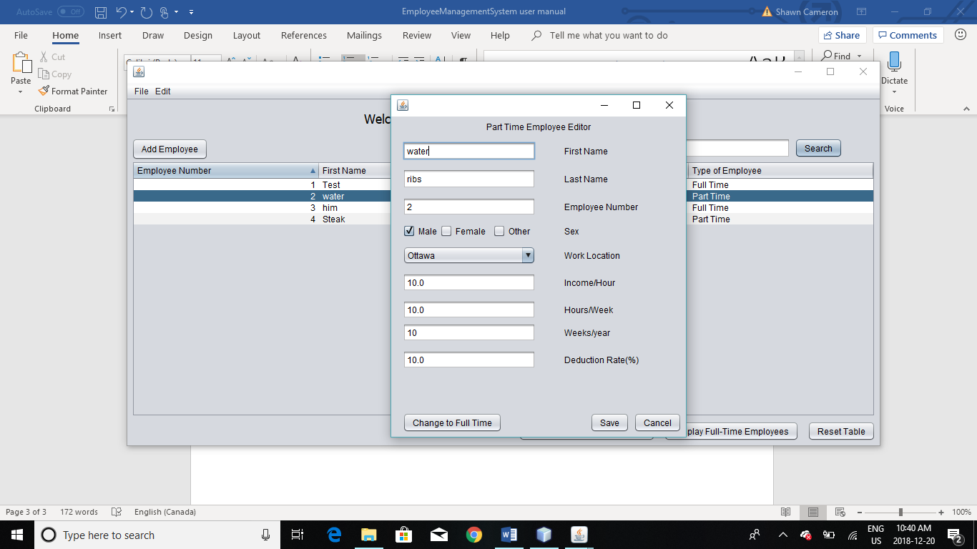

1. Click change button to change the type of the employee from full-time to part-time or from part-time to full-time. Click save when your done making your changes.

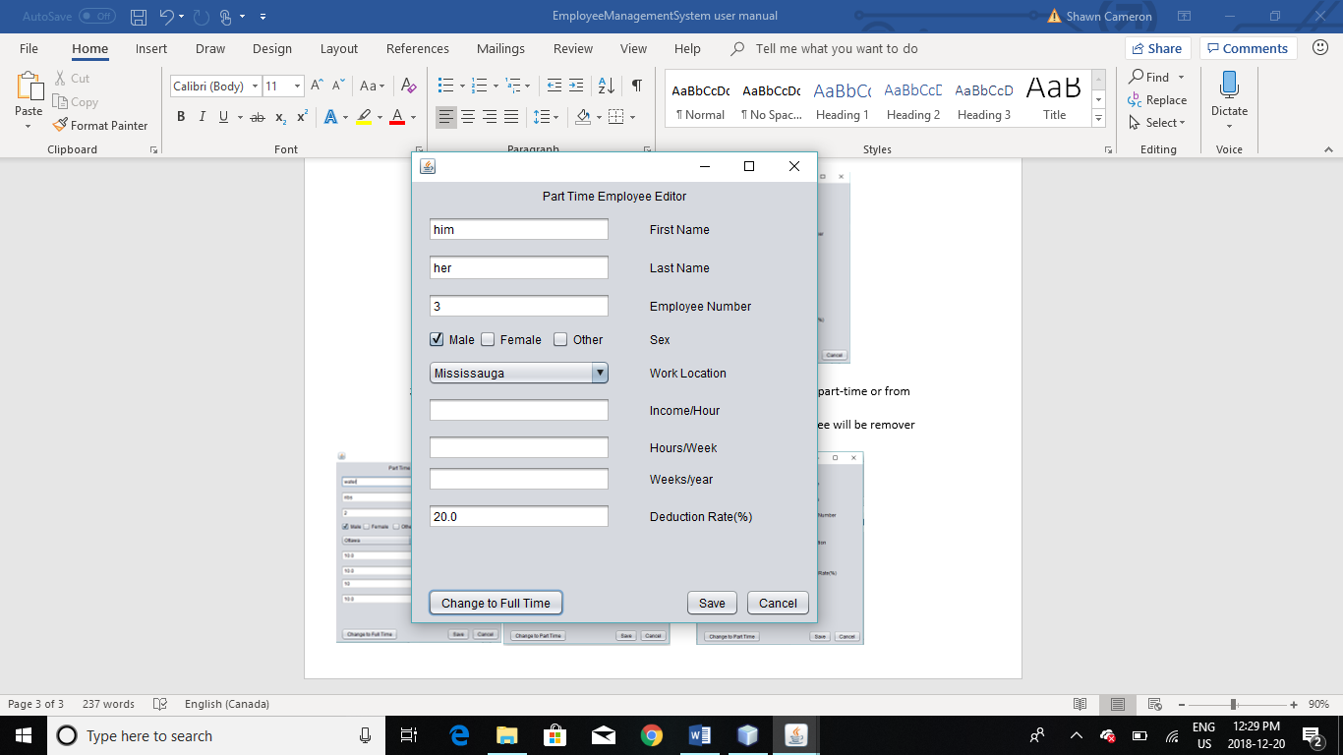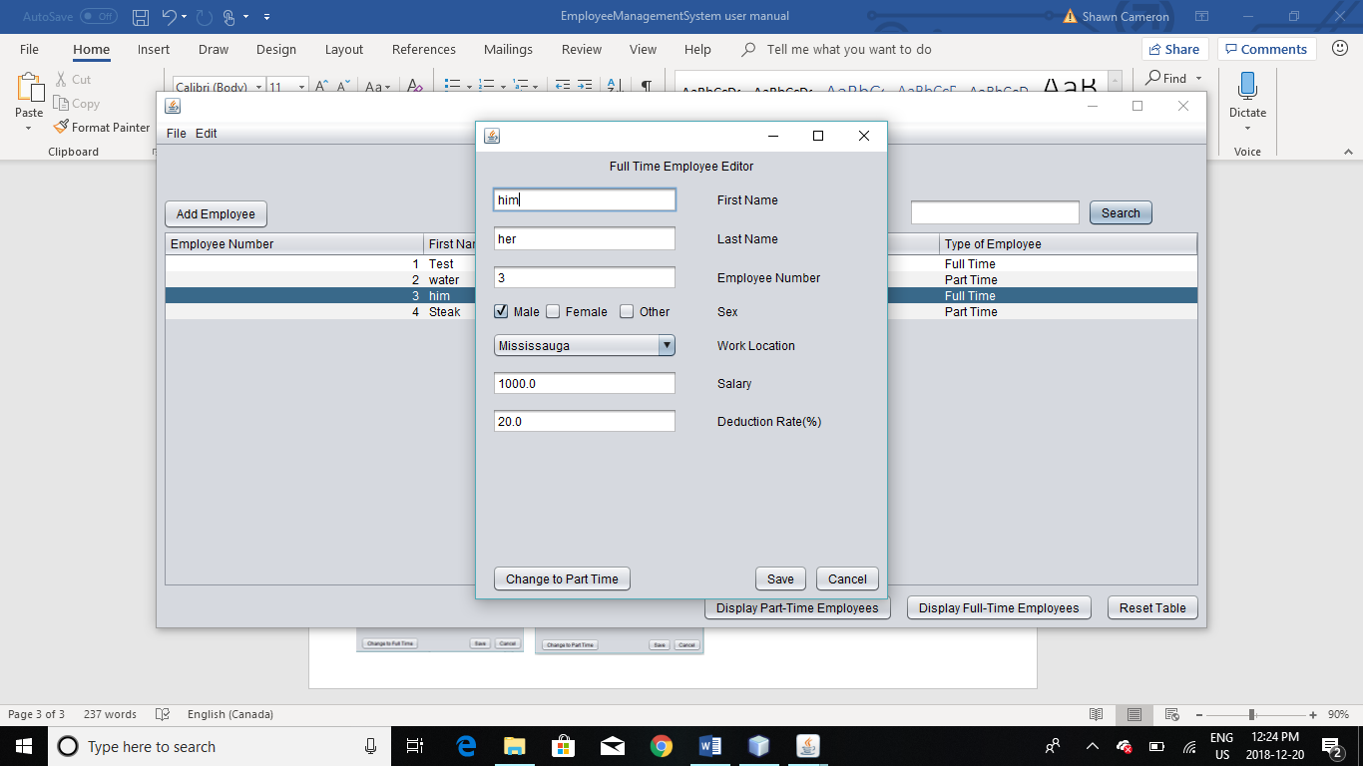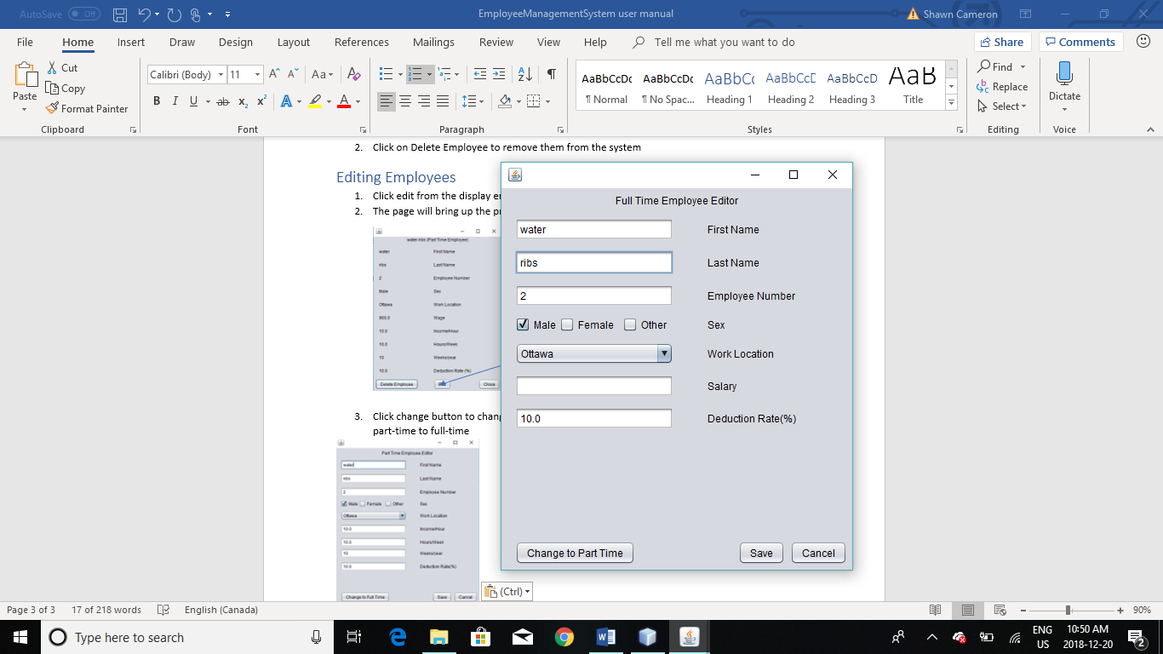Note: the specific information that corresponds to the type of the employee will be remover from the screen.

# Password Protection

## Adding/Editing Password

1. Open Edit > Add/Edit Password protection or press Ctrl+P to open the password editor.

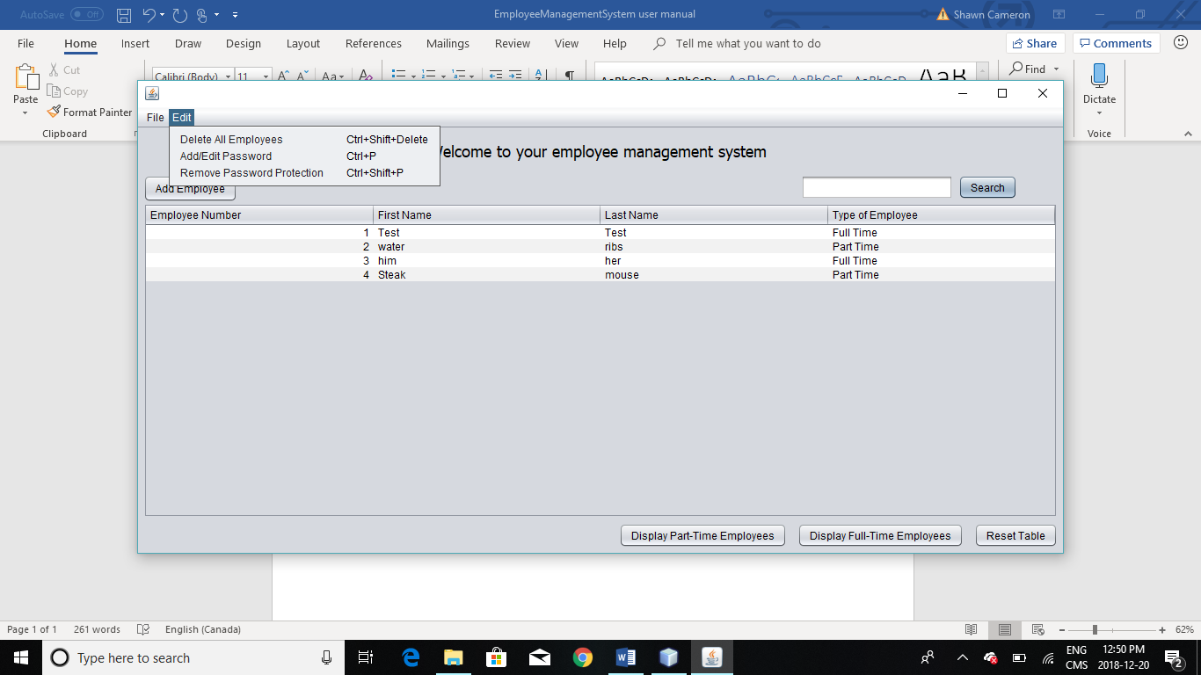

1. Enter a password that is over 5 characters and enter your phone number without the extension for recovery purposes.

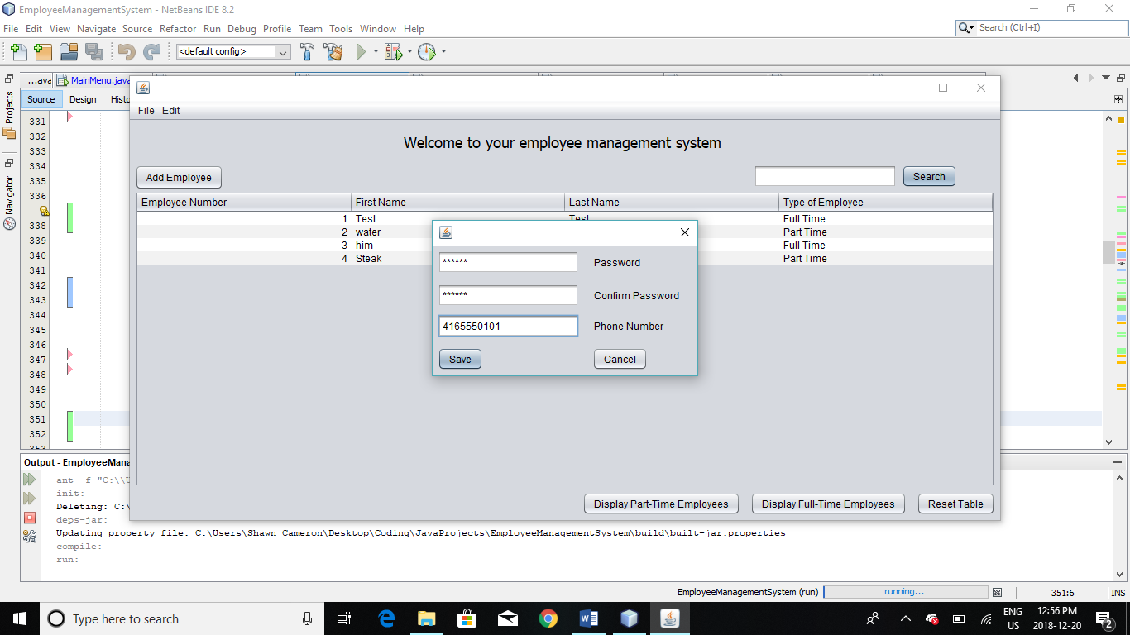

1. Do the same for changing your password but the old phone number entry will be displayed in the text box.

## Removing Password Protection

1. Select Edit > Remove Password Protection or press Ctrl+Shift+P to remove password protection.

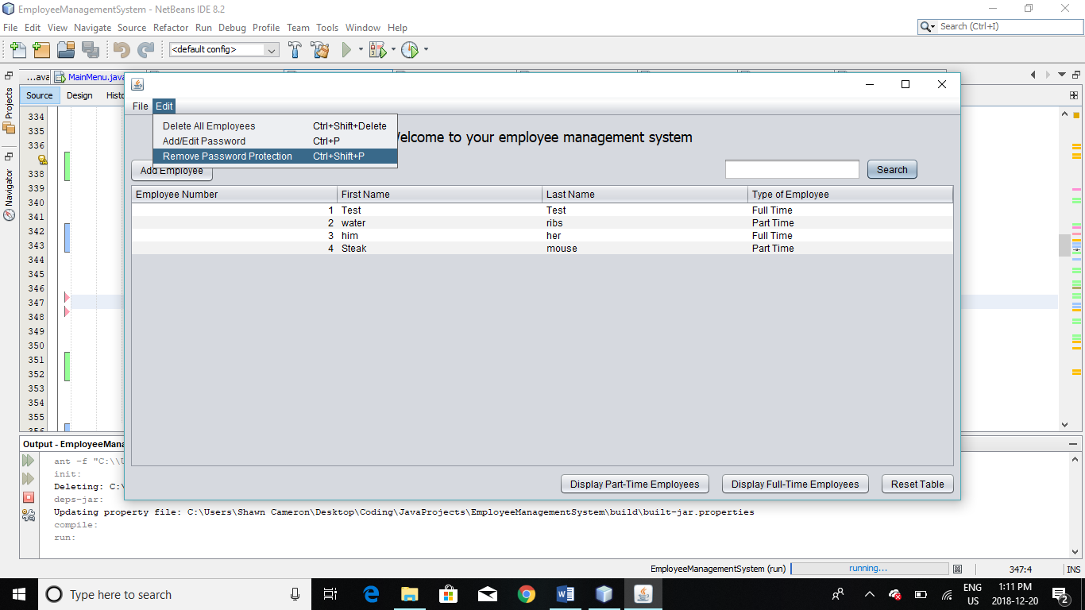

## Forgetting Password

1. A temporary code will be sent to your phone when you Click on Forget Password.

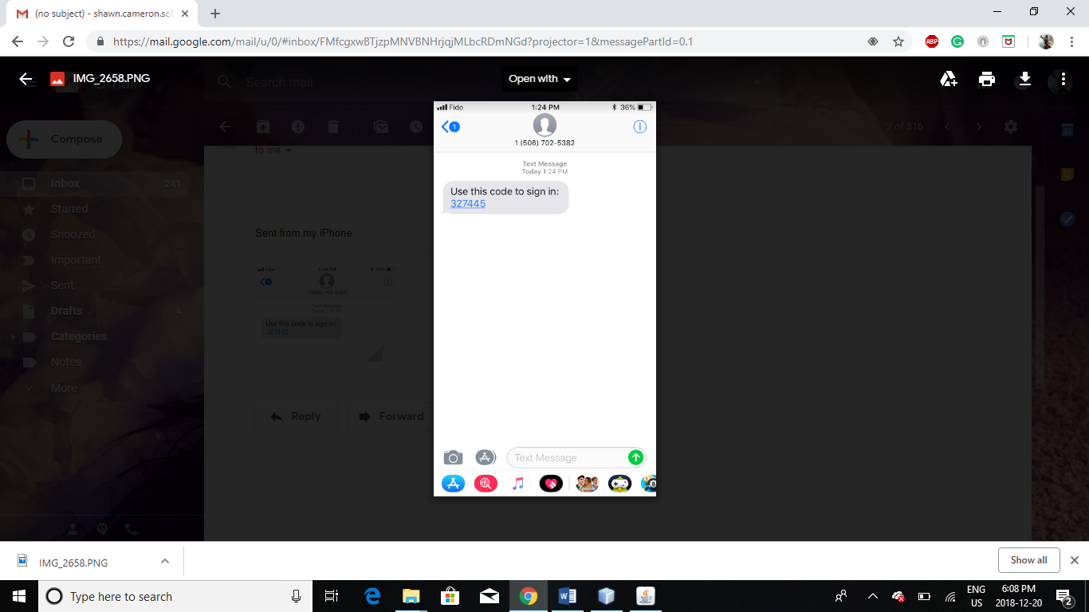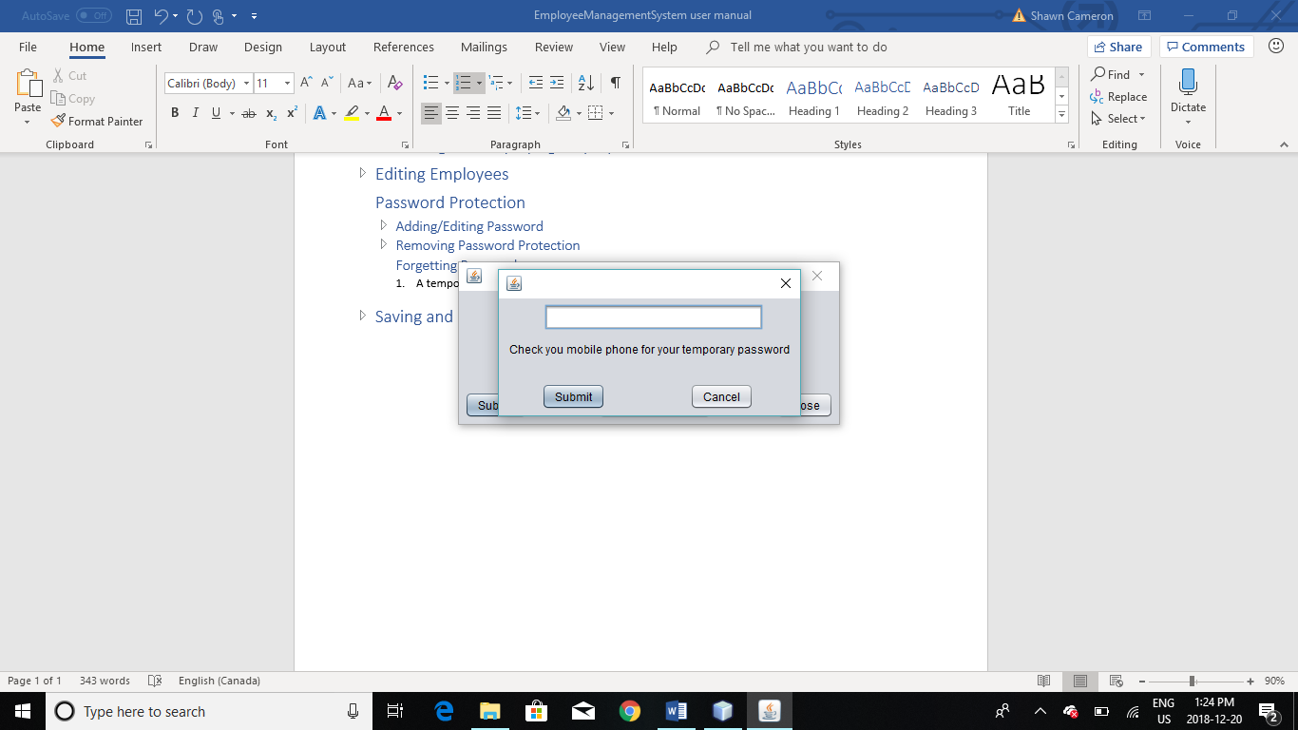

1. Enter the code into the field and click submit to login.
2. Recommended to change your password after recovering.

# Saving and Loading Information

## Saving

1. 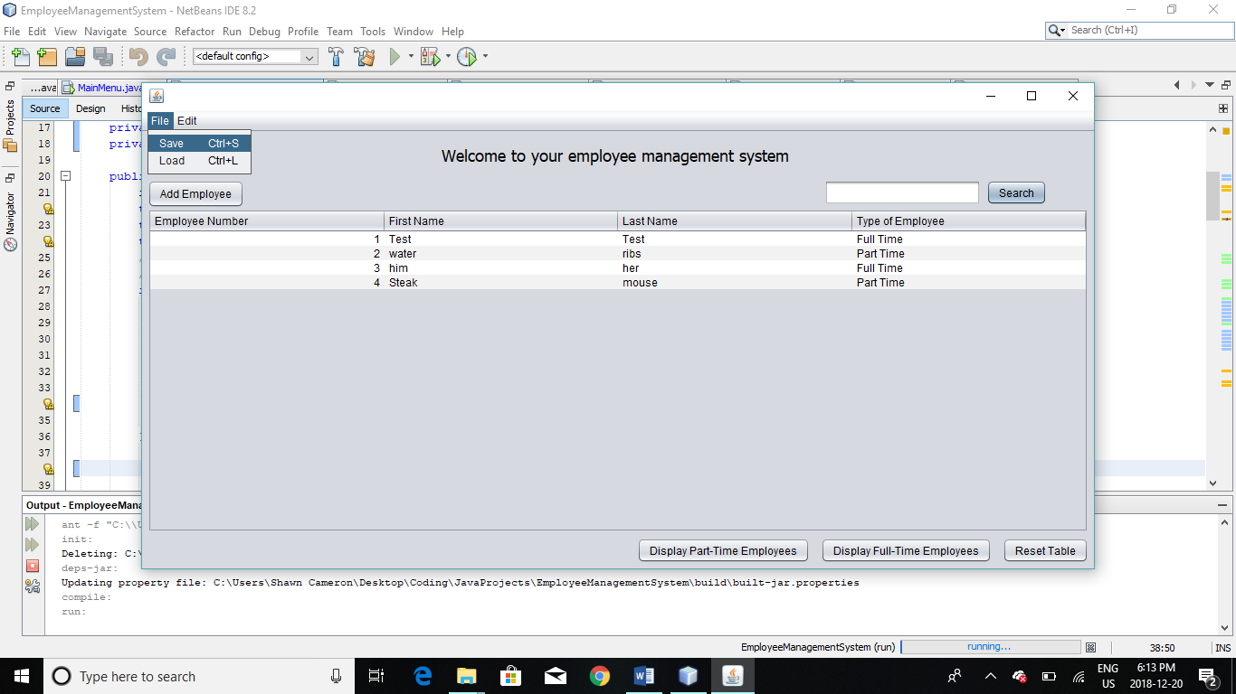To save your progress go to File then click Save or press Ctrl+S.
2. If your changes were not saved the system will ask if you want to save before you log out.

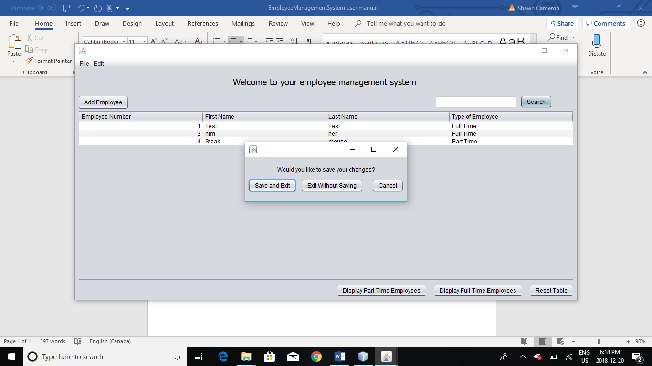

## Loading

1. To load the previously saved information, go to File then click Load or press Ctrl+L.

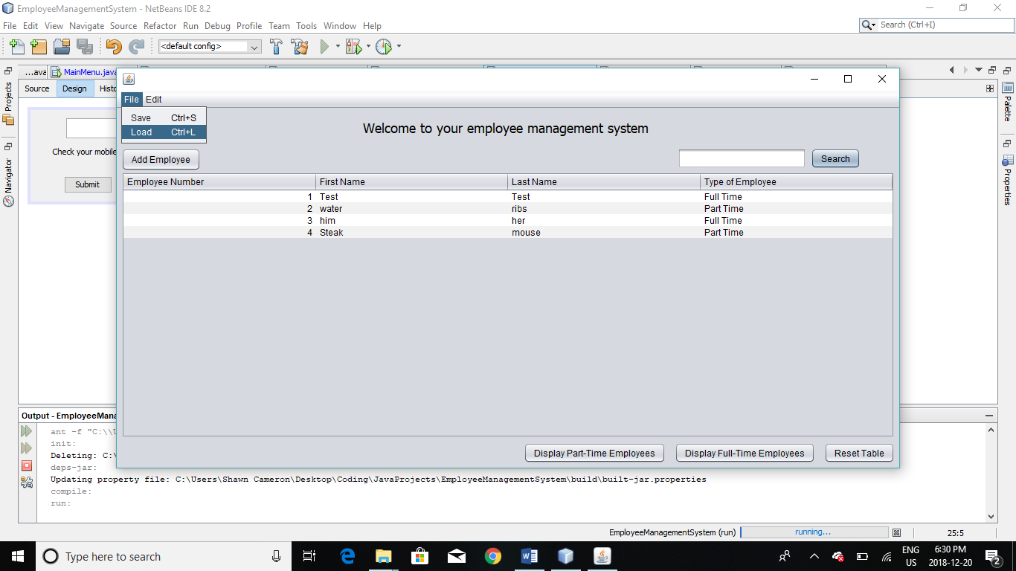

# Limitations

## Saving and Editing Employees

1. First Name and Last Name fields can not be empty.
2. Employee will not be added or edited if the Employee Number matches another Employee’s.
3. Deduction rate is entered as percentage between 0 and 100 percent, inclusive.
4. When adding a part time employee, the hours per week must be between 0 and 168 and weeks per year must be a whole number between 1 and 52, inclusive.

## Password protection

1. Password must be 6 characters in length or longer.
2. Confirm password must be the exact same as the first password entry.
3. System only supports Canadian and American phone numbers.
   1. 10-digit number with an extension of +1.