Project_PSTAT126

Xihao Wu & Anhui Shi

9/10/2018

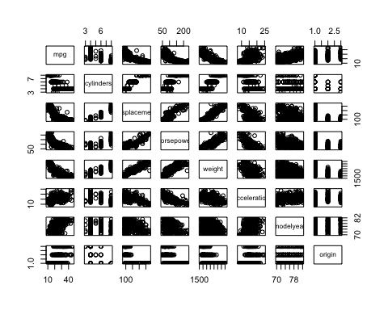

## Start: AIC=1611.93  
## mpg ~ 1  
##   
## Df Sum of Sq RSS AIC  
## + weight 1 16497.8 7321.2 1151.5  
## + displacement 1 15440.2 8378.8 1204.4  
## + horsepower 1 14433.1 9385.9 1248.9  
## + cylinders 1 14403.1 9415.9 1250.1  
## + modelyear 1 8027.7 15791.3 1452.8  
## + acceleration 1 4268.5 19550.5 1536.5  
## <none> 23819.0 1611.9  
##   
## Step: AIC=1151.49  
## mpg ~ weight  
##   
## Df Sum of Sq RSS AIC  
## + modelyear 1 2752.3 4569.0 968.66  
## + horsepower 1 327.4 6993.8 1135.56  
## + acceleration 1 168.3 7152.9 1144.37  
## + displacement 1 150.9 7170.3 1145.33  
## + cylinders 1 115.1 7206.1 1147.28  
## <none> 7321.2 1151.49  
## - weight 1 16497.8 23819.0 1611.93  
##   
## Step: AIC=968.66  
## mpg ~ weight + modelyear  
##   
## Df Sum of Sq RSS AIC  
## <none> 4569.0 968.66  
## + acceleration 1 10.5 4558.5 969.77  
## + cylinders 1 5.0 4564.0 970.24  
## + horsepower 1 3.3 4565.7 970.38  
## + displacement 1 0.0 4568.9 970.66  
## - modelyear 1 2752.3 7321.2 1151.49  
## - weight 1 11222.4 15791.3 1452.81

##   
## Call:  
## lm(formula = mpg ~ weight + modelyear, data = auto_mpg[, -8])  
##   
## Coefficients:  
## (Intercept) weight modelyear   
## -14.347253 -0.006632 0.757318

## (Intercept) cylinders displacement horsepower weight acceleration  
## 1 TRUE FALSE FALSE FALSE TRUE FALSE  
## 2 TRUE FALSE FALSE FALSE TRUE FALSE  
## 3 TRUE FALSE FALSE FALSE TRUE TRUE  
## 4 TRUE FALSE TRUE FALSE TRUE TRUE  
## 5 TRUE TRUE TRUE FALSE TRUE TRUE  
## 6 TRUE TRUE TRUE TRUE TRUE TRUE  
## modelyear  
## 1 FALSE  
## 2 TRUE  
## 3 TRUE  
## 4 TRUE  
## 5 TRUE  
## 6 TRUE

## [1] 0.6918423 0.8071941 0.8071393 0.8067872 0.8067841 0.8062826

## [1] 232.396144 1.169751 2.284200 3.992019 5.000800 7.000000

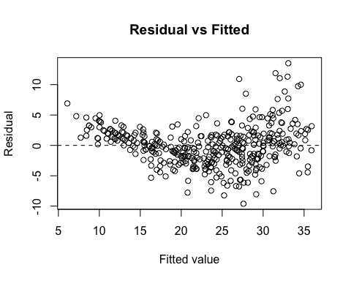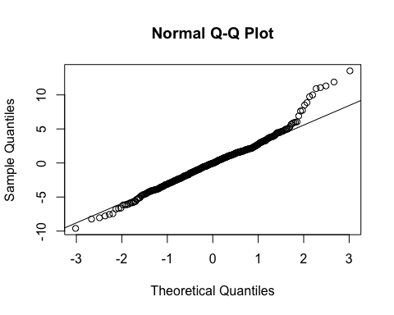

##   
## Shapiro-Wilk normality test  
##   
## data: e.2.selected  
## W = 0.97513, p-value = 2.951e-06

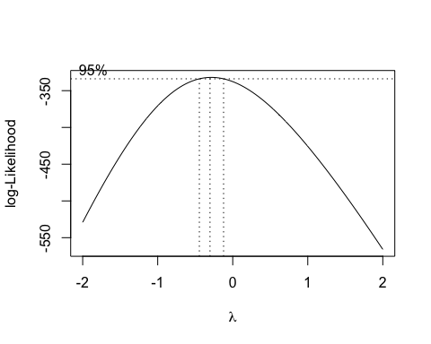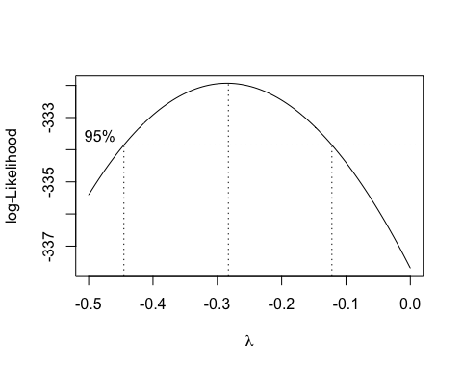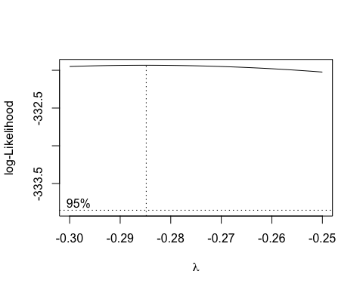

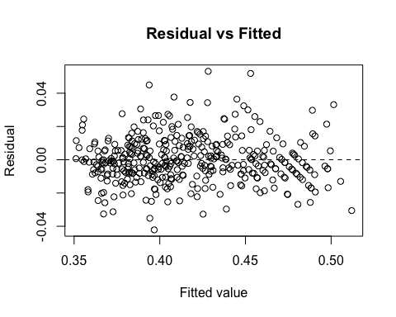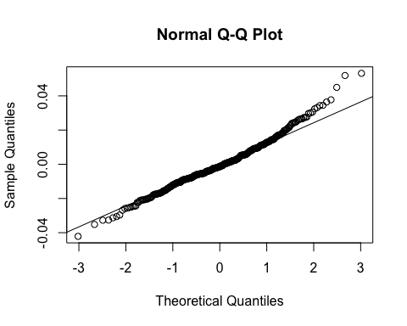

##   
## Shapiro-Wilk normality test  
##   
## data: e.2.trans  
## W = 0.98356, p-value = 0.0001951

##   
## Call:  
## lm(formula = mpg^(-0.285) ~ weight + modelyear + origin, data = auto_mpg)  
##   
## Residuals:  
## Min 1Q Median 3Q Max   
## -0.042143 -0.008286 -0.001333 0.008135 0.053164   
##   
## Coefficients:  
## Estimate Std. Error t value Pr(>|t|)   
## (Intercept) 5.975e-01 1.682e-02 35.526 < 2e-16 ***  
## weight 3.491e-05 1.088e-06 32.084 < 2e-16 ***  
## modelyear -3.731e-03 2.038e-04 -18.313 < 2e-16 ***  
## origin2 -7.769e-03 2.168e-03 -3.583 0.000383 ***  
## origin3 -5.412e-03 2.172e-03 -2.492 0.013123 *   
## ---  
## Signif. codes: 0 '***' 0.001 '**' 0.01 '*' 0.05 '.' 0.1 ' ' 1  
##   
## Residual standard error: 0.01397 on 387 degrees of freedom  
## Multiple R-squared: 0.8823, Adjusted R-squared: 0.8811   
## F-statistic: 725.5 on 4 and 387 DF, p-value: < 2.2e-16

## 355 210 296 356 54   
## 0.02725322 0.02667348 0.02664503 0.02637170 0.02619988

## 165 124 111 382 274   
## 3.882467 3.788329 3.286674 3.067614 2.748952

## 111 274 276   
## 0.03684560 0.03020079 0.02938542

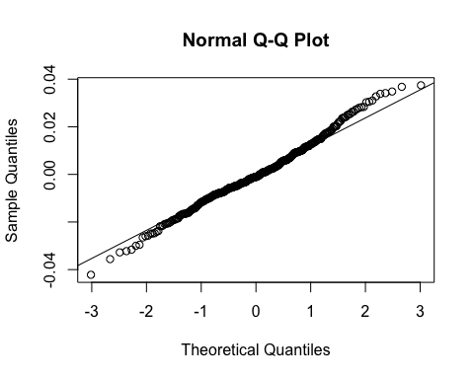

##   
## Shapiro-Wilk normality test  
##   
## data: e.deleted  
## W = 0.99213, p-value = 0.0378

## Analysis of Variance Table  
##   
## Model 1: mpg^(-0.285) ~ weight + modelyear + origin  
## Model 2: mpg^(-0.285) ~ weight + modelyear + origin + weight * modelyear +   
## weight * origin + modelyear * origin  
## Res.Df RSS Df Sum of Sq F Pr(>F)  
## 1 387 0.075545   
## 2 382 0.074799 5 0.00074532 0.7613 0.5782

##   
## Call:  
## lm(formula = mpg^(-0.285) ~ weight + modelyear + origin, data = auto_mpg)  
##   
## Residuals:  
## Min 1Q Median 3Q Max   
## -0.042143 -0.008286 -0.001333 0.008135 0.053164   
##   
## Coefficients:  
## Estimate Std. Error t value Pr(>|t|)   
## (Intercept) 5.975e-01 1.682e-02 35.526 < 2e-16 ***  
## weight 3.491e-05 1.088e-06 32.084 < 2e-16 ***  
## modelyear -3.731e-03 2.038e-04 -18.313 < 2e-16 ***  
## origin2 -7.769e-03 2.168e-03 -3.583 0.000383 ***  
## origin3 -5.412e-03 2.172e-03 -2.492 0.013123 *   
## ---  
## Signif. codes: 0 '***' 0.001 '**' 0.01 '*' 0.05 '.' 0.1 ' ' 1  
##   
## Residual standard error: 0.01397 on 387 degrees of freedom  
## Multiple R-squared: 0.8823, Adjusted R-squared: 0.8811   
## F-statistic: 725.5 on 4 and 387 DF, p-value: < 2.2e-16

## fit lwr upr  
## 1 25.92349 26.63265 25.23841