Final Project Report

Medicine Recommendation System


Project Supervisor
Dr. Mushtaq Hussain

Submitted By
themushtaq48

Mirza Shahan Baig bc190411036

Software Projects & Research Section,
Department of Computer Sciences,
Virtual University of Pakistan


CERTIFICATE

This is to certify that Mirza Shahan Baig (bc190411036) have worked on and completed their Software Project at Software & Research Projects Section, Department of Computer Sciences, Virtual University of Pakistan in partial fulfillment of the requirement for the degree of BS in Computer Sciences under my guidance and supervision.

In our opinion, it is satisfactory and up to the mark and therefore fulfills the requirements of BS in Computer Sciences.

Supervisor / Internal Examiner

Dr. Mushtaq Hussain
Supervisor,
Software Projects & Research Section,
Department of Computer Sciences
Virtual University of Pakistan

___________________
(Signature)

External Examiner/Subject Specialist
Dr. Mushtaq Hussain

___________________
(Signature)

Accepted By:

_____________
(For office use)

EXORDIUM

In the name of Allah, the Compassionate, the Merciful.

Praise be to Allah, Lord of Creation,
The Compassionate, the Merciful,
King of Judgment-day!

You alone we worship, and to You alone we pray for help,
Guide us to the straight path

The path of those who You have favored,

Not of those who have incurred Your wrath,
Nor of those who have gone astray.

DEDICATION
I dedicate this project to my beloved family, whose prayers, encouragement and continuous support gave me the strength to complete my work successfully. Their patience and trust in me motivated me during every stage of this project.
I also dedicate this work to my respected teachers and project supervisor, Dr. Mushtaq Hussain, for their valuable guidance and support. Their knowledge and suggestions helped me improve my skills and complete the Medicine Recommendation System.
Finally, I dedicate this project to healthcare professionals, pharmacists and researchers who work continuously to improve patient care and medicine safety. Their efforts inspired me to explore how machine learning, deep learning and web technologies can be used to support healthcare-related decision-making.
I hope this project will serve as a useful academic contribution and provide a foundation for further improvement in intelligent healthcare-support systems.
Acknowledgement
First of all, I am thankful to Allah Almighty for giving me the strength, patience and ability to complete this project successfully.
I would like to express my sincere gratitude to my project supervisor, Dr. Mushtaq Hussain, for his guidance, support and valuable feedback throughout the project. His suggestions helped me understand the problems clearly and improve my work at different stages of development.
I am also grateful to Virtual University of Pakistan and the Department of Computer Sciences for providing me with the required knowledge, learning resources and opportunity to work on this project. The concepts and practical skills learned during my degree helped me in developing the Medicine Recommendation System using Python, machine learning, deep learning and Streamlit.
I would also like to thank all my teachers for sharing their knowledge and helping me build a strong academic foundation. Special thanks to my family and friends for their prayers, encouragement and continuous support during the completion of this project.
Lastly, I am thankful to everyone who directly or indirectly contributed to this project. Their support and encouragement played an important role in completing this work.
PREFACE

This report presents the complete development work of the Medicine Recommendation System. It combines the approved project proposal, Software Requirements Specification, design document, implemented Streamlit application and model evaluation results in one document.
The main purpose of this project is to demonstrate how machine learning and deep learning techniques can be used to predict a possible medical condition from the symptoms entered by a user. Based on the predicted condition, the system displays ranked medicine suggestions along with confidence scores, explanations and important safety warnings.
This report explains the project requirements, data collection and preprocessing, system design, model training and testing, recommendation process and web-based user interface. It also discusses the tools and technologies used during development, implementation results, testing process, current limitations and possible future improvements.
The Medicine Recommendation System has been developed as an educational prototype. It is not intended to diagnose a medical condition, prescribe medicine or replace the advice of a qualified doctor or pharmacist. Any medicine-related result produced by the system should be reviewed by a healthcare professional.
TABLE OF CONTENTS

CHAPTER NO. 1
gathering & Analyzing info 10

1.1 Introduction

1.2 purpose

1.3 scope

1.4 definitions, acronyms and abbreviations

1.5 Project requirements

1.5.1 Functional Requirements

1.5.2 Non-Functional Requirements

1.6 use cases and usage scenarios

1.6.1 Use Case Diagrams

1.6.2 Usage Scenarios

1.7 Development Methodology

1.7.1 Chosen Methodology

1.7.2 Reasons for Chosen Methodology
1.7.2 Work Plan (Gantt Chart)
1.7.2 Project Schedule (Submission Calendar)

CHAPTER NO. 2
designing the project 12

2.1 Introduction

2.2 purpose

2.3 scope

2.4 definitions, acronyms and abbreviations

2.5 Architectural Representation (Architecture Diagram)

2.6 Dynamic Model: Sequence Diagrams

2.7 Object Model/Logical Model: Class Diagram

2.8 Database Model (Database Diagram)

2.9 Graphical User Interfaces

Chapter no.3
DEvelopment 13
3.1 Development plan (Architecture Diagram)

<<Dear Students, you have to take special care of page numbers, which are written against each Chapter and sub headings. You have to mention your own page numbers and correct one against each document heading. Make proper table of contents. Remember that if there are any new headings or you have included more headings in your documents then you also have to write these in table of contents and modify table of contents according to your documents material>>

<<Dear Students, before starting each chapter the following would be the title page for each chapter on a separate page>>

CHAPTER 1
Gathering & Analyzing Info

1.1 Introduction
Medication selection normally requires interpretation of symptoms, medical history, existing conditions, allergies, contraindications, and professional clinical judgment. The proposed system explores how machine learning can organize this information into a clear recommendation workflow for academic demonstration.

1.2 Purpose
The purpose is to develop an AI-assisted web prototype that preprocesses symptom data, compares machine-learning and deep-learning models, predicts a probable condition, and ranks related medicine candidates while displaying explanations and safety warnings.

1.3 Scope
- Included: dataset loading and cleaning, text normalization, condition encoding, train/test splitting, ML/DL model training, evaluation metrics, condition prediction, ranked medicine candidates, safety flags, and Streamlit presentation.
- Excluded: clinical diagnosis, prescription generation, dosage calculation, emergency treatment, online pharmacy ordering, payment processing, and replacement of professional medical advice.
- Target users: students and evaluators demonstrating the prototype, with future relevance to healthcare providers, pharmacists, and patients after proper clinical validation.

1.4 Definitions, Acronyms and Abbreviations
Term | Meaning
AI | Artificial Intelligence
ML | Machine Learning
DL | Deep Learning
SRS | Software Requirements Specification
TF-IDF | Term Frequency-Inverse Document Frequency
UI | User Interface
FR | Functional Requirement
NFR | Non-Functional Requirement
CSV | Comma-Separated Values
F1-score | Harmonic mean of precision and recall

1.5 Project Requirements

1.5.1 Functional Requirements
ID | Requirement | System response
FR-01 | Data collection and preprocessing | Load symptoms, diseases, prescriptions, medicines, and patient-history data; clean, normalize, validate, encode, and split model-ready records.
FR-02 | Model training and testing | Train and test Logistic Regression and Keras neural-network classifiers and compare prediction performance.
FR-03 | Fine-tuning and optimization | Use reproducible model settings, validation feedback, dropout/epoch configuration, and comparative evaluation to select an appropriate prototype model.
FR-04 | Medicine recommendation engine | Use predicted condition, symptoms, medical history, existing conditions, and allergies to rank candidates and identify safety-review needs.
FR-05 | Web-based user interface | Provide Streamlit tabs for recommendation input/output, dataset preview, and model evaluation.

1.5.2 Non-Functional Requirements
ID | Attribute | Acceptance interpretation
NFR-01 | Accuracy | Display measured metrics and confidence; avoid implying clinical validity.
NFR-02 | Usability | Use clear labels, simple tabs, readable tables, and concise warnings.
NFR-03 | Performance | Cache datasets and trained models so repeat interactions remain responsive.
NFR-04 | Privacy and security | Collect only demonstration inputs and avoid persistent storage of patient entries.
NFR-05 | Reliability | Validate missing symptoms and identify emergency terms without crashing.
NFR-06 | Maintainability | Separate data loading, preprocessing, models, recommendation logic, and UI modules.
NFR-07 | Compatibility | Run in a modern browser through Streamlit with documented Python dependencies.
NFR-08 | Ethical safety | Show a disclaimer and require clinician confirmation before medicine use.

1.6 Use Cases and Usage Scenarios
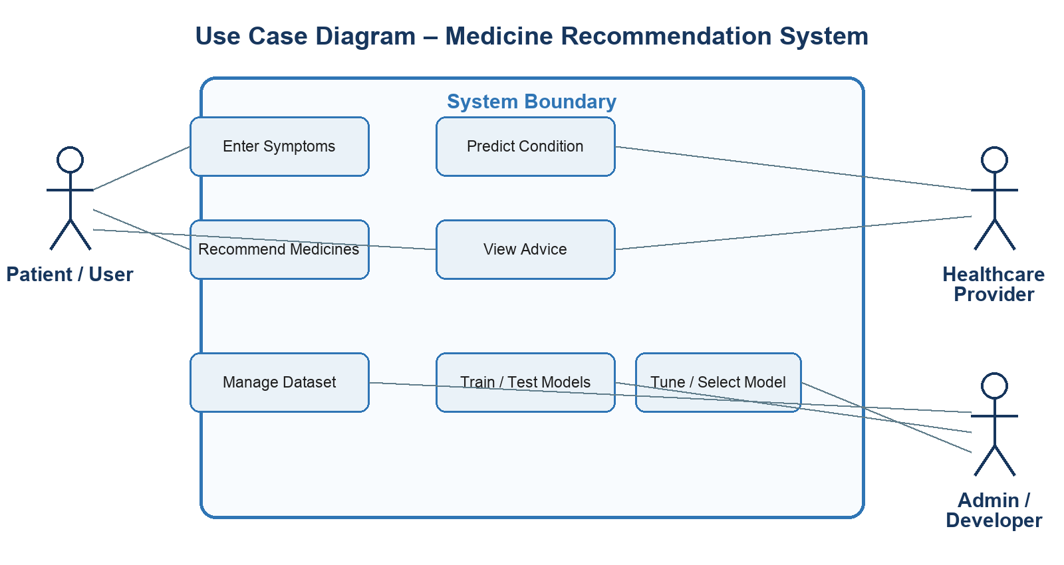
Figure 1.1: Medicine Recommendation System use-case diagram
ID | Use case | Actor | Main outcome
UC-01 | Open interface | Patient/User | View the recommendation form and medical disclaimer.
UC-02 | Enter symptoms | Patient/User | Enter symptoms, history, conditions, and allergies; validate input.
UC-03 | Predict condition | System | Normalize text and generate ranked condition probabilities.
UC-04 | Recommend medicines | System | Retrieve, safety-check, score, and rank medicine candidates.
UC-05 | View advice | Patient/User | Review confidence, explanation, safety status, and clinician warning.
UC-06 | Manage dataset | Admin/Developer | Load and inspect structured datasets and preprocessing results.
UC-07 | Train/test models | Admin/Developer | Train candidate models and inspect evaluation metrics.
UC-08 | Tune/select model | Admin/Developer | Compare configured models and select a suitable branch.

1.6.1 Detailed Scenario - Get Medicine Recommendation
Field | Description
Preconditions | The application is available and trained models and datasets have loaded successfully.
Trigger | The user submits at least one symptom.
Main flow | Validate input; normalize symptom text; predict condition probabilities; select the highest-ranked condition; retrieve linked medicines; calculate match scores; identify entered contraindications; display ranked output and warnings.
Alternative flow | If no symptom is entered, show a validation error. If emergency wording is detected, advise urgent professional help. If no medicine mapping exists, display no candidate rather than inventing one.
Postcondition | The user sees a probable condition, confidence information, ranked candidates, explanations, safety notes, and clinician-confirmation warning.

1.7 Adopted Methodology
The project follows the VU Process Model: a structured sequence of requirements, analysis, design, implementation, testing, and deployment, with risk review and iteration after major milestones. This is suitable for a machine-learning project because dataset quality and model behavior may require repeated refinement.
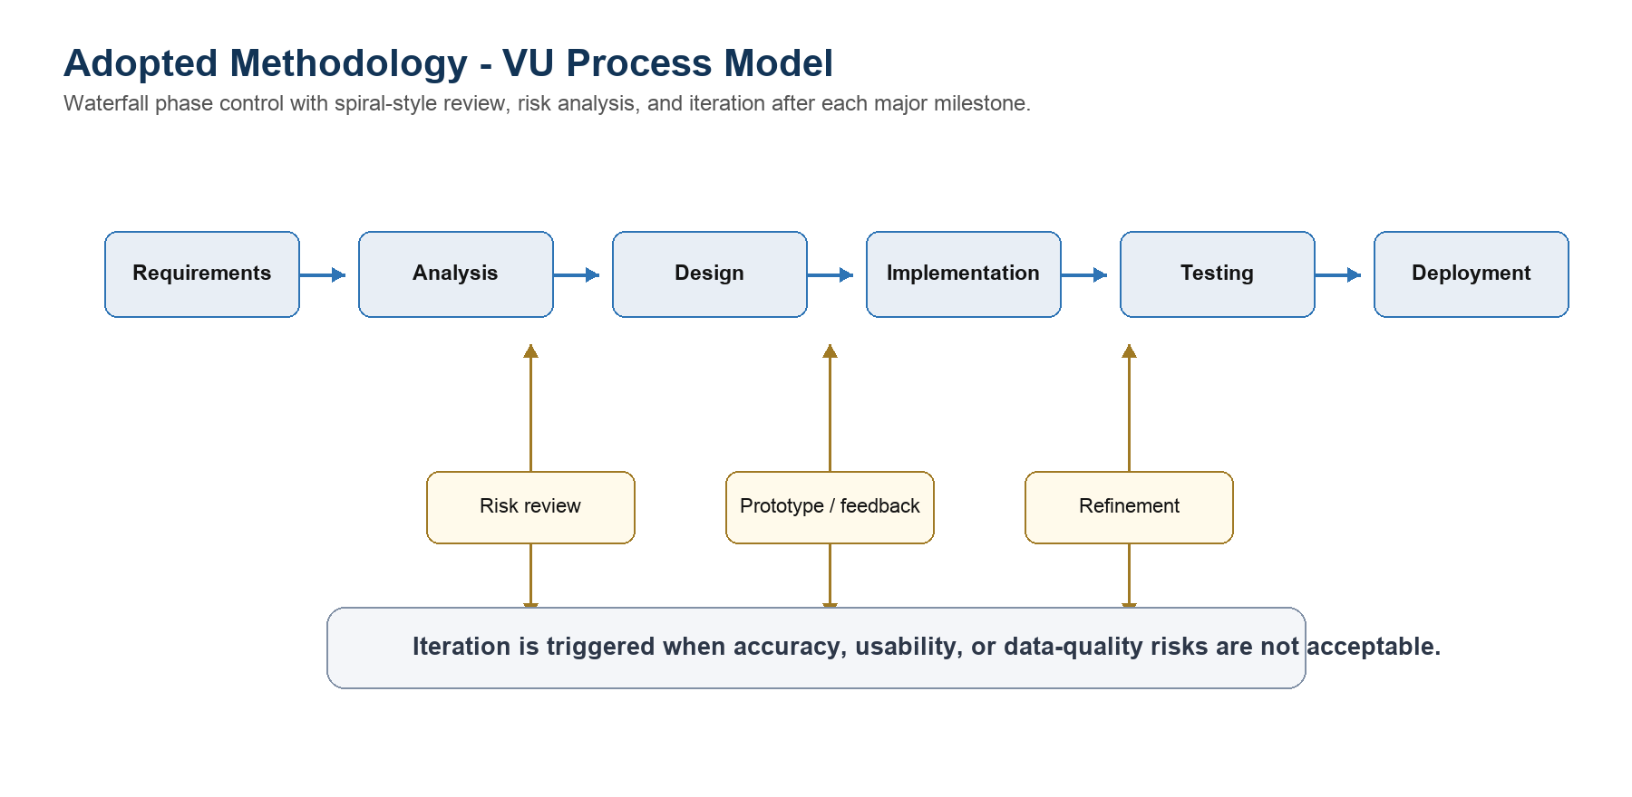
Figure 1.2: Adopted VU Process Model

1.8 Work Plan
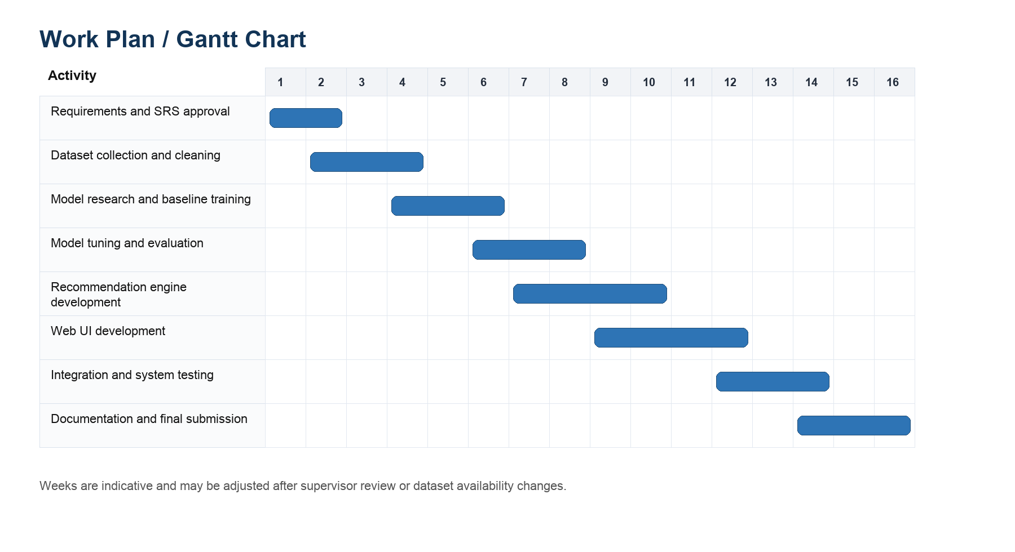
Figure 1.3: Sixteen-week project work plan

CHAPTER 2
Designing the Project

2.1 Design Purpose and Scope
The design separates the prototype into presentation, application, AI/ML, and data responsibilities. This modular structure keeps the code understandable, allows models to be compared through one interface, and maps each approved requirement to a concrete component.

2.2 Architectural Representation
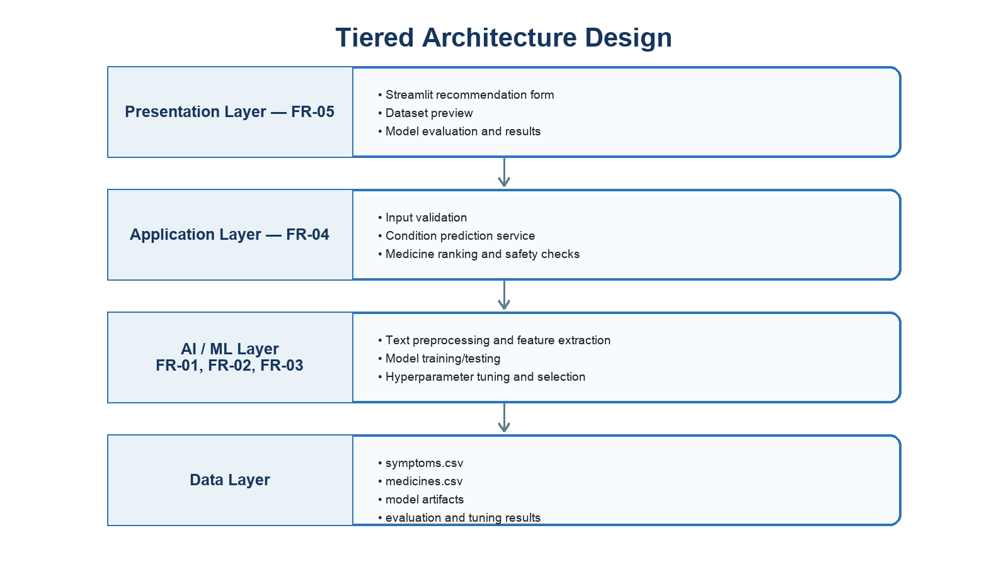
Figure 2.1: Tiered architecture mapped to FR-01 through FR-05
Layer | Responsibilities
Presentation | Streamlit input form, recommendation results, dataset preview, and model-evaluation views.
Application | Input validation, prediction orchestration, recommendation ranking, and safety checks.
AI/ML | Text preprocessing, TF-IDF features, Logistic Regression, Keras neural network, and metrics.
Data | CSV datasets for symptoms, medicines, diseases, prescriptions, and patient history.

2.3 Dynamic Model - Sequence Design
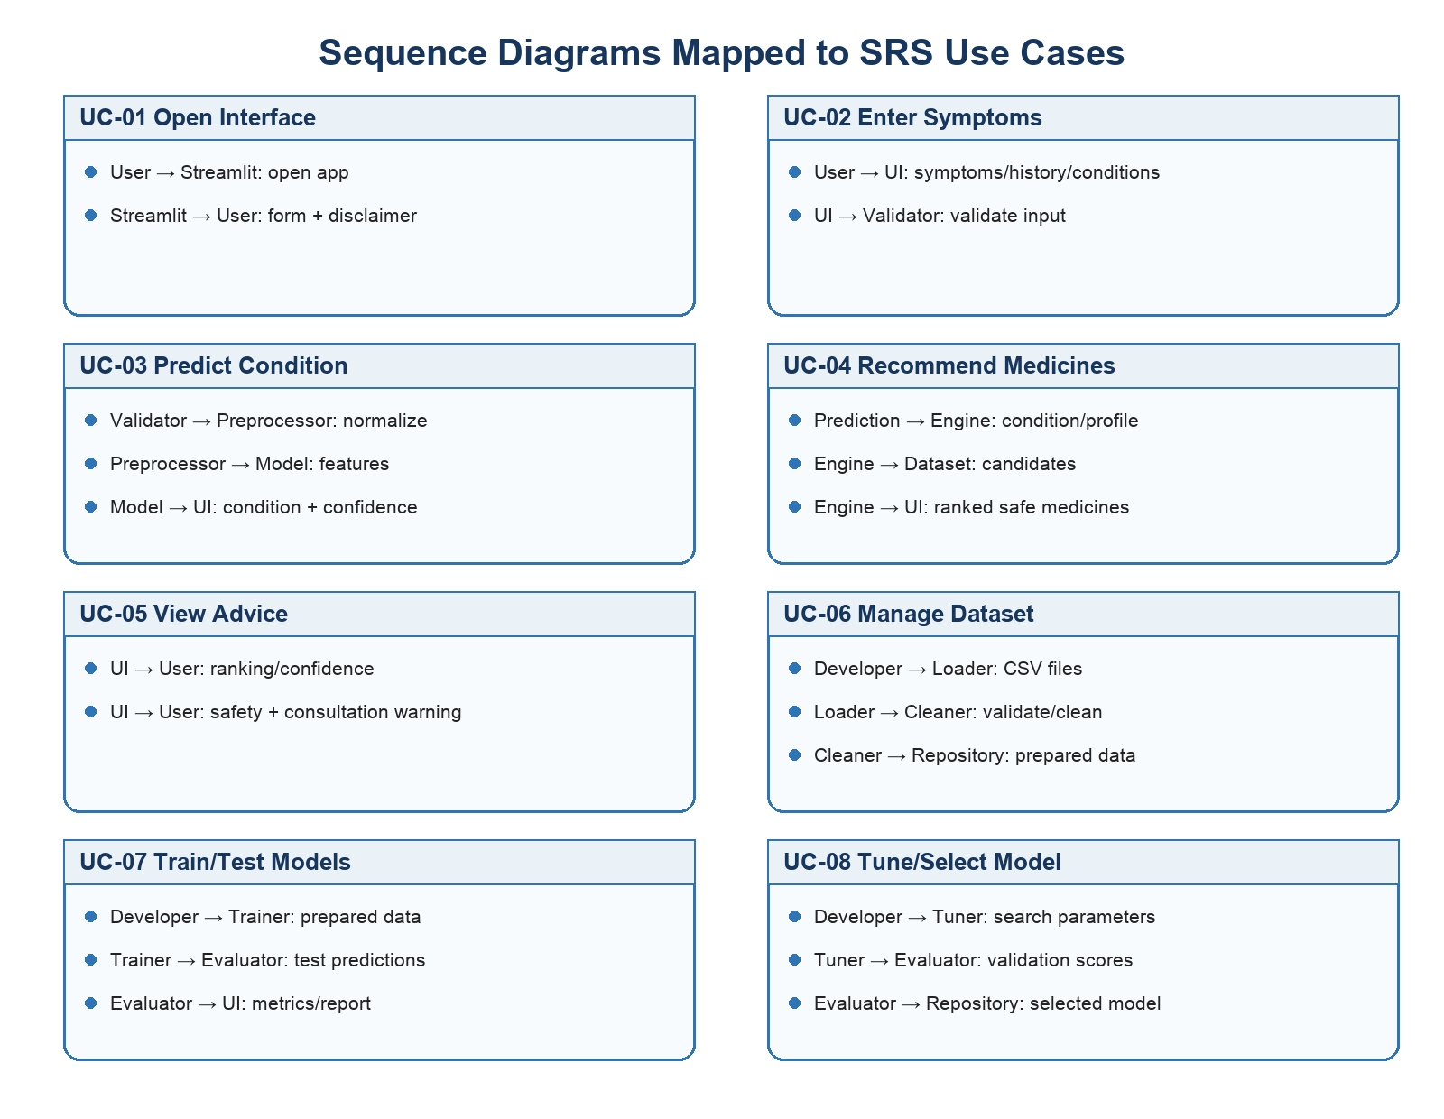
Figure 2.2: Main use-case sequence flows

2.4 Object Model - Class Design
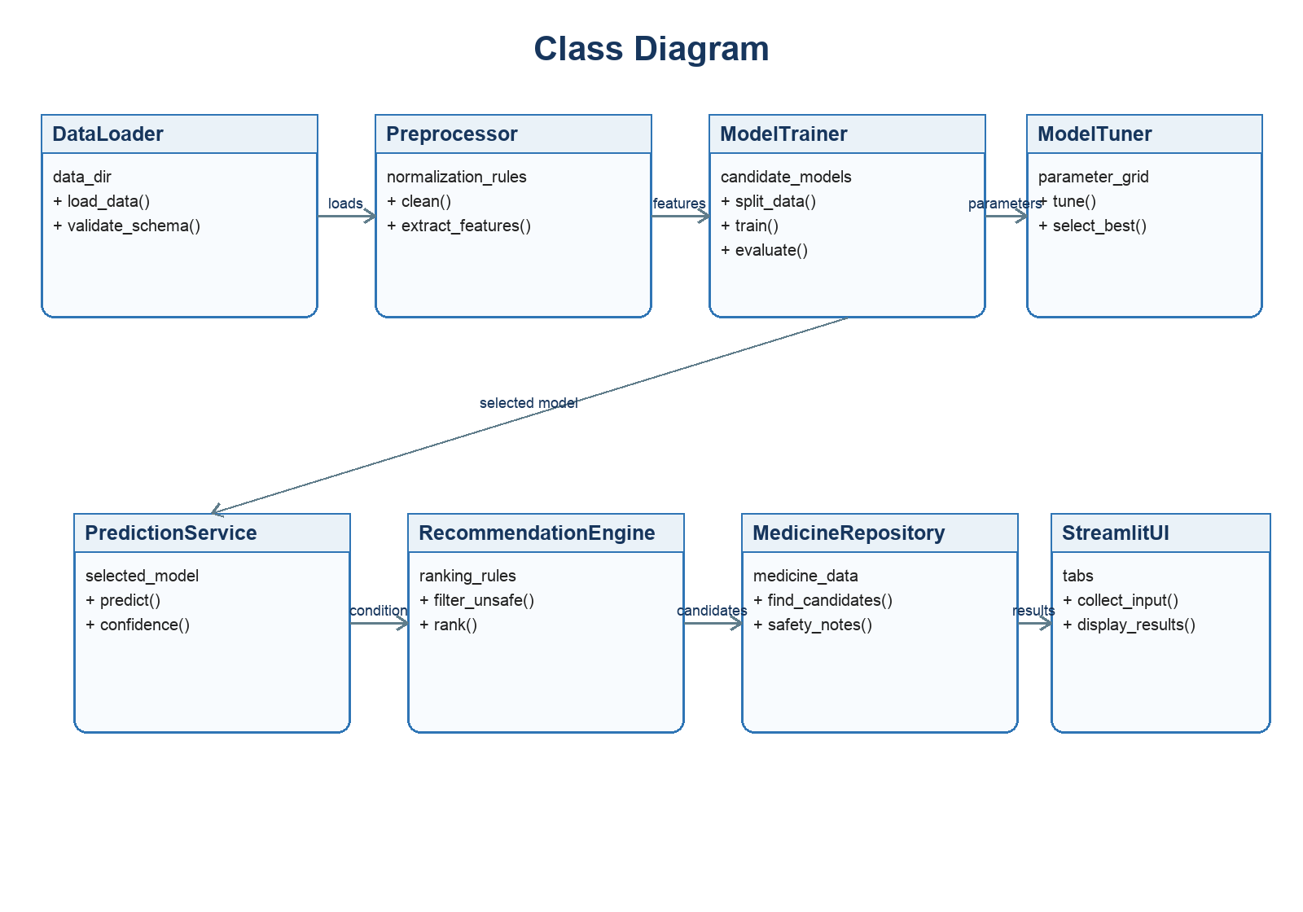
Figure 2.3: Main classes and responsibilities

2.5 Entity and Storage Design
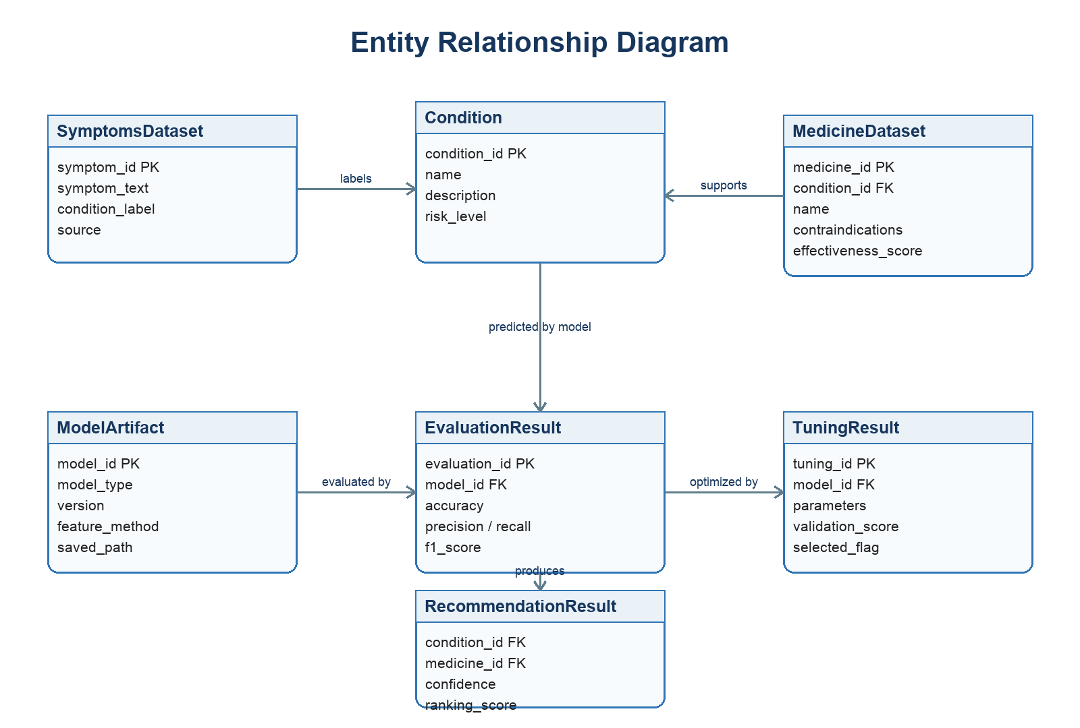
Figure 2.4: Entity relationship design
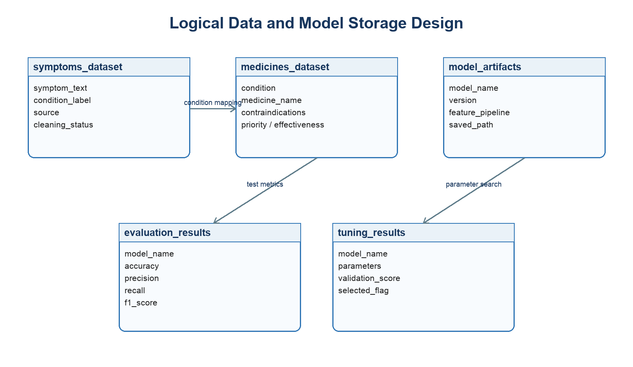
Figure 2.5: Logical data and model storage design
The working prototype uses CSV files rather than a transactional database. This is appropriate for a controlled academic demonstration and makes datasets easy to inspect. A future production version should use authenticated application services and a secure relational database with audit controls.

2.6 Graphical User Interfaces
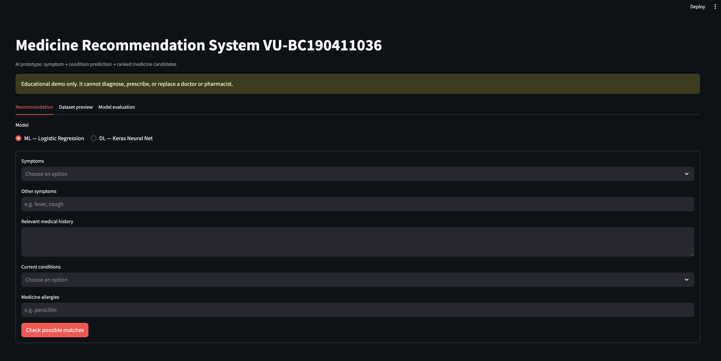
Figure 2.6: Recommendation input form
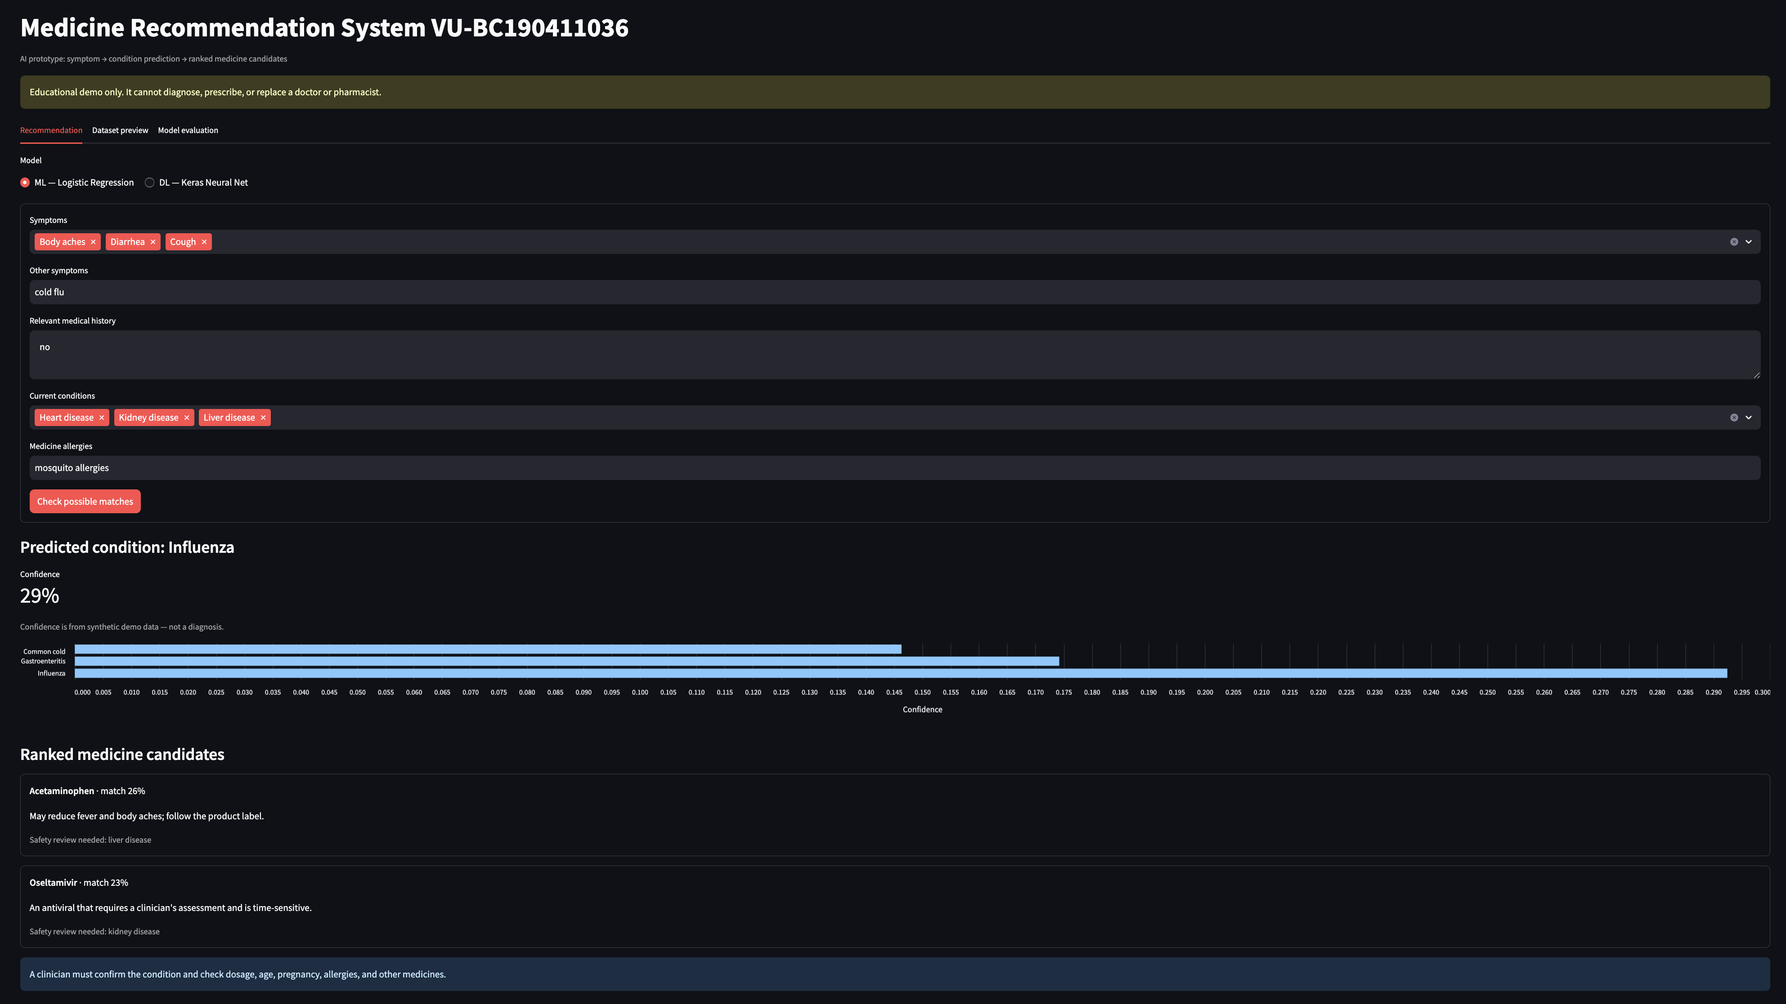
Figure 2.7: Predicted condition and ranked medicine results
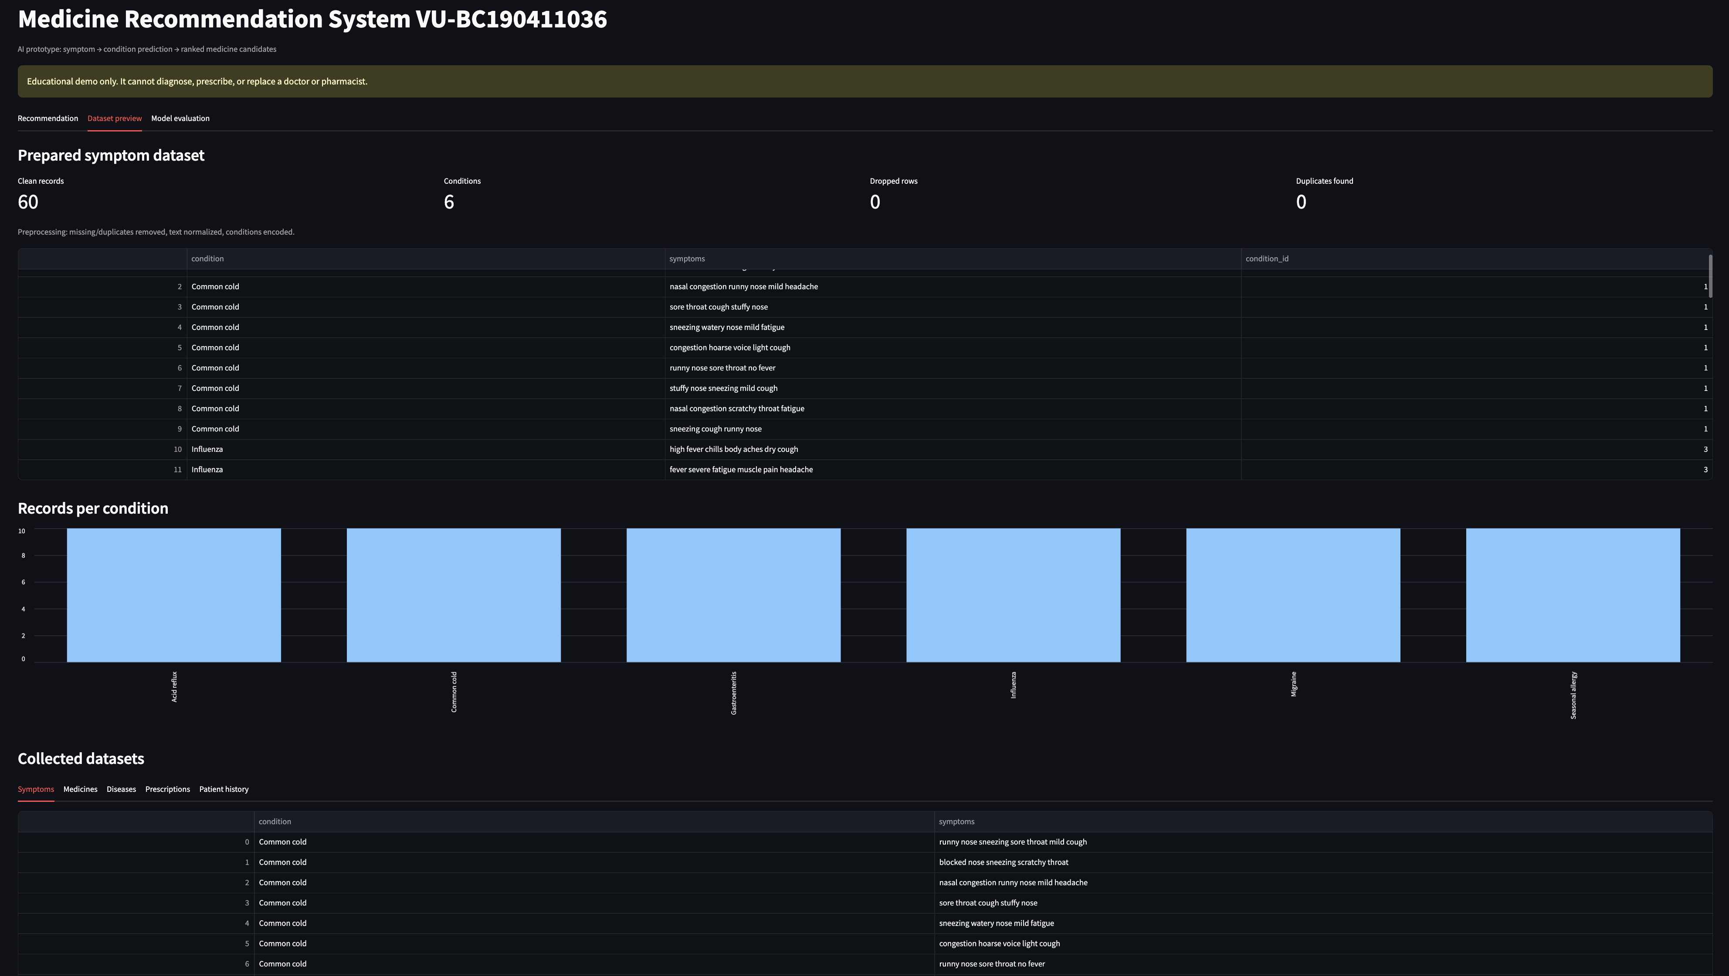
Figure 2.8: Prepared and collected dataset preview
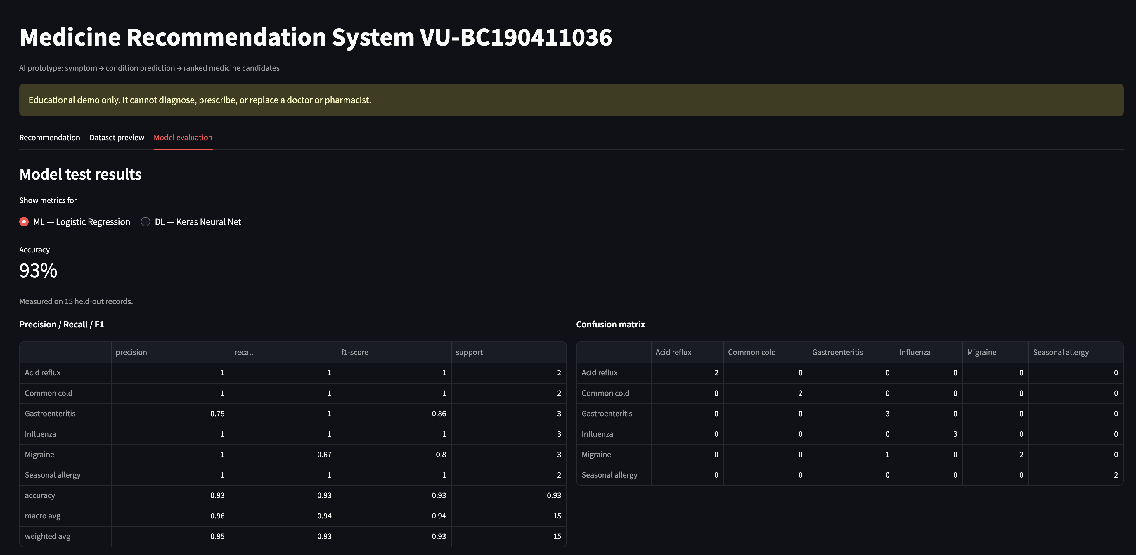
Figure 2.9: Model evaluation metrics and confusion matrix

CHAPTER 3
Development

3.1 Development Plan
Implementation was organized around reusable Python modules. Data is loaded first, symptom records are cleaned and encoded, models are trained and cached, then the selected model supplies probabilities to the recommendation engine. Streamlit presents the workflow through three tabs.

3.2 Human-Readable File Structure
File or folder | Purpose
app.py | Application entry point; page setup, dataset/model caching, and top-level tabs.
data/*.csv | Symptoms, medicines, diseases, prescriptions, and patient-history records.
src/config/settings.py | Paths, labels, model settings, form options, and emergency keywords.
src/config/data_loader.py | Loads all CSV datasets into Pandas DataFrames.
src/config/preprocess.py | Cleans text, handles missing/duplicate records, encodes labels, and creates stratified splits.
src/config/models.py | Trains Logistic Regression and Keras models, calculates metrics, and predicts top conditions.
src/config/recommender.py | Filters medicine mappings, computes match scores, and attaches safety notes.
src/ui/recommendation.py | Collects user input and displays prediction, chart, recommendations, and warnings.
src/ui/dataset_preview.py | Displays preparation statistics, datasets, tables, and class-distribution chart.
src/ui/model_evaluation.py | Displays accuracy, classification report, and confusion matrix by selected model.
requirements.txt | Pinned Python dependencies for reproducible setup.

3.3 Data Collection and Preprocessing
The application loads five CSV datasets. For symptom-model development, rows missing a condition or symptom description are removed, duplicate rows are eliminated, text is converted to lowercase, non-letter characters are removed, and repeated whitespace is collapsed. A LabelEncoder converts condition names into numeric identifiers for the neural network. The data is split with stratification so each condition remains represented in training and test partitions.
Measured item | Result
Raw symptom records | 60
Clean records | 60
Condition classes | 6
Dropped rows | 0
Duplicates detected | 0
Training records | 45
Held-out test records | 15

3.4 Model Training, Testing and Optimization
The machine-learning branch uses TF-IDF unigram/bigram features followed by Logistic Regression. The deep-learning branch uses the same sparse-text representation converted to dense input for a compact Keras multilayer perceptron with 64-unit and 32-unit ReLU layers, dropout, and a softmax output. A fixed random seed makes the comparison reproducible.
Optimization in the prototype is configuration-driven: the feature range, Logistic Regression iteration limit, neural-network layer sizes, dropout, epochs, batch size, and random seed are controlled in code and evaluated on held-out data. A larger production study should replace this small comparison with cross-validated hyperparameter search and an external validation dataset.
Model | Held-out accuracy | Interpretation
Logistic Regression | 93.3% (14/15) | Strong baseline; one held-out classification error.
Keras neural network | 100% (15/15) | Perfect on this small split; not evidence of clinical generalization.

3.5 Medicine Recommendation Engine
After condition prediction, the engine filters the medicine dataset for matching condition records. Each candidate receives a match score equal to its configured priority multiplied by the predicted-condition confidence. The output is sorted from highest to lowest score. The engine compares entered medical history, existing conditions, and allergy text with each candidate's avoid-if terms and displays a safety-review note when a conflict is found.
The ranking is deliberately described as a possible match, not a prescription. Dosage is not generated. The interface explicitly states that a clinician must confirm the condition and check age, pregnancy, allergies, interactions, and other medicines.

3.6 Streamlit Interface
The Recommendation tab contains the model selector and patient-input form. The Dataset Preview tab shows preprocessing statistics, prepared records, class balance, and all collected datasets. The Model Evaluation tab lets the evaluator switch between models and inspect accuracy, precision, recall, F1-score, and confusion matrix. Data and model objects are cached to reduce repeat loading and training delay.

3.7 Testing and Requirement Verification
Requirement | Status | Implementation evidence
FR-01 | Pass | Five datasets load; 60 symptom rows are normalized, encoded, split, and previewed.
FR-02 | Pass | Logistic Regression and Keras models train and produce held-out metrics.
FR-03 | Prototype pass | Reproducible configurations and validation comparison are implemented; automated search is recommended for future work.
FR-04 | Pass | Prediction, candidate mapping, score ranking, explanation, and entered-conflict warning are implemented.
FR-05 | Pass | Recommendation, dataset preview, and model evaluation are available through Streamlit tabs.

3.8 Functional Test Summary
Test | Action | Expected/observed result | Status
T-01 | Submit no symptom | Validation error shown | Pass
T-02 | Submit valid symptoms | Top conditions and confidence shown | Pass
T-03 | Select ML model | Logistic Regression prediction is used | Pass
T-04 | Select DL model | Keras neural-network prediction is used | Pass
T-05 | Enter conflicting condition/allergy | Candidate receives safety-review note | Pass
T-06 | Open dataset preview | Counts, tables, and distribution chart load | Pass
T-07 | Open model evaluation | Accuracy, report, and confusion matrix load | Pass
T-08 | Enter emergency keyword | Urgent-care warning replaces recommendation | Pass

3.9 Limitations
- The 60-record symptom dataset is small, balanced, and synthetic; it does not represent real clinical prevalence or diversity.
- A perfect neural-network test score on 15 records may reflect split simplicity and must not be treated as medical validation.
- The safety check is keyword-based and cannot replace drug-interaction databases, clinical guidelines, or pharmacist review.
- The prototype does not implement accounts, encrypted patient storage, dosage calculation, live clinical data, or regulatory controls.

3.10 Deployment and Run Procedure
Step | Command / action
1 | Open the project directory in VS Code or a terminal.
2 | Create and activate a Python virtual environment.
3 | Install dependencies: pip install -r requirements.txt
4 | Run the application: streamlit run app.py
5 | Open the local Streamlit address shown in the terminal.
6 | Select a model, enter symptoms and health information, then submit the form.

3.11 Future Enhancements
- Replace synthetic samples with larger, de-identified, clinically reviewed datasets and external validation.
- Add cross-validated GridSearch/RandomizedSearch or Bayesian optimization with experiment tracking.
- Integrate a trusted medicine-interaction and contraindication knowledge base.
- Add authentication, consent, encryption, audit logging, and role-based access before storing health information.
- Calibrate probabilities, explain predictions, support multilingual symptom input, and perform formal usability testing.

3.12 Conclusion
The completed prototype demonstrates the full academic workflow from requirement definition and data preparation through model training, recommendation generation, safety messaging, interface design, and evaluation. It provides a clear foundation for further research, but responsible use requires larger validated datasets, clinical oversight, and production-grade privacy and safety controls.

REFERENCES

- Virtual University of Pakistan. CS619 project proposal, SRS, design, and final-report templates.
Streamlit documentation. Web application framework for Python data applications.
- Pandas documentation. Data loading, cleaning, and tabular processing.
- Scikit-learn documentation. TF-IDF, Logistic Regression, preprocessing, splitting, and evaluation metrics.
- TensorFlow/Keras documentation. Neural-network model definition, training, and prediction.
- Project source files and supplied CSV datasets for the Medicine Recommendation System prototype.

APPENDIX

Appendix B - Safety Statement
Recommended one-line setup and launch command for macOS/Linux:
python3 -m venv .venv && source .venv/bin/activate && pip install -r requirements.txt && streamlit run app.py
For Windows PowerShell, activate the environment with .venv\Scripts\Activate.ps1 before installing requirements and running Streamlit.

Appendix B - Safety Statement
Educational demonstration only. This system cannot diagnose, prescribe, calculate dosage, or replace a doctor or pharmacist. Any medicine-related output must be reviewed by a qualified healthcare professional.

