Experiment No : 6
Name: Shawn Louis
Roll No: 31
Batch: B

Problem Statement: | To implement 0-1 Knapsack  1) Using Dynamic Programming  2) Show items added to the knapsack and the total profit.
Objective: | - To be able to implement a problem using dynamic programming
Expected Outcome: | - Ability to understand a given problem statement and build logic as per dynamic programming.  - Ability to write effficient code.
Theory: | Dynamic-0-1-knapsack (v, w, n, W)  for w = 0 to W do  c[0, w] = 0  for i = 1 to n do  c[i, 0] = 0  for w = 1 to W do  if w_{i} ≤ w then  if v_{i} + c[i-1, w-w_{i}] then  c[i, w] = v_{i} + c[i-1, w-w_{i}]  else c[i, w] = c[i-1, w]  else  c[i, w] = c[i-1, w]
Algorithm: | Let i be the highest-numbered item in an optimal solution S for W dollars. Then S' = S - {i} is an optimal solution for W - w_{i} dollars and the value to the solution S is V_{i} plus the value of the sub-problem.  We can express this fact in the following formula: define c[i, w] to be the solution for items 1,2, … , i and the max_{i}mum weight w.  The algorithm takes the following inputs  - The max_{i}mum weight W  - The number of items n  - The two sequences v = <v₁, v₂, …, v_{n}> and w = <w₁, w₂, …, w_{n}>  The set of items to take can be deduced from the table, starting at c[n, w] and tracing backwards where the optimal values came from.  If c[i, w] = c[i-1, w], then item i is not part of the solution, and we continue tracing with c[i-1, w]. Otherwise, item i is part of the solution, and we continue tracing with c[i-1, w-W].
Program Code: | #include<stdio.h>  #include<conio.h>  int max(int x, int y)  {  if(x > y)  return x;  else  return y;  }  void main()  {  int i, j, n, m;  int p[50], w[50], v[50][50];  clrscr();  printf("Enter the number of objects : ");  scanf("%d", &n);  printf("Enter the Knapsack capacity : ");  scanf("%d", &m);  printf("\nEnter the profit and weight of each object : ");  for(i = 1; i <= n; i++)  {  printf("Profit of obj no. %d : ", i);  scanf("%d", &p[i]);  printf("Weight of obj no. %d : ", i);  scanf("%d", &w[i]);  printf("\n");  }  for (i = 0; i <= n; i++)  {  v[i][0] = 0;  }  for (j = 0; j <= m; j++)  {  v[0][j] = 0;  }  for(i = 1; i <= n; i++)  for(j = 1; j <= m; j++)  if(i == 1)  if(j < w[1])  v[1][j] = 0;  else  v[1][j] = p[1];  else if(j < w[i])  v[i][j] = v[i-1][j];  else  v[i][j] = max(v[i-1][j], v[i-1][j-w[i]] + p[i]);  printf("\n Maximum profit earned : %d\n", v[n][m]);  printf("\nValue table is as shown \n");  for(i = 0; i <= n; i++)  {  for(j = 0; j <= m; j++)  printf("%5d", v[i][j]);  printf("\n");  }  printf("\nObjects included in Knapsack are : ");  i = n;  j = m;  while(i > 0 && j > 0)  {  if(v[i][j] != v[i-1][j])  {  printf("%d -> ", i);  j = j - w[i];  i = i - 1;  }  else  i = i -1;  }  getch();  }
Output Snapshot: | 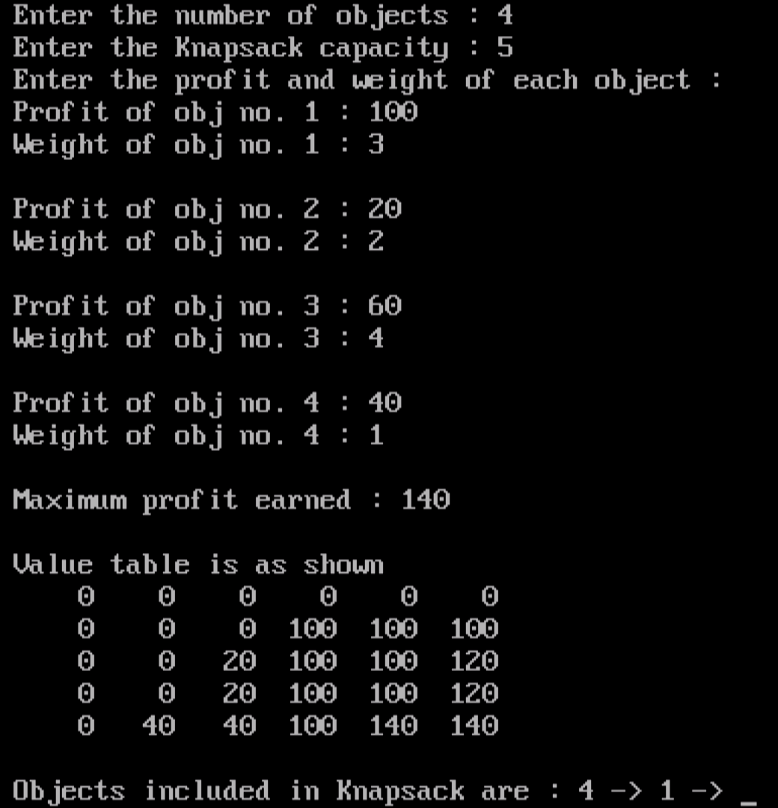
Application | - Finding the least wasteful way to cut raw materials  - Selection of investments and portfolios  - Knapsack Cryptosystems
Outcome: | Successfully analysed and implemented 0/1 Knapsack problem using Dynamic Programming in C.

