**Getting started with Qt**

Download Qt (Open Source LGPL license; for student use) from <https://www.qt.io/offline-installers>. The download automatically recommended by the website is the online installer, but you should not download that as it is buggy. Click the link for offline packages at the end of the download page and choose a suitable offline installer for Qt 5.12.2.

* **Windows users**: In the “Configure Project” step written later, it is advisable to use MinGW as the compiler (the 32-bit version works fine on 64-bit machines). You can also use compilers already installed, like Visual Studio. If these don't work, you need to install a compiler to make Qt creator compile your code.
* **Linux users:** Check this page: <http://doc.qt.io/qt-5/linux.html>
* **Mac users:** Make sure you have the latest version of Xcode installed on your machine before installing the software.

Finally install Qt by following the instructions in the dialog boxes that appear. You can find help with installation on Youtube [here](https://www.youtube.com/watch?v=eS7ank-qFjg&index=2&list=PLS1QulWo1RIZiBcTr5urECberTITj7gjA). Once installed, open the Qt creator to check if the installation was successful and you can try creating your own project and running some sample code on your own.

**Using Qt’s editor and compiler (once homework 1 is released):**

1. Run “Qt Creator” :
   1. By double clicking the ImgFilter.pro file in the starter kit folder of Homework 1 or by selecting “Open file or project” from File menu in Qt Creator window and then the file “ImgFilter.pro”.
   2. If you are asked "Do you want to load the settings for ImgFilter.pro.user?", click No. Then click “Configure Project” (ensure that default compiler is selected).
   3. Click on the "Edit" tab on the left panel and then on the “Sources” folder. You should see a file named Project*.cpp (where * denotes 1, 2 or 3 depending on the homework number) along with a main.cpp file and a mainwindow.cpp file.
   4. Click on the "Projects" tab on the left panel and under the "General" section, ensure that the "Shadow build" box is **unchecked**.
   5. To compile and run, click on the green play button at the bottom left of the window. The application window will open on the screen. You can select between debug and release builds above (and below) the green play button.

**Using Visual Studio’s editor and compiler:**

1. Run “Visual Studio” (2010 preferable)
   1. Select “Open Project/Solution” from File menu.
   2. Select the file “ImgFilter.vcproj”
   3. Right click on the ImgFilter project and select “Properties”
   4. Select “Configuration Properties -> C/C++ -> General
   5. Update the directories under “Additional Include Directories” with “Qt” in the name according to where you installed Qt.
   6. In the same window select “Configuration Properties -> Linker”.

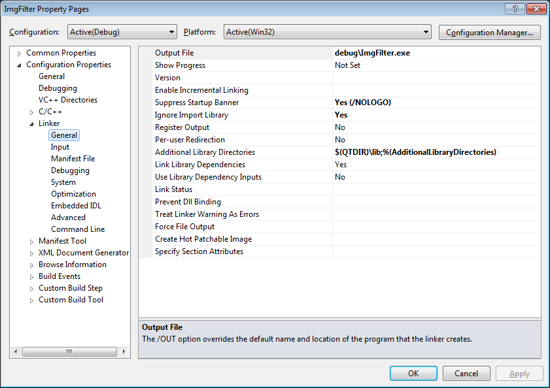

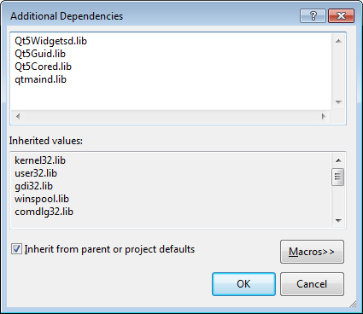

* 1. Update the directory in “Additional Library Directories” according to where you installed Qt and add the libraries.
  2. Compile and Run.
  3. If it complains about not finding Qt’s dlls when running, you should update your system’s “path” variable to include Qt’s “bin” directory. To update the “path” variable, type “environment” into the window search box and select “Edit the system’s environment variables”. Press the “Environment Variable…” button and find “path” in the second list box.
  4. Qt also has a VS add-in that is nice for editing UIs. This isn’t necessary for the assignment, but you can find it at the same download page. [**Visual Studio Add-in 1.2.2 for Qt5**](https://download.qt.io/official_releases/vsaddin/1.2.2/) is preferable. Here is the [documentation](https://doc.qt.io/archives/vs-addin/index.html).
  5. You shouldn’t have to do this – but just in case. If you’d like to convert a Qt project to a Visual Studio project use the following command “qmake -tp vc test.pro”. This will create a file test.vcproj.
  6. If it complains about MOC/UIC not found, make sure the Qt Project Settings look like this and the modules should be selected like this:

