After finishing all the codes, now I run the first python file.

1. run the q3_run.py

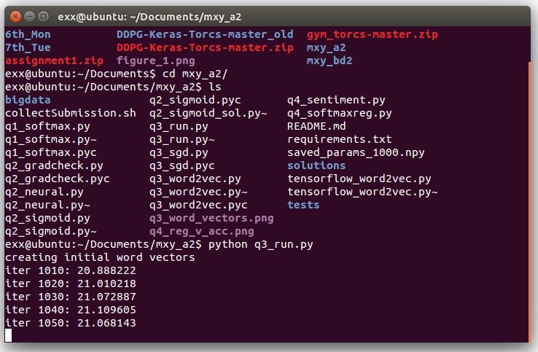

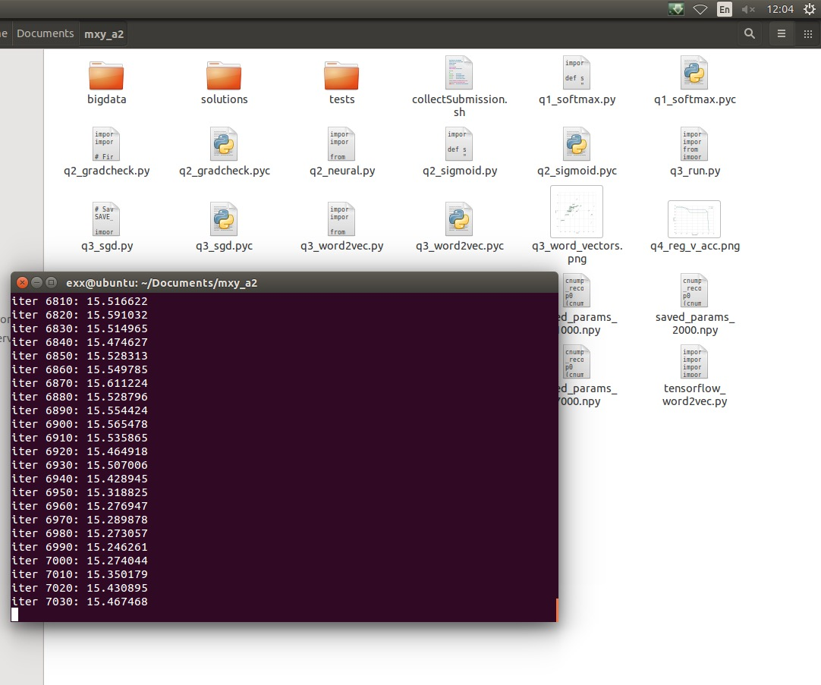

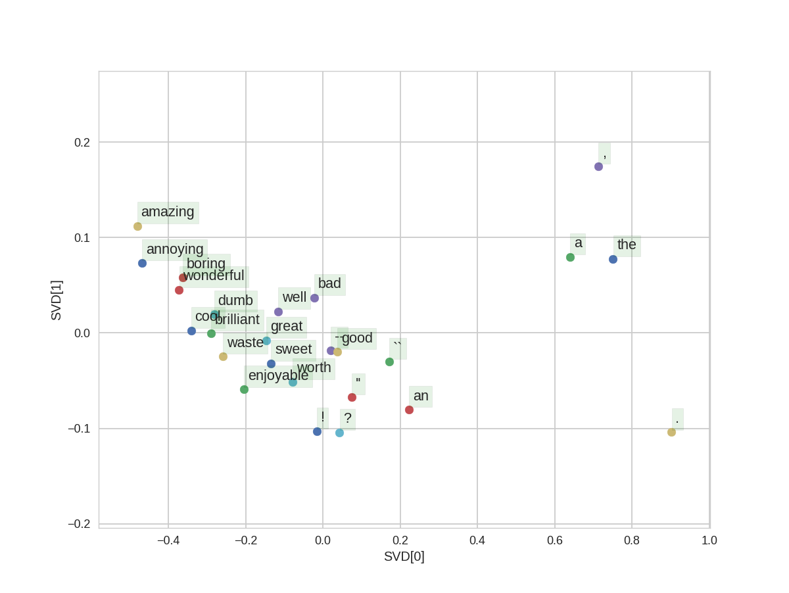

2. Run q4_sentiment.py, and plot the classification accuracy on the train and dev set with respect to the regularization value, using a logarithmic scale on the x-axis.

