AI Agent System Design
From Classical Computer Engineering to Modern Agent Architectures - Part I: Chapters 1-3

Working Draft v0.2 - 2026-06-29

Preface
This document is not an API tutorial and not a transcript of a conversation. It is a technical essay written from the perspective of software engineering and distributed systems. Its goal is to explain why modern AI agents increasingly resemble classical computer systems.
The central thesis is simple: LLMs were the breakthrough, but once LLMs are placed inside real products and workflows, the hard problems start to look familiar again. We need to manage state, reduce expensive remote calls, decide what to load into context, route requests to different compute layers, and design systems that remain observable, reliable, and scalable.
Part I completes the first three chapters. Chapter 1 establishes the system-level viewpoint. Chapter 2 reframes the LLM as a compute engine. Chapter 3 explains why an agent is better understood as an orchestrator than as a chatbot.
Core thesis: the LLM is a new compute engine, while the agent is the orchestrator that manages context, tools, state recovery and resource scheduling around it.

Table of Contents
Chapter | Title | Status
Chapter 1 | Why AI Agents Remind Me of Classical Computer Engineering | Complete
Chapter 2 | LLM as a New Compute Engine | Complete
Chapter 3 | Agent as an Orchestrator | Complete
Chapter 4 | Memory, Tools and Planner | Planned
Chapter 5 | Compute / Storage Separation | Planned
Chapter 6 | Stateless Agents | Planned
Chapter 7 | Context Engineering and Query Optimization | Planned
Chapter 8 | AGENTS.md as a Prompt Index | Planned
Chapter 9 | Retrieval and Context Routing | Planned
Chapter 10 | Distillation, Small Models and Tiered Compute | Planned
Chapter 11 | Multi-Agent Systems and Distributed Systems | Planned
Chapter 12 | Toward an Agent Operating System | Planned

Terminology
Term | Meaning in this document | Engineering analogy
LLM | Large language model used for inference | Compute Engine
Agent | System layer that organizes memory, tools, planning and context | Orchestrator / Runtime
Memory | Long-term preferences, project context and task state | Database / Cache
Context | The working set sent to the model for the current request | Working Set / Buffer Pool
Tool | External capability such as files, mail, calendar, GitHub or shell | RPC / API
Distillation | Moving capability from a large model to a smaller model or fixed workflow | Precomputation / Tiered Compute

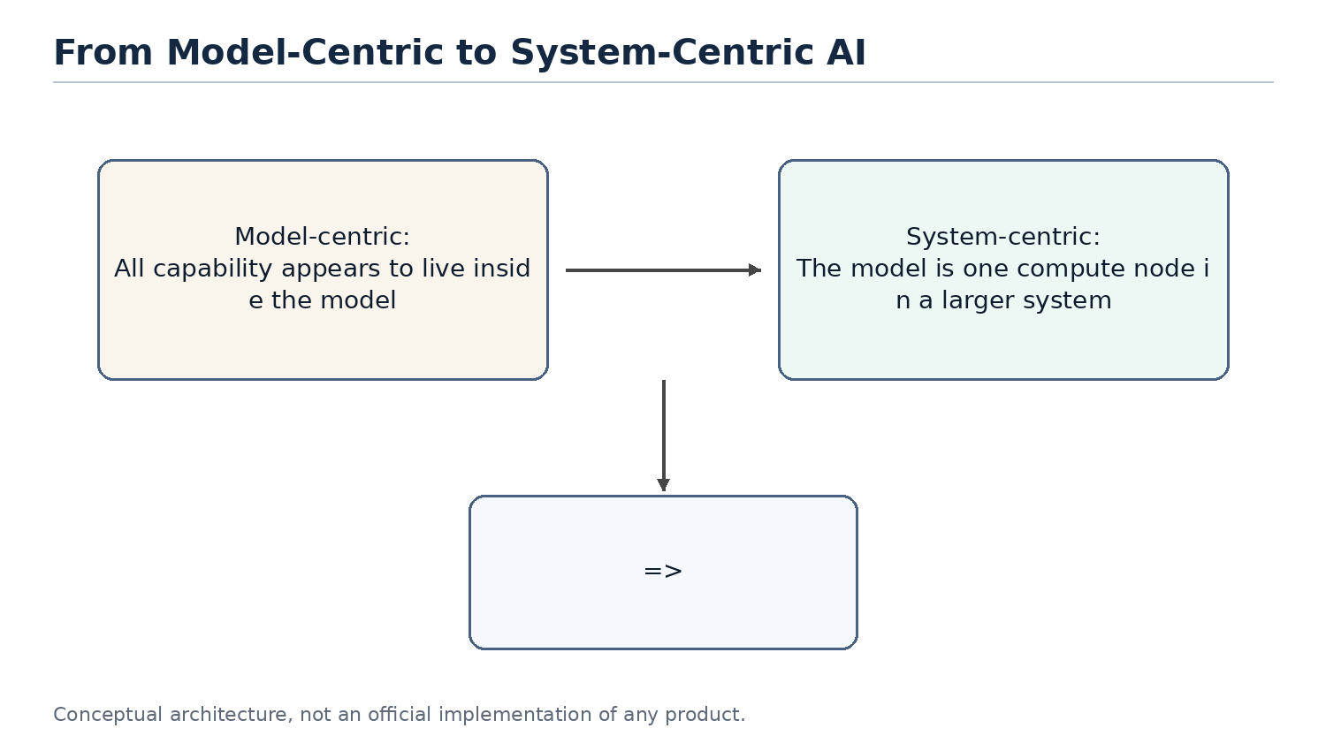
Figure 1. The discussion is shifting from model-centric AI to system-centric agent design.

Chapter 1. Why AI Agents Remind Me of Classical Computer Engineering
Chapter focus: establish the shift from model capability to system architecture.

1.1 The Question
Most public discussions of AI still focus on models: larger models, stronger reasoning, better coding, longer context, and better benchmarks. These improvements matter, but they do not fully explain the recent shift from chatbots to agents. The important change is that AI products are moving from answering questions to completing tasks.
Once the goal becomes task completion, the problem is no longer only model quality. The system must remember long-term state, access external tools, understand the current workspace, decide which historical information matters, and balance cost, latency and reliability. These are not new problems. They are the same type of problems classical computer engineering has been solving for decades.

1.2 Core Thesis
The core thesis of this chapter is that AI agents do not make software engineering obsolete. They make many classical software engineering ideas important again. LLMs introduce a new high-capability compute node, but building reliable, scalable and cost-efficient systems around that node still depends on layering, abstraction, caching, indexing, scheduling, statelessness, and separation of compute and storage.
From this perspective, an agent is not just a smarter chat box. It is closer to an application runtime that organizes user intent, long-term memory, project files, tool calls and model inference into a complete execution process.

1.3 Classical Engineering Concepts Behind the Pattern
Classical computer systems rarely place every responsibility inside a single component. Web systems separate application logic, cache, database, queues, object storage and external APIs. Distributed systems emphasize stateless services, externalized state, retries and horizontal scalability. Database systems emphasize indexes, query optimization, buffer pools and execution plans.
The shared goal behind these techniques is to avoid wasting expensive resources. Databases avoid full table scans. Distributed systems avoid unnecessary cross-service calls. Operating systems avoid unnecessary disk access. Modern agents face a similar problem: do not send every memory, every document and every tool result to the LLM; do not route every task to the most expensive model; do not ask the model to repeat work that can be handled by rules, small models or cached results.

1.4 How This Appears in AI Agents
In the agent world, these engineering ideas appear under new names: Memory, RAG, Context Engineering, Tool Calling, Planner, Router, Distillation, MCP and Multi-Agent systems. They sound new, and some details are new, but many system motivations are familiar.
Memory acts like external state. The context window is the working set of a request. RAG and retrieval resemble loading relevant pages. AGENTS.md can behave like a project-level prompt index. A planner resembles a scheduler. Tool calling resembles RPC. MCP resembles a tool protocol. Distillation and small models resemble moving expensive computation to a lower-cost compute layer.

1.5 Where the Analogy Breaks
Analogies help us think, but they are not proofs. AI agents differ from classical systems in important ways. Traditional APIs are usually deterministic; LLM outputs are probabilistic. A cache hit returns a fixed value; a small model generates an answer and can still be wrong. A database query has a schema; natural language tasks are often ambiguous and open-ended.
Therefore, this document does not claim that an agent is literally a database or that an LLM is literally a CPU. The better claim is that once LLMs become a new compute primitive, many proven computer engineering principles are being reapplied to AI systems.

1.6 Engineering Analysis
From an engineering perspective, the core challenge of AI agents is not only improving a single model response. The challenge is making the whole system complete tasks reliably, continuously and at reasonable cost. This requires three capabilities: context management, resource scheduling and state management.
Context management decides what information enters the model. Resource scheduling decides whether to use a rule, a small model or a large model. State management decides what should be written back to memory, files or external systems. These are system design problems, not just prompt-writing problems.

1.7 Summary
This chapter establishes the document's basic viewpoint: the rapid development of AI agents is not only the result of stronger models. It is the result of combining model capability with classical computer engineering ideas. The LLM is a new high-capability compute node, but the agent system must manage context, state, tools and cost around it.

1.8 Agent 与经典计算机工程的快速对应
Agent concept | Classical engineering concept | Explanation
LLM | Compute Engine | Performs high-capability inference but should not own all state
Memory | Database / Cache | Stores long-term preferences, project context and task history
Context Window | Working Set / Buffer Pool | The data loaded for the current request
AGENTS.md | Index / Router | A small entry point that helps locate relevant project knowledge
Tool Calling | RPC / API | Calls external software systems to perform real operations
Planner | Scheduler / Workflow Engine | Breaks tasks into steps and orders execution
Small Model | Tiered Compute | Handles common tasks cheaply and escalates complex tasks

Note: these mappings are thinking tools, not exact equivalences.

Chapter 2. LLM as a New Compute Engine
Chapter focus: position the LLM as a compute node, not as the entire system.

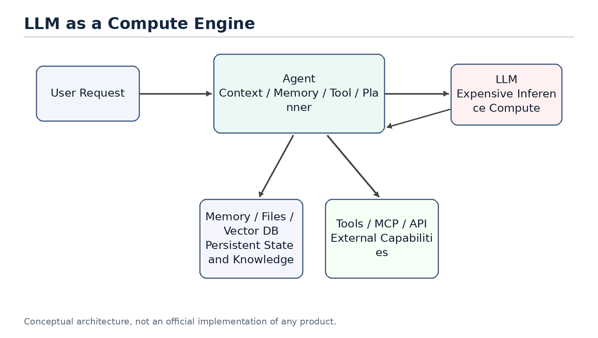
Figure 2. LLM as an expensive compute engine inside an agent system.

2.1 The Question
People often mix products such as ChatGPT, Claude or Gemini with the underlying LLM. A product is not just a model. It usually includes a user interface, an agent layer, memory, tool calling, permissions, file handling, monitoring, billing and safety policies. The LLM is only the most important and often the most expensive compute node inside the larger system.
Thinking of the LLM as a compute engine helps clarify agent architecture. The model does not inherently store your long-term memory or your project history. It performs inference based on the context provided in the current request. The agent layer is responsible for recovering state, selecting information and calling tools.

2.2 System Role of the LLM
In classical systems, expensive compute services are rarely exposed directly to all business logic without a management layer. Search engines have indexing services. Databases have optimizers. GPU inference clusters may have batching, caching and routing layers in front of them.
LLMs should be understood in a similar way. They can process language, code, reasoning and planning, but that does not mean all state should live inside the model or every task should go directly to the largest model. An LLM is a powerful but expensive remote compute service. Every call consumes input tokens, output tokens, latency and GPU resources.

2.3 Stateless Compute
From the perspective of a single inference request, an LLM can mostly be treated as stateless compute. It does not permanently remember a specific user in its weights just because it had a conversation with that user in the previous turn. If the next request does not include the relevant context, the model cannot reliably know what happened before.
This means that when a product appears to remember you, the memory usually comes from the agent layer. The agent retrieves memory, recent conversation, file snippets and tool results, then composes them into the prompt. The model appears to remember because the required state has been restored for that request.
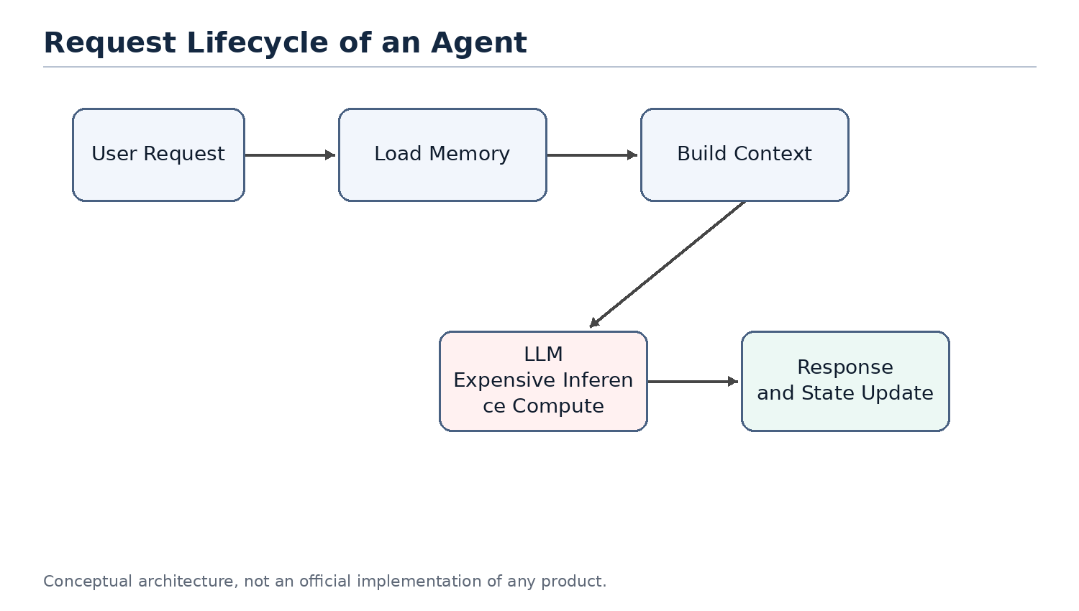
Figure 3. A stateless LLM requires the agent to restore context for each request.

2.4 LLM API as an Expensive Remote Call
Calling an LLM API is similar to calling an expensive remote service. It is slower than a local function call, more expensive than most database reads, and less deterministic than traditional APIs. Therefore, a central goal of agent design is reducing unnecessary calls to large models.
This mirrors classical system optimization. We used to reduce cross-service RPC calls, database queries and disk IO. Now we also reduce unnecessary LLM calls, redundant context and repeated reasoning. Tokens, context length, model tier and call count are becoming new performance metrics for AI systems.

2.5 Token Cost and Compute Cost Are Not the Same
It is important to distinguish token count from compute cost. Prompt compression, retrieval and indexing can directly reduce input tokens. Distillation, however, does not necessarily reduce token count. A small model and a large model may receive the same number of tokens, but the small model is cheaper to run.
Therefore, a more precise statement is that distillation primarily reduces the use of expensive large models, not necessarily the number of tokens. Token usage decreases only when distillation shortens the workflow, reduces repeated planning calls, or replaces several large-model calls with a smaller computation.

2.6 Analogy to Classical Compute
As a compute engine, an LLM can be compared to a database execution engine, a remote compute service or a GPU inference cluster. It is powerful, but it should not carry every responsibility in the system. A database does not own business workflow. A CPU does not perform operating-system scheduling by itself. Similarly, an LLM should not be viewed as the entire agent system.
This viewpoint explains why the agent layer matters. The agent does not replace the model; it ensures that the model is called at the right time, with the right context, and at a reasonable cost.

2.7 Summary
This chapter positions the LLM as a new high-capability compute engine. It is powerful, expensive, mostly stateless and usually accessed through an API. This explains why memory, context, tools and planning should be viewed as parts of the agent system rather than as properties of the model alone.

Chapter 3. Agent as an Orchestrator
Chapter focus: the agent is the orchestration layer that routes work to the right resource.

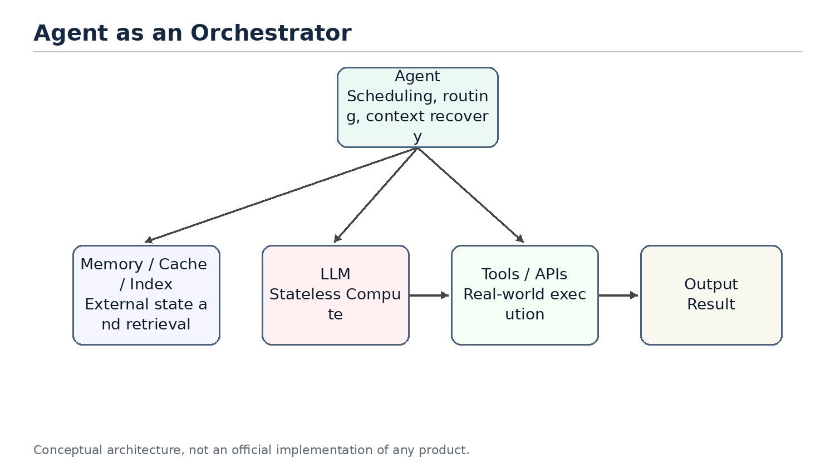
Figure 4. The agent as an orchestrator rather than a chatbot.

3.1 The Question
If the LLM is the compute engine, what is the agent? A common misunderstanding is to treat an agent as a wrapper around a large model or as a chatbot with tools. That description captures part of the surface behavior, but it misses the architectural role.
A better definition is that an agent is an orchestrator. It receives a user goal, restores relevant state, selects context, decides whether to call tools, chooses which model or compute layer to use, and organizes multiple steps into an executable workflow.

3.2 Core Components of an Agent
A typical agent contains several logical components. Memory stores long-term preferences, project background and task history. A context builder decides what should enter the current prompt. A planner decomposes the user goal into steps. A tool layer calls external systems. A router or scheduler decides whether to use rules, small models or large models. An evaluator or guardrail decides whether the result is reliable enough.
These components may be physically distributed across multiple services or hidden inside a product. But logically, they are part of the agent layer, not part of the LLM itself.

3.3 Typical Execution Flow
When an agent receives a request, it should not immediately send the raw user message to the largest model. A more efficient flow is to classify the task, retrieve relevant memory or files, build context, then select a compute resource. If a simple rule can solve the task, no model is needed. If the task matches a common pattern, a small model may be enough. If the task is complex or risky, the agent escalates to a large model.
This is the difference between a chatbot and an agent. A chatbot tends to map one input to one response. An agent receives a goal and organizes a set of computations and operations to complete it.

3.4 Agent, API Gateway and Scheduler
From a systems perspective, an agent resembles a mixture of API gateway, workflow engine and scheduler. It exposes a unified interface to the user while connecting internally to models, tools, memory, files and external services. It also chooses an execution path based on task complexity and cost.
That is the role of an orchestrator. It may not perform all computation by itself, but it decides which resources participate, in what order they participate, how results are combined, and whether failures should trigger retries, fallbacks or escalation.

3.5 Tiered Compute: Rule, Cache, Small Model, Large Model
Agent scheduling can be abstracted as tiered compute. The lowest layer is rules: lowest cost and fastest, but limited coverage. The next layer is cache or retrieval, which reuses existing results or finds relevant context. Above that is a small model. A small model does not store fixed answers like a cache; it stores capabilities learned through training or distillation. The highest layer is the large model, which is the most capable and the most expensive.
This resembles multi-level caches, hot/cold storage tiers and service degradation strategies in traditional systems. A good agent should not route every request directly to the most expensive model. It should solve as many requests as possible at cheaper layers.
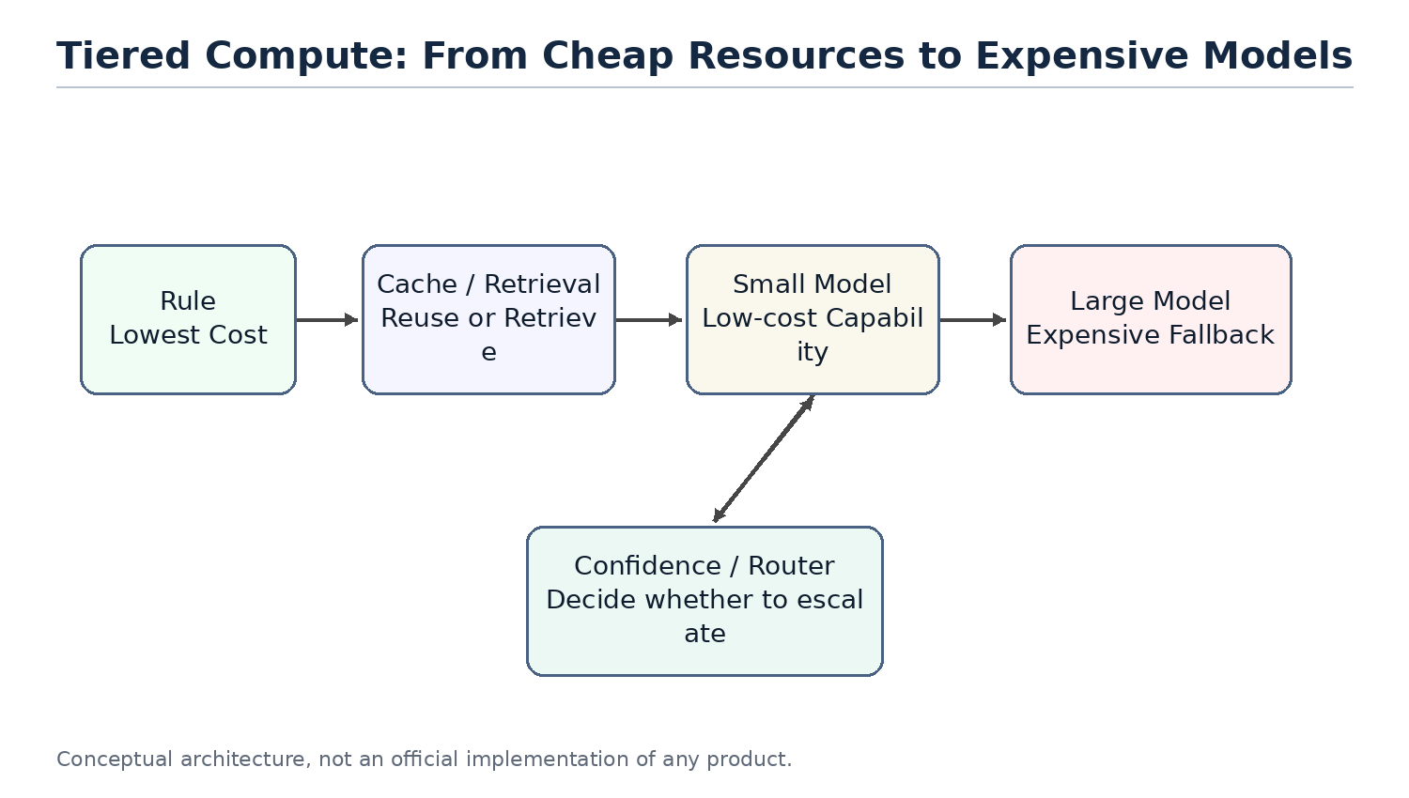
Figure 5. Tiered compute prevents every request from hitting the largest model.

3.6 Why a Small Model Is Not Just a Cache
Small models are sometimes compared to caches, but that analogy needs refinement. A normal cache stores results. On a hit, it returns a fixed value. A small model stores capability. It still performs inference based on the input. It cannot guarantee a fixed answer like Redis, but it can generalize to problems that were not explicitly seen during training.
A better phrase is capability cache. Distillation compresses behavior observed from a larger model into a lower-cost compute layer. It does not eliminate computation; it moves computation from an expensive model to a cheaper model.

3.7 Risks and Limits of Agent Orchestration
An agent as orchestrator introduces new risks. A bad router may send simple tasks to an expensive model or complex tasks to an underpowered model. Bad memory retrieval can make the model reason over the wrong context. Multi-step tool calls can amplify small mistakes. Probabilistic model behavior makes traditional testing incomplete.
Therefore, agent systems need observability, logs, audits, replay, evaluation sets and escalation policies. This again shows that agents are not just conversation interfaces. They are software systems that need system engineering discipline.

3.8 Summary
This chapter positions the agent as an orchestrator. It is not the model itself. It is the system layer that organizes memory, tools, planning, context and resource scheduling around the model. This prepares the ground for later chapters: why memory resembles storage, why AGENTS.md resembles an index, why distillation resembles tiered compute, and why multi-agent systems increasingly resemble distributed systems.

Plan for the Remaining Chapters
Part I completes the foundational system perspective. Later chapters will continue the same line of reasoning: how memory maps to storage, how stateless agents map to stateless services, why context engineering resembles query optimization, why AGENTS.md can act like an index, and why distillation and small models fit naturally into tiered compute.
- Chapter 4 will separate the responsibilities of memory, tools and planner.
- Chapters 5-6 will focus on compute/storage separation and stateless agents.
- Chapters 7-8 will connect context engineering and AGENTS.md with database optimization.
- Chapters 9-10 will discuss retrieval, distillation, small models and tiered compute.
- Chapters 11-12 will return to multi-agent systems, distributed systems and agent OS.

