6. Plot Quantity and Occurrences of GN versus All Names

Shawn Behrend

2022-05-07

This code produces two plots. The first is the Quantity of GN Names versus All Names. The second is the Occurrences of GN Names versus All Names.

sum_all_decades_df<-read.csv("C:/Users/shawn/OneDrive/Shawn/CSU_global/MIS581/project_r_code/name_files/all_decades_summary_table.csv")  
Ratio.of.GN.Names.to.All.Names<-sum_all_decades_df$X..of.GN.Names/2000  
q_test_set<-data.frame(sum_all_decades_df$Years,Ratio.of.GN.Names.to.All.Names,sum_all_decades_df$Ratio.of.GN.Occurrances.to.Total.Occurrances)  
xaxis_labels<-unlist(q_test_set[1])  
xaxis<-c(1:length(xaxis_labels))  
  
#plot quantity of names  
ratio_quan_gn_to_all<-as.numeric(unlist(q_test_set[2]))  
ratio_occur_gn_to_all<-as.numeric(unlist(q_test_set[3]))  
  
#plot ratio of quantity  
plot(xaxis,ratio_quan_gn_to_all,main="Ratio: Quantity of GN Names versus All Names\nBy Decade: 1880-2020", xlab="",xaxt="n",ylab="Ratio",type="l",lwd=2,col="blue",cex.main=0.9,cex.axis=0.8)  
axis(1, at=seq_along(xaxis),labels=as.character(xaxis_labels), las=2,cex=0.6)

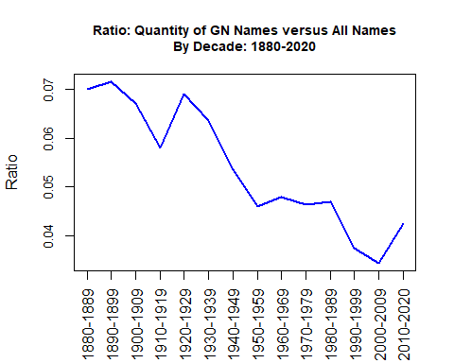

#plot ratio of occurrences  
plot(xaxis,ratio_occur_gn_to_all,main="Ratio: Occurrances of GN Names versus All Names\nBy Decade: 1880-2020",xlab="",xaxt="n",ylab="Ratio",type="l",lwd=2,col="green",ylim=c(0,0.6),cex.main=0.9,cex.axis=0.8)  
axis(1, at=seq_along(xaxis),labels=as.character(xaxis_labels), las=2,cex=0.6)

