8. Plot New and Common GN Names

Shawn Behrend

2022-05-07

After creation of the gn_all.csv which contains all the gender-neutral names along with the last year of the decade they are a part of, this CSV is then processed in Microsoft Excel. It is sorted by Name and then by Year to determine if each name is new within a decade or was common with the previous decade. An excerpt is shown here. Names from 1889 are not considered to be new or common since there is no previous data.

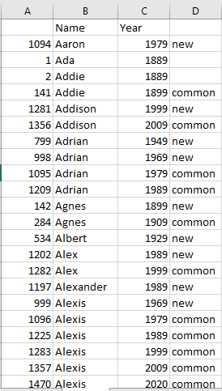

Once that is complete, the count of how many names were new per decade versus common with the previous decade was done. This is shown here.

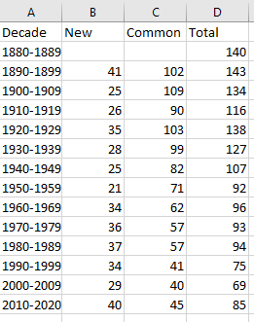

Next those counts are plotted per decade.

#load data files  
new_common_df<-read.csv("C:/Users/shawn/OneDrive/Shawn/CSU_global/MIS581/project_r_code/name_files/gn_all_with_status.csv")  
xaxis_labels<-unlist(new_common_df[1])  
xaxis<-c(1:length(xaxis_labels))  
new<-as.numeric(unlist(new_common_df[2]))  
common<-as.numeric(unlist(new_common_df[3]))  
total<-as.numeric(unlist(new_common_df[4]))  
  
# x axis for all plots  
  
#plot first data line  
plot(xaxis,total,main="Gender Neutral Names: \nTotal Names, New Names and Common Names\nBy Decade: 1880-2020",xlab="",xaxt="n",ylab="Number of Names",type="l",lwd=2,col="blue",ylim=c(20,140),cex.main=0.9,cex.axis=0.8)  
# plot additional lines  
lines(xaxis,new,lwd=3,col="red")  
lines(xaxis,common,lwd=3,col="green")  
axis(1, at=seq_along(total),labels=as.character(xaxis_labels), las=2,cex=0.6)  
# legend  
legend("topright",legend=c("Total","New", "Common"),cex=0.6,col=c("blue", "red", "green"),lwd=2,lty=1)

