9. Correlation Test and Plots

Shawn Behrend

2022-05-07

Using the All Decades Summary Table created in a previous step, correlation tests were run for the occurrences of gender neutral names versus the total occurrences of any name, for both males and females.

# Load ggplot2  
library("ggplot2")

## Registered S3 methods overwritten by 'tibble':  
## method from   
## format.tbl pillar  
## print.tbl pillar

sum_all_decades_df<-read.csv("C:/Users/shawn/OneDrive/Shawn/CSU_global/MIS581/project_r_code/name_files/all_decades_summary_table.csv")  
  
#correlation for female names  
f_test_set<-data.frame(sum_all_decades_df$Years,sum_all_decades_df$F.occurrances.of.GN.names,sum_all_decades_df$Total.F.occurrances)  
f_gn_names<-as.numeric(unlist(f_test_set[2]))  
f_all_names<-as.numeric(unlist(f_test_set[3]))  
f_gn_all<-data.frame(f_gn_names,f_all_names)  
# correlation tests  
f_gn_scatter_plot <- ggplot(f_gn_all, aes(f_gn_names, f_all_names))  
f_gn_scatter_plot + geom_point() + labs(title="Female Name Usage: Gender-Neutral versus All",x = "GN Names - Female", y = "All Names - Female") + geom_smooth(method="lm")

## `geom_smooth()` using formula 'y ~ x'

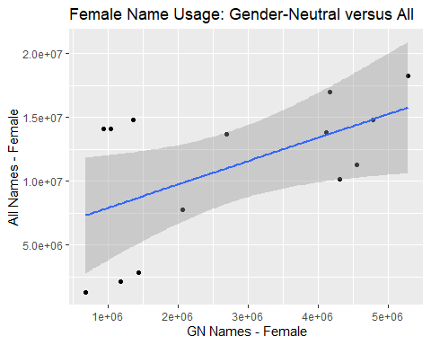

cortest_f<-cor.test(f_gn_names, f_all_names, method = "pearson")  
  
sink("C:/Users/shawn/OneDrive/Shawn/CSU_global/MIS581/project_r_code/name_files/f_gn_names_corr.txt")  
print(cortest_f)

##   
## Pearson's product-moment correlation  
##   
## data: f_gn_names and f_all_names  
## t = 2.3283, df = 12, p-value = 0.03819  
## alternative hypothesis: true correlation is not equal to 0  
## 95 percent confidence interval:  
## 0.03870847 0.83984009  
## sample estimates:  
## cor   
## 0.5578313

sink() # returns output to the console  
#----  
#correlation for male names  
m_test_set<-data.frame(sum_all_decades_df$Years,sum_all_decades_df$M.occurrances.of.GN.names,sum_all_decades_df$Total.M.occurrances)  
m_gn_names<-as.numeric(unlist(m_test_set[2]))  
m_all_names<-as.numeric(unlist(m_test_set[3]))  
m_gn_all<-data.frame(m_gn_names,m_all_names)  
# correlation tests  
m_gn_scatter_plot <- ggplot(m_gn_all, aes(m_gn_names, m_all_names))  
m_gn_scatter_plot + geom_point() + labs(title="Male Name Usage: Gender-Neutral versus All",x = "GN Names - Male", y = "All Names - Male") + geom_smooth(method="lm")

## `geom_smooth()` using formula 'y ~ x'

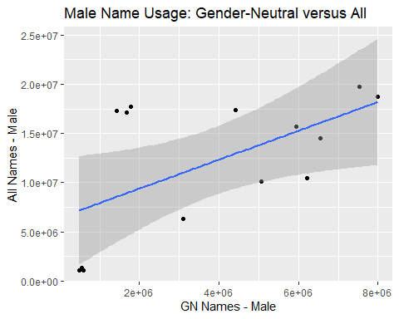

cortest_m<-cor.test(m_gn_names, m_all_names, method = "pearson")  
#---  
sink("C:/Users/shawn/OneDrive/Shawn/CSU_global/MIS581/project_r_code/name_files/f_gn_names_corr.txt")  
print(cortest_f)

##   
## Pearson's product-moment correlation  
##   
## data: f_gn_names and f_all_names  
## t = 2.3283, df = 12, p-value = 0.03819  
## alternative hypothesis: true correlation is not equal to 0  
## 95 percent confidence interval:  
## 0.03870847 0.83984009  
## sample estimates:  
## cor   
## 0.5578313

sink() # returns output to the console  
  
sink("C:/Users/shawn/OneDrive/Shawn/CSU_global/MIS581/project_r_code/name_files/m_gn_names_corr.txt")  
print(cortest_m)

##   
## Pearson's product-moment correlation  
##   
## data: m_gn_names and m_all_names  
## t = 2.4599, df = 12, p-value = 0.03004  
## alternative hypothesis: true correlation is not equal to 0  
## 95 percent confidence interval:  
## 0.06986763 0.84881121  
## sample estimates:  
## cor   
## 0.578984

sink() # returns output to the console